Supplementary materials

Supplementary Table 1. The BJ-HepaGS model interpreted inflammation improvement and fibrosis regression in paired sets before and after treatment
Histology features | BJ-HepaGS Model | Consensus | p value
Inflammatory Assessment |  |  | 0.855
Improvement | 33 (66%) | 34 (68%)
Stable | 13 (26%) | 11 (22%)
Worsening | 4 (8%) | 5 (10%)
Fibrosis Assessment |  |  | 0.388
Regression | 22 (44%) | 23 (46%)
Indeterminate | 25 (50%) | 23 (56%)
Progression | 3 (6%) | 4 (8%)

Supplementary Table 2. The BJ-HepaGS model helped improvement histological grading and staging by expert pathologists
Discordance | Senior experts | Junior experts
Inflammation | 59 (20%, 59/300) | 70 (23%, 70/300)
Maintain | 33 (56%) | 37 (54%)
Modified | 26 (44%) | 32 (46%)
Modify to AI | 23 (88%) | 28 (88%)
New interpretation | 3 (12%) | 4 (13%)
Fibrosis | 117 (39%) | 128 (43%)
Maintain | 83 (71%) | 88 (69%)
Modified | 34 (29%) | 40 (31%)
Modify to AI | 26 (76%) | 32 (80%)
New interpretation | 8 (24%) | 8 (20%)

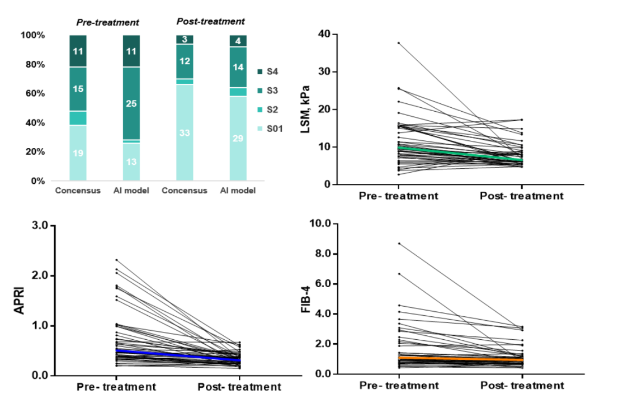
Supplementary Fig. 1. Changes in fibrosis stage distribution and non-invasive markers before and after treatment based in the paired set

