Appendix

Appendix A: Survey Questionnaire

Survey on Perceptions of Universal Basic Income

1. Demographic Information
• Age: ____
• Gender: ____
• Occupation: ____
• Country of Residence: ____
2. Perceptions of UBI
• How familiar are you with the concept of Universal Basic Income (UBI)?
• Very Familiar
• Somewhat Familiar
• Not Familiar
• What do you think are the potential benefits of UBI? (Select all that apply)
• Poverty Reduction
• Economic Stability
• Improved Well-being
• Increased Freedom
• Other: ____
• What do you think are the potential challenges of UBI? (Select all that apply)
• Funding
• Impact on Employment
• Inflation
• Public Support
• Other: ____
3. Open-ended Questions
• In your opinion, how should UBI be funded sustainably?
• What additional policies would complement UBI to address socio-economic issues effectively?

Appendix B: Interview Guide

Interview Questions for Policymakers and Economists

1. Understanding of UBI
• Can you describe your understanding of Universal Basic Income and its objectives?
• How do you see UBI fitting within the broader social and economic policy landscape?
2. Impact Assessment
• Based on your experience, what have been the key impacts of UBI in the regions where it has been implemented?
• How does UBI affect employment rates and economic activity in these regions?
3. Challenges and Solutions
• What are the main challenges associated with implementing UBI?
• What strategies or solutions have been proposed or implemented to address these challenges?
4. Future Prospects
• How do you foresee the future development of UBI policies?
• Are there any emerging trends or innovations in UBI that you find particularly promising?

Appendix C: Case Study Data

Table 1: Summary of UBI Case Studies

Case Study | Country | Duration | Monthly UBI Amount | Key Findings
Finland | Finland | 2017-2018 | €560 | Improved well-being; Limited impacts on employment
Ontario | Canada | 2017-2018 | CAD 1,400 | Reduced Poverty; Improved health outcomes
Alaska | USA | 1982-Present | $1,000/year | Increased Savings; Modest impact on employment
Kenya | Kenya | 2016-Present | KES 2,000 | Significant poverty reduction; improved cohesion

Figure 1: Impact of UBI on Well-being and Poverty Reduction

This figure illustrates the comparative impact of UBI on well-being and poverty reduction across the case study countries. Data is represented as percentage changes observed in the respective regions.

Graph 1: Employment Rates Pre- and Post-UBI Implementation

This graph shows the changes in employment rates before and after the implementation of UBI in the case study regions.
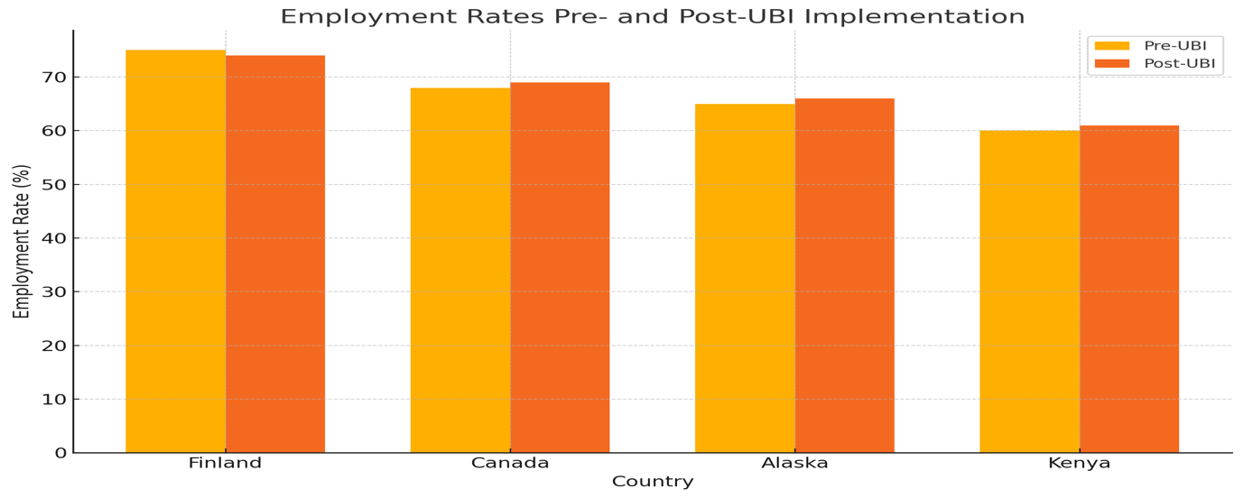

Appendix D: Additional Resources

Resource List

• UBI Research Reports and Policy Briefs
• Link to UBI research reports
• Policy Documents and Guidelines
• Link to policy documents
• Relevant Databases and Statistical Sources
• Link to databases

