Appendix A
An example of a student team's work is presented in Appendix A to illustrate the project outcomes. In this course, students applied the AI-assisted sustainable design model to redesign bus stops in the Jimei University district.
Fig. A1 illustrates the main design activities students conducted in Project Phase 1. During the field research, students visited several bus stops in the Jimei University district and observed how passengers interacted with the facilities. Subsequently, they utilized ChatGPT to assist in the design and analysis of user research. Students then interpreted and synthesized the findings to generate key insights.
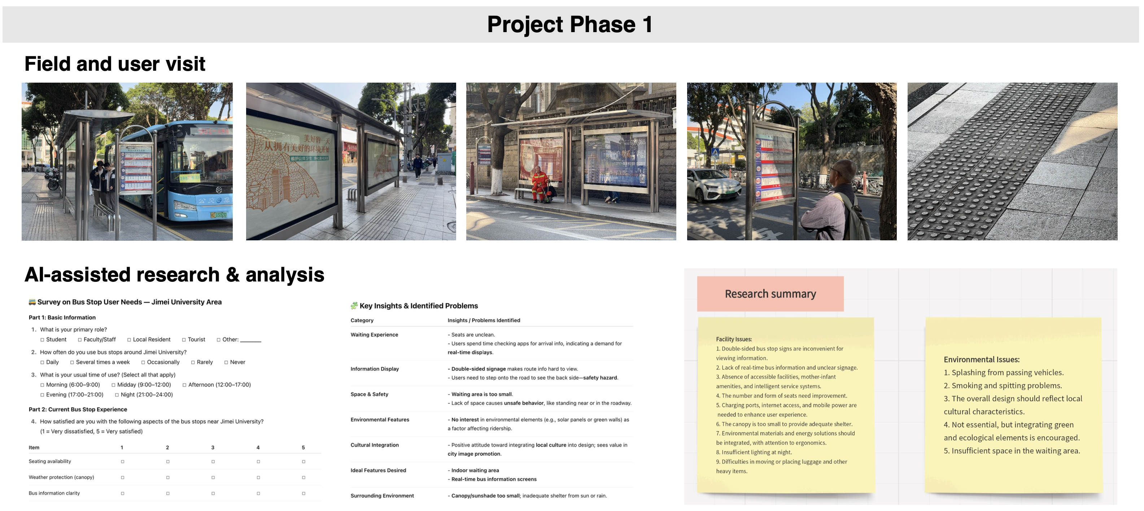
Fig. A1 Students’ work in Project Phase 1

Project Phase 2 involved a highly iterative design process (Fig. A2). At the beginning of this process, students focused on generating a wide range of design concepts. ChatGPT and Midjourney assisted them in expanding their ideas from various sustainability perspectives and visualizing those concepts effectively. They then narrowed their focus to three primary design options and used AI tools to further examine their sustainability performance with respect to core materials, energy use, and transportation. The EcoDesign Strategy Wheel was subsequently applied to evaluate each of the three design options individually, and the option with the strongest sustainability performance was selected as the final design solution.
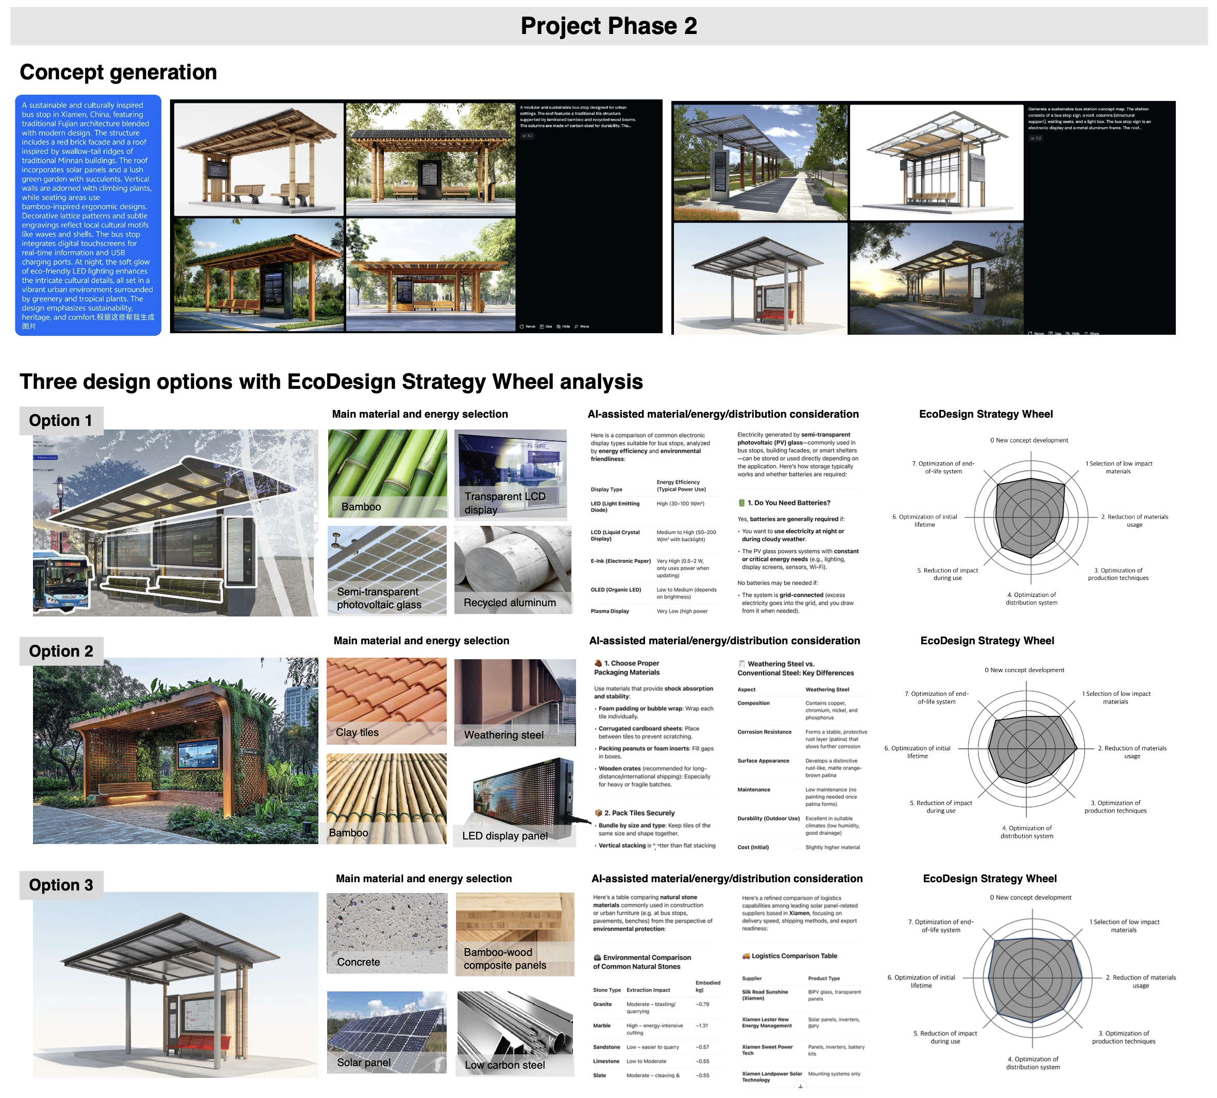
Fig. A2 Students’ work in Project Phase 2

During Project Phase 3, each student team further refined and improved their final solutions, using traditional modeling software to present design details and usage scenarios (Fig. A3).
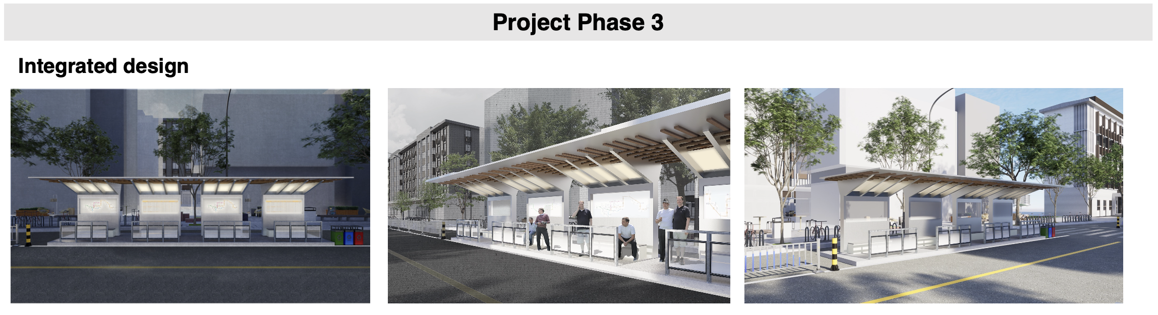
Fig. A3 Students’ work in Project Phase 3

