Supplemental Figures
Supplemental Fig. 1.
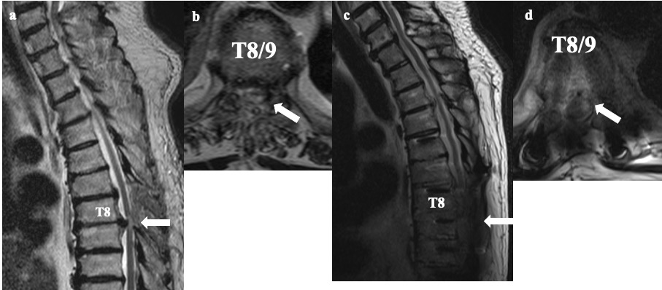
Supplemental Fig. 2
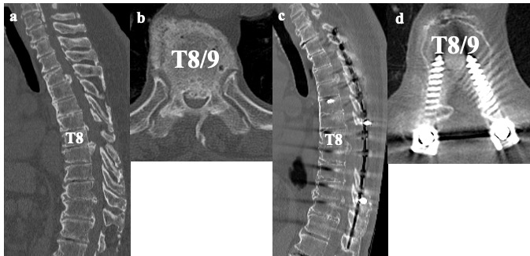
Supplemental Fig. 3.
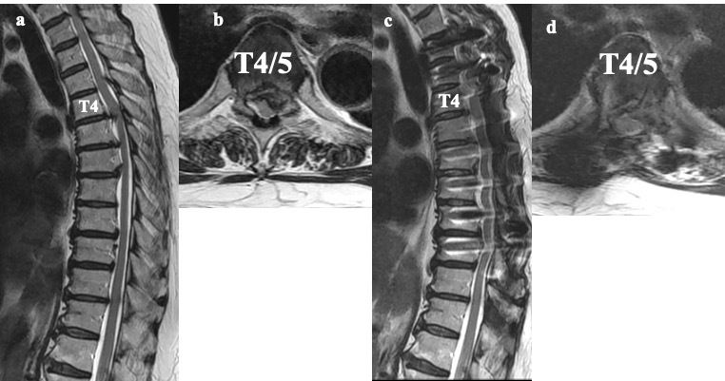
Supplemental Fig. 4.
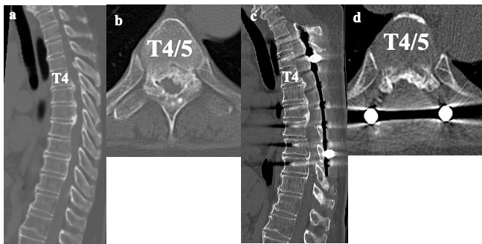
Supplemental Figures‘ Legends
Supplemental Fig. 1. Case 1: MRI scan of the 84-year-old male patient with cervical and thoracic OPLL+OLF. (a) Preoperative sagittal plane MRI; (b) preoperative axial plane MRI; (c) 8-year postoperative sagittal plane MRI; and (d) 8-year postoperative axial plane MRI. The white arrows show the intraspinal high-intensity areas. MRI, magnetic resonance imaging; OPLL, ossification of the posterior longitudinal ligament; OLF, ossification of the ligamentum flavum.
Supplemental Fig. 2. Case 1: CT scan of the 84-year-old male patient with cervical and thoracic OPLL+OLF. (a) Preoperative sagittal plane CT; (b) preoperative axial plane CT; (c) 8-year postoperative sagittal plane CT; and (d) 8-year postoperative axial plane CT. CT, computed tomography; OPLL, ossification of the posterior longitudinal ligament; OLF, ossification of the ligamentum flavum.
Supplemental Fig. 3. Case 2: MRI scan of the 61-year-old female patient with cervical and thoracic OPLL+OLF. (a) Preoperative sagittal plane MRI; (b) preoperative axial plane MRI; (c) 10-year postoperative sagittal plane MRI; and (d) 10-year postoperative axial plane MRI. MRI, magnetic resonance imaging; OPLL, ossification of the posterior longitudinal ligament; OLF, ossification of the ligamentum flavum.
Supplemental Fig. 4. Case 2: CT scan of the 61-year-old male patient with cervical and thoracic OPLL+OLF. (a) Preoperative sagittal plane CT; (b) preoperative axial plane CT; (c) 10-year postoperative sagittal plane CT; and (d) 10-year postoperative axial plane CT. CT, computed tomography; OPLL, ossification of the posterior longitudinal ligament; OLF, ossification of the ligamentum flavum.

