Synergistic Bone Regeneration Through Sequential Dual-drug Delivery

Jae Won Jang^{1,2,†}, Hyunji Kim^{1,2,†}, Joon Seok Oh^{3,†}, Dongtak Lee⁴, Hye-Jung Choi⁵, Hyunjung Shin⁶, Chang-Nam Son⁷, Xian Jin⁸, Hyo Gi Jung^{1,2}, Yonghwan Kim^{1,2}, Jisung Yoon^{1,2}, Seung-Hyun Kim⁹, Hak Chang^{3,*}, and Dae Sung Yoon^{1,2,*}
¹School of Biomedical Engineering, Korea University, Seoul, 02841, Republic of Korea
²Interdisciplinary Program in Precision Public Health, Korea University, Seoul, 02841, South Korea
³Department of Plastic and Reconstructive Surgery, Seoul National University Hospital, Seoul National University College of Medicine, Seoul 03080, Republic of Korea
⁴Division of Bioengineering, Incheon National University, Incheon, 22012, Republic of Korea
⁵Department of Emergency Medical Technology, Gyeongbuk Provincial College, Yecheon, 36830, Republic of Korea
⁶Department of Energy Science, Nature Inspired Materials Processing Research Center, Sungkyunkwan University, Suwon, 16419, Republic of Korea
⁷Department of Rheumatology, Uijeongbu Eulji Medical Center, Eulji University School of Medicine, Uijeongbu, Korea
⁸Department of Plastic Surgery, The Second Affiliated Hospital of Zhejiang University School of Medicine, Hangzhou, China
⁹School of Engineering, Brown University, Providence, RI 02912, USA

†These authors contributed equally to this work.

*E-mail addresses: hchang@snu.ac.kr (Hak Chang); dsyoon@korea.ac.kr (Dae Sung Yoon)

Keywords: bone regeneration, sequential drug delivery, bioinspired scaffold, BMP-2, OPG-Fc
Supplementary Material
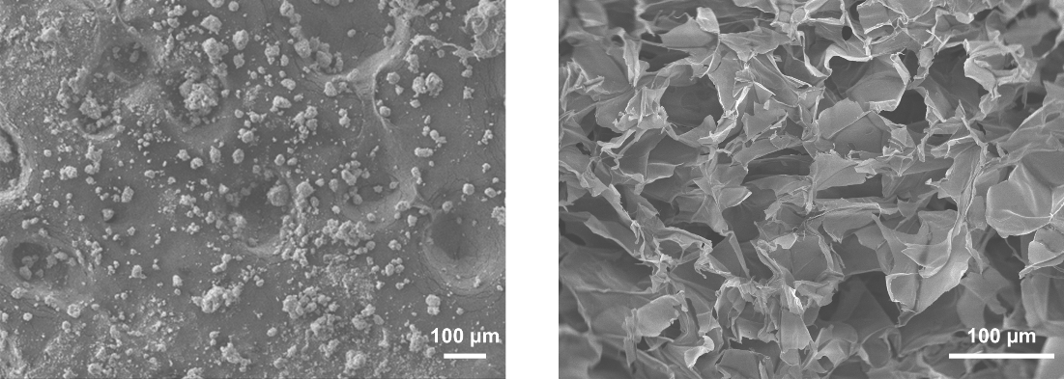
Figure S1. SEM image of hydroxyapatite (left) and collagen gel scaffold (right).

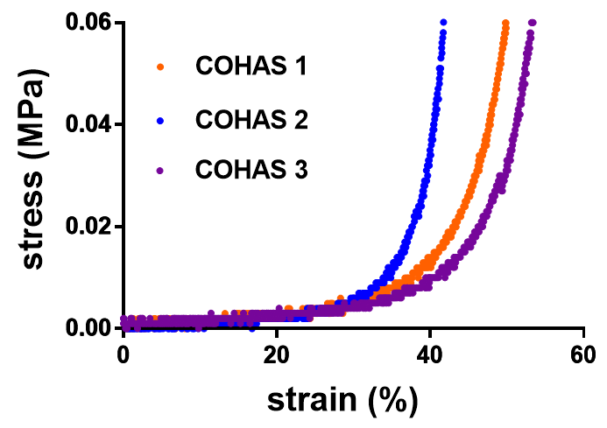
Figure S2. Compressive stress-strain curve of PBS-rehydrated COHASs (n=3).

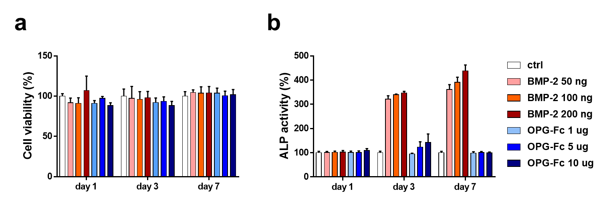
Figure S3. (a) The cell viability and (b) ALP activity assay of MC3T3-E1 with various concentrations of BMP-2 and OPG-Fc. Every individual data point represents a set of triplicate measurements.

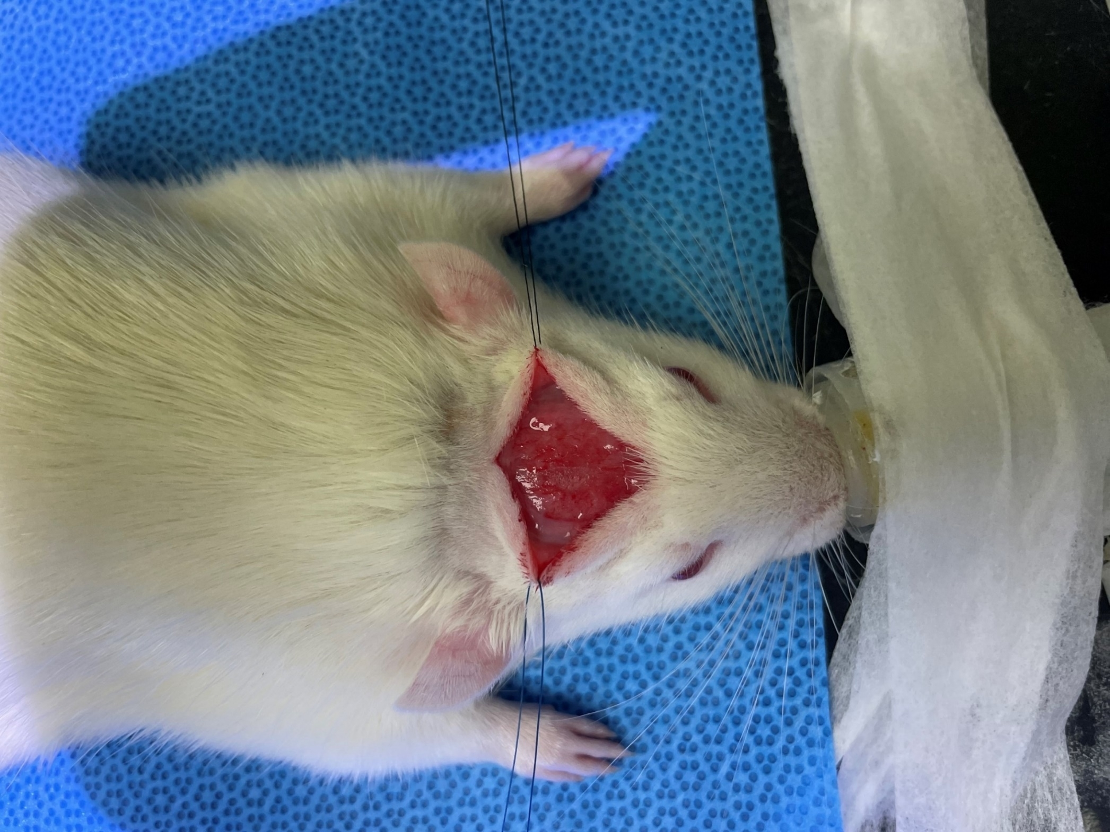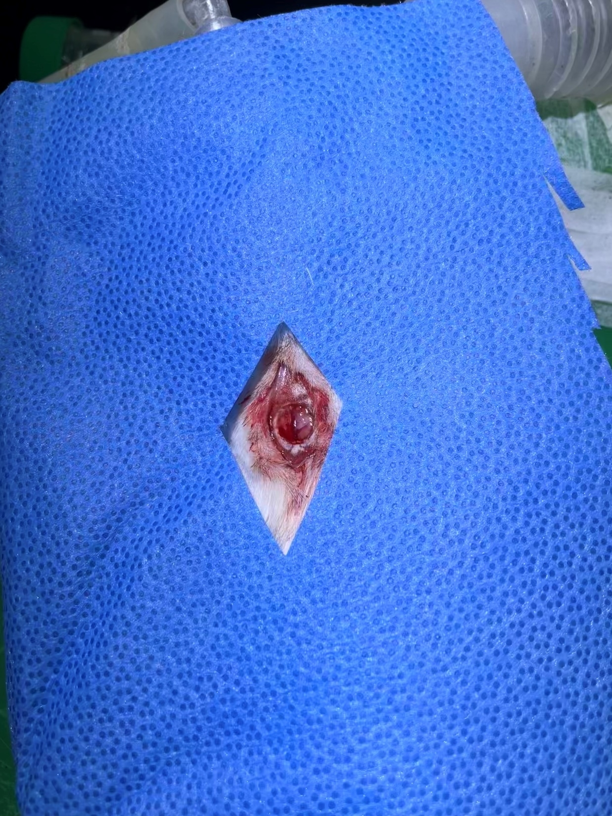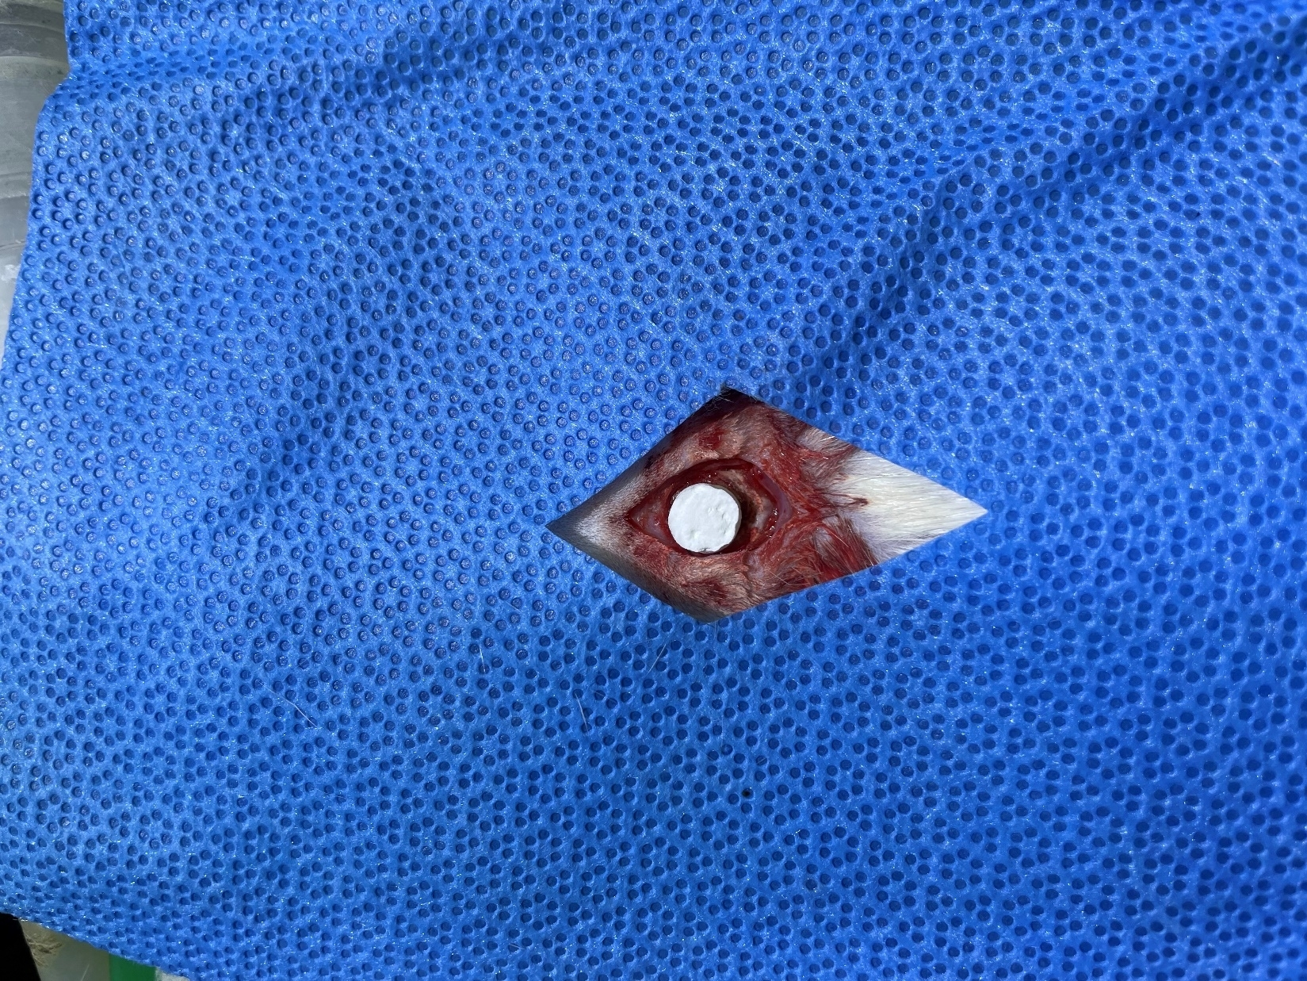
Figure S4. Incision made down to periosteal level (left). 8 mm-sized cranial defect made by trephination (middle). Insertion of COHAS into the defect site (right).

Table S1. Porosity of COHASs measured from eight samples.
Diameter (mm) | Height (mm) | Mass (g) | Volume (mm³) | Measured density (g/mm³) | Measured density (g/cm³) | Theoretical density (g/cm³) | Porosity (%) | Average porosity (%)
8.44 | 3.14 | 0.022 | 175.67 | 1.25×10⁻⁴ | 0.12 | 2.83 | 95.59 | 95.82
8.8 | 3.82 | 0.024 | 232.34 | 1.02×10⁻⁴ | 0.10 | 2.83 | 96.40 | 95.82
8.73 | 3.7 | 0.027 | 221.47 | 1.22×10⁻⁴ | 0.12 | 2.83 | 95.69 | 95.82
8.13 | 3.13 | 0.020 | 162.49 | 1.23×10⁻⁴ | 0.12 | 2.83 | 95.65 | 95.82
8.25 | 2.9 | 0.015 | 155.02 | 9.68×10⁻⁴ | 0.10 | 2.83 | 96.58 | 95.82
8.07 | 3 | 0.018 | 153.45 | 1.17×10⁻⁴ | 0.12 | 2.83 | 95.85 | 95.82
8.23 | 2.9 | 0.022 | 154.27 | 1.43×10⁻⁴ | 0.14 | 2.83 | 94.96 | 95.82
8.31 | 1.95 | 0.014 | 105.76 | 1.32×10⁻⁴ | 0.13 | 2.83 | 95.32 | 95.82

Table S2. Bone area and volume estimate from micro CT analysis.
Time | Week 2 | Week 4 | Week 8
Group | Week 2 | Week 4 | Week 8
Area
COHAS | 91.71±35.60 | 267.54±109.41 | 355.74±140.30
COHAS_B | 94.85±8.78 | 255.69±30.47 | 464.96±99.73
COHAS_O | 120.26±43.60 | 203.57±42.55 | 329.76±90.75
COHAS_B_O | 108.69±16.42 | 218.67±33.82 | 331.59±101.38
COHAS_P@B_O | 100.52±9.38 | 250.45±13.35 | 433.74±16.28
COHAS_B_P@O | 225.39±35.87 | 318.80±18.12 | 547.85±62.20
Volume
COHAS | 11.92±6.52 | 20.75±7.76 | 28.68±10.09
COHAS_B | 13.66±1.26 | 23.01±2.74 | 44.13±11.74
COHAS_O | 13.99±2.27 | 21.65±4.57 | 33.01±2.49
COHAS_B_O | 15.65±2.37 | 19.68±3.04 | 29.84±9.12
COHAS_P@B_O | 15.99±3.02 | 26.21±7.35 | 42.70±5.49
COHAS_B_P@O | 21.34±2.18 | 30.36±1.35 | 52.17±4.13

Table S3. Bone regeneration area from micro CT analysis with reference to COHAS group
 | Estimate | 95% Confidence Interval | p-value¹⁾ | p-value²⁾
COHAS | Reference |  |  | 0.0262
COHAS_B | 33.501 | (-52.1,119.103) | 0.4105
COHAS_O | -20.47 | (-106.072,65.132) | 0.6118
COHAS_B_O | -18.681 | (-104.283,66.92) | 0.643
COHAS_P@B_O | 23.239 | (-62.363,108.84) | 0.5652
COHAS_B_P@O | 125.68 | (40.08,211.283) | 0.0076
Week 2 | Reference |  |  | <0.0001
Week 4 | 128.88 | (90.659,167.101) | <0.0001
Week 8 | 287.04 | (248.816,325.257) | <0.0001
- P-value whether each group has a statistically different area compared to reference
- P- value whether the difference in bone area is statistically significant

Table S4. Bone regeneration volume from micro CT analysis with reference to COHAS group
 | Estimate | 95% Confidence Interval | p-value¹⁾ | p-value²⁾
COHAS | Reference |  |  | 0.0170
COHAS_B | 6.483 | (-1.297,14.263) | 0.0945
COHAS_O | 2.434 | (-5.346,10.214) | 0.5083
COHAS_B_O | 1.276 | (-6.504,9.056) | 0.7271
COHAS_P@B_O | 7.85 | (0.07,15.63) | 0.0483
COHAS_B_P@O | 14.176 | (6.396,21.956) | 0.0019
Week 2 | Reference |  |  | <0.0001
Week 4 | 8.187 | (4.572,11.802) | <0.0001
Week 8 | 23.001 | (19.385,26.616) | <0.0001
- P-value whether each group has a statistically different volume compared to reference
- P- value whether the difference in bone volume is statistically significant

Table S5. At the 8-week time point, a mixed model analysis including the group-time interaction term was conducted to examine bone regeneration area
 | Estimate | p-value¹⁾
COHAS vs COHAS_B_P@O | -192.11 | 0.0012
COHAS_B_O vs COHAS_B_P@O | -216.26 | 0.0004

Table S6. At the 8-week time point, a mixed model analysis including the group-time interaction term was conducted to examine bone regeneration volume
 | Estimate | p-value¹⁾
COHAS vs COHAS_B_P@O | -23.49 | <0.0001
COHAS_B_O vs COHAS_B_P@O | -22.33 | <0.0001

