Supplementary Information

Conjugated Backbone-Directed Side Chain-Electrolyte Coupling toward Nonvolatile Artificial Synapse

Junho Sung¹, Sein Chung², Byeongjun Jeon¹, Donghwa Lee¹, Myungjin An³, Jiyeong Shin², Yoohyeon Jang¹, Bumjoon Seo^{1*}, and Eunho Lee^{1*}

¹Department of Chemical and Biomolecular Engineering, Seoul National University of Science and Technology, Seoul 01811, Republic of Korea
²Department of Chemical Engineering, Pohang University of Science and Technology, Pohang 37673, Republic of Korea
³Department of Chemical Engineering, Kumoh National Institute of Technology, Gumi, 39177, Republic of Korea

† These authors jointly supervised this work
* Corresponding authors bseo@seoultech.ac.kr (B.S.), ehl@seoultech.ac.kr (E.L.).


Supplementary Figure S1. Optical micrograph of our fabricated EGOST with p(g2T-R)-based polymer film.

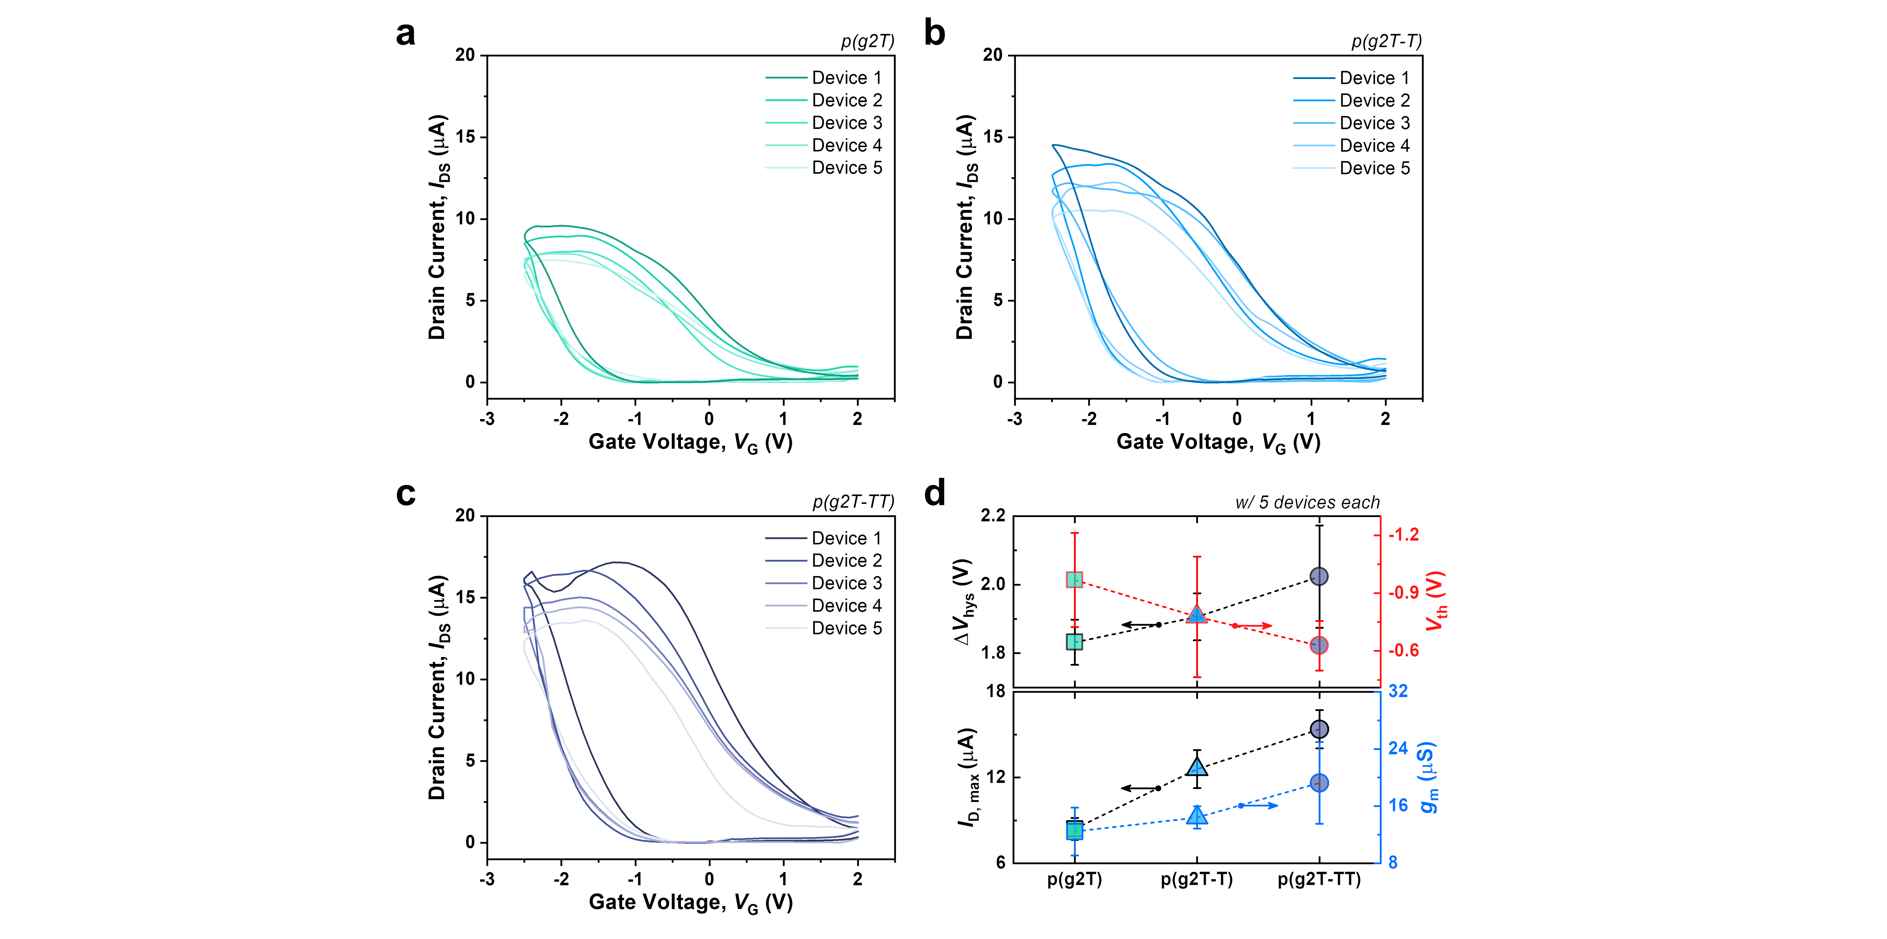
Supplementary Figure S2. Transfer curves for a) p(g2T), b) p(g2T-T), and c) p(2gT-TT) for each of the five devices. d) Comparison of parameter values for each of the 5 p(g2T-R) based devices.

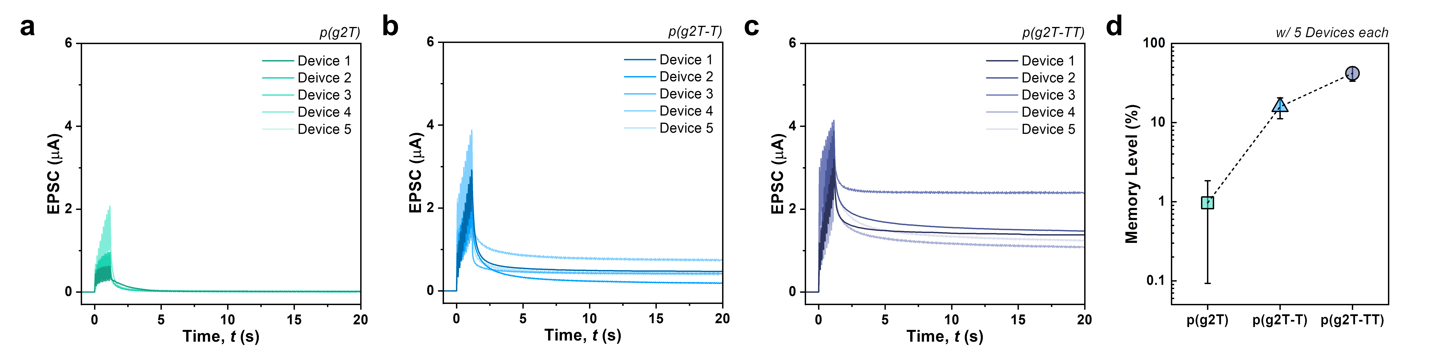
Supplementary Figure S3. Long-term plasticity characteristics of artificial synapses based on a) p(g2T), b) p(g2T-T), and c) p(2gT-TT) with 5 devices each. d) Memory level (five devices) about 20 seconds after pulse application to p(g2T-R)-based EOGSTs.

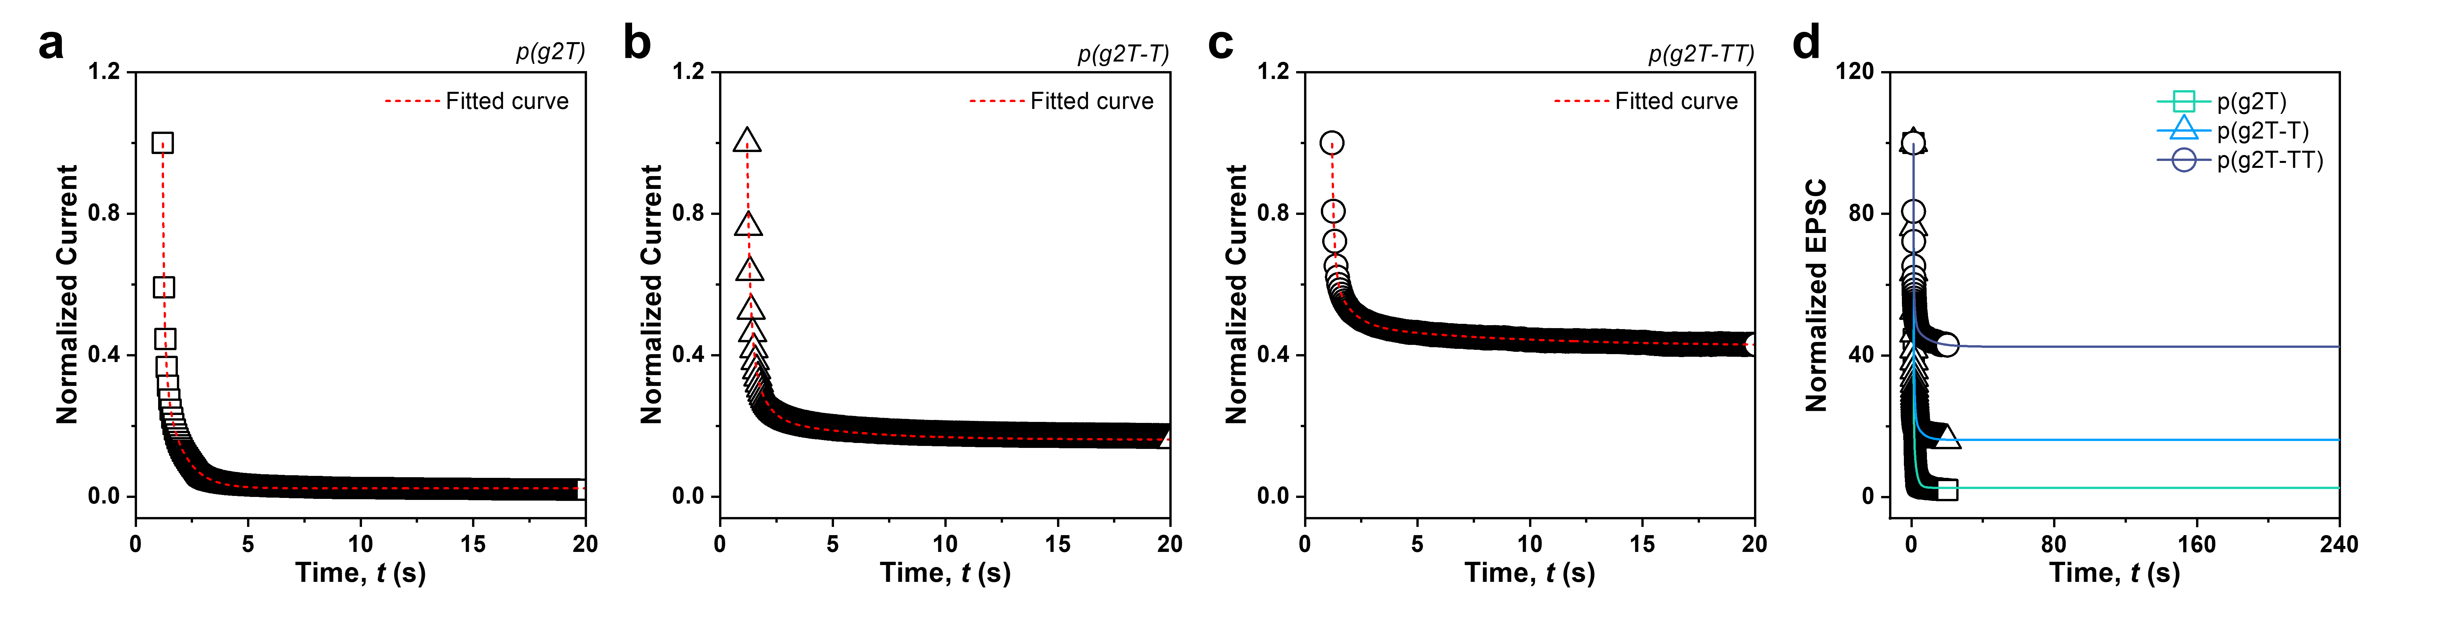
Supplementary Figure S4. The decrease in EPSC after applying 10 consecutive pulses to artificial synapses a) p(g2T), b) p(g2T-T), and c) p(g2T-TT) and the curve fitted to the tri-exponential function. d) Tri-exponential function fitting extended to 240 seconds.

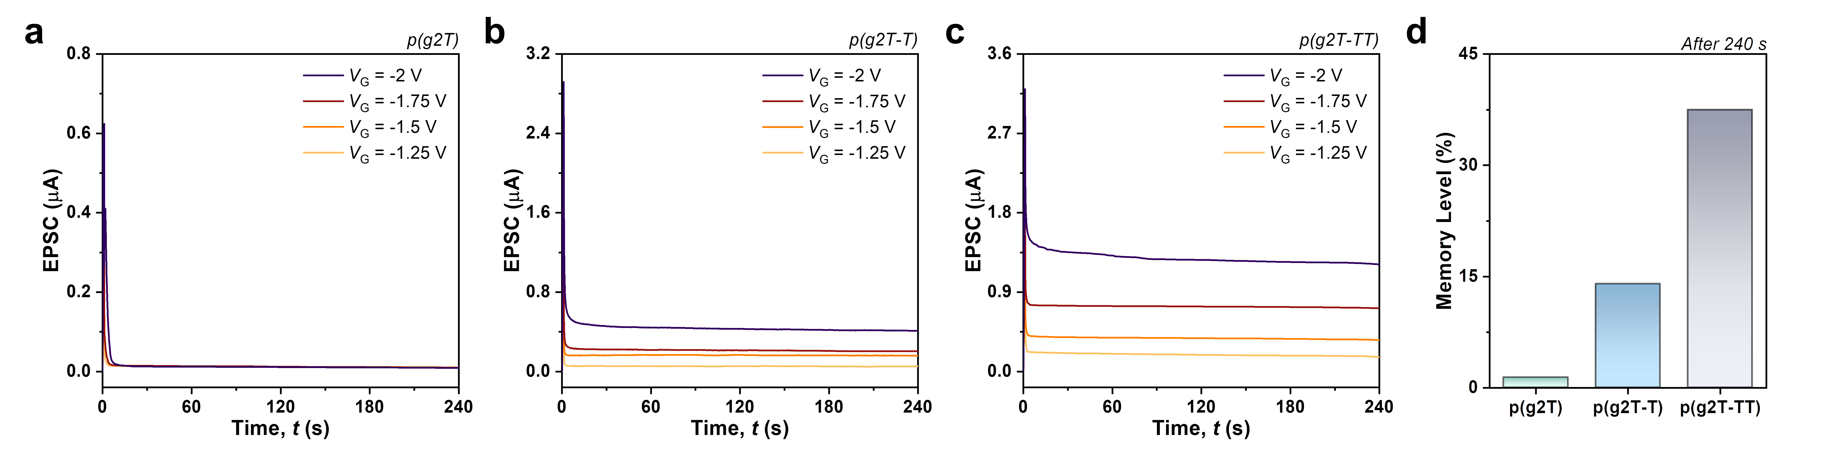
Supplementary Figure S5. a-c) LTP characteristics over 240 seconds depending on the voltage amplitude (V_{pulse} = −2, −1.75, −1.5, and −1.25 V) of 10 consecutive pulses (t_{pulse} = 60 ms, t_{interval} = 60 ms) of p(g2T-R)-based EGOST. d) Comparison of memory level retention 240 seconds after pulse application to each device.

Supplementary Figure S6. EPSC responses of a) p(g2T), b) p(g2T-T), and c) p(g2T-TT) EGOSTs depending on the number of pulses applied. EPSC variation depending on the width of 10 consecutive pulses applied to d) p(g2T), e) p(g2T-T), and f) p(g2T-TT) EGOSTs. g-i) Changes in peak EPSC as a function of pulse number and width for EGOSTs based on p(g2T-R).

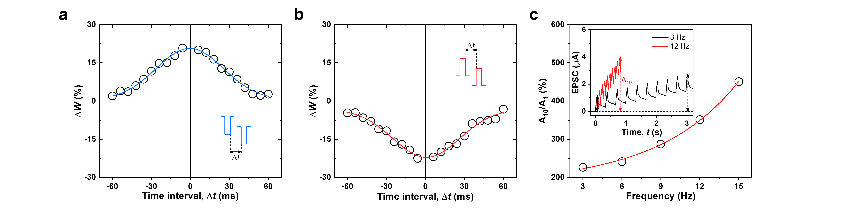
Supplementary Figure S7. Implementations of STDP characteristics according to a) Symmetric Hebbian learning and b) anti-Hebbian learning rules of p(g2T-TT) EGOST. c) Changes in the ratio of A₁ and A₁₀ according to frequency changes in the p(g2T-TT) device, meaning high-pass filtering characteristics. Inset: Changes in EPSC due to pulse application at 3 and 12 Hz.

Note S1. Quantum Chemistry Methods.
All density functional theory (DFT) calculations were performed using ORCA 6.0.0.^{S1} All DFT calculations were performed at the B3LYP^{S2,S3}/6-31G(d,p)^{S4} level of theory. D3BJ for dispersion interactions^{S5} and split-RI-J approximation^{S6,S7} for the Coulomb integrals and chain-of-spheres (RIJCOSX) integration for the Hartree-Fock exchange integrals were used for the geometry optimization and single-point energy calculations. The initial geometries of the structures were generated based on universal force-field (UFF) optimization of all-trans conformers.^{S8} Geometry optimizations at the DFT level were performed on the low-energy conformers to characterize the single-point energy. The asymmetric structure of p(g2T-T) results in different interchain distances at the upper (u) and lower (l) regions. So, we placed two anions in the structure, one positioned between the upper polymer chains and the other between the lower chains. To calculate adsorption energy, the single-point energy of full structure containing both anions and the polymer was compared with the sum of the single-point energies calculated separately for the polymer with one anion and for the isolated second anion.
$$E_{ad}=E_{polymer+2anions}-(E_{polymer+1anion\left(u/l\right)}+E_{1anion(l/u)})$$
In the case of 2gT-T, due to the difference in the distances between the upper and lower chains, the adsorption energy was calculated as the average of the values obtained when the anion was positioned on the upper chain and the lower chain.

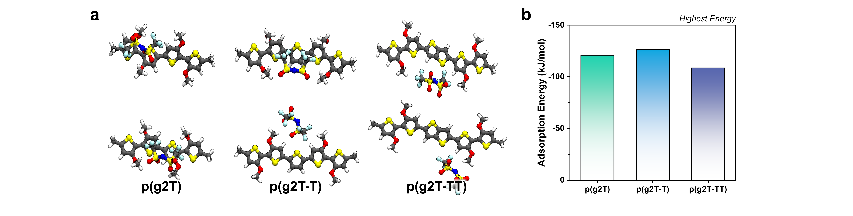
Supplementary Figure S8. Schematic illustrations of structure optimization results for each polymer with the highest adsorption energy between polymer and 1 anion in validated calculation for backbone without chains.


Supplementary Figure S9. Schematic of the anion when it is a) parallel to the backbone and b) perpendicular to it.

Supplementary Table S1. Adsorption energy of each polymer without chains based on the input location of the anion in validated calculations.
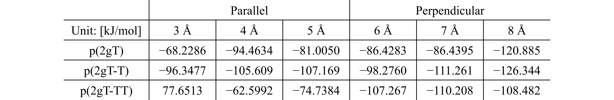

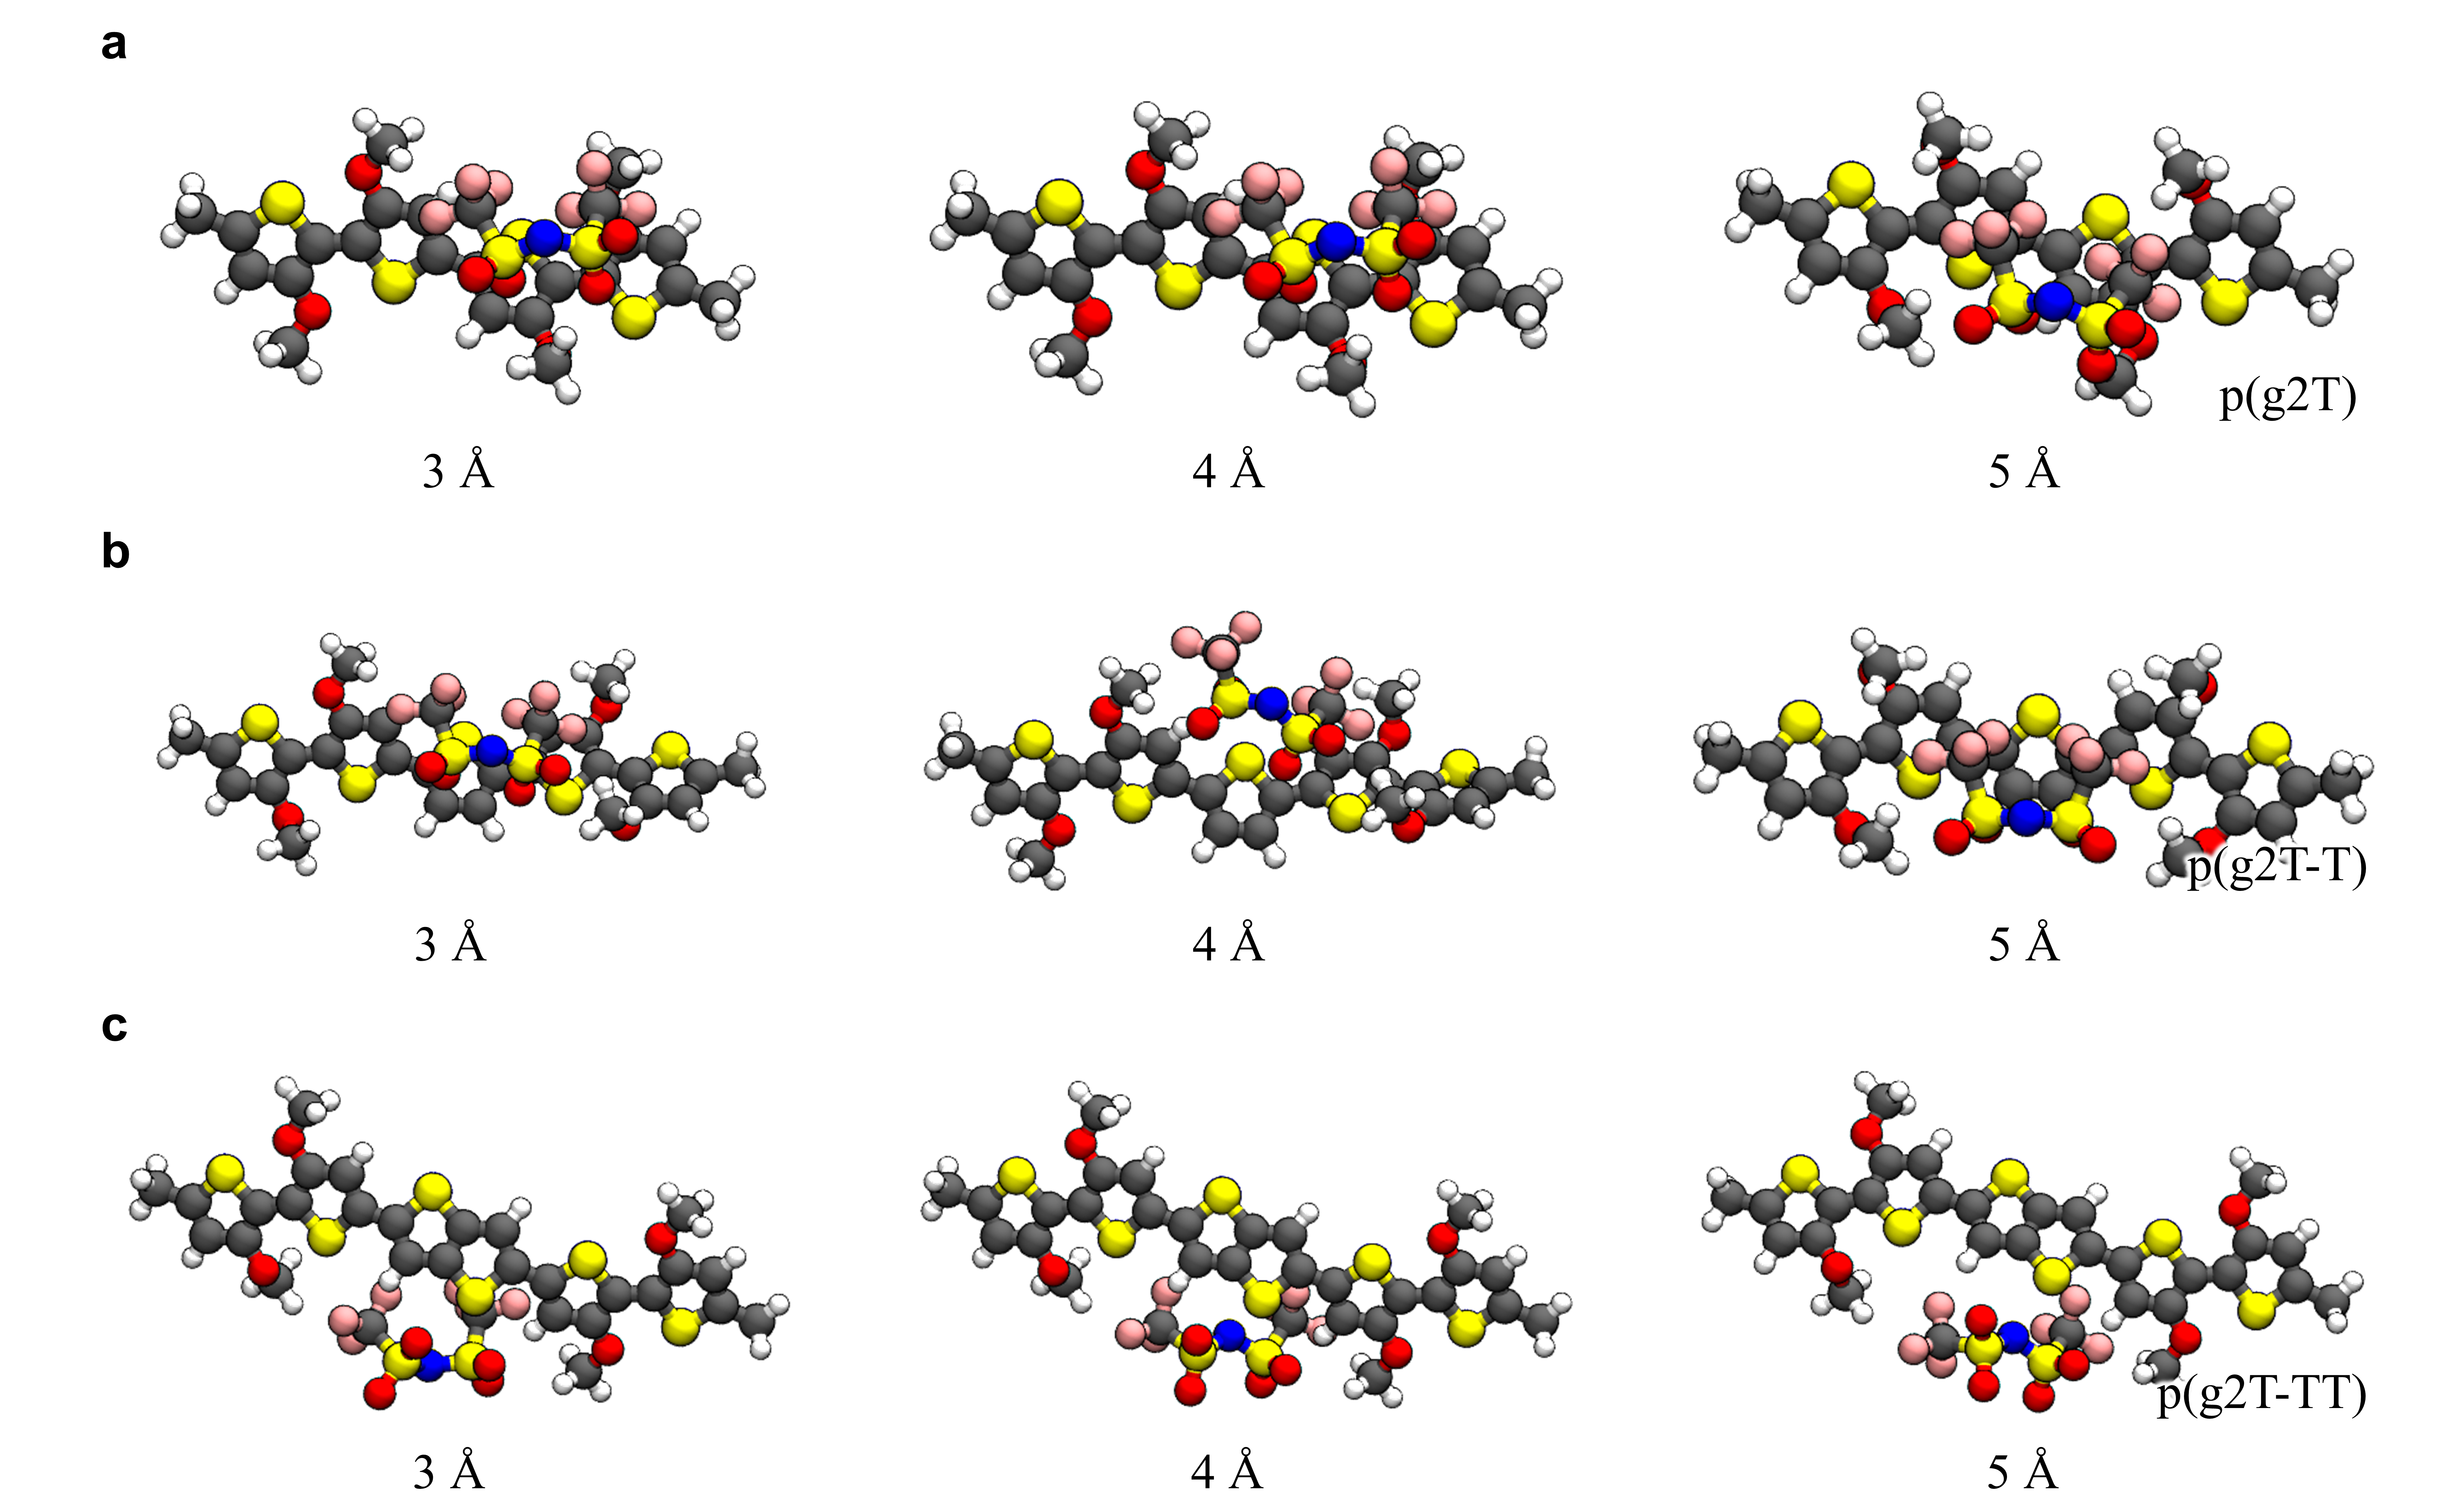
Supplementary Figure S10. Schematic illustration of structure optimization results for polymers with the highest adsorption energies at different distances between a) p(g2T), b) p(g2T-T), and p(g2T-TT) polymer backbone and parallel anions.

Supplementary Figure S11. Schematic illustration of structure optimization results for polymers with the highest adsorption energies at different distances between a) p(g2T), b) p(g2T-T), and p(g2T-TT) polymer backbone and perpendicular anions.


Supplementary Figure S12. Sites defined as inner, middle, and outer based on distance from Backbone.

Supplementary Table S2. Adsorption energy of each polymer based on the input location of the 2 anions in calculation.
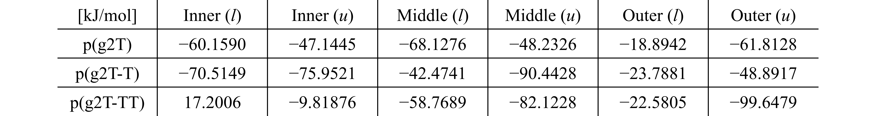

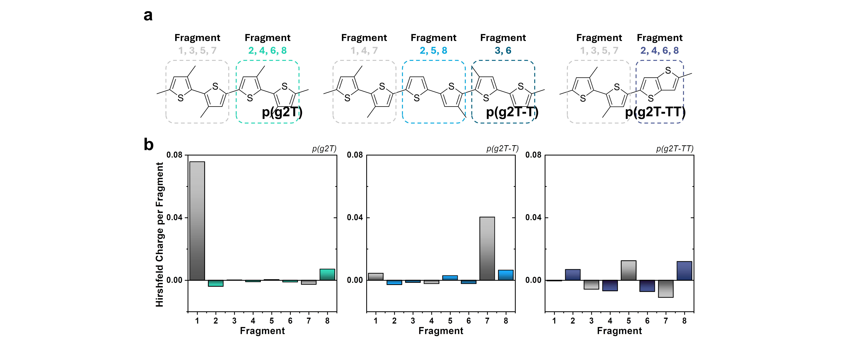
Supplementary Figure S13. a) Schematic illustration of fragments defined in p(g2T), p(g2T-T), and p(g2T-TT), respectively. b) Hirshfeld Charge distribution in fragments of different polymers.

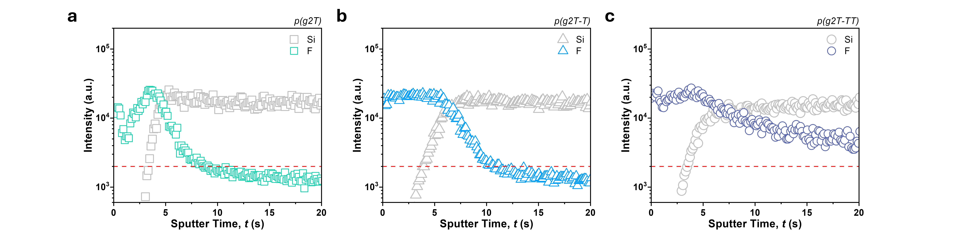
Supplementary Figure S14. TOF-SIMS depth profiles of fluorine and silicon after applying a voltage of −2 V for 10 seconds to the a) p(g2T), b) p(g2T-T), and c) p(g2T-TT) films.


Supplementary Figure S15. Changes in a) π- π stacking distance and b) lamellar stacking distance with doping of p(g2T-R) based polymer films.

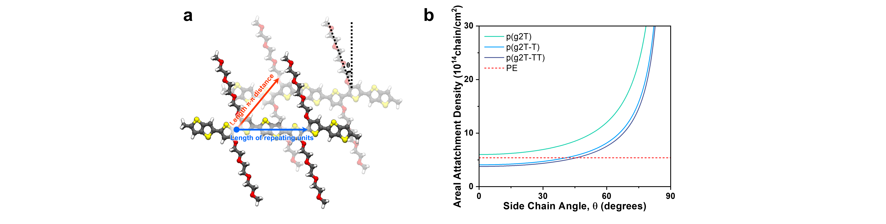
Supplementary Figure S16. a) Diagram of a p(g2T-TT) orientation model with tilted side chains. b) Areal attachment density calculated as a function of side chain angle in p(g2T-R)-based films.

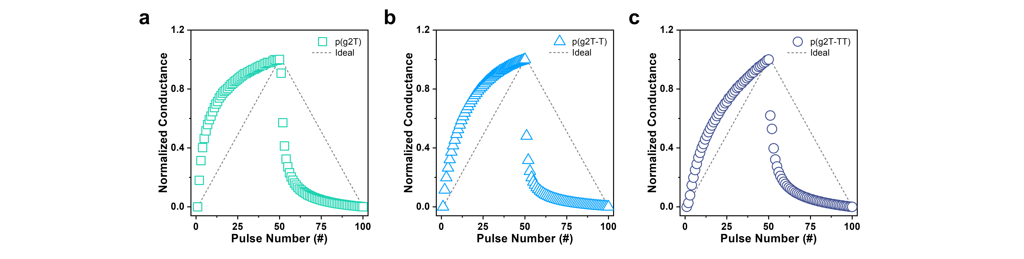
Supplementary Figure S17. Normalized LTP/D curves for a) p(g2T), b) p(g2T-T), and c)p(g2T-TT) devices. The dotted line indicates the ideal LTP/D curve with NL = 0.

Supplementary Note S2. Parameters for artificial neural network (ANN)-based recognition simulation
In ANN simulation, linearity (NL) in the long-term potentiation/depression (LTP/D) curve is considered to reflect the weight update performance of EGOST. The NL value can be extracted using the following equation; ^{S9,S10}
$${\text{G}}_{\text{LTP}} \text{=} \text{B}\left(\text{1} - {\text{e} }^{\left(-\frac{\text{P}}{{\text{A}}_{\text{P}}}\right)}\right) \text{+} {\text{G}}_{\text{min}}$$
$${\text{G}}_{\text{LTD}} \text{=} -\text{B}\left(\text{1} - {\text{e}}^{\left(\frac{\text{P} -{ \text{P}}_{\text{max}}}{{\text{A}}_{\text{D}}}\right)}\right) \text{+} {\text{G}}_{\text{max}}$$
$$\text{B} \text{=} {\left({\text{G}}_{\text{max}}-{\text{G}}_{\text{min}}\right) }/{ \text{(1} -{\text{e}}^{\frac{-{\text{P}}_{\text{max}}}{{\text{A}}_{\text{P, D}}}}}\text{),}$$
Where G_{LTP/D} denotes conductance in the LTP and LTD regions. P is the number of pulses, and A is a parameter for fitting the measured LTP/D curve, which is converted to an NL value as shown in Figure S18a. In addition, in order to fully reflect the characteristics of our artificial synapses, we applied calculations considering not only NL but also pulse number, dynamic range, and variation.

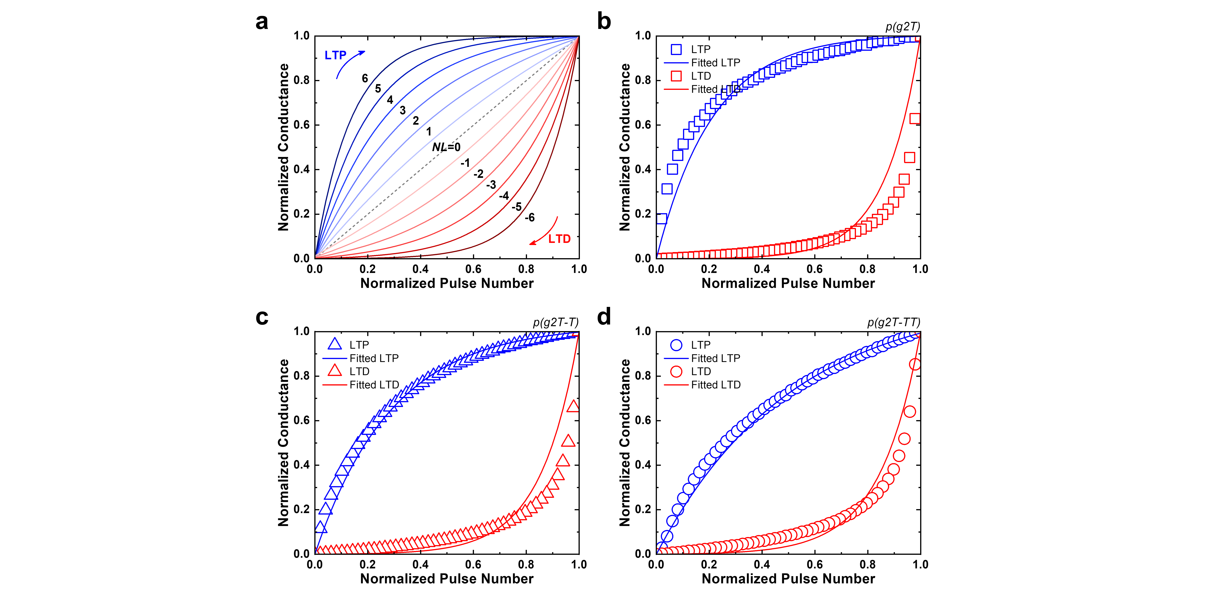
Supplementary Figure S18. a) Fitting curve based on NL values of LTP/D characteristics. Normalized conductance changes of b) p(g2T), c) p(g2T-T), and d) p(g2T-TT) based on LTP/D curves. The symbols and lines represent the measured conductance and fitted lines, respectively.

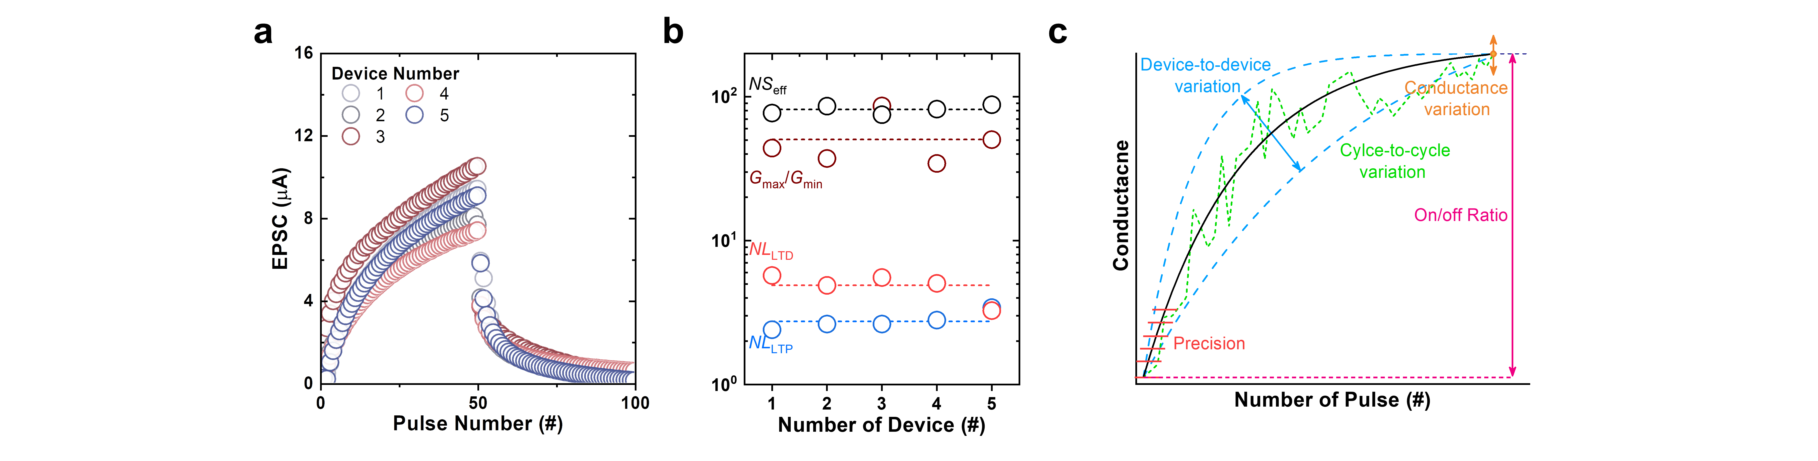
Supplementary Figure S19. a) LTP/D curves and b) NL, G_{max}/G_{min}, NS_{eff} variation of five p(g2T-TT)-based artificial synapses. c) Variation of LTP/D curves considered in ANN simulation.

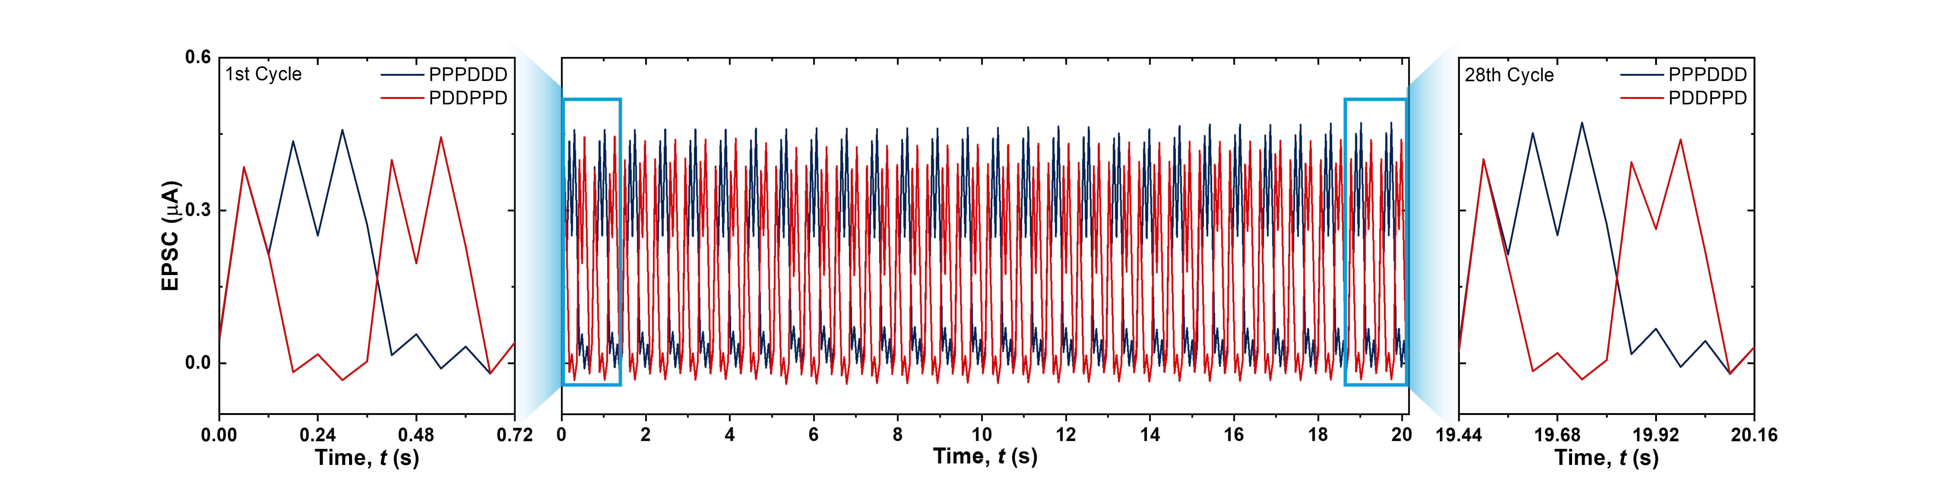
Supplementary Figure S20. State stability for two pulse sets (PPPDDD/PDDPPD) randomly composed of potentiation (−1.5 V) and depression (+1.5 V) pulses.

Supplementary Reference
S1. Neese, F., Wennmohs, F., Becker, U. & Riplinger, C. The ORCA quantum chemistry program package. J. Chem. Phys. 152, (2020).
S2. Becke, A. D. Density‐functional thermochemistry. III. The role of exact exchange. J. Chem. Phys. 98, 5648–5652 (1993).
S3. Lee, C., Yang, W. & Parr, R. G. Development of the Colle-Salvetti correlation-energy formula into a functional of the electron density. Phys. Rev. B 37, 785–789 (1988).
S4. Hehre, W. J., Ditchfield, R. & Pople, J. A. Self—Consistent Molecular Orbital Methods. XII. Further Extensions of Gaussian—Type Basis Sets for Use in Molecular Orbital Studies of Organic Molecules. J. Chem. Phys. 56, 2257–2261 (1972).
S5. Grimme, S., Ehrlich, S. & Goerigk, L. Effect of the damping function in dispersion corrected density functional theory. J. Comput. Chem. 32, 1456–1465 (2011).
S6. Weigend, F. Accurate Coulomb-fitting basis sets for H to Rn. Phys. Chem. Chem. Phys. 8, 1057–1065 (2006).
S7. Neese, F., Wennmohs, F., Hansen, A. & Becker, U. Efficient, approximate and parallel Hartree–Fock and hybrid DFT calculations. A ‘chain-of-spheres’ algorithm for the Hartree–Fock exchange. Chem. Phys. 356, 98–109 (2009).
S8. Rappe, A. K., Casewit, C. J., Colwell, K. S., Goddard, W. A. I. & Skiff, W. M. UFF, a full periodic table force field for molecular mechanics and molecular dynamics simulations. J. Am. Chem. Soc. 114, 10024–10035 (1992).
S9. Luo, Y., Peng, X. & Yu, S. MLP+NeuroSimV3.0: Improving On-chip Learning Performance with Device to Algorithm Optimizations. in Proceedings of the International Conference on Neuromorphic Systems 1–7 (Association for Computing Machinery, New York, NY, USA, 2019). doi:10.1145/3354265.3354266.
S10. Chen, P.-Y. & Yu, S. Technological Benchmark of Analog Synaptic Devices for Neuroinspired Architectures. IEEE Des. Test 36, 31–38 (2019).

