BIOGRAPHIES OF AUTHORS

 | Rahmon Ariyo Badru
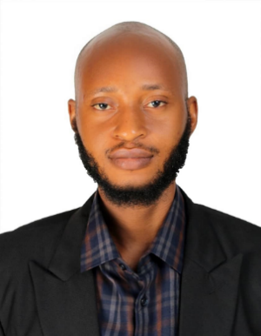 | Arikeuyo A. O. (Student Member, IEEE) was born in Ijebu Igbo, Ogun state, Nigeria, on April 10. He received the B.Sc. degree in computer and information science in 2020 and is currently pursuing the M.Sc. degree in software engineering at Lead City University, Ibadan, Oyo State, Nigeria.  He is currently a Freelance Front-End Developer, specializing in responsive web design and user interface development. His professional experience includes collaborating with clients to deliver scalable and efficient web solutions. His research interests include software engineering best practices, front-end technologies, and human-computer interaction.  Mr. Arikeuyo is an active member of the Nigeria Computer Society (NCS). His contributions to the field focus on leveraging modern web frameworks to enhance user experience and accessibility.
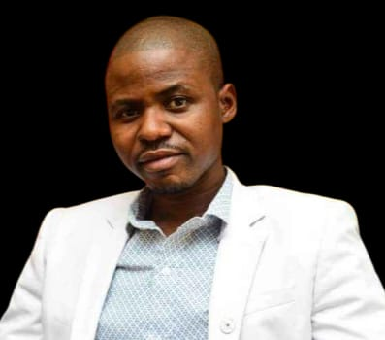 | Idowu Olugbenga Adewumi is a distinguished Nigerian engineering lecturer with robust academic and professional accomplishments. Idowu is currently the Head of Department, Department of Computer Science, Federal College of Agriculture, Ibadan, Nigeria. His cross-disciplinary expertise spans agricultural and environmental engineering, ICT, renewable energy, and AI-based agricultural solutions. A prolific author of both research articles (64 academic journals) and educational textbooks (16 textbooks), he also actively contributes to youth leadership and advocacy across academic and student communities. He is an ECOWAS Youth Ambassador and has held leadership roles in professional and community organizations. His contributions emphasize advancing sustainable energy technologies, innovative agricultural solutions, and youth development across Nigeria, West Africa and World at large.

