Supplementary Appendix

This appendix has been created by the authors to give readers additional information about their work.

Supplement to: Roj B, Sun R, Ferguson L, et al. MIAs – symmetrical coincidence or a true independent risk factor?

Supplemental Tables and Figure for on-line publication only

Supplemental Table 1 - Incidence rates per 100 person-years by group

Endpoint | Group | IR per 100 PY | 95% CI
All-cause mortality | ASymMultiples | 3.44 | 2.94–4.01
All-cause mortality | MirrorMultiples | 5.52 | 4.33–6.94
All-cause mortality | Single | 4.87 | 4.12–5.72
SAH-specific mortality | ASymMultiples | 0.19 | 0.08–0.35
SAH-specific mortality | MirrorMultiples | 1.21 | 0.69–1.96
SAH-specific mortality | Single | 0.36 | 0.18–0.64
First UIA rupture | ASymMultiples | 0.76 | 0.54–1.05
First UIA rupture | MirrorMultiples | 1.74 | 1.10–2.61
First UIA rupture | Single | 0.39 | 0.20–0.69
Treatment initiation | ASymMultiples | 5.65 | 5.00–6.36
Treatment initiation | MirrorMultiples | 5.75 | 4.53–7.19
Treatment initiation | Single | 10.49 | 9.38–11.71

IR = incidence rate; PY = person-years; SAH = subarachnoid hemorrhage; UIA = unruptured intracranial aneurysm. Rates are crude with exact Poisson 95% confidence intervals.

Supplemental Table 2 - Pairwise incidence rate ratios (IRR) by endpoint (Poisson with log person-time offset; robust SEs; BH-FDR)

Endpoint | Contrast | IRR | p-value | q-value (FDR)
All-cause mortality | MirrorMultiples vs ASymMultiples | 1.60 | 0.0010 | 0.0031
All-cause mortality | Single vs ASymMultiples | 1.42 | 0.0026 | 0.0038
All-cause mortality | MirrorMultiples vs Single | 1.13 | 0.3927 | 0.3927
SAH-specific mortality | MirrorMultiples vs ASymMultiples | 6.37 | 0.0001 | 0.0002
SAH-specific mortality | MirrorMultiples vs Single | 3.36 | 0.0038 | 0.0057
SAH-specific mortality | Single vs ASymMultiples | 1.90 | 0.1980 | 0.1980
First UIA rupture | MirrorMultiples vs Single | 4.46 | 0.0001 | 0.0003
First UIA rupture | MirrorMultiples vs ASymMultiples | 2.29 | 0.0029 | 0.0044
First UIA rupture | ASymMultiples vs Single | 1.95 | 0.0628 | 0.0628
Treatment initiation | Single vs ASymMultiples | 1.86 | <0.0001 | <0.0001
Treatment initiation | Single vs MirrorMultiples | 1.83 | <0.0001 | <0.0001
Treatment initiation | MirrorMultiples vs ASymMultiples | 1.02 | 0.8950 | 0.8950

IRR estimated from Poisson regression with log(person-time) offset and Huber–White robust standard errors; p-values are two-sided Wald tests; q-values are Benjamini–Hochberg false discovery rate–adjusted.

Supplemental Table 3 - Per-aneurysm risk by endpoint and group (Wilson 95% CI)

Endpoint | Group | Events (n) | Aneurysms (n) | Risk % | 95% CI
Rupture | Single | 12 | 799 | 1.50 | 0.86–2.61
Rupture | ASymMultiples | 12 | 897 | 1.34 | 0.77–2.32
Rupture | MirrorMultiples | 7 | 289 | 2.42 | 1.18–4.91
Growth ≥1 mm | Single | 65 | 799 | 8.14 | 6.43–10.24
Growth ≥1 mm | ASymMultiples | 75 | 897 | 8.36 | 6.72–10.36
Growth ≥1 mm | MirrorMultiples | 38 | 289 | 13.15 | 9.73–17.53
Morphology change | Single | 29 | 799 | 3.63 | 2.54–5.16
Morphology change | ASymMultiples | 28 | 897 | 3.12 | 2.17–4.47
Morphology change | MirrorMultiples | 22 | 289 | 7.61 | 5.08–11.26

Risk is per aneurysm; CIs are Wilson score intervals.

Supplemental Table 4 - GEE (modified Poisson, patient-clustered) risk ratios vs Single

Endpoint | Contrast (vs Single) | RR | 95% CI (low) | 95% CI (high) | p-value
Rupture | ASymMultiples vs Single | 0.95 | 0.40 | 2.22 | 0.9035
Rupture | MirrorMultiples vs Single | 1.49 | 0.49 | 4.50 | 0.4787
Growth ≥1 mm | ASymMultiples vs Single | 1.03 | 0.74 | 1.43 | 0.8818
Growth ≥1 mm | MirrorMultiples vs Single | 1.67 | 1.09 | 2.56 | 0.0183
Morphology change | ASymMultiples vs Single | 0.86 | 0.51 | 1.44 | 0.5688
Morphology change | MirrorMultiples vs Single | 2.10 | 1.21 | 3.64 | 0.0081

Population-averaged RRs from GEE with Poisson log link; exchangeable working correlation; robust SEs clustered by patient.

Supplemental Table 5 - Pairwise GEE risk ratios (Wald tests, patient-clustered) with FDR

Endpoint | Group 1 | Group 2 | RR | 95% CI (low) | 95% CI (high) | p-value | q-value (FDR)
Rupture | Single | ASymMultiples | 0.95 | 0.40 | 2.22 | 0.9035 | 0.9035
Rupture | Single | MirrorMultiples | 1.49 | 0.49 | 4.50 | 0.4787 | 0.7180
Rupture | ASymMultiples | MirrorMultiples | 1.57 | 0.50 | 4.95 | 0.4400 | 0.7180
Growth ≥1 mm | Single | ASymMultiples | 1.03 | 0.74 | 1.43 | 0.8818 | 0.8818
Growth ≥1 mm | Single | MirrorMultiples | 1.67 | 1.09 | 2.56 | 0.0183 | 0.0380
Growth ≥1 mm | ASymMultiples | MirrorMultiples | 1.63 | 1.06 | 2.50 | 0.0253 | 0.0380
Morphology change | Single | ASymMultiples | 0.86 | 0.51 | 1.44 | 0.5688 | 0.5688
Morphology change | Single | MirrorMultiples | 2.10 | 1.21 | 3.64 | 0.0081 | 0.0121
Morphology change | ASymMultiples | MirrorMultiples | 2.44 | 1.40 | 4.28 | 0.0018 | 0.0053

Pairwise Wald contrasts are patient-clustered with Benjamini–Hochberg FDR control across tests within each endpoint.

Supplemental Table 6 – Details of Cox Proportional Hazard model coefficients

 | coef | Exp  (coef) | coef lower 95% | coef upper 95% |  | Exp  (coef) lower 95% | Exp (coef) upper 95%
Aneurysm outer diameter at diagnosis (mm) | 0.05 | 1.05 | 0.01 | 0.09 | 1.01 |  | 1.09
Total number of aneurysms | 0.16 | 1.17 | -0.07 | 0.39 |  | 0.94 | 1.47
Is_MCA | -1.03 | 0.36 | -1.73 | -0.33 |  | 0.18 | 0.72
Is_ICA | -0.87 | 0.42 | -1.58 | -0.16 |  | 0.21 | 0.85
Is_ACA | -0.75 | 0.47 | -1.61 | 0.10 |  | 0.20 | 1.11
Is_Mirror | 1.44 | 4.24 | 0.51 | 2.38 |  | 1.66 | 10.84
Is_ASymMultiple | 0.52 | 1.68 | -0.31 | 1.34 |  | 0.73 | 3.84

Mirror variable highlighted in blue
Variables used in the Cox proportional hazards modelling with:
- Corresponding coefficients (coef)
- Exponentiated coefficients (exp(coef))
- Coefficient 95% confidence interval lower boundary (coef lower 95%)
- Coefficient 95% confidence interval upper boundary (coef upper 95%)
- Exponentiated coefficient 95% confidence interval lower boundary (exp(coef) lower 95%)
- Exponentiated coefficient 95% confidence interval upper boundary (exp(coef) upper 95%)

Supplemental Figure 1 – Hazard ratio of mortality variables

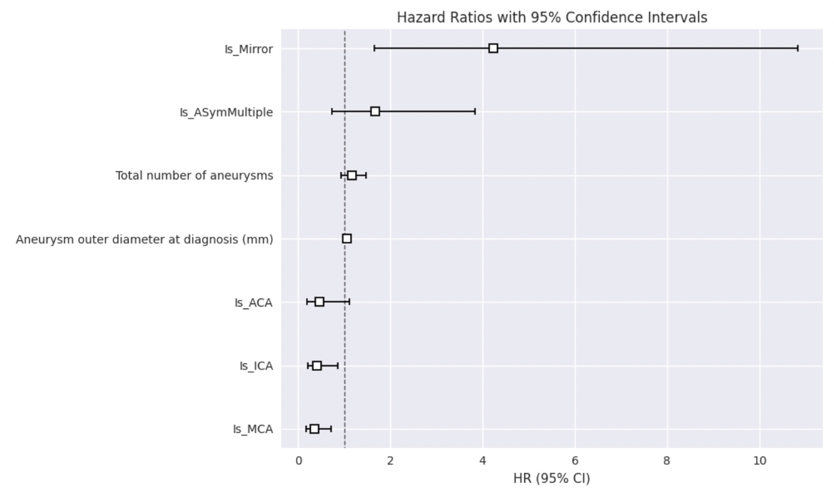

Forest plot showing the hazard ratio and 95% confidence intervals of mortality variables

