Supplementary Item 4: Example Jamboard slides from the Delphi prioritization activity

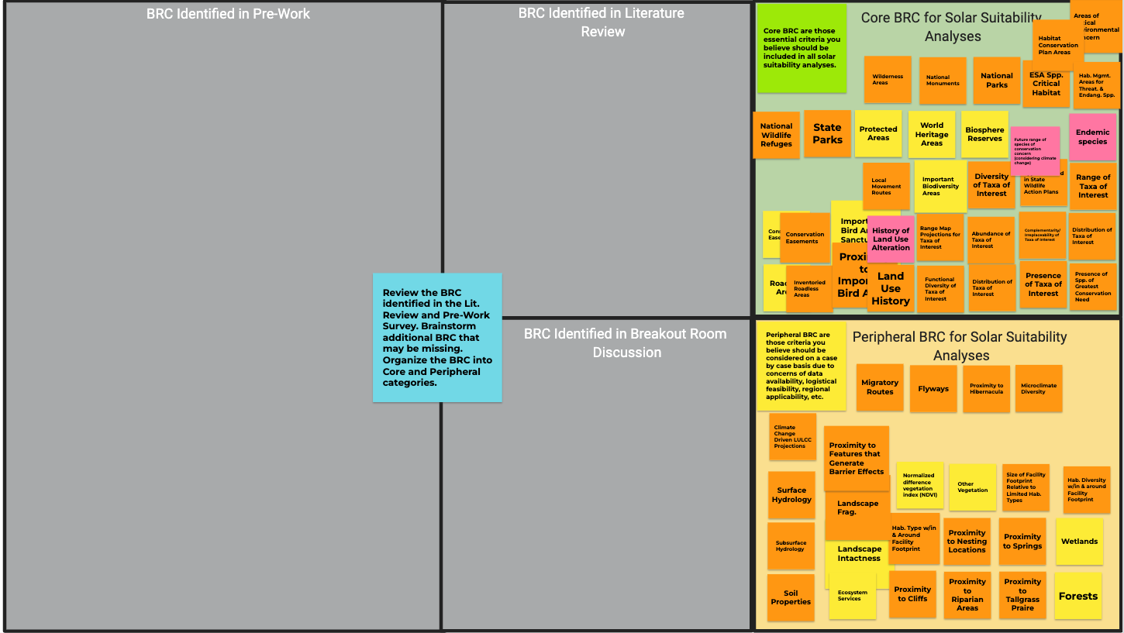
Figure a | Example breakout room Jamboard panel, Delphi round 1. Practitioners were asked to move the pre-identified literature review criteria (yellow sticky notes) and pre-survey criteria (orange sticky notes) to the “core” criteria box (green, top right) or “peripheral” criteria box (yellow, bottom right). Pink sticky notes represented practitioner-identified biodiversity-relevant criteria.

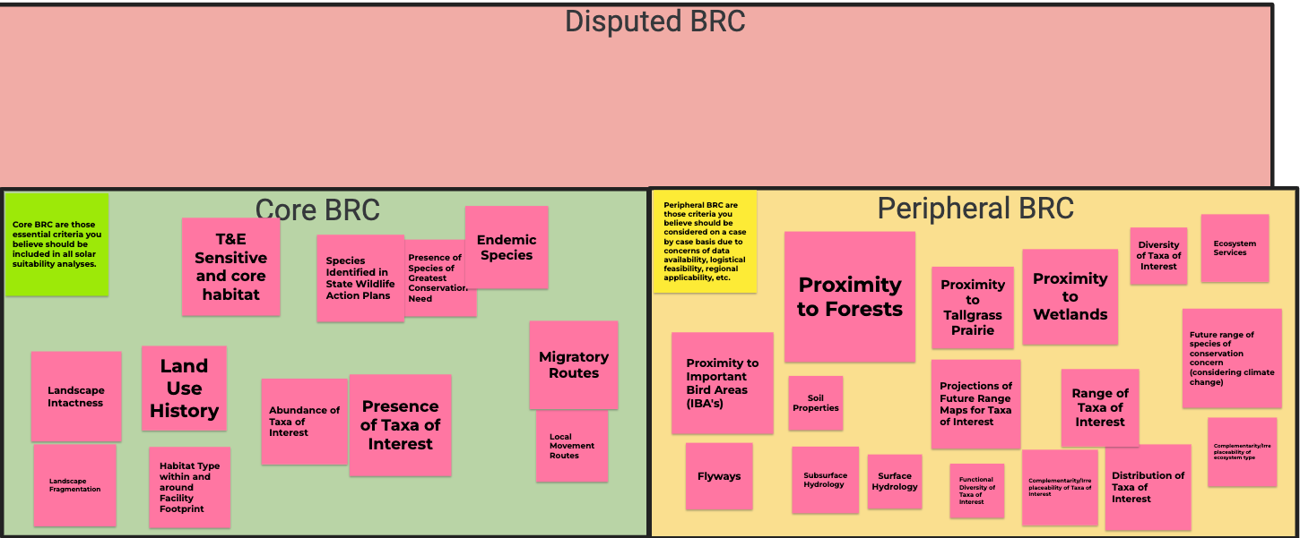
Figure b | Example breakout room Jamboard panel, Delphi round 2. Practitioners were asked to move the disputed biodiversity-relevant criteria to the “core” criteria box (green, bottom left) or “peripheral” criteria box (yellow, bottom right).

