Supporting Information
Ultrahigh water permeation with high multivalent metal ions rejection through graphene oxide membranes
Fangfang Dai¹, Feng Zhou², Junlang Chen¹, Shanshan Liang^{3,}*, Liang Chen^{1,}*, and Haiping Fang³
Department of Optical Engineering, Zhejiang Prov Key Lab Carbon Cycling Forest Ecosy, College of Environmental and Resource Sciences, Zhejiang A&F University, Hangzhou 311300, China.
2 Radiation Monitoring Technical Center of Ministry of Environmental Protection, State Environmental Protection Key Laboratory of Radiation monitoring, Key Laboratory of Radiation Monitoring of Zhejiang Province, Hangzhou 310012, China.
3 Department of Physics, East China University of Science and Technology, Shanghai 200237, China.

Contents
PS1: Materials and methods 3
PS2: SEM Characterization methods for the GO membranes 3
PS3: Filtration performance of the nanofiltration membranes reported in literature in terms of water permeances and rejection rates for multivalent ions 5
PS4: Effect of concentration of FeCl₃ solution on permeation behavior 10
PS5: Effect of membrane thickness on FeCl₃ permeation behaviour 11
PS6: Experimental setup for X-ray diffraction detection 11
PS7: Experimental setup for long-term experiment 12
PS8: Adsorption experiment for the GO membrane in high concentration solution 14
PS9: Experimental setup for the mass balance experiment 14
PS10: Effect of anions on permeation behavior 16
Reference 17

PS1: Materials and methods

Fabrication of GO suspension
Graphene oxide (GO) were prepared from natural graphite powder via a modified Hummers method^{S1-S3}. Graphite powders were put into concentrated H₂SO₄, K₂S₂O₈, and P₂O₅ solution with continuous stirring for several hours. Then the mixture was diluted with deionized water (DI), centrifuged, and washed with DI water. After dry, the preoxidized graphite was obtained. Then, they were further oxidized in concentrated H₂SO₄ and KMnO₄, diluted with DI water, followed by the addition of 30% H₂O₂. The product was centrifuged and washed with 1:10 HCl aqueous solution and DI water sequentially to remove ion species. At last, the concentration of the as-prepared GO suspension (4 mg/mL) was diluted to about 7.5 mg/L with DI water.

PS2: SEM Characterization methods for the GO membranes
GO membranes with different thicknesses were prepared from 20 mL, 40 mL, 80 mL, and 160 mL GO suspensions on MCE substrates using vacuum filtration, respectively, which are denoted as GO-20, GO-40, GO-80, and GO-160, respectively. SEM images showed that the GO membrane with tuneable thickness was continuous and free of macro pores or defects (Fig. S1).
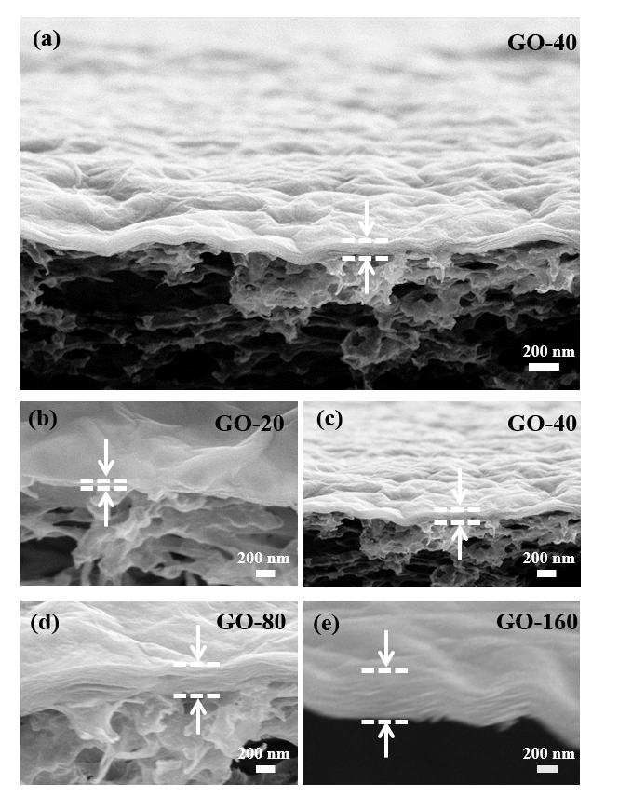
Supplementary Fig. S1 Cross-sectional SEM images of the GO membranes with different thicknesses. (a) and (c) Cross-sectional SEM images of the GO-40 membrane. (b), (d), and (e) Cross-sectional SEM images of the GO-20, GO-80, and GO-160 membranes, respectively.

PS3: Filtration performance of the nanofiltration membranes reported in literature in terms of water permeances and rejection rates for multivalent ions

Supplementary Table S1 Comparisons of different nanofiltration membranes in water permeances and rejection rates for multivalent metal ions in literature.
Material | Solution | Water permeance  (L m⁻² h⁻¹ bar⁻¹) | Rejection rate | Ref
ZIF-PA | MgSO₄ | 45.5 | 40% | f1
Noria–PEI IP | MgSO₄ | 27.6 | 97.7% | f2
TMC/CNC-PES | MgSO₄ | 34.1 | 82% | f3
TMC/SWCNTS-PES | Mg Cl₂ | 38.0 | 92.5% | f4
TMC/ PVC UF | MgCl₂ | 15.2 | 98.6% | f5
TMC/MWCNTS-PES | MgCl₂ | 17.6 | 78% | f6
PIP-TMC/TA-DETA/ PSF | MgCl₂ | 10.5 | 70.0% | f7
TMC/UCN | MgSO₄ | 17.6 | 79.8%/ | f8
TMC/PDA/PES | MgCl₂ | 11.4 | 12.3% | f9
PDA-MWCNTS +TMC/PSF | MgCl₂ | 15.3 | 91.4% | f10
PVA-TMC/PSF | MgCl₂ | 13.4 | 6.5% | f11
MWNT-rGO/PVDF | MgCl₂ | 11.3 | 9.6% | f12
CNT-PA | MgSO₄ | 12.0 | 98.3% | f13
DCPO-IPDC /BTEC/PSF | MgCl₂ | 17.9 | 92.1% | f14
BPF/PIP-TMC/PES | MgCl₂ | 11.9 | 49.4% | f15
PVA-TMC/PSF | MgCl₂ | 24.9 | 91.2% | f16
Dow-Filmtec NF 270 | MgCl₂ | 13.2 | 60.0% | f17
Dow-Filmtec NF 90 | MgCl₂ | 6.7 | 96.0% | f18
PSE-GO-DMF | Cr³⁺ | 13.5 | 91.2% | f19
HPEI-GO 10 | Ni²⁺ | 4.2 | 94.6% | f20
Chitosan PES composite membrane | Pb(NO₃)₂ | 3.5 |  | f21
PDA/TFC composite membrane | Pb(NO₃)₂ | 3.5 | 91.1% | f22
PDA functionalized nanotube PEI membranes | Pb(NO₃)₂ | ~ 50 | 79.0% | f23
TFC membrane on  PES support | NiCl₂ | > 2 | 66.0% | f24
GO/TiO2-PDDA | MgCl₂ | 51.2 | 93.2% | f25
TMV | MgSO₄ | 62.0 | 98.0% | f26
GO/QDs | CdCl₂ | 17.36 | 29.4% | f27
GO/PAN | MgCl₂ | 17.0 | 37.0% | f28
GO | FeCl₃  CuSO₄  Pb(NO₃)₂  ZnSO₄ | 75.2  56.6  46.6  48.7 | 99.9%  97.8%  86.9%  83.0% | This work

f1. Wang, Z., et al., Nanoparticle-templated nanofiltration membranes for ultrahigh performance desalination. Nat. Commun., 2018, 9(1), 2004.
f2. Zhai, Z., et al., Fabrication of advanced nanofiltration membranes with nanostrand hybrid morphology mediated by ultrafast Noria–polyethyleneimine codeposition. J. Mater. Chem. A, 2018, 6(42), 21207-21215.
f3. Wang, J.-J., et al., Nanofiltration membranes with cellulose nanocrystals as an interlayer for unprecedented performance. J. Mater. Chem. A, 2017, 5(31), 16289-16295.
f4. Zhu, Y., et al., Single-Walled Carbon Nanotube Film Supported Nanofiltration Membrane with a Nearly 10 nm Thick Polyamide Selective Layer for High-Flux and High-Rejection Desalination. Small, 2016, 12(36), 5034-5041.
f5. Liu, S., et al., One-step constructed ultrathin Janus polyamide nanofilms with opposite charges for highly efficient nanofiltration. J. Mater. Chem. A, 2017, 5(44), 22988-22996.
f6. Wu, M.-B., et al., Thin film composite membranes combining carbon nanotube intermediate layer and microfiltration support for high nanofiltration performances. J. Membr. Sci., 2016, 515, 238-244.
f7. Zhang, X., et al., Polyphenol Coating as an Interlayer for Thin-Film Composite Membranes with Enhanced Nanofiltration Performance. ACS Appl. Mater. Inter., 2016, 8(47), 32512-32519.
f8. Soyekwo, F., et al., Cellulose nanofiber intermediary to fabricate highly-permeable ultrathin nanofiltration membranes for fast water purification. J. Membr. Sci., 2017, 524, 174-185.
f9. Li, Y., et al., Preparation of thin film composite nanofiltration membrane with improved structural stability through the mediation of polydopamine. J. Membr. Sci, 2015, 476, 10-19.
f10. Zhao, F.-Y., et al., High-Flux Positively Charged Nanocomposite Nanofiltration Membranes Filled with Poly(dopamine) Modified Multiwall Carbon Nanotubes. ACS Appl. Mater. Inter., 2016, 8(10), 6693-6700.
f11. Wang, T., et al., Fabrication of high flux nanofiltration membrane via hydrogen bonding based co-deposition of polydopamine with poly(vinyl alcohol). J. Membr. Sci., 2018. 552, 222-233.
f12. Han, Y., Y. Jiang, and C. Gao, High-Flux Graphene Oxide Nanofiltration Membrane Intercalated by Carbon Nanotubes. ACS Appl. Mater. Inter., 2015, 7(15), 8147-8155.
f13. Gong, G., et al., New Insights into the Role of an Interlayer for the Fabrication of Highly Selective and Permeable Thin-Film Composite Nanofiltration Membrane. ACS Appl. Mater. Inter., 2019, 11(7), 7349-7356.
f14. Zhao, Y., et al., Preparation of a highly permeable nanofiltration membrane using a novel acyl chloride monomer with -PO(Cl)₂ group. Desalination, 2018, 431, 56-65.
f15. Tang, Y.-J., et al., Tailoring the polyester/polyamide backbone stiffness for the fabrication of high performance nanofiltration membrane. J. Membr. Sci., 2017, 541, 483-491.
f16. Tan, Z., et al., Polyamide membranes with nanoscale Turing structures for water purification. Science, 2018, 360 (6388), 518-521.
f17. Fang, W., L. Shi, and R. Wang, Mixed polyamide-based composite nanofiltration hollow fiber membranes with improved low-pressure water softening capability. J. Membr. Sci., 2014, 468, 52-61.
f18. Liu, C., L. Shi, and R. Wang, Crosslinked layer-by-layer polyelectrolyte nanofiltration hollow fiber membrane for low-pressure water softening with the presence of SO₄²⁻ in feed water. J. Membr. Sci., 2015, 486, 169-176.
f19. Mukherjee, R., P. Bhunia, and S. De, Impact of graphene oxide on removal of heavy metals using mixed matrix membrane. Chem. Eng. J., 2016, 292, 284-297.
f20. Zhang, Y., et al., Layer-by-layer construction of graphene oxide (GO) framework composite membranes for highly efficient heavy metal removal. J. Membrane Sci., 2016, 515, 230-237.
f21. Zhang, S., et al., Thin Film Interfacial Cross-Linking Approach To Fabricate a Chitosan Rejecting Layer over Poly(ether sulfone) Support for Heavy Metal Removal. Ind. Eng. Chem. Res., 2015, 54(1), 472-479.
f22. Wang, T., et al., Large-eddy simulations of the multi-mode Richtmyer–Meshkov instability and turbulent mixing under reshock. High Energ. Dens. Phys., 2016, 19, 65-75.
f23. Hebbar, R.S., et al., Fabrication of polydopamine functionalized halloysite nanotube/polyetherimide membranes for heavy metal removal. J. Mater. Chem. A, 2016, 4(3), 764-774.
f24. Mahdavi, H., F. Razmi, and T. Shahalizade, Polyurethane TFC nanofiltration membranes based on interfacial polymerization of poly(bis-MPA) and MDI on the polyethersulfone support. Sep. Purif. Technol., 2016, 162, 37-44.
f25 Zhang M, Guan K, Ji Y, Liu G, Jin W, Xu N. Controllable ion transport by surface-charged graphene oxide membrane. Nat. Commun., 2019, 10, 1253.
f26 Gui L, Dong J, Fang W, Zhang S, Zhou K, Zhu Y, et al. Ultrafast Ion Sieving from Honeycomb-like Polyamide Membranes Formed Using Porous Protein Assemblies. Nano Lett., 2020, 20(8), 5821-5829.
f27 Zhao G, Hu R, Zhao X, He Y, Zhu H. High flux nanofiltration membranes prepared with a graphene oxide homo-structure. J. Membr. Sci., 2019, 585, 29-37.
f28 Zhang M, Sun J, Mao Y, Liu G, Jin W. Effect of substrate on formation and nanofiltration performance of graphene oxide membranes. J. Membr. Sci., 2019, 574, 196-204.

PS4: Effect of concentration of FeCl₃ solution on permeation behavior
Supplementary Fig. S2 (a) Digital images of the GO membranes before and after rejection for 250 mg/L FeCl₃ solution, and FeCl₃ solution added in feed side and the filtrate solution though the GO membranes. (b) Water permeances and rejection rates of the GO membranes as a function of concentration of FeCl₃ solutions.

PS5: Effect of membrane thickness on FeCl₃ permeation behaviour
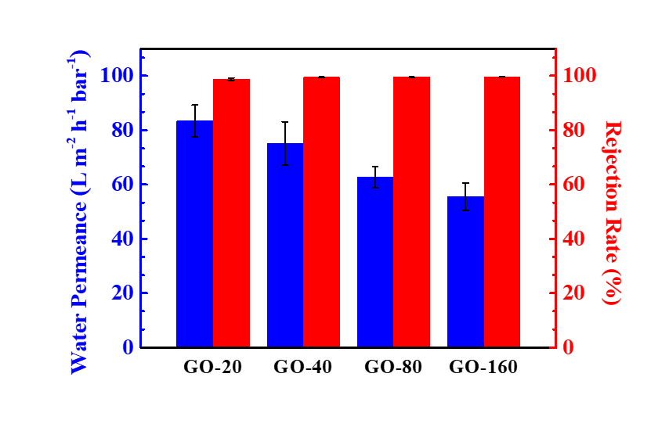
Supplementary Fig. S3 Water permeances and rejection rates of 5 mg/L FeCl₃ solutions through the GO membranes as a function of thickness.

PS6: Experimental setup for X-ray diffraction detection
The GO membranes (prepared by the vacuum method and conventional drop-casting method) were immersed in 5 mg/L solutions of salts (FeCl₃, Pb(NO₃)₂, ZnSO₄ and CuSO₄) at room temperature for half an hour. Then the wet membranes saturated with salt solution were removed and analysed by X-ray diffraction.
For the ZnSO₄ controlled GO membranes or the FeCl₃ controlled GO membranes, the GO membranes were soaked in pure water for half an hour, and then immersed to ZnSO₄ or FeCl₃ solutions for half hour for pretreatment. The ZnSO₄ controlled GO membranes or the Fe³⁺ controlled GO membranes were toke out and immersed to mixed salt solutions included 5 mg/L ZnSO₄ or FeCl₃with 5 mg/L target ions (Pb(NO₃)₂, CuSO₄, FeCl₃ or ZnSO₄) for half hour. Finally, the membranes were removed from the mixed salt solutions and analysed by X-ray diffraction.
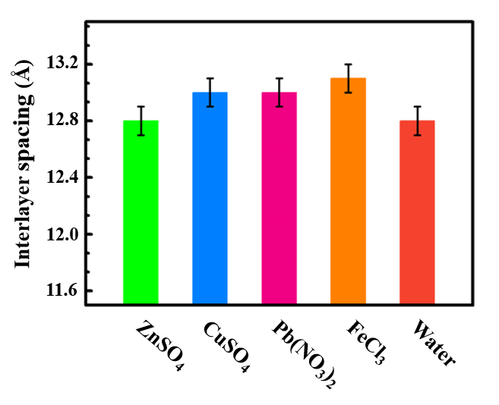
Supplementary Fig. S4 Interlayer spacings of the GO membranes fabricated by drop-casting methods immersed in different multivalent ions solutions. Error bars indicate the standard deviation from three different samples.

PS7: Experimental setup for long-term experiment
100 mL, 500 mg/L FeCl₃ solution was added into the feed side, after the GO membrane were prepared using vacuum filtration. Under a pressure of 1 bar, the salt solutions were filtered through GO membranes. 30 mL filtrates were collected after 20 min when the filtration process became steady. Then, removed the residual salt solution, rinsed the GO membrane in the feed side for surface cleaning, and added another 30 mL DI water into the feed side, kept still before subsequent permeation of the DI water for filtration cleaning. Repeated the filtration process three times per day. The long-term test was conducted for 5 days, as shown in Fig. S5.

Supplementary Fig. S5 Long-term performance measurements of the GO membranes for 500 mg/L FeCl₃ solution for 5 days.

PS8: Adsorption experiment for the GO membrane in high concentration solution
Supplementary Fig. S6. Concentration variations of 500 mg/L FeCl₃ solution adsorbed by the GO membranes as a function of adsorption time.

PS9: Experimental setup for the mass balance experiment
The mass balance experiments for 500 mg/L FeCl₃ solution rejection has been investigated to justify the mass balance of feed and permeate during the rejection experiments. As shown in Fig. S7(a), during the filtration process, we recycled the filtrates into the feed side to test the change of salt concentration in the feed, which is referred to the method reported previously ^{S4}.
Supplementary Fig. S7. (a) Schematic of operation process for semi-continuous mass balance experiment and (b) Variations of feed concentration with cycle numbers. Feed volume is 200 mL, operation pressure is 1 bar, and effective filtration area is 11.74 cm².

In details, 200 mL FeCl₃ solution was added to the feed side, then the salt solution was filtered through the GO membranes under a pressure of 1 bar. When the filtrate was collected to approximately 80 mL solution, the filtrate was recycled into the feed side. The feed concentrations of the FeCl₃ solution before and after recycling filtrate were measured, respectively. As shown in Fig. S7(b), the periodic variation of salt concentration in the feed was about 500~800 mg/L. In one cycle, the salt concentrations in feed side significantly increased from ~500 mg/L to ~800 mg/L, indicating an effective rejection rather than adsorption by our membranes. Moreover, a stable rejection for the FeCl₃ solution was presented from the stable and periodic variations of salt concentration, even though concentration polarization was enhanced due to the increase of salt concentrations in the feed side.

PS10: Effect of anions on permeation behavior
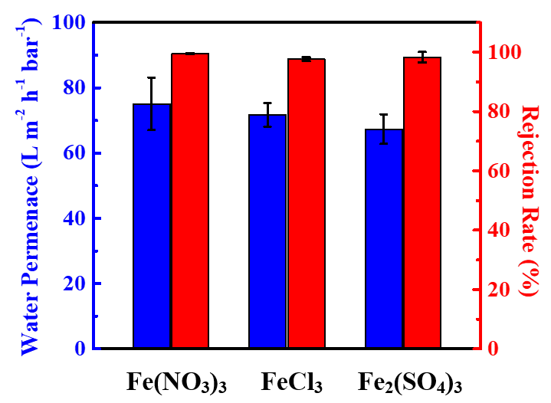
Supplementary Fig. S8. Water permeances and rejection rates for the GO membranes with different anions.

References
S1. Hummers, et al. Preparation of Graphitic Oxide. J. Am. Chem. Soc. 1958, 80, 1339.
S2. Xu, Y., et al. Flexible graphene films via the filtration of water-soluble noncovalent functionalized graphene sheets. J. Am. Chem. Soc. 2008, 130, 5856-5857.
S3. Pan, D. et al. Li Storage Properties of Disordered Graphene Nanosheets. Chem. Mater. 2009, 21, 3136-3142.
S4. Zhang M. et al. Controllable ion transport by surface-charged graphene oxide membrane. Nat. Commun. 2019, 10, 1253.

