Appendix A: Excerpts comprising audio corpus - main features and scores
 | Composer | Piece | Part | Main Compositional Features
1 | J. S. Bach | Sonata no. 1 in G minor, BWV 1001 | Presto,  bars 1-3 | G minor, regular rhythm (sixteenth notes), fast tempo,  down pitch contour, arpeggio.
2 | Bartók  (arr. Székely) | Roumanian Folk Dances, No. 4 | bars 19-20 | A Phrygian dominant scale, legato articulation,  moderate tempo, irregular rhythm, small intervals,  high pitch register, mainly-stepwise melodic motion.
3 | Brahms | Sonata no. 3 in D minor, op. 108 | Mov. 1,  bars 1-5 | D minor, legato articulation, moderate tempo, soft loudness, rapid loudness variations (“hairpins”), high pitch register, flowing rhythm.
4 | Brahms | Sonata no.3 in D minor, op. 108 | Mov. 2,  bars 1-5 | D major, legato articulation, slow tempo, flowing rhythm, stepwise and leaps melodic motion, medium pitch register.
5 | Bruch | Concerto no. 1 in G minor, op. 26 | Mov. 2,  bars 17-21 | E flat major, slow tempo, medium pitch register, flowing rhythm, descending then ascending melody, small intervals.
6 | Corelli (arr. Léonard) | La Folia, op. 5 no. 12 | bars 1-4 | D minor, chord progression with a C Major chord in the last excerpt bar, fast tempo, medium pitch register, narrow melodic range, flowing rhythm.
7 | Dont | 24 Etudes and Caprices, op. 35, No. 3 | bar 4 | E minor, regular rhythm (sixteenth notes), fast tempo, descending then ascending pitch contour, mainly arpeggios.
8 | Dvořák | Sonatina in G, op. 100 | Mov. 1,  bars 1-4 | G major, staccato articulation, fast tempo, medium pitch register, simple and consonant harmony, mainly arpeggio.
9 | Elgar | Chanson de Matin | bars 9-12 | G major, moderate tempo, high to medium pitch register, mostly stepwise descending melodic contour, consonant harmony, flowing rhythm.
10 | Elgar | Chanson de Matin | bars 30-32 | B minor, legato articulation, moderate tempo, dissonant harmony involving a half-diminished seventh cord, medium to low pitch register, rapid loudness variations (“hairpin”), flowing rhythm.
11 | Elgar | Sonate in E minor, op. 82 | Mov. 1,  bars 9-12 | E minor, staccato articulation with accents on each beat,  fast tempo, cut time meter, regular rhythm, descending melodic contour from high to moderate pitch register involving dissonant intervals.
12 | Glazunov | Concerto in A minor, op. 82 | Mov. 1,  bars 1-2 | A minor, legato articulation, slow to moderate tempo,  low pitch register, chromatic notes, flowing rhythm.
13 | Grieg | Sonata in C minor, op. 45 | Mov. 1,  bars 1-2 | C minor, legato articulation with accents on each beat, fast tempo, loud, compound duple meter, regular rhythm (one long and three shorts), almost-stepwise melodic motion, low pitch register.
14 | Grieg | Sonata in C minor, op. 45 | Mov. 3,  bars 2-5 | C minor, staccato articulation with accents on the first beat of each bar, fast tempo, cut time meter, regular rhythm, soft loudness, stepwise and leaps melodic motion, low to medium pitch register.
15 | Kayser | Etudes, op. 20, No. 1 | bars 3-5 | C major (first bar and a half in G major), moderate to fast tempo, regular rhythm (eight notes), mostly arpeggios and scales.
16 | Kreutzer | 42 Etudes ou caprices, No. 10 | bar 1 | G major, moderate to fast tempo, regular rhythm, melodic contour involving ascending leap of large intervals (octave, tenth) and descending arpeggio, low and high pitch register.
17 | Mendelssohn | Concerto in E minor, op.64 | Mov. 1,  bars 139-142 | G major, flowing rhythm, portato and legato articulations, moderate tempo, cut time meter, moderate pitch register, narrow melodic range, descending pitch contour, small intervals, soft loudness.
18 | Mozart | Sonata in E minor, K304 | Mov. 2,  bars 101-105 | E major, portato articulation, moderate tempo,  regular rhythm, high pitch register.
19 | Schubert | Sonatina in A minor, op. 137 no. 2 | Mov. 4,  bars 63-69 | F major going to D minor, legato and then staccato articulations, fast tempo, irregular rhythm (triplets), loudness increasing, ascending and then descending pitch contour, stepwise melodic motion, chromatic notes.
20 | Wieniawski | Concerto no. 2 in D minor, op. 22 | Mov. 2,  bars 1-4 | B flat major turning to E flat minor, mostly legato articulation, slow tempo, compound quadruple meter, flowing rhythm, soft loudness, medium pitch register, stepwise and leap melodic motion, narrow melodic range.
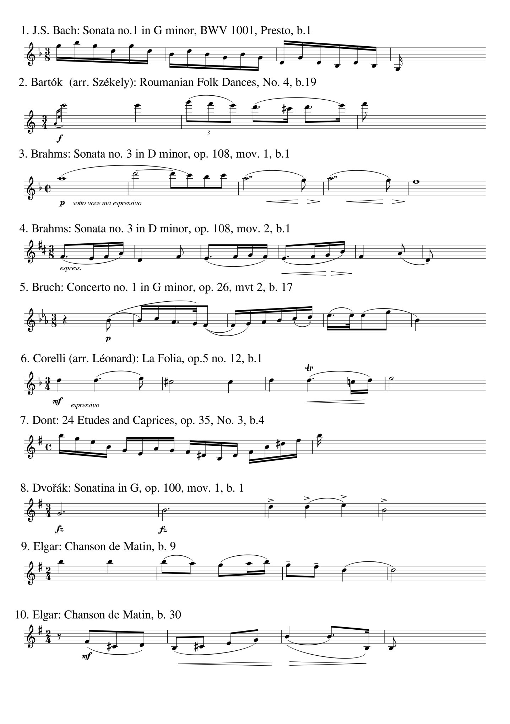
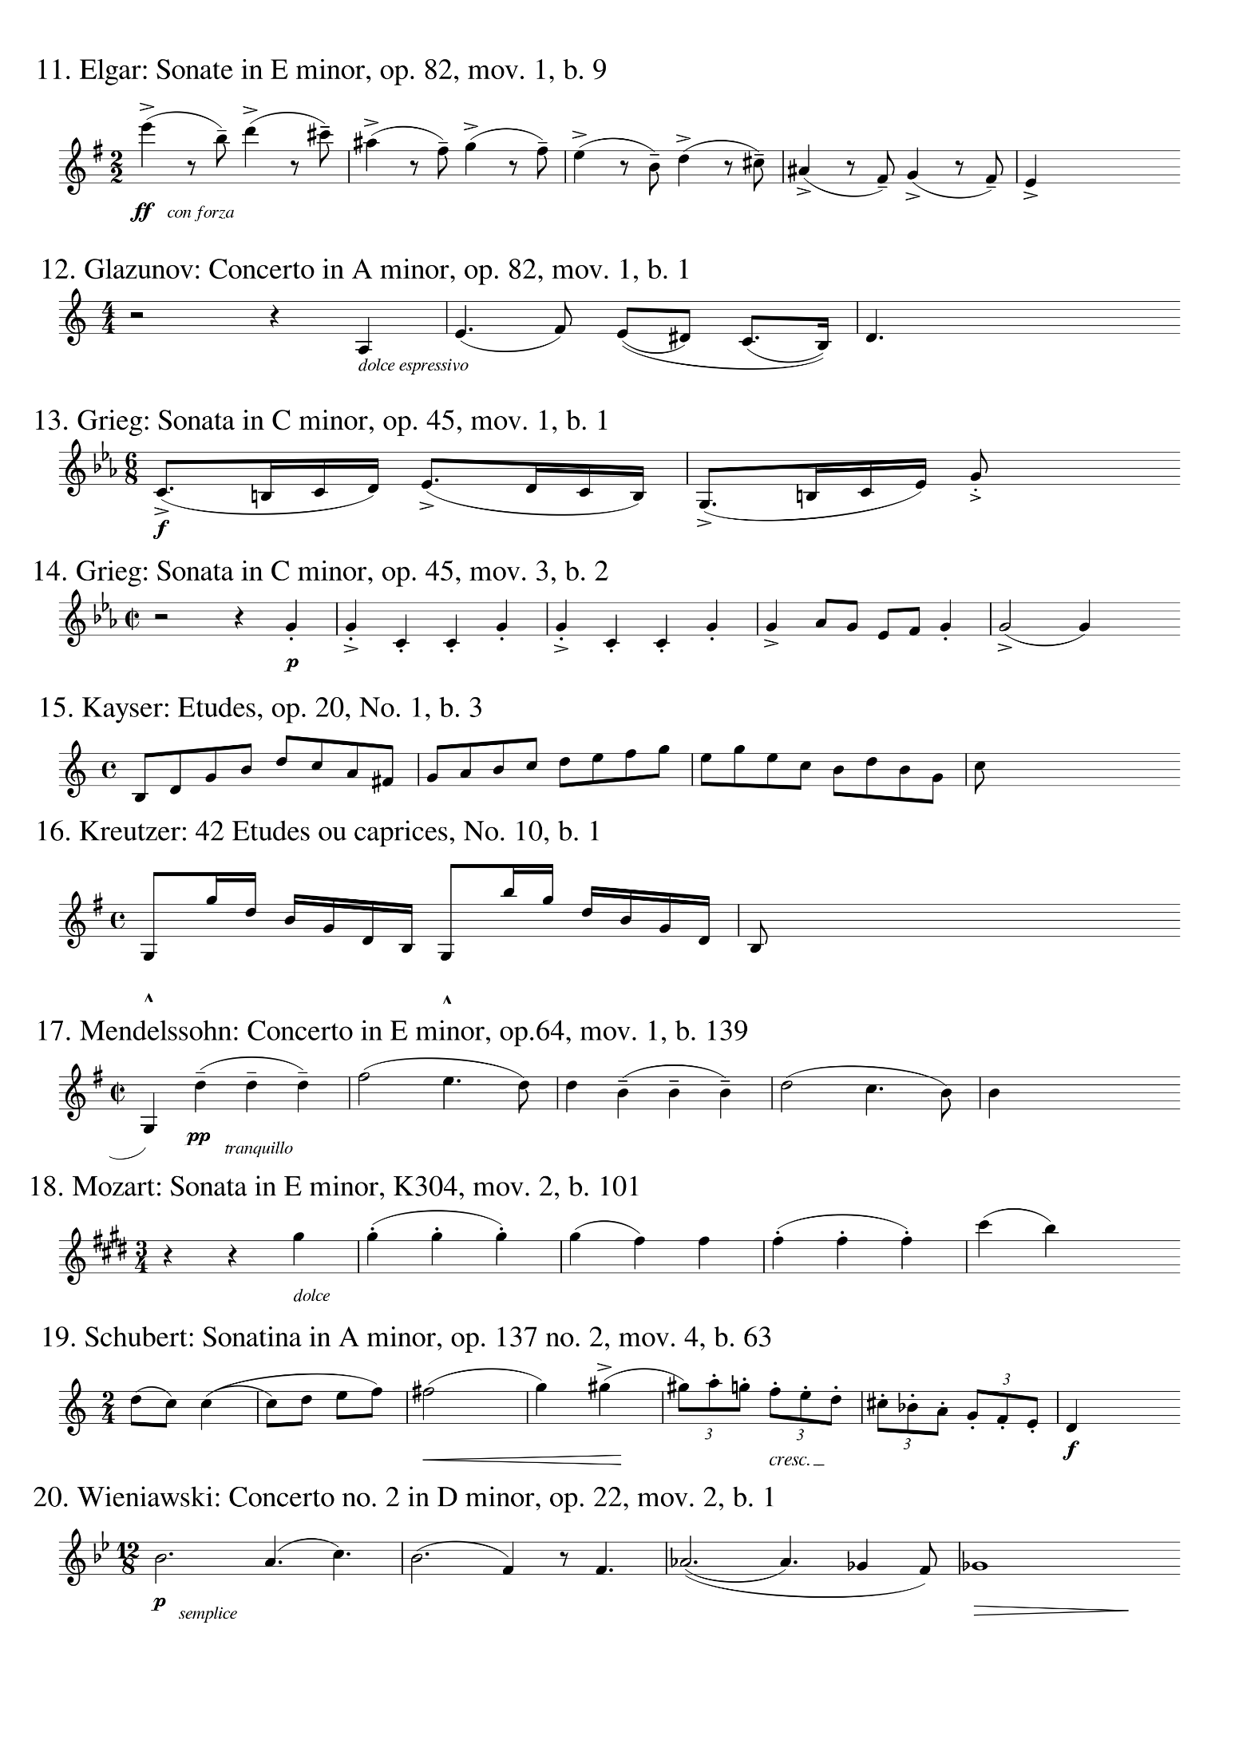
Appendix B: Performances selected for use in the Experiment and their mean ratings relative to the intended EMT categories, together with the standard deviations
 | Amoroso /  Affettuoso |  | Giocoso /  Animato |  | Risoluto /  Feroce |  | Tristamente / Lagrimoso |  | Neutral
Least confused | A1_{a} | Dont: Etude no. 3, Affettuoso1 | G1_{a} | Mendelssohn: Concerto E minor, mov. 1, Giocoso1 | R1_{a} | Dont: Etude no. 3, Risoluto1 | T1_{a} | Glazunov: Concerto A minor, mov. 1, Tristamente2 | N1_{a} | Wieniawski: Concerto no. 2, D minor, mov. 2, Neutral
Least confused | A1_{b} | Mendelssohn: Concerto E minor, mov. 1, Affettuoso2 | G1_{b} | Mozart: Sonata E minor, mov. 2, Giocoso2 | R1_{b} | Kreutzer: Etude no. 10, Risoluto1 | T1_{b} | Wieniawski: Concerto no. 2 D minor, mov. 2, Tristamente1 | N1_{b} | Mendelssohn: Concerto E minor, mov. 1, Neutral
Least confused | A1_{c} | Mozart: Sonata E minor, mov. 2, Affettuoso1 | G1_{c} | Bach: Sonata no. 1 G minor, Presto, Giocoso1 | R1_{c} | Glazunov: Concerto A minor, mov. 1, Risoluto1 | T1_{c} | Brahms: Sonata no. 3 D minor, mov. 1, Tristamente2 | N1_{c} | Schubert: Sonatina A minor, mov. 4, Neutral
Moderately confused | A2_{a} | Elgar: Chanson De Matin, Affettuoso2 | G2_{a} | Dvorak: Sonatina G Major, Giocoso2 | R2_{a} | Grieg: Sonata C minor, mov. 3, Risoluto2 | T2_{a} | Brahms: Sonata no. 3, D minor, mov. 2, Tristamente2 | N2_{a} | Kreutzer: Etude no. 10, Neutral
Moderately confused | A2_{b} | Grieg: Sonata C minor, mov. 1, Affettuoso2 | G2_{b} | Elgar: Chanson De Matin, Giocoso2 | R2_{b} | Mozart: Sonata E minor, mov. 2, Risoluto2. | T2_{b} | Elgar: Chanson De Matin, b. 30, Tristamente2 | N2_{b} | Grieg: Sonata C minor, mov. 3, Neutral
Moderately confused | A2_{c} | Mendelssohn: Concerto E minor, mov. 1, Affettuoso1 | G2_{c} | Bruch: Concerto no. 1 G minor, mov. 2, Giocoso2 | R2_{c} | Elgar: Chanson De Matin, Risoluto1 | T2_{c} | Mendelssohn: Concerto E minor, mov. 1, Tristamente2 | N2_{c} | Kayser: Etude no. 1, Neutral
Moderately confused | A2_{d} | Schubert: Sonatina A minor, mov. 4, Affettuoso2 | G2_{d} | Schubert: Sonatina A minor, mov. 4, Giocoso2 | R2_{d} | Bartok: Roumanian Folk Dance no. 4, Risoluto2 | T2_{d} | Elgar: Sonata E minor, mov. 1, Tristamente1 | N2_{d} | Elgar: Chanson De Matin, Neutral
Most confused | A3_{a} | Brahms: Sonata no. 3 D minor, mov. 1, Affettuoso1 | G3_{a} | Grieg: Sonata C minor, mov. 3, Giocoso1 | R3_{a} | Bach: Sonata 1 G minor, Presto, Risoluto1 | T3_{a} | Dvorak, Sonatina G Major, Tristamente2 | N3_{a} | Bach: Sonata no. 1 G minor, Presto, Neutral
Most confused | A3_{b} | Brahms: Sonata no. 3, D minor, mov. 2, Affettuoso2 | G3_{b} | Glazunov: Concerto A minor, mov. 1, Giocoso2 | R3_{b} | Elgar: Chanson De Matin, b. 30, Risoluto2 | T3_{b} | Grieg: Sonata C minor, mov. 3, Tristamente2 | N3_{b} | Dont: Etude no. 3, Neutral
Most confused | A3_{c} | Glazunov: Concerto A minor, mov. 1, Affettuoso2 | G3_{c} | Brahms: Sonata no. 3 D minor, mov. 2, Giocoso2 | R3_{c} | Brahms: Sonata no. 3 D minor, mov. 2, Risoluto2 | T3_{c} | Kayser: Etude no. 1, Tristamente2 | N3_{c} | Bartok: Roumanian Folk Dance no. 4, Neutral

 | Amoroso / Affettuoso |  |  | Giocoso /  Animato |  |  | Risoluto /  Feroce |  |  | Tristamente / Lagrimoso |  |  | Neutral
 | Name | $$M$$ | $$SD$$ | Name | $$M$$ | $$SD$$ | Name | $$M$$ | $$SD$$ | Name | $$M$$ | $$SD$$ | Name | $$M$$ | $$SD$$
Least confused | A1_{a} | 4.14 | 1.21 | G1_{a} | 5.00 | 0.00 | R1_{a} | 5.00 | 0.00 | T1_{a} | 4.57 | 0.49 | N1_{a} | 5.00 | 0.00
Least confused | A1_{b} | 3.71 | 1.89 | G1_{b} | 4.86 | 0.35 | R1_{b} | 5.00 | 0.00 | T1_{b} | 3.71 | 2.05 | N1_{b} | 5.00 | 0.00
Least confused | A1_{c} | 3.57 | 1.90 | G1_{c} | 4.57 | 1.05 | R1_{c} | 4.86 | 0.35 | T1_{c} | 3.71 | 1.83 | N1_{c} | 5.00 | 0.00
Moderately confused | A2_{a} | 3.00 | 1.93 | G2_{a} | 3.14 | 1.64 | R2_{a} | 3.43 | 2.19 | T2_{a} | 3.14 | 2.10 | N2_{a} | 3.71 | 2.21
Moderately confused | A2_{b} | 3.14 | 2.10 | G2_{b} | 3.14 | 2.03 | R2_{b} | 3.14 | 1.88 | T2_{b} | 3.00 | 2.33 | N2_{b} | 3.57 | 2.15
Moderately confused | A2_{c} | 3.29 | 1.67 | G2_{c} | 3.00 | 2.33 | R2_{c} | 3.29 | 1.83 | T2_{c} | 2.71 | 2.19 | N2_{c} | 3.14 | 2.27
Moderately confused | A2_{d} | 2.86 | 1.81 | G2_{d} | 2.86 | 2.10 | R2_{d} | 2.71 | 2.37 | T2_{d} | 3.29 | 2.19 | N2_{d} | 4.29 | 1.89
Most confused | A3_{a} | 1.00 | 1.31 | G3_{a} | 1.00 | 1.41 | R3_{a} | 1.57 | 1.92 | T3_{a} | 1.29 | 2.05 | N3_{a} | 1.43 | 2.44
Most confused | A3_{b} | 1.29 | 1.67 | G3_{b} | 1.43 | 2.26 | R3_{b} | 1.00 | 1.31 | T3_{b} | 1.43 | 1.99 | N3_{b} | 2.86 | 2.47
Most confused | A3_{c} | 1.00 | 1.77 | G3_{c} | 1.43 | 1.84 | R3_{c} | 1.71 | 1.83 | T3_{c} | 1 | 1.77 | N3_{c} | 2.86 | 2.47

Appendix C: The 25 performances which were randomly used in the pre-experiment for determination of timbre descriptors by EMT categories together with the graphical user interface
Amoroso/ Affettuoso | Giocoso/  Animato | Risoluto/  Feroce | Tristamente/ Lagrimoso | Neutral
Bartok: Roumanian Folk Dance no. 4, Affettuoso2 | Bach: Sonata 1 G minor, Presto, Giocoso2 | Dont: Etude no. 3, Risoluto1 | Corelli: La Folia, Tristamente1 | Brahms: Sonata no. 3 D minor, mov. 1, Neutral
Brahms: Sonata no. 3 D minor, mov. 1, Affettuoso1 | Dont: Etude no. 3, Giocoso1 | Dvorak: Sonatina G Major, Risoluto1 | Glazunov: Concerto A minor, mov. 1, Tristamente2 | Bruch: Concerto no. 1 G minor, mov. 2, Neutral
Glazunov: Concerto A minor, mov. 1, Affettuoso2 | Elgar: Chanson De Matin, Giocoso2 | Grieg: Sonata C minor, mov. 3, Risoluto2 | Grieg: Sonata C minor, mov. 1, Tristamente1 | Elgar: Chanson De Matin, b. 30, Neutral
Mendelssohn: Concerto E minor, mov. 1, Affettuoso1 | Mendelssohn: Concerto E minor, mov. 1, Giocoso1 | Schubert: Sonatina A minor, mov. 4, Risoluto1 | Mendelssohn: Concerto E minor, mov. 1, Tristamente1 | Elgar: Chanson De Matin, Neutral
Mozart: Sonata E minor, mov. 2, Affettuoso2 | Mozart: Sonata E minor, mov. 2, Giocoso1 | Wieniawski: Concerto no. 2 D minor, mov. 2, Risoluto2 | Wieniawski: Concerto no. 2, D minor, mov. 2, Tristamente1 | Mozart: Sonata E minor, mov. 2, Neutral

