Supplemental Table 1: SYBR and TaqMan Assays used for mRNA and miR qRT-PCR analysis.
Probes | Species | Chemistry | Assay ID/Sequence
-mRNA Expression
IL-10 | Human | SYBR | F: 5’-GCCTAACATGCTTCGAGATC-3’  R: 5’-TGATGTCTGGGTCTTGGTTC-3’
TNFA | Human | SYBR | F: 5’-CTCGAACCCCGAGTGACA-3’  R: 5’-GCTGCCCCTCAGCTTGAG-3’
CCL2 | Human | TaqMan | Hs00234140_m1
MRC1 | Human | TaqMan | HGNC ID:7228
CXCL8 | Human | TaqMan | HS00174103_m1
AZU1 | Human | TaqMan | Hs00156049_m1
NANOG | Human | SYBR | F: 5’-ATCTGCTTATTCAGGACAGCCC-3’  R: 5’-GAAGTGGGTTGTTTGCCTTTG-3’
OCT4 | Human | SYBR | F: 5’-AAGAACATGTGTAAGCTGCGGC-3’  R: 5’-CATTGTTGTCAGCTTCCTCCAC-3’
SOX2 | Human | TaqMan | Hs04260357_g1
GAPDH (VICTM Dye) | Human | TaqMan | Hs99999905_m1
-miRNA Expression
hsa-miR-155-5p | Human | TaqMan | 002623
hsa-miR-21-5p | Human | TaqMan | 000397
hsa-let7c | Human | TaqMan | 000379
Sn RNU6 | Human, Mouse | TaqMan | 001973

Supplemental Table 2: List of miRNA assays included in TaqMan™ OpenArray™ Human Advanced microRNA panels.
miRNA | Assay Code | miRNA | Assay Code | miRNA | Assay Code
ath-miR-159a | 478411 | miR-31-5p | 478015 | miR-145-5p | 477916
let-7a-5p | 478575 | miR-32-5p | 478026 | miR-146a-5p | 478399
let-7b-3p | 478221 | miR-34a-3p | 478047 | miR-146b-5p | 478513
let-7b-5p | 478576 | miR-34a-5p | 478048 | miR-148a-3p | 477814
let-7c-5p | 478577 | miR-34b-5p | 478050 | miR-148b-3p | 477824
let-7e-5p | 478579 | miR-34b-3p | 478049 | miR-150-5p | 477918
let-7f-2-3p | 477843 | miR-34c-3p | 478051 | miR-151a-3p | 477919
let-7f-5p | 478578 | miR-34c-5p | 478052 | miR-151a-5p | 478505
let-7g-5p | 478580 | miR-92a-3p | 477827 | miR-153-3p | 477922
let-7i-5p | 478375 | miR-92b-3p | 477823 | miR-155-5p | 477927
miR-1-3p | 477820 | miR-93-5p | 478210 | miR-181a-5p | 477857
miR-9-5p | 478214 | miR-99a-3p | 479224 | miR-181b-5p | 478583
miR-9-3p | 478211 | miR-99b-5p | 478343 | miR-181c-5p | 477934
miR-10a-5p | 479241 | miR-100-3p | 478619 | miR-181d-5p | 479517
miR-10b-5p | 478494 | miR-100-5p | 478224 | miR-183-3p | 477936
miR-15a-5p | 477858 | miR-101-3p | 477863 | miR-185-5p | 477939
miR-15b-5p | 478313 | miR-103a-3p | 478253 | miR-186-5p | 477940
miR-17-5p | 478447 | miR-103a-2-5p | 477864 | miR-190a-5p | 478358
miR-19a-3p | 479228 | miR-106b-3p | 477866 | miR-191-3p | 477951
miR-19b-3p | 478264 | miR-106b-5p | 478412 | miR-191-5p | 477952
miR-20a-5p | 478586 | miR-107 | 478254 | miR-193a-5p | 477954
miR-21-5p | 477975 | miR-122-5p | 477855 | miR-194-5p | 477956
miR-22-3p | 477985 | miR-124-3p | 477879 | miR-195-5p | 477957
miR-23a-3p | 478532 | miR-125a-5p | 477884 | miR-196a-5p | 478230
miR-23b-3p | 478602 | miR-125a-3p | 477883 | miR-199a-3p | 477961
miR-24-3p | 477992 | miR-125b-5p | 477885 | miR-199a-5p | 478231
miR-25-3p | 477994 | miR-126-5p | 477888 | miR-200c-3p | 478351
miR-26a-5p | 477995 | miR-127-3p | 477889 | miR-203a-3p | 478316
miR-26b-5p | 478418 | miR-128-3p | 477892 | miR-204-5p | 478491
miR-27a-3p | 478384 | miR-129-2-3p | 478544 | miR-205-5p | 477967
miR-27b-3p | 478270 | miR-130a-3p | 477851 | miR-206 | 477968
miR-27b-5p | 478789 | miR-132-3p | 477900 | miR-210-3p | 477970
miR-28-5p | 478000 | miR-133a-3p | 478511 | miR-211-5p | 478507
miR-29a-3p | 478587 | miR-133b | 480871 | miR-216a-5p | 477976
miR-29c-5p | 478005 | miR-135a-5p | 478581 | miR-218-5p | 477977
miR-30a-3p | 478273 | miR-137 | 477904 | miR-219a-5p | 477980
miR-30c-1-3p | 479412 | miR-142-3p | 477910 | miR-221-3p | 477981
miR-30c-2-3p | 479401 | miR-142-5p | 477911 | miR-222-3p | 477982
miR-30c-5p | 478008 | miR-143-3p | 477912 | miR-223-3p | 477983
miR-30d-5p | 478606 | miR-144-3p | 477913 | miR-302b-3p | 478591
miR-30e-3p | 478388 | miR-145-3p | 477915 | miR-302d-3p | 478237
Supplemental Table 2 (Continued): List of miRNA assays included in TaqMan™ OpenArray™ Human Advanced microRNA panels.
miRNA | Assay Code | miRNA | Assay Code | miRNA | Assay Code
miR-320a | 478594 | miR-939-5p | 478245 | miR-885-5p | 478207
miR-320b | 478588 | miR-486-5p | 478128 | miR-937-3p | 479212
miR-323a-3p | 477853 | miR-487a-3p | 477826 | miR-1247-5p | 477882
miR-325 | 478025 | miR-489-3p | 478130 | miR-1249-3p | 478654
miR-326 | 478027 | miR-490-3p | 478131 | miR-1260a | 478476
miR-328-3p | 478028 | miR-497-5p | 478138 | miR-1264 | 478670
miR-335-5p | 478324 | miR-501-3p | 478350 | miR-1292-5p | 478691
miR-338-3p | 478037 | miR-502-3p | 478348 | miR-1298-5p | 479452
miR-339-5p | 478040 | miR-505-3p | 478145 | miR-1911-5p | 479583
miR-342-3p | 478043 | miR-513a-5p | 479483
miR-361-3p | 478055 | miR-515-3p | 478976
miR-361-5p | 478056 | miR-516b-5p | 478979
miR-363-3p | 478060 | miR-518d-3p | 479393
miR-369-3p | 478067 | miR-518e-3p | 479408
miR-369-5p | 478068 | miR-518f-3p | 478984
miR-373-3p | 478363 | miR-520h | 479499
miR-374b-5p | 478389 | miR-523-3p | 478994
miR-375 | 478074 | miR-524-3p | 479338
miR-376a-3p | 478240 | miR-525-3p | 478995
miR-376c-3p | 478459 | miR-532-3p | 478336
miR-378a-3p | 478349 | miR-532-5p | 478151
miR-378a-5p | 478076 | miR-548d-5p | 480870
miR-383-5p | 478079 | miR-548e-3p | 478362
miR-410-3p | 478085 | miR-548k | 479374
miR-411-5p | 478086 | miR-548n | 479024
miR-412-3p | 478087 | miR-551a | 478158
miR-423-5p | 478090 | miR-570-3p | 479053
miR-424-5p | 478092 | miR-576-3p | 478164
miR-425-5p | 478094 | miR-583 | 479065
miR-448 | 478105 | miR-593-5p | 479077
miR-449a | 478561 | miR-615-3p | 478175
miR-449b-5p | 479528 | miR-628-3p | 478181
miR-450b-3p | 478913 | miR-633 | 479115
miR-450b-5p | 478914 | miR-642a-5p | 479121
miR-451a | 478107 | miR-645 | 478188
miR-452-3p | 478917 | miR-652-3p | 478189
miR-452-5p | 478109 | miR-653-3p | 479134
miR-454-3p | 478329 | miR-656-3p | 479137
miR-455-3p | 478112 | miR-660-5p | 478192
miR-483-3p | 478122 | miR-664a-3p | 478193
miR-483-5p | 478432 | miR-770-5p | 479178
miR-484 | 478308 | miR-876-3p | 479186

Supplemental Figures
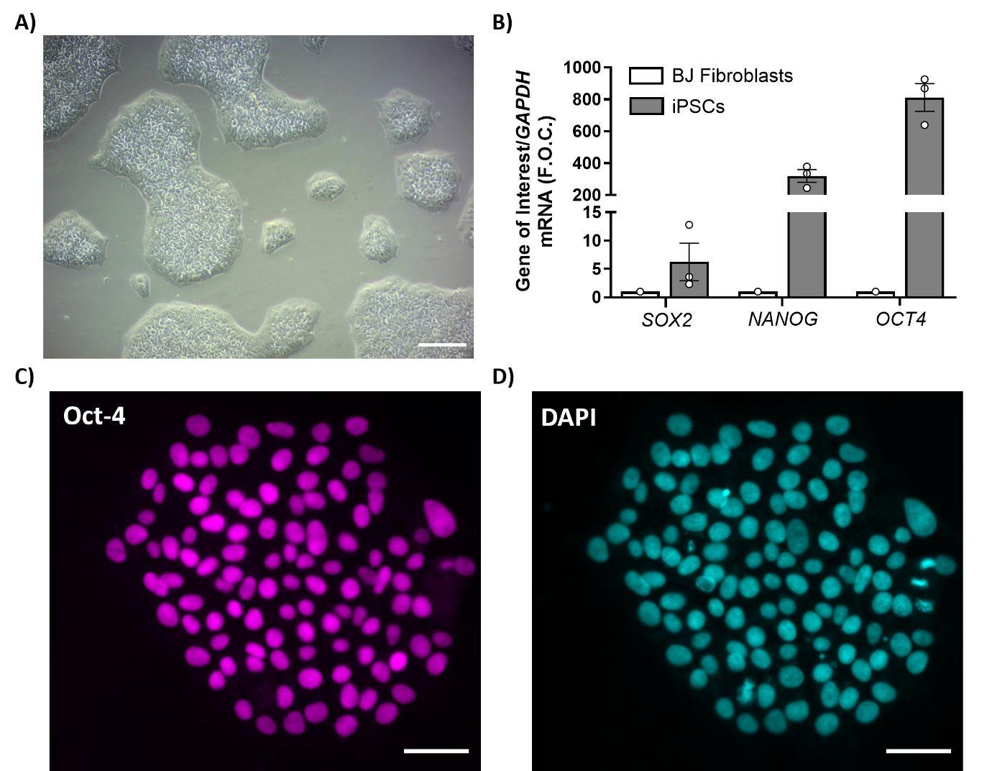
Supplemental Figure 1: iPSC characterization. A) Brightfield image of iPSC colonies. B) Gene expression of the markers of pluripotency, SOX2, NANOG and OCT4 in iPSCs (n=3) in comparison to a BJ fibroblast cell line using GAPDH as the endogenous control. C) iPSCs were positive for Oct-4 and D) DAPI was used as the nuclear stain. Scale bar = 50µm.

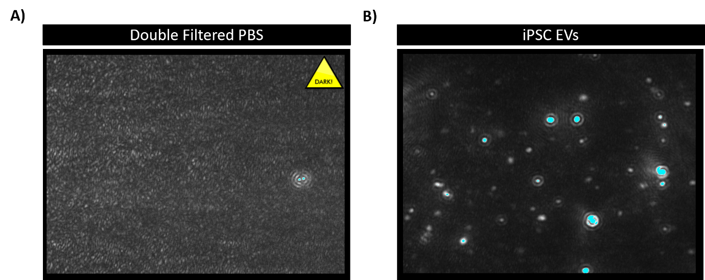
Supplementary Figure 2: Nanoparticle tracking analysis. A) Field of view image from Nanosight NS300 with double filtered PBS sample injected. B) Field of view image from Nanosight NS300 with iPSC EV sample resuspended in double filtered PBS injected. Dots represent particles in solution moving in Brownian motion.

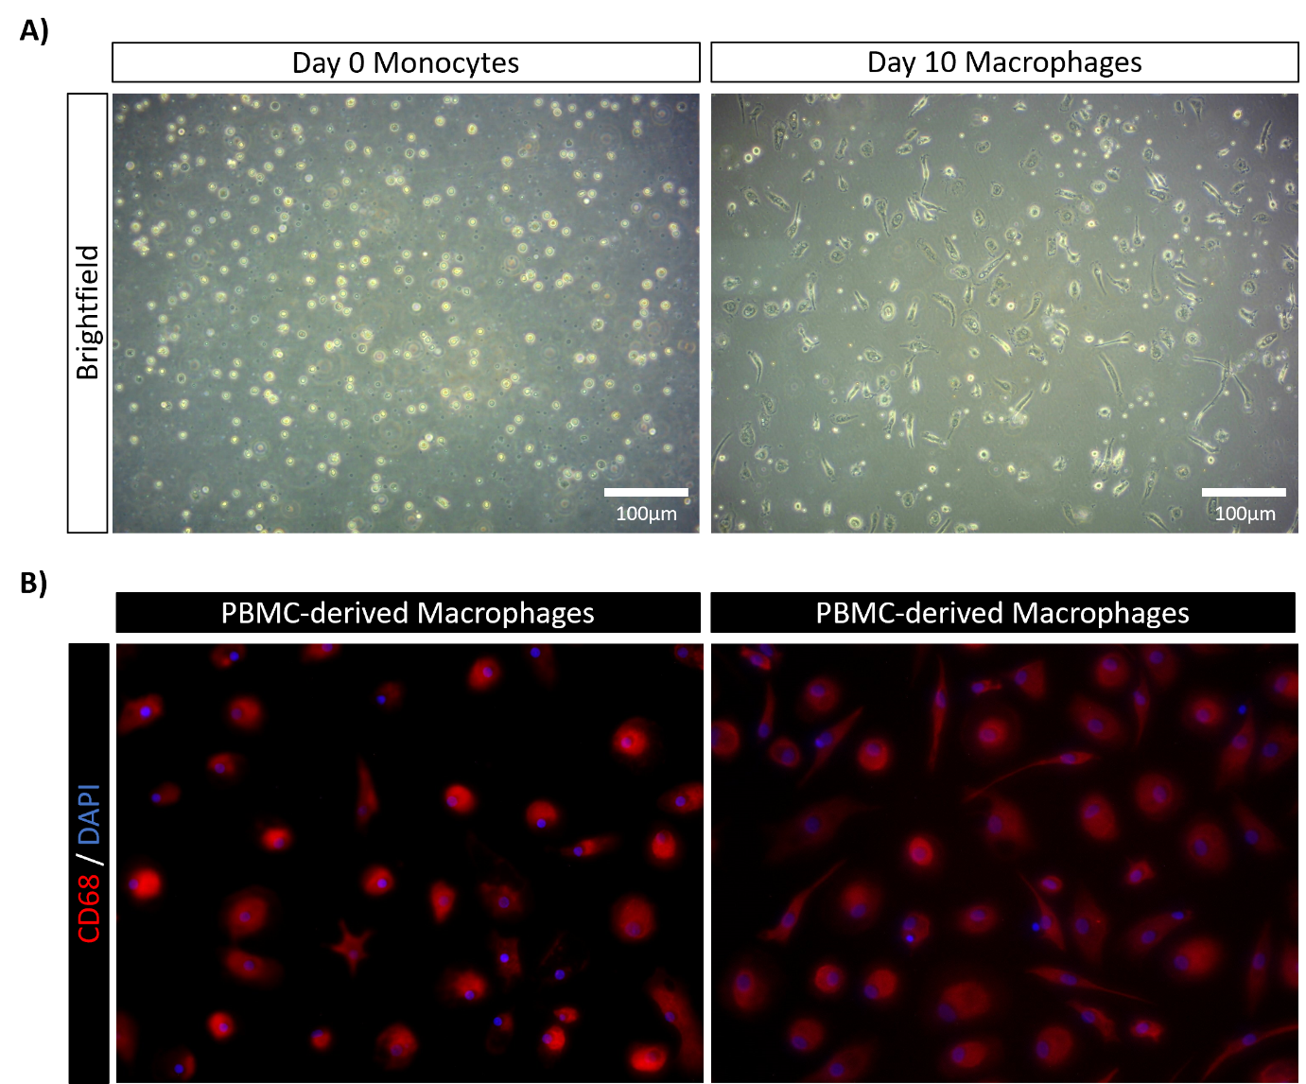
Supplemental Figure 3: PBMC derived macrophage positive for the pan-macrophage marker CD68. A) Monocytes were isolated from PBMCs using plastic adherence and imaged at Day 0 and then cultured for 10 days to differentiate into macrophages. B) Day 10 macrophages were positive for CD68.

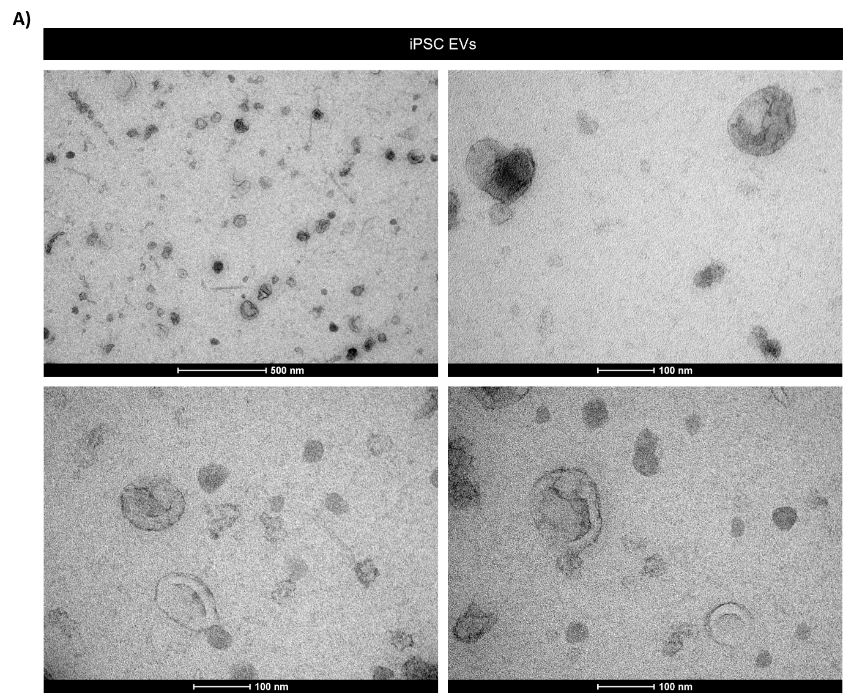
Supplementary Figure 4: Transmission electron microscopy of iPSC-derived EVs. A) Transmission electron microscopy (TEM) representative images of EVs isolated from the supernatant of iPSCs. EVs have characteristic cup-shaped morphology. An FEI Tecnai 12 Transmission Electron Microscope with the acceleration voltage set at 120 kv was used to image the EVs at a magnification of 43,000X and 135,000X.

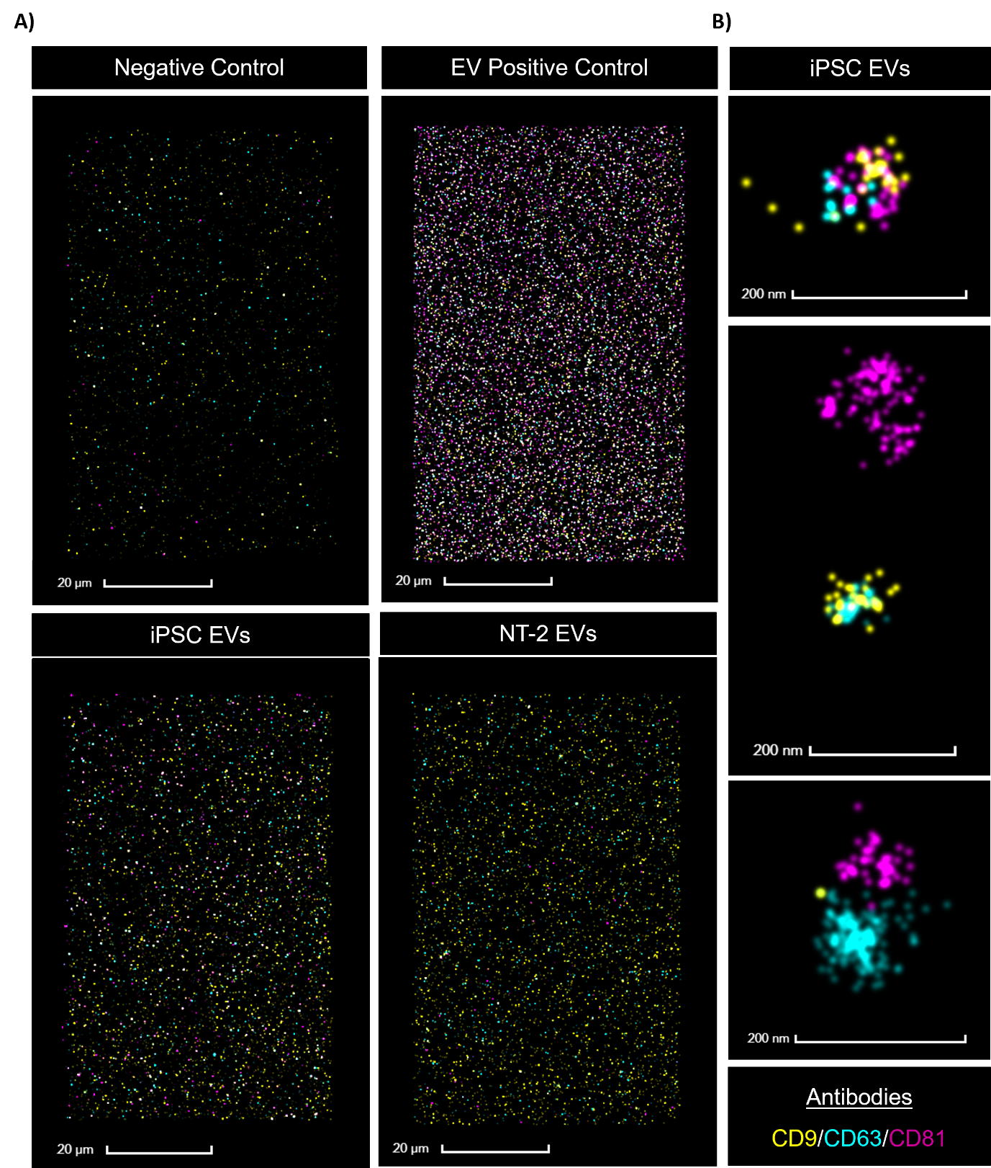
Supplementary Figure 5: Super resolution microscopy of the exosome markers CD9, CD63 and CD81 on EVs. EV samples were stained with the EV antibody cocktail CD9, CD63 and CD81. Images were generated by dSTORM. A) Representative compiled image captured by the NanoImager of the EV Profiler Chip. For generation of the negative control only buffers and antibody cocktail was loaded into the lane on the chip. The standard EV control in the EV Profiler Kit was used as the positive control. Representative images of iPSC EVs and NT-2 EVs positive for the antibodies were also captured. B) Additional images of triple positive, double positive and single positive iPSC-EVs.

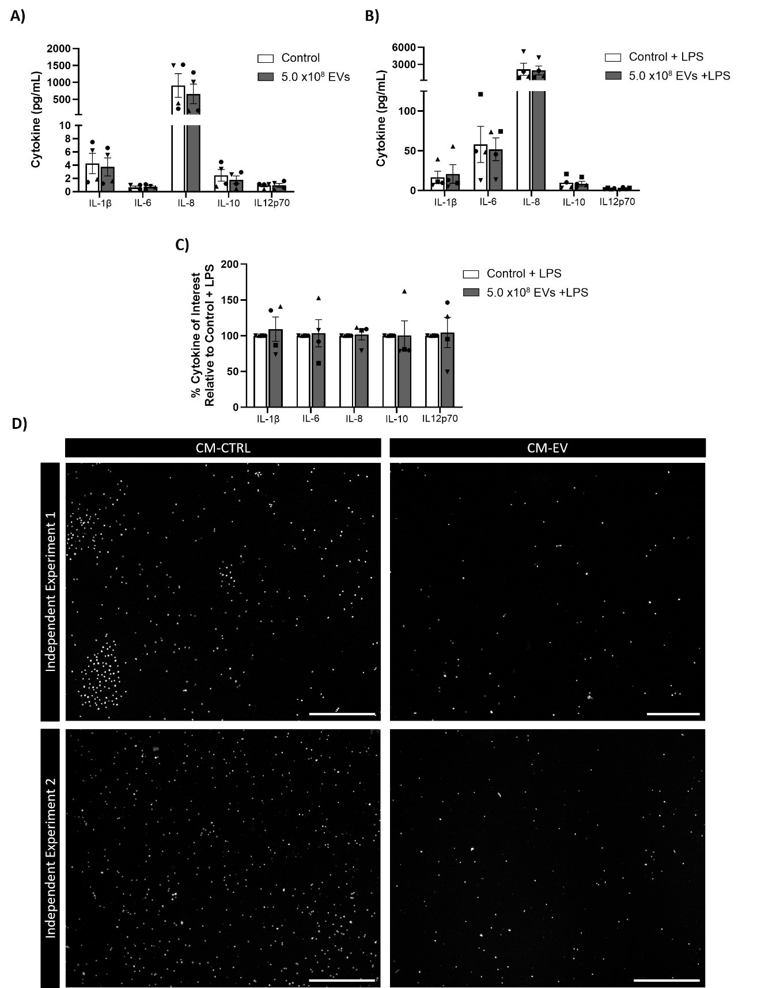Supplemental Figure 6: Cytokine analysis and chemotactic effects of conditioned media (CM) from macrophages treated with iPSC EVs on THP-1 monocyte migration. A-C) Supernatants from EV treated macrophages stimulated with and without LPS were analysed by MSD assay for the cytokines IL-1β, IL-6, IL-8, IL-10 and IL-12p70 were analysed in the cell supernatant by MSD assay and graphed as pg/mL and as percentage relative to control. Symbols represent independent experiments. D) Images are representative of two independent experiments testing migratory effects of CM on monocyte migration. Images of polycarbonate membrane transwell inserts obtained using a microscope (5X). White dots are Hoechst positive nuclei indicative of a transmigrating monocyte. Scale bar = 500µm.

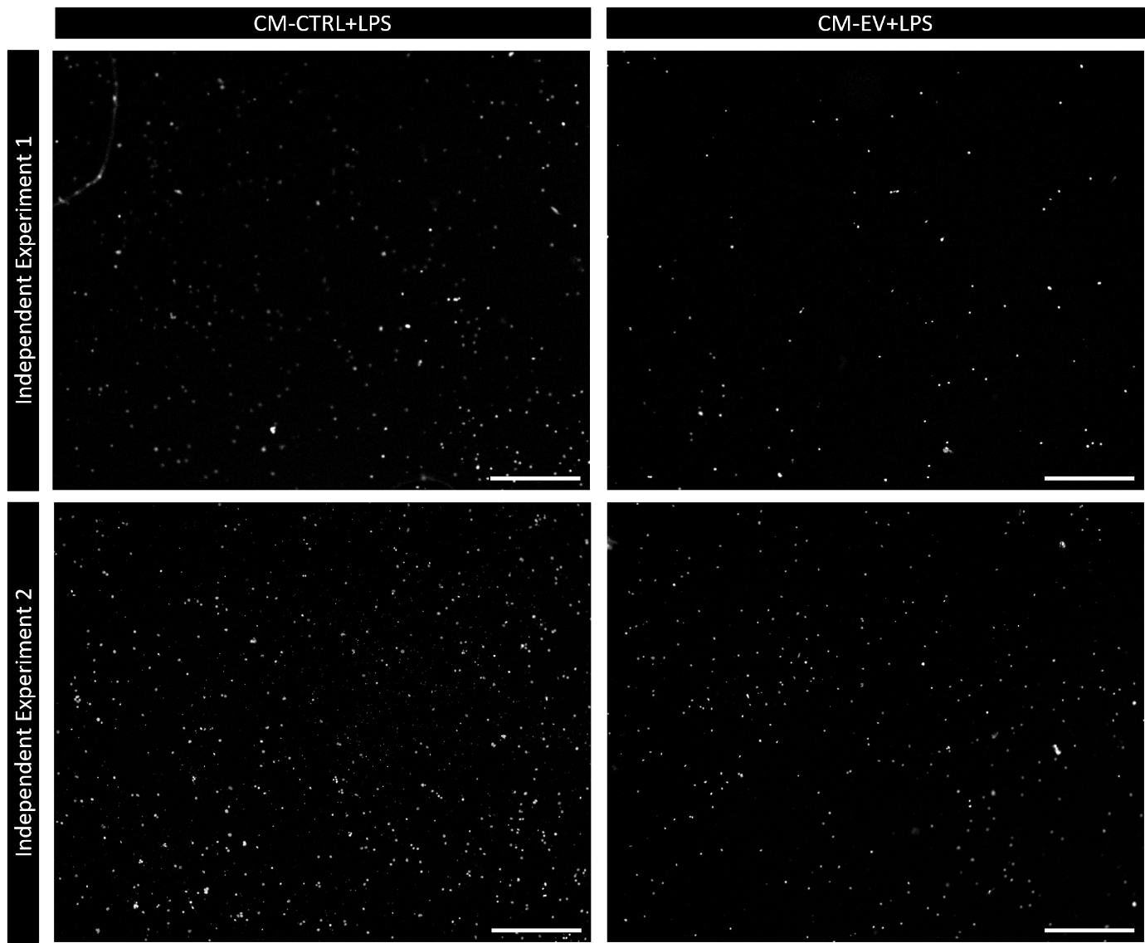
Supplemental Figure 7: Chemotactic effect of conditioned media (CM) from macrophages treated with iPSC EVs and LPS on THP-1 monocyte migration. Images are representative of two independent experiments. Images of polycarbonate membrane transwell inserts obtained using a microscope (10X). White dots are Hoechst positive nuclei indicative of a transmigrating monocyte. Scale bar = 100µm.

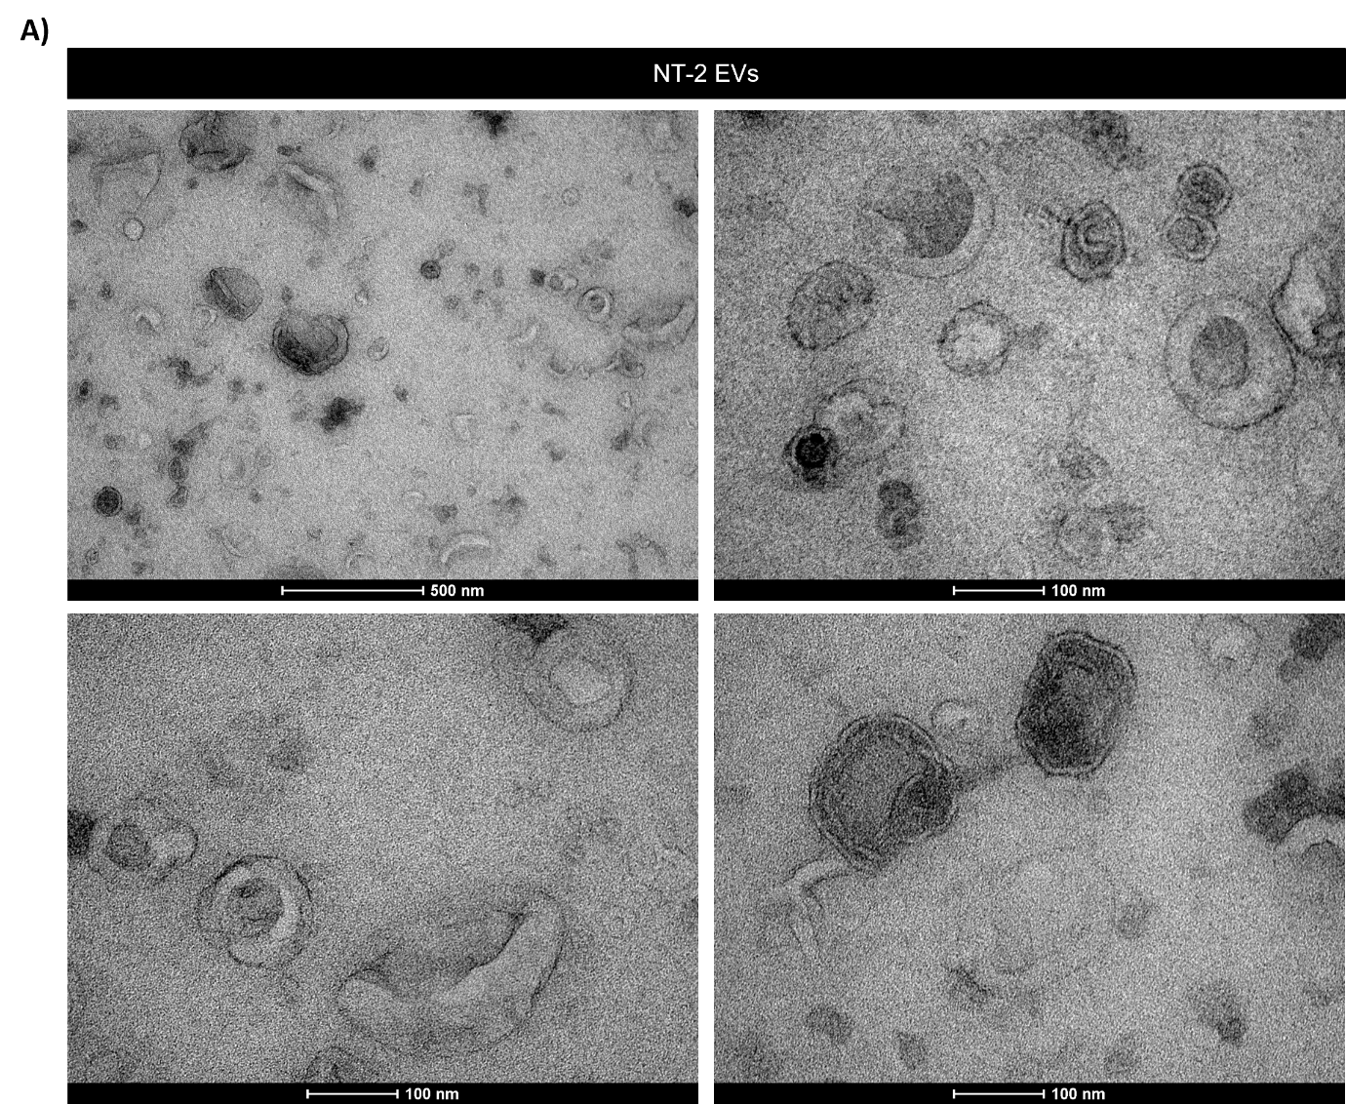
Supplementary Figure 8: Transmission electron microscopy of NT-2-derived EVs. A) Transmission electron microscopy (TEM) representative images of EVs isolated from the supernatant of NT-2 cells. EVs have characteristic cup-shaped morphology. An FEI Tecnai 12 Transmission Electron Microscope with the acceleration voltage set at 120 kv was used to image the EVs at a magnification of 43,000X and 135,000X.

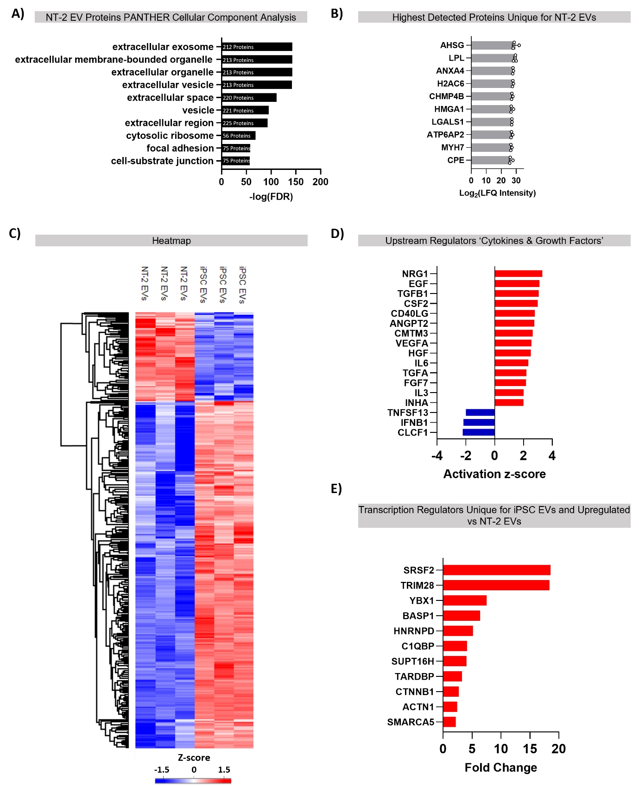
Supplemental Figure 9: A) Analysis of NT-2 EV proteins by Cellular Component Analysis using PANTHER. B) The top 10 most abundant proteins unique to the NT-2 EVs. C) A heatmap of the significantly altered proteins between NT-2 EVs and iPSC EVs. D) IPA analysis of the significantly altered proteins was used to identify the upstream regulators which was filtered for ‘Cytokines and Growth Factors’. E) The fold change of the transcription regulators (identified by IPA molecule analysis) unique for iPSC-EVs and upregulated in comparison to NT-2 EVs were graphed.

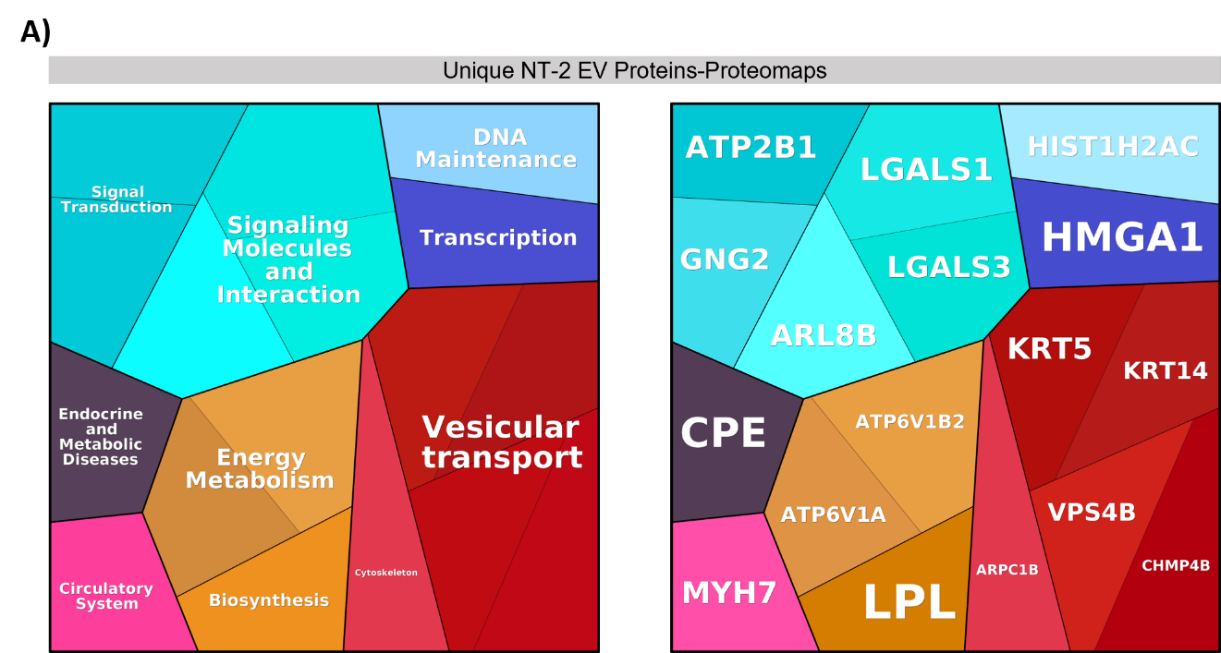
Supplemental Figure 10: A) Proteins unique to NT-2 EVs were analysed by Proteomaps. Proteomaps coverage of the unique NT-2 EV proteins was 53.1% (17/32).

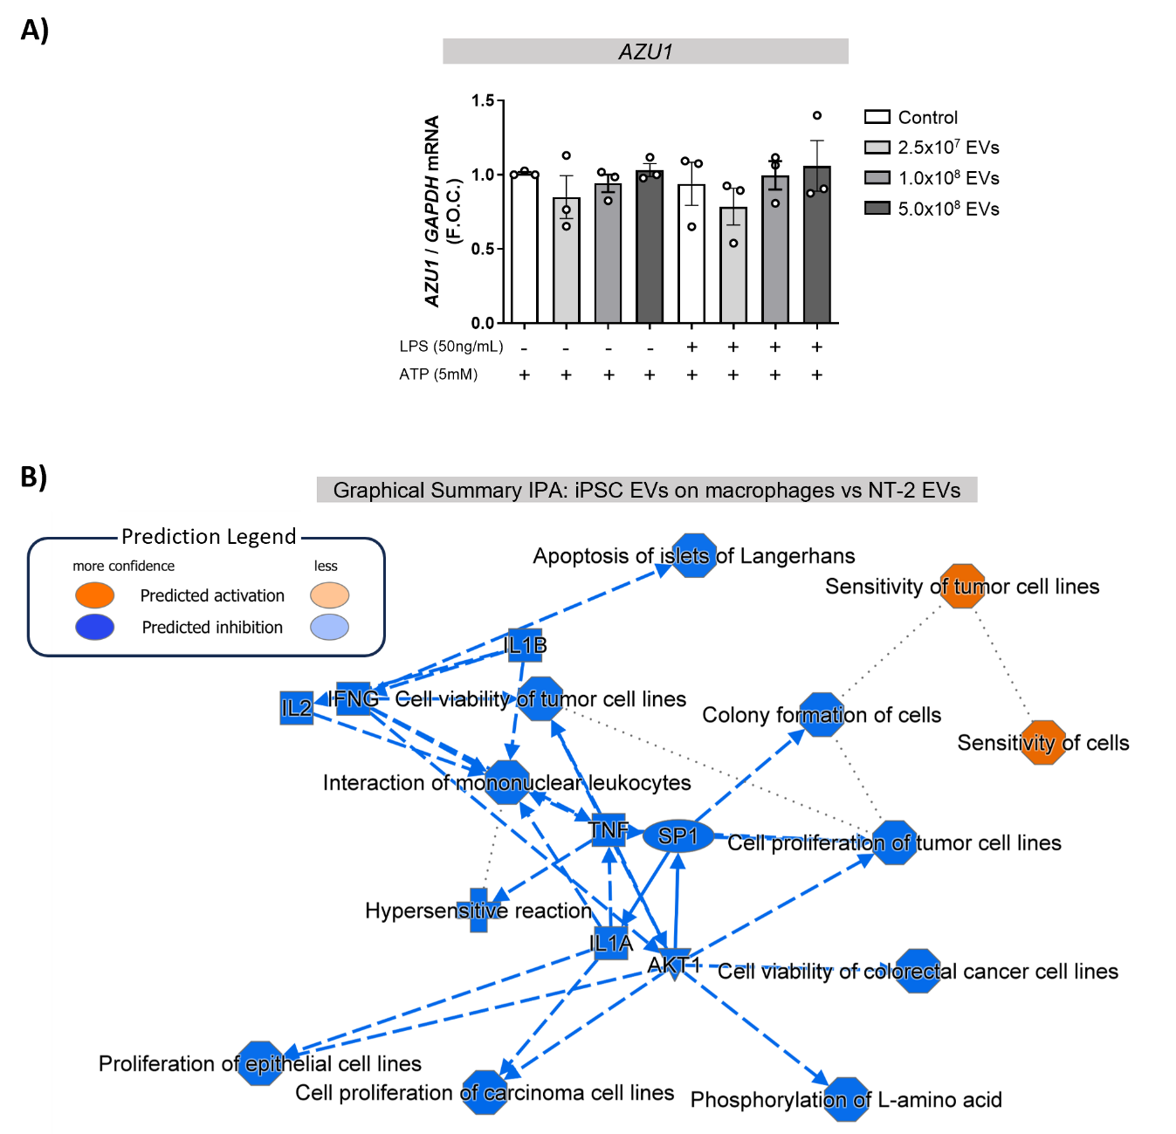
Supplemental Figure 11: A) AZU1 gene expression in macrophages treated with iPSC EVs using GAPDH as the control. B) Graphical summary generated by IPA from analysis of iPSC EV effects on macrophages in comparison to NT-2 EVs.

