Achieving Robust Cholesteric Liquid Crystal Polymer Networks with High Luminescence Dissymmetry Factor

Xiaomei Wu#, Yuxia Zhang*#, Xiao Wang, Jing Zhang, Zhongxing Geng, Shujuan Liu, Yun Ma* and Qiang Zhao*

Table of Contents
1. Measurements and materials.
2. Synthesis and characterizations.
3. Molecular dynamics (MD) simulations method.
4. POM images and XRD data of FC1/FC6/PC6.
5. Photophysical properties of (S-M)-FC1/FC6/PC6.
6. Chiral properties of (S-M)-FC1/FC6/PC6.
7. FT-IR spectroscopy
8. Chiral properties of (R/S-M)_{0.01}-(FC6)_{0.98}-(PETMP)_{0.01} and (R/S-M)_{0.01}-(FC6)_{0.98}-(GDMD)_{0.01}.
9. Detailed preparation method of samples for SEM measures.
10. POM images of (S-M)-FC1/PC6.
11. SEM images of FC1/FC6/PC6.
12. SEM images of (S-M)-FC1/FC6/PC6.
13. DFT calculations and MD simulations.
14. ¹H and ¹³C NMR Spectra of Compounds.
15. References

1. Measurements and materials.
All NMR spectra were obtained by using a Bruker (400 MHz) spectrometer. Chemical shifts were recorded as parts per million (ppm, δ) relative to tetramethylsilane (δ 0.00) or chloroform (δ = 7.26, singlet). 1H NMR splitting patterns are designated as singlet (s), doublet (d), triplet (t), multiplets (m) and etc. Ultraviolet-visible (UV-vis) spectra were measured by using a Shimadzu UV-2600 spectrophotometer. Fluorescence spectra were tested from a HORIBA Scientific FluoroMax-4 Spectrofluorometer. X-ray diffraction (XRD) was measured by using D8 Advance A25 X-ray diffractometer (Germany) with Cu radiation (λ = 1.5406 Å), which was operated at a voltage of 40 kV and a current of 40 mA. The glass transition temperature (T_{g}) was obtained on a DSC214 differential scanning calorimeter under N₂ atmosphere with a heating rate of 10 °C min⁻¹ from 25 °C to 300 °C (T_{g} was collected from the second H⁺·eating scan). Thermogravimetric analysis (TGA) was carried out by using a PerkinElmer Pyris⁻¹ instrument under N₂ atmosphere with a heating rate of 10 °C min⁻¹ from 25 °C to 600 °C. The absolute PL quantum yield were measured by a HORIBA Fluorolog-3 3D-Spectrofluorometer. Circular dichroism (CD) spectra were performed on a JASCO J-810 spectropolarimeter. CPL spectra were collected on a JASCO CPL-300 spectrofluoropolarimeter. In the CPL measurements, scan speed was 200 nm/min, number of scans was 1, and slit width was 4000 μm. Scanning electron microscope (SEM) images were taken in Hitachi S-4800 field emission scanning electron microscopy. The liquid crystalline textures were investigated and photographed using liquid crystal cells with a polarized optical microscope (POM) equipped with a Leitz-350 heating stage and an associated Nikon (D3100) digital camera. All solvents and reagents were commercially available A.R. grade.

2. Synthesis and characterizations.
Scheme S1: The synthesis procedures of FC1, FC6 and PC6.

a) Synthesis and characterizations of M1.
Under N₂ atmosphere, to the mixture of 4-Vinylphenol (1.0 equiv, 15 mmol, 1.8 g), 1,6-Dibromohexane (1.5 equiv, 22.5 mmol, 5.5 g) and anhydrous K₂CO₃ (3.0 equiv, 45 mmol, 6.2 g) was added in 25 mL Acetone. The mixture was heated to 80 °C and stirred 18 hours. After completion of the reaction, the solvent was evaporated under vacuum. The residue was poured into water (50 mL) and extracted with CH₂Cl₂ (3 × 30 mL). The combined organic layer was washed with brine, dried over Na₂SO₄, and concentrated under vacuum. The crude product was purified by flash column chromatography (silica gel) to afford a white solid (57% yield, 2.4 g). ¹H NMR (400 MHz, CDCl₃) δ(ppm): 7.37-7.30 (m, 2H), 6.88-6.82 (m, 2H), 6.66 (dd, J = 17.6, 10.8 Hz, 1H), 5.60 (dd, J = 17.6, 1.2 Hz, 1H), 5.12 (dd, J = 10.8, 1.2 Hz, 1H), 3.96 (t, J = 6.4 Hz, 2H), 3.43 (t, J = 6.8 Hz, 2H), 1.90 (m, J = 6.8 Hz, 2H), 1.79 (m, J = 6.8 Hz, 2H), 1.55-1.46 (m, 4H). ¹³C NMR (101 MHz, CDCl₃) δ (ppm): 158.9, 136.3, 130.3, 127.4, 114.5, 111.5, 67.8, 33.8, 32.7, 29.1, 27.9, 25.3.
b) Synthesis and characterizations of M2.
To a 250 mL round-bottomed flask was added 2-Bromo-9,9-dioctyl-9H-fluorene (1.0 equiv, 8.0 mmol, 3.7 g), 2-(9,9-Dioctyl-9H-fluoren-2-yl)-4,4,5,5-tetramethyl-1,3,2-dioxaborolane (1.2 equiv, 9.6 mmol, 5.0 g), anhydrous K₂CO₃ (6 equiv, 48 mmol, 6.6 g), Tetrakis (triphenylphosphine) palladium (0.05 equiv, 0.4 mmol, 0.46 g), Tetrabutylammonium bromide (0.4 equiv, 3.2 mmol, 1.0 g) and Toluene: H₂O (21 mL: 7 mL). The reaction was refluxed at 85 °C until the reaction was completed (detected by TLC). After completion of the reaction, the solvent was evaporated under vacuum. The residue was poured into water (50 mL) and extracted with CH₂Cl₂ (3 × 30 mL). The combined organic layer was washed with brine, dried over Na₂SO₄, and concentrated under vacuum. The crude product was purified by flash column chromatography (silica gel) to afford a white solid (83% yield, 5.2 g). ¹H NMR (400 MHz, CDCl₃) δ (ppm): 7.81 (dd, J = 16.4, 7.6 Hz, 4H), 7.73-7.66 (m, 4H), 7.45-7.34 (m, 6H), 2.16-2.02 (m, 8H), 1.28-1.06 (m, 40H), 0.87 (t, J = 6.8 Hz, 12H), 0.77 (d, J = 8.8 Hz, 8H). ¹³C NMR (101 MHz, CDCl₃) δ (ppm): 151.5, 151.0, 140.8, 140.5, 140.3, 127.0, 126.8, 126.0, 122.9, 121.4, 119.9, 119.7, 55.2, 53.4, 40.4, 31.8, 30.1, 29.2, 23.8, 22.6, 14.1.
c) Synthesis and characterizations of M3.
Under N₂ atmosphere, to the mixture of M2 (1.0 equiv, 3.5 mmol, 2.7 g) was dissolved in CHCl₃ (60 mL) at 0 °C. Bromine (2.2 equiv, 7.7 mmol, 0.4 mL) in CHCl₃ was slowly added dropwise to the solution. After the dropwise addition, the reaction was stirred at room temperature for 3 hours. The reaction was extracted with CH₂Cl₂. The combined organic layer was washed with brine, dried over Na₂SO₄, and concentrated under vacuum. The crude product was purified by flash column chromatography (silica gel) to afford a white solid (83% yield, 2.7 g). ¹H NMR (400 MHz, CDCl₃) δ (ppm): 7.74 (d, J = 7.6 Hz, 2H), 7.65-7.55 (m, 6H), 7.48 (s, 3H), 7.46 (d, J = 2.0 Hz, 1H), 2.08-1.92 (m, 8H), 1.22-1.05 (m, 40H), 0.81 (t, J = 6.8 Hz, 12H), 0.74-0.64 (m, 8H). ¹³C NMR (101 MHz, CDCl₃) δ (ppm): 153.4, 151.3, 140.9, 139.9, 139.5, 130.1, 126.4, 126.4, 121.5, 121.2, 121.2, 120.2, 55.7, 53.6, 40.4, 31.9, 30.1, 29.3, 29.3, 23.9, 22.7, 14.2.
d) Synthesis and characterizations of M4.
To a mixture of M3 (1 equiv, 2.5 mmol, 2.3 g), 4-(tert-Butyldimethylsilyloxy) phenylboronic acid (2.5 equiv, 6.25 mmol, 1.6 g), K₂CO₃ (6 equiv, 15 mmol, 2.1 g), Pd(PPh₃)₄ (0.05 equiv, 0.13 mmol, 0.14 g), TBAB (0.6 equiv, 1.5 mmol, 0.48 g) and Toluene: H₂O (30 mL: 10 mL). The mixture was heated to 85 °C for overnight. After completion of the reaction, the solvent was evaporated under vacuum. The residue was poured into water (50 mL) and extracted with CH₂Cl₂ (3 × 30 mL). The combined organic layer was washed with brine, dried over Na₂SO₄, and concentrated under vacuum. Transfer the mixture to a 50 mL round-bottomed flask was added Tetrabutylammonium fluoride (3.5 mL, 1.0 mol/L in THF) was dissolved in THF (20 mL) at 0 °C, the reaction lasted for 8 hours. The reaction was extracted with CH₂Cl₂. The combined organic layer was washed with brine, dried over Na₂SO₄. The crude product was used directly in the subsequent reaction without further purification.
e) Synthesis and characterizations of FC1.
To a 50 mL round-bottomed flask was added M4 (1 equiv, 0.25 mmol, 234.25 mg), 4-vinylbenzyl chloride (2.5 equiv, 0.625 mmol, 177 mg), K₂CO₃ (3 equiv, 0.75 mmol, 103.66 mg), Pd(PPh₃)₄ (0.1 equiv, 0.025 mmol, 8.06 mg) and Acetonitrile (15 mL). The mixture was heated to 60 °C and stirred 72 hours. After completion of the reaction, the solvent was evaporated under vacuum. The residue was poured into water (50 mL) and extracted with CH₂Cl₂ (3 × 30 mL). The combined organic layer was washed with brine, dried over Na₂SO₄, and concentrated under vacuum. The crude product was purified by flash column chromatography (silica gel) to afford a white solid (40.9% yield, 139.9 mg). ¹H NMR (400 MHz, CDCl3) δ (ppm): 7.78 (t, J = 7.6 Hz, 4H), 7.64 (dd, J = 15.2, 8 Hz, 8H), 7.58-7.51 (m, 4H), 7.45 (dd, J = 10.8, 8 Hz, 8H), 7.07 (s, 4H), 6.74 (dd, J = 17.6, 11.2 Hz, 2H), 5.78 (d, J = 17.6 Hz, 2H), 5.27 (d, J = 10.8 Hz, 2H), 5.14 (s, 4H), 2.12-1.98 (m, 8H), 1.13 (m, 40H), 0.84-0.71 (m, 20H). ¹³C NMR (101 MHz, CDCl₃) δ (ppm): 158.2, 151.7, 140.4, 140.0, 139.6, 139.6, 137.4, 136.6, 136.5, 134.6, 128.2, 127.7, 126.5, 126.1, 125.6, 121.4, 121.2, 119.9, 119.9, 115.2, 114.2, 69.9, 55.3, 40.4, 31.8, 30.0, 29.2, 29.2, 23.9, 22.6, 14.1; HRMS(ESI) m/z: [M+H]⁺ calcd for C₈₈H₁₀₆O₂ 1195.8266; Found 1195.8202.
f) Synthesis and characterizations of FC6.
FC6 was synthesized according to the method of FC1. ¹H NMR (400 MHz, CDCl3) δ (ppm): 7.79 (m, 4H), 7.64 (m, 12H), 7.37 (br, 4H), 7.03 (br, 4H), 6.89 (br, 4H), 6.69 (m, 2H), 5.63 (d, J = 17.6 Hz, 2H), 5.15 (d, J = 12.4 Hz, 2H), 4.04 (d, J = 21.6 Hz, 8H), 2.09 (br, 8H), 1.87 (br, 8H), 1.60 (br, 8H), 1.16 (br, 40H), 0.82 (m, 20H). ¹³C NMR (101 MHz, CDCl₃) δ (ppm): 159.00, 158.70, 151.78, 140.44, 140.16, 139.79, 139.58, 136.36, 134.19, 130.36, 128.26, 127.47, 126.18, 125.66, 121.48, 121.21, 120.04, 119.94, 114.90, 114.57, 111.54, 68.05, 67.95, 55.35, 53.57, 40.53, 31.90, 30.14, 29.34, 29.31, 26.02, 23.96, 22.71, 14.19. HRMS(ESI) m/z: [M+H]⁺ calcd for C₉₈H₁₂₆O₄ 1368.9763; Found 1368.9707.
g) Synthesis and characterizations of M5.
M5 was synthesized according to the method of M2. ¹H NMR (400 MHz, CDCl3) δ (ppm): 7.69 (d, J = 8 Hz, 1H), 7.62-7.40 (m, 7H), 6.94 (d, J = 7.6 Hz, 2H), 4.88 (s, 1H), 1.97 (d, J = 9.2 Hz, 4H), 1.08 (m, 20H), 0.81 (t, J = 6 Hz, 6H), 0.65 (br, 4H). ¹³C NMR (101 MHz, CDCl₃) δ (ppm): 155.11, 153.17, 151.04, 140.10, 139.90, 138.79, 134.33, 129.96, 128.46, 126.16, 125.72, 121.04, 121.00, 120.87, 120.01, 115.70, 55.48, 40.32, 31.79, 29.96, 29.22, 29.18, 23.72, 22.62, 14.09.
h) Synthesis and characterizations of M6.
M6 was synthesized according to the method of M4. The crude product was used directly in the subsequent reaction without further purification.
i) Synthesis and characterizations of PC6.
PC6 was synthesized according to the method of FC1. ¹H NMR (CDCl₃, 400 MHz) δ (ppm): 8.26 (dd, J = 18.4, 9.2 Hz, 4H), 8.08 (dd, J = 11.6, 8 Hz, 4H), 7.91 (d, J = 7.6 Hz, 2H), 7.84 (d, J = 8 Hz, 2H), 7.67-7.57 (m, 12H), 7.35 (d, J = 8.4 Hz, 4H), 7.03 (d, J = 8 Hz, 4H), 6.87 (d, J = 8.4 Hz, 4H), 6.67 (dd, J = 17.6, 10.8 Hz, 2H), 5.62 (d, J = 17.6 Hz, 2H), 5.13 (d, J = 11.2 Hz, 2H), 4.03 (dt, J = 22.8, 6.4 Hz, 8H), 2.15-2.04 (m, 8H), 1.92-1.82 (m, 8H), 1.59 (s, 8H), 1.14 (s, 40H), 0.83 (m, 20H). ¹³C NMR (101 MHz, CDCl₃) δ (ppm): 158.9, 158.6, 151.8, 151.1, 140.1, 139.9, 139.8, 139.6, 138.5, 136.3, 134.1, 130.4, 130.3, 129.4, 129.0, 128.2, 127.9, 127.5, 127.4, 125.7, 125.4, 125.4, 124.4, 121.2, 120.1, 119.6, 114.9, 114.5, 111.5, 68.0, 67.9, 55.3, 40.5, 31.8, 30.1, 29.3, 29.3, 25.9, 24.0, 22.6, 14.1; HRMS(ESI) m/z: [M+K]⁺ calcd for C₁₀₂H₁₂₆O₄ 1606.9948; Found 1607.0135.
3. Molecular dynamics (MD) simulations method.
All molecular dynamics simulations were carried out using Gromacs 2018.8 program^{[1]} with general Amber force fields (GAFF).^{[2]} In this work, all molecules were optimized by Gaussian 16 program using M06-2X hybrid functional with 6-31G* basis set.^{[3]} Multiwfn was used to construct RESP charges.^{[4]} Using packmol software,^{[5]} 10 R-M molecules were placed in boxes of 22*5*5 nm, 30*8*8 nm, and 30*7*7 nm, along with 22FC1 molecules, 215 FC6 molecules, and 17 PC6 molecules, respectively. The co-assembly simulation process of the three simulation box systems used NVT ensemble and their simulation time was 100 ns to ensure that all assembly processes were balanced. The whole MD process was a simulated annealing process.

4. POM images and XRD data of FC1/FC6/PC6.
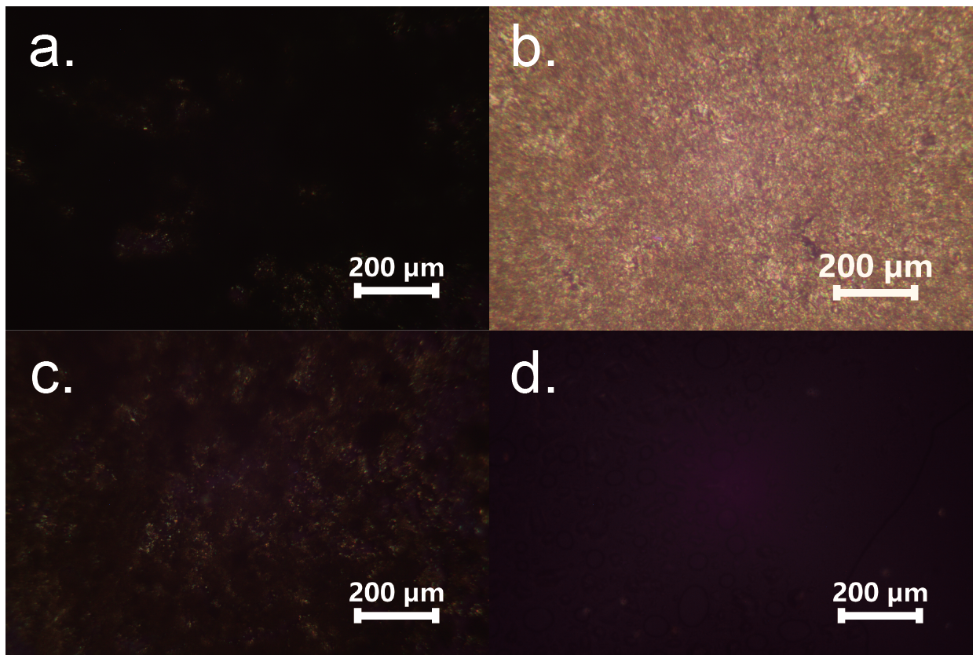
Supplementary Fig. 1. POM images of FC1 heating at a) 108 °C, b) 125 °C, c) 128 °C, and d) 130 °C, respectively.
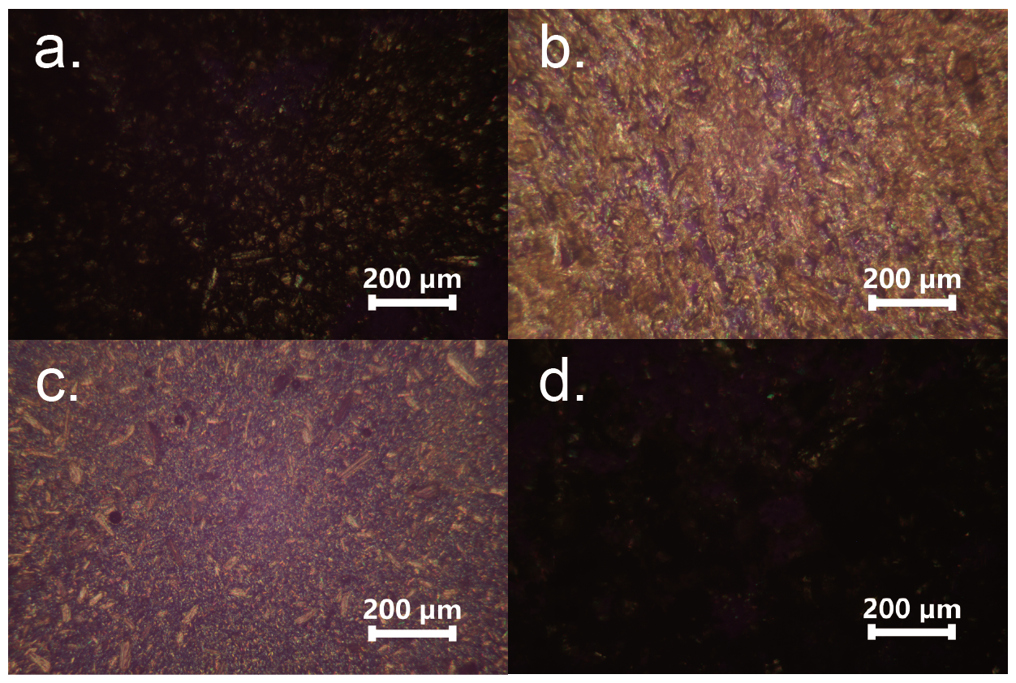
Supplementary Fig. 2. POM images of FC6 heating at a) 52 °C, b) 60 °C, c) 71 °C, and d) 76 °C, respectively.
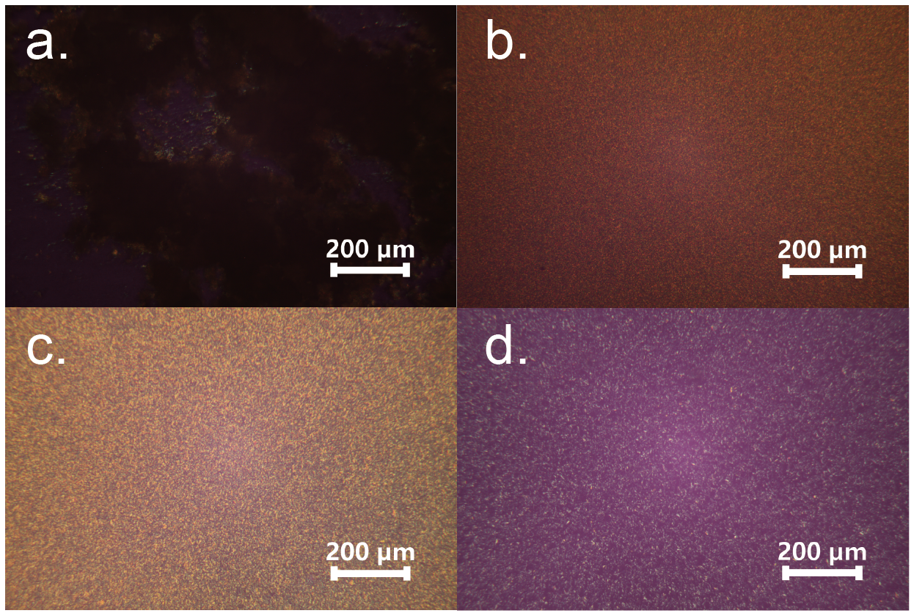
Supplementary Fig. 3. POM images of PC6 heating at a) 92 °C, b) 122 °C, c) 125 °C, and d) 133 °C, respectively.

Supplementary Fig. 4. XRD patterns of FC1/FC6/PC6 after thermal annealing.

5. Photophysical properties of (S-M)-FC1/FC6/PC6.
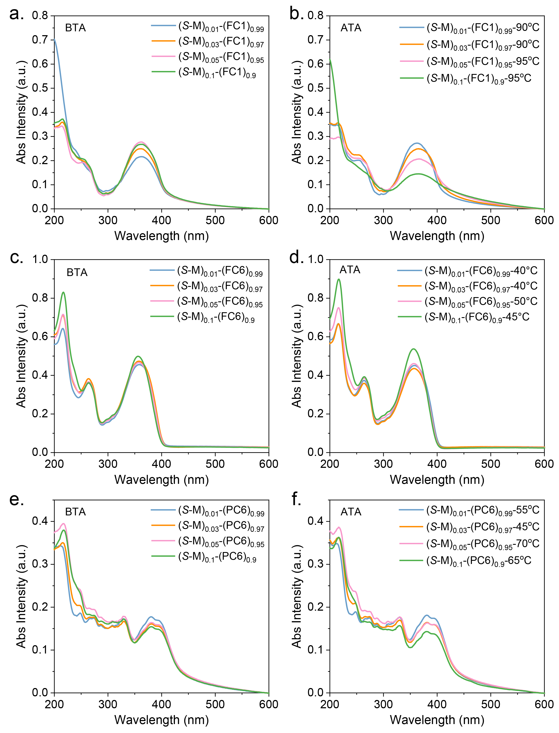
Supplementary Fig. 5. UV-vis absorption spectra of chiral co-assemblies: a,b) (S-M)-FC1; c,d) (S-M)-FC6; e,f) (S-M)-PC6 (BTA: before thermal annealing; ATA: after thermal annealing at different annealing temperature).
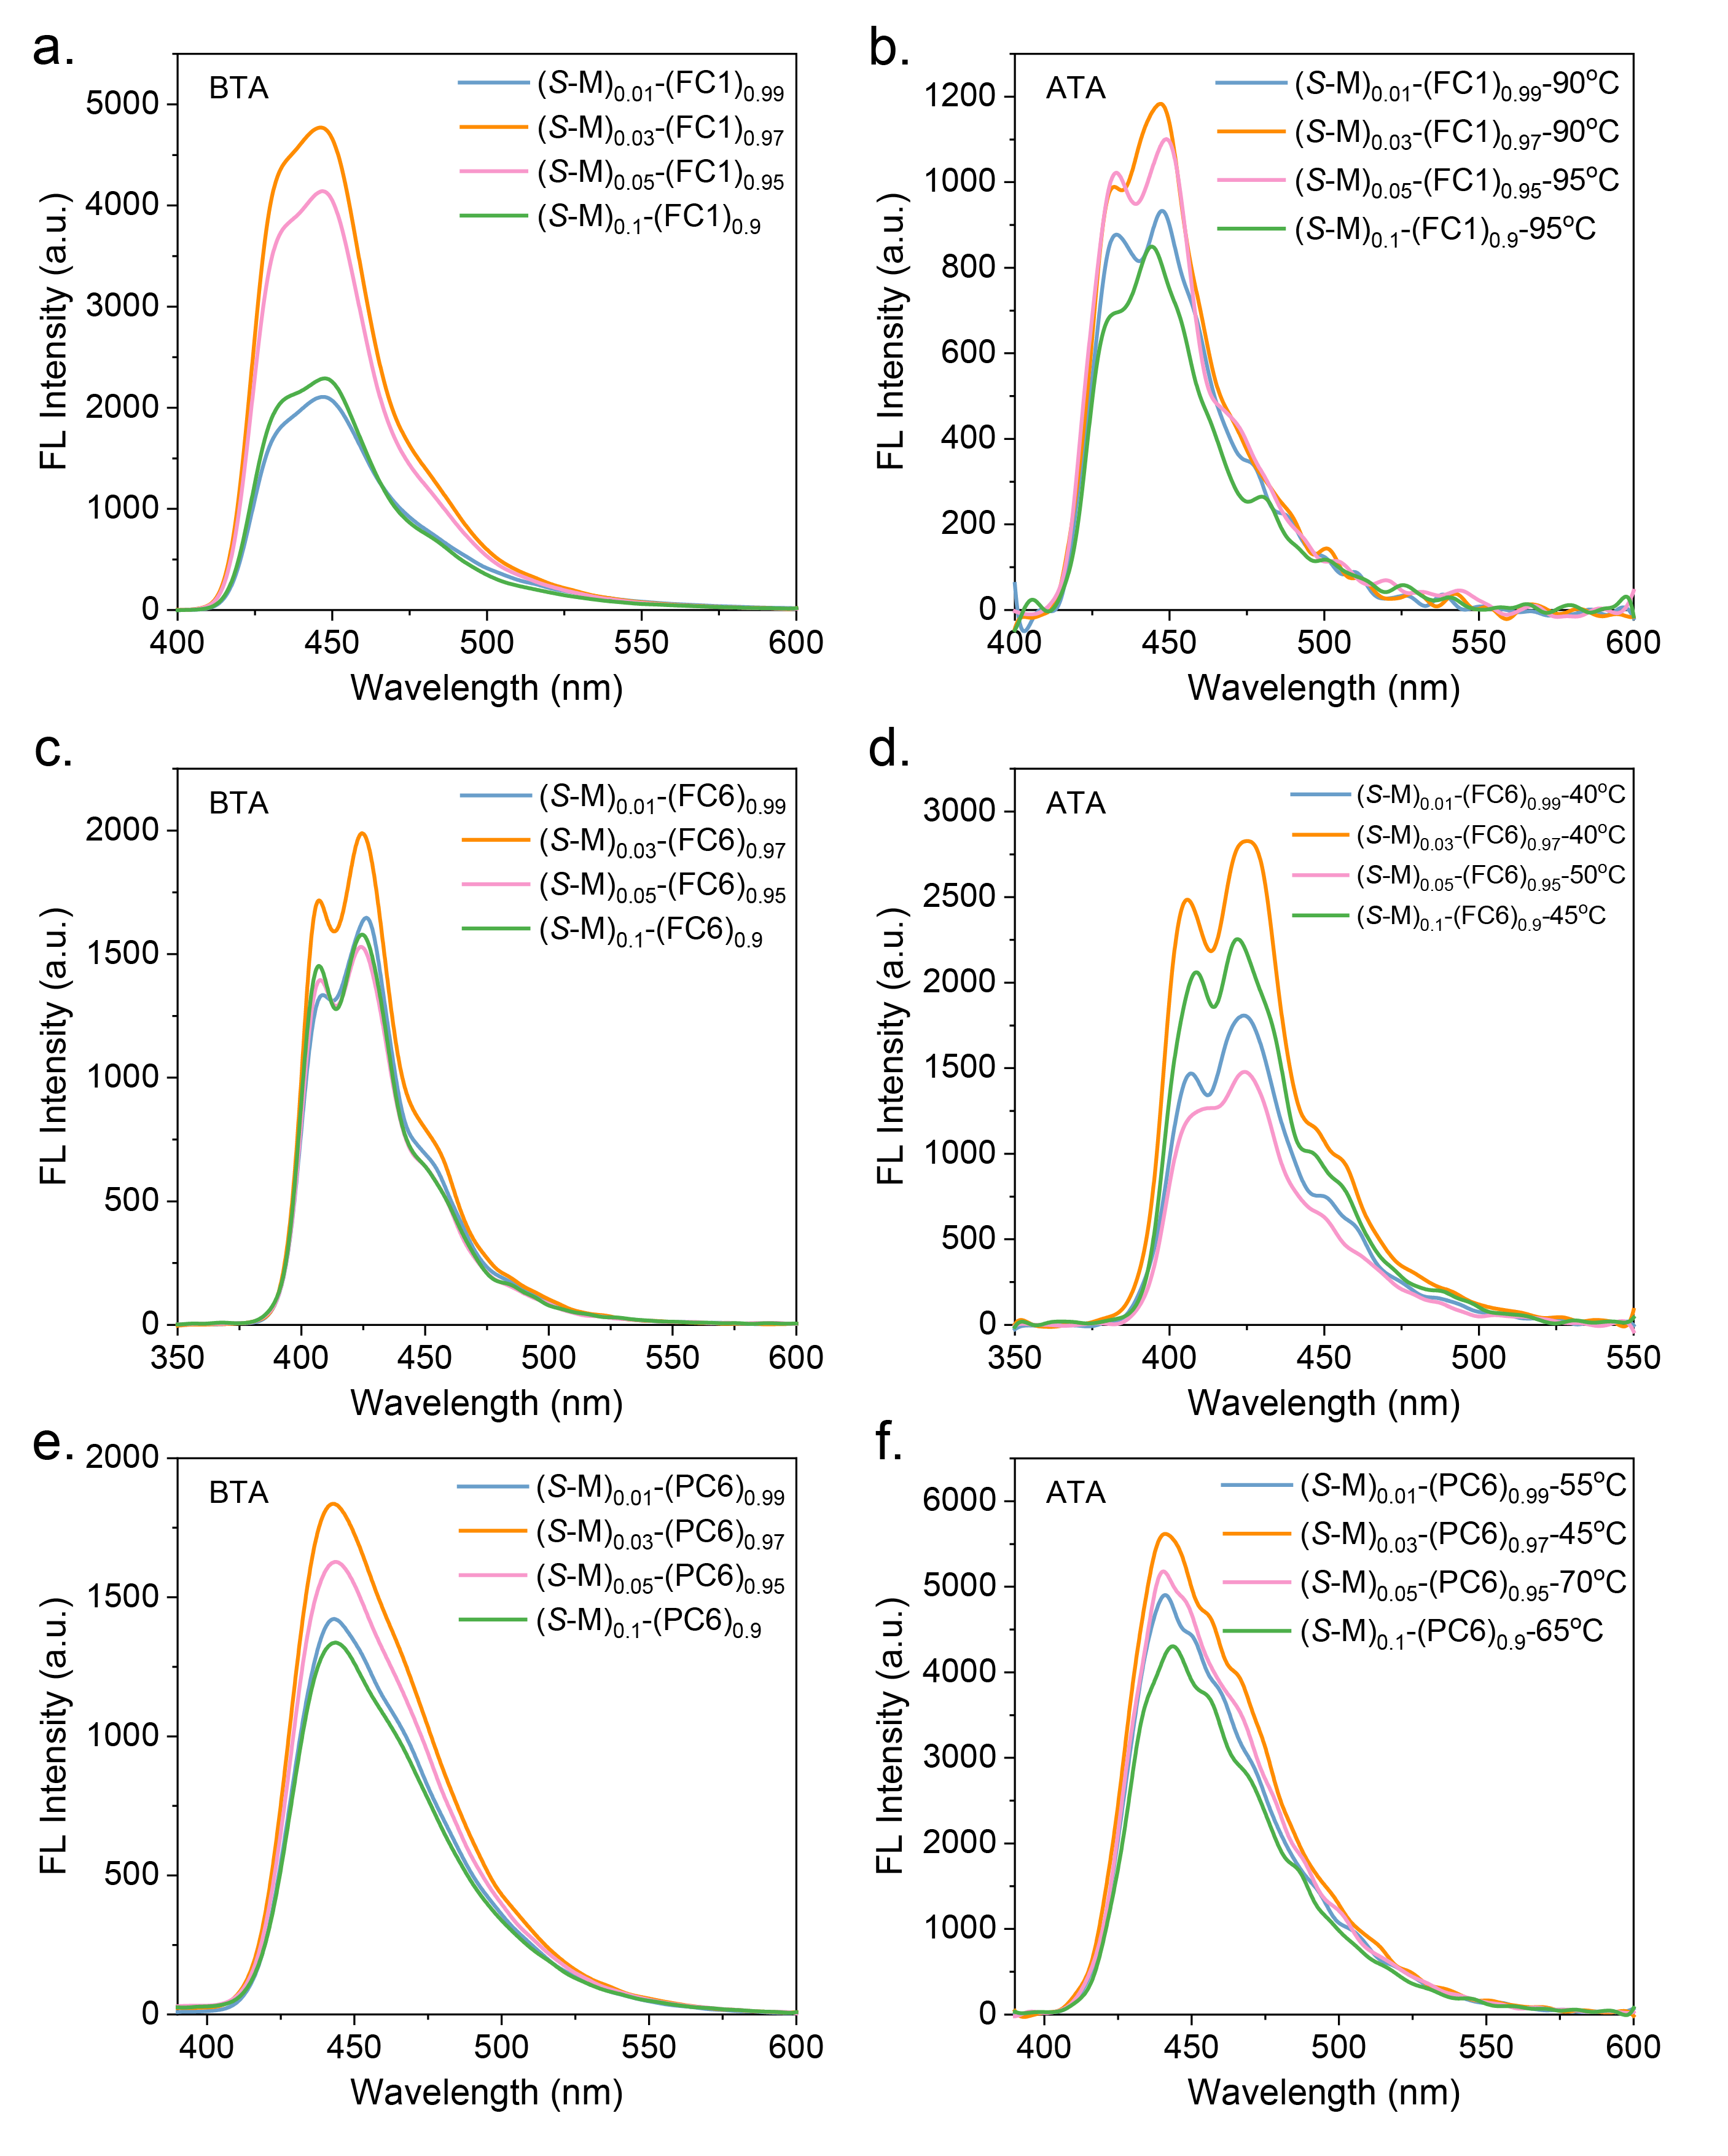
Supplementary Fig. 6. FL spectra of chiral co-assemblies: a,b) (S-M)-FC1; c,d) (S-M)-FC6; e,f) (S-M)-PC6 (BTA: before thermal annealing; ATA: after thermal annealing at different annealing temperature).

6. Chiral properties of (S-M)-FC1/FC6/PC6.
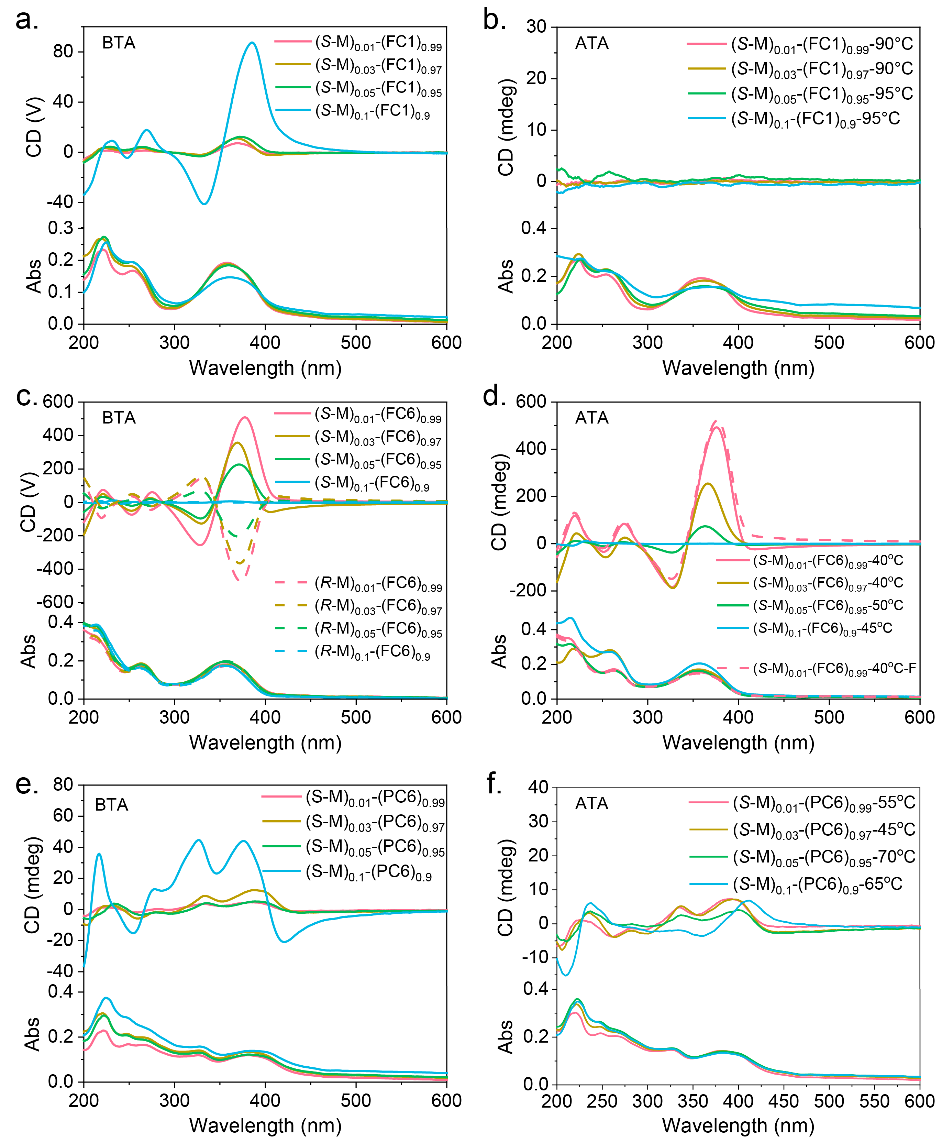
Supplementary Fig. 7. CD spectra of chiral co-assemblies: a,b) (S-M)-FC1; c,d) (R/S-M)-FC6; e,f) (S-M)-PC6 (BTA: before thermal annealing; ATA: after thermal annealing; F; away from the detector: “Backward”).

7. FT-IR spectroscopy
Supplementary Fig. 8. FT-IR spectroscopy of FC6 and crosslinked (S-M)_{0.01}-(FC6)_{0.98}-(GDMD)_{0.01}.
8. Chiral properties of (R/S-M)_{0.01}-(FC6)_{0.98}-(PETMP)_{0.01} and (R/S-M)_{0.01}-(FC6)_{0.98}-(GDMD)_{0.01}.
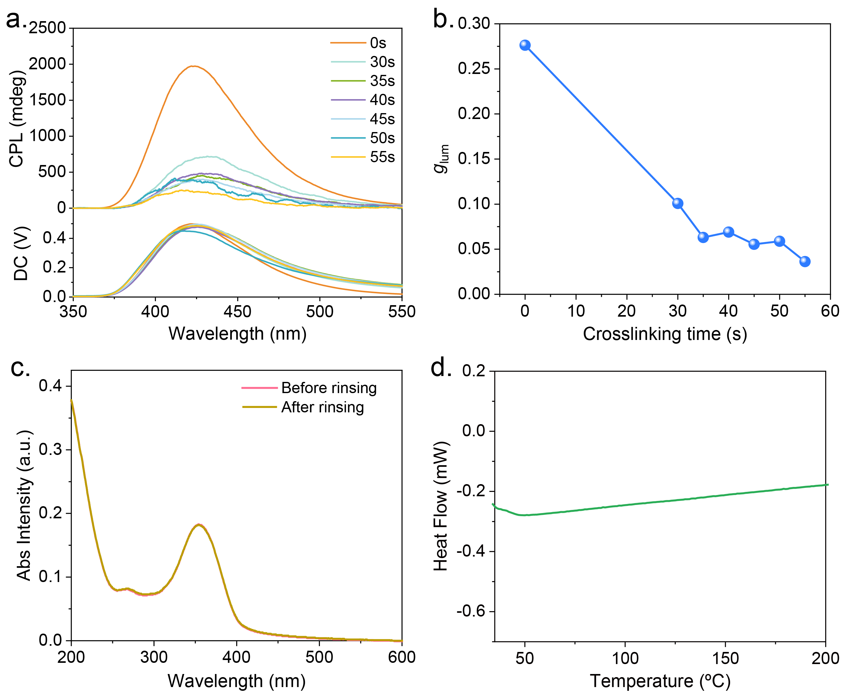
Supplementary Fig. 9. a) CPL spectra and b) the g_{lum} values of (S-M)_{0.01}-(FC6)_{0.98}-(PETMP)_{0.01} after different crosslinking time; c) UV-vis absorption spectra of crosslinked (S-M)_{0.01}-(FC6)_{0.98}-(PETMP)_{0.01} (the crosslinking time is 55 s) before and after rinsing with chloroform; d) DSC curves based on crosslinked (S-M)_{0.01}-(FC6)_{0.98}-(PETMP)_{0.01} (the crosslinking time is 55 s).
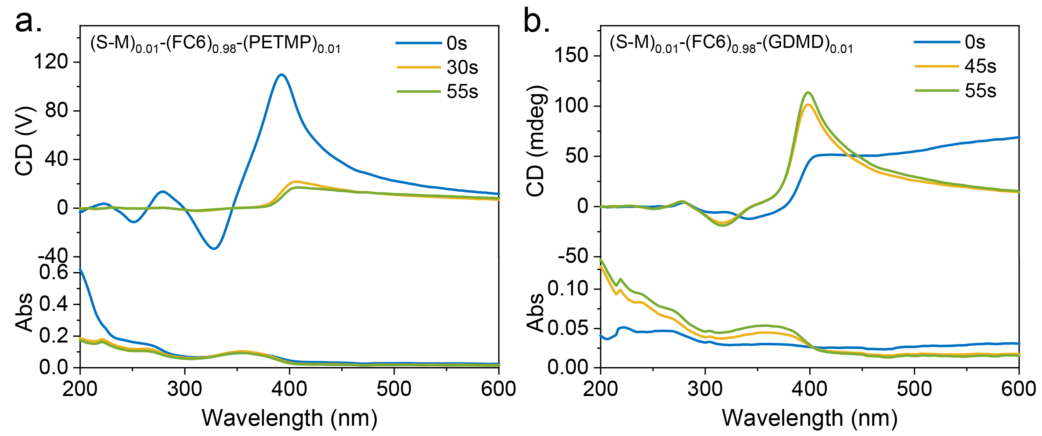
Supplementary Fig. 10. CD spectra of a) (S-M)_{0.01}-(FC6)_{0.98}-(PETMP)_{0.01} and b) (S-M)_{0.01}-(FC6)_{0.98}-(GDMD)_{0.01} after different crosslinking time.
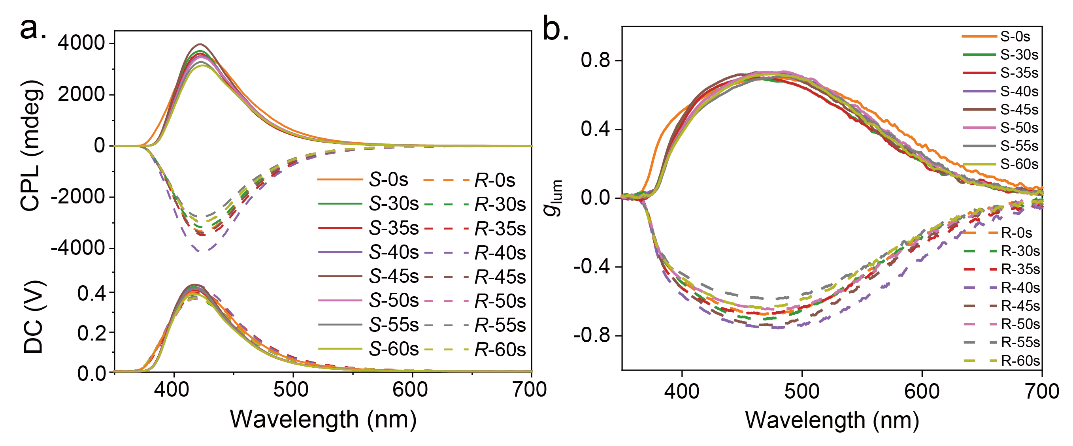
Supplementary Fig. 11. a) CPL spectra and b) the g_{lum} values of (S-M)_{0.01}-(FC6)_{0.98}-(GDMD)_{0.01} after different crosslinking time.
9. Detailed preparation method of samples for SEM measures.
Film from 10⁻¹ mg/mL solution in chloroform: 3 μL of the above10 mg/mL solution was added into 300 μL chloroform to obtain 10⁻¹ mg/mL solution. The mixtures (3 μL) were dropped on silicon wafer and the co-assemblies were collected from the above solutions after chloroform naturally evaporated at room temperature.
Aggregate state from 10⁻³ mg/mL mixed solution in THF/H₂O = 40/60: 3 μL of the above 10⁻¹ mg/mL solution was added into 300 μL THF/H₂O (v/v = 40/60) to obtain 10⁻³ mg/mL mixed solution. The mixtures (10 μL) were dropped on silicon wafer and the co-assemblies were collected from the above solutions after THF/H₂O naturally evaporated at room temperature.

10. POM images of (S-M)-FC1/PC6.
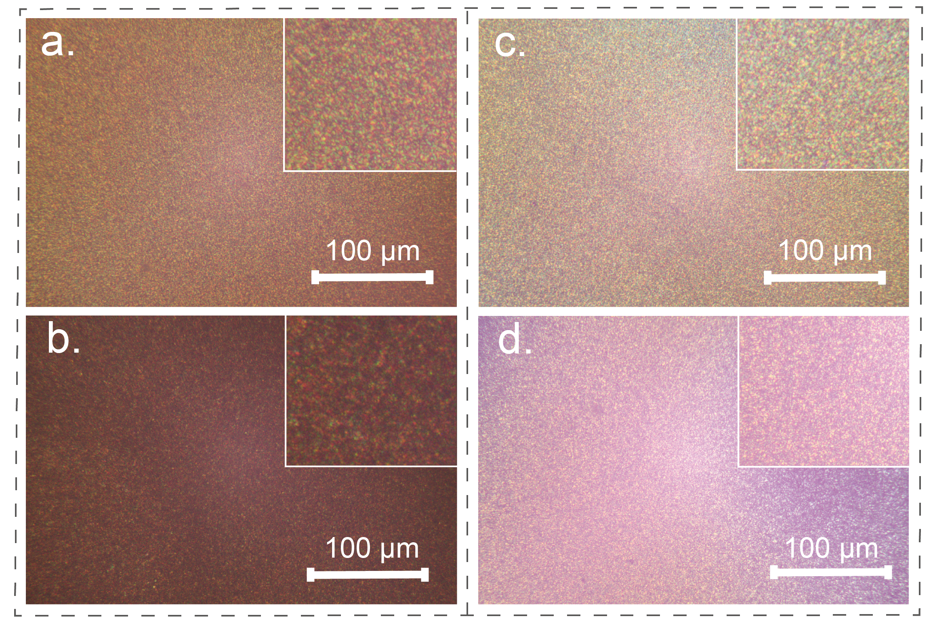
Supplementary Fig. 12. POM images of (S-M)_{0.1}-(FC1)_{0.9} a) BTA and b) ATA at 95 °C; (S-M)_{0.1}-(PC6)_{0.9} c) BTA and d) ATA at 65 °C (BTA: before thermal annealing; ATA: after thermal annealing).
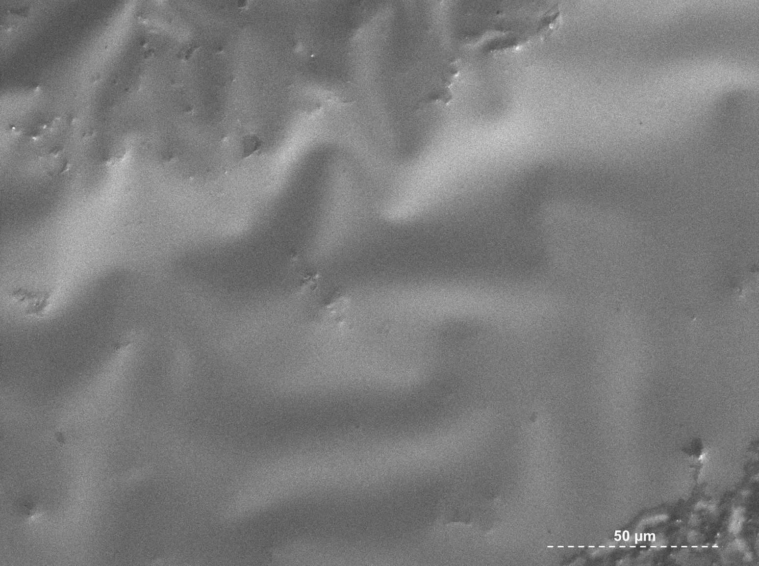
11. SEM images of FC1/FC6/PC6.
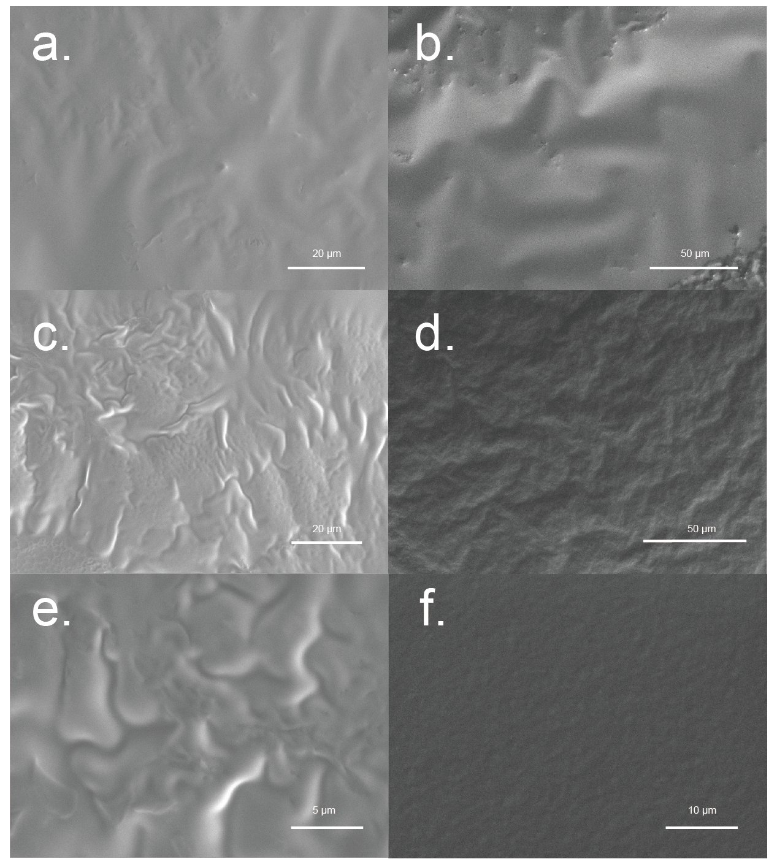
Supplementary Fig. 13. SEM images of FC1 a) BTA and b) ATA at 125 °C; FC6 c) BTA and d) ATA at 40 °C; PC6 e) BTA and f) ATA at 118 °C. (film, 10⁻¹ mg/mL; BTA: before thermal annealing; ATA: after thermal annealing).
12. SEM images of (S-M)-FC1/FC6/PC6.
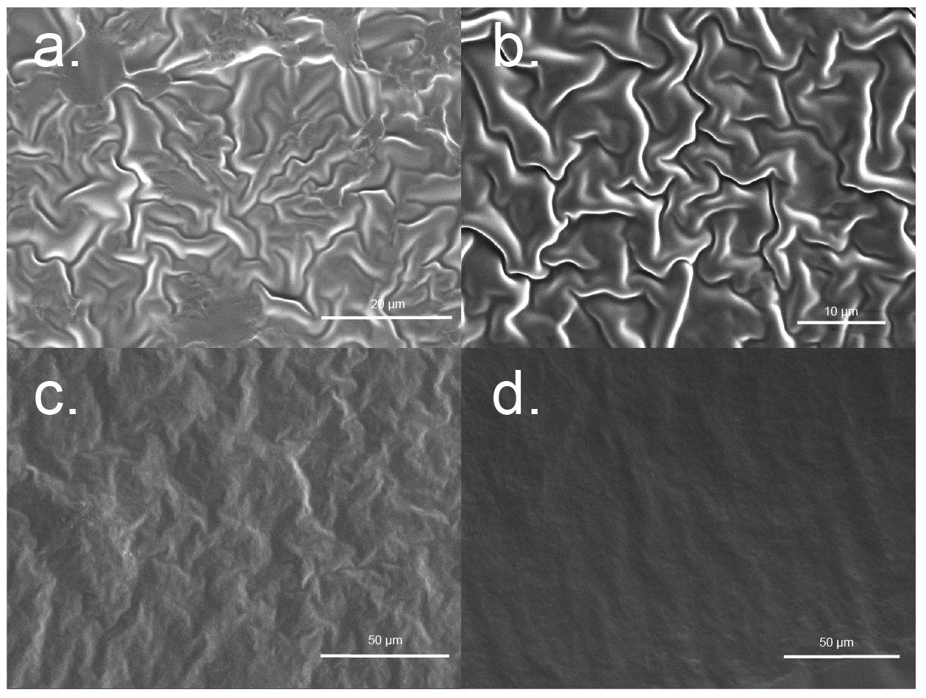
Supplementary Fig. 14. SEM images of a) (S-M)_{0.1}-(FC1)_{0.9} BTA; b) (S-M)_{0.1}-(PC6)_{0.9} BTA; (S-M)_{0.01}-(FC6)_{0.99} e) BTA and f) ATA at 40 °C. (film, 10⁻¹ mg/mL; BTA: before thermal annealing; ATA: after thermal annealing).
13. DFT calculations and MD simulations.
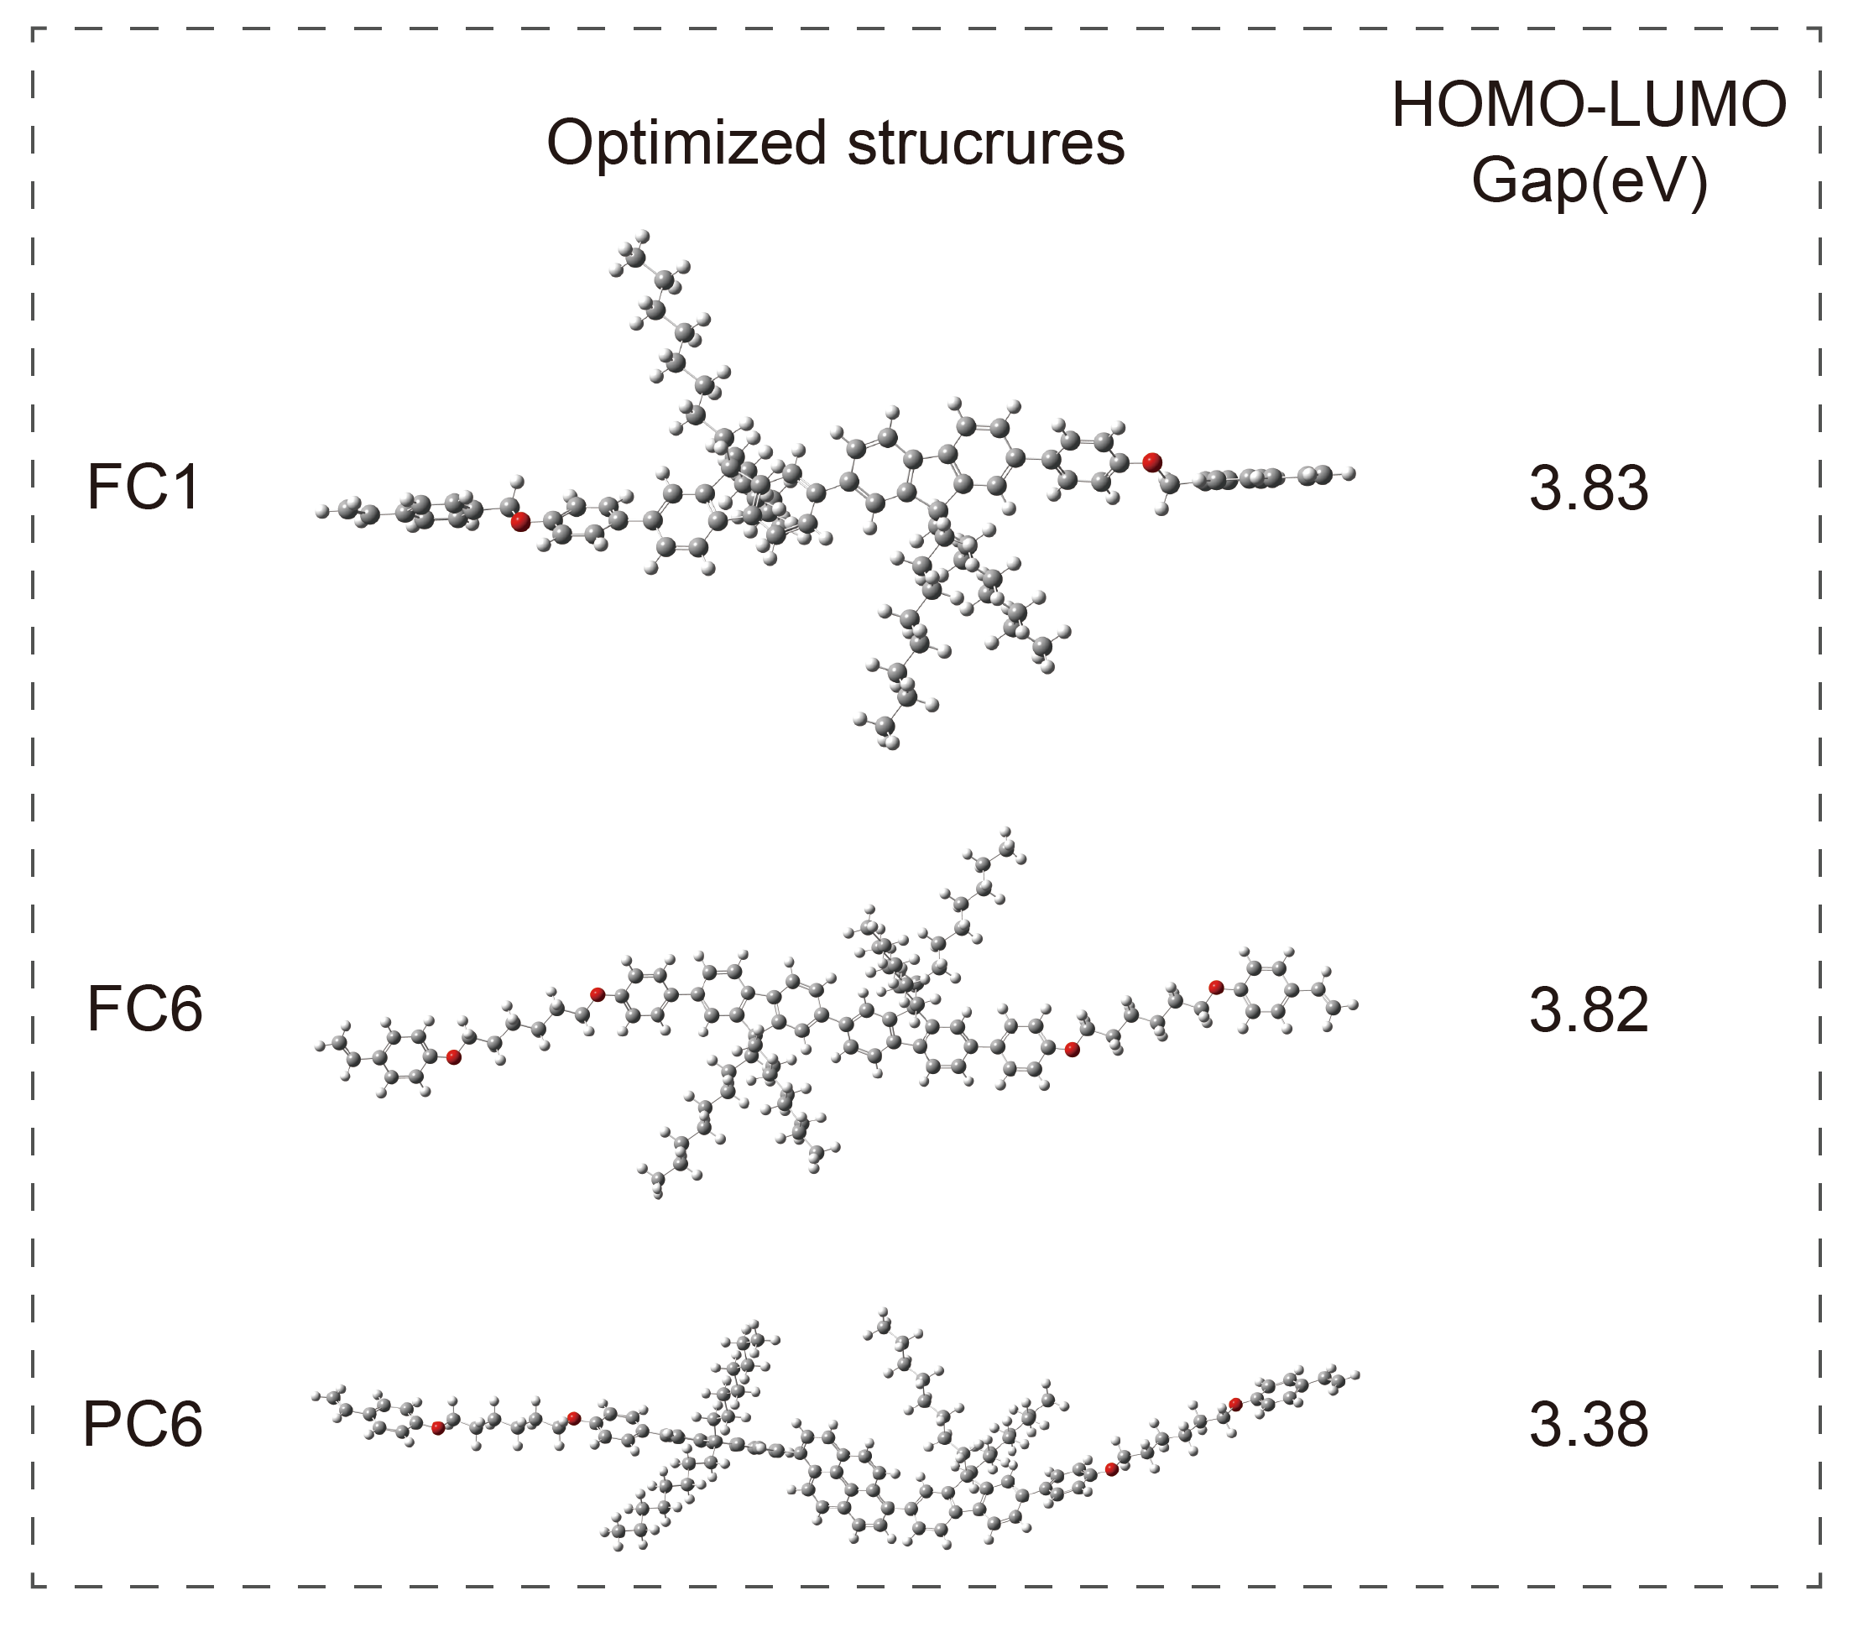
Supplementary Fig. 15. Optimized structures of FC1/FC6/PC6.

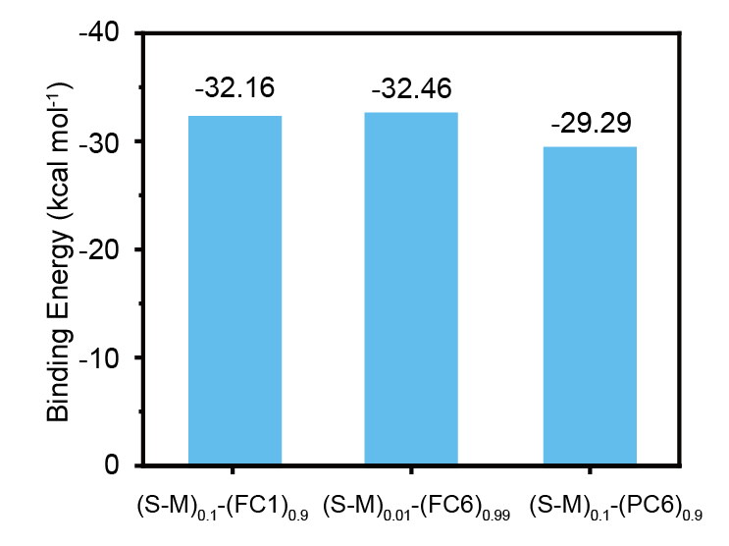
Supplementary Fig. 16. The simulation binging energy of chiral co-assemblies.
14. ¹H and ¹³C NMR Spectra of Compounds.
Supplementary Fig. 17. ¹H NMR spectrum of M1 (400 MHz, CDCl₃).
Supplementary Fig. 18. ¹³C NMR spectrum of M1 (400 MHz, CDCl₃).

Supplementary Fig. 19. ¹H NMR spectrum of M2 (400 MHz, CDCl₃).
Supplementary Fig. 20. ¹³C NMR spectrum of M2 (400 MHz, CDCl₃).

Supplementary Fig. 21. ¹H NMR spectrum of M3 (400 MHz, CDCl₃).
Supplementary Fig. 22. ¹³C NMR spectrum of M3 (400 MHz, CDCl₃).

Supplementary Fig. 23. ¹H NMR spectrum of M5 (400 MHz, CDCl₃).
Supplementary Fig. 24. ¹³C NMR spectrum of M5 (400 MHz, CDCl₃).

Supplementary Fig. 25. ¹H NMR spectrum of FC1 (400 MHz, CDCl₃).
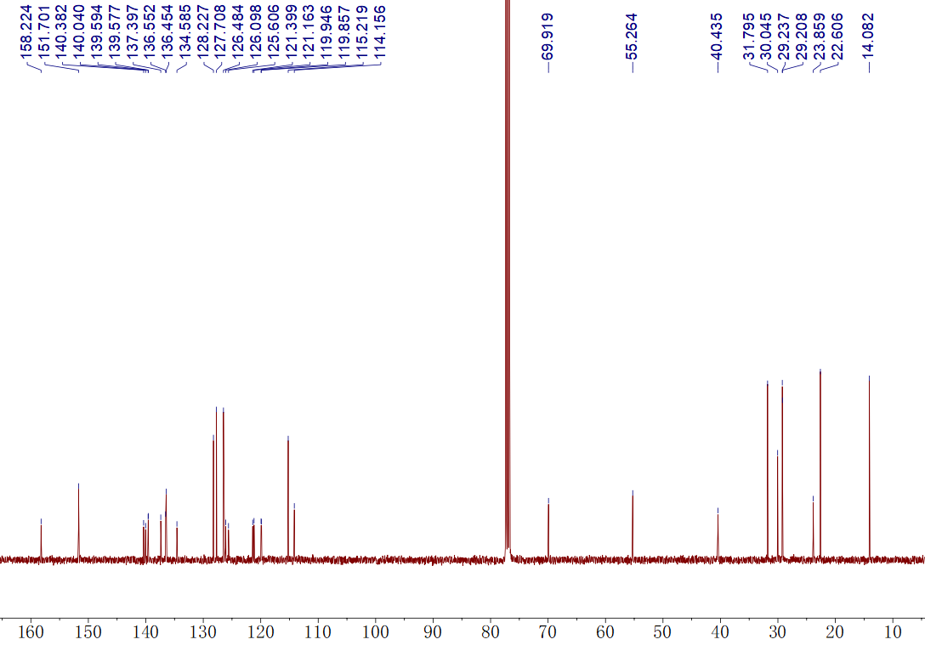
Supplementary Fig. 26. ¹³C NMR spectrum of FC1 (400 MHz, CDCl₃).

Supplementary Fig. 27. ¹H NMR spectrum of FC6 (400 MHz, CDCl₃).
Supplementary Fig. 28. ¹³C NMR spectrum of FC6 (400 MHz, CDCl₃).

Supplementary Fig. 29. ¹H NMR spectrum of PC6 (400 MHz, CDCl₃).
Supplementary Fig. 30. ¹³C NMR spectrum of PC6 (400 MHz, CDCl₃).
15. References
1. Abraham, M. J. et al. GROMACS: high performance molecular simulations through multi-level parallelism from laptops to supercomputers. SoftwareX 1-2, 19-25 (2015).
2. Wang, J., Wolf, R. M., Caldwell, J. W., Kollman, P. A. & Case, D. A. Development and testing of a general amber force field. J. Comput. Chem. 26, 114-114 (2004).
3. Frisch, M. et al. Gaussian 16, Revision B.01. (2016).
4. Lu, T. & Chen, F. Multiwfn: a multifunctional wavefunction analyzer. J. Comput. Chem. 33, 580-592 (2011).
5. Martínez, L., Andrade, R., Birgin, E. G. & Martínez, J. M. PACKMOL: a package for building initial configurations for molecular dynamics simulations. J. Comput. Chem. 30, 2157-2164 (2009).

