Additional file 1 for
Optimization of Expression and Thermostability of Terminal Deoxynucleotidyl Transferase through Iterative Mutagenesis and Computational Design
Nikiteev I.A.¹, Kuzmina J.E.¹, Rog I.S.¹, Bugrova A.D.², Gushchin I.Yu.², Naberezhnov D.S.¹, Shevelyova M.P.³, Maksimenko O.G.⁴, Zaynullin K.F.¹, Fedorov O.V.¹
¹Scientific Research Institute of System Biology and Medicine of Rospotrebnadzor, 117246, Russian Federation, Moscow, Nauchnyi proezd, 18. E-mail: nikiteev.ilya@mail.ru
²Research Center for Molecular Mechanisms of Aging and Age-Related Diseases, Moscow Institute of Physics and Technology, 141700 Dolgoprudny, Russia.
³Institute for Biological Instrumentation, Pushchino Scientific Center for Biological Research of the Russian Academy of Sciences, Pushchino, Moscow Region 142290, Russia
⁴Institute of Gene Biology, Russian Academy of Sciences, Moscow 119334, Russia; maksog@mail.ru

Additional file Legends
Table S1 List of primers used for saturation mutagenesis.
Table S2 Effects of substitutions predicted by neural networks on TdT.
Table S3 Kinetic parameters.
Fig. S1 Map of the pET-28a(+) plasmid containing the gene for SUMO-tagged TdT used for cloning and transformation.
Fig. S2 An example of the activity screening for rationally designed mutants in cell supernatants using a fluorescently labeled primer. The image shows the residual activity at 37°C following a 10-minute incubation at the indicated temperature.
Fig. S3 An example of the screening for the best mutants obtained via saturation mutagenesis at the ED230 site. The reaction was performed in cell supernatants using a fluorescently labeled primer. The image shows the residual activity at 37°C following a 10-minute incubation at the indicated temperature.
Fig. S4 Interactions of the R182 residue.
Fig. S5 Protein unfolding curves and peak temperature obtained using Tycho NT.6
Fig. S6 Temperature dependencies of the excess specific heat capacity and thermal denaturation parameters Tₘ and Δh of wild-type (WT) TdT protein, 275, A4, H11 and G2 mutant samples obtained by DSC measurements.
Fig. S7 Measurement of residual activity of the wild-type (WT) enzyme. Samples were pre-incubated at 45°C for the times indicated in the figure. Residual activity was then measured at 37°C. Each curve represents the average of three independent replicates.
Fig. S8 Measurement of residual activity of the mutant A4. Samples were pre-incubated at 45°C for the times indicated in the figure. Residual activity was then measured at 37°C. Each curve represents the average of four independent replicates.
Table S1 List of primers used for saturation mutagenesis.

Type of mutants | Primer sequences 5`--> 3` | Plasmid templates
KI149NNK | CGGCGGTTAAGNNKNNKTCACAGTACGCATGCCAGCGTCGCAC | pet28a+ Sumo-TdT (ED230AT+Q287K)
KI149NNK | GCGTACTGTGAMNNMNNCTTAACCGCCGGTGCTGGAACGTTTTGAG | pet28a+ Sumo-TdT (ED230AT+Q287K)
E177NNK | ACATCCTGGCGNNKAACGACGAATTGCGTGAAAATGAAGG | pet28a+ Sumo-TdT
E177NNK | TCGTCGTTMNNCGCCAGGATGTCGAGGGCATCGGTGAACAG | pet28a+ Sumo-TdT
RE182NNK | ACGACGAATTGNNKNNKAATGAAGGCTCGTGTCTGGCGTTCATGC | pet28a+ Sumo-TdT (ED230AT+Q287K+S223K)
RE182NNK | GAGCCTTCATTMNNMNNCAATTCGTCGTTTTCCGCCAGGATGTCG | pet28a+ Sumo-TdT (ED230AT+Q287K+S223K)
S223NNK | ACAAGGTGAAANNKATTATCGAAGGTATCATCGAGGACGG | pet28a+ Sumo-TdT
S223NNK | CCTTCGATAATMNNTTTCACCTTGTCACCCAAACACGGAA | pet28a+ Sumo-TdT
S223NNK + ED230AT | ACAAGGTGAAANNKATTATCGAAGGTATCATCGCGACGGG | pet28a+ Sumo-TdT (ED230AT+Q287K)
S223NNK + ED230AT | CCTTCGATAATMNNTTTCACCTTGTCACCCAAACACGGAA | pet28a+ Sumo-TdT (ED230AT+Q287K)
ED230NNK | AAGGTATCATCNNKNNKGGTGAAAGCTCTGAGGCCAAAGCGGTG | pet28a+ Sumo-TdT
ED230NNK | GAGCTTTCACCMNNMNNGATGATACCTTCGATAATGCTTTTCAC | pet28a+ Sumo-TdT
Q287NNK | TCCGCTTTACCNNKATGCAGAAAGCGGGCTTCCTGTATTA | pet28a+ Sumo-TdT or pet28a+ Sumo-TdT (ED230AT)
Q287NNK | GCTTTCTGCATMNNGGTAAAGCGGAGGGACTTGTCGCTTT | pet28a+ Sumo-TdT or pet28a+ Sumo-TdT (ED230AT)
A353NNK | CAAGTCCAGAANNKACCGAAGATGAAGAGCAGCAGCTGTTG | pet28a+ Sumo-TdT
A353NNK | TCATCTTCGGTMNNTTCTGGACTTGTGATCAGGAAATCAAC | pet28a+ Sumo-TdT
T354NNK | GTCCAGAAGCGNNKGAAGATGAAGAGCAGCAGCTGTTGCA | pet28a+ Sumo-TdT
T354NNK | TCATCTTCMNNCGCTTCTGGACTTGTGATCAGGAAATCAACG | pet28a+ Sumo-TdT
QQ371NNK | ATTTCTGGAAANNKNNKGGTCTGCTGCTGTATTGCGACATTCTGG | pet28a+ Sumo-TdT (ED230AT+Q287K)
QQ371NNK | AGCAGCAGACCMNNMNNTTTCCAGAAATCGGTCACTTTATGCAAC | pet28a+ Sumo-TdT (ED230AT+Q287K)
V395NNK | CAAGCCGCAAANNKGATGCGCTTGATCACTTCCAGAAATG | pet28a+ Sumo-TdT (ED230AT+Q287K)
V395NNK | TCAAGCGCATCMNNTTTGCGGCTTGGTTGTTTGAACTTCTC | pet28a+ Sumo-TdT (ED230AT+Q287K)
R414NNK | TGGATCACGGTNNKGTTCATTCTGAGAAATCGGGTCAGCAGG | pet28a+ Sumo-TdT (ED230AT+Q287K+S223K+RE182SR)
R414NNK | TCAGAATGAACMNNACCGTGATCCAGTTTAAGAATGAGAAAAC | pet28a+ Sumo-TdT (ED230AT+Q287K+S223K+RE182SR)
EK418NNK | TGTTCATTCTNNKNNKTCGGGTCAGCAGGAAGGTAAAGGTTGG | pet28a+ Sumo-TdT (ED230AT+Q287K+S223K+RE182SR)
EK418NNK | TGCTGACCCGAMNNMNNAGAATGAACACGACCGTGATCCAGTTT | pet28a+ Sumo-TdT (ED230AT+Q287K+S223K+RE182SR)
A510NNK | GGGAACGTAATNNKTGAcaaagcccgaaaggaagctg | pet28a+ Sumo-TdT (ED230AT+Q287K)
A510NNK | ggctttgTCAMNNATTACGTTCCCACGGTTCAATGTAATC | pet28a+ Sumo-TdT (ED230AT+Q287K)

Table S2 Effects of substitutions predicted by neural networks on TdT.
Substitution | Influence on activity | Comment
K287Q + L294K | Decreased
M339E | No Effect | Potentially promising, but weak fluorescence signal
F388D | No Effect | Potentially promising, but weak fluorescence signal
R414L | No Effect | Potentially promising, but weak fluorescence signal
W369F | No Effect
C404A | Decreased
F445Y | Lost
L260K | Lost
S312Y | No Effect
C302P | Decreased
D231N | Lost
S235P | Lost
R245Y | Decreased
K247Q | No Effect | Weak fluorescence signal
SK275EE | Increased
D356E | Decreased | Weak fluorescence signal
W369F | No Effect | Weak fluorescence signal
A476R | Decreased | Weak fluorescence signal
С216N | No Effect
M471E | Lost
M313E | No Effect | Weak fluorescence signal

Table S3 Kinetic parameters.

 | WT | A4 | G2
k_{cat} (s⁻¹) | 0,22±0,02 | 1,39±0,51 | 0,45

The rate constants for WT and the A4 mutant are reported as the mean ± standard deviation from three (n=3) and two (n=2) independent measurements, respectively. For the G2 mutant, a single measurement was performed (n=1), and thus the value is reported without error.

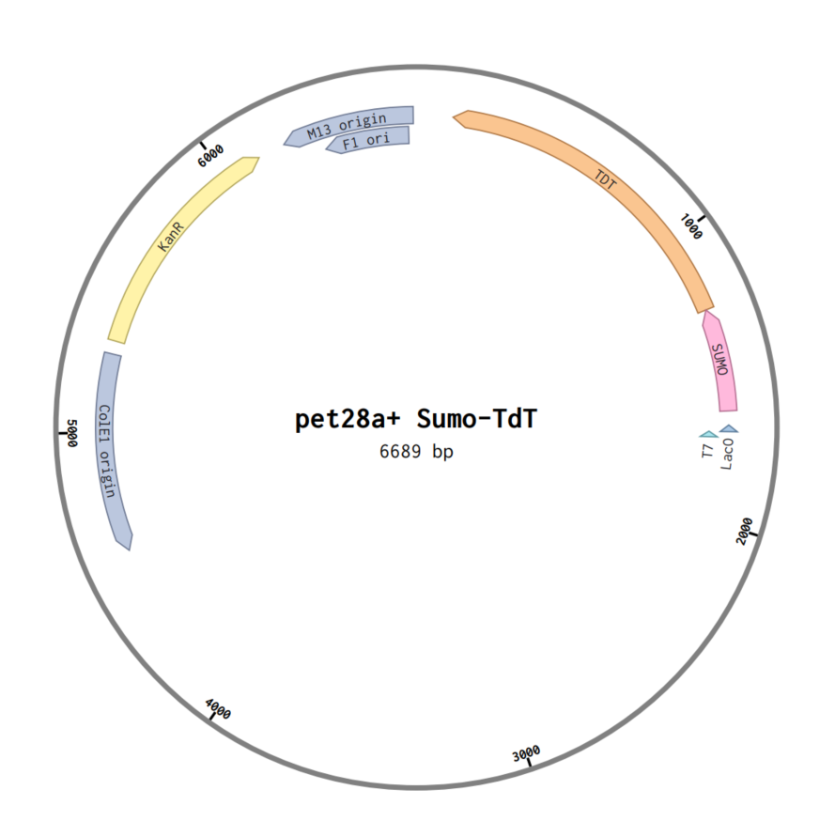

Fig. S1 Map of the pET-28a(+) plasmid containing the gene for SUMO-tagged TdT used for cloning and transformation.

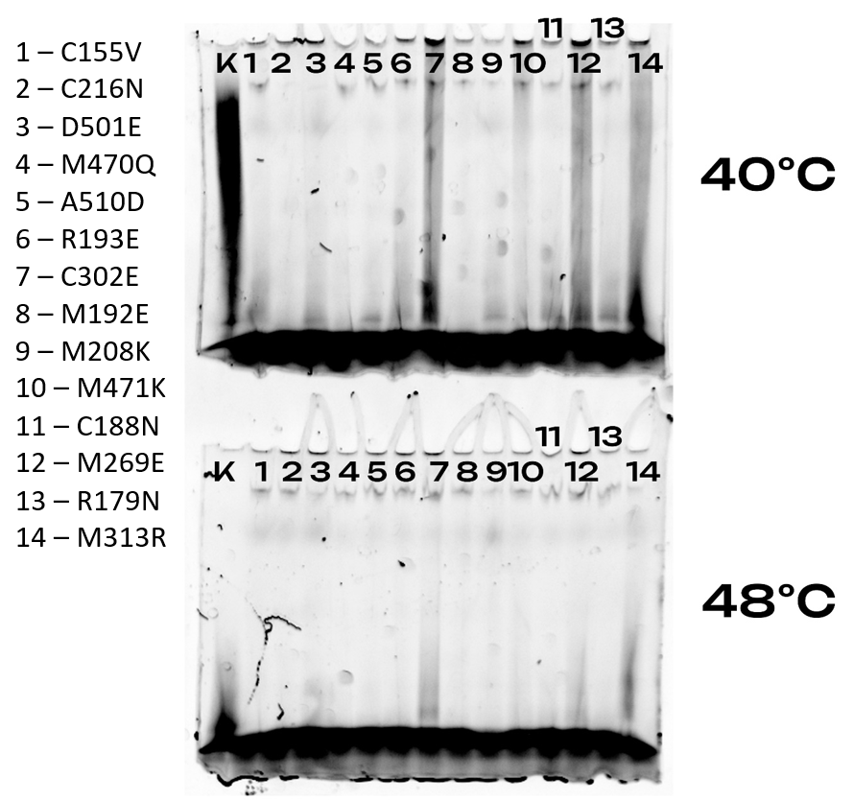
Fig. S2 An example of the activity screening for rationally designed mutants in cell supernatants using a fluorescently labeled primer. The image shows the residual activity at 37°C following a 10-minute incubation at the indicated temperature.

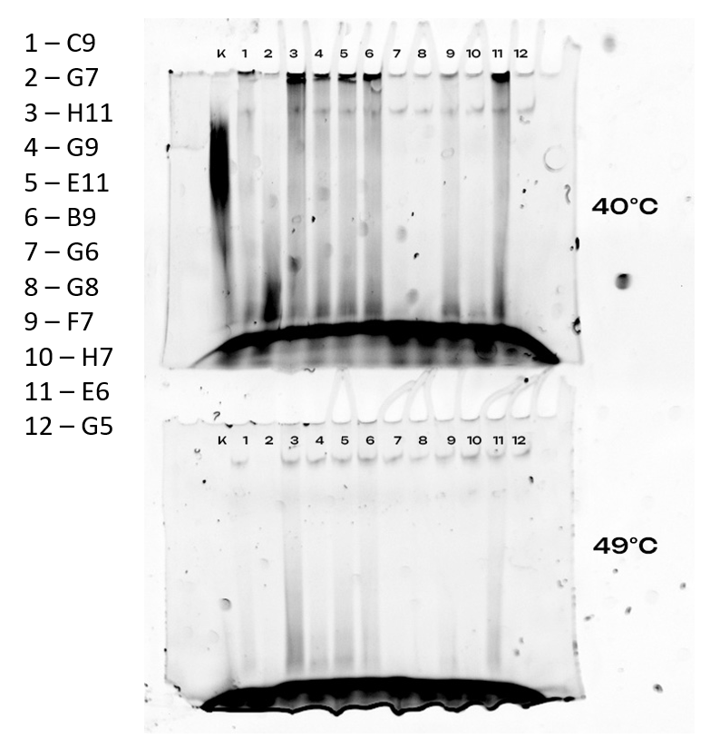

Fig. S3 An example of the screening for the best mutants obtained via saturation mutagenesis at the ED230 site. The reaction was performed in cell supernatants using a fluorescently labeled primer. The image shows the residual activity at 37°C following a 10-minute incubation at the indicated temperature.

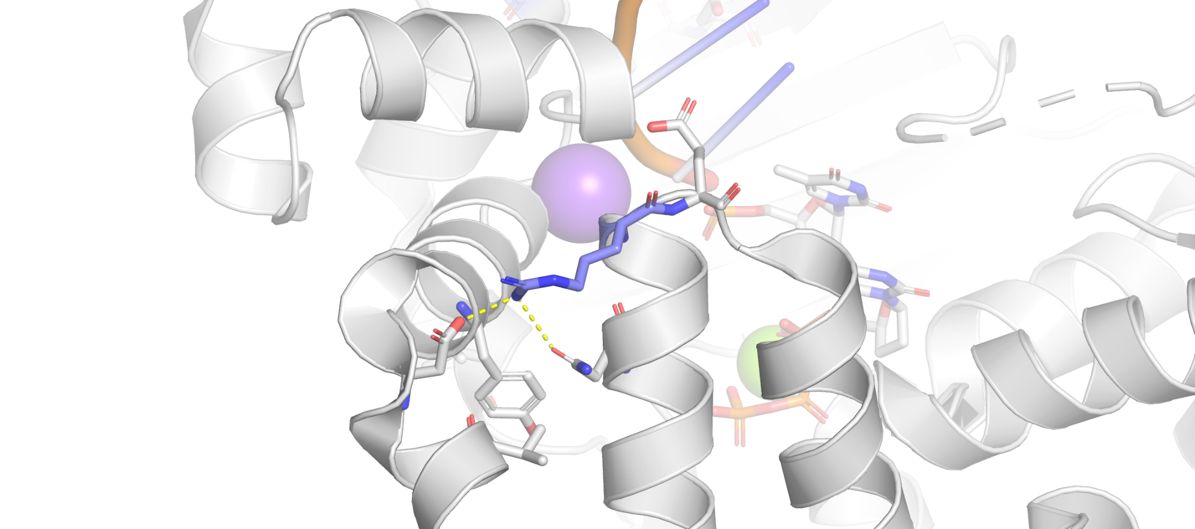
Fig. S4 Interactions of the R182 residue.

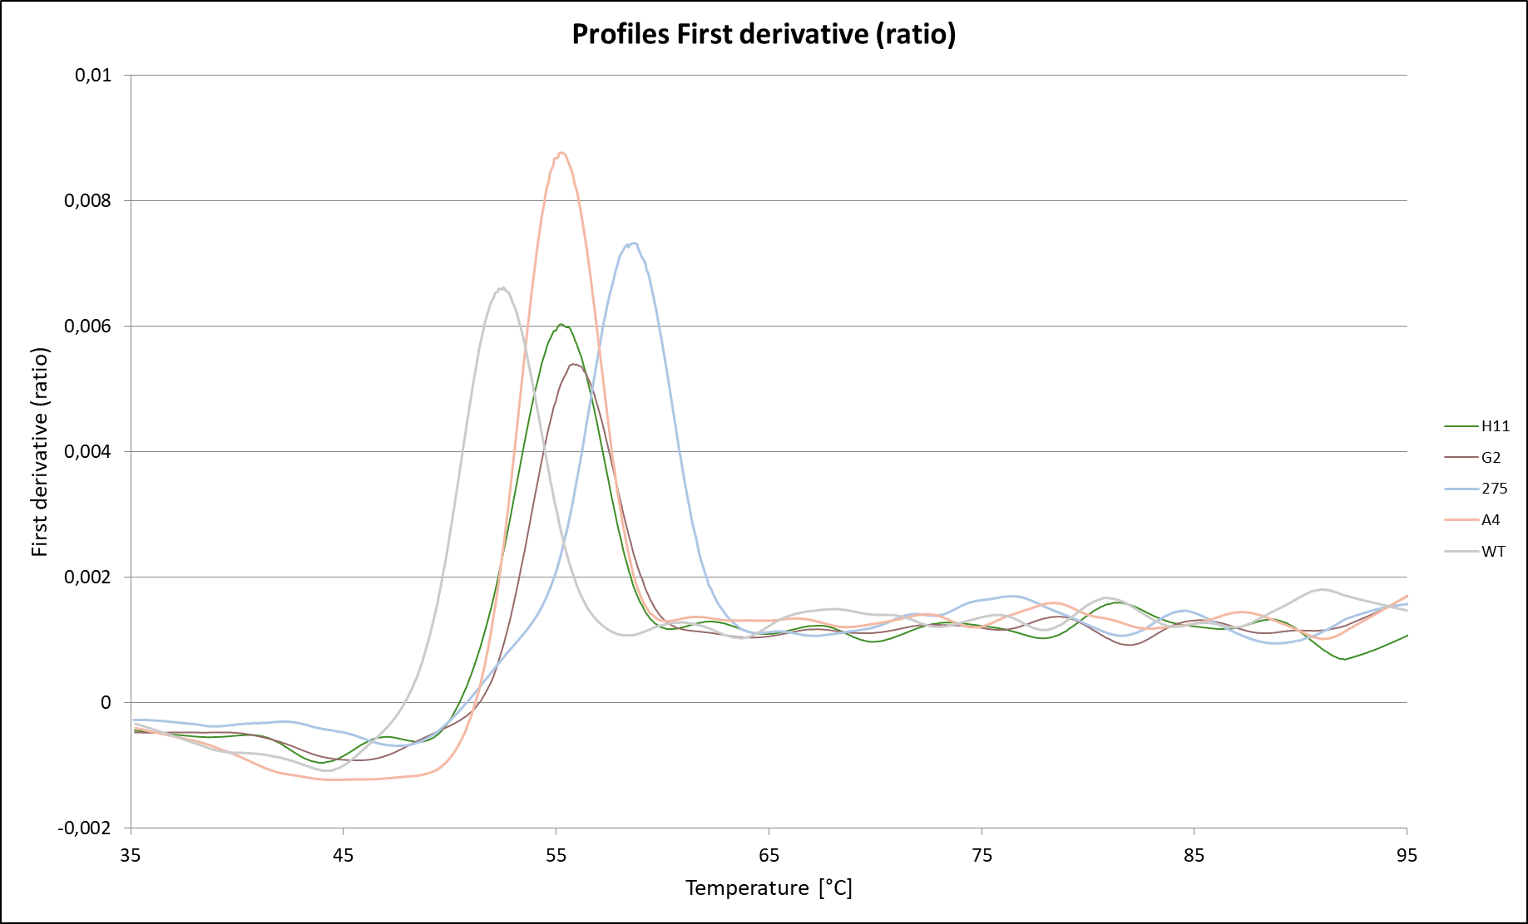
 | WT | H11 | G2 | A4 | 275
Unfolding temperature, °C | 52,5±0,1 | 55,3±0,1 | 55,7±1,4 | 55,4±0,3 | 58,8±0,2

Fig. S5 Protein unfolding curves and peak temperature obtained using Tycho NT.6

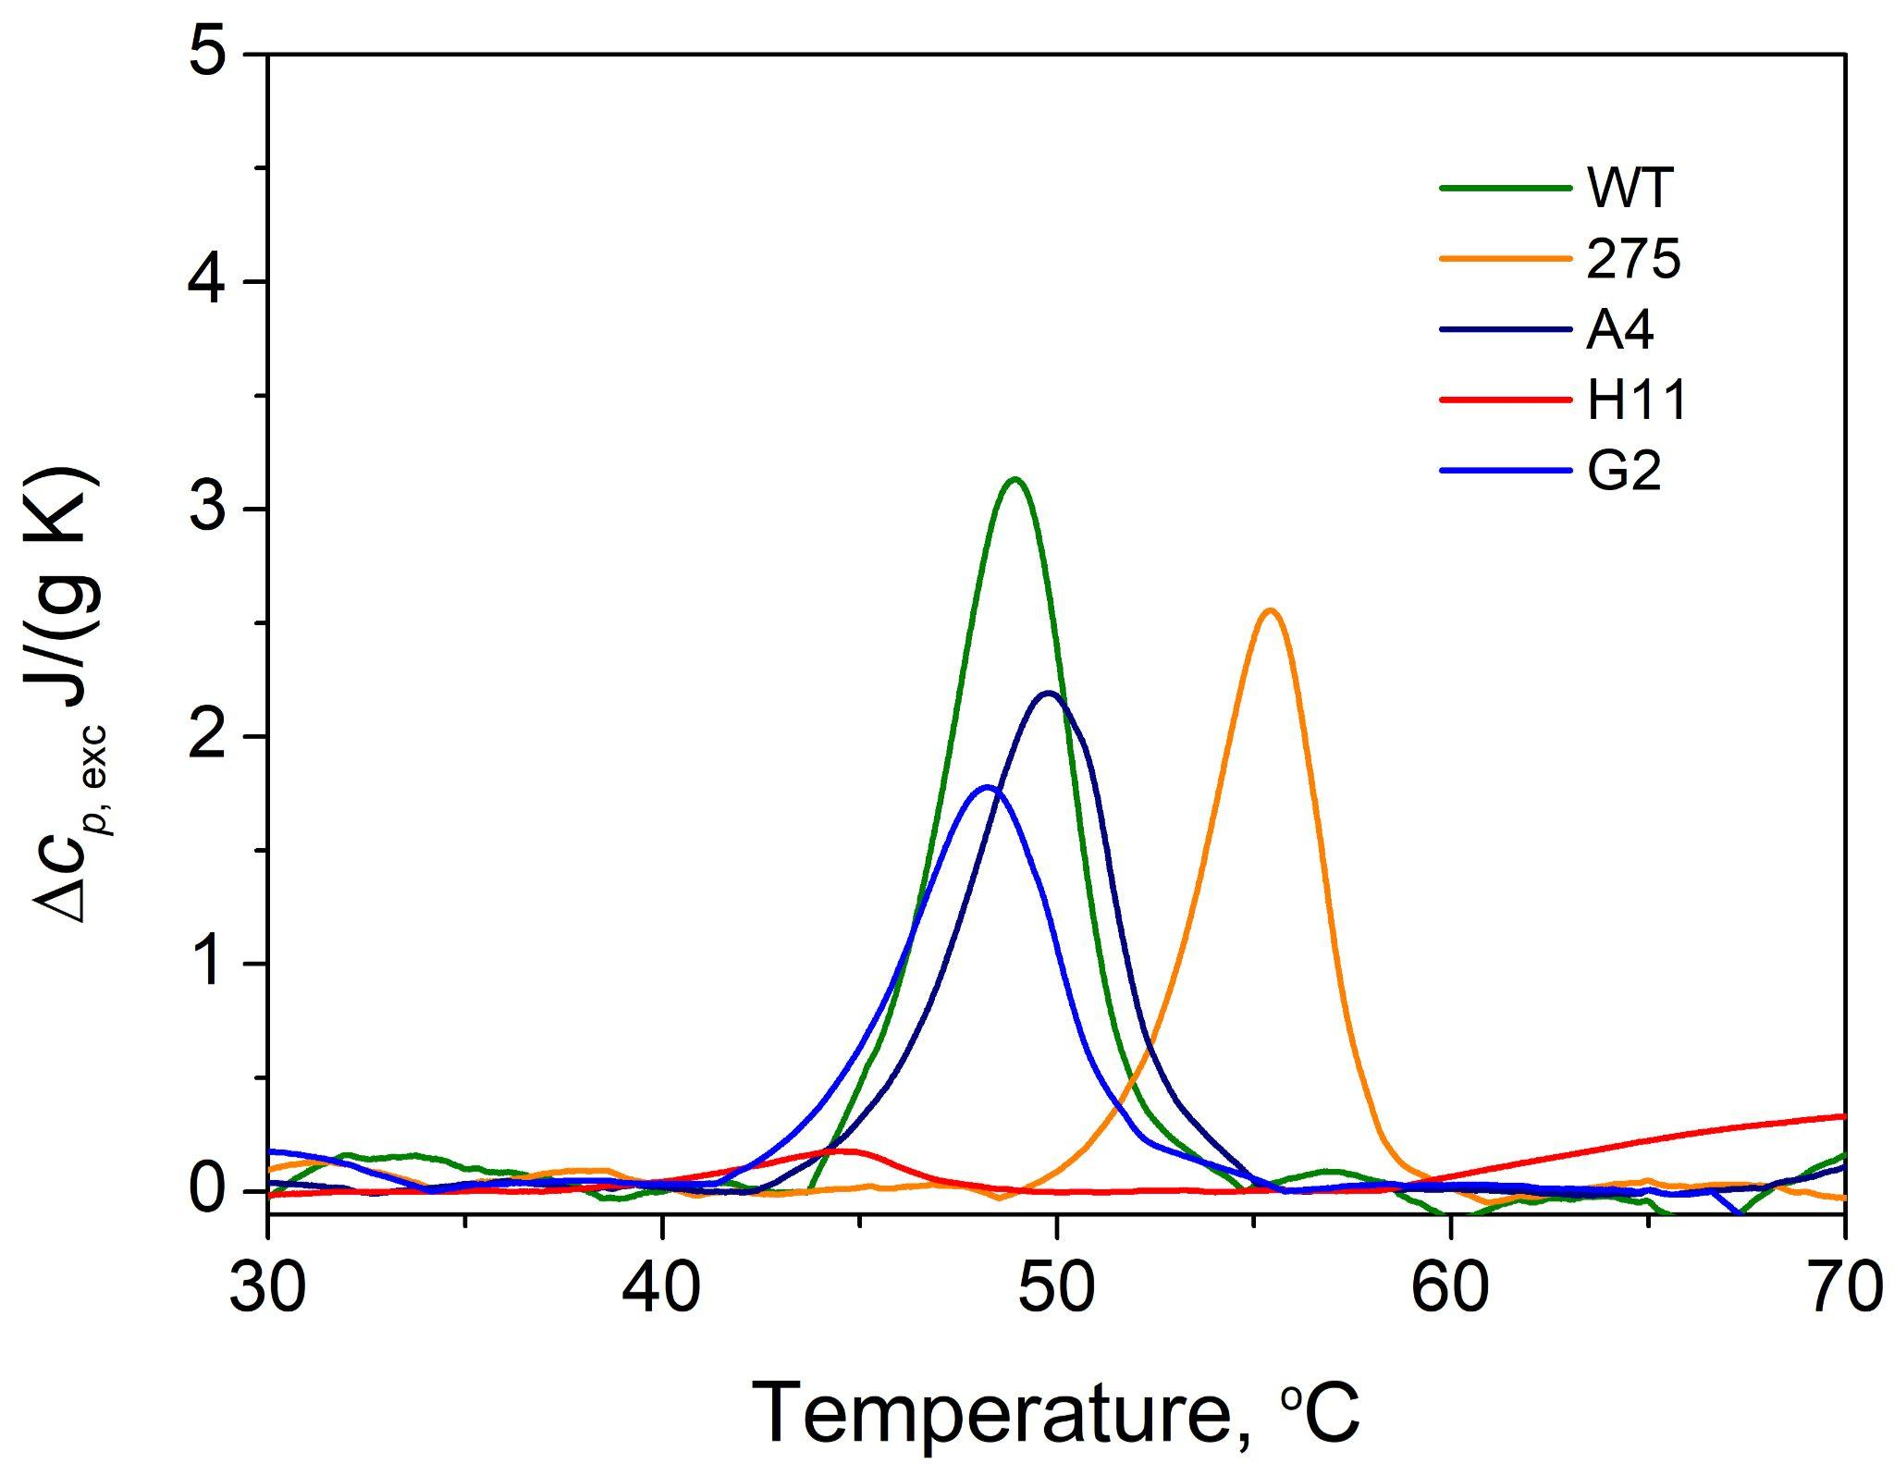
 | Tₘ, ºC | Δh, J/g
WT | 48.75±0.01 | 12.08±0.07
275 | 55.18±0.01 | 8.96±0.07
A4 | 49.56±0.01 | 9.63±0.07
H11 (ED230AT) | 44.08±0.01 | 0.67±0.01
G2 (ED230AT+Q287K) | 48.04±0.01 | 8.01±0.04
Fig. S6 Temperature dependencies of the excess specific heat capacity and thermal denaturation parameters Tₘ and Δh of wild-type (WT) TdT protein, 275, A4, H11 and G2 mutant samples obtained by DSC measurements.

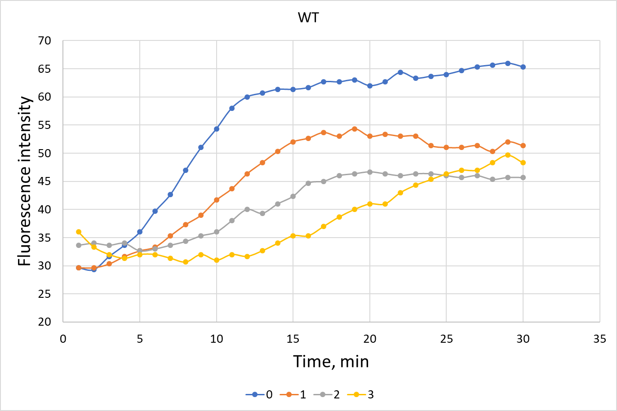
Fig. S7 Measurement of residual activity of the wild-type (WT) enzyme. Samples were pre-incubated at 45°C for the times indicated in the figure. Residual activity was then measured at 37°C. Each curve represents the average of three independent replicates.

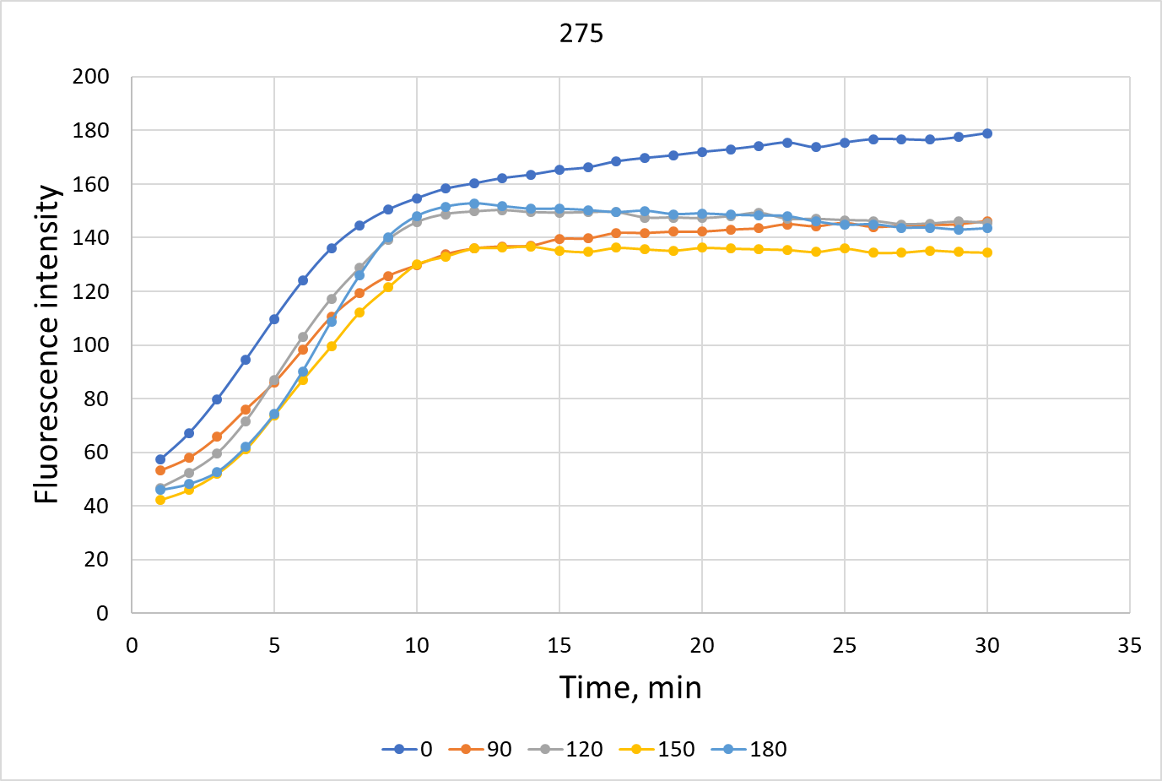
Fig. S8 Measurement of residual activity of the mutant A4. Samples were pre-incubated at 45°C for the times indicated in the figure. Residual activity was then measured at 37°C. Each curve represents the average of four independent replicates.

