Supplementary Information for
Significant Rural Contributions to Coastal Urban Flooding Through Flow Connectivity Donghui Xu^{1,*}, Gautam Bisht¹, Dongyu Feng¹, Zeli Tan¹, Dalei Hao¹, Darren Engwirda², James Benedict³, Ngoc Vinh Tran⁴, Mukesh Kumar⁵, Valeriy Ivanov⁴, Ruby Leung¹
1 Atmospheric, Climate, & Earth Sciences Division, Pacific Northwest National Laboratory, Richland, WA, USA
2 Commonwealth Scientific and Industrial Research Organisation, Hobart, Tasmania, Australia
3 Los Alamos National Laboratory, T-3 Fluid Dynamics and Solid Mechanics Group, Los Alamos, NM, USA
4 Department of Civil and Environmental Engineering, University of Michigan, Ann Arbor, MI, USA
5 Department of Civil, Construction, and Environmental Engineering, University of Alabama, Tuscaloosa, AL, USA

* Correspondence to: Donghui Xu, donghui.xu@pnnl.gov

This PDF file includes:
Text S1 to Text S3
Figure S1 to Figure S15

Text S1. Recent advances in high-resolution Earth system model developments
Current ESMs have struggled to capture extreme events accurately due to their typical coarse spatial resolution (i.e., 50 km ~ 200 km) ¹, simplified process representations, and parametric uncertainties ². Recent computational advancements and model developments have pushed the spatial resolution of ESMs to the kilometer scale, which is critical for simulating extreme events ³. For example, ref. ⁴ leveraged the new generation of heterogeneous Central Processing Unit (CPU) and Graphic Processing Unit (GPU) computer systems to implement the atmosphere model at 3.25 km, which improves some mesoscale features and the precipitation diurnal cycle. Similarly, a global ocean model has been run at 1 km resolution on heterogeneous supercomputers ⁵. Ref. ⁶ implemented barotropic tides in a global ocean model, which was later used to simulate storm surge at a sub-kilometer resolution ⁷. A land surface model has been configured at 1 km resolution ^{8, 9} to capture the land surface response to the heterogeneous surface characteristics derived from high-resolution satellite data ⁸. These developments hold promise for enhancing the simulation of extreme rainfall, storm surge, and heterogeneous runoff response, which are critical drivers for simulating various types of flooding dynamics. A multi-scale configuration of an ESM with the above features can capture the dynamic interactions among those drivers at appropriate spatial resolutions for simulating compound flooding in coastal environments.
Despite these computational and modeling advances in the atmosphere, ocean, and land components of ESMs, flooding dynamics remain poorly represented in existing ESMs’ river component because they rely on simplified 1-dimensional (1D) channel routing schemes that neglect the overland flow process in 2-dimensions, thus restricting broader flooding influences due to pluvial processes ¹⁰. In addition, the large-scale river routing model cannot be implemented at a high spatial resolution necessary for accurate flooding simulation (i.e., sub-100-meter scales ¹¹). The above limitations stem from the focus of large-scale river routing models on channel routing and the assumption that every computational unit contains a representative channel for water transport between cells ^{12, 13}. This assumption is invalid at a high resolution, as there are grid cells that may not intersect a river, or the width of a river may span multiple grid cells (e.g., the Amazon River can be up to 10 km wide). To overcome this limitation, high-resolution ESM configurations could instead incorporate the 2-dimensional Shallow Water Equations (2D SWE) based routing scheme to solve fluvial, pluvial, and coastal flooding processes. Moreover, such a 2D SWE model can capture the dynamic interactions of the flooding processes when coupled with other components during extreme events.
Numerical models that solve 2D SWE have been widely used to simulate flooding dynamics in small watersheds at very high spatial resolutions (i.e., 3m ~ 30m) ^{14, 15, 16, 17, 18}. Although these models effectively capture flood wave propagation across various terrains ¹⁹, including complex urban environments ^{14, 20, 21}, such high resolution significantly increases the computational cost, hindering their applications to larger domains and longer simulation periods in the context of ESMs. Recent developments of 2D SWE-based models support heterogeneous computing architectures, such as GPU ^{22, 23, 24}, increasing their computational efficiency by more than 30 times than using CPU ²⁵. In addition, using a variable resolution mesh can further reduce computational cost without sacrificing accuracy in refined key areas ²⁶. Leveraging these advancements, a new open-source numerical library for solving 2D SWE, named River Dynamic Core (RDycore) ²⁵, was developed recently and was integrated within the Energy Exascale Earth System Model (E3SM) ²⁷ to capture flooding dynamics at an actionable scale ($Ο(10)m$). RDycore has been rigorously validated and verified using idealized problems with analytical solutions, methods of manufactured solutions, and real-world flooding events ²⁵.

Text S2. Evaluation of multi-scale E3SM simulation and satellite-based flooding map with gauge observation
To further evaluate flood detection performance, we compared both our simulation and the satellite dataset against in-situ observations from 100 USGS gauges (out of 167 selected validation gauges) where flooding action stage information from the National Weather Service is available (see Methods). Among these, 81 gauges recorded water levels exceeding the flood action stage during the event, while the remaining 19 did not experience flooding (Figure S6). Our simulation correctly predicts flooding at 50 of the 81 flooded gauges and no flooding at 17 of the 19 non-flooded gauges, yielding an overall accuracy of 67%. However, the satellite dataset performs poorly, detecting flooding at only 2 of the flooded gauges. This limited performance is likely due to the inherent limitations of the optical satellite data used in the ref. ²⁸. Optical sensors cannot directly measure water height and are limited by cloud cover, canopy obstruction, low spatial resolution, and difficulties in detecting shallow or rapidly moving water ^{29, 30}. Moreover, when accounting for areas identified as permanent water bodies, the satellite dataset identifies an additional 29 gauges as water-covered, though these may not reflect actual flood conditions. Overall, while satellite observations provide useful surface water information ^{31, 32}, our evaluation suggests they currently lack the accuracy to reliably detect and quantify flood extent, particularly during extreme events under cloudy or complex terrain conditions. Remarkably, the multi-scale E3SM framework demonstrates robust performance in predicting flood extent.

Text S3. Sensitivity of streamflow simulation to antecedent soil moisture
Antecedent soil moisture is a critical factor for flooding generation ^{33, 34}. Compared to the baseline simulation, initializing the model with wetter antecedent soil moisture conditions results in a 32% increase in peak streamflow (Figure S4b). Streamflow remains elevated for a significantly longer duration following the peak than in the baseline simulation, indicating that the co-occurrence of a hurricane with wetter antecedent soil moisture can exacerbate flood risk. This amplification is primarily driven by increased subsurface runoff contributions under wetter soil conditions, while the surface runoff remains similar among different antecedent soil moisture conditions (Figure S7).
For drier soil moisture conditions, a previous study reported that reducing antecedent soil moisture by 20% led to a dramatic drop in peak simulated streamflow from 4000 [$m^{3}/s$] to 1000 [$m^{3}/s$] ³⁵. In contrast, our multi-scale E3SM framework shows a relatively modest sensitivity; even using the driest soil moisture condition that occurred in the past only reduced peak streamflow by 15% (Figure S4b). This reduced sensitivity is likely due to the use of a high-resolution satellite dataset for deriving land surface parameters in our land component simulation (i.e., 1km), highlighting the importance of accurate representations of soil types and urbanized areas. Urban areas characterize a substantial fraction of impervious surfaces, which reduces the sensitivity of runoff generation to soil moisture. In addition, despite relatively wet initial soil conditions before Hurricane Irene (Figure S3), there was still sufficient storage capacity for infiltration at the onset of the storm (Figure S4b and c), further limiting the influence of antecedent soil moisture on peak streamflow.

Text S4. Computational efficiency of RDycore
It remains computationally challenging to extend the multi-scale E3SM framework to continental and global scales due to the significant computational burdens in RDycore and other high-resolution components. For example, it took RDycore ~3 hours on 32 GPU cores (i.e., NVIDIA A100 GPUs) to complete the 1-week simulation for the Delaware River Basin, which spans an area of 32,260 km², representing 0.42% of COUNS. Although RDycore exhibits good strong scaling performance for big problems with up to 471 million cells ²⁵, it requires a lot of computational resources and storage for continental and global simulations at 30 m resolution. However, extreme flooding events usually last a few days and do not occur everywhere. We could implement adaptive mesh refinement to refine the affected region with other regions at a manageable resolution (e.g., 1 km) in a large-scale simulation ³⁶ to significantly reduce the computational burden.

Figure S1. Schematic for multi-scale Earth System Modeling framework using recent development of Energy Exascale Earth System Model (E3SM).

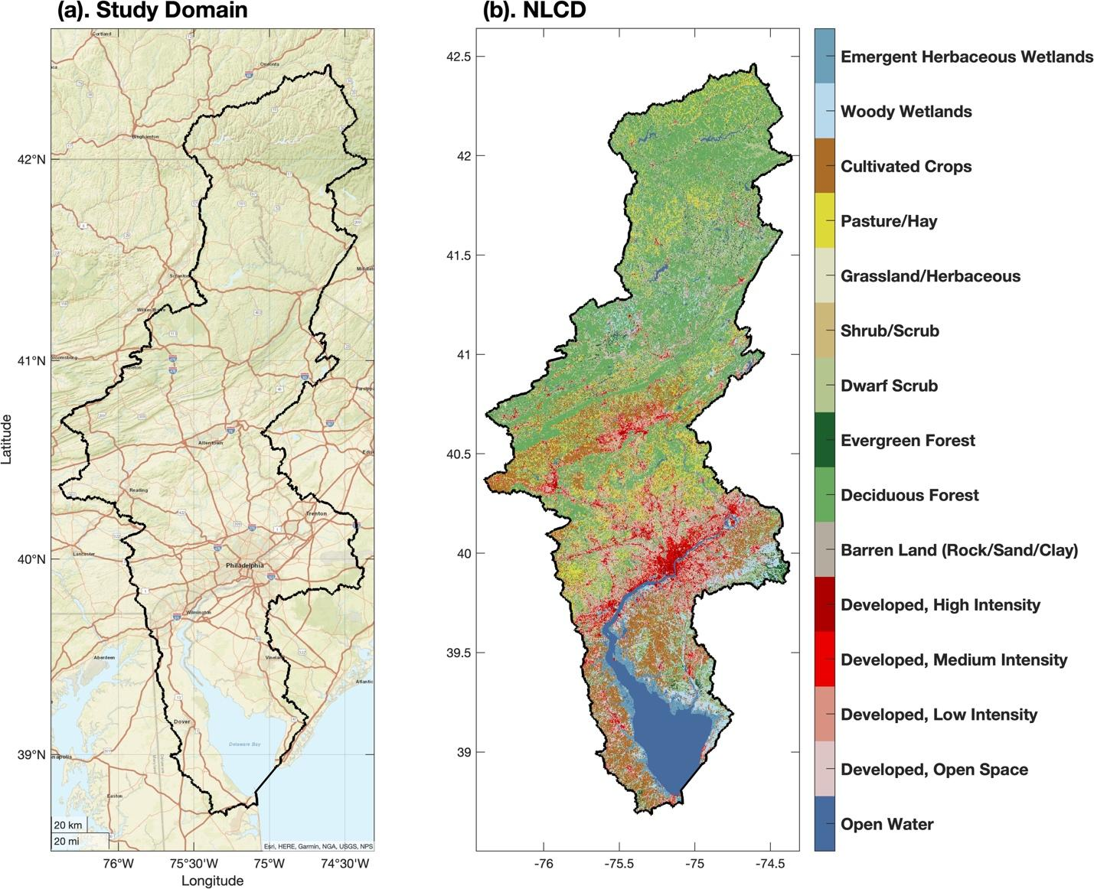
Figure S2. National Land Cover Dataset for the study domain.

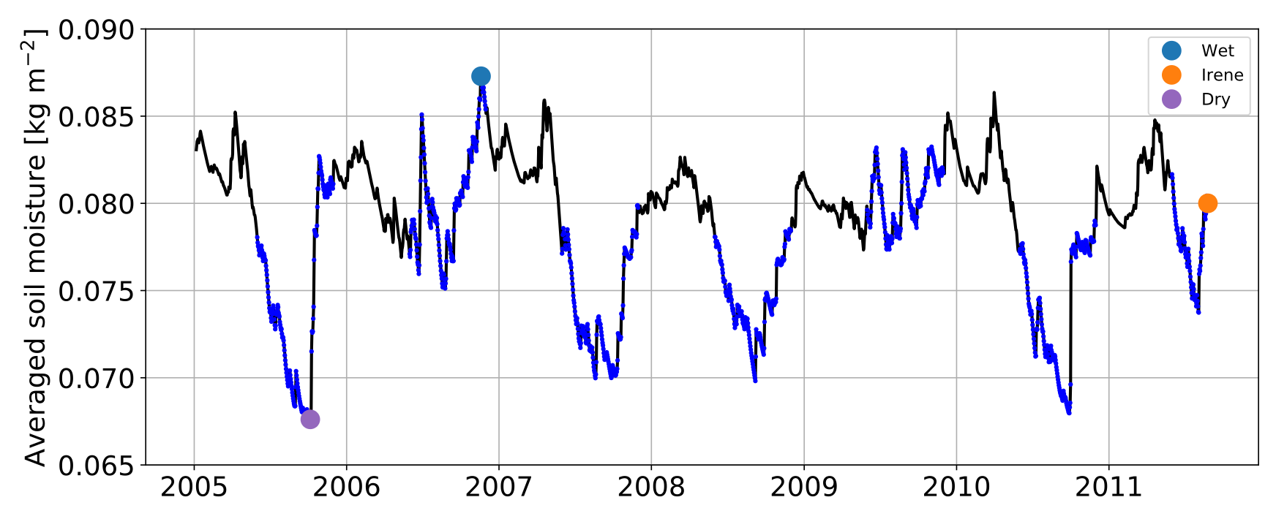
Figure S3. Antecedent soil moisture used as initial condition for ELM simulations.

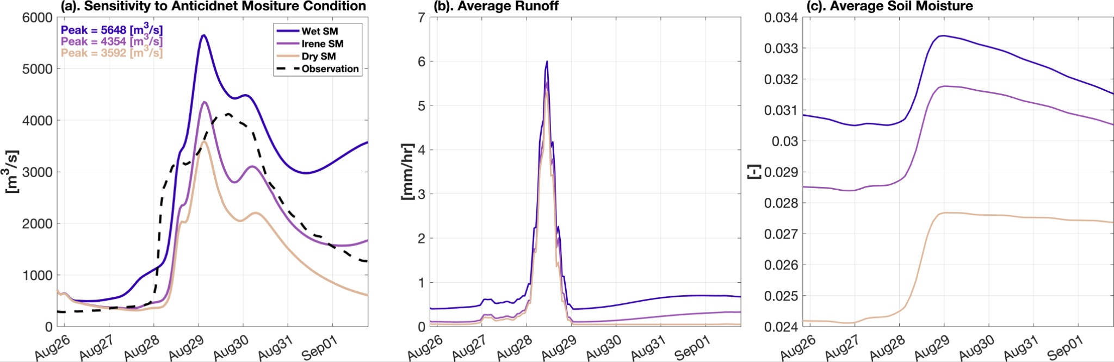
Figure S4. Evaluation of the impacts of the Manning coefficient and antecedent soil moisture on the streamflow variability at the outlet of the Delaware River Basin. (a). Simulated streamflow with different antecedent soil moisture conditions. The Wet SM indicates simulation with an initial condition of maximum soil moisture that occurred in the historical period, while the Dry SM indicates simulation with an initial condition of minimum soil moisture that occurred in the historical period (see Methods). (b). Hourly basin averaged runoff with different antecedent soil moisture conditions. (c). Hourly basin averaged soil moisture from all the soil layers (i.e., total depth = 3.8m) with different antecedent soil moisture conditions.

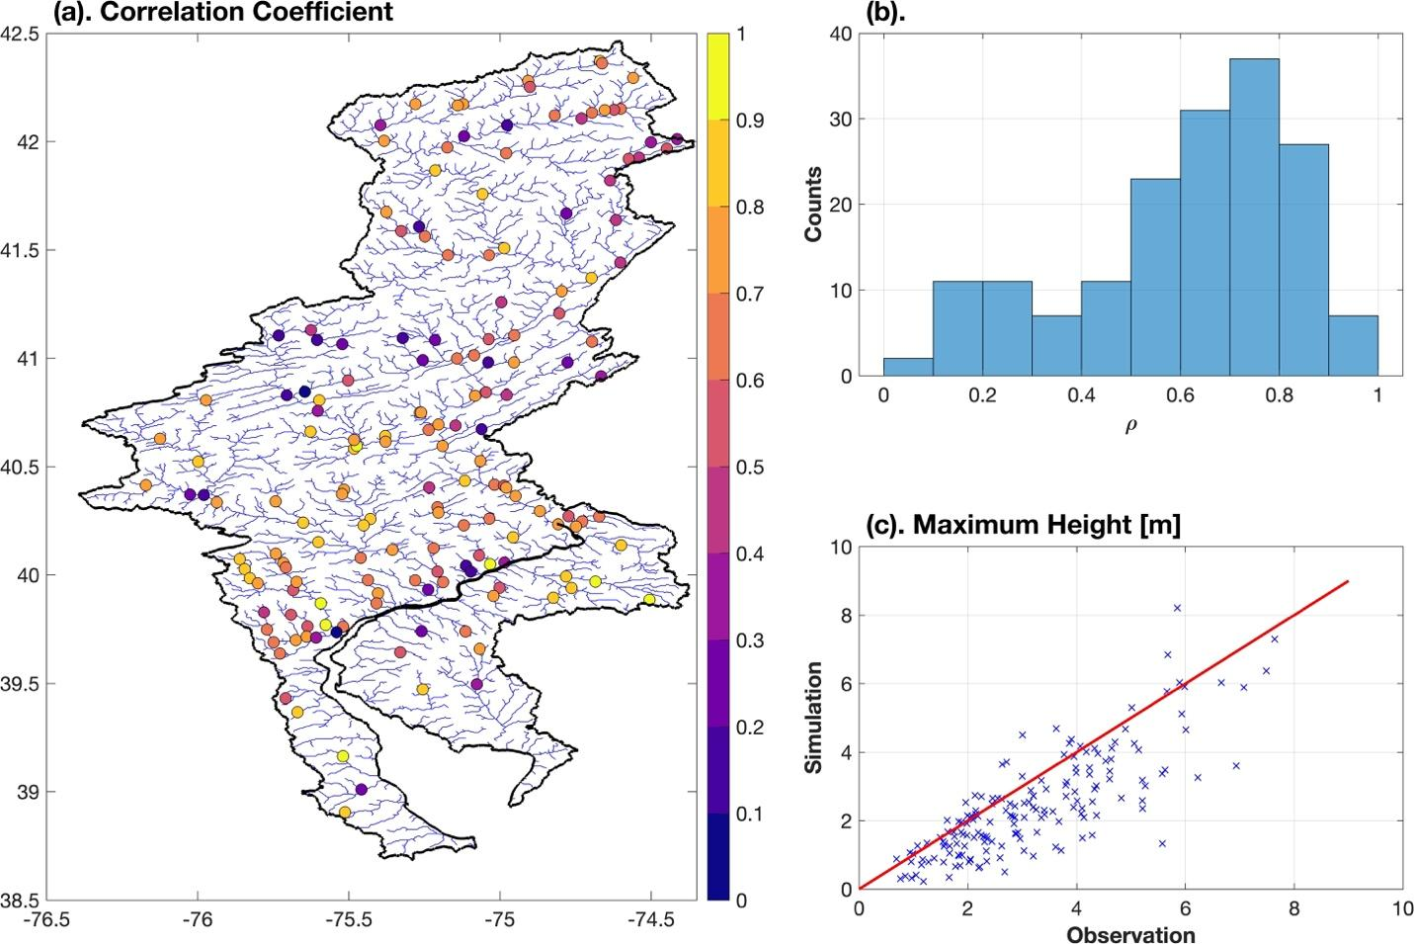
Figure S5. Validation of simulated water height at 164 USGS gauges. (a). Correlation coefficient between the simulated water height and the observation. (b). Distribution of the correlation coefficient. (c). Comparison of maximum water height between simulation and observation.

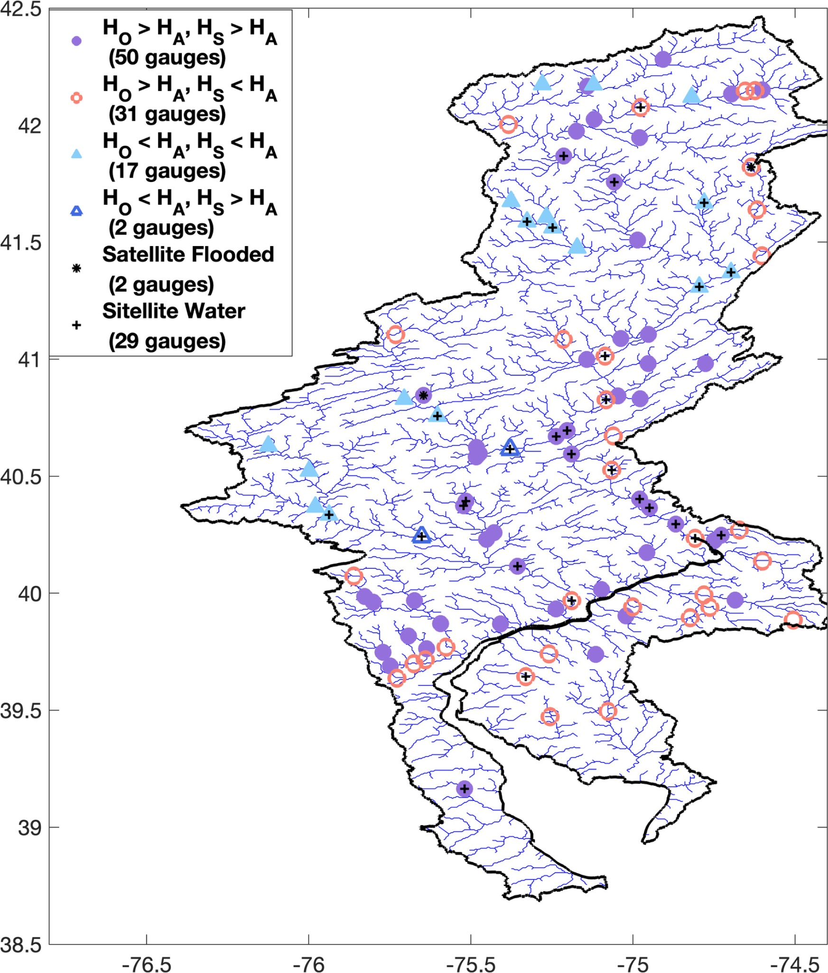
Figure S6. Actionable-scale ESM shows significantly better performance than satellite dataset in detecting flooding at gauge level. $H_{O}$, $H_{S}$, and $H_{A}$ represent observed water height, simulated water height, and flooding action stage, respectively. Satellite Flooded and Water represent the gauges detected as flooded and permanently covered by water from (Tellman et al., 2021). A buffer was used to allocate the gauge to the satellite-based flooding map, such as if any of the cell the gauge is within or its neighboring cells was labelled as flooded, the gauge was assigned as flooded. The blue lines are the streamlines from HydroRIVERS. The flooding action stage of 100 USGS gauges were obtained from the National Weather Prediction Service.

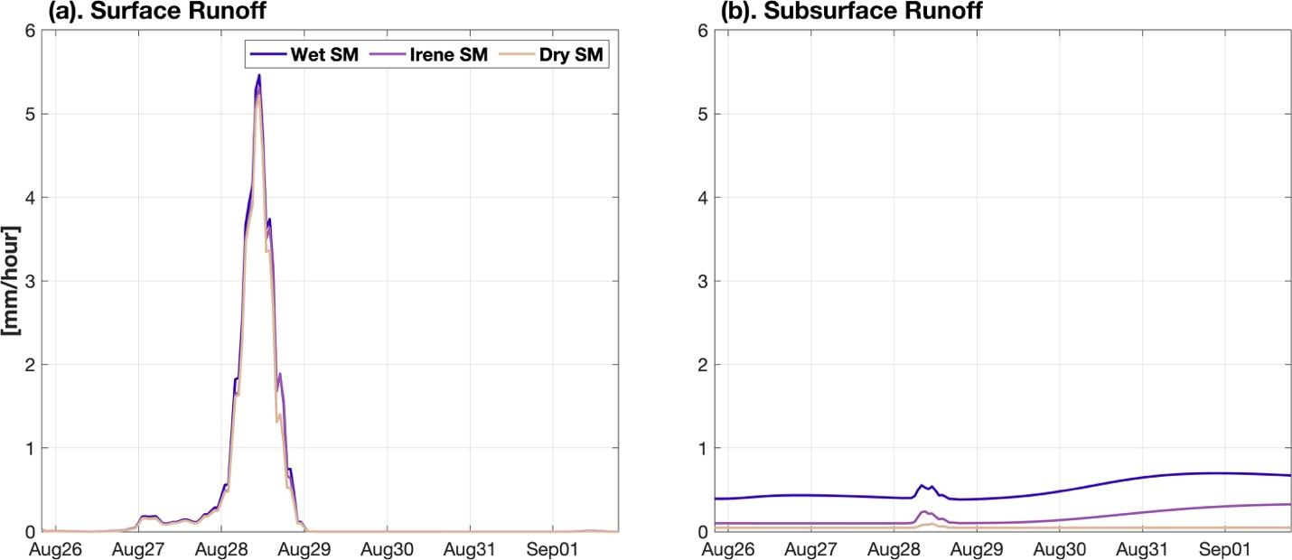
Figure S7. Basin averaged (a). surface and (b). subsurface runoff.

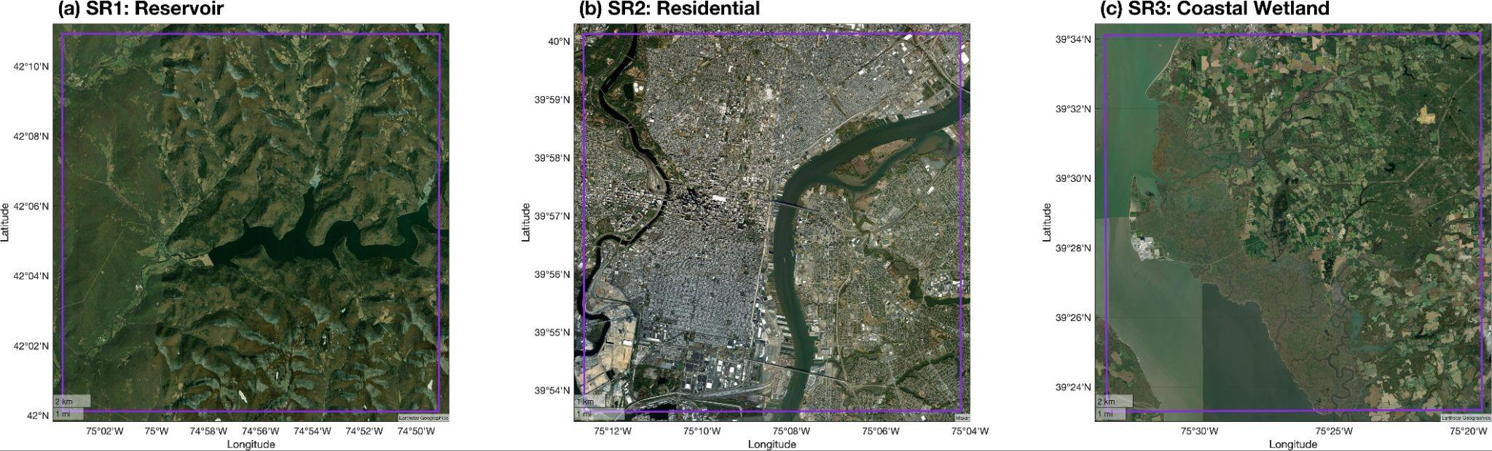
Figure S8. Satellite images for the three zoomed in subregions (SRs) in Figure 3: (a). Upstream reservoir, (b) Densely residential areas, and (c). Coastal wetland

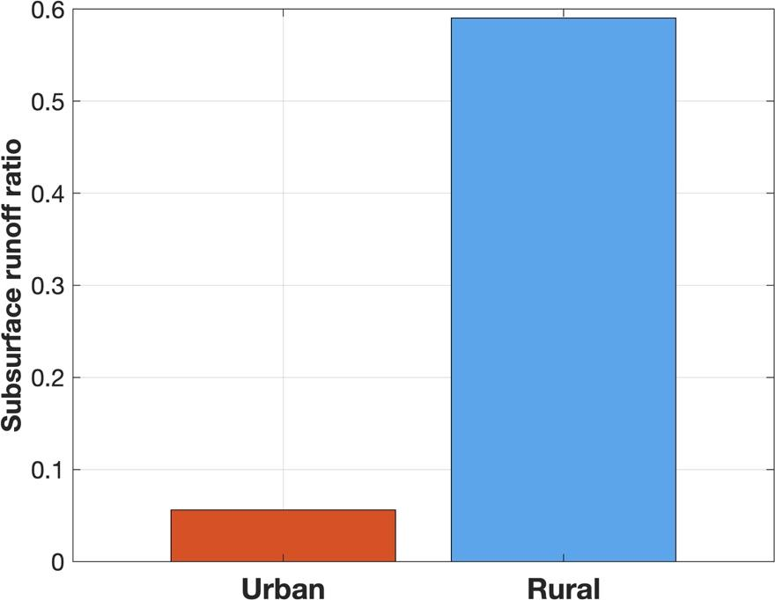
Figure S9. Subsurface runoff ratio to the total runoff in urban and rural areas.

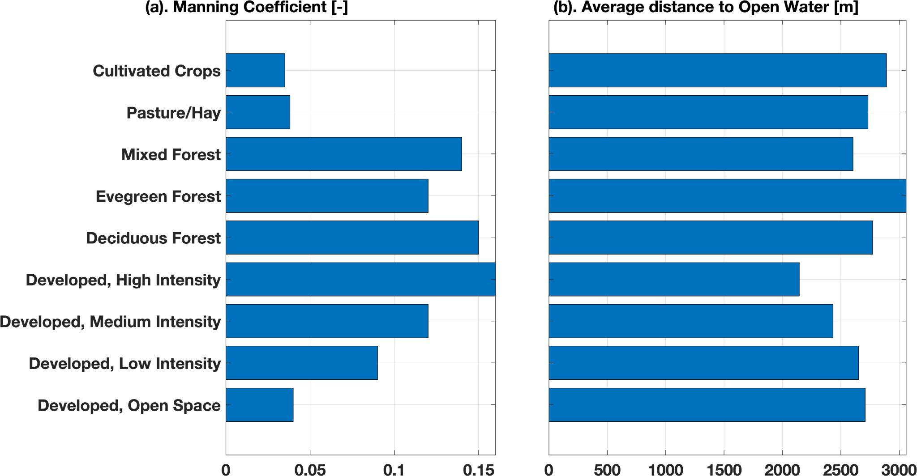
Figure S10. (a). NLCD based Manning coefficient and (b). Average distance to major rivers from HydroRIVERS (e.g., ORD_FLOW <= 6) with for each land cover type.

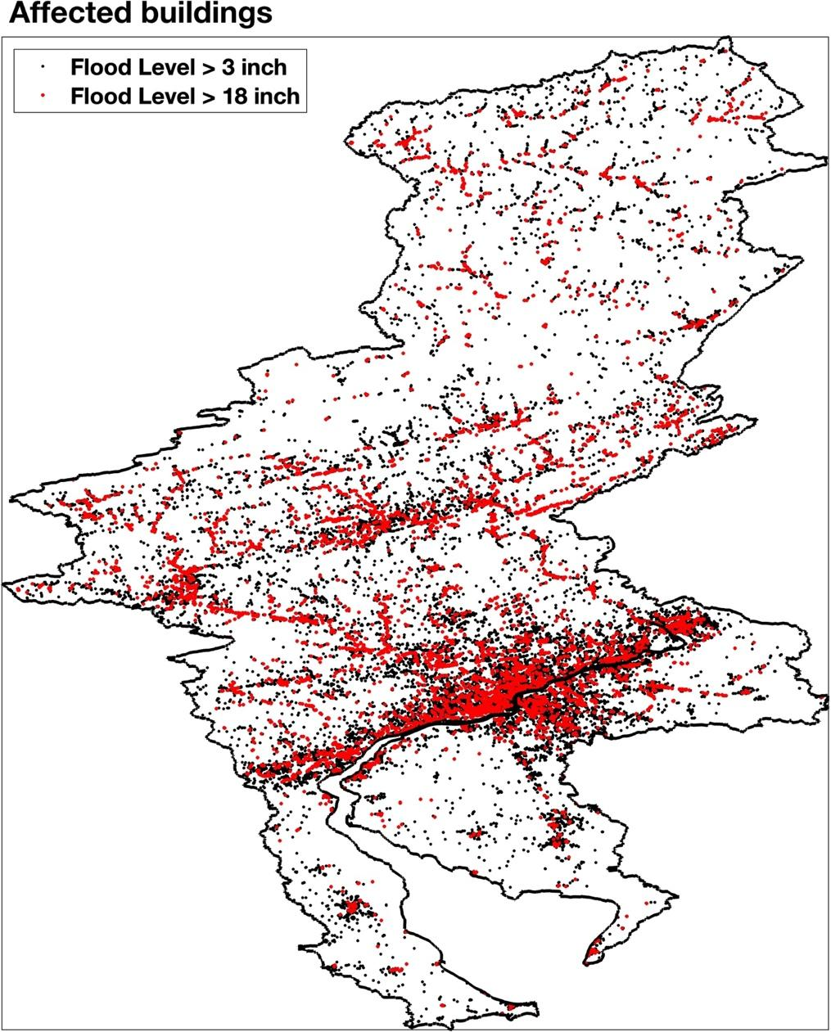
Figure S11. Buildings affected by flooding at different water levels.
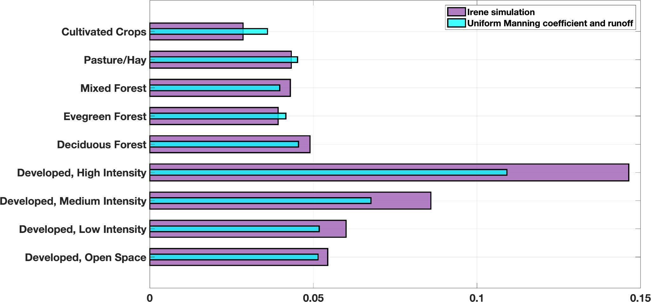
Figure S12. Comparison of averaged maximum inundation depth between baseline simulation and simulation with spatially uniform Manning coefficient and runoff that averaged at basin scale.

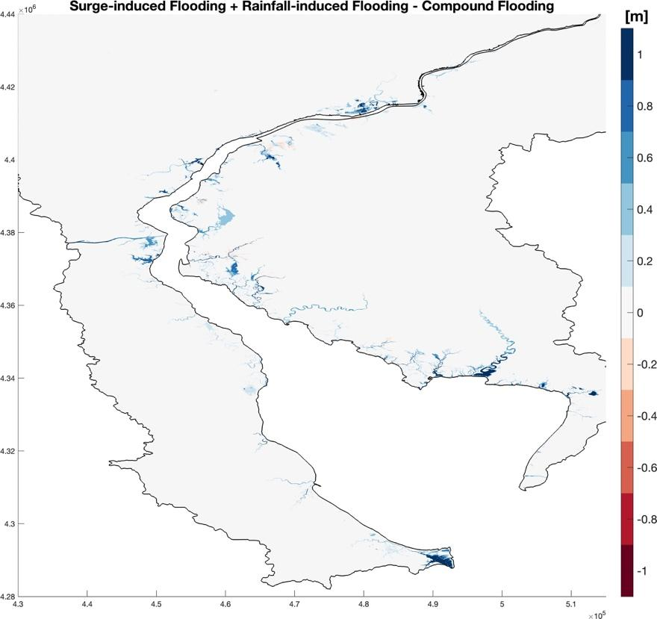
Figure S13. Nonlinearity of surge-induced flooding and rainfall-induced flooding.

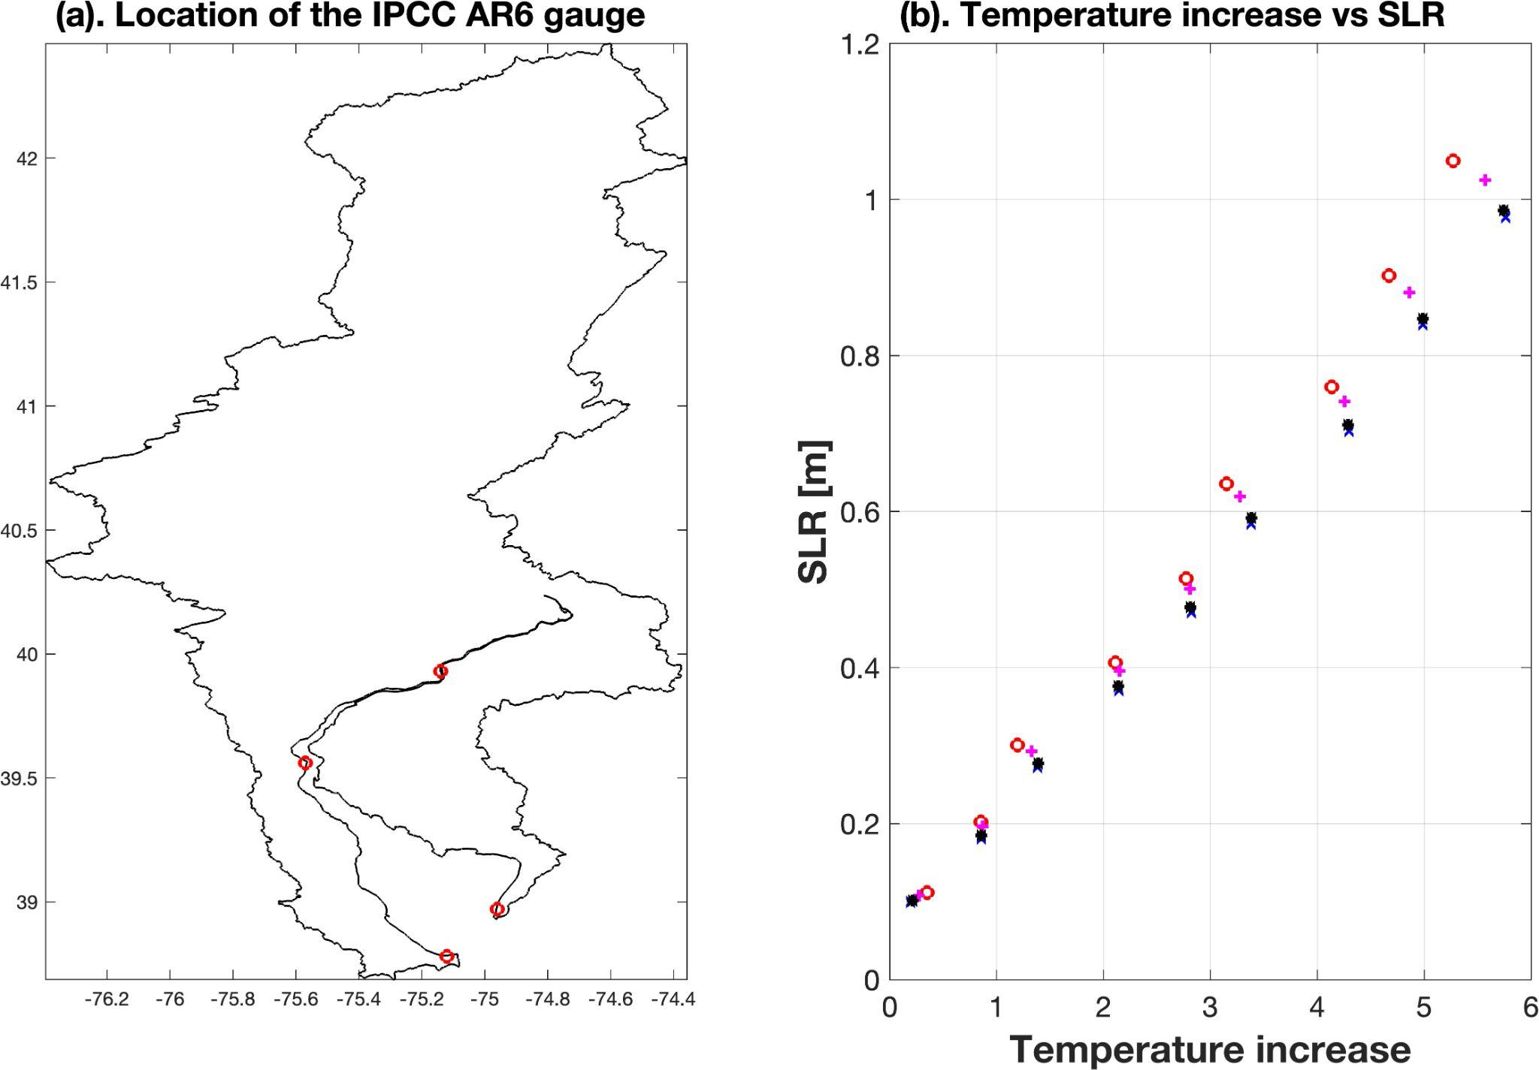
Figure S14. (a). Location of the IPCC AR6 gauges for the sea-level rise (SLR) projection. (b). Projection of SLR for the four gauges within the study.

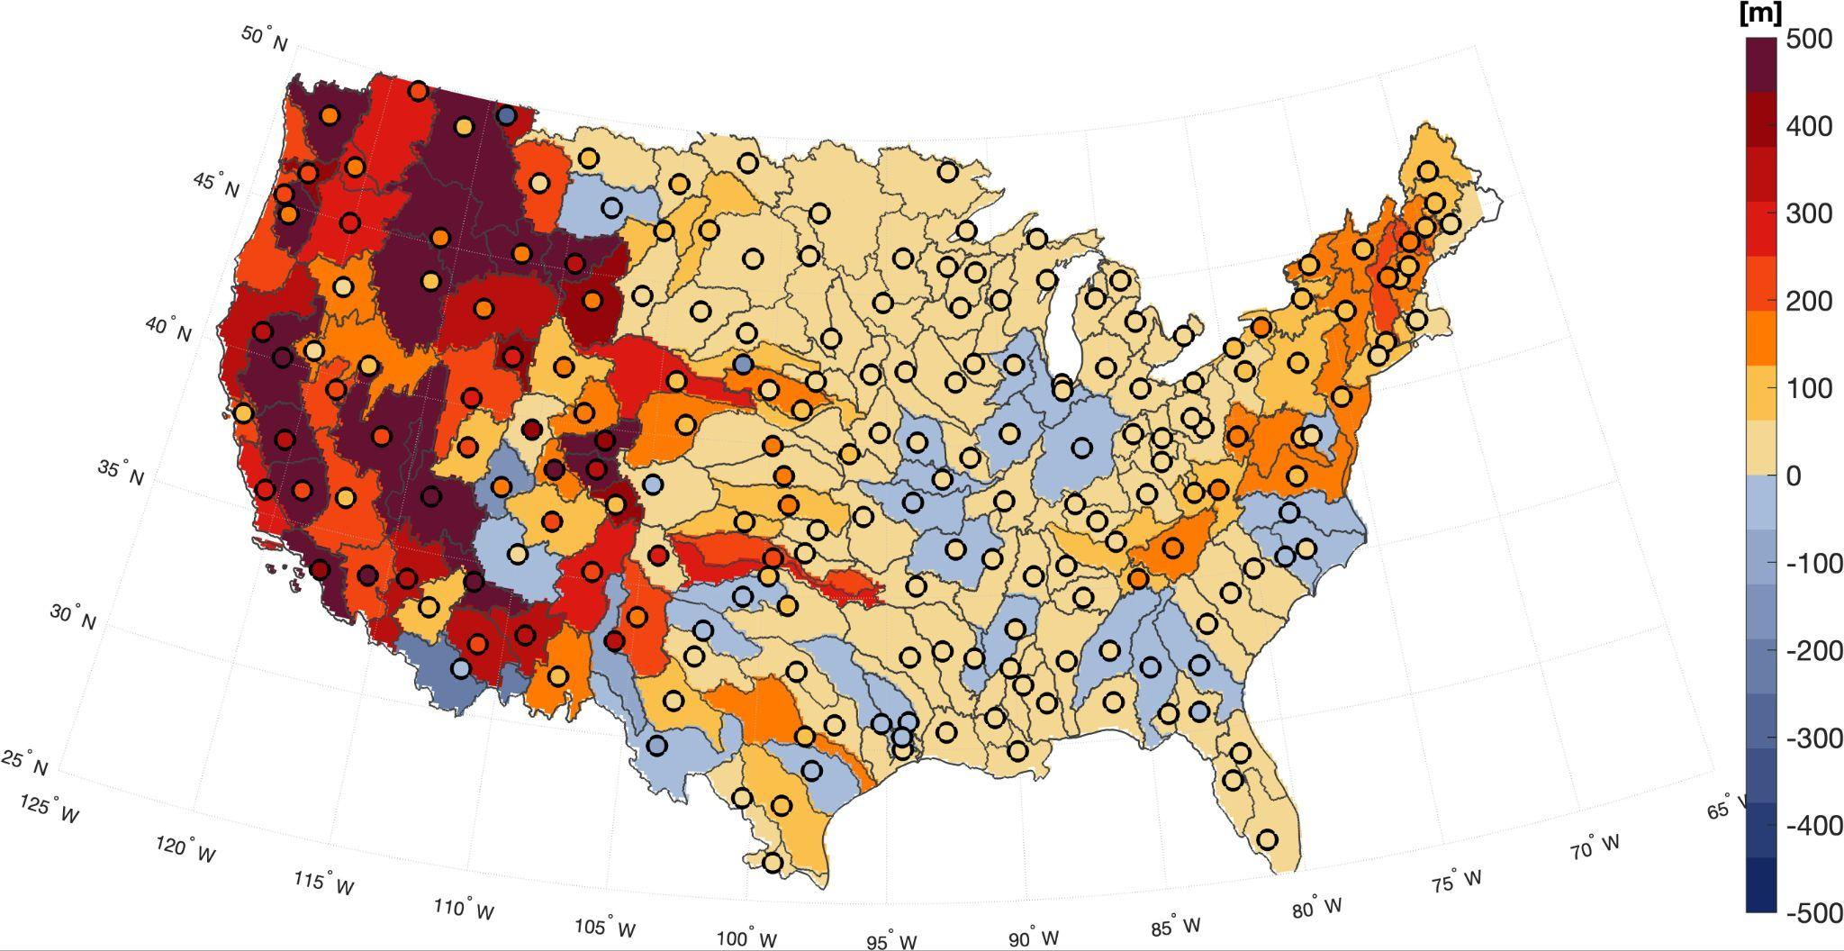
Figure 15. Average elevation difference between rural (excluding open water and wetlands) and urban (including all developed areas) land covers at basin scales. The circle shows the average elevation difference between the developed, open space, and developed, high intensity land covers at basin scales. The basins are the 4-digit hydrological units from the U.S. Geological Survey.

Reference
1. Gettelman A, et al. The future of Earth system prediction: Advances in model-data fusion. Science Advances 8, eabn3488 (2022).

2. Qian Y, et al. Parametric Sensitivity and Uncertainty Quantification in the Version 1 of E3SM Atmosphere Model Based on Short Perturbed Parameter Ensemble Simulations. Journal of Geophysical Research: Atmospheres 123, 13,046-013,073 (2018).

3. Schär C, et al. Kilometer-Scale Climate Models: Prospects and Challenges. B Am Meteorol Soc 101, E567-E587 (2020).

4. Donahue AS, et al. To Exascale and Beyond—The Simple Cloud-Resolving E3SM Atmosphere Model (SCREAM), a Performance Portable Global Atmosphere Model for Cloud-Resolving Scales. J Adv Model Earth Sy 16, e2024MS004314 (2024).

5. Wei J, et al. A Performance-Portable Kilometer-Scale Global Ocean Model on ORISE and New Sunway Heterogeneous Supercomputers. In: SC24: International Conference for High Performance Computing, Networking, Storage and Analysis). IEEE (2024).

6. Pal N, et al. Barotropic tides in MPAS-Ocean (E3SM V2): impact of ice shelf cavities. Geosci Model Dev 16, 1297-1314 (2023).

7. Lilly JR, Capodaglio G, Petersen MR, Brus SR, Engwirda D, Higdon RL. Storm Surge Modeling as an Application of Local Time-Stepping in MPAS-Ocean. J Adv Model Earth Sy 15, e2022MS003327 (2023).

8. Li L, Bisht G, Hao D, Leung LR. Global 1 km land surface parameters for kilometer-scale Earth system modeling. Earth Syst Sci Data 16, 2007-2032 (2024).

9. Singh RS, Reager JT, Miller NL, Famiglietti JS. Toward hyper-resolution land-surface modeling: The effects of fine-scale topography and soil texture on CLM4.0 simulations over the Southwestern U.S. Water Resour Res 51, 2648-2667 (2015).

10. Tanaka T, Kiyohara K, Tachikawa Y. Comparison of fluvial and pluvial flood risk curves in urban cities derived from a large ensemble climate simulation dataset: A case study in Nagoya, Japan. J Hydrol 584, 124706 (2020).

11. Thomas Steven Savage J, Pianosi F, Bates P, Freer J, Wagener T. Quantifying the importance of spatial resolution and other factors through global sensitivity analysis of a flood inundation model. Water Resour Res 52, 9146-9163 (2016).

12. Li H, et al. A Physically Based Runoff Routing Model for Land Surface and Earth System Models. J Hydrometeorol 14, 808-828 (2013).

13. Yamazaki D, Kanae S, Kim H, Oki T. A physically based description of floodplain inundation dynamics in a global river routing model. Water Resour Res 47, (2011).

14. Ivanov VY, et al. Breaking Down the Computational Barriers to Real-Time Urban Flood Forecasting. Geophys Res Lett n/a, e2021GL093585 (2021).

15. Dullo TT, et al. Simulation of Hurricane Harvey flood event through coupled hydrologic-hydraulic models: Challenges and next steps. Journal of Flood Risk Management 14, e12716 (2021).

16. Cea L, Bladé E. A simple and efficient unstructured finite volume scheme for solving the shallow water equations in overland flow applications. Water Resour Res 51, 5464-5486 (2015).

17. Ming X, Liang Q, Xia X, Li D, Fowler HJ. Real-Time Flood Forecasting Based on a High-Performance 2-D Hydrodynamic Model and Numerical Weather Predictions. Water Resour Res 56, e2019WR025583 (2020).

18. Liang Q. Flood Simulation Using a Well-Balanced Shallow Flow Model. Journal of Hydraulic Engineering 136, 669-675 (2010).

19. Bradford SF, Sanders BF. Finite-Volume Model for Shallow-Water Flooding of Arbitrary Topography. Journal of Hydraulic Engineering 128, 289-298 (2002).

20. Noh SJ, Lee J-H, Lee S, Kawaike K, Seo D-J. Hyper-resolution 1D-2D urban flood modelling using LiDAR data and hybrid parallelization. Environmental Modelling & Software 103, 131-145 (2018).

21. Tran VN, et al. Connectivity in urbanscapes can cause unintended flood impacts from stormwater systems. Nature Cities 1, 654-664 (2024).

22. Sharifian MK, Kesserwani G, Chowdhury AA, Neal J, Bates P. LISFLOOD-FP 8.1: new GPU-accelerated solvers for faster fluvial/pluvial flood simulations. Geosci Model Dev 16, 2391-2413 (2023).

23. Vacondio R, Dal Palù A, Mignosa P. GPU-enhanced Finite Volume Shallow Water solver for fast flood simulations. Environmental Modelling & Software 57, 60-75 (2014).

24. Wittmann R, Bungartz H-J, Neumann P. High performance shallow water kernels for parallel overland flow simulations based on FullSWOF2D. Computers & Mathematics with Applications 74, 110-125 (2017).

25. Bisht G, et al. Development of a River Dynamical Core for E3sm to Simulate Compound Flooding on Exascale-Class Heterogeneous Supercomputers. Available at SSRN 5167194, (2025).

26. Xu D, Bisht G, Engwirda D, Feng D, Tan Z, Ivanov VY. Uncertainties in Simulating Flooding During Hurricane Harvey Using 2D Shallow Water Equations. Water Resour Res 61, e2024WR038032 (2025).

27. Golaz J-C, et al. The DOE E3SM Model Version 2: Overview of the Physical Model and Initial Model Evaluation. J Adv Model Earth Sy 14, e2022MS003156 (2022).

28. Tellman B, et al. Satellite imaging reveals increased proportion of population exposed to floods. Nature 596, 80-86 (2021).

29. DeVries B, Huang C, Armston J, Huang W, Jones JW, Lang MW. Rapid and robust monitoring of flood events using Sentinel-1 and Landsat data on the Google Earth Engine. Remote Sens Environ 240, 111664 (2020).

30. Huang C, Chen Y, Zhang S, Wu J. Detecting, Extracting, and Monitoring Surface Water From Space Using Optical Sensors: A Review. Rev Geophys 56, 333-360 (2018).

31. Pekel J-F, Cottam A, Gorelick N, Belward AS. High-resolution mapping of global surface water and its long-term changes. Nature 540, 418-422 (2016).

32. Pickens AH, et al. Mapping and sampling to characterize global inland water dynamics from 1999 to 2018 with full Landsat time-series. Remote Sens Environ 243, 111792 (2020).

33. Ivancic TJ, Shaw SB. Examining why trends in very heavy precipitation should not be mistaken for trends in very high river discharge. Climatic Change 133, 681-693 (2015).

34. Berghuijs WR, Woods RA, Hutton CJ, Sivapalan M. Dominant flood generating mechanisms across the United States. Geophys Res Lett 43, 4382-4390 (2016).

35. Deb M, et al. Interacting Effects of Watershed and Coastal Processes on the Evolution of Compound Flooding During Hurricane Irene. Earth's Future 11, e2022EF002947 (2023).

36. Gong W, Shimizu Y, Iwasaki T. A case study of flood modeling with adaptive mesh refinement. In: Proceedings of the 22nd IAHR APD Congress (Sapporo) (2020).

