Soil temperature strongly increases: evidences from long-term trends (1951–2018) in North-Rhine Westphalia, Germany

This word document includes

Figure S1 Altitude-dependent correlation with pedological and meteorological variables.
Figure S2 Soil temperature (ST) for the decades from 1951-1960 to 2011-2018.
Figure S3 Development of new snow cover and soil temperature for site Kahler Asten.
Figure S4 Development of phenological days.

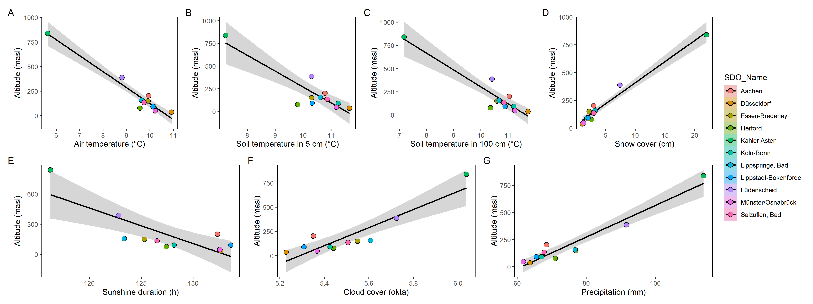
Figure S1 Altitude-dependent correlation with pedological (B and C) and meteorological variables (A; D to G) of the study sites in North-Rhine Westphalia. The grey band highlights the 95% confidence level interval for predictions from a linear model.
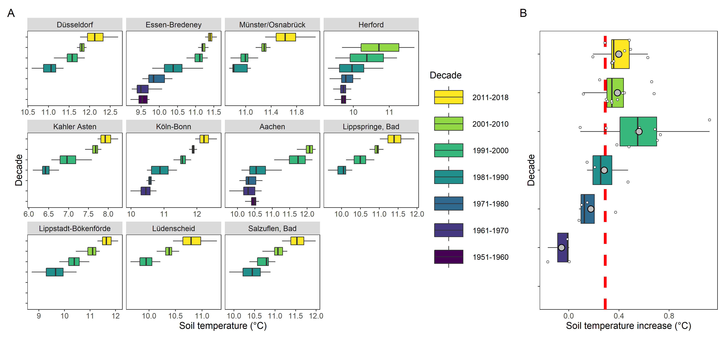
Figure S2 Soil temperature (ST) for the decades from 1951-1960 to 2011-2018 for each study site (A). Audit of the data has not been finished until 2020-12-31 and therefore, the last decade from 2011 onwards accounts only for eight years of data. The data is based on the extracted trend of the raw data derived by the seasonal trend decomposition. The decadal increase in ST accounts for all study sites and was calculated by setting the previous decade as the reference and displayed as boxplot with the mean of each decade as grey dot and the red dashed line is the overall mean for all decades (B).

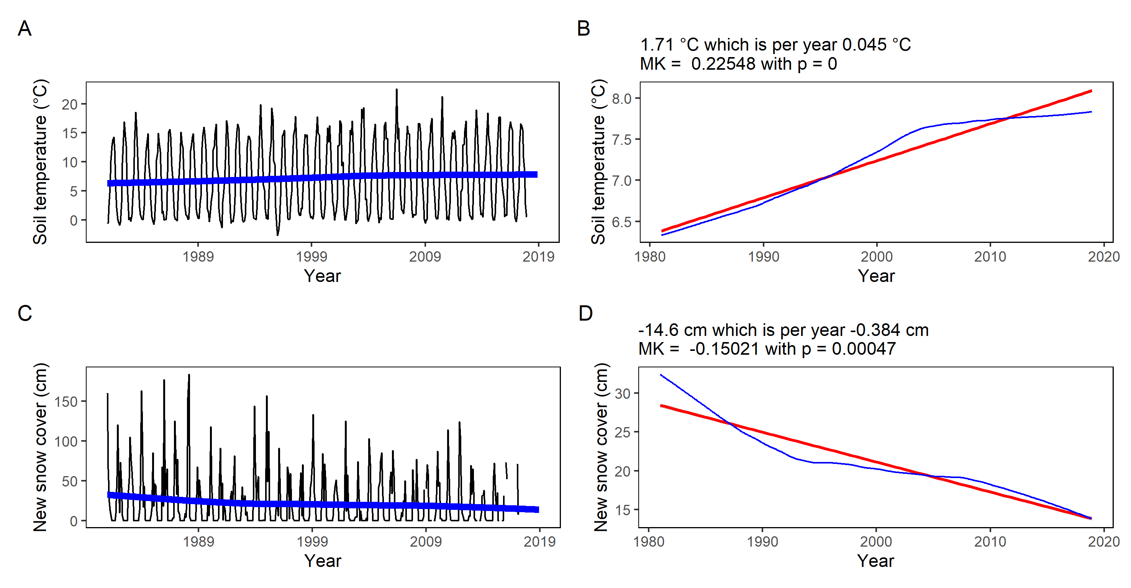
Figure S3 Development of the monthly soil temperature (A) and new snow cover (C) for the study site Kahler Asten (black) with the decomposed trend line (blue). The linear regression of the trend (red) indicates a cumulative increase of 1.71 °C in soil temperature and a decrease of –14.6 cm new snow cover, which is statistically significant (p < 0.05) according to the seasonal adjusted Mann-Kendall (MK) trend test (B and D).

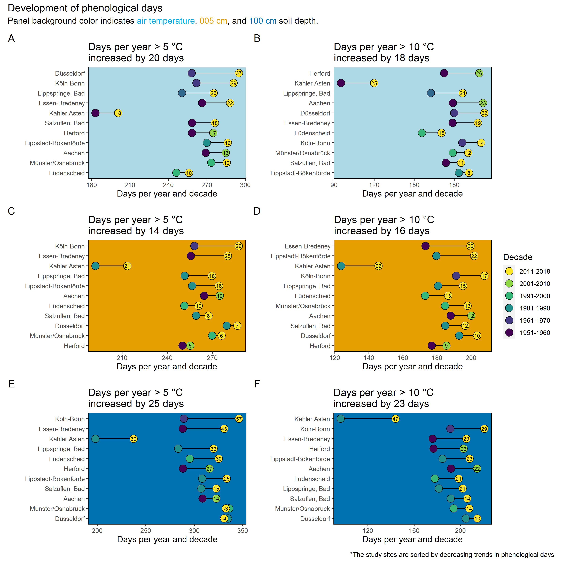
Figure S4 The development of phenological days with temperatures > 5 °C (A, C, E) and > 10 °C per year (B, D, F) is the mean per decade and the colored circles indicate the first and the last decade where monitoring for the individual study site was conducted. The length of the line reflects the increase in phenological days.

