Stabilizing Interfacial Structure of LiCoO₂ with Ultrahigh Capacity and Prolonged Cyclability at 4.6V

Fig. S1. SEM images of (a) LCO and (b) LCO@LGPO.

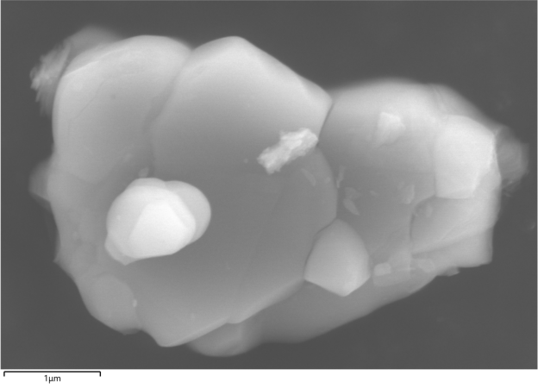
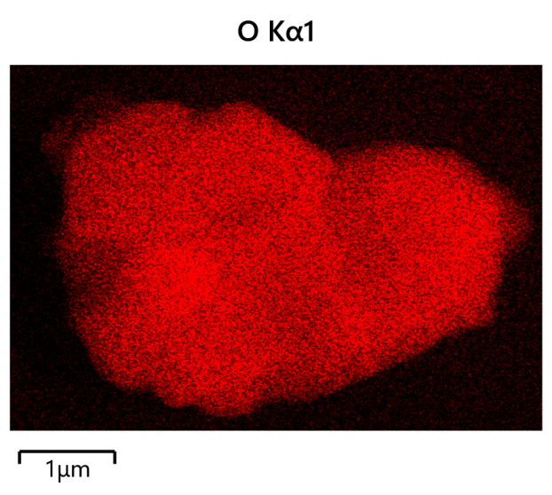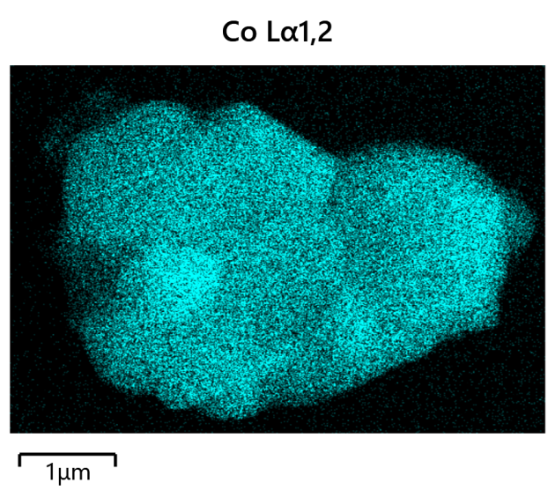
Fig. S2. (a) The SEM image and corresponding (b) EDX mappings of LCO.

Fig. S3. The fitted equivalent circuit of Nyquist plots.

II
I
Fig. S4. Transmission electron microscope images of the LCO and LCO@LGPO coating layer, Fourier transform results and inverse Fourier transform results

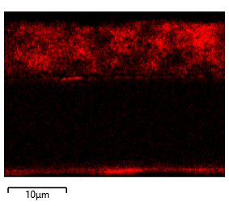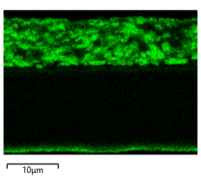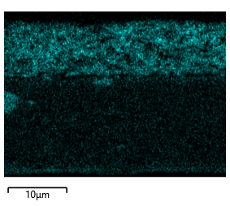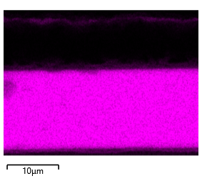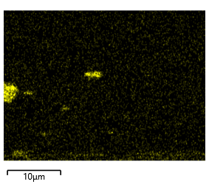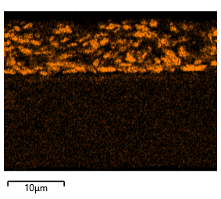
(f)
(e)
(d)
(c)
(b)
(a)
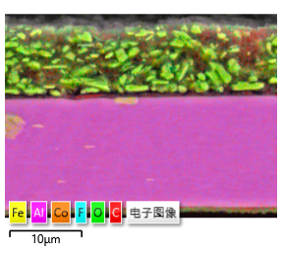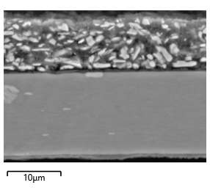
Fig. S5. Electron Backscattering Diffraction (EBSD) metal element analysis of cross-sectional microstructures of post-cycling electrode slices of LCO-coated LGPO after 200 cycles, (a) C, (b)O, (c) F,(d) Al, (e) Fe,(f) Co.

Fig. S5. The whole spectra of LCO and LCO@LGPO probed by XPS depth profile.

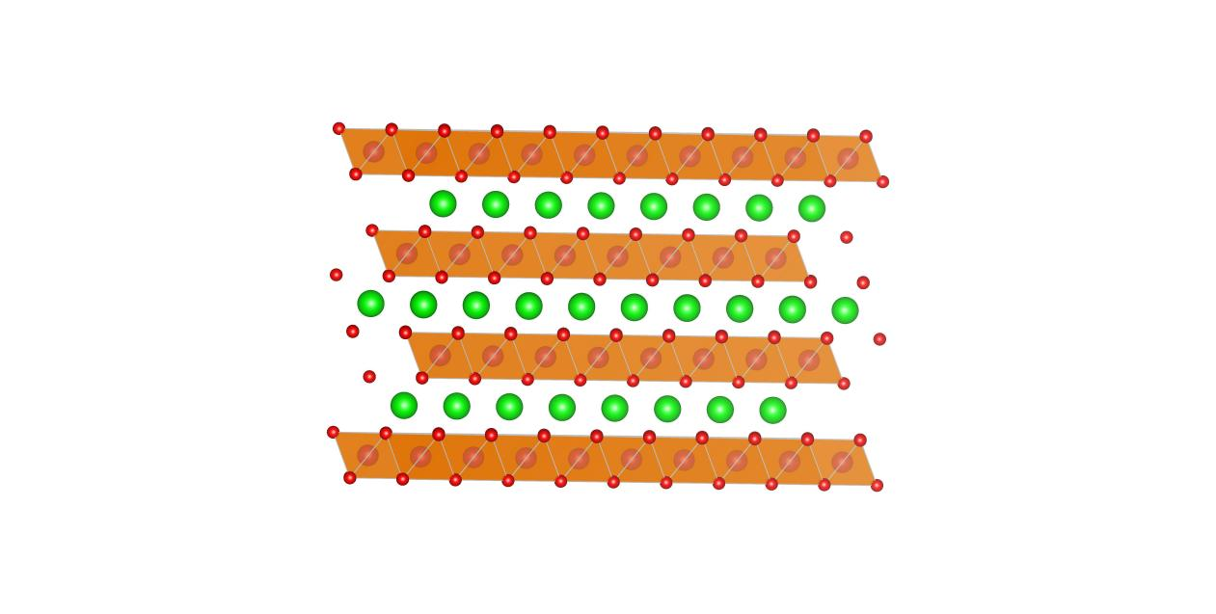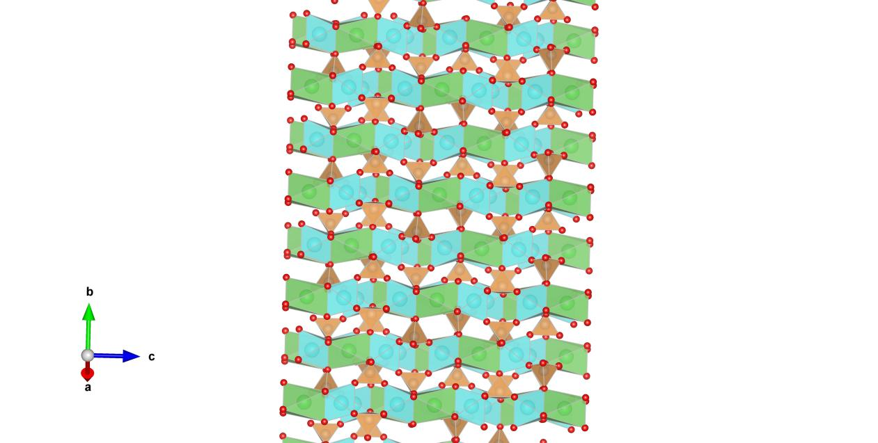
Fig. S7. Diagram of crystal structure of (a) LCO and (b) LCO@LGPO.

Table S1. The doping concentration of Zr, P and Co in all samples obtained from ICP-MS.
Samples | Mole ratio /%
Samples | Zr | P | Co
LCO@LGPO | 0.2415 | 0.1667 | 61.1645
LCO | / | / | 62.2504

Table S2. Refined refinement lattice parameters of LCO@LGPO and LCO samples.
Sample | a (Å) | c (Å) | c/a ratio | Refinement parameters
LCO@LGPO | 2.8537 | 14.1851 | 4.9708 | R_{p}: 3.88%,R_{wp}:5.02%
LCO | 2.8556 | 14.2086 | 4.9757 | R_{p}: 4.04%,R_{wp}:5.52%

Table S3. The mass and volume percentage of each element in the cross-section of LCO@LGPO cathode material.
Element | Wt% | Wt% Sigma | At%
C | 23.98 | 0.14 | 40.18
O | 11.92 | 0.06 | 14.99
F | 1.81 | 0.04 | 1.92
Al | 53.50 | 0.11 | 39.90
Fe | 0.33 | 0.02 | 0.12
Co | 8.46 | 0.06 | 2.89
All | 100 |  | 100

