Supplementary Material: Functional microbiome reprogramming links dietary interventions to neuroinflammatory outcomes in multiple sclerosis
Friederike Gutmann^{1,2,3,4,5,*}, Lina Samira Bahr^{1,2,3}, Ulrike Brüning⁵, Víctor Hugo Jarquín-Díaz^{1,2,3,4}, Lajos Markó^{1,2,3,4}, Martin Weygandt^{1,2,3}, Rebekka Rust^{1,2,3,6}, Judith Bellmann-Strobl^{1,2,3}, Friedemann Paul^{1,2,3}, Sofia K. Forslund-Startceva^{1,2,3,4,7,**} & Jennifer A. Kirwan^{5,8,**}
¹Max Delbrück Center for Molecular Medicine in the Helmholtz Association (MDC), Berlin, Germany
²Charité – Universitätsmedizin Berlin, corporate member of Freie Universität Berlin and Humboldt‐Universität zu Berlin, Berlin, Germany
³Experimental and Clinical Research Center (ECRC), a cooperation between the Max Delbrück Center for Molecular Medicine in the Helmholtz Association and the Charité, Berlin, Germany
⁴German Centre for Cardiovascular Research (DZHK), Partner Site Berlin, Berlin, Germany
⁵Berlin Institute of Health (BIH) at Charité, BIH Metabolomics Platform, Berlin, Germany
⁶Institute for Immunology at Charité Berlin, Berlin, Germany
⁷European Molecular Biology Laboratory, Heidelberg, Germany
⁸Current address: Metabolomics, University of Veterinary Medicine Vienna, Vienna, Austria

* Corresponding author: friederike.gutmann@mdc-berlin.de

** Co-senior authorship

Supplementary Table 1. Baseline characteristics of the NAMS intention-to-treat population [1].
Characteristic | Total | CD | FD | KD
Number of participants | 105 | 34 | 35 | 36
Age [years], mean (StD) | 42 (9) | 43 (10) | 41 (9) | 41 (10)
Ethnicity [Caucasian], n (%) | 100 (95) | 34 (100) | 34 (97) | 32 (89)
Gender [female], n (%) | 88 (84) | 29 (85) | 28 (80) | 31 (86)
Disease duration since manifestation [years], median (IQR) | 8.0 (13.8–2.4) | 5.0 (13.0–2.1) | 8.9 (13.6–3.8) | 8.6 (16.1–3.0)
Disease duration since diagnosis [years], median (IQR) | 3.6 (10.3–1.3) | 2.1 (5.4–1.2) | 5.3 (11.1–2.1) | 3.8 (10.6–1.3)
Expanded disability status scale score, median (IQR) | 2.0 (2.5–1.5) | 2.0 (2.5–1.5) | 2.0 (2.1–1.5) | 2.0 (3.1–1.5)
Number of T2-lesions, median (IQR) | 35 (75–19) | 36 (76–21) | 39 (67–23) | 31 (76–17)
Participants without DMT, n (%) | 45 (43) | 14 (41) | 15 (43) | 16 (44)
Body mass index [kg/m²], median (IQR) | 24.3 (26.6–22.2) | 25.1 (26.8–22.8) | 23.6 (26.3–21.6) | 23.7 (26.3–22.3)
25-OH-Vitamin D₃ [nmol/L], mean (StD) | 101.0 (37.1) | 105.1 (37.4) | 93.9 (34.1) | 104.2 (39.7)
Fatigue severity scale score, median (IQR) | 3.7 (5.3–2.2) | 4.3 (5.6–1.8) | 3.8 (5.2–2.8) | 3.4 (4.4–2.2)
Beck depression inventory II score, median (IQR) | 7 (12–3) | 7 (12–2) | 9 (13–5) | 6 (11–3)
Symbol digit modalities test score, median (IQR) | 56 (63–49) | 54 (62–50) | 57 (62–50) | 57 (65–47)

CD, control diet; DMT, disease modifying therapy; FD, fasting diet; IQR, interquartile range; KD, ketogenic diet; StD, standard deviation

Supplementary Material 1. Covariates individually considered as potential confounders.
- Ethnicity [Caucasian/Non-Caucasian]
- Gender [Woman/Man]
- Age [years]
- Body mass index (BMI)
- Weight [kg]
- Height [cm]
- Waist circumference [cm]
- Hip circumference [cm]
- Waist-to-hip ratio
- Fat mass [kg]
- Free fat mass [kg]
- Body cell mass [kg]
- Body cell mass [%]
- Extracellular water [L]
- Extracellular water [%]
- Total body water [L]
- Total amount of medication
- Number of dermatologicals
- Number of anti-infectives for systemic use
- Number of antineoplastic and immunomodulating agents
- Number of injectable disease-modifying therapies (DMTs)
- Number of oral DMTs
- Number of antibody DMTs
- Number of musculoskeletal system medications
- Number of nervous system medications
- Number of respiratory system medications
- Number of sensory organs and medication
- Number of genitourinary system medications and sex hormones
- Mental health composite score
- Physical health composite score
- Handgrip strength right [kg]
- Handgrip strength light [kg]
- Multiple sclerosis functional composite (MSFC) z-score
- Paced auditory serial addition test (PASAT) score
- Fatigue severity scale (FSS) score
- Expanded disability status scale (EDSS) score
- Six-minute walking test (6MWT) result
- Beck depression inventory II (BDI-II) score
- Symbol digit modalities test (SDMT) score
- Systolic blood pressure [mmHG]
- Diastolic blood pressure [mmHG]
- Heart rate [bpm]
- Low-density lipoprotein (LDL) cholesterol [mg/dL]
- High-density lipoprotein (HDL) cholesterol [mg/dL]
- Non-HDL cholesterol [mg/dL]
- Total cholesterol [mg/dL]
- Leptin [ng/mL]
- Triglycerides [mg/dL]
- Insulin [mU/L]
- Adiponectin [ng/mL]
- 25-OH-Vitamin D3 [nmol/L]
- Blood protein [g/L]
- Blood glucose [mg/dL]
- R-Homa index
- Insulin-like growth factor 1 (IGF1) [ng/mL]
- Neurofilament light chain (NfL) [ng/mL]
- Relapse during the intervention period [yes/no]
- Number of T2 lesions
- Volume of T2 lesions [mL]
- T2 lesion load based on lesion count [high/low]
- Brain volume change [%]
- Dietary protein consumed [g]
- Dietary tryptophan consumed [g]
- Dietary fiber consumed [g]

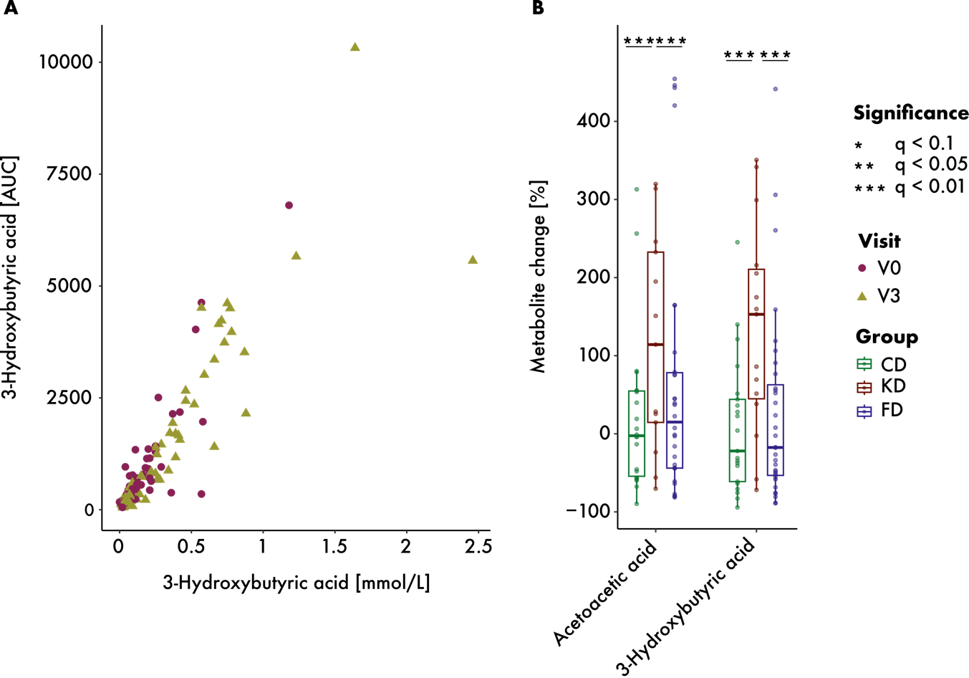

Figure S1. Serum ketone body levels. (A) Correlation between 3-hydroxybutyric acid measurements performed on the same samples in our lab and the contract lab Labor Berlin (p = 2.2e^-16, rho = 0.91). (B) Change in AUC from 0 to 9 months. KD led to increased acetoacetic acid and 3-hydroxybutyric acid levels, which were significantly larger than changes occurring in the other diet groups.

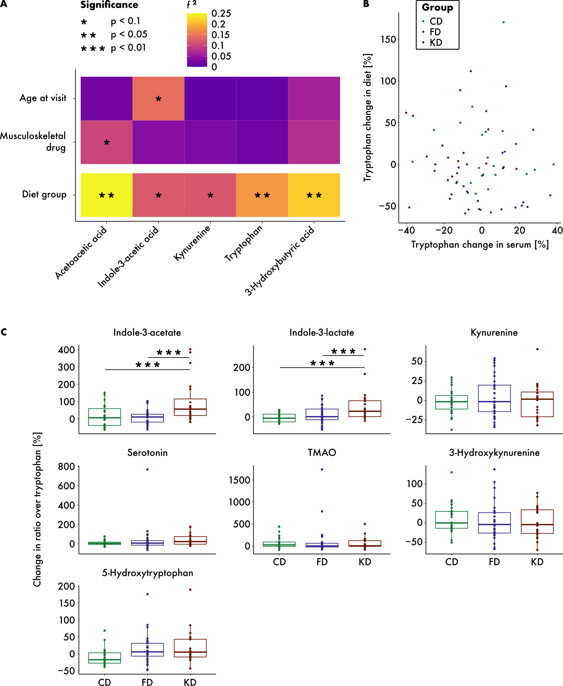

Figure S2. No covariate confounded the diet association with key serum metabolites. (A) Results of confounding analysis. Age and the number of musculoskeletal drugs consumed were co-associated with indole-3-acetate and acetoacetic acid, respectively, but did not confound the group-metabolite association. (B) Tryptophan changes measured in blood and calculated from dietary protocols showed no correlation (p = 0.63, rho = 0.06). (C) Changes in the ratios of each measured tryptophan metabolite to tryptophan in serum were significantly higher in KD than in CD or FD for indole-3-acetic acid and indole-3-lactate.

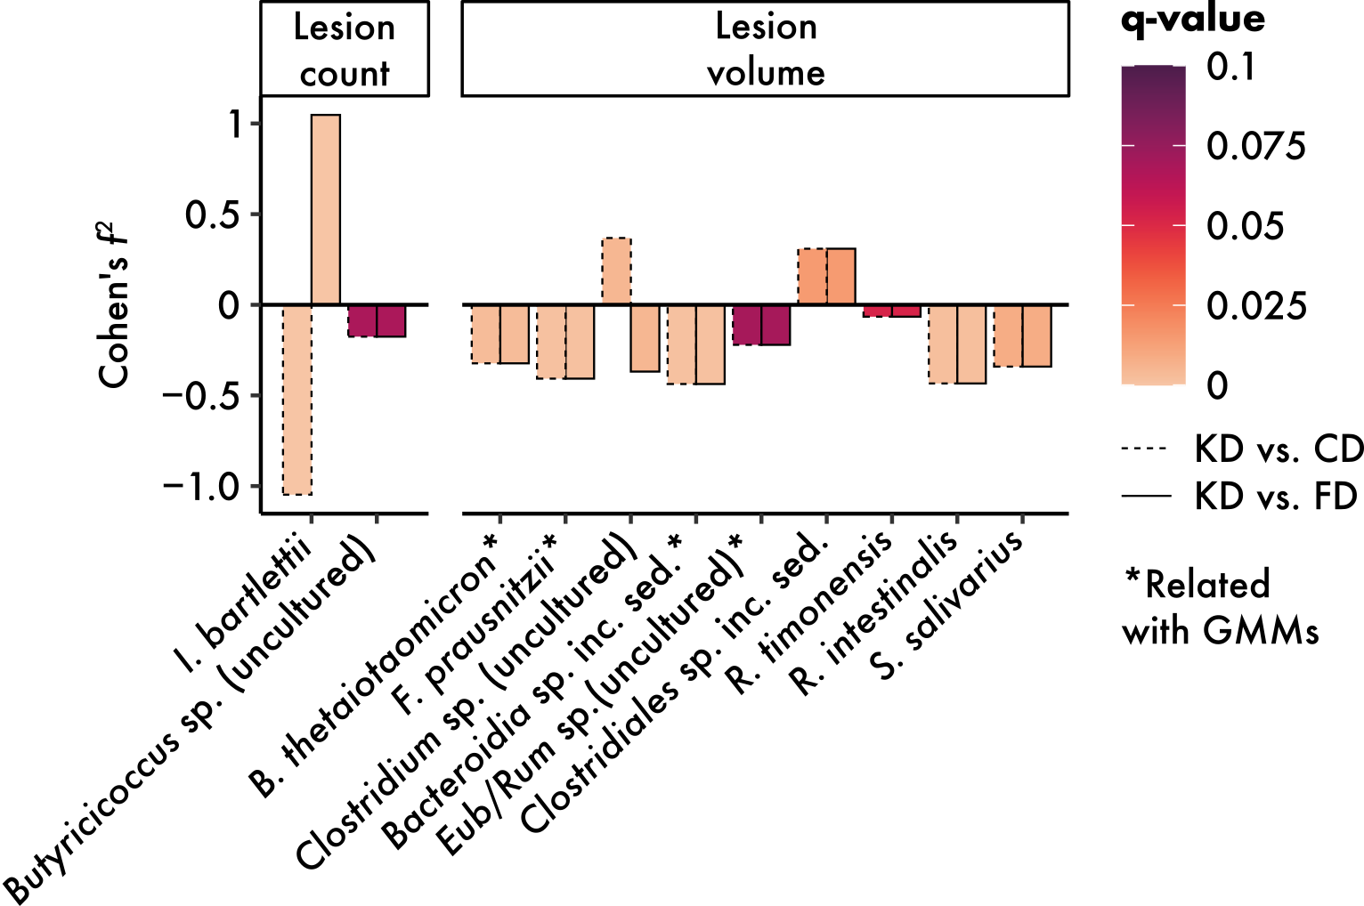

Figure S3. Bacterial species demonstrating group-dependent associations with lesion volume and lesion count over time. Species that mirror the gut microbial module (GMM)-outcome relationship are indicated with an asterisk.

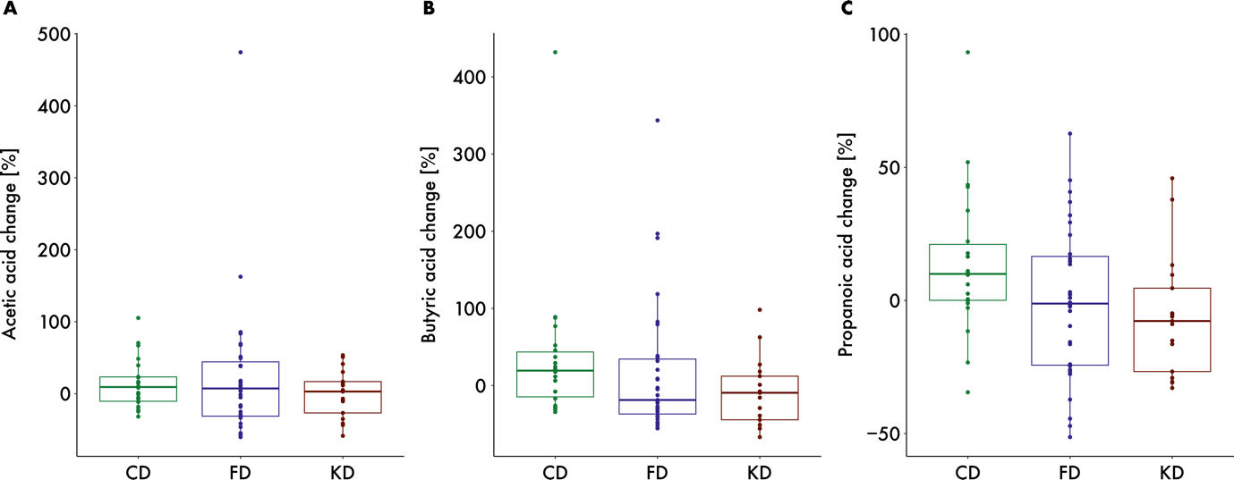

Figure S4. Changes in stool metabolites related to propionate CoA transferase metabolic pathways over 9 months by dietary intervention group showed no significant differences. (A) Acetic acid (p = 0.54, f² = 0.02). (B) Butyric acid (p = 0.11, f² = 0.08). (C) Propanoic acid (p = 0.11, f² = 0.09).

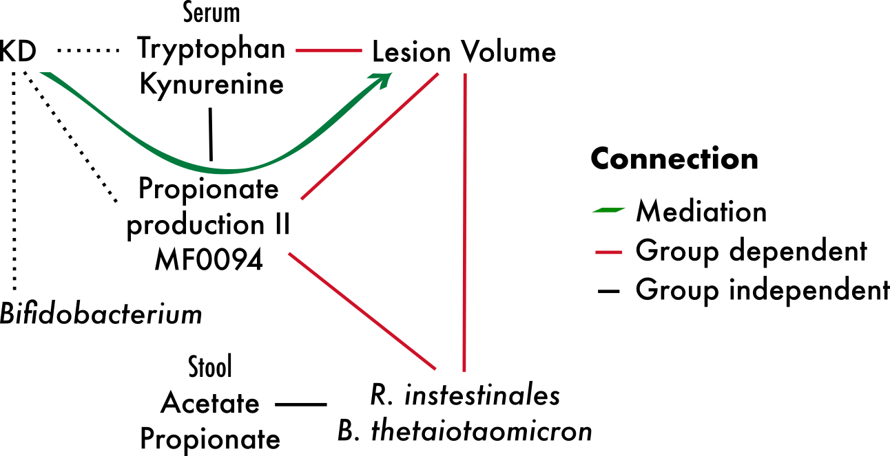

Figure S5. The GMM propionate production II (MF0094) mediated the effect of the diet on lesion volume (p_{KDvs.CD} = 0.06, p_{KDvs.FD} = 0.02, p_{FDvs.CD} = 0.77, proportion mediated_{KDvs.CD} = 0.66, proportion mediated_{KDvs.FD} = 0.71, proportion mediated_{FDvs.CD} = 0.03). In MS patients receiving KD, shifts in microbial function showed stronger associations with changes in serum metabolites, specific microbial species, and lesion outcomes compared to associations with stool metabolite levels or the KD-specific reduction in Bifidobacterium genus abundance.

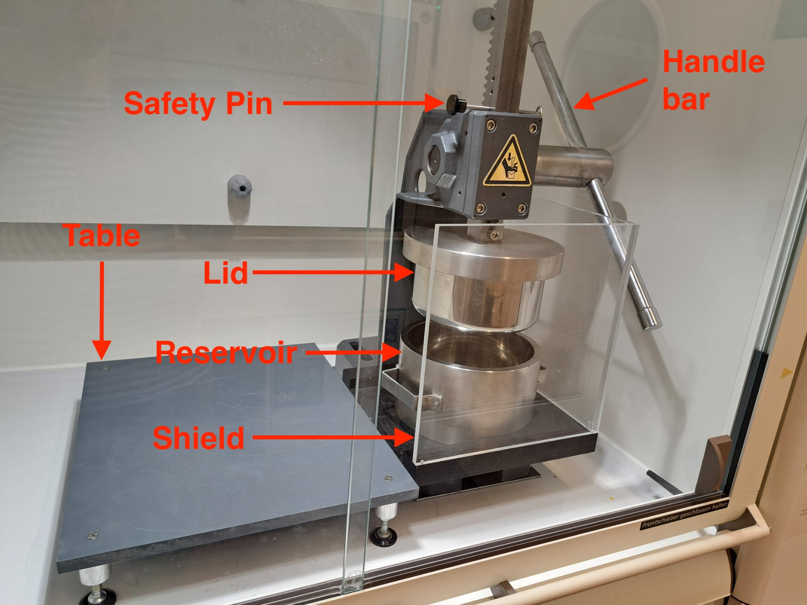

Figure S6. Custom stool homogenization device consisting of a lever with a handle-bar attached to a lid that can be lowered into a reservoir containing frozen stool samples in sterile Whirl-Pak® Standard Sterilized Sampling Bags (Whirl-Pak, Madison, WI, USA) following removal of a safety pin. A protective shield was attached for safety, and a work table was placed adjacent to the device to facilitate the smooth removal of the heavy reservoir.

References

- Bahr, L. S. et al. Fasting, ketogenic, and anti-inflammatory diets in multiple sclerosis: a randomized controlled trial with 18-month follow-up. BMC Nutr 11, 167 (2025).

