a b
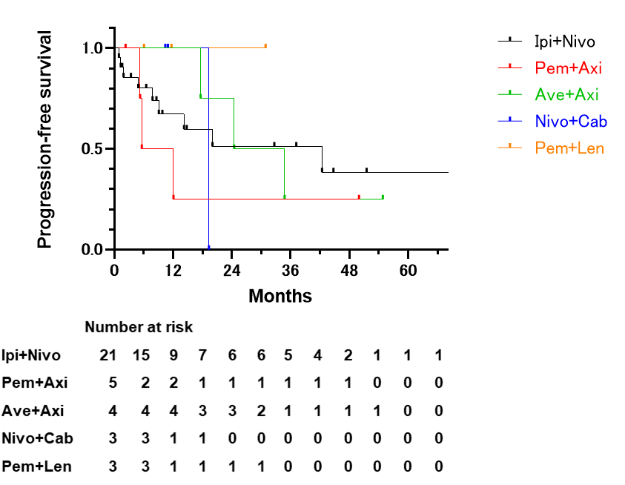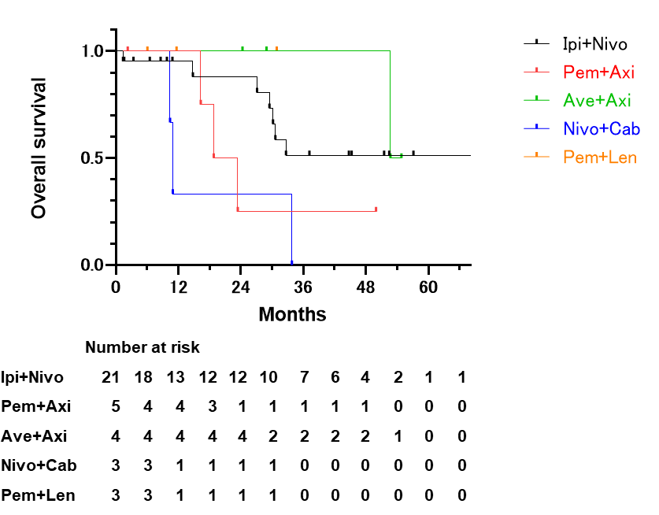
c d
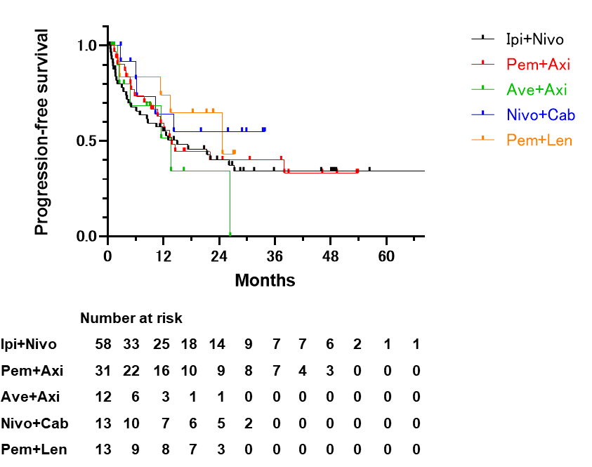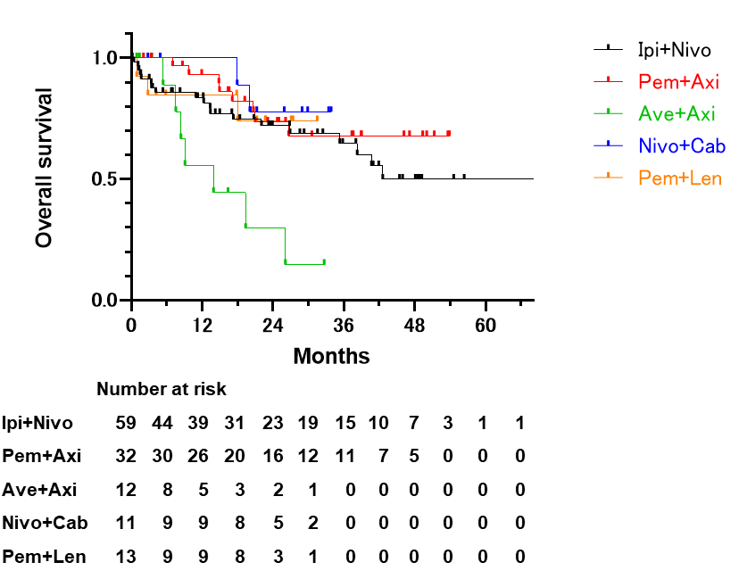
e f
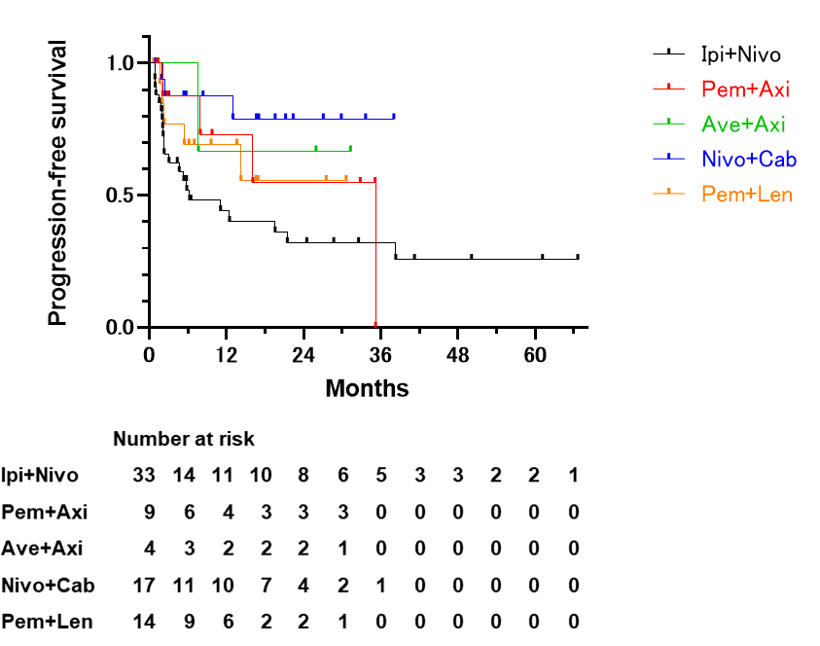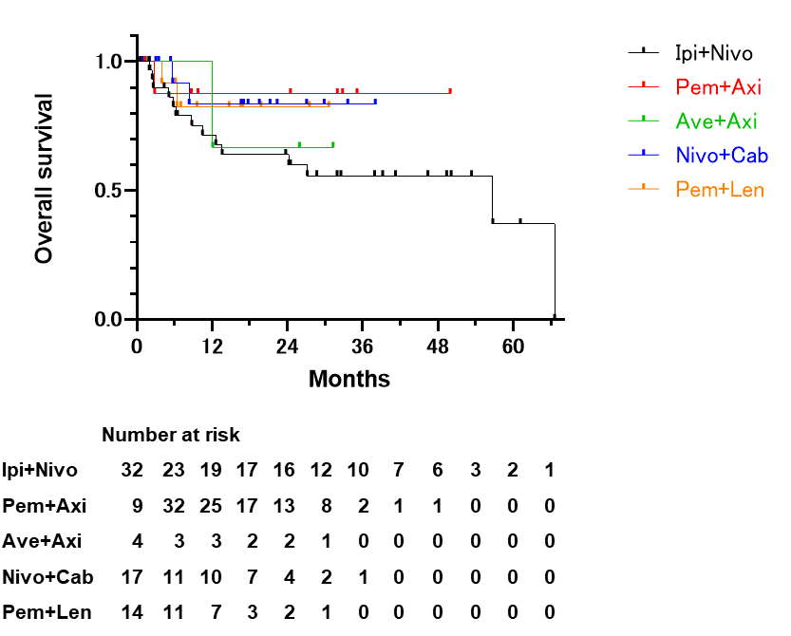
g h
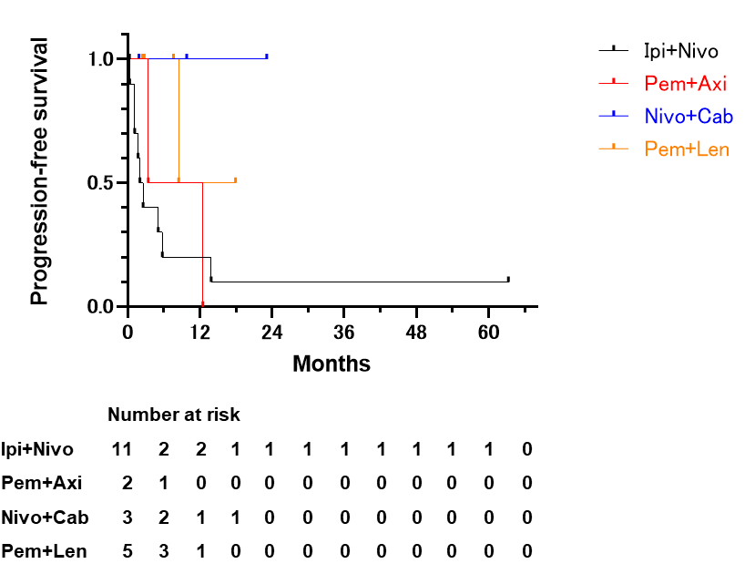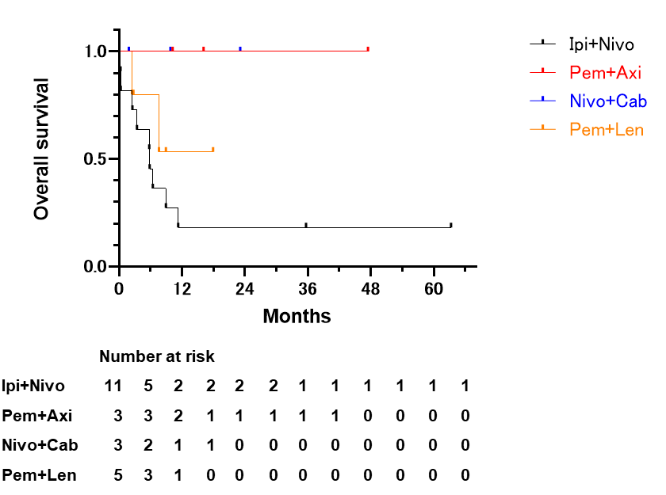
i j
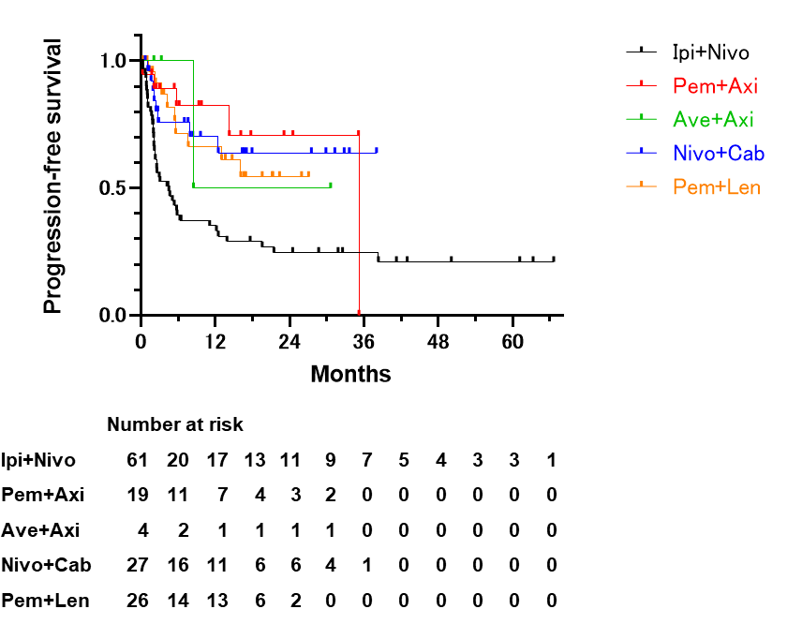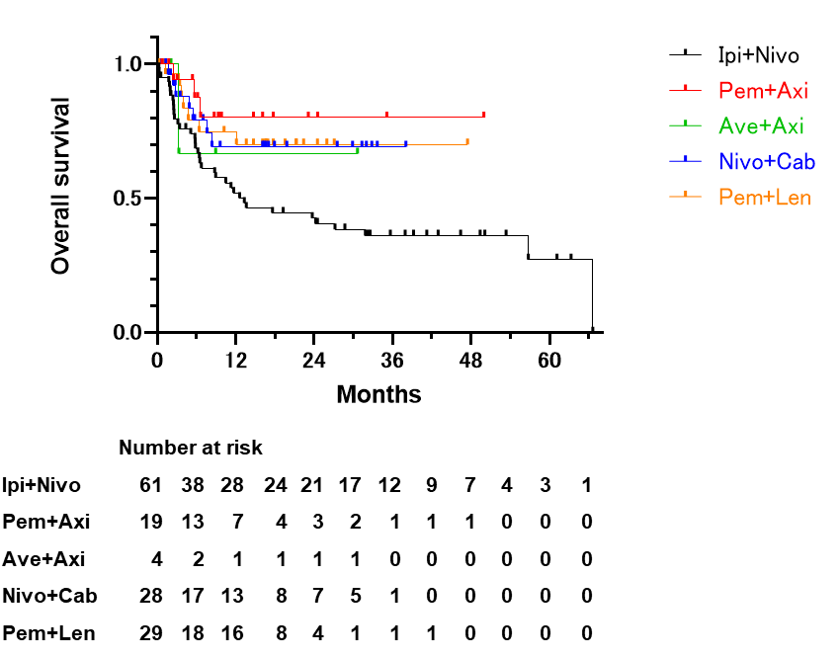
k l
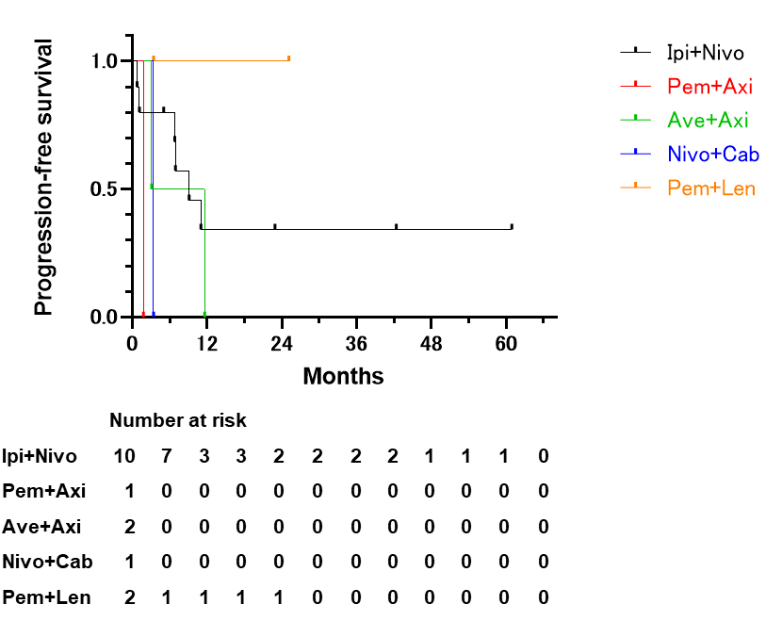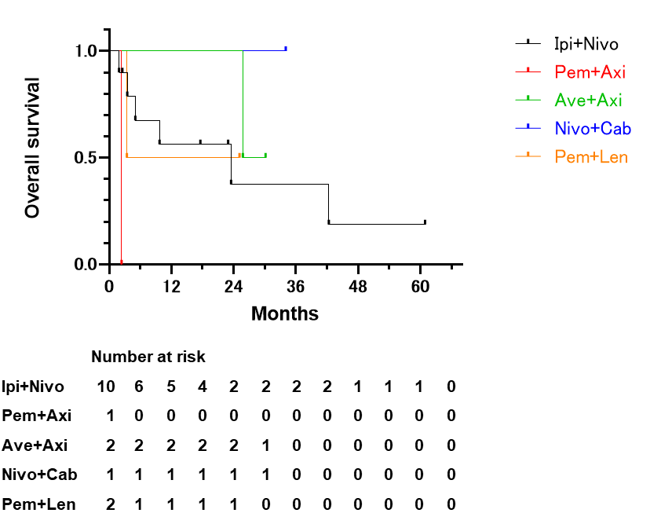
Supplementary Fig. 1. Kaplan–Meier curves for PFS and OS by metastatic site in patients with mRCC treated with each regimen.
PFS (a) and OS (b) in patients with lymph node-only metastases. PFS (c) and OS (d) in patients with lung metastases regardless of lymph node metastases. PFS (e) and OS (f) in patients with bone metastases regardless of lung and/or lymph node metastases. PFS (g) and OS (h) in patients with liver metastases regardless of lung and/or lymph node metastases. PFS (i) and OS (j) in patients with liver and/or bone metastases regardless of lung, lymph node, or other distant metastases. PFS (k) and OS (l) in patients with brain metastases.
IO, immuno-oncology; TKI, tyrosine kinase inhibitor; OS, overall survival; PFS, progression-free survival; mRCC, metastatic renal cell carcinoma.

a b
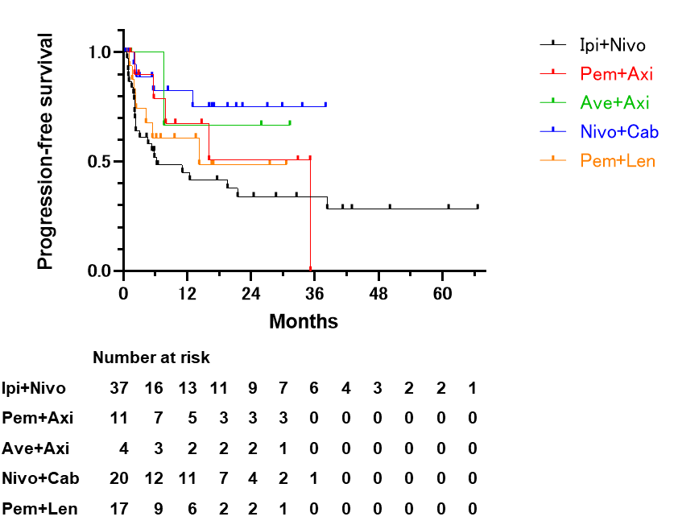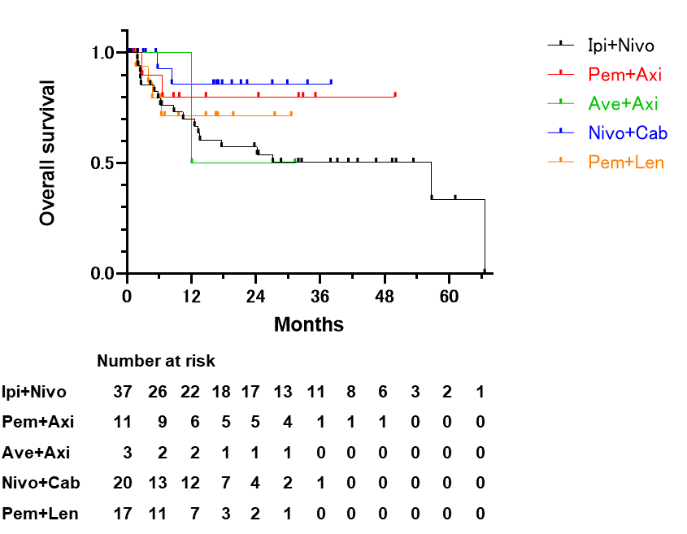
c d
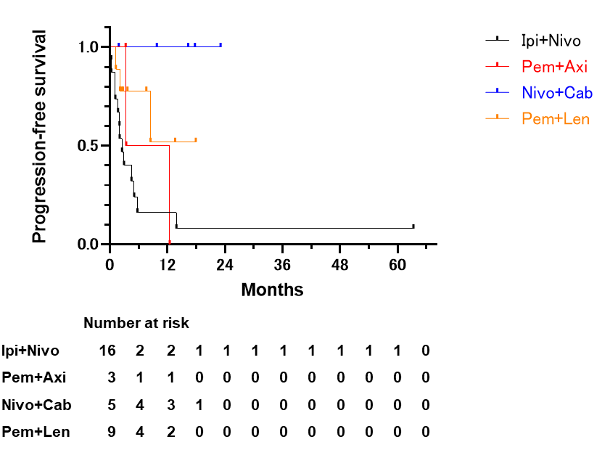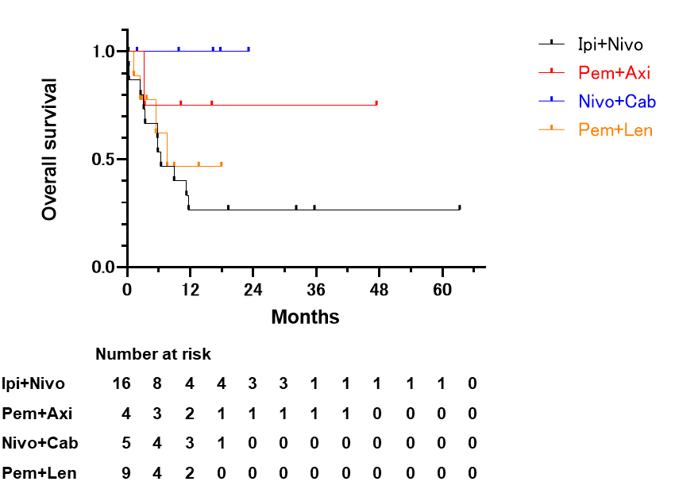
Supplementary Fig. 2. Kaplan–Meier curves for PFS and OS by metastatic site in patients with mRCC treated with each regimen.
PFS (a) and OS (b) in patients with bone metastases, with or without lung and/or lymph node metastases and/or other distant metastasis. PFS (c) and OS (d) in patients with liver metastases, with or without lung and/or lymph node metastases and/or other distant metastasis.
OS, overall survival; PFS, progression-free survival; mRCC, metastatic renal cell carcinoma.

