Supplemental Information

Global landscape of antibiotic resistance genes in the human gut microbiome MAG

Chenjie Wangª; Cancan Wang^{a,b}; Si Chenª; Kai Shiª; Juanjuan Yuª; Yiping Dingª; Yujie Yueª; Yi Huaª; Hong Wang^{a,*}; Jianwei Chen^{a,*}
ªCollege of Pharmaceutical Science & Collaborative Innovation Center of Yangtze River Delta Region Green Pharmaceuticals, Zhejiang University of Technology, Hangzhou 310014, China.
^{b}School of Chinese Materia Medica, Bozhou University, Bozhou 236800, China.

*Corresponding author: Hong Wang (hongw@zjut.edu.cn); Jianwei Chen (cjw983617@zjut.edu.cn)

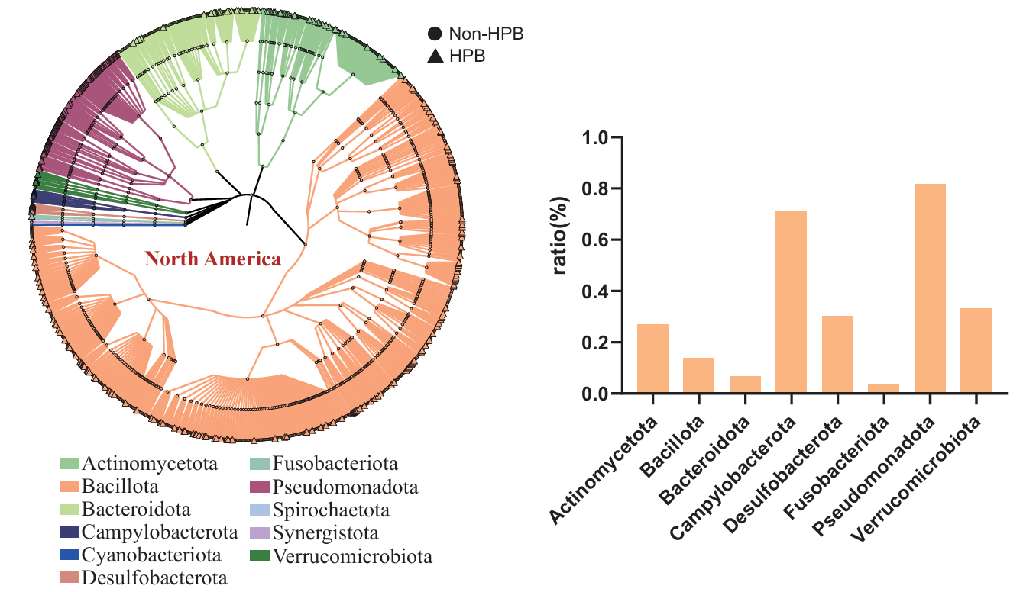
Fig. S1. Circular phylogenetic tree showing the taxonomic classification of ARG-hosting species in North America. From the innermost to the outermost rings, the layers represent phylum, class, order, family, genus, and species. The colors of the lines and nodes indicate different phyla. The outer symbols denote HPB: circles represent non-HPB, and triangles represent HPB. The accompanying bar chart indicates the proportion of pathogenic species within each phylum in North America.
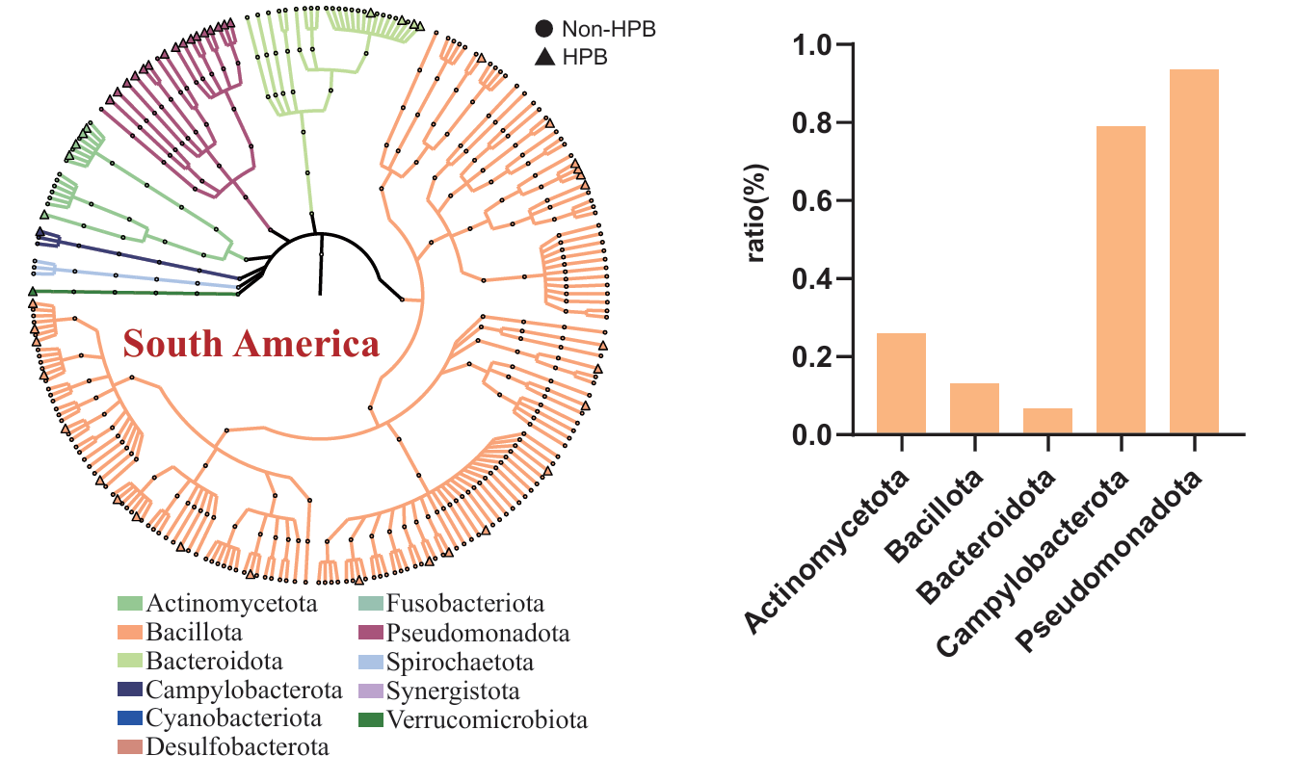
Fig. S2. Circular phylogenetic tree showing the taxonomic classification of ARG-hosting species in South America. From the innermost to the outermost rings, the layers represent phylum, class, order, family, genus, and species. The colors of the lines and nodes indicate different phyla. The outer symbols denote HPB: circles represent non-HPB, and triangles represent HPB. The accompanying bar chart indicates the proportion of pathogenic species within each phylum in South America.
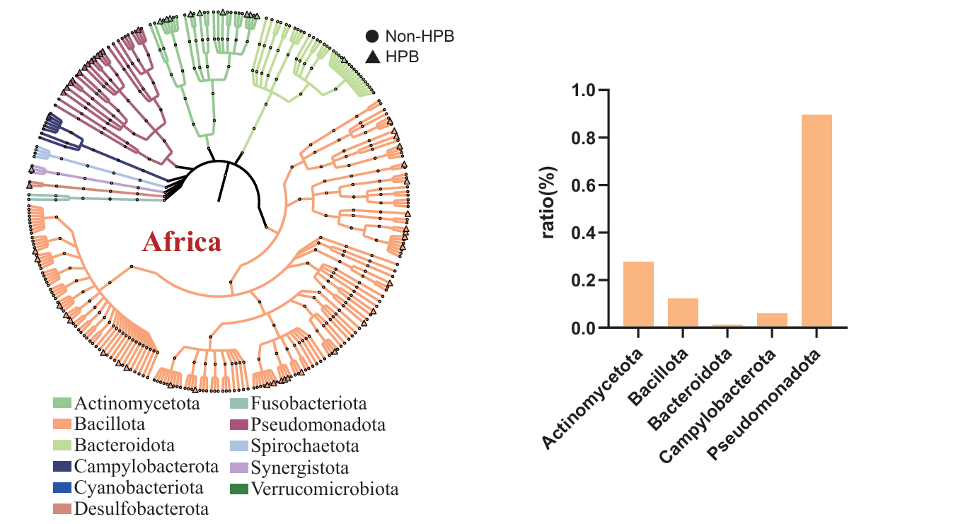
Fig. S3. Circular phylogenetic tree showing the taxonomic classification of ARG-hosting species in Africa. From the innermost to the outermost rings, the layers represent phylum, class, order, family, genus, and species. The colors of the lines and nodes indicate different phyla. The outer symbols denote human pathogenic bacteria (HPB): circles represent non-HPB, and triangles represent HPB. The accompanying bar chart indicates the proportion of pathogenic species within each phylum in Africa.

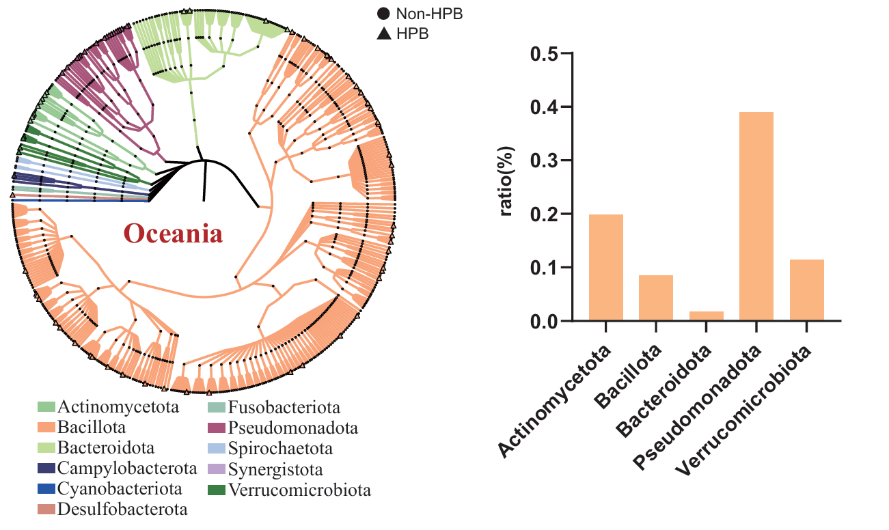
Fig. S4. Circular phylogenetic tree showing the taxonomic classification of ARG-hosting species in Oceania. From the innermost to the outermost rings, the layers represent phylum, class, order, family, genus, and species. The colors of the lines and nodes indicate different phyla. The outer symbols denote HPB: circles represent non-HPB, and triangles represent HPB. The accompanying bar chart indicates the proportion of pathogenic species within each phylum in Oceania.

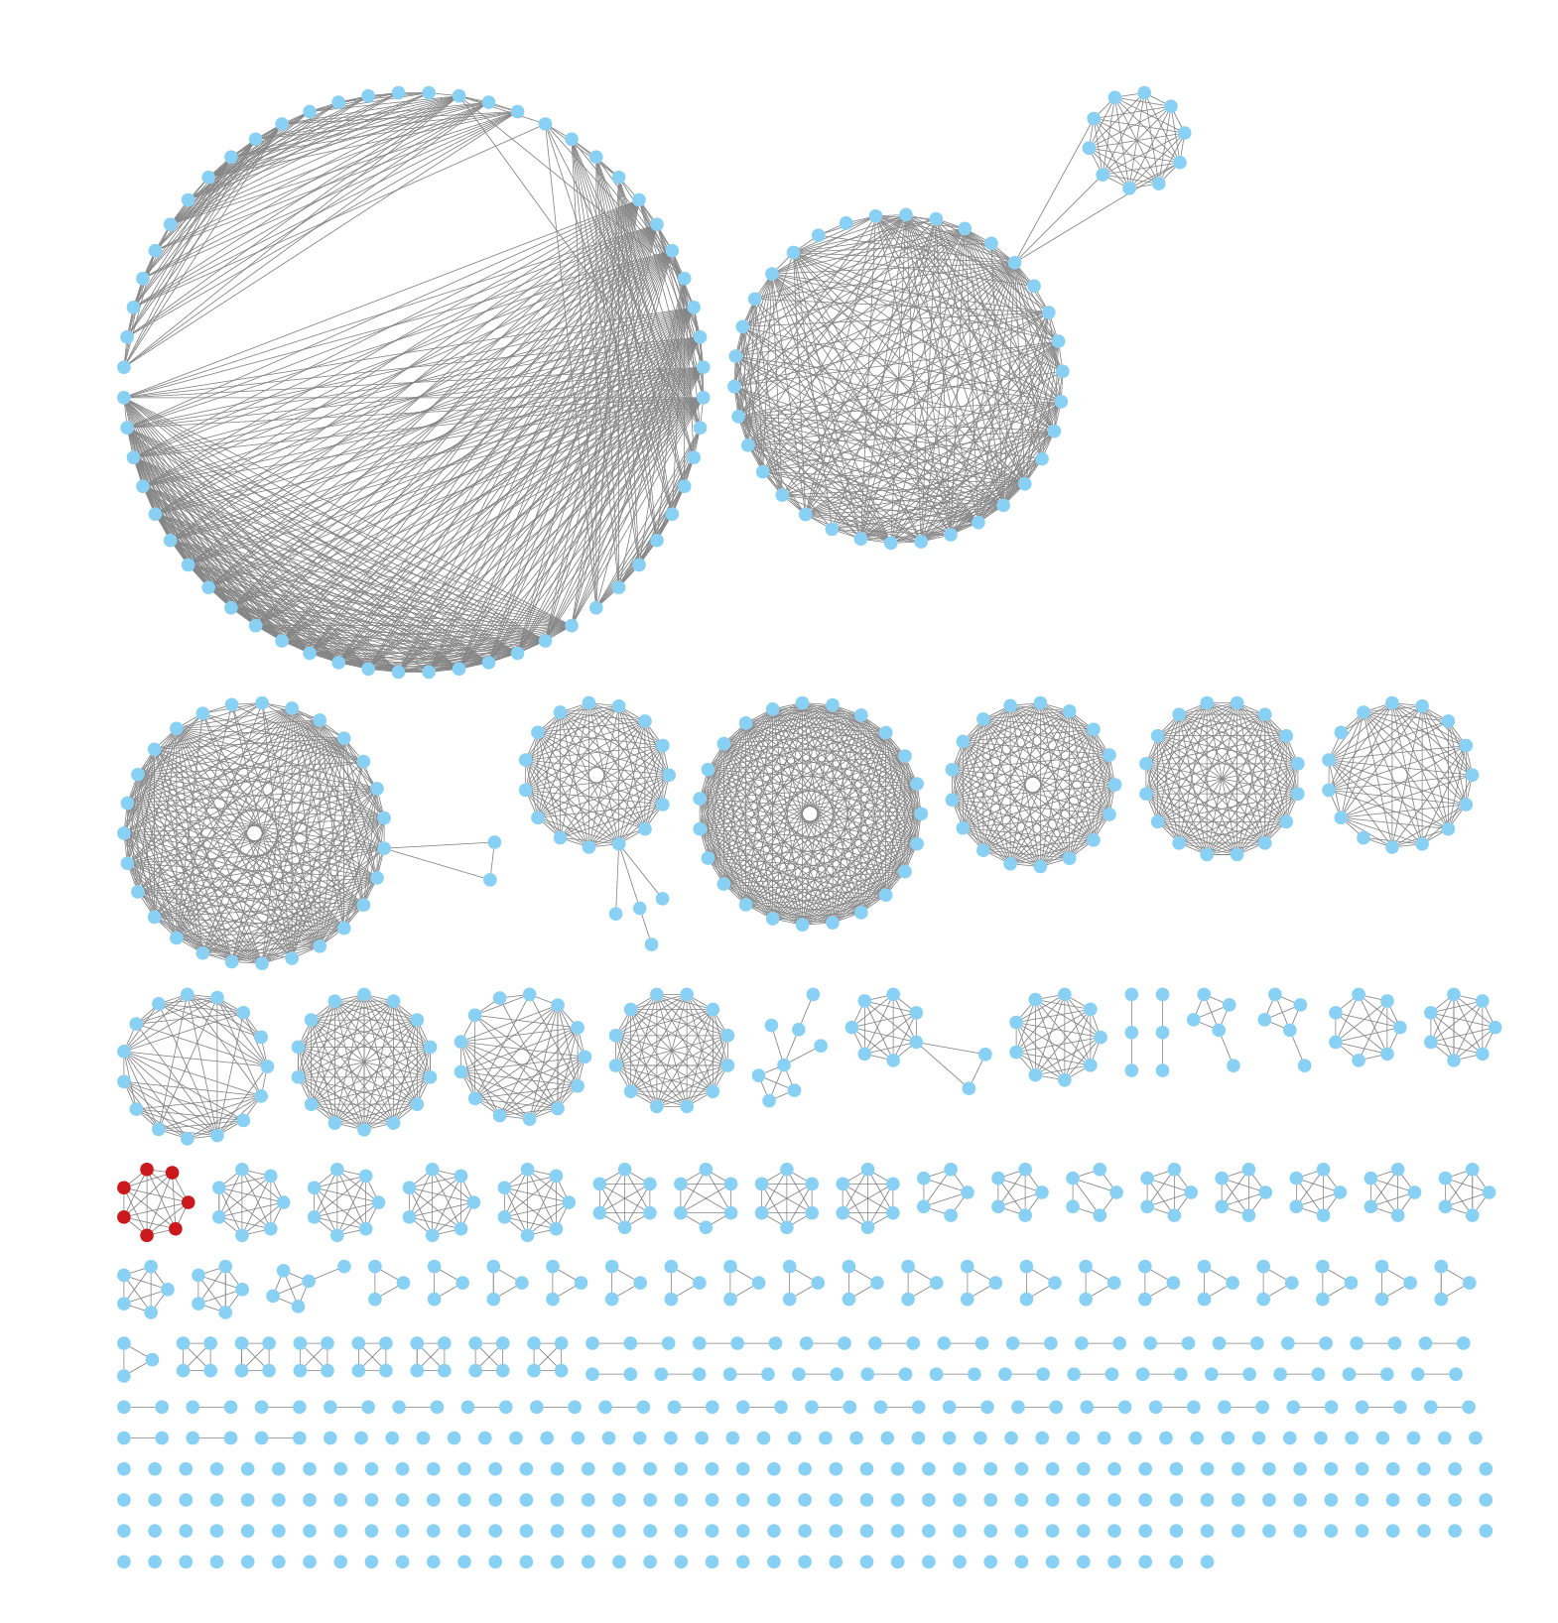
Fig. S5 Similarity-based network of potential ARGs in Africa.

