Supplementary Figure SF1: Sarcopenia Status Changes Following 6-Month Cholecalciferol Supplementation

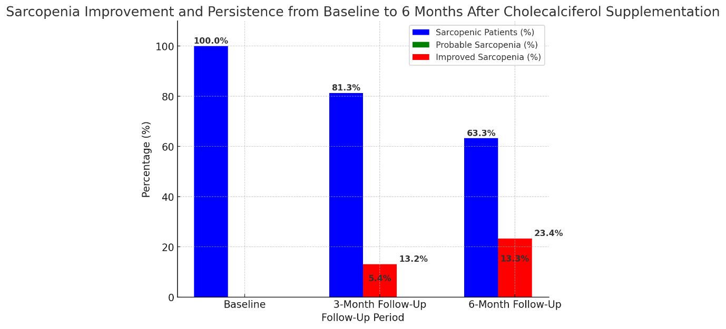

Figure shows percentage distribution of sarcopenia classifications at baseline, 3-month, and 6-month follow-up. Blue: sarcopenic patients, Green: probable sarcopenia, Red: improved sarcopenia. Baseline n=134, 6-month n=120. P<0.001.

Table S1. Longitudinal Comparison of outcome parameters- ASMI, Handgrip, MUAC, MAMC, TTF from (0 to 6 months)
 |  |  |  | *Common p-value | **p-value B/w months
Parameter | 0 month | 3 months | 6 months | *Common p-value | **p-value B/w months
Parameter | Mean ± SD. | Mean ± SD. | Mean ± SD. | *Common p-value | **p-value B/w months
ASMI (kg/m²) | 5.09 ± 1.39 | 5.45 ± 1.02 | 6.08 ± 1.53 | 0.0001** | a.0001**  b.0001**  c.0001**
Hand grip (kg) | 15.8 ± 1.39 | 17.38 ± 0.09 | 18.33 ± 1.20 | 0.0001** | a.0001**  b.0001**  c.0.001
Gait speed | 51.28 ± 2.39 | 61.32 ± 1.14 | 79.63 ± 1.23 | 0.0001** | a.0001**  b.0001**  c.001**
BMI | 19.99 ± 3.39 | 20.69 ± 1.14 | 20.99 ± 1.08 | 0.005** | a.0001**  b.0001  c.1000
MUAC | 24.51 ± 3.39 | 25.44 ± 2.03 | 25.64 ± 3.03 | 0.0001** | a.0001**  b.0001**  c.0001**
MAMC | 19.14 ± 3.09 | 19.45 ± 1.76 | 24.79 ± 1.09 | 0.0001** | a.0001**  b.0001**  c.0001**
TTF | 17.08 ± 1.09 | 19.04 ± 1.14 | 19.4 ± 1.34 | 0.0001** | a.0001**  b.0001**  c.0001**

FOOTNOTES- One-way Repeated Measures (ANOVA), showing Mean ± SD. in different timelines from baseline to 6 months &* p-value and ** p-value is estimated using Univariate &Post Hoc in Repeated measures: **(a) 0 vs. 3 months (b) 0 vs. 6 months (c) 3 vs. 6 months.

FIGURE SF 2: Longitudinal Trends in Sarcopenia-Related Parameters

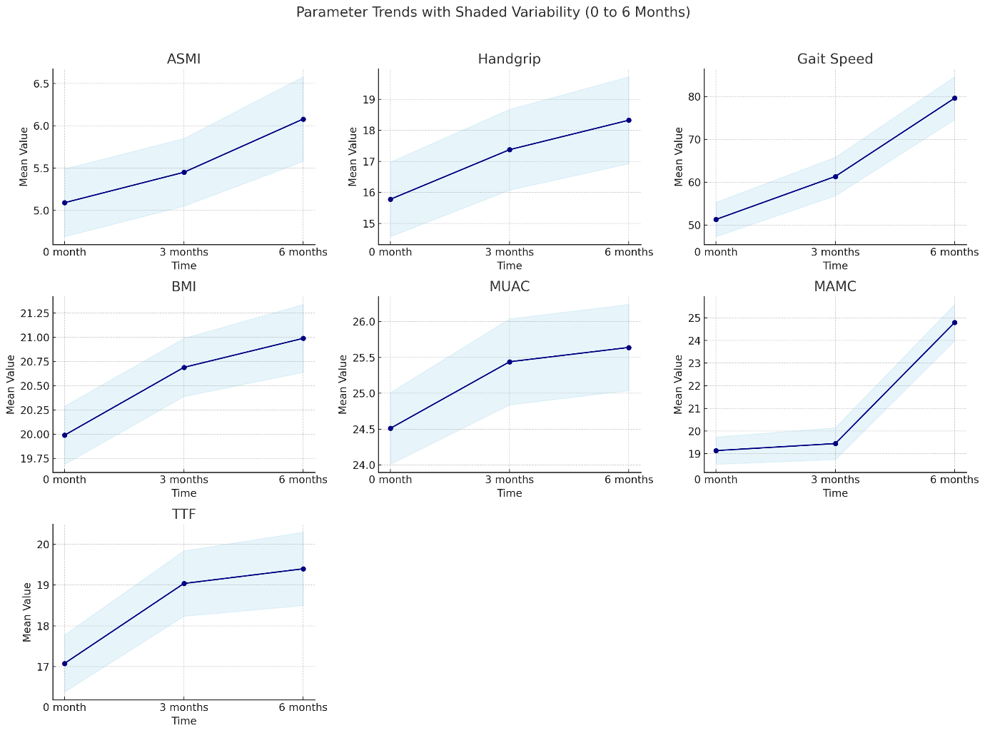

Table S3: Correlation of Serum 25(OH)D With Hormonal Parameters in Non-Responders:

Hormonal Marker | Vitamin D Deficient Non-Responders  Correlation (r) | p-value | Vitamin D Sufficient Non-Responders  Correlation (r) | p-value
Testosterone | 0.64 | 0.032* | 0.12 | 0.412
IGF-1 | 0.76 | 0.028* | –0.68 | 0.046*
HOMA-R | –0.61 | 0.041* | 0.09 | 0.532
Prolactin | 0.22 | 0.314 | 0.08 | 0.561
LH | 0.18 | 0.374 | 0.06 | 0.600
FSH | 0.14 | 0.420 | 0.02 | 0.788
Insulin | –0.16 | 0.390 | 0.05 | 0.645
T3 | 0.10 | 0.492 | 0.11 | 0.470
T4 | 0.07 | 0.601 | 0.03 | 0.738

FOOTNOTES- Correlation analysis between vitamin D levels and hormonal markers was performed separately in vitamin D–deficient and vitamin D–sufficient non-responders using Spearman’s rank correlation. Positive and negative correlation coefficients (r) indicate direct and inverse associations, respectively. p < 0.05 was considered statistically significant.
Supplementary Table S4a: Univariate and multivariate logistic regression analysis for factors associated with sarcopenia at baseline :
Variable | Univariate Analysis |  |  | Multivariate Analysis
Variable | P | OR | 95%CI | P | OR | 95%CI
Age | 0.662 | 0.78 | 0.256 - 2.374 | - | - | -
Male Gender | 0.203 | 1.956 | 0.696 - 5.493 | - | - | -
HTN | 0.489 | 0.476 | 0.058 - 3.892 | - | - | -
DM | 0.013 | 4.495 | 1.379 - 14.654 | 0.004 | 9.251 | 2.066 - 41.430
CAD | 0.276 | 0.458 | 0.112 - 1.866 | - | - | -
Dialysis Status | 0.021 | 4.03 | 1.237 - 13.128 | 0.167 | 2.678 | 0.662 - 10.833
BMI | 0.768 | 0.984 | 0.887 - 1.093 | - | - | -
MUAC | 0.006 | 1.266 | 1.070 - 1.498 | 0.148 | 1.91 | 0.794 - 4.592
TTF | 0.653 | 1.047 | 0.858 - 1.276 | - | - | -
MAMC | 0.009 | 1.242 | 1.056 - 1.461 | 0.392 | 0.695 | 0.303 - 1.598
iPTH | 0.268 | 0.999 | 0.996 - 1.001 | - | - | -
Vitamin D def | 0.017 | 1.045 | 1.008 - 1.084 | - | - | -
FOOTNOTES- Univariate and multivariate logistic regression analyses were performed to identify factors associated with non-response to vitamin D supplementation. Odds ratios (OR) with 95% confidence intervals (CI) are shown. Variables with p < 0.05 in univariate analysis were considered for multivariate analysis. p < 0.05 was considered statistically significant.

Supplementary table S4b: Univariate and Multivariate Logistic Regression Analyses for Risk Factors Associated with Sarcopenia non responder in CKD Patients
Variable | Univariate P | Univariate OR | Univariate 95% CI | Multivariate P | Multivariate OR | Multivariate 95% CI
Age >45 years | 0.045 | 1.95 | 1.015 - 3.745 | 0.08 | 1.76 | 0.927- 3.345
Male sex | 0.068 | 1.6 | 0.963 - 2.659 | - | - | -
Diabetes | 0.045 | 2.11 | 1.016 - 4.380 | 0.032 | 2.3 | 1.075 - 4.920
CAD | 0.074 | 2.76 | 0.911 - 8.373 | - | - | -
Catheter access | 0.036 | 3.15 | 1.082 - 9.180 | 0.041 | 2.98 | 1.045 - 8.509
Dialysis vintage >12 mo | 0.042 | 1.9 | 1.023 - 3.525 | 0.067 | 1.65 | 0.962 - 3.423
Low MUAC | 0.12 | 2.4 | 0.799 - 7.207 | - | - | -
Low MAMC | 0.239 | 2.55 | 0.551 - 11.809 | - | - | -
Low TTF | 0.034 | 3.35 | 1.096 - 10.235 | 0.048 | 2.9 | 1.008 - 8.353
Handgrip ↓ (per 1kg) | 0.001 | 4.12 | 1.795 - 9.459 | 0.003 | 3.95 | 1.601 - 9.748
ASMI ↓ (per 1 kg/m²) | 0.001 | 3.89 | 1.728 - 8.750 | 0.005 | 3.6 | 1.470 - 8.811
Low testosterone | 0.001 | 3.45 | 1.623 - 7.337 | 0.008 | 2.98 | 1.315 - 6.746
High prolactin | 0.004 | 2.95 | 1.404 - 6.200 | 0.022 | 2.45 | 1.143 - 5.263
High HOMA-R | 0.006 | 2.8 | 1.338 - 5.859 | 0.027 | 2.36 | 1.106 - 5.052
Low IGF-1 | 0.002 | 2.98 | 1.478 - 6.013 | 0.01 | 2.65 | 1.255 - 5.610
Low LH | 0.31 | 1.05 | 0.707 - 1.557 | - | - | -
Low FSH | 0.285 | 1.1 | 0.741 - 1.634 | - | - | -

FOOTNOTES- Univariate and multivariate logistic regression were performed to identify predictors of non-response to vitamin D supplementation among sarcopenic CKD patients. Variables with p < 0.05 in univariate analysis were included in the multivariate model. Odds ratios (OR) with 95% confidence intervals (CI) are reported. A p-value < 0.05 was considered statistically significant.

