SUPPLEMENTS

Compiled report of the R script
library(dplyr)
##
## Attaching package: 'dplyr'
## The following objects are masked from 'package:stats':
##
## filter, lag
## The following objects are masked from 'package:base':
##
## intersect, setdiff, setequal, union
library(tidyr)
library(ggplot2)
library(gridExtra)
##
## Attaching package: 'gridExtra'
## The following object is masked from 'package:dplyr':
##
## combine
library(psych)
##
## Attaching package: 'psych'
## The following objects are masked from 'package:ggplot2':
##
## %+%, alpha
d <- read.csv("/Users/dogus/Desktop/Distraction_EMME/data/Cueing_Results.csv")
# data cleaning: create scales, filter relevant scales, omit item-level data etc.
d$ultrasound_prkno <- rowMeans(d[, c("US_anat_identification", "US_interpretation", "preknowledge")],
na.rm = TRUE)
d$page_flow <- factor(d$page_flow,
levels = c("noDistractionsNoCueing",
"distractionsNoCueing",
"noDistractionsCueing",
"distractionsCueing"))
d <- d %>%
separate(page_flow, into = c("distraction", "cueing"), sep = "(?<=Distractions|distractions)(?=Cueing|NoCueing)", remove = FALSE)
d1<- d %>%
select(page_flow,
distraction,
cueing,
age,
gender,
ultrasound_prkno,
preparation,
SUM_ANATOMY_PERFORMANCE,
SUM_PRE_TIME,
SUM_POST_TIME,
SUM_PRE_PERFORMANCE,
SUM_POST_PERFORMANCE,
ICL_t1,
ICL_t2,
ICL_t3,
ECL_t1,
ECL_t2,
ECL_t3)%>%
mutate(
gender = recode(as.factor(gender), `1` = "male", `2` = "female"),
cueing = as.factor(cueing),
page_flow = as.factor(page_flow),
distraction = as.factor(distraction),
across(!c(gender, page_flow, distraction, cueing), ~ as.numeric(.)
)
)
summary(d1)
## page_flow distraction cueing age
## noDistractionsNoCueing:32 distractions :55 Cueing :55 Min. :19.00
## distractionsNoCueing :31 noDistractions:63 NoCueing:63 1st Qu.:20.00
## noDistractionsCueing :31 Median :20.00
## distractionsCueing :24 Mean :21.08
## 3rd Qu.:21.00
## Max. :40.00
## gender ultrasound_prkno preparation SUM_ANATOMY_PERFORMANCE
## male :42 Min. :1.000 Min. :1.000 Min. :1.000
## female:76 1st Qu.:1.333 1st Qu.:1.000 1st Qu.:3.000
## Median :1.667 Median :2.000 Median :4.000
## Mean :1.777 Mean :2.034 Mean :4.695
## 3rd Qu.:2.250 3rd Qu.:3.000 3rd Qu.:6.000
## Max. :3.333 Max. :4.000 Max. :9.000
## SUM_PRE_TIME SUM_POST_TIME SUM_PRE_PERFORMANCE SUM_POST_PERFORMANCE
## Min. : 151440 Min. :109572 Min. : 2.000 Min. : 4.00
## 1st Qu.: 322849 1st Qu.:163844 1st Qu.: 7.000 1st Qu.: 8.25
## Median : 385734 Median :209016 Median : 8.000 Median :10.00
## Mean : 412114 Mean :217023 Mean : 8.492 Mean :10.37
## 3rd Qu.: 467180 3rd Qu.:262248 3rd Qu.:10.000 3rd Qu.:12.00
## Max. :1313248 Max. :383583 Max. :14.000 Max. :16.00
## ICL_t1 ICL_t2 ICL_t3 ECL_t1
## Min. :1.000 Min. :1.000 Min. :1.000 Min. :1.000
## 1st Qu.:3.333 1st Qu.:3.333 1st Qu.:3.000 1st Qu.:2.000
## Median :3.667 Median :4.000 Median :3.500 Median :3.000
## Mean :3.689 Mean :3.788 Mean :3.489 Mean :2.996
## 3rd Qu.:4.333 3rd Qu.:4.333 3rd Qu.:4.000 3rd Qu.:4.000
## Max. :5.000 Max. :5.000 Max. :5.000 Max. :5.000
## ECL_t2 ECL_t3
## Min. :1.000 Min. :1.000
## 1st Qu.:3.000 1st Qu.:2.000
## Median :4.000 Median :2.750
## Mean :3.682 Mean :2.894
## 3rd Qu.:4.500 3rd Qu.:4.000
## Max. :5.000 Max. :5.000
# overview, check data quality
hist(d1$SUM_ANATOMY_PERFORMANCE)
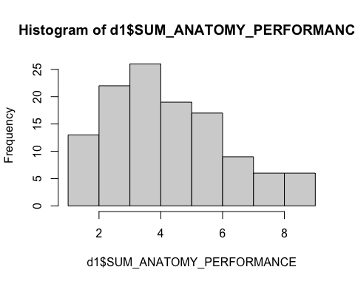
hist(d1$SUM_PRE_TIME) # one outlier detected
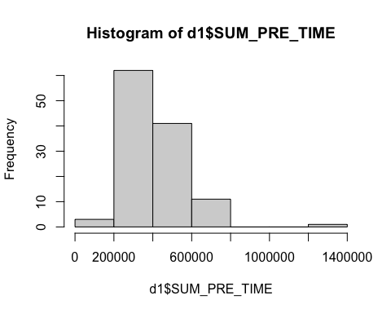
boxplot(d1$SUM_PRE_TIME) # one outlier confirmed
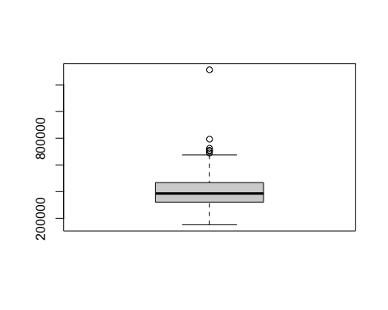
d2 <- d1[-118,] # outlier in row 118 excluded (distractionNoCueing group)
hist(d2$SUM_PRE_TIME) # check after exclusion looks good
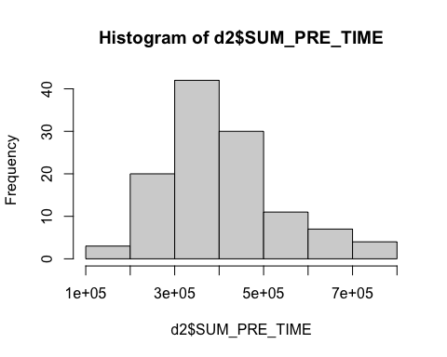
hist(d2$SUM_POST_TIME)
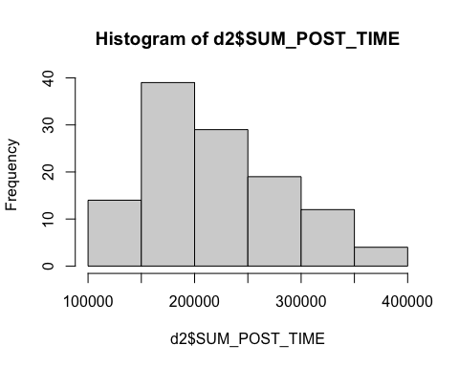
hist(d2$SUM_PRE_PERFORMANCE)
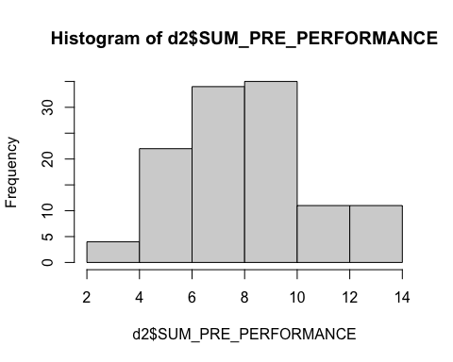
hist(d2$SUM_POST_PERFORMANCE)
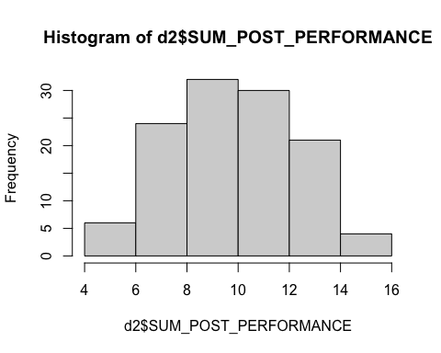
hist(d2$ICL_t1)
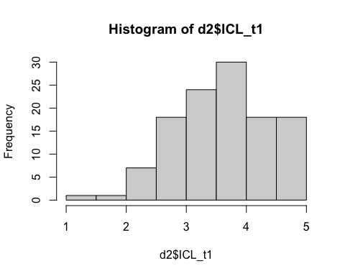
hist(d2$ICL_t2) # low variance
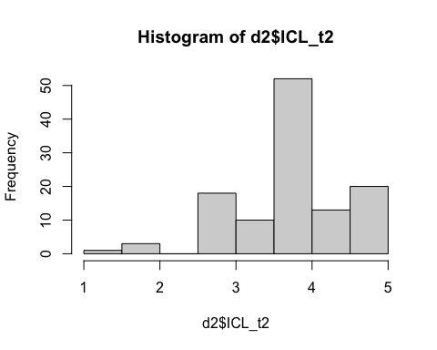
hist(d2$ICL_t3)
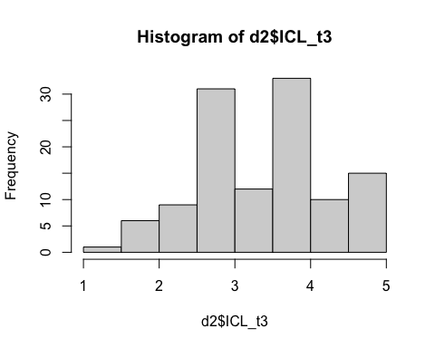
hist(d2$ECL_t1) # bimodal distribution
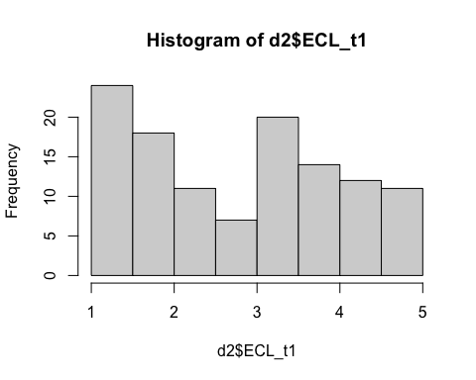
hist(d2$ECL_t2)
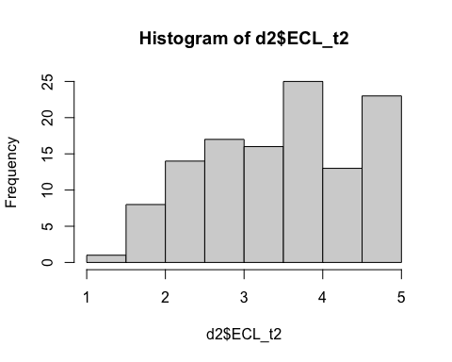
hist(d2$ECL_t3)
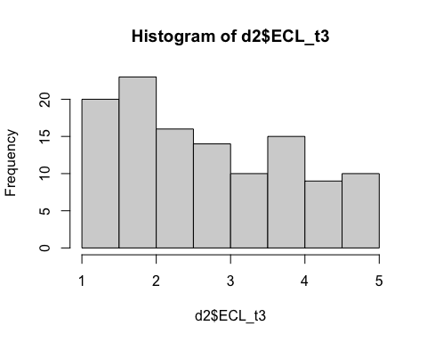
# repeated measures anova for performance (pre vs. post for distraction vs. cueing)
d2$subject_id <- seq_len(nrow(d2))
d_long <- pivot_longer(d2,
cols = c(SUM_PRE_PERFORMANCE, SUM_POST_PERFORMANCE),
names_to = "time",
values_to = "performance")
d_long$time <- factor(d_long$time, levels = c("SUM_PRE_PERFORMANCE", "SUM_POST_PERFORMANCE"))
d_long$cueing <- factor(d_long$cueing)
d_long$distraction <- factor(d_long$distraction)
anova_result <- aov(performance ~ time * cueing * distraction +
Error(subject_id/time), data = d_long)
summary(anova_result)
##
## Error: subject_id
## Df Sum Sq Mean Sq
## cueing 1 0.6206 0.6206
##
## Error: subject_id:time
## Df Sum Sq Mean Sq
## time 1 150.4 150.4
##
## Error: Within
## Df Sum Sq Mean Sq F value Pr(>F)
## time 1 56.6 56.59 9.228 0.00267 **
## cueing 1 1.1 1.09 0.177 0.67400
## distraction 1 4.2 4.16 0.678 0.41124
## time:cueing 1 31.1 31.09 5.070 0.02531 *
## time:distraction 1 44.0 44.00 7.174 0.00795 **
## cueing:distraction 1 39.6 39.63 6.463 0.01169 *
## time:cueing:distraction 1 12.2 12.21 1.991 0.15964
## Residuals 224 1373.7 6.13
## ---
## Signif. codes: 0 '***' 0.001 '**' 0.01 '*' 0.05 '.' 0.1 ' ' 1
# repeated measures anova for ecl and icl (pre, during, post for distraction vs. cueing)
d2$subject_id <- seq_len(nrow(d2))
d_long <- pivot_longer(d2,
cols = c(SUM_PRE_PERFORMANCE, SUM_POST_PERFORMANCE),
names_to = "time",
values_to = "performance")
d_long$time <- factor(d_long$time, levels = c("SUM_PRE_PERFORMANCE", "SUM_POST_PERFORMANCE"))
d_long$cueing <- factor(d_long$cueing)
d_long$distraction <- factor(d_long$distraction)
anova_result <- aov(performance ~ time * cueing * distraction +
Error(subject_id/time), data = d_long)
summary(anova_result)
##
## Error: subject_id
## Df Sum Sq Mean Sq
## cueing 1 0.6206 0.6206
##
## Error: subject_id:time
## Df Sum Sq Mean Sq
## time 1 150.4 150.4
##
## Error: Within
## Df Sum Sq Mean Sq F value Pr(>F)
## time 1 56.6 56.59 9.228 0.00267 **
## cueing 1 1.1 1.09 0.177 0.67400
## distraction 1 4.2 4.16 0.678 0.41124
## time:cueing 1 31.1 31.09 5.070 0.02531 *
## time:distraction 1 44.0 44.00 7.174 0.00795 **
## cueing:distraction 1 39.6 39.63 6.463 0.01169 *
## time:cueing:distraction 1 12.2 12.21 1.991 0.15964
## Residuals 224 1373.7 6.13
## ---
## Signif. codes: 0 '***' 0.001 '**' 0.01 '*' 0.05 '.' 0.1 ' ' 1
# Create summary statistics for plotting
d_summary <- d_long %>%
group_by(time, cueing, distraction) %>%
summarise(
mean_performance = mean(performance, na.rm = TRUE),
sd_performance = sd(performance, na.rm = TRUE),
se_performance = sd_performance / sqrt(n()),
n = n(),
.groups = 'drop'
)
# 1. Main interaction plot: Time x Cueing x Distraction
p1 <- ggplot(d_summary, aes(x = time, y = mean_performance,
color = cueing, group = cueing)) +
geom_line(size = 1.2, position = position_dodge(0.1)) +
geom_point(size = 3, position = position_dodge(0.1)) +
geom_errorbar(aes(ymin = mean_performance - se_performance,
ymax = mean_performance + se_performance),
width = 0.1, position = position_dodge(0.1)) +
facet_wrap(~ factor(distraction, levels = c("noDistractions", "distractions")),
labeller = label_both) +
scale_x_discrete(labels = c("Pre", "Post")) +
scale_color_brewer(type = "qual", palette = "Set1") +
labs(title = "Performance Over Time by Cueing and Distraction Conditions",
subtitle = "Error bars represent standard error",
x = "Time Point",
y = "Mean Performance",
color = "Cueing Condition") +
theme_bw() +
theme(axis.text.x = element_text(angle = 45, hjust = 1),
plot.title = element_text(hjust = 0.5),
plot.subtitle = element_text(hjust = 0.5))
## Warning: Using `size` aesthetic for lines was deprecated in ggplot2 3.4.0.
## ℹ Please use `linewidth` instead.
## This warning is displayed once every 8 hours.
## Call `lifecycle::last_lifecycle_warnings()` to see where this warning was
## generated.
# 2. Box plots showing distributions
p2 <- ggplot(d_long, aes(x = time, y = performance, fill = cueing)) +
geom_boxplot(position = position_dodge(0.8), alpha = 0.7) +
facet_wrap(~ distraction, labeller = label_both) +
scale_x_discrete(labels = c("Pre", "Post")) +
scale_fill_brewer(type = "qual", palette = "Set2") +
labs(title = "Distribution of Performance Scores",
x = "Time Point",
y = "Performance",
fill = "Cueing Condition") +
theme_bw() +
theme(plot.title = element_text(hjust = 0.5))
# 3. Individual trajectories plot (spaghetti plot) - grouped by distraction condition
p3 <- ggplot(d_long, aes(x = time, y = performance, group = subject_id)) +
geom_line(aes(color = cueing), alpha = 0.4) +
geom_smooth(aes(group = cueing, color = cueing),
method = "lm", se = TRUE, size = 1.5, alpha = 0.8) +
facet_wrap(~ distraction, labeller = label_both) +
scale_x_discrete(labels = c("Pre", "Post")) +
scale_color_brewer(type = "qual", palette = "Set1") +
labs(title = "Individual Trajectories by Distraction and Cueing Conditions",
subtitle = "Individual lines and group trends colored by cueing condition",
x = "Time Point",
y = "Performance",
color = "Cueing Condition") +
theme_bw() +
theme(plot.title = element_text(hjust = 0.5),
plot.subtitle = element_text(hjust = 0.5))
# 4. Change scores (Post - Pre) by conditions
d_change <- d2 %>%
mutate(change_score = SUM_POST_PERFORMANCE - SUM_PRE_PERFORMANCE)
p4 <- ggplot(d_change, aes(x = distraction, y = change_score, fill = cueing)) +
geom_boxplot(position = position_dodge(0.8), alpha = 0.7) +
geom_hline(yintercept = 0, linetype = "dashed", color = "red") +
scale_fill_brewer(type = "qual", palette = "Pastel1") +
labs(title = "Change Scores (Post - Pre) by Experimental Conditions",
subtitle = "Dashed line at zero indicates no change",
x = "Distraction Condition",
y = "Change Score (Post - Pre)",
fill = "Cueing Condition") +
theme_bw() +
theme(plot.title = element_text(hjust = 0.5),
plot.subtitle = element_text(hjust = 0.5),
axis.text.x = element_text(angle = 45, hjust = 1))
# 5. Bar plot with error bars
p5 <- ggplot(d_summary, aes(x = time, y = mean_performance, fill = cueing)) +
geom_bar(stat = "identity", position = position_dodge(0.9), alpha = 0.8) +
geom_errorbar(aes(ymin = mean_performance - se_performance,
ymax = mean_performance + se_performance),
position = position_dodge(0.9), width = 0.3) +
facet_wrap(~ distraction, labeller = label_both) +
scale_x_discrete(labels = c("Pre", "Post")) +
scale_fill_brewer(type = "qual", palette = "Set3") +
labs(title = "Mean Performance by Condition",
x = "Time Point",
y = "Mean Performance",
fill = "Cueing Condition") +
theme_bw() +
theme(plot.title = element_text(hjust = 0.5))
# Display all plots
print(p1)
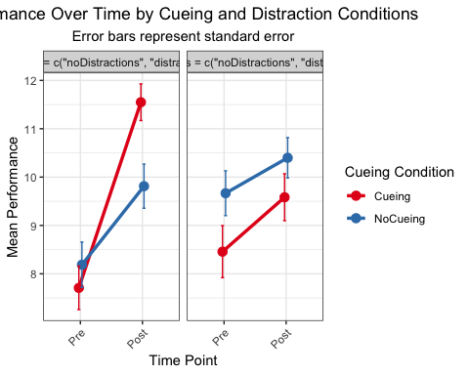
print(p2)
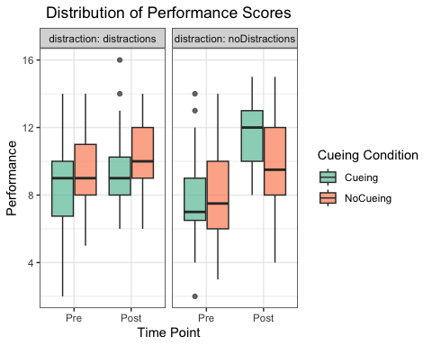
print(p3)
## `geom_smooth()` using formula = 'y ~ x'
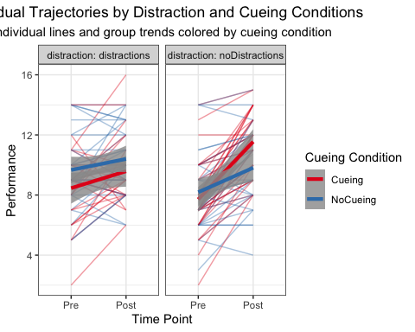
print(p4)
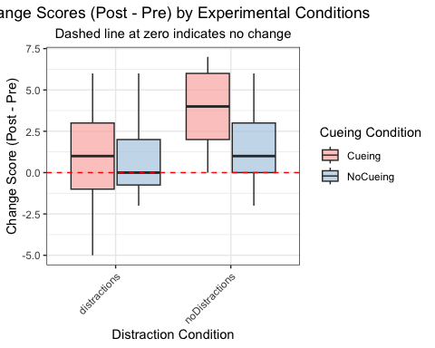
print(p5)
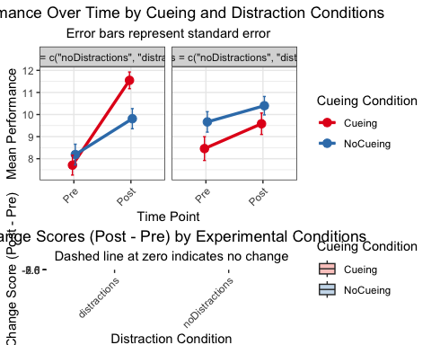
# Print statistics
print("Summary Statistics by Condition:")
## [1] "Summary Statistics by Condition:"
print(d_summary)
## # A tibble: 8 × 7
## time cueing distraction mean_performance sd_performance se_performance n
## <fct> <fct> <fct> <dbl> <dbl> <dbl> <int>
## 1 SUM_P… Cueing distractio… 8.46 2.64 0.538 24
## 2 SUM_P… Cueing noDistract… 7.71 2.51 0.450 31
## 3 SUM_P… NoCue… distractio… 9.67 2.54 0.463 30
## 4 SUM_P… NoCue… noDistract… 8.19 2.66 0.470 32
## 5 SUM_P… Cueing distractio… 9.58 2.38 0.485 24
## 6 SUM_P… Cueing noDistract… 11.5 2.11 0.379 31
## 7 SUM_P… NoCue… distractio… 10.4 2.28 0.417 30
## 8 SUM_P… NoCue… noDistract… 9.81 2.58 0.457 32
# Additional analysis: change scores
effect_sizes <- d_change %>%
group_by(cueing, distraction) %>%
summarise(
mean_change = mean(change_score, na.rm = TRUE),
sd_change = sd(change_score, na.rm = TRUE),
n = n(),
cohen_d = mean_change / sd_change,
.groups = 'drop'
)
print("Effect Sizes (Cohen's d) for Change Scores:")
## [1] "Effect Sizes (Cohen's d) for Change Scores:"
print(effect_sizes)
## # A tibble: 4 × 6
## cueing distraction mean_change sd_change n cohen_d
## <fct> <fct> <dbl> <dbl> <int> <dbl>
## 1 Cueing distractions 1.12 2.76 24 0.408
## 2 Cueing noDistractions 3.84 2.02 31 1.90
## 3 NoCueing distractions 0.733 1.96 30 0.373
## 4 NoCueing noDistractions 1.62 1.98 32 0.821
######### COGNITIVE LOAD ANALYSIS
# Create long format data for ICL measures
icl_long <- d2 %>%
select(subject_id, page_flow, distraction, cueing, ICL_t1, ICL_t2, ICL_t3) %>%
pivot_longer(cols = c(ICL_t1, ICL_t2, ICL_t3),
names_to = "time_point",
values_to = "ICL_score") %>%
mutate(time_point = factor(time_point, levels = c("ICL_t1", "ICL_t2", "ICL_t3")))
# Create long format data for ECL measures
ecl_long <- d2 %>%
select(subject_id, page_flow, distraction, cueing, ECL_t1, ECL_t2, ECL_t3) %>%
pivot_longer(cols = c(ECL_t1, ECL_t2, ECL_t3),
names_to = "time_point",
values_to = "ECL_score") %>%
mutate(time_point = factor(time_point, levels = c("ECL_t1", "ECL_t2", "ECL_t3")))
# Summary statistics for ICL
icl_summary <- icl_long %>%
group_by(time_point, cueing, distraction) %>%
summarise(
mean_icl = mean(ICL_score, na.rm = TRUE),
sd_icl = sd(ICL_score, na.rm = TRUE),
se_icl = sd_icl / sqrt(n()),
n = n(),
.groups = 'drop'
)
# Summary statistics for ECL
ecl_summary <- ecl_long %>%
group_by(time_point, cueing, distraction) %>%
summarise(
mean_ecl = mean(ECL_score, na.rm = TRUE),
sd_ecl = sd(ECL_score, na.rm = TRUE),
se_ecl = sd_ecl / sqrt(n()),
n = n(),
.groups = 'drop'
)
# SPLIT COGNITIVE LOAD INTO PHASES
# Long format for ICL & ECL
icl_long <- d2 %>%
select(subject_id, page_flow, distraction, cueing, ICL_t1, ICL_t2, ICL_t3) %>%
pivot_longer(cols = c(ICL_t1, ICL_t2, ICL_t3),
names_to = "time_point",
values_to = "ICL_score") %>%
mutate(time_point = factor(time_point,
levels = c("ICL_t1", "ICL_t2", "ICL_t3"),
labels = c("t1", "t2", "t3")))
ecl_long <- d2 %>%
select(subject_id, page_flow, distraction, cueing, ECL_t1, ECL_t2, ECL_t3) %>%
pivot_longer(cols = c(ECL_t1, ECL_t2, ECL_t3),
names_to = "time_point",
values_to = "ECL_score") %>%
mutate(time_point = factor(time_point,
levels = c("ECL_t1", "ECL_t2", "ECL_t3"),
labels = c("t1", "t2", "t3")))
# TEST PHASE (t1 vs t3)
icl_test <- icl_long %>% filter(time_point %in% c("t1", "t3"))
ecl_test <- ecl_long %>% filter(time_point %in% c("t1", "t3"))
# TRAINING PHASE (t2 only)
icl_training <- icl_long %>% filter(time_point == "t2")
ecl_training <- ecl_long %>% filter(time_point == "t2")
# RM-ANOVA: TEST PHASE (t1 vs t3)
anova_icl_test <- aov(ICL_score ~ time_point * cueing * distraction +
Error(subject_id/time_point),
data = icl_test)
anova_ecl_test <- aov(ECL_score ~ time_point * cueing * distraction +
Error(subject_id/time_point),
data = ecl_test)
cat("\n--- ICL TEST PHASE RM-ANOVA ---\n")
##
## --- ICL TEST PHASE RM-ANOVA ---
print(summary(anova_icl_test))
##
## Error: subject_id
## Df Sum Sq Mean Sq
## cueing 1 1.85 1.85
##
## Error: subject_id:time_point
## Df Sum Sq Mean Sq
## time_point 1 2.383 2.383
##
## Error: Within
## Df Sum Sq Mean Sq F value Pr(>F)
## time_point 1 0.21 0.2129 0.316 0.575
## cueing 1 0.23 0.2254 0.334 0.564
## distraction 1 1.19 1.1876 1.761 0.186
## time_point:cueing 1 0.15 0.1484 0.220 0.639
## time_point:distraction 1 1.33 1.3318 1.975 0.161
## cueing:distraction 1 0.05 0.0549 0.081 0.776
## time_point:cueing:distraction 1 0.28 0.2831 0.420 0.518
## Residuals 224 151.06 0.6744
cat("\n--- ECL TEST PHASE RM-ANOVA ---\n")
##
## --- ECL TEST PHASE RM-ANOVA ---
print(summary(anova_ecl_test))
##
## Error: subject_id
## Df Sum Sq Mean Sq
## cueing 1 3.467 3.467
##
## Error: subject_id:time_point
## Df Sum Sq Mean Sq
## time_point 1 0.3475 0.3475
##
## Error: Within
## Df Sum Sq Mean Sq F value Pr(>F)
## time_point 1 0.2 0.1745 0.113 0.737
## cueing 1 0.2 0.1591 0.103 0.749
## distraction 1 0.5 0.5347 0.345 0.557
## time_point:cueing 1 0.5 0.4870 0.314 0.576
## time_point:distraction 1 0.1 0.0815 0.053 0.819
## cueing:distraction 1 0.0 0.0179 0.012 0.914
## time_point:cueing:distraction 1 0.0 0.0260 0.017 0.897
## Residuals 224 346.9 1.5485
# Between-subjects ANOVA: TRAINING PHASE (t2)
aov_t2_icl <- aov(ICL_score ~ cueing * distraction, data = icl_training)
aov_t2_ecl <- aov(ECL_score ~ cueing * distraction, data = ecl_training)
cat("\n--- ICL TRAINING PHASE ANOVA (t2) ---\n")
##
## --- ICL TRAINING PHASE ANOVA (t2) ---
print(summary(aov_t2_icl))
## Df Sum Sq Mean Sq F value Pr(>F)
## cueing 1 0.93 0.9306 1.779 0.185
## distraction 1 0.10 0.0968 0.185 0.668
## cueing:distraction 1 0.06 0.0639 0.122 0.727
## Residuals 113 59.12 0.5232
cat("\n--- ECL TRAINING PHASE ANOVA (t2) ---\n")
##
## --- ECL TRAINING PHASE ANOVA (t2) ---
print(summary(aov_t2_ecl))
## Df Sum Sq Mean Sq F value Pr(>F)
## cueing 1 8.04 8.044 9.163 0.00306 **
## distraction 1 1.39 1.387 1.580 0.21141
## cueing:distraction 1 0.35 0.345 0.393 0.53184
## Residuals 113 99.20 0.878
## ---
## Signif. codes: 0 '***' 0.001 '**' 0.01 '*' 0.05 '.' 0.1 ' ' 1
### PLOTS
# 1. ICL Line Plot with Error Bars
p_icl_line <- ggplot(icl_summary, aes(x = time_point, y = mean_icl,
color = cueing, group = cueing)) +
geom_line(size = 1.2, position = position_dodge(0.1)) +
geom_point(size = 3, position = position_dodge(0.1)) +
geom_errorbar(aes(ymin = mean_icl - se_icl,
ymax = mean_icl + se_icl),
width = 0.1, position = position_dodge(0.1)) +
facet_wrap(~ factor(distraction, levels = c("noDistractions", "distractions")),
labeller = label_both) +
scale_x_discrete(labels = c("T1", "T2", "T3")) +
scale_color_brewer(type = "qual", palette = "Set1") +
labs(title = "Intrinsic Cognitive Load (ICL) Across Time Points",
subtitle = "Error bars represent standard error",
x = "Time Point",
y = "Mean ICL Score",
color = "Cueing Condition") +
theme_bw() +
theme(axis.text.x = element_text(angle = 0, hjust = 0.5),
plot.title = element_text(hjust = 0.5),
plot.subtitle = element_text(hjust = 0.5))
# 2. ECL Line Plot with Error Bars
p_ecl_line <- ggplot(ecl_summary, aes(x = time_point, y = mean_ecl,
color = cueing, group = cueing)) +
geom_line(size = 1.2, position = position_dodge(0.1)) +
geom_point(size = 3, position = position_dodge(0.1)) +
geom_errorbar(aes(ymin = mean_ecl - se_ecl,
ymax = mean_ecl + se_ecl),
width = 0.1, position = position_dodge(0.1)) +
facet_wrap(~ factor(distraction, levels = c("noDistractions", "distractions")),
labeller = label_both) +
scale_x_discrete(labels = c("T1", "T2", "T3")) +
scale_color_brewer(type = "qual", palette = "Set1") +
labs(title = "Extraneous Cognitive Load (ECL) Across Time Points",
subtitle = "Error bars represent standard error",
x = "Time Point",
y = "Mean ECL Score",
color = "Cueing Condition") +
theme_bw() +
theme(axis.text.x = element_text(angle = 0, hjust = 0.5),
plot.title = element_text(hjust = 0.5),
plot.subtitle = element_text(hjust = 0.5))
# 5. Individual Trajectories for ICL (Spaghetti Plot)
p_icl_spaghetti <- ggplot(icl_long, aes(x = time_point, y = ICL_score, group = subject_id)) +
geom_line(aes(color = cueing), alpha = 0.4) +
geom_smooth(aes(group = cueing, color = cueing),
method = "lm", se = TRUE, size = 1.5, alpha = 0.8) +
facet_wrap(~ distraction, labeller = label_both) +
scale_x_discrete(labels = c("T1", "T2", "T3")) +
scale_color_brewer(type = "qual", palette = "Set1") +
labs(title = "Individual ICL Trajectories Across Time Points",
subtitle = "Individual lines and group trends colored by cueing condition",
x = "Time Point",
y = "ICL Score",
color = "Cueing Condition") +
theme_bw() +
theme(plot.title = element_text(hjust = 0.5),
plot.subtitle = element_text(hjust = 0.5))
# 6. Individual Trajectories for ECL (Spaghetti Plot)
p_ecl_spaghetti <- ggplot(ecl_long, aes(x = time_point, y = ECL_score, group = subject_id)) +
geom_line(aes(color = cueing), alpha = 0.4) +
geom_smooth(aes(group = cueing, color = cueing),
method = "lm", se = TRUE, size = 1.5, alpha = 0.8) +
facet_wrap(~ distraction, labeller = label_both) +
scale_x_discrete(labels = c("T1", "T2", "T3")) +
scale_color_brewer(type = "qual", palette = "Set1") +
labs(title = "Individual ECL Trajectories Across Time Points",
subtitle = "Individual lines and group trends colored by cueing condition",
x = "Time Point",
y = "ECL Score",
color = "Cueing Condition") +
theme_bw() +
theme(plot.title = element_text(hjust = 0.5),
plot.subtitle = element_text(hjust = 0.5))
# Display all plots
print(p_icl_line)
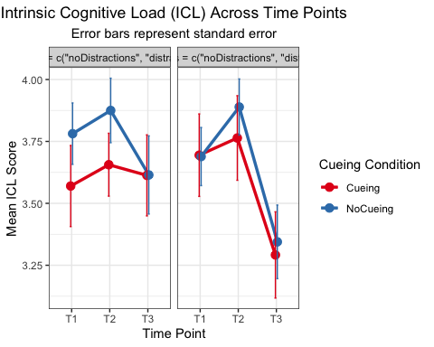
print(p_ecl_line)
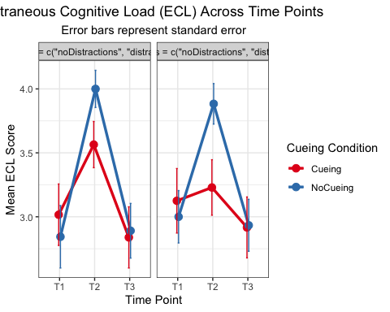
print(p_icl_spaghetti)
## `geom_smooth()` using formula = 'y ~ x'
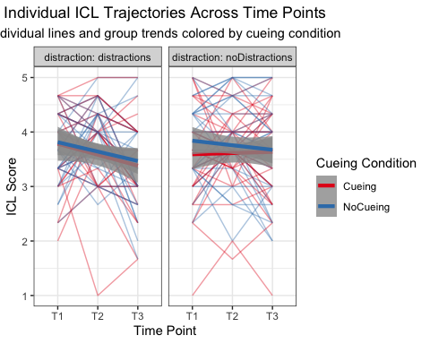
print(p_ecl_spaghetti)
## `geom_smooth()` using formula = 'y ~ x'
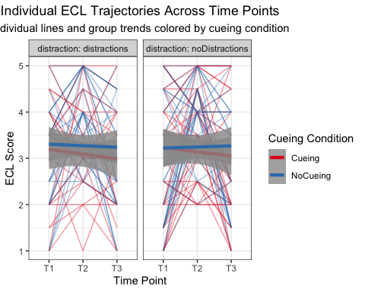
# Print summary statistics
print("ICL Summary Statistics by Condition and Time Point:")
## [1] "ICL Summary Statistics by Condition and Time Point:"
print(icl_summary)
## # A tibble: 12 × 7
## time_point cueing distraction mean_icl sd_icl se_icl n
## <fct> <fct> <fct> <dbl> <dbl> <dbl> <int>
## 1 ICL_t1 Cueing distractions 3.69 0.816 0.167 24
## 2 ICL_t1 Cueing noDistractions 3.57 0.912 0.164 31
## 3 ICL_t1 NoCueing distractions 3.69 0.643 0.117 30
## 4 ICL_t1 NoCueing noDistractions 3.78 0.701 0.124 32
## 5 ICL_t2 Cueing distractions 3.76 0.837 0.171 24
## 6 ICL_t2 Cueing noDistractions 3.66 0.707 0.127 31
## 7 ICL_t2 NoCueing distractions 3.89 0.621 0.113 30
## 8 ICL_t2 NoCueing noDistractions 3.88 0.737 0.130 32
## 9 ICL_t3 Cueing distractions 3.29 0.853 0.174 24
## 10 ICL_t3 Cueing noDistractions 3.61 0.911 0.164 31
## 11 ICL_t3 NoCueing distractions 3.34 0.814 0.149 30
## 12 ICL_t3 NoCueing noDistractions 3.61 0.892 0.158 32
print("ECL Summary Statistics by Condition and Time Point:")
## [1] "ECL Summary Statistics by Condition and Time Point:"
print(ecl_summary)
## # A tibble: 12 × 7
## time_point cueing distraction mean_ecl sd_ecl se_ecl n
## <fct> <fct> <fct> <dbl> <dbl> <dbl> <int>
## 1 ECL_t1 Cueing distractions 3.12 1.24 0.252 24
## 2 ECL_t1 Cueing noDistractions 3.02 1.34 0.240 31
## 3 ECL_t1 NoCueing distractions 3 1.12 0.205 30
## 4 ECL_t1 NoCueing noDistractions 2.84 1.38 0.244 32
## 5 ECL_t2 Cueing distractions 3.23 1.06 0.217 24
## 6 ECL_t2 Cueing noDistractions 3.56 1.01 0.181 31
## 7 ECL_t2 NoCueing distractions 3.88 0.868 0.158 30
## 8 ECL_t2 NoCueing noDistractions 4 0.823 0.145 32
## 9 ECL_t3 Cueing distractions 2.92 1.17 0.238 24
## 10 ECL_t3 Cueing noDistractions 2.84 1.33 0.239 31
## 11 ECL_t3 NoCueing distractions 2.93 1.11 0.203 30
## 12 ECL_t3 NoCueing noDistractions 2.89 1.21 0.214 32
###### ADDITIONAL DESCRIPTIVES
desc_stats <- d_change %>%
select(age, gender, ultrasound_prkno, preparation, SUM_ANATOMY_PERFORMANCE)
print("Descriptive Statistics:")
## [1] "Descriptive Statistics:"
print(summary(desc_stats))
## age gender ultrasound_prkno preparation
## Min. :19.00 male :42 Min. :1.000 Min. :1.000
## 1st Qu.:20.00 female:75 1st Qu.:1.333 1st Qu.:1.000
## Median :20.00 Median :1.667 Median :2.000
## Mean :21.09 Mean :1.775 Mean :2.017
## 3rd Qu.:21.00 3rd Qu.:2.333 3rd Qu.:3.000
## Max. :40.00 Max. :3.333 Max. :4.000
## SUM_ANATOMY_PERFORMANCE
## Min. :1.000
## 1st Qu.:3.000
## Median :4.000
## Mean :4.684
## 3rd Qu.:6.000
## Max. :9.000
print("Extended Descriptive Statistics (numeric variables):")
## [1] "Extended Descriptive Statistics (numeric variables):"
print(describe(select(desc_stats, -gender)))
## vars n mean sd median trimmed mad min max range
## age 1 117 21.09 2.35 20.00 20.65 1.48 19 40.00 21.00
## ultrasound_prkno 2 117 1.77 0.59 1.67 1.73 0.49 1 3.33 2.33
## preparation 3 117 2.02 1.03 2.00 1.91 1.48 1 4.00 3.00
## SUM_ANATOMY_PERFORMANCE 4 117 4.68 1.97 4.00 4.59 1.48 1 9.00 8.00
## skew kurtosis se
## age 4.89 33.88 0.22
## ultrasound_prkno 0.56 -0.40 0.05
## preparation 0.66 -0.77 0.10
## SUM_ANATOMY_PERFORMANCE 0.41 -0.44 0.18
print("Gender Distribution:")
## [1] "Gender Distribution:"
print(table(desc_stats$gender))
##
## male female
## 42 75

