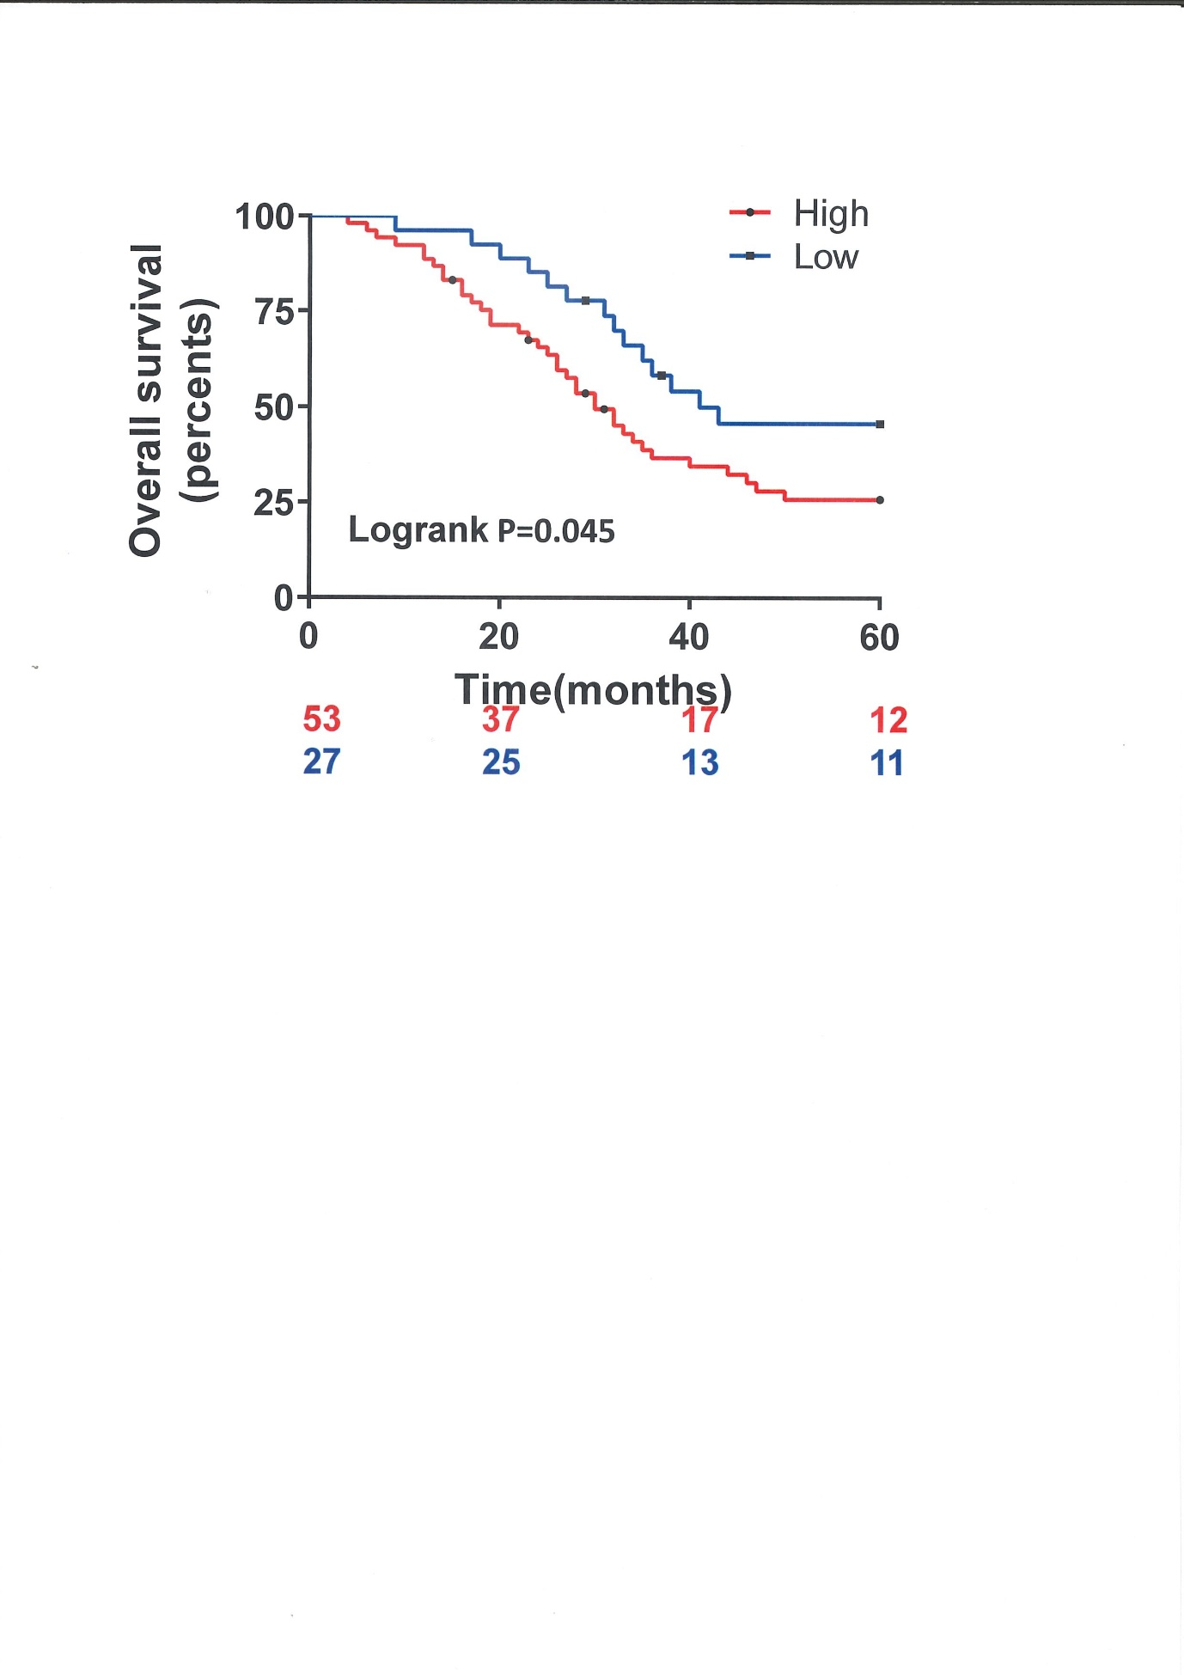

Fig. S1. (A) Kaplan-Meier survival curves and log-rank test analysis show the association between PGK1 expression and lung cancer patients' overall survival. The number under the curve indicates the number of patients at risk.

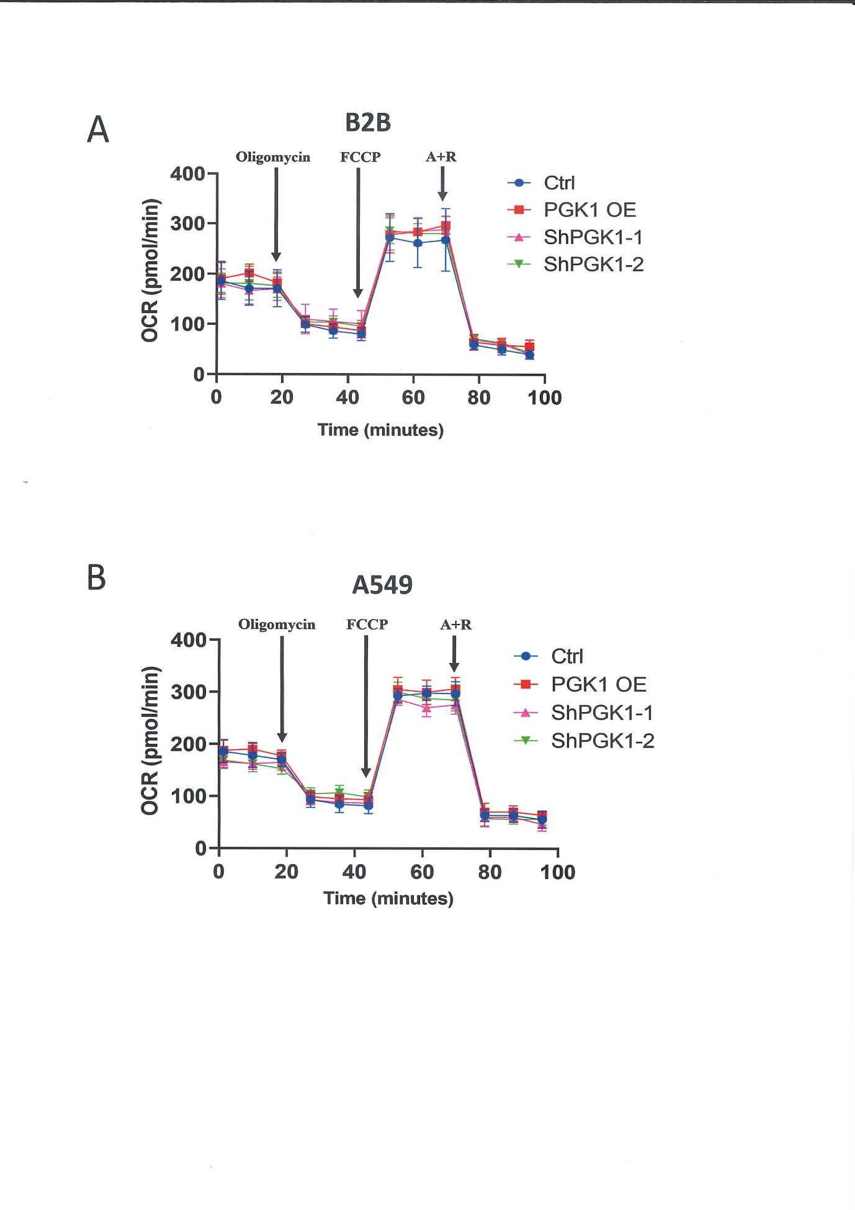

Fig. S2. The mitochondrial function did not change when PGK1 was dysregulated. (A-B) Oxygen consumption rate data in B2B (A) and A549 (B) cells transfected with control, PGK1-overexpression, or PGK1 shRNAs. FCCP, Carbonyl cyanide-4-(trifluoromethoxy) phenylhydrazone; A+R, Antimycin A, and Rotenone. Data are presented as mean + SD, n=3. A student's t-test with a two-tailed distribution was used to evaluate the significance.

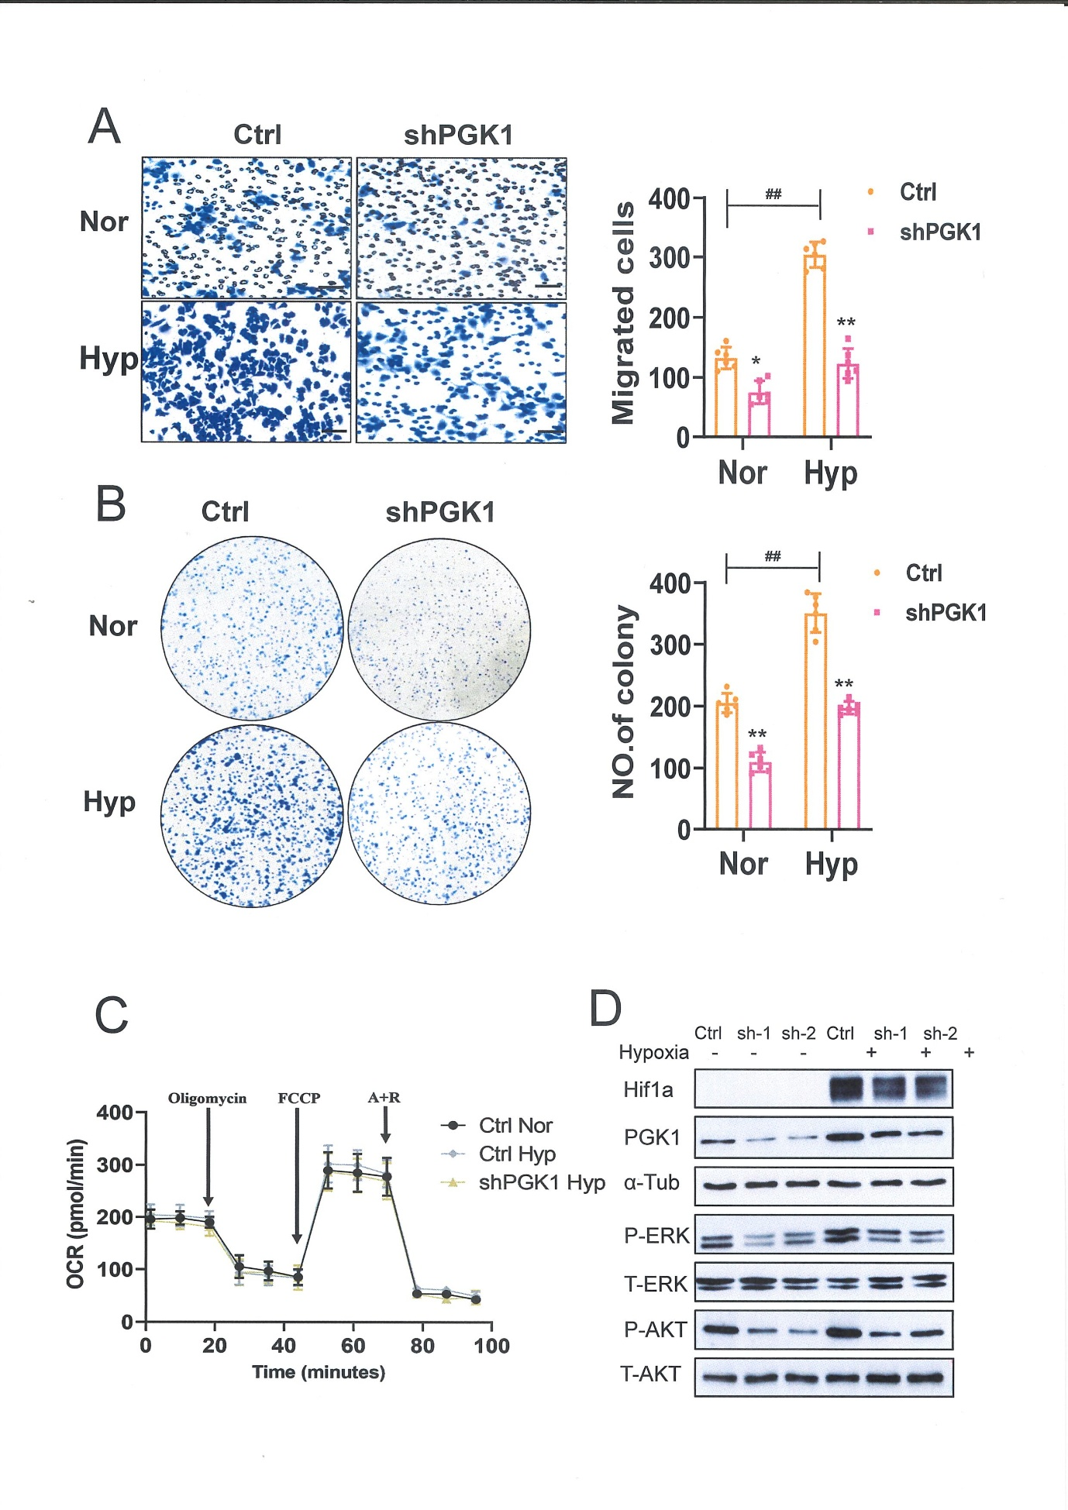

Fig. S3. PGK1 plays a role in hypoxia-induced lung cancer metastasis. (A) Boyden chamber migration assay and correspondence quantification of cells per field (right panel) with A549 cells transfected with control or shPGK1 vector treated or not treated under hypoxia. (B) Plate colony formation assay and correspondence quantification of colonies per field (right panel) with A549 cells transfected with control or shPGK1 vector treated or not treated under hypoxia. (C) Oxygen consumption rate data from A549 cells transfected with control or shPGK1 vector treated or not treated under hypoxia. FCCP, Carbonyl cyanide-4-(trifluoromethoxy) phenylhydrazone; A+R, Antimycin A, and Rotenone. Data are presented as mean + SD. n=4. Statistical analysis was performed using a student's t-test with the two-tailed distribution. (D) Western blot analysis of HIF1α, PGK1, activated AKT, ERK, and total AKT, ERK A549 cells transfected with control or shPGK1 vector treated or not treated under hypoxia. α -Tub, α-tubulin.

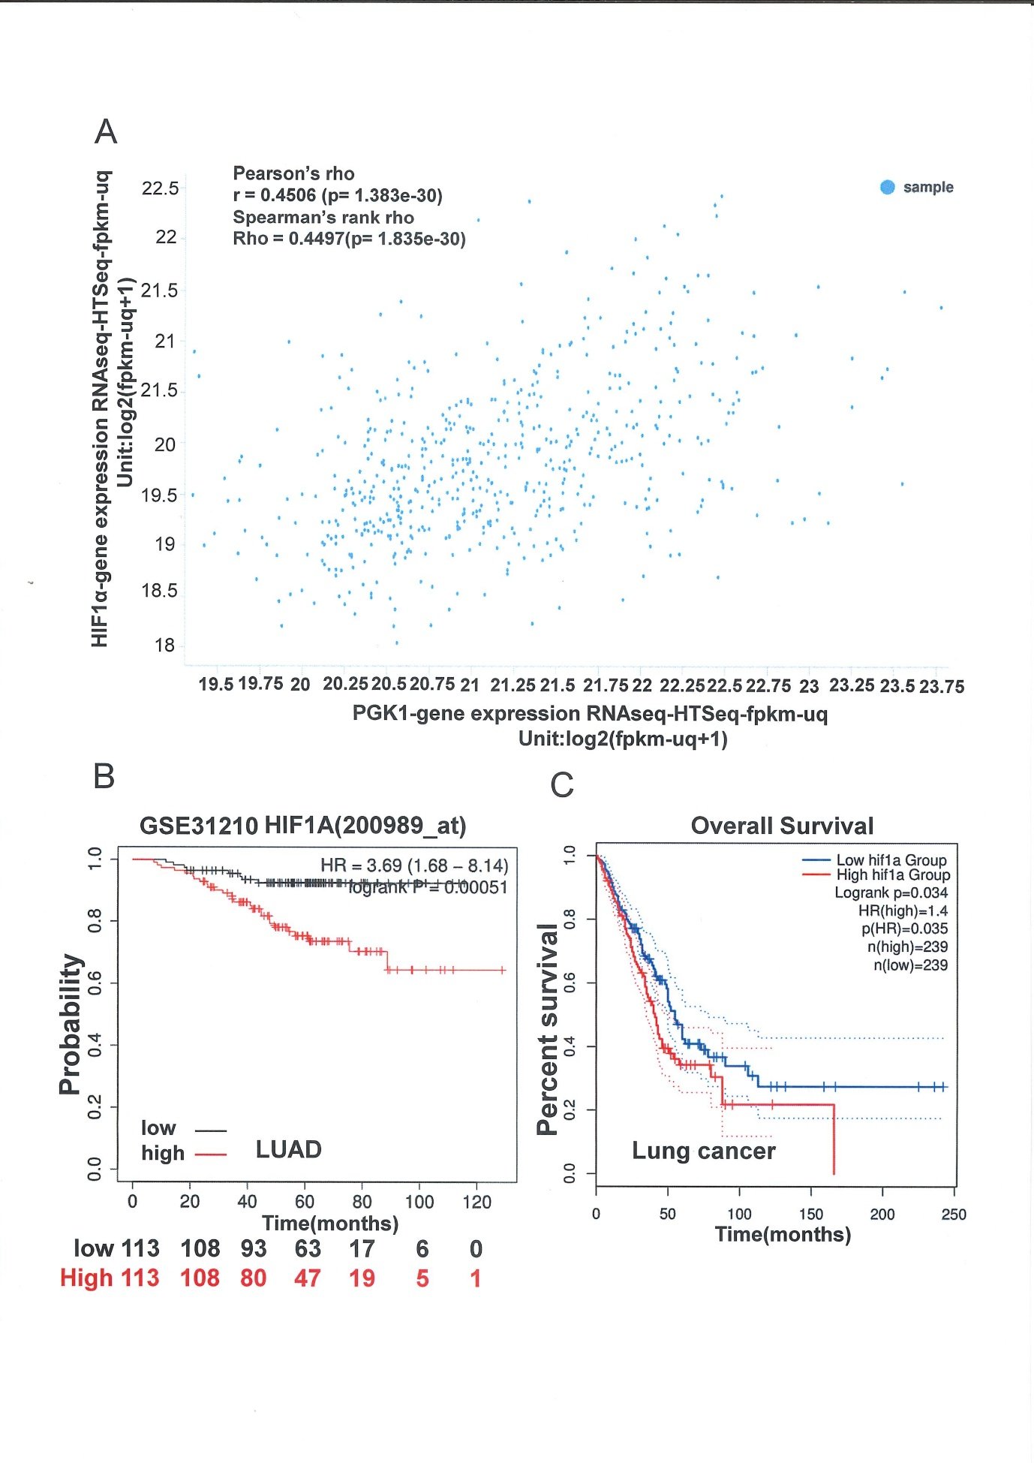

Fig. S4. (A) The correlation analysis between the HIF1α gene expression level and PGK1 gene expression level in TCGA lung cancer patients. Data were obtained from UCSC Xena. (B) Kaplan-Meier analysis of HIF1α expression at low or high levels at the endpoint of overall survival probability in GSE31210 patients with lung adenocarcinoma. (B) Kaplan-Meier analysis of HIF1α expression at low or high levels at the endpoint of overall survival probability in TCGA database patients with lung cancer. Data was obtained from GEPIA2.

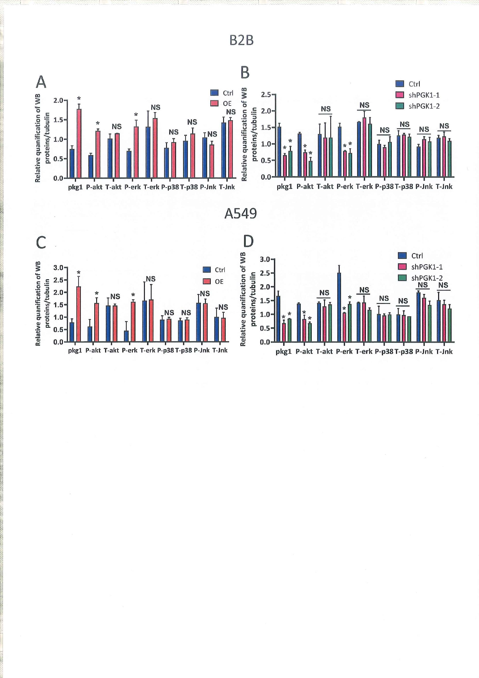

Fig. S5. Quantitative analysis for the WB of Figure 6. Data are shown as mean ± SD. *, p<0.05. NS, no significance. Statistical analysis was performed by student's t-test with a two-tailed distribution.

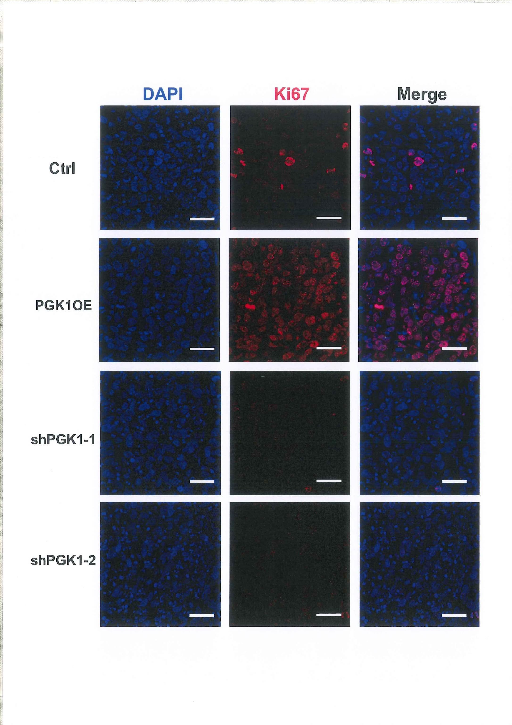

Fig. S6. Ki-67 immunofluorescence of representative different groups of transplanted tumors. Scale bar, 20 μm.

