Supplements
1 The Shanghai Sleep Health Study Cohort 2
1.1 Correlation Heatmap in the SSHSC 2
1.2 Post-hoc Explanation in Machine Learning in the SSHSC 3
2 The Sleep Heart Health Study 4
2.1 Correlation Heatmap in the SHHS 4
2.2 Post-hoc Explanation in Machine Learning in the SHHS 4
2.3 Model Evaluation and Comparison in the SHHS 7
2.4 Survival Analysis 8
2.5 Restricted Cubic Spline 18
3 Dependence Plots 20
3.1 Dependence Plots of Sleep Temporal Entropy in the SSHSC 20
3.2 Dependence Plots of Stage-Specific Temporal Entropy in the SHHS 24

1 The Shanghai Sleep Health Study Cohort

1.1 Correlation Heatmap in the SSHSC
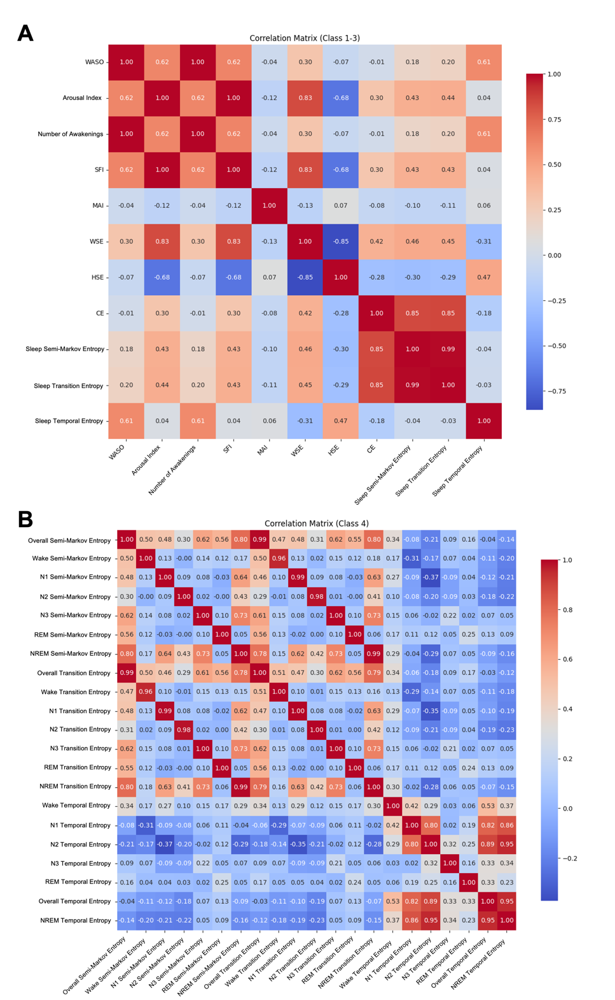
Correlation matrices of sleep fragmentation metrics categorized into different classes: Panel A represents metrics from Class 1–3 in the SSHSC cohort: Class 1 includes traditional metrics such as WASO and Arousal Index (ArI); Class 2 consists of entropy-based metrics, including Haar Spectral Entropy (HSE), Walsh Spectral Entropy (WSE), and Conditional Entropy (CE); Class 3 introduces novel markers, such as Transition Entropy, Temporal Entropy, and Semi-Markov Entropy. Panel B extends the analysis to Class 4, including stage-specific entropy metrics (e.g., NREM, REM, N1, N2, and N3 STE), highlighting correlations across sleep stages and overall temporal entropy. Correlation coefficients are color-coded, with red representing strong positive correlations and blue indicating strong negative correlations.

1.2 Post-hoc Explanation in Machine Learning in the SSHSC

Table 1-1: Performance of XGBoost Model for Predicting Disease Outcomes
 | Accuracy | Precision | Recall | F1 | ROC AUC
Hypertension | 0.737 | 0.521 | 0.295 | 0.375 | 0.697
Diabetes | 0.810 | 0.295 | 0.500 | 0.369 | 0.754
Hyperlipidemia | 0.630 | 0.606 | 0.720 | 0.658 | 0.669
All models used XGBoost (XGBClassifier) with binary: logistic as the objective function for binary classification tasks. Cross-validation: A 5-fold cross-validation strategy was employed, with each fold using training and validation to evaluate model performance, ensuring robust generalization.

2 The Sleep Heart Health Study

2.1 Correlation Heatmap in the SHHS
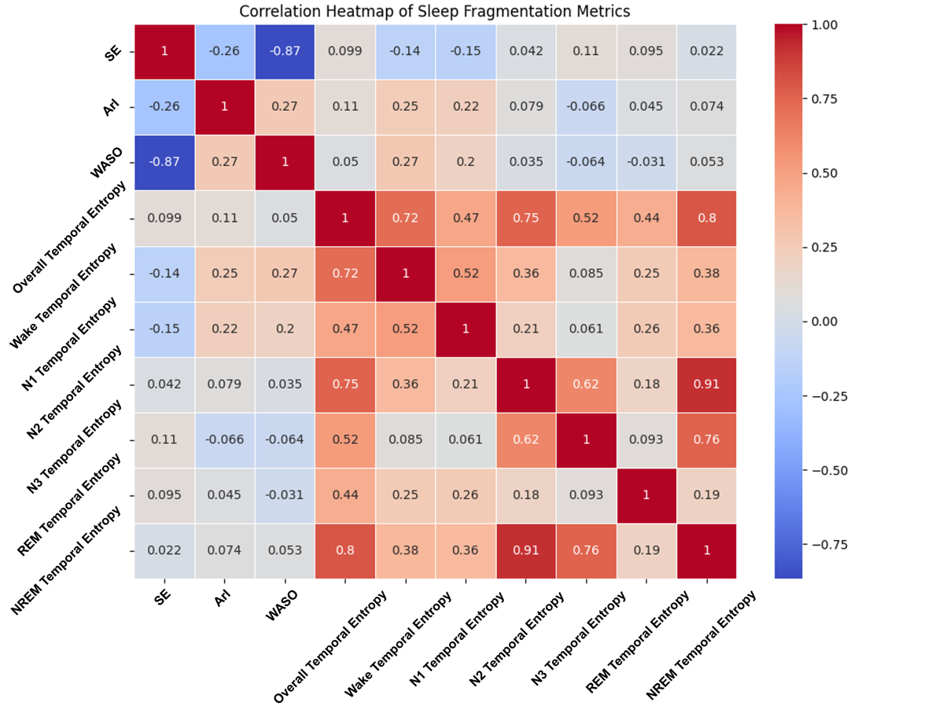
Correlation heatmap of sleep fragmentation metrics in the SHHS cohort: Comparing traditional metrics (Sleep Efficiency [SE], Arousal Index [ArI], and WASO) with both whole-night and stage-specific Time Entropy. This analysis builds on findings from the SSHSC, where Time Entropy demonstrated superior overall performance. The heatmap illustrates the relationships between traditional and entropy-based metrics, with red indicating positive correlations and blue representing negative correlations.

2.2 Post-hoc Explanation in Machine Learning in the SHHS

Table 2-1: Performance of Different Machine Learning Models for Predicting All-Cause Mortality
Model |  | Accuracy | Precision | Recall | ROC AUC
XGBoost | 5-Fold CV Mean | 0.861 | 0.670 | 0.243 | 0.812
 | Test | 0.870 | 0.650 | 0.250 | 0.836
RF | 5-Fold CV Mean | 0.838 | 0.489 | 0.498 | 0.818
 | Test | 0.847 | 0.496 | 0.611 | 0.853
SVM | 5-Fold CV Mean | 0.725 | 0.329 | 0.713 | 0.792
 | Test | 0.864 | 0.634 | 0.246 | 0.826
KNN | 5-Fold CV Mean | 0.828 | 0.421 | 0.232 | 0.667
 | Test | 0.821 | 0.337 | 0.186 | 0.637
Logistic Regression | 5-Fold CV Mean | 0.709 | 0.321 | 0.75 | 0.793
 | Test | 0.724 | 0.331 | 0.805 | 0.829
Performance metrics of different machine learning models for predicting all-cause mortality in the SHHS cohort. Metrics include accuracy, precision, recall, and ROC AUC, presented for both 5-fold cross-validation (CV) means and test datasets. Models evaluated include XGBoost, Random Forest (RF), Support Vector Machine (SVM), k-Nearest Neighbors (KNN), and Logistic Regression. ROC AUC reflects the area under the receiver operating characteristic curve, while precision and recall evaluate the balance between positive predictions and actual positive cases. XGBoost and RF demonstrated the highest ROC AUC values across both cross-validation and test datasets.

Table 2-2: Performance of Different Machine Learning Models for Predicting CVD Mortality
Model |  | Accuracy | Precision | Recall | ROC AUC
XGBoost | 5-Fold CV Mean | 0.952 | 0.326 | 0.036 | 0.864
 | Test | 0.952 | 0.600 | 0.075 | 0.838
RF | 5-Fold CV Mean | 0.937 | 0.345 | 0.272 | 0.858
 | Test | 0.934 | 0.34 | 0.375 | 0.796
SVM | 5-Fold CV Mean | 0.772 | 0.144 | 0.774 | 0.846
 | Test | 0.951 | 0.500 | 0.025 | 0.815
KNN | 5-Fold CV Mean | 0.941 | 0.109 | 0.026 | 0.591
 | Test | 0.939 | 0 | 0 | 0.545
Logistic Regression | 5-Fold CV Mean | 0.765 | 0.149 | 0.838 | 0.849
 | Test | 0.759 | 0.134 | 0.725 | 0.804
Performance metrics of different machine learning models for predicting CVD mortality in the SHHS cohort. Metrics include accuracy, precision, recall, and ROC AUC, presented for both 5-fold cross-validation (CV) means and test datasets. Models evaluated include XGBoost, Random Forest (RF), Support Vector Machine (SVM), k-Nearest Neighbors (KNN), and Logistic Regression. ROC AUC reflects the area under the receiver operating characteristic curve, while precision and recall evaluate the balance between positive predictions and actual positive cases. XGBoost and RF demonstrated the highest ROC AUC values across both cross-validation and test datasets.

2.3 Model Evaluation and Comparison in the SHHS
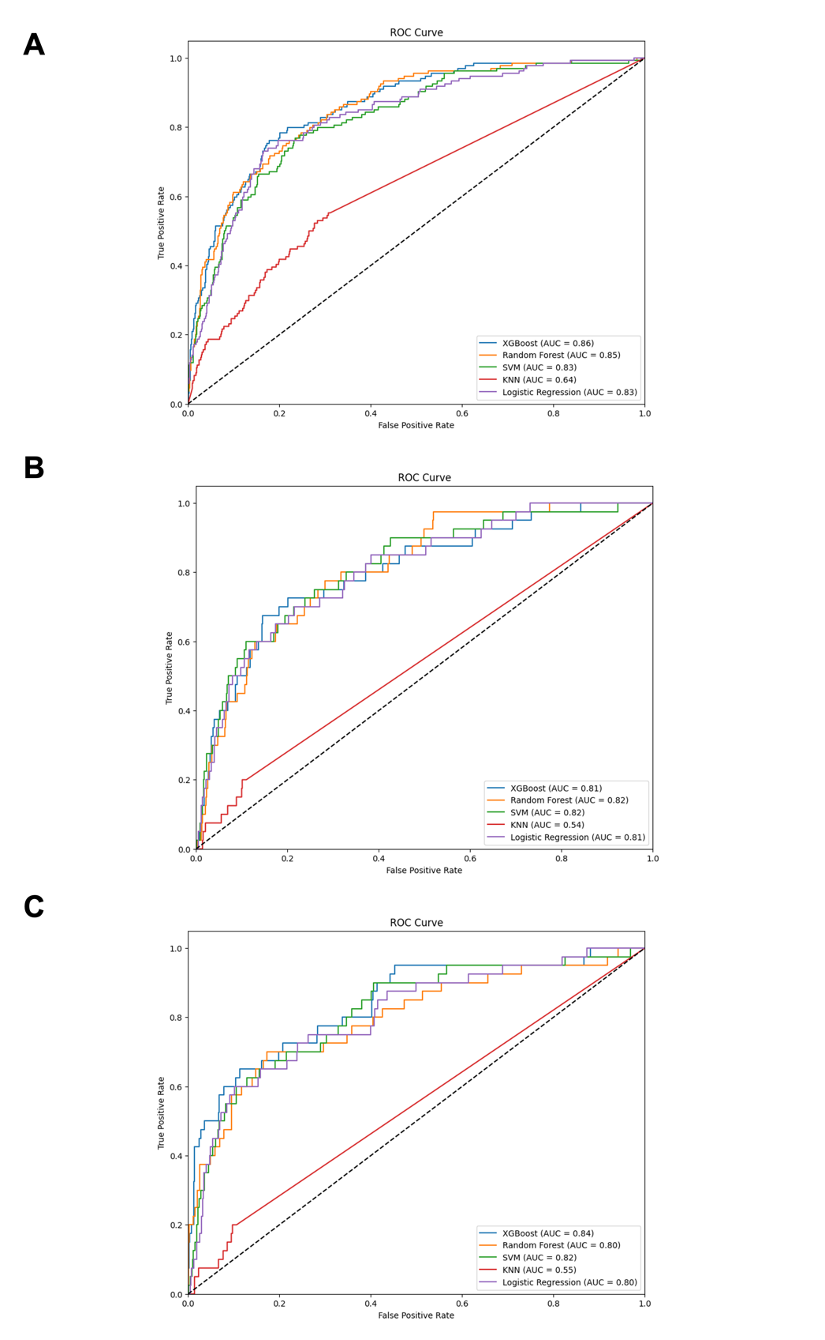
Panels A–C represent the Receiver Operating Characteristic (ROC) curves for different models: (A) Whole-Night Metrics for All-Cause Mortality, (B) Whole-Night Metrics for CVD Mortality, and (C) Stage-Specific Metrics for CVD Mortality. Each panel compares the performance of various machine learning models, including XGBoost, Random Forest, SVM, KNN, and Logistic Regression, as indicated by their respective AUC values.
Table 2-3: Comparison of Model Performance Metrics with and without STE
Input | Accuracy | Precision | Recall | F1 Score | ROC AUC Score
without markers | 0.86532 | 0.627119 | 0.274074 | 0.381443 | 0.823682
with markers | 0.874718 | 0.709091 | 0.291045 | 0.412698 | 0.85801
Difference Value | 0.009398 | 0.081972 | 0.016971 | 0.031255 | 0.034328
The results presented in this table are based on the all-cause mortality data from the Sleep Heart Health Study (SHHS). ROC AUC (Receiver Operating Characteristic Area Under the Curve) is used to evaluate the classification performance of the models. Accuracy refers to the proportion of correctly classified samples, while precision is the proportion of true positive predictions out of all positive predictions. Recall measures the proportion of actual positive samples correctly predicted by the model, and F1 Score is the harmonic mean of precision and recall, providing a balanced measure of model performance. All-cause mortality represents the risk of death from all causes. The Difference column shows the change in model performance when Sleep Temporal Entropy (STE) is added, indicating whether the inclusion of STE improves the predictive capability of the model.

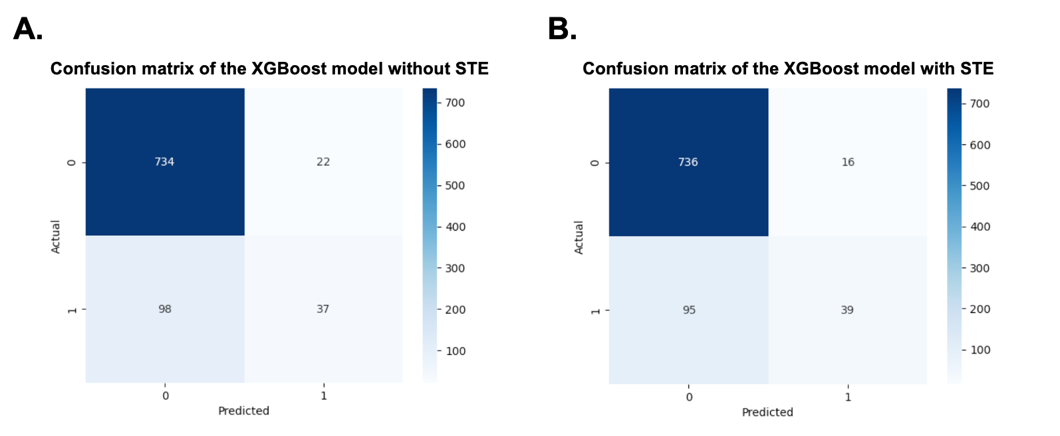
Confusion matrices for all-cause mortality prediction using the XGBoost model, with and without the inclusion of Sleep Temporal Entropy (STE). Panel A shows the confusion matrix for the model without STE, and Panel B presents the results after incorporating STE. The inclusion of STE slightly improves classification performance by increasing the number of true positives (from 37 to 39) and reducing false positives (from 22 to 16), suggesting modest but measurable enhancement in model sensitivity and precision.

2.4 Survival Analysis

2.4.1 Cohort Characteristics and Proportional Hazards Assumption Test

Table 2-4: Cohort characteristics of the Sleep Heart Health Study by All-cause and CVD Mortality
Characteristics | Alive  (n = 3743) | All-cause mortality  (n = 1119) | CVD Mortality  (n = 344)
Basic characteristics
Age (years), median (IQR) | 60.0 [54.0, 69.0] | 75.0 [69.0, 79.5] | 76.0 [72.8, 81.0]
Gender, n(%)
Male | 1657 (44.3) | 589 (52.6) | 188 (54.7)
Female | 2086 (55.7) | 530 (47.4) | 156 (45.3)
Race, n(%)
White | 3244 (86.7) | 981 (87.7) | 295 (85.8)
Black | 204 (5.5) | 113 (10.1) | 47 (13.7)
Other | 295 (7.9) | 25 (2.2) | 2 (0.6)
BMI (kg/m2), median (IQR) | 27.8 [24.9, 30.9] | 27.0 [24.3, 30.5] | 27.1 [24.1, 30.1]
Smoking, n(%) | 361 (9.6) | 107 (9.6) | 23 (6.7)
Medical History
Hypertension, n(%) | 1041 (27.8) | 549 (49.1) | 197 (57.3)
Angina, n(%) | 226 (6.0) | 169 (15.1) | 69 (20.1)
Coronary Angioplasty, n(%) | 92 (2.5) | 65 (5.8) | 25 (7.3)
CABG, n(%) | 82 (2.2) | 103 (9.2) | 45 (13.1)
HF, n(%) | 27 (0.7) | 62 (5.5) | 24 (7.0)
MI, n(%) | 160 (4.3) | 163 (14.6) | 74 (21.5)
Other Heart/Cardiac Surgery, n(%) | 68 (1.8) | 57 (5.1) | 27 (7.8)
Diabetes, n(%) | 179 (4.8) | 175 (15.6) | 78 (22.7)
Asthma, n(%) | 336 (9.0) | 88 (7.9) | 28 (8.1)
COPD, n(%) | 31 (0.8) | 25 (2.2) | 4 (1.2)
Chronic Bronchitis, n(%) | 186 (5.0) | 86 (7.7) | 20 (5.8)
Emphysema, n(%) | 57 (1.5) | 58 (5.2) | 19 (5.5)
Sleep Apnea, n(%) | 33 (0.9) | 14 (1.3) | 2 (0.6)
Sleeppills, n(%)
Never | 2568 (68.6) | 676 (60.4) | 218 (63.4)
Rarely | 339 (9.1) | 86 (7.7) | 22 (6.4)
Sometimes | 207 (5.5) | 57 (5.1) | 15 (4.4)
Often | 93 (2.5) | 34 (3.0) | 8 (2.3)
Almost always | 158 (4.2) | 57 (5.1) | 22 (6.4)
PSG
Total Sleep Time(mins), median (IQR) | 376.5 [332.0, 413.5] | 355.0 [306.8, 390.5] | 359.0 [297.3, 395.0]
N1 Sleep Time(mins), median (IQR) | 16.5 [10.0, 25.0] | 17.5 [10.5, 28.5] | 17.5 [10.0, 25.0]
N2 Sleep Time(mins), median (IQR) | 207.5 [170.5, 240.5] | 201.0 [160.0, 239.0] | 204.0 [154.5, 249.0]
N3 Sleep Time(mins), median (IQR) | 65.5 [36.0, 94.0] | 54.5 [24.0, 89.5] | 52.0 [20.5, 86.0]
REM Sleep Time(mins), median (IQR) | 76.5 [58.0, 94.5] | 64.0 [45.5, 82.0] | 62.0 [45.5, 83.0]
Sleep Efficiency (%), median (IQR) | 86.2 [79.4, 91.0] | 81.1 [73.1, 88.0] | 81.1 [73.7, 87.1]
Arousal Index(events/hour), median (IQR) | 16.4 [11.8, 22.9] | 18.2 [12.6, 25.7] | 18.2 [13.0, 25.7]
WASO (minutes), median (IQR) | 46.5 [29.0, 75.5] | 66.5 [38.0, 103.8] | 70.8 [44.9, 105.1]
AHI (events/hour), median (IQR) | 12.3 [6.2, 21.6] | 14.6 [8.3, 24.1] | 16.1 [8.7, 24.7]
Hypoxic Burden (%·min/h), median (IQR) | 38.3 [19.8, 68.9] | 51.9 [26.8, 86.9] | 54.6 [32.1, 94.8]
T90 Category (%), n (%)
0 | 3111 (83.1) | 883 (78.9) | 278 (80.8)
0-5 | 25 (0.7) | 10 (0.9) | 0 (0.0)
>5 | 607 (16.2) | 226 (20.2) | 66 (19.2)
Sleep Time Entropy
Wake Time Entropy, median (IQR) | 2.6 [2.0, 3.2] | 2.7 [2.1, 3.3] | 2.8 [2.2, 3.4]
N1 Time Entropy, median (IQR) | 3.8 [3.3, 4.3] | 3.9 [3.3, 4.4] | 3.9 [3.3, 4.4]
N2 Time Entropy, median (IQR) | 4.5 [4.2, 4.9] | 4.5 [4.0, 4.9] | 4.5 [4.1, 4.8]
N3 Time Entropy, median (IQR) | 3.5 [2.9, 4.0] | 3.5 [2.8, 4.0] | 3.4 [2.7, 4.0]
REM Time Entropy, median (IQR) | 2.6 [2.1, 3.0] | 2.4 [1.8, 2.9] | 2.3 [1.9, 3.0]
Overall Time Entropy, median (IQR) | 5.5 [5.1, 5.8] | 5.4 [4.9, 5.8] | 5.4 [4.9, 5.8]
NREM Time Entropy, median (IQR) | 5.2 [4.8, 5.6] | 5.2 [4.7, 5.6] | 5.2 [4.7, 5.6]
Note n: Number of subjects; IQR: Interquartile range; BMI: Body mass index; CABG: Coronary artery bypass graft; HF: Heart failure; MI: Myocardial infarction; COPD: Chronic obstructive pulmonary disease; WASO: Wake after sleep onset; T90: proportion of total sleep time with oxygen saturation < 90%. Participants were categorized into 0%, 0–5%, and >5% groups; TE: Temporal entropy; STE: Sleep temporal entropy.

Table 2-5: Proportional Hazards Assumption Test Results for Mortality Outcomes in the Sleep Heart Health Study
STE | P-value  (All-Cause Mortality) | P-value  (CVD Mortality)
Overall Temporal Entropy | 0.400 | 0.280
Wake Temporal Entropy | 0.450 | 0.760
N1 Temporal Entropy | < 0.001 | 0.770
N2 Temporal Entropy | < 0.001 | 0.012
N3 Temporal Entropy | 0.074 | 0.860
REM Temporal Entropy | 0.490 | 0.250
NREM Temporal Entropy | 0.001 | 0.001
Note The P-values presented above are results of the proportional hazards assumption test. A p-value less than 0.05 suggests that the proportional hazards assumption is violated, meaning the effect of the covariate may change over time. The variables were divided into five quintiles to facilitate the analysis.

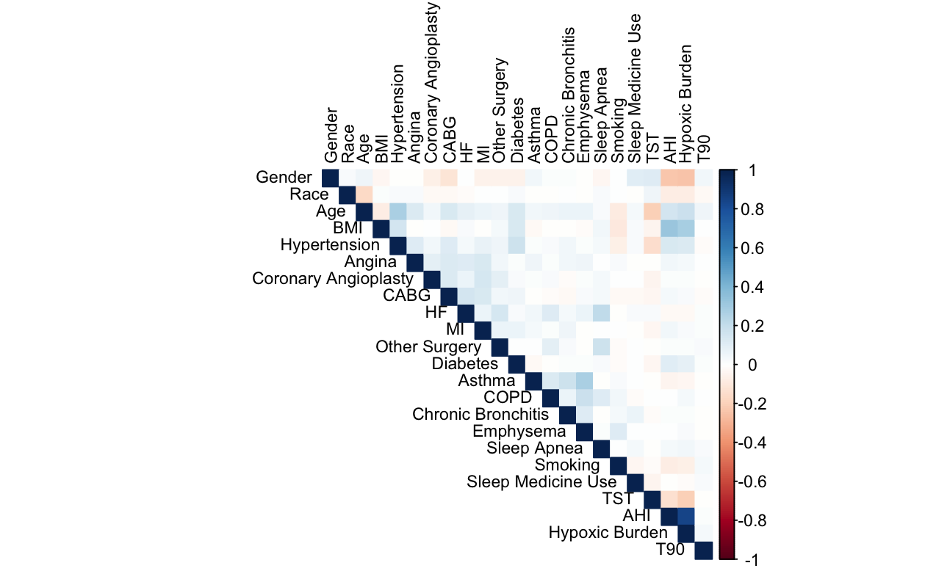
Note: Heatmap of Pearson correlation coefficients among covariates included in the multivariable models. Blue indicates positive correlations, and red indicates negative correlations. Darker colors represent stronger correlations.
Abbreviations: BMI: Body mass index; CABG: Coronary artery bypass graft; HF: Heart failure; MI: Myocardial infarction; COPD: Chronic obstructive pulmonary disease; TST: Total sleep time; AHI: Apnea–hypopnea index; T90: Proportion of total sleep time with oxygen saturation <90%; Hypoxic Burden: Integrated measure of the area under the desaturation curve during apneic/hypopneic events.

2.4.2 Sensitivity Analyses of Sleep Temporal Entropy Metrics and Mortality Outcomes

Table 2-6: Variance Inflation Factors (VIF) for Covariates in CVD and All-Cause Mortality Models
Variable | VIF
 | CVD Mortality | All-Cause Mortality
Gender | 1.14 | 1.14
Race | 1.05 | 1.05
Age | 1.29 | 1.29
BMI | 1.21 | 1.21
Hypertension | 1.17 | 1.17
Angina | 1.07 | 1.07
Coronary Angioplasty | 1.05 | 1.05
CABG | 1.10 | 1.10
HF | 1.12 | 1.12
MI | 1.06 | 1.06
Other Heart/Cardiac Surgery | 1.07 | 1.07
Diabetes | 1.07 | 1.07
Asthma | 1.12 | 1.12
COPD | 1.08 | 1.08
Chronic Bronchitis | 1.06 | 1.06
Emphysema | 1.14 | 1.14
Sleep Apnea | 1.09 | 1.09
Smoking | 1.05 | 1.05
Sleep Medicine Use | 1.03 | 1.03
TST | 1.11 | 1.11
AHI | 3.61 | 3.61
Hypoxic Burden | 3.59 | 3.59
T90 | 1.01 | 1.01
Note: VIF: Variance inflation factor; BMI: Body mass index; CABG: Coronary artery bypass graft; HF: Heart failure; MI: Myocardial infarction; COPD: Chronic obstructive pulmonary disease; TST: Total sleep time; AHI: Apnea–hypopnea index; T90: Proportion of total sleep time with oxygen saturation <90%; Hypoxic Burden: Integrated measure of the area under the desaturation curve during apneic/hypopneic events.

Table 2-7: Sensitivity Analysis of Sleep Temporal Entropy and CVD Mortality Risk Across Quintiles
Fragmentation Metric | HR (95% CI)
Fragmentation Metric | Q1 | Q2 | Q3 | Q4 | Q5
Overall STE | 0.53 ( 0.26 - 1.08 ) | 0.94 ( 0.54 - 1.63 ) | 1 [Reference] | 0.90 ( 0.52 - 1.56 ) | 0.60 ( 0.34 - 1.04 )
Wake TE | 0.83 ( 0.44 - 1.57 ) | 0.70 ( 0.36 - 1.33 ) | 1 [Reference] | 1.41 ( 0.82 - 2.41 ) | 1.14 ( 0.65 - 1.99 )
REM STE | 1.65 ( 0.88 - 3.11 ) | 1.37 ( 0.70 - 2.69 ) | 1 [Reference] | 1.76 ( 0.90 - 3.47 ) | 2.40 ( 1.27 - 4.52 )
N1 STE | 1.24 ( 0.68 - 2.26 ) | 0.97 ( 0.52 - 1.79 ) | 1 [Reference] | 1.27 ( 0.73 - 2.23 ) | 1.17 ( 0.66 - 2.09 )
N2 STE | 2.22 ( 1.03 - 4.80 ) | 2.70 ( 1.33 - 5.48 ) | 1 [Reference] | 2.31 ( 1.17 - 4.56 ) | 1.60 ( 0.78 - 3.30 )
N3 STE | 0.83 ( 0.46 - 1.50 ) | 0.85 ( 0.51 - 1.42 ) | 1 [Reference] | 0.75 ( 0.44 - 1.26 ) | 0.39 ( 0.21 - 0.71 )
NREM STE | 0.94 ( 0.49 - 1.79 ) | 1.13 ( 0.65 - 1.98 ) | 1 [Reference] | 0.77 ( 0.46 - 1.31 ) | 0.53 ( 0.30 - 0.93 )
STE: Sleep Temporal Entropy. Bold values denote statistical significance at p < 0.05.
Hazard ratios were derived from Cox proportional hazards models adjusting for gender, race, age, BMI, hypertension, diabetes, asthma, COPD, sleep apnea, smoking, sleep medication use, Apnea-Hypopnea Index (AHI), total sleep time (TST), hypoxic burden, and T90.

Table 2-8: Sensitivity Analysis of Sleep Temporal Entropy and All-Cause Mortality Risk Across Quintiles
Fragmentation Metric | HR (95% CI)
Fragmentation Metric | Q1 | Q2 | Q3 | Q4 | Q5
Overall STE | 0.91 ( 0.76 - 1.09 ) | 0.91 ( 0.79 - 1.05 ) | 1 [Reference] | 1.02 ( 0.89 - 1.16 ) | 0.99 ( 0.86 - 1.13 )
Wake TE | 0.96 ( 0.83 - 1.11 ) | 1.01 ( 0.88 - 1.16 ) | 1 [Reference] | 1.00 ( 0.87 - 1.15 ) | 1.03 ( 0.90 - 1.19 )
REM STE | 0.79 ( 0.68 - 0.93 ) | 0.96 ( 0.84 - 1.11 ) | 1 [Reference] | 1.02 ( 0.90 - 1.17 ) | 0.98 ( 0.85 - 1.12 )
N1 STE | 1.01 ( 0.88 - 1.17 ) | 0.97 ( 0.84 - 1.11 ) | 1 [Reference] | 1.01 ( 0.88 - 1.16 ) | 1.03 ( 0.89 - 1.19 )
N2 STE | 0.84 ( 0.71 - 1.00 ) | 0.90 ( 0.78 - 1.04 ) | 1 [Reference] | 0.89 ( 0.78 - 1.01 ) | 0.98 ( 0.86 - 1.12 )
N3 STE | 0.98 ( 0.84 - 1.13 ) | 0.99 ( 0.86 - 1.14 ) | 1 [Reference] | 1.02 ( 0.89 - 1.17 ) | 1.04 ( 0.90 - 1.19 )
NREM STE | 0.83 ( 0.69 - 0.99 ) | 0.92 ( 0.80 - 1.06 ) | 1 [Reference] | 0.91 ( 0.80 - 1.04 ) | 0.94 ( 0.83 - 1.08 )
STE: Sleep Temporal Entropy. Bold values denote statistical significance at p < 0.05.
Hazard ratios were derived from Cox proportional hazards models adjusting for gender, race, age, BMI, hypertension, diabetes, asthma, COPD, sleep apnea, smoking, sleep medication use, Apnea-Hypopnea Index (AHI), total sleep time (TST), hypoxic burden, and T90.

2.4.3 Whole-Night Kaplan-Meier Survival Curves for Fully Adjusted Models
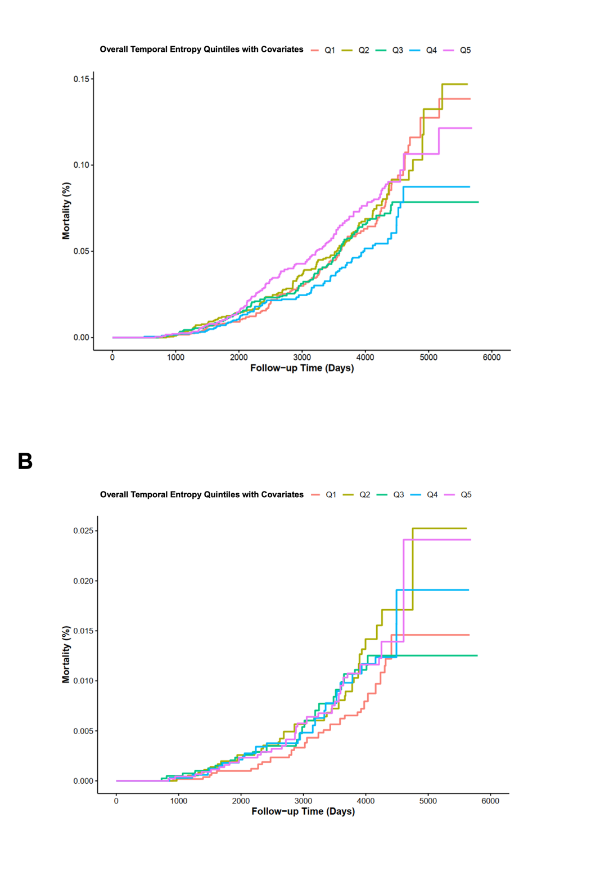
Panels A and B represent Kaplan-Meier (KM) survival curves for fully adjusted models: (A) Whole-Night Metrics for All-Cause Mortality (Section 2.4.1) and (B) Whole-Night Metrics for CVD Mortality (Section 2.4.2). The fully adjusted models include covariates for demographic factors (gender, race, age, and BMI), comorbidities (hypertension, diabetes, asthma, COPD, and sleep apnea), lifestyle factors (smoking and sleep medication use), and total sleep time (TST). For stage-specific STE models (e.g., REM STE, N3 STE), the corresponding sleep stage duration (e.g., REM sleep time, N3 sleep time) is also included as a covariate.

2.4.3 Stage-Specific Kaplan-Meier Survival Curves All-Cause Mortality
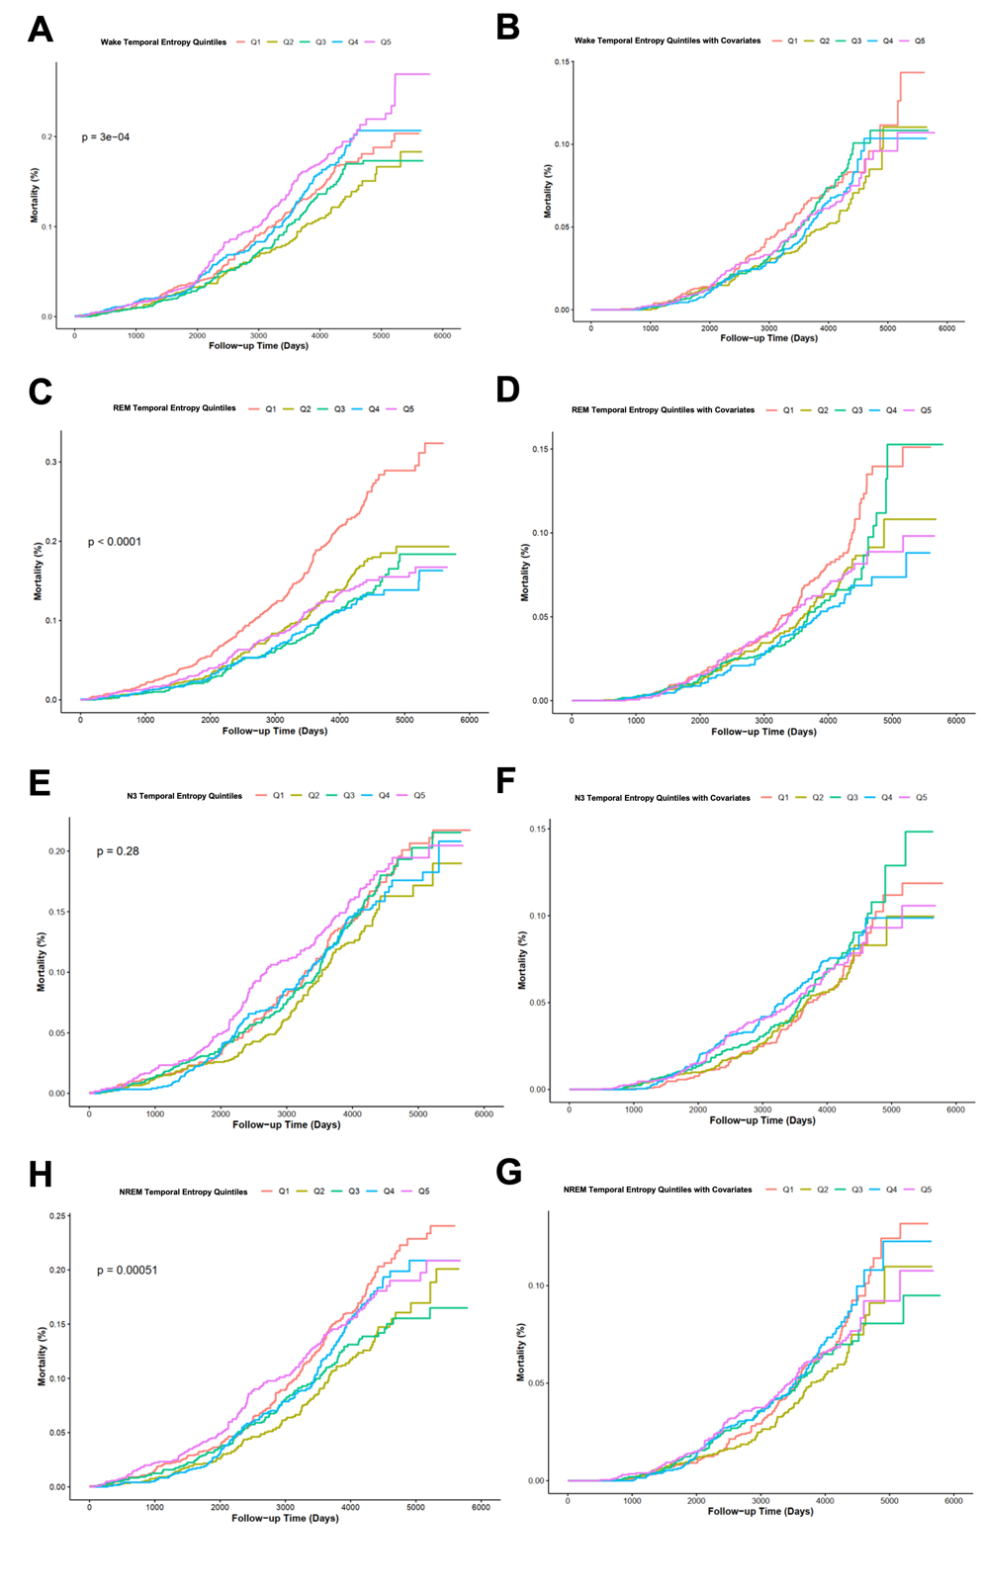
Kaplan-Meier (KM) curves for stage-specific sleep temporal entropy (STE) quintiles and all-cause mortality: Panels A and B represent Wake Temporal Entropy, with (A) unadjusted and (B) fully adjusted models. Panels C and D display REM Temporal Entropy, with (C) unadjusted and (D) fully adjusted models. Panels E and F show N3 Temporal Entropy, with (E) unadjusted and (F) fully adjusted models. Panels G and H depict NREM Temporal Entropy, with (G) unadjusted and (H) fully adjusted models. Fully adjusted models account for demographic factors (gender, race, age, BMI), comorbidities (hypertension, diabetes, asthma, COPD, sleep apnea), lifestyle factors (smoking, sleep medication use), and total sleep time (TST). For stage-specific STE, the corresponding sleep stage duration (e.g., REM sleep time, N3 sleep time) is also included as a covariate.

2.4.3 Stage-Specific Kaplan-Meier Survival Curves for CVD Mortality
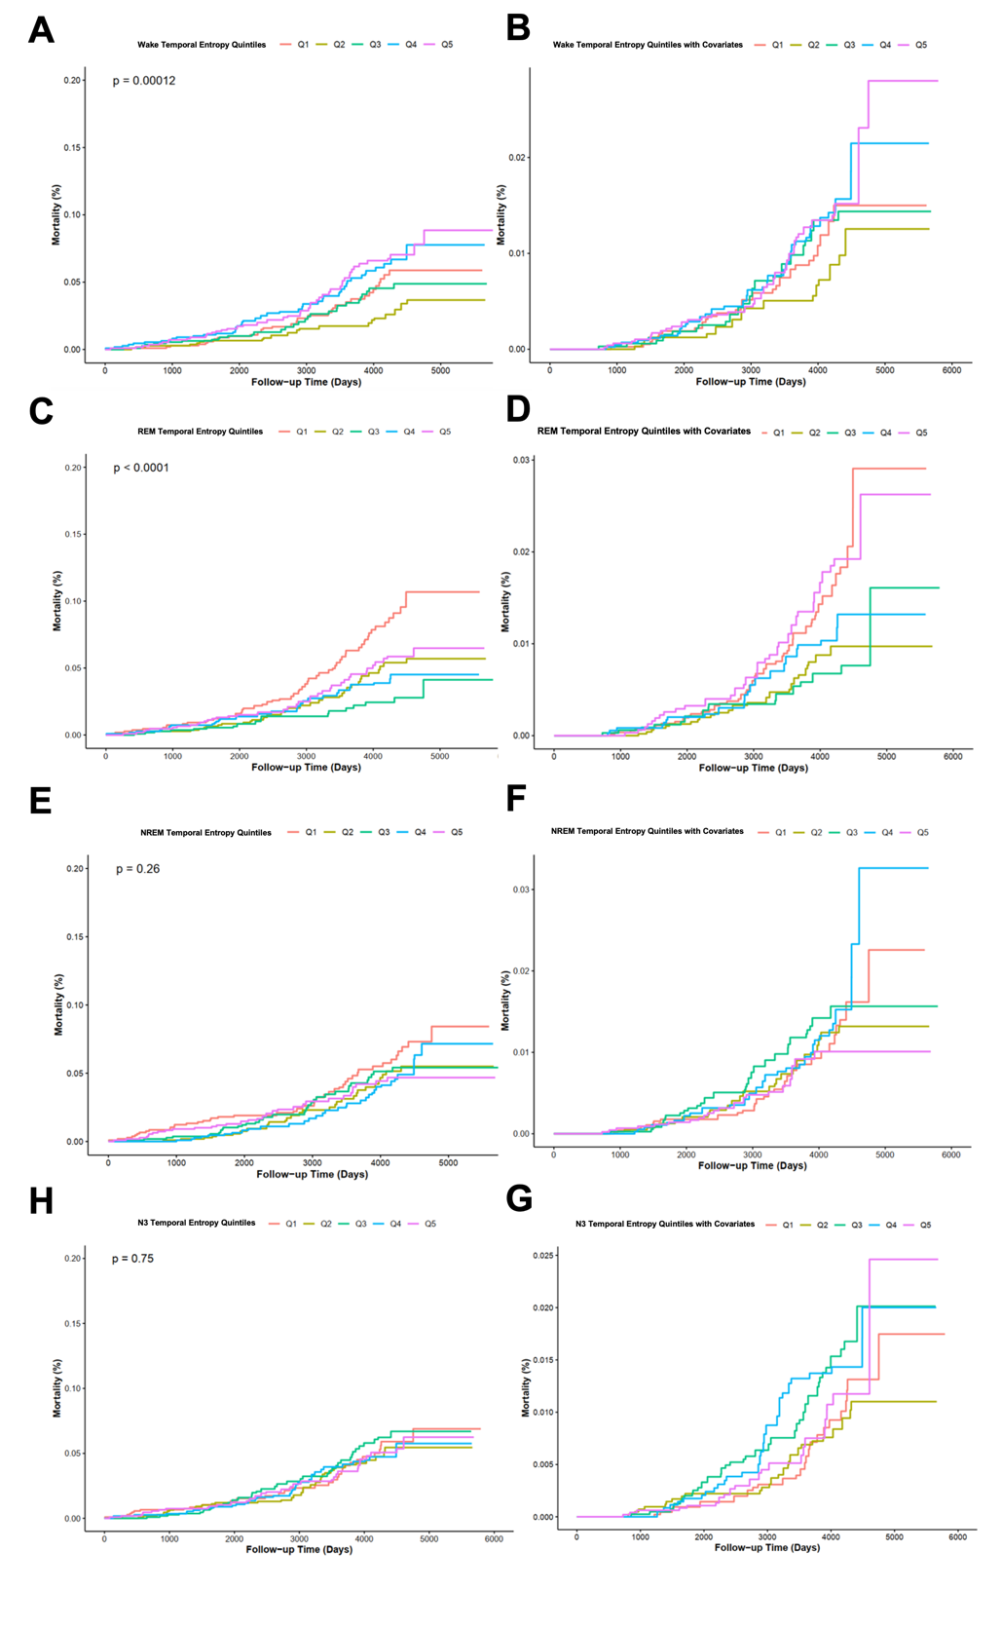
Kaplan-Meier (KM) curves for stage-specific sleep temporal entropy (STE) quintiles and CVD mortality: Panels A and B represent Wake Temporal Entropy, with (A) unadjusted and (B) fully adjusted models. Panels C and D display REM Temporal Entropy, with (C) unadjusted and (D) fully adjusted models. Panels E and F show NREM Temporal Entropy, with (E) unadjusted and (F) fully adjusted models. Panels G and H depict N3 Temporal Entropy, with (G) unadjusted and (H) fully adjusted models. Fully adjusted models include the same covariates as described previously.

2.5 Restricted Cubic Spline

2.5.1 Stage-Specific Restricted Cubic Spline Curves for All-Cause Mortality
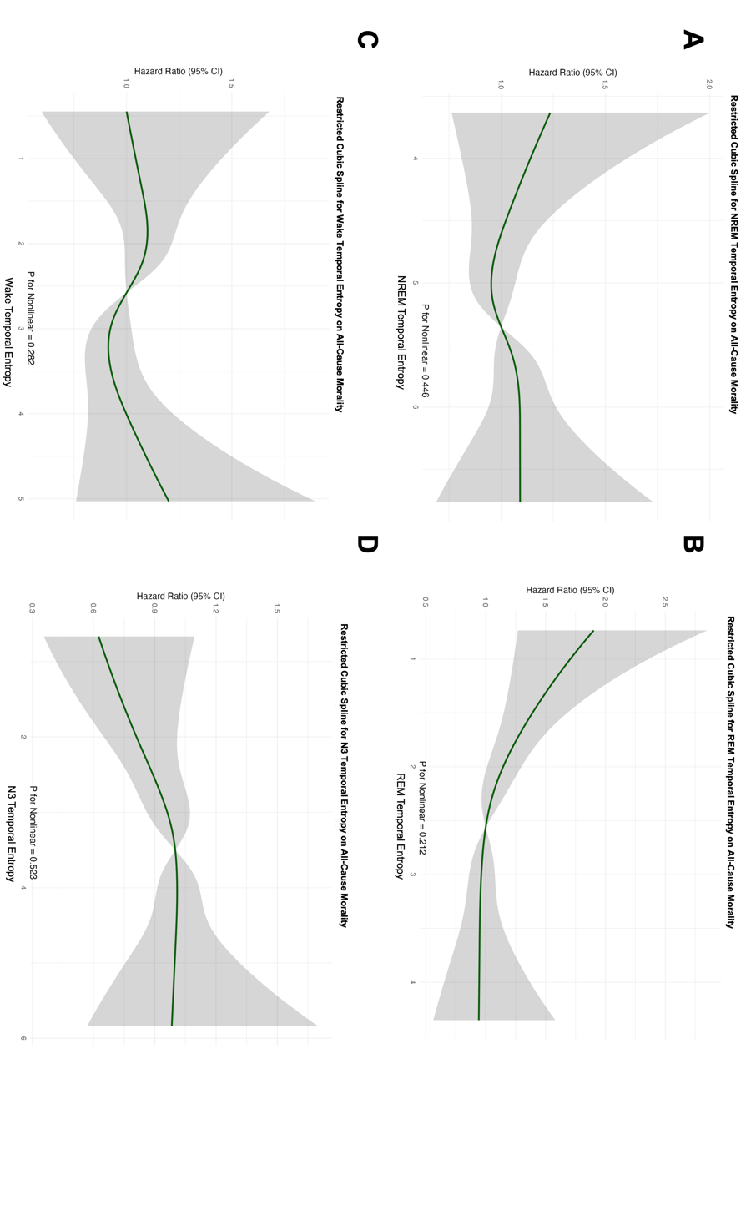
Restricted Cubic Spline (RCS) curves for fully adjusted models showing the relationship between stage-specific sleep temporal entropy (STE) and all-cause mortality: Panels A–D represent: (A) NREM Temporal Entropy, (B) REM Temporal Entropy, (C) Wake Temporal Entropy, and (D) N3 Temporal Entropy. Fully adjusted models include the same covariates as described previously. Shaded areas indicate 95% confidence intervals, and p-values for nonlinearity are noted for each model.

2.5.2 Stage-Specific Restricted Cubic Spline Curves for CVD Mortality
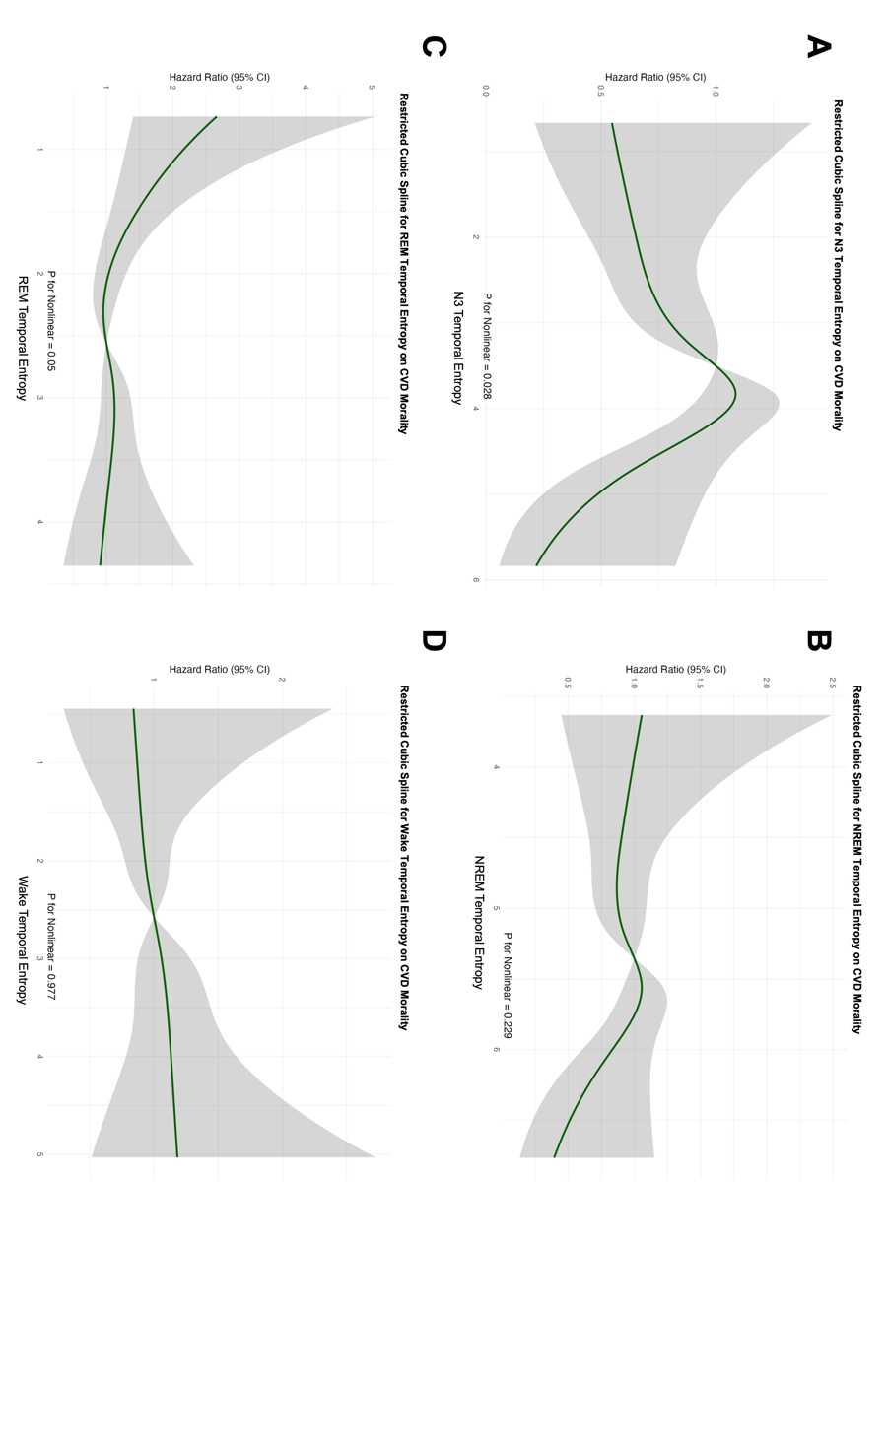
Restricted Cubic Spline (RCS) curves for fully adjusted models showing the relationship between stage-specific sleep temporal entropy (STE) and CVD mortality: Panels A–D represent: (A) N3 Temporal Entropy, (B) NREM Temporal Entropy, (C) REM Temporal Entropy, and (D) Wake Temporal Entropy. Fully adjusted models include the same covariates as described previously. Shaded areas indicate 95% confidence intervals, and p-values for nonlinearity are noted for each model. Shaded areas indicate 95% confidence intervals, and p-values for nonlinearity are noted for each model.

3 Dependence Plots

3.1 Dependence Plots of Sleep Temporal Entropy in the SSHSC

3.1.1 Whole-Night Dependence Plots of Sleep Temporal Entropy for Adverse Cardiometabolic Outcomes
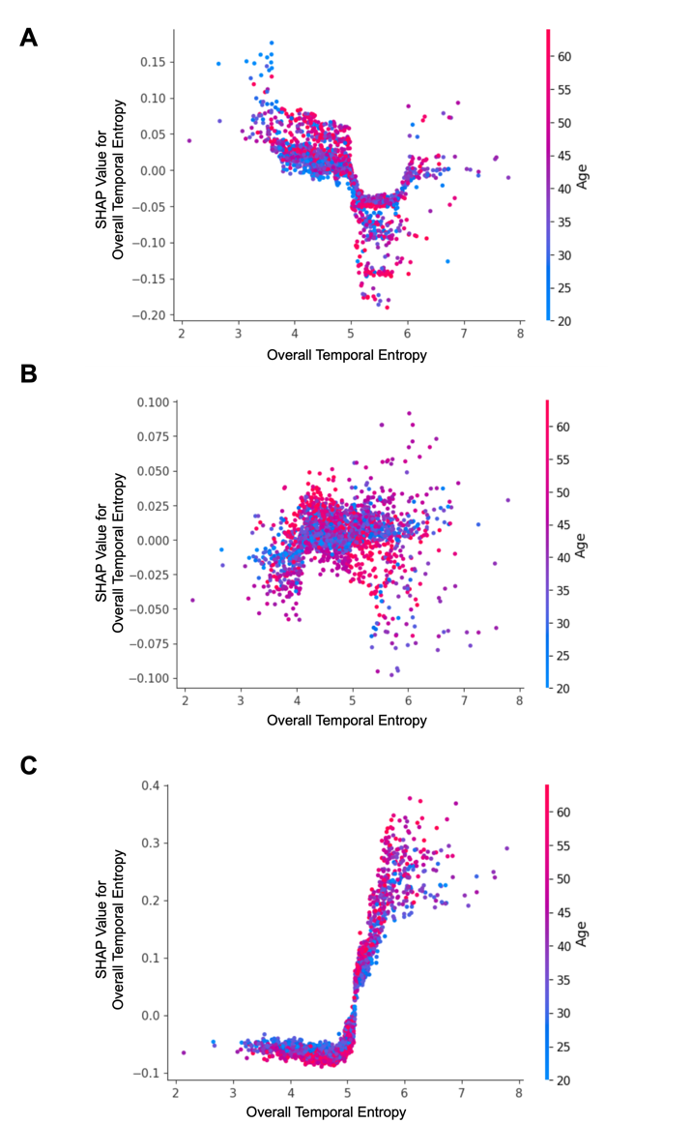
SHAP dependence plots for Overall Temporal Entropy (OTE) with age represented by the color gradient, illustrating its relationship with different outcomes: (A) Hypertension, (B) Diabetes, and (C) Hyperlipidemia. Each dot represents an individual participant, where the x-axis shows the OTE value, and the y-axis indicates the SHAP value, reflecting the contribution of OTE to the prediction of the outcome. Positive SHAP values indicate a higher risk of the corresponding condition, while negative values indicate a lower risk. The color gradient denotes participant age, showing the interaction effects of age and entropy on each outcome.

3.1.2 Stage-Specific Dependence Plots of Sleep Temporal Entropy for Hypertension
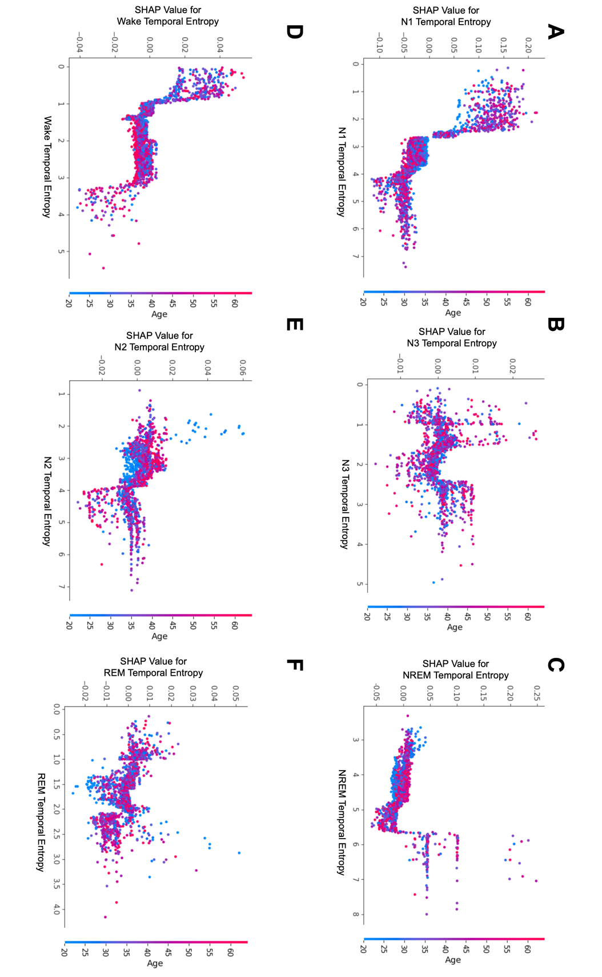
SHAP dependence plots for stage-specific temporal entropy (STE) with age represented by the color gradient, illustrating their relationship with hypertension: Panels A–F correspond to: (A) Wake Temporal Entropy, (B) N1 Temporal Entropy, (C) N2 Temporal Entropy, (D) N3 Temporal Entropy, (E) REM Temporal Entropy, and (F) NREM Temporal Entropy. Each dot represents an individual participant, with the x-axis showing STE values for the corresponding sleep stage and the y-axis indicating SHAP values, reflecting the contribution of STE to the prediction of hypertension. Positive SHAP values suggest a higher risk of hypertension, while negative values indicate a lower risk. The color gradient denotes participant age, highlighting age-dependent interactions with STE in predicting hypertension.

3.1.3 Stage-Specific Dependence Plots of Sleep Temporal Entropy for Diabetes
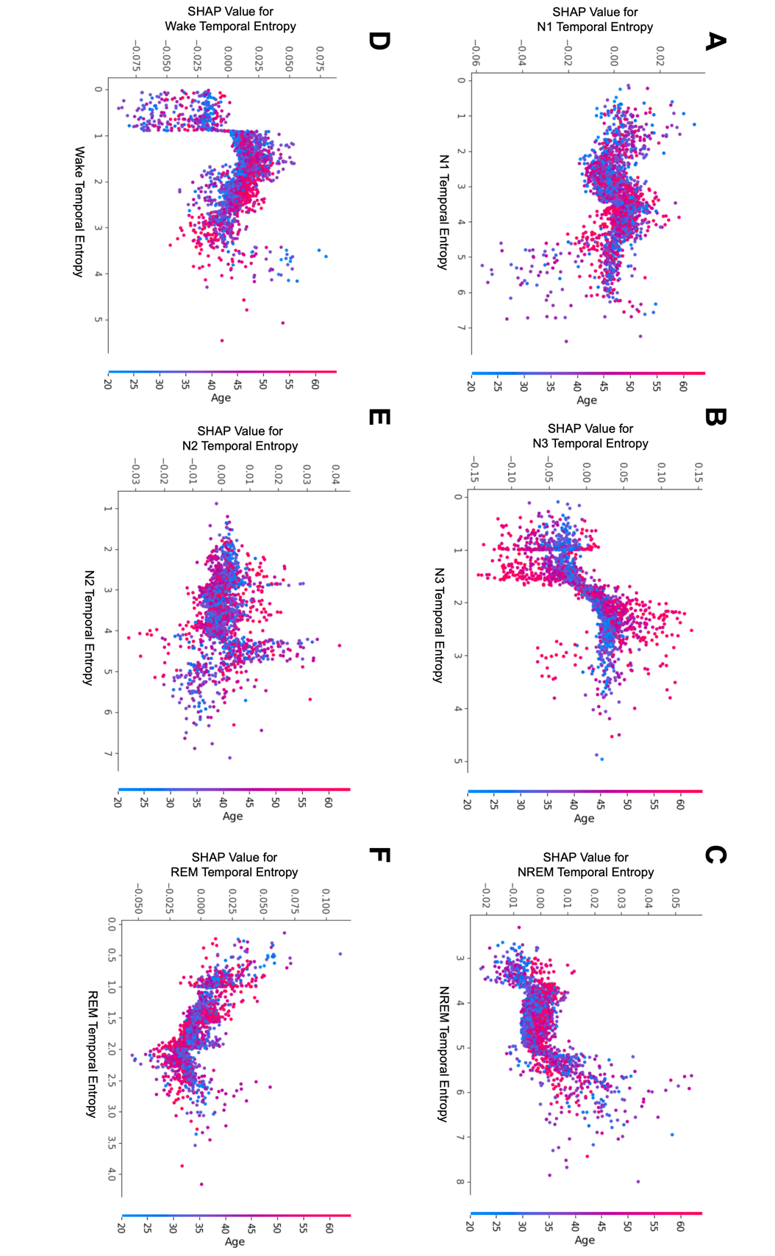
SHAP dependence plots for stage-specific temporal entropy (STE) with age represented by the color gradient, illustrating their relationship with diabetes: Panels A–F correspond to: (A) N1 Temporal Entropy, (B) N3 Temporal Entropy, (C) NREM Temporal Entropy, (D) Wake Temporal Entropy, (E) N2 Temporal Entropy, and (F) REM Temporal Entropy.

3.1.4 Stage-Specific Dependence Plots of Sleep Temporal Entropy for Hyperlipidemia
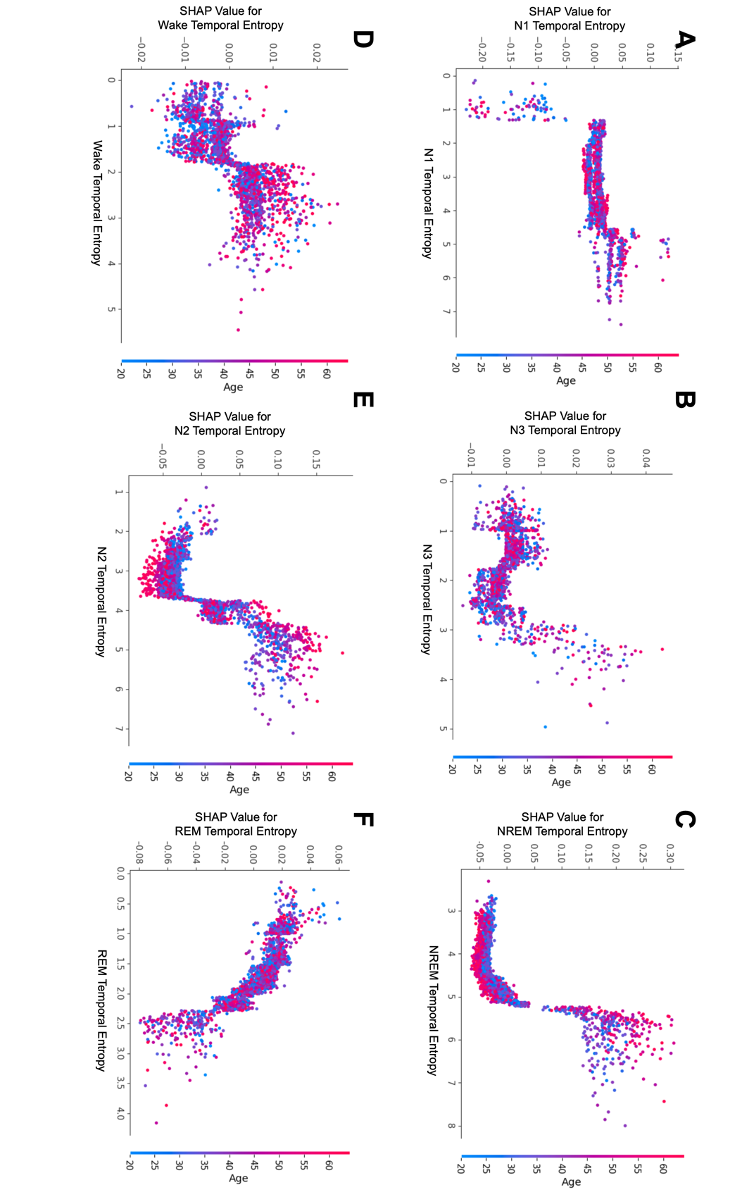
SHAP dependence plots for stage-specific temporal entropy (STE) with age represented by the color gradient, illustrating their relationship with hyperlipidemia: Panels A–F correspond to: (A) N1 Temporal Entropy, (B) N3 Temporal Entropy, (C) NREM Temporal Entropy, (D) Wake Temporal Entropy, (E) N2 Temporal Entropy, and (F) REM Temporal Entropy.

3.2 Dependence Plots of Stage-Specific Temporal Entropy in the SHHS

3.2.1 All-Cause Mortality
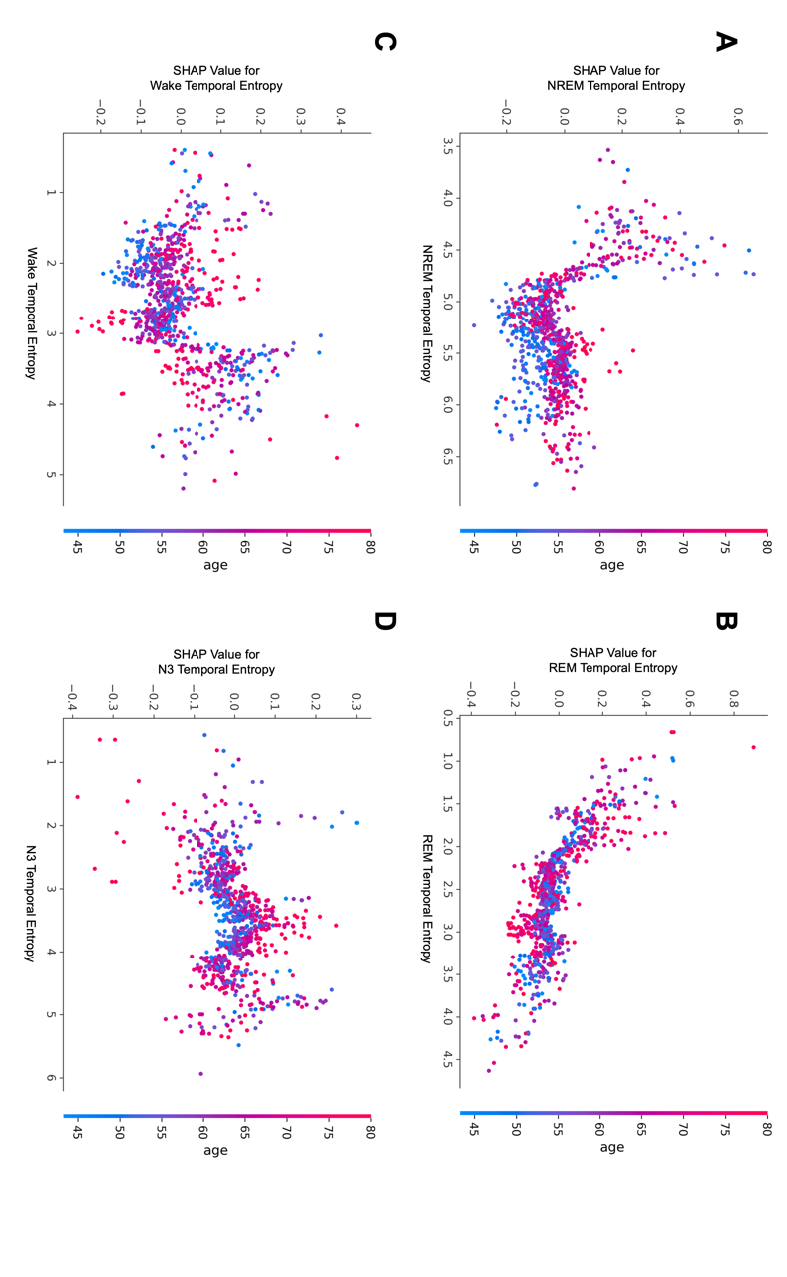
SHAP dependence plots for stage-specific temporal entropy (STE) with age represented by the color gradient, illustrating their relationship with all-cause mortality in the SHHS cohort: Panels A–D correspond to: (A) NREM Temporal Entropy, (B) REM Temporal Entropy, (C) Wake Temporal Entropy, and (D) N3 Temporal Entropy.

    - CVD Mortality
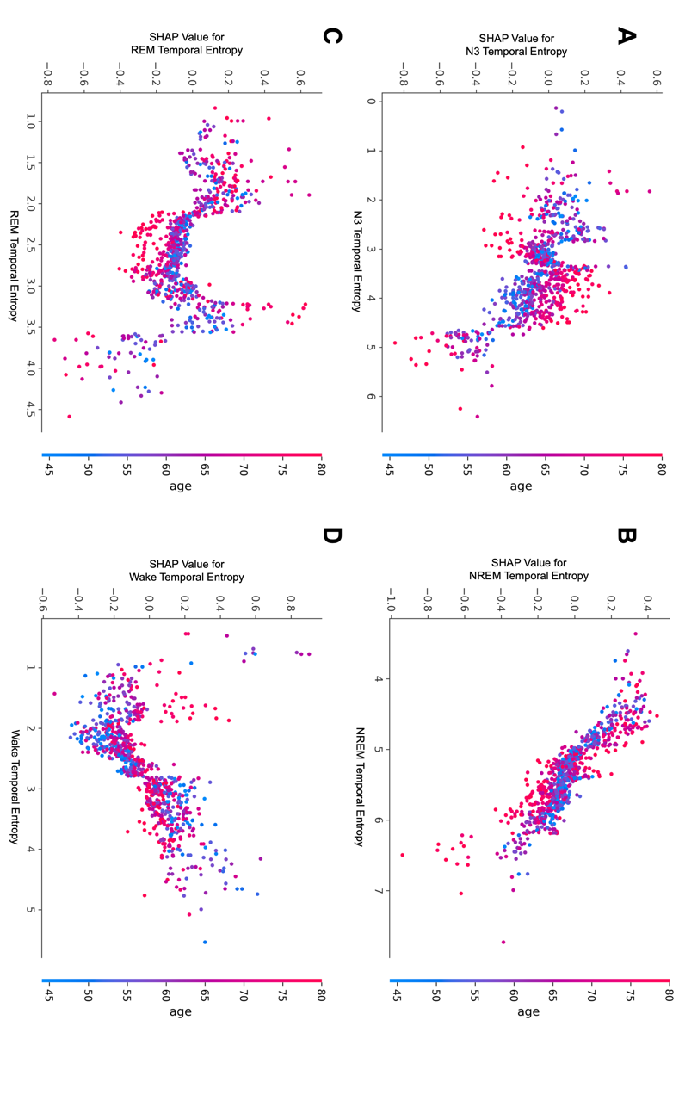
SHAP dependence plots for stage-specific temporal entropy (STE) with age represented by the color gradient, illustrating their relationship with CVD mortality in the SHHS cohort: Panels A–D correspond to: (A) N3 Temporal Entropy, (B) NREM Temporal Entropy, (C) REM Temporal Entropy, and (D) Wake Temporal Entropy.

