Graphical abstracts
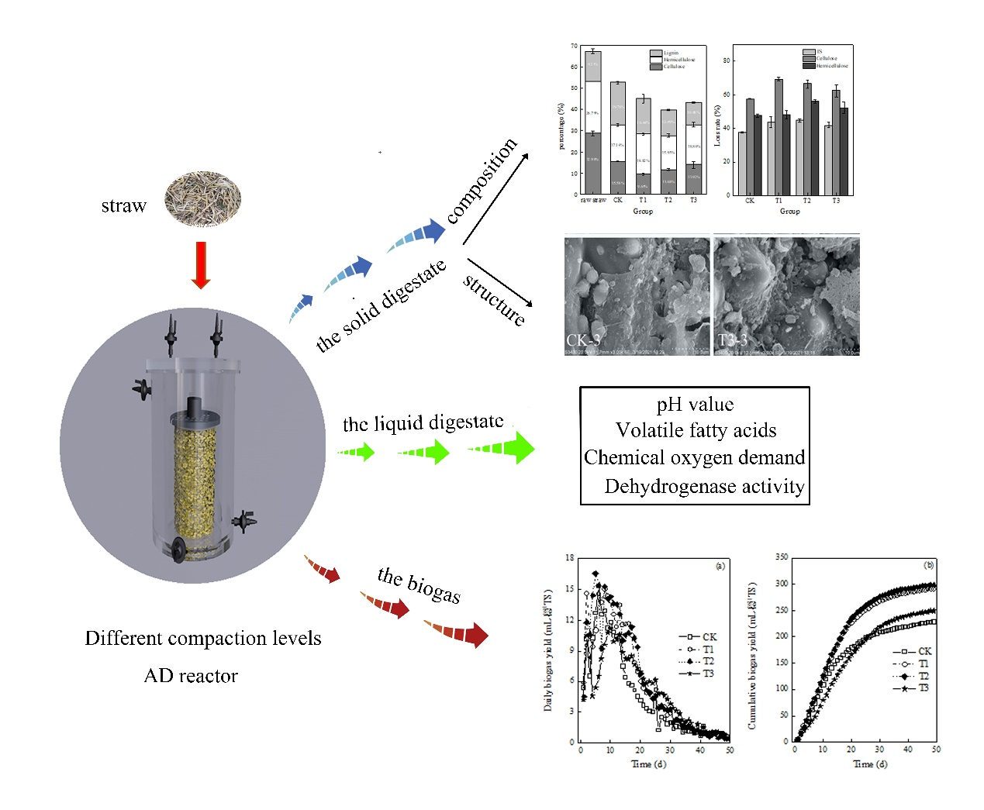
The impacts of compaction on the physicochemical indexes of the liquid digestate, structural and compositional changes of solid digestate, and biogas yield

