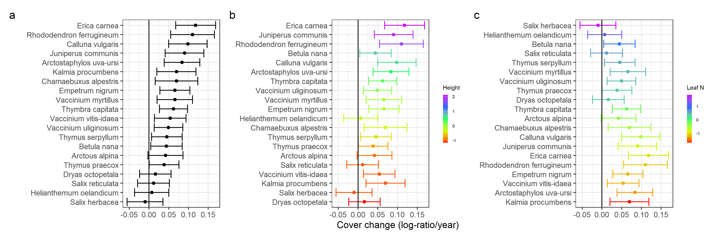
Figure S1. Model estimates (mean ± 95% CI) for the shrub species’ cover changes over time (calculated as long-response ratios) as function of the mean trait values for plant height, specific leaf area (SLA), seed mass and leaf nitrogen (N) content. Shrub species are ordered (top to bottom) according to decreasing modelled cover changes (a), plant height (b) and leaf N content (c). Mean trait values were z-transformed in the model and presented on this scaled axis. While the shrubs species’ cover changes increased significantly with increasing mean plant height, they decreased significantly with increasing mean leaf N values. The plant’s SLA and seed mass did not show a significant relationship with the cover changes over time, and were therefore not displayed on this figure. Shrub species absent from these graphs contained missing mean trait values and were therefore not included in the model.

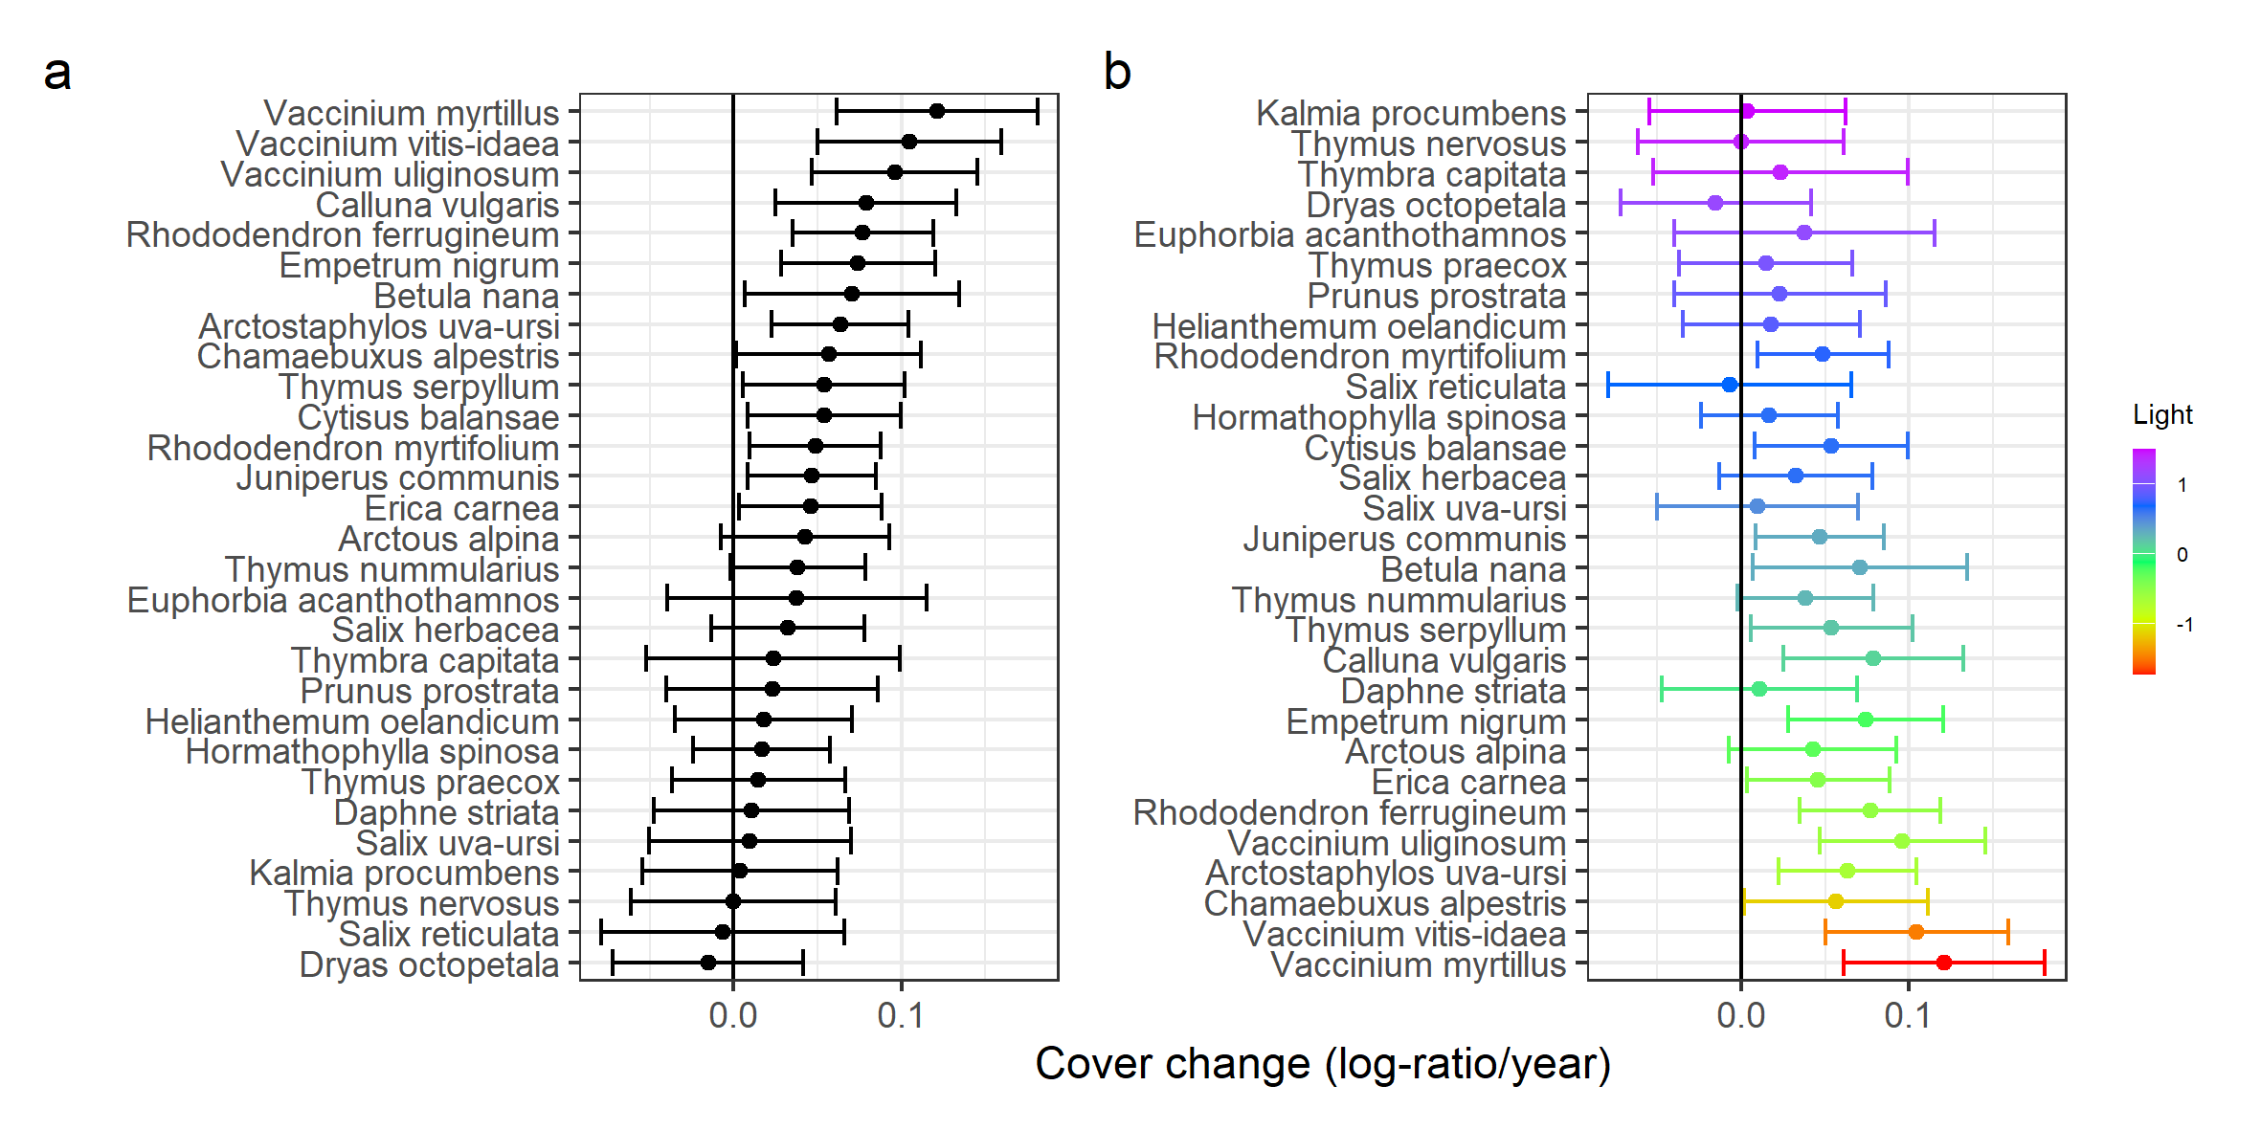
Figure S2. Model estimates (mean ± 95% CI) for the shrub species’ cover changes over time (calculated as long-response ratios) as function of the niche optima for moisture, soil reaction, nutrient levels, light and temperature (EIVE indicator values). Shrub species are ordered (top to bottom) according to decreasing modelled cover changes (a) and EIVE indicator for light optimum (b). Niche optima values were z-transformed in the model and presented on this scaled axis. While the shrubs species’ cover changes increased significantly with the EIVE indicator for light, the other niche dimensions did not show a significant relationship and were therefore not displayed on this figure. Shrub species absent from these graphs contained missing mean trait values and were therefore not included in the model.

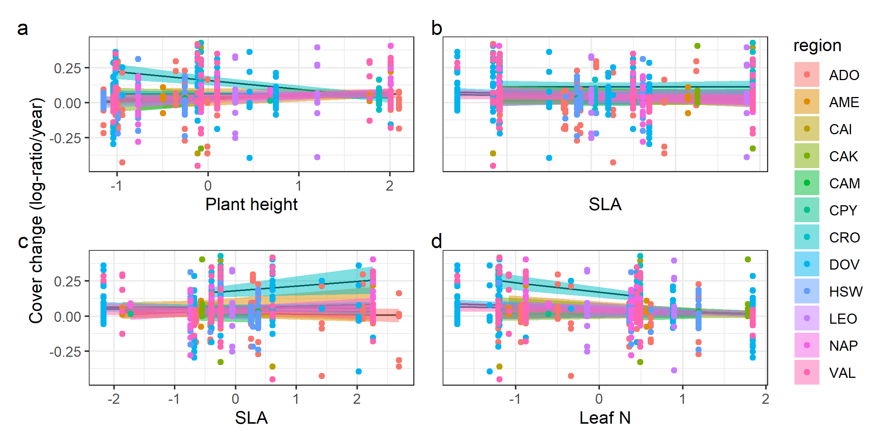
Figure S3. Scatterplots for the alterative series of univariate models with the mean trait values as random slope terms to account for the fact that trait effects of shrub species’ cover changes may vary depending on the region. Models were fit for each trait separately: plant height (a), specific leaf area (SLA; b), seed mass (c) and leaf nitrogen (N) content (d), and depict their separate effects on the shrub species’ cover changes, decoupled per region. Region codes match full region names and geographic positioning in Table S1. Regions with missing values were not displayed on these graphs. Overall, relationships between species cover changes and mean plant traits were uniform across regions (see Table S6 for model summaries).

