TOC
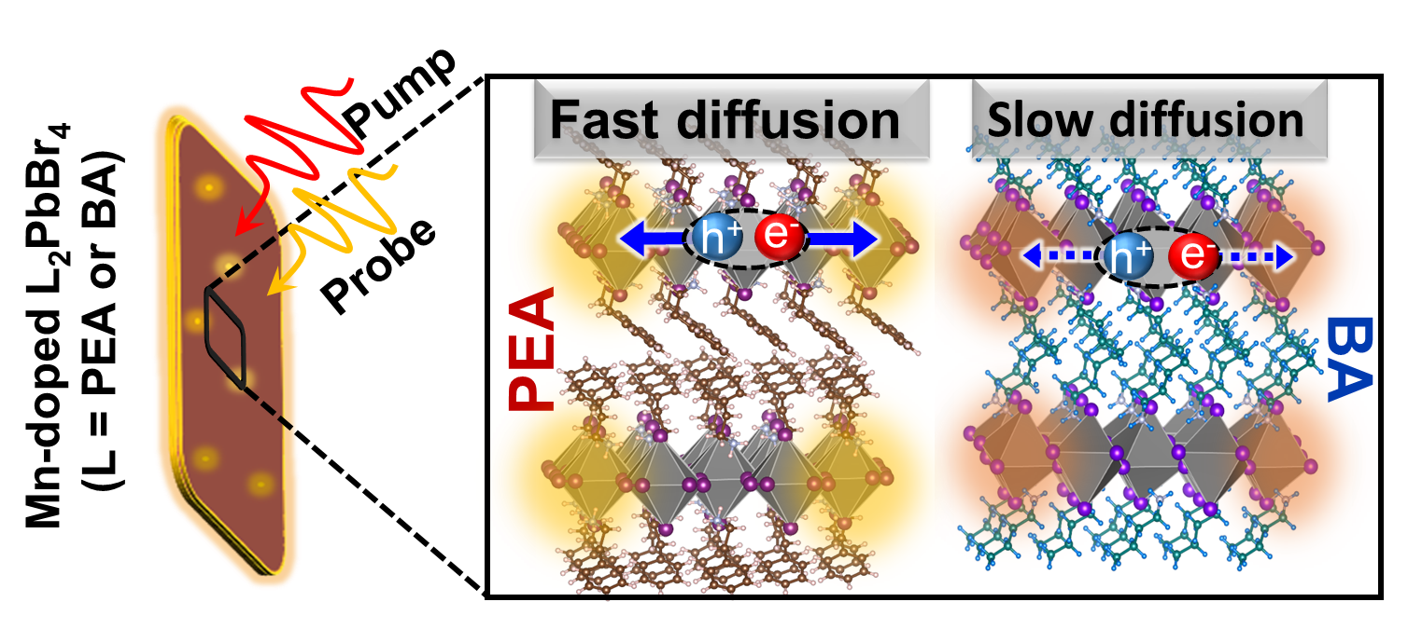
Understanding and controlling the flow of energy and charge in 2D hybrid perovskites provides a powerful pathway to tailor their optoelectronic properties. This study investigates the influence of spacer ligand modulation on the light-emitting properties of Mn-doped 2D RP perovskites, correlating their structural features with exciton transport dynamics.

