Supplementary Material

Unpacking the personality–cognitive ability link: A cross-national facet-level analysis of the Big Five

S1 Detailed results: (Pooled) parameter estimates (PEs) of the Big Five domains and facets on cognitive ability across 11 PIAAC 2023 countries.
Table S1.1
Regression results of Big Five Domains and Facets on the Cognitive Skill Domain Numeracy
 | Domains only |  |  |  | Facets only
 | PE | SD | 95% CI |  | PE | SD | 95% CI
Extraversion | 0.00 | 0.06 | [-0.01, 0.01]
Assertiveness |  |  |  |  | 0.10 | 0.03 | [0.09, 0.12]
Energy Level |  |  |  |  | -0.02 | 0.07 | [-0.04, -0.01]
Sociability |  |  |  |  | -0.07 | 0.04 | [-0.08, -0.05]
Agreeableness | -0.03 | 0.06 | [-0.04, -0.01]
Compassion |  |  |  |  | 0.00 | 0.04 | [-0.02, 0.01]
Respectfulness |  |  |  |  | 0.00 | 0.06 | [-0.01, 0.02]
Trust |  |  |  |  | -0.04 | 0.05 | [-0.05, -0.02]
Conscientiousness | -0.04 | 0.09 | [-0.06, -0.03]
Organization |  |  |  |  | -0.07 | 0.05 | [-0.08, -0.05]
Productiveness |  |  |  |  | -0.04 | 0.08 | [-0.06, -0.03]
Responsibility |  |  |  |  | 0.05 | 0.06 | [0.04, 0.07]
Emotional stability | 0.14 | 0.05 | [0.12, 0.15]
Anxiety |  |  |  |  | 0.03 | 0.06 | [0.01, 0.04]
Depression |  |  |  |  | 0.06 | 0.05 | [0.04, 0.07]
Emotional Volatility |  |  |  |  | 0.10 | 0.06 | [0.08, 0.11]
Open-Mindedness | 0.14 | 0.05 | [0.12, 0.15]
Aesthetic Sensitivity |  |  |  |  | 0.09 | 0.07 | [0.07, 0.10]
Intellectual Curiosity |  |  |  |  | 0.07 | 0.08 | [0.05, 0.08]
Creative Imagination |  |  |  |  | 0.00 | 0.07 | [-0.02, 0.01]
Adjusted R² | 0.06 | 0.03 | [0.05, 0.06] |  | 0.10 | 0.03 | [0.09, 0.11]
Note. Domain-level scores and facet-level scores were analyzed separately. PE = point estimate from regression analyses; SD = standard deviation of the point estimate; 95% CI = 95% confidence interval
Table S1.2
Regression results of Big Five Domains and Facets on the Cognitive Skill Domain Adaptive Problem Solving
 | Domains only |  |  |  | Facets only
 | PE | SD | 95% CI |  | PE | SD | 95% CI
Extraversion | -0.01 | 0.05 | [-0.03, 0.00]
Assertiveness |  |  |  |  | 0.08 | 0.01 | [0.06, 0.09]
Energy Level |  |  |  |  | -0.02 | 0.07 | [-0.04, -0.01]
Sociability |  |  |  |  | -0.06 | 0.05 | [-0.07, -0.05]
Agreeableness | -0.02 | 0.05 | [-0.03, 0.00]
Compassion |  |  |  |  | 0.00 | 0.06 | [-0.01, 0.02]
Respectfulness |  |  |  |  | 0.00 | 0.05 | [-0.01, 0.02]
Trust |  |  |  |  | -0.03 | 0.04 | [-0.05, -0.02]
Conscientiousness | -0.05 | 0.08 | [-0.07, -0.04]
Organization |  |  |  |  | -0.08 | 0.05 | [-0.09, -0.06]
Productiveness |  |  |  |  | -0.04 | 0.08 | [-0.06, -0.03]
Responsibility |  |  |  |  | 0.06 | 0.05 | [0.05, 0.08]
Emotional stability | 0.09 | 0.05 | [0.08, 0.11]
Anxiety |  |  |  |  | 0.00 | 0.05 | [-0.01, 0.02]
Depression |  |  |  |  | 0.05 | 0.05 | [0.03, 0.06]
Emotional Volatility |  |  |  |  | 0.08 | 0.06 | [0.06, 0.09]
Open-Mindedness | 0.13 | 0.07 | [0.12, 0.15]
Aesthetic Sensitivity |  |  |  |  | 0.09 | 0.07 | [0.08, 0.11]
Intellectual Curiosity |  |  |  |  | 0.07 | 0.08 | [0.05, 0.08]
Creative Imagination |  |  |  |  | -0.01 | 0.07 | [-0.03, 0]
Adjusted R² | 0.04 | 0.02 | [0.04, 0.05] |  | 0.08 | 0.03 | [0.08, 0.09]
Note. Domain-level scores and facet-level scores were analyzed separately. PE = point estimate from regression analyses; SD = standard deviation of the point estimate; 95% CI = 95% confidence interval.
Figure S1.1
Illustration of Results for the Cognitive Skill Domains Numeracy and Adaptive Problem Solving

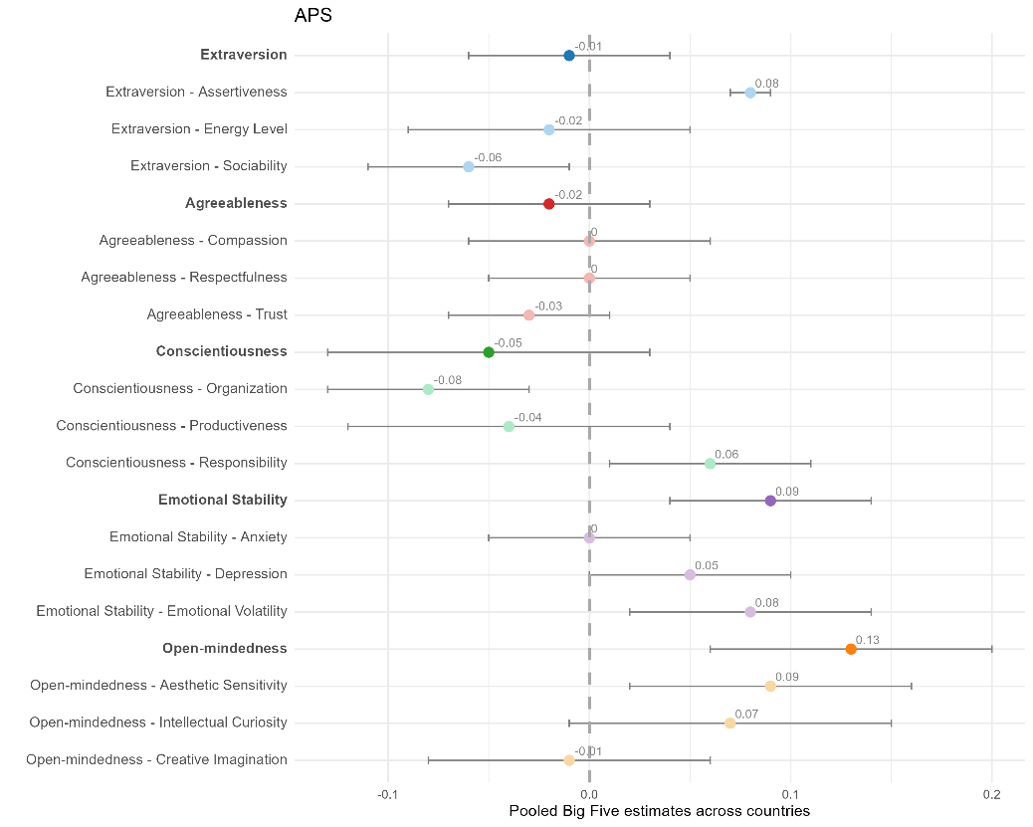
A Numeracy B Adaptive Problem Solving
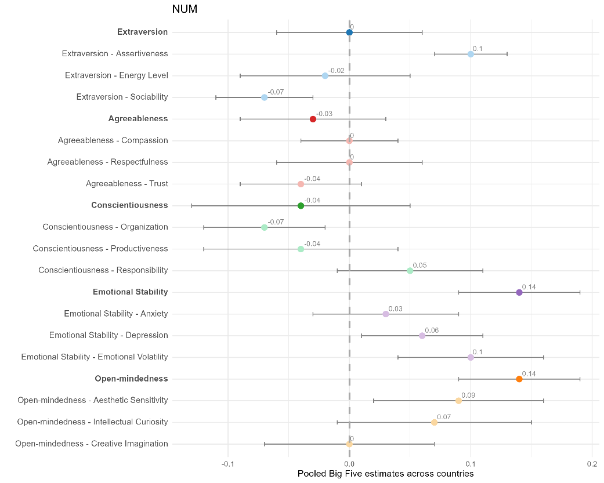
Note. Standardized regression coefficients of the Big Five domains (dark colors) and facets (corresponding light colors) on cognitive ability pooled across 11 PIAAC 2023 countries. Bars represent standard deviations across the 11 countries.

Figure S1.2
Overview of Results for all three Cognitive Skill Domains simultaneously
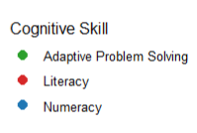

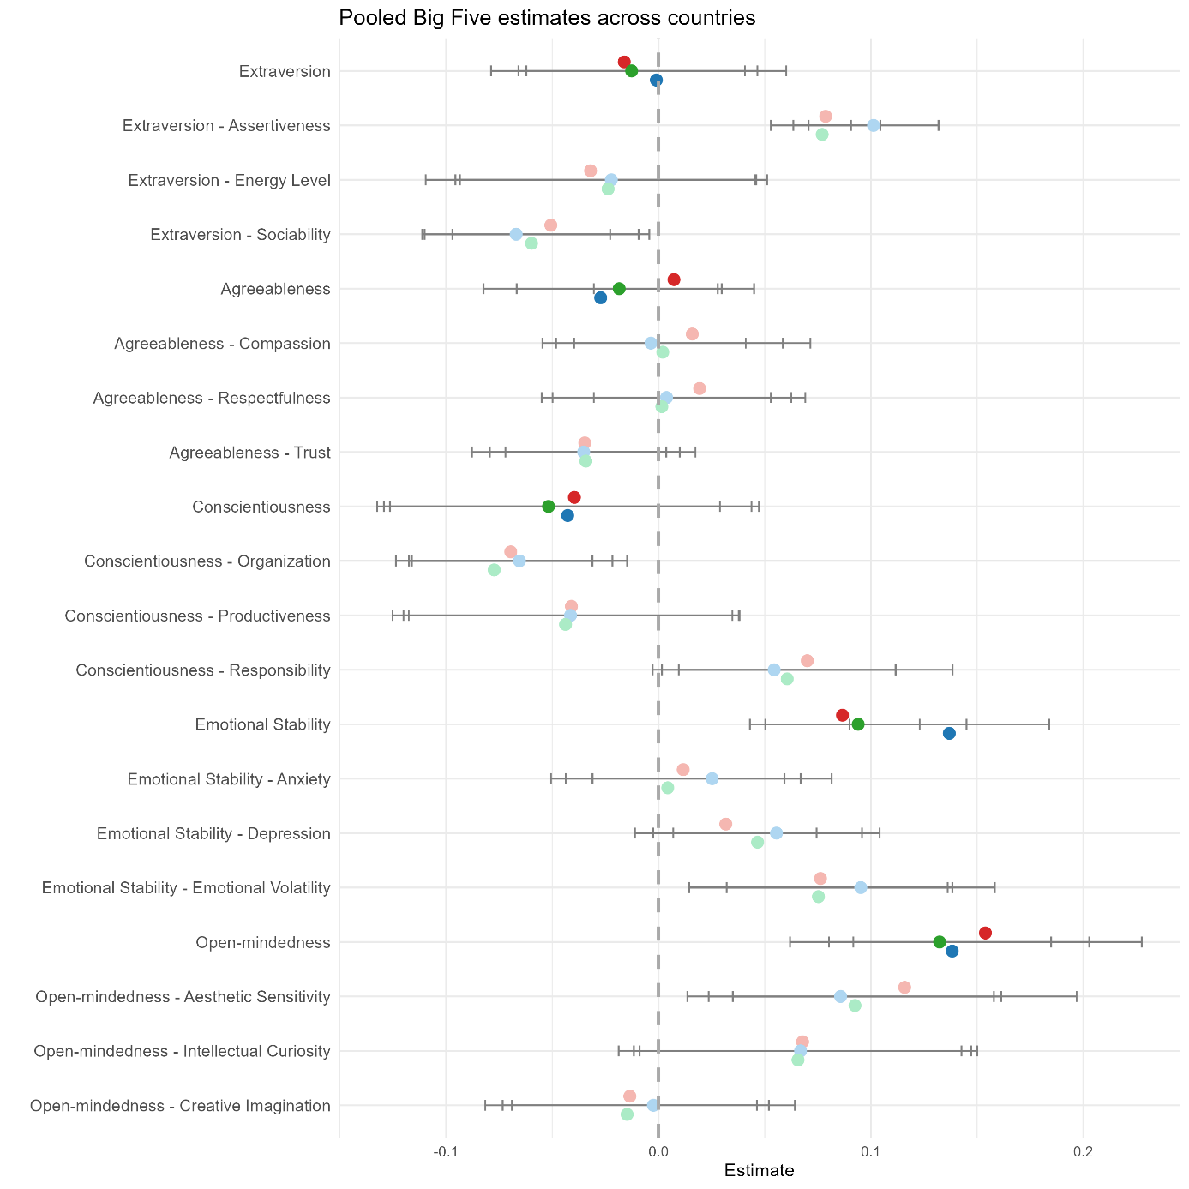

S2 Detailed results: (Pooled) parameter estimates (PEs) of the Big Five domains on cognitive ability separately for each country
Figure S2.1
Illustration of results for Cognitive Skill Domains Numeracy and Adaptive Problem Solving

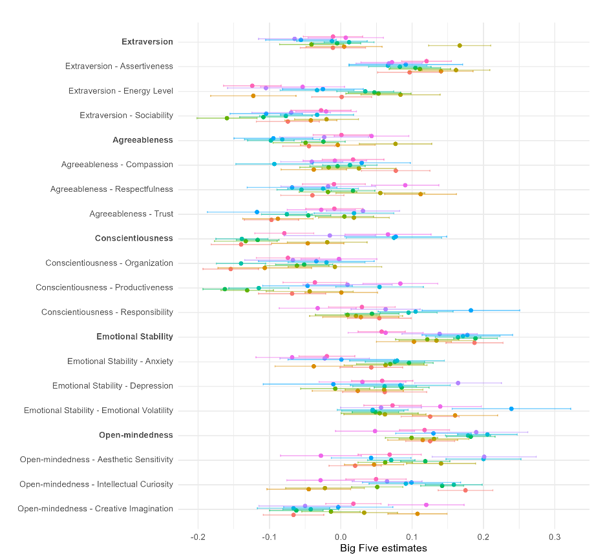
A Numeracy B Adaptive Problem Solving
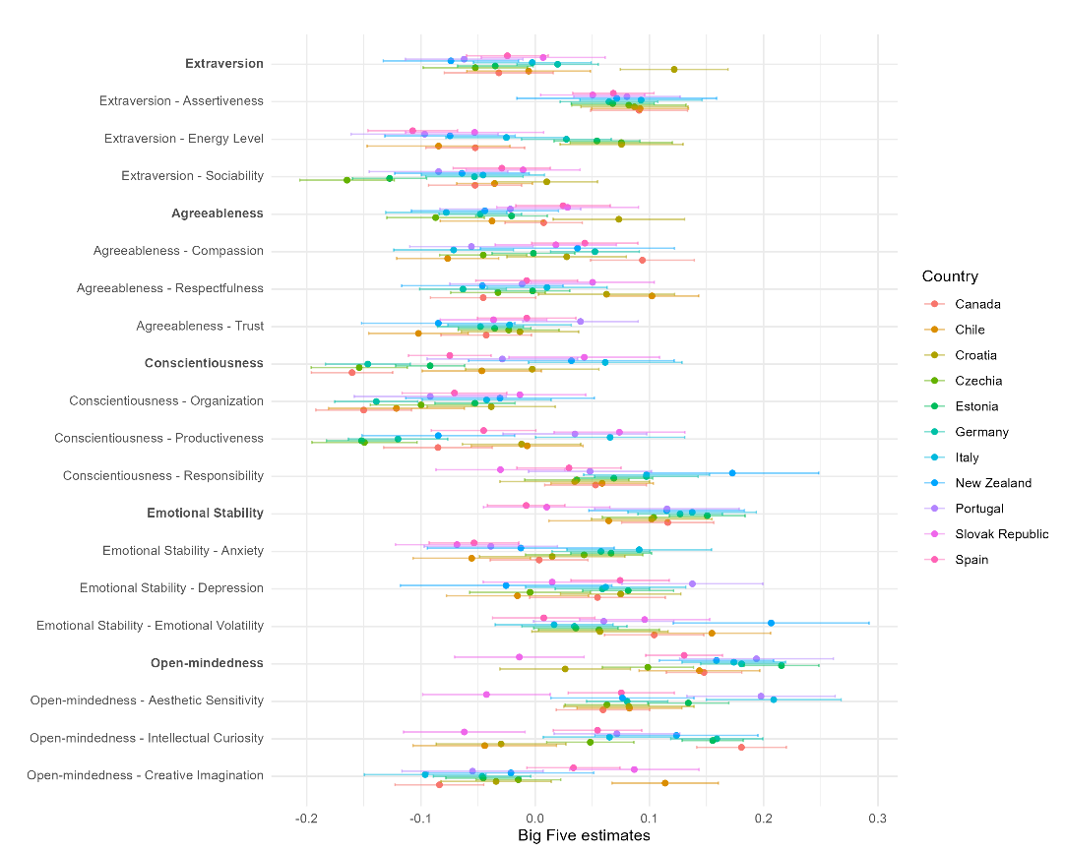

Table 2.1
Country-level results for the Cognitive Skill Domain Literacy
 | Extraversion |  | Agreeableness |  | Conscientiousness |  | Emotional Stability |  | Openness
Country | PE | 95% CI | PE | 95% CI | PE | 95% CI | PE | 95% CI | PE | 95% CI | R² _{adj}
Canada | -0.04 | [-0.08, 0.01] | 0 | [-0.03, 0.03] | -0.11 | [-0.15, -0.08] | 0.09 | [0.05, 0.13] | 0.19 | [0.16, 0.22] | 0.05
Chile | -0.04 | [-0.08, 0.01] | 0 | [-0.05, 0.06] | -0.02 | [-0.06, 0.03] | 0.07 | [0.02, 0.12] | 0.15 | [0.11, 0.2] | 0.03
Croatia | 0.14 | [0.09, 0.18] | 0.07 | [0.02, 0.13] | -0.02 | [-0.07, 0.04] | 0.14 | [0.08, 0.19] | 0.07 | [0.01, 0.12] | 0.08
Czechia | -0.06 | [-0.1, -0.02] | -0.03 | [-0.08, 0.01] | -0.14 | [-0.19, -0.1] | 0.07 | [0.02, 0.11] | 0.11 | [0.08, 0.15] | 0.04
Estonia | -0.01 | [-0.04, 0.02] | 0.03 | [0, 0.06] | -0.11 | [-0.14, -0.07] | 0.13 | [0.1, 0.16] | 0.24 | [0.21, 0.27] | 0.08
Germany | 0.00 | [-0.03, 0.04] | -0.03 | [-0.06, 0.01] | -0.14 | [-0.17, -0.1] | 0.08 | [0.05, 0.11] | 0.2 | [0.17, 0.24] | 0.08
Italy | 0.00 | [-0.05, 0.05] | -0.03 | [-0.09, 0.02] | 0.1 | [0.03, 0.18] | 0.13 | [0.08, 0.18] | 0.18 | [0.14, 0.23] | 0.08
New Zealand | -0.07 | [-0.12, -0.02] | -0.01 | [-0.07, 0.04] | 0.09 | [0.01, 0.17] | 0.11 | [0.05, 0.17] | 0.18 | [0.13, 0.22] | 0.05
Portugal | -0.09 | [-0.14, -0.04] | -0.01 | [-0.07, 0.05] | -0.05 | [-0.12, 0.01] | 0.09 | [0.04, 0.14] | 0.22 | [0.16, 0.29] | 0.06
Slovak Republic | 0.03 | [-0.02, 0.08] | 0.07 | [0.02, 0.12] | 0.04 | [-0.03, 0.1] | 0.04 | [-0.01, 0.09] | -0.02 | [-0.07, 0.04] | 0.02
Spain | -0.04 | [-0.08, -0.01] | 0.02 | [-0.02, 0.06] | -0.08 | [-0.12, -0.03] | 0.02 | [-0.01, 0.05] | 0.16 | [0.12, 0.19] | 0.03

Table S2.2
Country-level results for the Cognitive Skill Domain Numeracy
 | Extraversion |  | Agreeableness |  | Conscientiousness |  | Emotional Stability |  | Openness
Country | PE | 95% CI | PE | 95% CI | PE | 95% CI | PE | 95% CI | PE | 95% CI | R² _{adj}
Canada | -0.01 | [-0.06, 0.03] | -0.04 | [-0.08, -0.01] | -0.14 | [-0.18, -0.10] | 0.19 | [0.15, 0.23] | 0.13 | [0.09, 0.16] | 0.05
Chile | 0.00 | [-0.05, 0.06] | 0.00 | [-0.06, 0.05] | -0.05 | [-0.10, 0.00] | 0.1 | [0.05, 0.16] | 0.11 | [0.07, 0.16] | 0.02
Croatia | 0.17 | [0.12, 0.21] | 0.08 | [0.03, 0.13] | -0.02 | [-0.07, 0.04] | 0.13 | [0.08, 0.19] | 0.13 | [0.08, 0.18] | 0.12
Czechia | -0.04 | [-0.09, 0] | -0.05 | [-0.09, 0] | -0.13 | [-0.18, -0.09] | 0.12 | [0.08, 0.17] | 0.1 | [0.06, 0.14] | 0.04
Estonia | -0.01 | [-0.04, 0.03] | -0.02 | [-0.06, 0.01] | -0.12 | [-0.15, -0.09] | 0.19 | [0.16, 0.22] | 0.18 | [0.15, 0.22] | 0.07
Germany | 0.01 | [-0.02, 0.05] | -0.10 | [-0.13, -0.07] | -0.14 | [-0.18, -0.10] | 0.16 | [0.13, 0.20] | 0.18 | [0.15, 0.21] | 0.09
Italy | -0.01 | [-0.06, 0.04] | -0.08 | [-0.13, -0.03] | 0.07 | [0.01, 0.14] | 0.17 | [0.12, 0.22] | 0.21 | [0.16, 0.25] | 0.09
New Zealand | -0.06 | [-0.11, -0.01] | -0.09 | [-0.15, -0.04] | 0.08 | [0.01, 0.15] | 0.18 | [0.11, 0.24] | 0.13 | [0.08, 0.18] | 0.05
Portugal | -0.06 | [-0.12, -0.01] | -0.02 | [-0.09, 0.04] | -0.02 | [-0.08, 0.05] | 0.14 | [0.09, 0.19] | 0.19 | [0.12, 0.26] | 0.05
Slovak Republic | 0.01 | [-0.05, 0.06] | 0.04 | [-0.01, 0.1] | 0.07 | [0.01, 0.13] | 0.06 | [0.01, 0.12] | 0.05 | [-0.01, 0.1] | 0.03
Spain | -0.01 | [-0.05, 0.03] | 0 | [-0.04, 0.04] | -0.08 | [-0.12, -0.04] | 0.06 | [0.02, 0.09] | 0.12 | [0.08, 0.15] | 0.02

Table S2.3
Country-level results for the Cognitive Skill Domain Adaptive Problem Solving
 | Extraversion |  | Agreeableness |  | Conscientiousness |  | Emotional Stability |  | Openness
Country | PE | 95% CI | PE | 95% CI | PE | 95% CI | PE | 95% CI | PE | 95% CI | R² _{adj}
Canada | -0.03 | [-0.08, 0.02] | 0.01 | [-0.03, 0.04] | -0.16 | [-0.2, -0.12] | 0.12 | [0.08, 0.16] | 0.15 | [0.11, 0.18] | 0.05
Chile | -0.01 | [-0.06, 0.05] | -0.04 | [-0.08, 0.01] | -0.05 | [-0.1, 0.01] | 0.06 | [0.01, 0.12] | 0.14 | [0.09, 0.20] | 0.02
Croatia | 0.12 | [0.07, 0.17] | 0.07 | [0.02, 0.13] | 0.00 | [-0.06, 0.06] | 0.10 | [0.05, 0.15] | 0.03 | [-0.03, 0.08] | 0.05
Czechia | -0.05 | [-0.1, -0.01] | -0.09 | [-0.13, -0.04] | -0.15 | [-0.2, -0.11] | 0.10 | [0.06, 0.15] | 0.10 | [0.06, 0.14] | 0.05
Estonia | -0.03 | [-0.07, 0.00] | -0.02 | [-0.05, 0.01] | -0.09 | [-0.12, -0.06] | 0.15 | [0.12, 0.18] | 0.22 | [0.18, 0.25] | 0.06
Germany | 0.02 | [-0.02, 0.06] | -0.05 | [-0.08, -0.01] | -0.15 | [-0.18, -0.11] | 0.13 | [0.09, 0.16] | 0.18 | [0.14, 0.22] | 0.08
Italy | 0.00 | [-0.05, 0.05] | -0.08 | [-0.13, -0.02] | 0.06 | [-0.01, 0.13] | 0.14 | [0.08, 0.19] | 0.17 | [0.13, 0.22] | 0.06
New Zealand | -0.07 | [-0.13, -0.01] | -0.04 | [-0.11, 0.02] | 0.03 | [-0.06, 0.12] | 0.12 | [0.05, 0.18] | 0.16 | [0.11, 0.21] | 0.03
Portugal | -0.06 | [-0.11, -0.01] | -0.02 | [-0.08, 0.04] | -0.03 | [-0.09, 0.04] | 0.12 | [0.05, 0.18] | 0.19 | [0.13, 0.26] | 0.05
Slovak Republic | 0.01 | [-0.05, 0.06] | 0.03 | [-0.03, 0.09] | 0.04 | [-0.02, 0.11] | 0.01 | [-0.05, 0.07] | -0.01 | [-0.07, 0.04] | 0.00
Spain | -0.02 | [-0.06, 0.01] | 0.02 | [-0.02, 0.07] | -0.07 | [-0.11, -0.04] | -0.01 | [-0.04, 0.03] | 0.13 | [0.10, 0.16] | 0.02

S3 Detailed results: (Pooled) parameter estimates (PEs) of the Big Five facets on cognitive ability separately for each country
Table S3.1
Country-level results for the Cognitive Skill Domain Literacy
 | Extraversion |  |  |  |  |  | Agreeableness
 | Assertiveness |  | Energy Level |  | Sociability |  | Compassion |  | Respectfulness |  | Trust
Country | PE | 95% CI | PE | 95% CI | PE | 95% CI | PE | 95% CI | PE | 95% CI | PE | 95% CI
Canada | 0.09 | [0.05, 0.13] | -0.06 | [-0.1, -0.01] | -0.05 | [-0.1, -0.01] | 0.12 | [0.07, 0.17] | -0.03 | [-0.08, 0.02] | -0.1 | [-0.13, -0.06]
Chile | 0.12 | [0.07, 0.16] | -0.13 | [-0.19, -0.08] | -0.04 | [-0.08, 0] | -0.02 | [-0.07, 0.03] | 0.1 | [0.06, 0.15] | -0.08 | [-0.13, -0.04]
Croatia | 0.12 | [0.07, 0.16] | 0.08 | [0.02, 0.14] | 0.01 | [-0.03, 0.05] | 0.02 | [-0.03, 0.07] | 0.08 | [0.03, 0.14] | 0 | [-0.05, 0.05]
Czechia | 0.09 | [0.04, 0.14] | 0.05 | [0, 0.1] | -0.15 | [-0.19, -0.11] | -0.02 | [-0.06, 0.02] | 0 | [-0.03, 0.04] | -0.01 | [-0.05, 0.04]
Estonia | 0.07 | [0.04, 0.11] | 0.06 | [0.02, 0.1] | -0.1 | [-0.13, -0.07] | 0.01 | [-0.03, 0.04] | 0.04 | [0, 0.07] | -0.02 | [-0.06, 0.01]
Germany | 0.06 | [0.01, 0.1] | 0.03 | [-0.01, 0.07] | -0.06 | [-0.1, -0.03] | 0.06 | [0.03, 0.1] | -0.06 | [-0.1, -0.02] | -0.06 | [-0.1, -0.02]
Italy | 0.08 | [0.02, 0.13] | -0.02 | [-0.07, 0.03] | -0.02 | [-0.07, 0.03] | -0.07 | [-0.13, -0.02] | 0 | [-0.05, 0.06] | 0.02 | [-0.03, 0.08]
New Zealand | 0.07 | [-0.01, 0.15] | -0.07 | [-0.12, -0.01] | -0.07 | [-0.12, -0.01] | 0.05 | [-0.02, 0.13] | -0.02 | [-0.08, 0.05] | -0.1 | [-0.17, -0.03]
Portugal | 0.03 | [-0.01, 0.08] | -0.12 | [-0.18, -0.06] | -0.05 | [-0.1, 0.01] | -0.05 | [-0.1, 0] | 0.01 | [-0.05, 0.07] | 0.02 | [-0.04, 0.08]
Slovak Republic | 0.05 | [0.01, 0.1] | -0.05 | [-0.11, 0.01] | 0.01 | [-0.04, 0.05] | 0.04 | [0, 0.08] | 0.07 | [0.02, 0.12] | -0.03 | [-0.08, 0.01]
Spain | 0.09 | [0.06, 0.13] | -0.12 | [-0.16, -0.09] | -0.03 | [-0.08, 0.01] | 0.03 | [-0.01, 0.07] | 0 | [-0.04, 0.05] | -0.02 | [-0.06, 0.02]

 | Conscientiousness |  |  |  |  |  | Emotional stability
 | Organization |  | Productiveness |  | Responsibility |  | Anxiety |  | Depression |  | Emotional volatility
Country | PE | 95% CI | PE | 95% CI | PE | 95% CI | PE | 95% CI | PE | 95% CI | PE | 95% CI
Canada | -0.13 | [-0.18, -0.09] | -0.06 | [-0.1, -0.01] | 0.06 | [0.02, 0.11] | -0.02 | [-0.06, 0.03] | 0.04 | [-0.02, 0.1] | 0.12 | [0.08, 0.16]
Chile | -0.08 | [-0.14, -0.01] | -0.01 | [-0.07, 0.04] | 0.06 | [0.01, 0.11] | -0.05 | [-0.1, 0] | 0 | [-0.06, 0.07] | 0.15 | [0.09, 0.21]
Croatia | -0.01 | [-0.08, 0.05] | -0.02 | [-0.07, 0.04] | 0.02 | [-0.05, 0.08] | 0.1 | [0.03, 0.16] | 0.04 | [-0.02, 0.09] | 0.03 | [-0.03, 0.09]
Czechia | -0.1 | [-0.14, -0.06] | -0.13 | [-0.17, -0.09] | 0.04 | [-0.01, 0.08] | 0.06 | [0.01, 0.1] | -0.03 | [-0.08, 0.02] | 0.04 | [-0.02, 0.09]
Estonia | -0.06 | [-0.09, -0.02] | -0.17 | [-0.2, -0.13] | 0.07 | [0.04, 0.11] | 0.07 | [0.03, 0.1] | 0.08 | [0.04, 0.12] | 0.01 | [-0.02, 0.04]
Germany | -0.15 | [-0.19, -0.12] | -0.11 | [-0.16, -0.07] | 0.12 | [0.08, 0.17] | 0.04 | [0.01, 0.08] | 0.02 | [-0.02, 0.06] | 0.03 | [-0.02, 0.08]
Italy | -0.02 | [-0.07, 0.04] | 0.06 | [0, 0.12] | 0.14 | [0.09, 0.19] | 0.06 | [0, 0.13] | 0.03 | [-0.03, 0.1] | 0.05 | [0, 0.1]
New Zealand | -0.03 | [-0.11, 0.05] | -0.05 | [-0.12, 0.01] | 0.21 | [0.14, 0.27] | -0.02 | [-0.11, 0.06] | -0.02 | [-0.1, 0.07] | 0.2 | [0.11, 0.28]
Portugal | -0.1 | [-0.16, -0.04] | 0.01 | [-0.05, 0.07] | 0.06 | [0.01, 0.1] | -0.03 | [-0.08, 0.03] | 0.12 | [0.06, 0.18] | 0.04 | [-0.02, 0.09]
Slovak Republic | -0.02 | [-0.08, 0.03] | 0.09 | [0.04, 0.14] | -0.06 | [-0.12, 0] | -0.07 | [-0.12, -0.02] | 0.01 | [-0.05, 0.07] | 0.14 | [0.08, 0.19]
Spain | -0.06 | [-0.1, -0.02] | -0.07 | [-0.11, -0.02] | 0.05 | [0.01, 0.09] | -0.02 | [-0.06, 0.02] | 0.05 | [0, 0.09] | 0.04 | [0, 0.08]

 | Open-mindedness
 | Aesthetic sensitivity |  | Productiveness |  | Responsibility
Country | PE | 95% CI | PE | 95% CI | PE | 95% CI | R² _{adj}
Canada | 0.1 | [0.07, 0.14] | 0.17 | [0.13, 0.21] | -0.07 | [-0.11, -0.03] | 0.12
Chile | 0.12 | [0.08, 0.16] | -0.04 | [-0.09, 0.02] | 0.07 | [0.03, 0.12] | 0.11
Croatia | 0.13 | [0.08, 0.18] | -0.04 | [-0.1, 0.02] | 0.00 | [-0.05, 0.04] | 0.09
Czechia | 0.1 | [0.06, 0.13] | 0.05 | [0.01, 0.09] | -0.03 | [-0.07, 0.01] | 0.08
Estonia | 0.17 | [0.14, 0.21] | 0.16 | [0.14, 0.19] | -0.06 | [-0.1, -0.03] | 0.12
Germany | 0.13 | [0.1, 0.15] | 0.12 | [0.08, 0.16] | -0.03 | [-0.07, 0.01] | 0.12
Italy | 0.19 | [0.14, 0.24] | 0.09 | [0.04, 0.14] | -0.08 | [-0.13, -0.03] | 0.11
New Zealand | 0.06 | [0.01, 0.12] | 0.14 | [0.07, 0.21] | 0 | [-0.07, 0.08] | 0.11
Portugal | 0.24 | [0.17, 0.31] | 0.07 | [0.03, 0.12] | -0.06 | [-0.12, 0] | 0.11
Slovak Republic | -0.08 | [-0.13, -0.02] | -0.04 | [-0.09, 0.01] | 0.11 | [0.05, 0.17] | 0.05
Spain | 0.12 | [0.08, 0.16] | 0.06 | [0.02, 0.1] | 0.01 | [-0.03, 0.04] | 0.05

Table S3.2
Country-level results for the Cognitive Skill Domain Numeracy
 | Extraversion |  |  |  |  |  | Agreeableness
 | Assertiveness |  | Energy Level |  | Sociability |  | Compassion |  | Respectfulness |  | Trust
Country | PE | 95% CI | PE | 95% CI | PE | 95% CI | PE | 95% CI | PE | 95% CI | PE | 95% CI
Canada | 0.09 | [0.05, 0.13] | -0.05 | [-0.1, -0.01] | -0.05 | [-0.09, -0.01] | 0.09 | [0.05, 0.14] | -0.05 | [-0.09, 0] | -0.04 | [-0.08, 0]
Chile | 0.09 | [0.05, 0.13] | -0.08 | [-0.15, -0.02] | -0.04 | [-0.07, 0] | -0.08 | [-0.12, -0.03] | 0.1 | [0.06, 0.14] | -0.1 | [-0.15, -0.06]
Croatia | 0.09 | [0.04, 0.13] | 0.08 | [0.02, 0.13] | 0.01 | [-0.03, 0.05] | 0.03 | [-0.02, 0.08] | 0.06 | [0, 0.12] | -0.01 | [-0.06, 0.04]
Czechia | 0.08 | [0.03, 0.13] | 0.08 | [0.03, 0.12] | -0.16 | [-0.21, -0.12] | -0.05 | [-0.08, -0.01] | -0.03 | [-0.07, 0.01] | -0.02 | [-0.07, 0.02]
Estonia | 0.07 | [0.03, 0.1] | 0.05 | [0.02, 0.09] | -0.13 | [-0.16, -0.09] | 0 | [-0.04, 0.03] | 0 | [-0.03, 0.03] | -0.04 | [-0.07, 0]
Germany | 0.06 | [0.02, 0.11] | 0.03 | [-0.01, 0.07] | -0.05 | [-0.1, -0.01] | 0.05 | [0.01, 0.09] | -0.06 | [-0.1, -0.03] | -0.05 | [-0.09, -0.01]
Italy | 0.09 | [0.04, 0.15] | -0.03 | [-0.08, 0.03] | -0.05 | [-0.1, 0.01] | -0.07 | [-0.12, -0.02] | 0.01 | [-0.04, 0.06] | -0.02 | [-0.08, 0.03]
New Zealand | 0.07 | [-0.02, 0.16] | -0.07 | [-0.13, -0.02] | -0.06 | [-0.12, -0.01] | 0.04 | [-0.05, 0.12] | -0.05 | [-0.12, 0.02] | -0.08 | [-0.15, -0.02]
Portugal | 0.08 | [0.03, 0.13] | -0.1 | [-0.16, -0.03] | -0.08 | [-0.15, -0.02] | -0.06 | [-0.11, 0] | -0.01 | [-0.07, 0.05] | 0.04 | [-0.01, 0.09]
Slovak Republic | 0.05 | [0, 0.1] | -0.05 | [-0.11, 0.01] | -0.01 | [-0.06, 0.04] | 0.02 | [-0.03, 0.07] | 0.05 | [0, 0.1] | -0.04 | [-0.08, 0.01]
Spain | 0.07 | [0.03, 0.1] | -0.11 | [-0.15, -0.07] | -0.03 | [-0.07, 0.01] | 0.04 | [0, 0.09] | -0.01 | [-0.05, 0.04] | -0.01 | [-0.05, 0.04]

 | Conscientiousness |  |  |  |  |  | Emotional stability
 | Organization |  | Productiveness |  | Responsibility |  | Anxiety |  | Depression |  | Emotional volatility
Country | PE | 95% CI | PE | 95% CI | PE | 95% CI | PE | 95% CI | PE | 95% CI | PE | 95% CI
Canada | -0.15 | [-0.19, -0.11] | -0.09 | [-0.13, -0.04] | 0.05 | [0.01, 0.1] | 0.00 | [-0.04, 0.05] | 0.05 | [0, 0.11] | 0.1 | [0.06, 0.15]
Chile | -0.12 | [-0.18, -0.06] | -0.01 | [-0.06, 0.04] | 0.06 | [0.01, 0.1] | -0.06 | [-0.11, 0] | -0.02 | [-0.08, 0.05] | 0.15 | [0.1, 0.21]
Croatia | -0.04 | [-0.09, 0.02] | -0.01 | [-0.06, 0.04] | 0.03 | [-0.03, 0.1] | 0.01 | [-0.05, 0.08] | 0.07 | [0.02, 0.13] | 0.06 | [0, 0.12]
Czechia | -0.1 | [-0.14, -0.06] | -0.15 | [-0.2, -0.1] | 0.04 | [-0.01, 0.08] | 0.04 | [-0.01, 0.09] | 0 | [-0.06, 0.05] | 0.06 | [0, 0.11]
Estonia | -0.05 | [-0.09, -0.02] | -0.15 | [-0.18, -0.12] | 0.07 | [0.03, 0.1] | 0.07 | [0.03, 0.1] | 0.08 | [0.04, 0.12] | 0.04 | [0, 0.07]
Germany | -0.14 | [-0.18, -0.1] | -0.12 | [-0.16, -0.08] | 0.1 | [0.05, 0.14] | 0.06 | [0.01, 0.1] | 0.06 | [0.02, 0.1] | 0.03 | [-0.01, 0.08]
Italy | -0.04 | [-0.1, 0.01] | 0.07 | [0, 0.13] | 0.1 | [0.04, 0.15] | 0.09 | [0.03, 0.15] | 0.06 | [-0.01, 0.13] | 0.02 | [-0.03, 0.07]
New Zealand | -0.03 | [-0.11, 0.05] | -0.08 | [-0.15, -0.02] | 0.17 | [0.1, 0.25] | -0.01 | [-0.09, 0.07] | -0.03 | [-0.12, 0.07] | 0.21 | [0.12, 0.29]
Portugal | -0.09 | [-0.16, -0.03] | 0.03 | [-0.03, 0.1] | 0.05 | [-0.01, 0.1] | -0.04 | [-0.1, 0.02] | 0.14 | [0.08, 0.2] | 0.06 | [0, 0.12]
Slovak Republic | -0.01 | [-0.07, 0.04] | 0.07 | [0.02, 0.13] | -0.03 | [-0.09, 0.03] | -0.07 | [-0.12, -0.01] | 0.01 | [-0.05, 0.08] | 0.1 | [0.04, 0.15]
Spain | -0.07 | [-0.12, -0.02] | -0.05 | [-0.09, 0] | 0.03 | [-0.02, 0.08] | -0.05 | [-0.09, -0.01] | 0.07 | [0.03, 0.12] | 0.01 | [-0.04, 0.05]

 | Open-mindedness
 | Aesthetic sensitivity |  | Productiveness |  | Responsibility
Country | PE | 95% CI | PE | 95% CI | PE | 95% CI | R² _{adj}
Canada | 0.06 | [0.02, 0.1] | 0.18 | [0.14, 0.22] | -0.08 | [-0.12, -0.04] | 0.11
Chile | 0.08 | [0.04, 0.13] | -0.04 | [-0.11, 0.02] | 0.11 | [0.07, 0.16] | 0.1
Croatia | 0.08 | [0.03, 0.14] | -0.03 | [-0.09, 0.03] | -0.03 | [-0.08, 0.01] | 0.06
Czechia | 0.06 | [0.03, 0.1] | 0.05 | [0.01, 0.09] | -0.01 | [-0.05, 0.02] | 0.09
Estonia | 0.13 | [0.1, 0.17] | 0.16 | [0.13, 0.18] | -0.05 | [-0.08, -0.01] | 0.1
Germany | 0.08 | [0.04, 0.12] | 0.16 | [0.12, 0.2] | -0.05 | [-0.09, 0] | 0.12
Italy | 0.21 | [0.15, 0.27] | 0.07 | [0.01, 0.12] | -0.1 | [-0.15, -0.04] | 0.1
New Zealand | 0.08 | [0.01, 0.14] | 0.12 | [0.05, 0.2] | -0.02 | [-0.09, 0.05] | 0.09
Portugal | 0.2 | [0.13, 0.26] | 0.07 | [0.02, 0.13] | -0.05 | [-0.12, 0.01] | 0.1
Slovak Republic | -0.04 | [-0.1, 0.01] | -0.06 | [-0.12, -0.01] | 0.09 | [0.03, 0.14] | 0.03
Spain | 0.08 | [0.03, 0.12] | 0.05 | [0.02, 0.09] | 0.03 | [-0.01, 0.07] | 0.04

Table S3.3
Country-level results for the Cognitive Skill Domain Adaptive Problem Solving
 | Extraversion |  |  |  |  |  | Agreeableness
 | Assertiveness |  | Energy Level |  | Sociability |  | Compassion |  | Respectfulness |  | Trust
Country | PE | 95% CI | PE | 95% CI | PE | 95% CI | PE | 95% CI | PE | 95% CI | PE | 95% CI
Canada | -0.04 | [-0.08, 0.01] | 0 | [-0.03, 0.03] | -0.11 | [-0.15, -0.08] | 0.09 | [0.05, 0.13] |  |  | 0.19 | [0.16, 0.22]
Chile | -0.04 | [-0.08, 0.01] | 0 | [-0.05, 0.06] | -0.02 | [-0.06, 0.03] | 0.07 | [0.02, 0.12] |  |  | 0.15 | [0.11, 0.2]
Croatia | 0.14 | [0.09, 0.18] | 0.07 | [0.02, 0.13] | -0.02 | [-0.07, 0.04] | 0.14 | [0.08, 0.19] |  |  | 0.07 | [0.01, 0.12]
Czechia | -0.06 | [-0.1, -0.02] | -0.03 | [-0.08, 0.01] | -0.14 | [-0.19, -0.1] | 0.07 | [0.02, 0.11] |  |  | 0.11 | [0.08, 0.15]
Estonia | -0.01 | [-0.04, 0.02] | 0.03 | [0, 0.06] | -0.11 | [-0.14, -0.07] | 0.13 | [0.1, 0.16] |  |  | 0.24 | [0.21, 0.27]
Germany | 0.00 | [-0.03, 0.04] | -0.03 | [-0.06, 0.01] | -0.14 | [-0.17, -0.1] | 0.08 | [0.05, 0.11] |  |  | 0.2 | [0.17, 0.24]
Italy | 0.00 | [-0.05, 0.05] | -0.03 | [-0.09, 0.02] | 0.1 | [0.03, 0.18] | 0.13 | [0.08, 0.18] |  |  | 0.18 | [0.14, 0.23]
New Zealand | -0.07 | [-0.12, -0.02] | -0.01 | [-0.07, 0.04] | 0.09 | [0.01, 0.17] | 0.11 | [0.05, 0.17] |  |  | 0.18 | [0.13, 0.22]
Portugal | -0.09 | [-0.14, -0.04] | -0.01 | [-0.07, 0.05] | -0.05 | [-0.12, 0.01] | 0.09 | [0.04, 0.14] |  |  | 0.22 | [0.16, 0.29]
Slovak Republic | 0.03 | [-0.02, 0.08] | 0.07 | [0.02, 0.12] | 0.04 | [-0.03, 0.1] | 0.04 | [-0.01, 0.09] |  |  | -0.02 | [-0.07, 0.04]
Spain | -0.04 | [-0.08, -0.01] | 0.02 | [-0.02, 0.06] | -0.08 | [-0.12, -0.03] | 0.02 | [-0.01, 0.05] |  |  | 0.16 | [0.12, 0.19]

 | Conscientiousness |  |  |  |  |  | Emotional stability
 | Organization |  | Productiveness |  | Responsibility |  | Anxiety |  | Depression |  | Emotional volatility
Country | PE | 95% CI | PE | 95% CI | PE | 95% CI | PE | 95% CI | PE | 95% CI | PE | 95% CI
Canada | -0.04 | [-0.08, 0.01] | 0 | [-0.03, 0.03] | -0.11 | [-0.15, -0.08] | 0.09 | [0.05, 0.13] |  |  | 0.19 | [0.16, 0.22]
Chile | -0.04 | [-0.08, 0.01] | 0 | [-0.05, 0.06] | -0.02 | [-0.06, 0.03] | 0.07 | [0.02, 0.12] |  |  | 0.15 | [0.11, 0.2]
Croatia | 0.14 | [0.09, 0.18] | 0.07 | [0.02, 0.13] | -0.02 | [-0.07, 0.04] | 0.14 | [0.08, 0.19] |  |  | 0.07 | [0.01, 0.12]
Czechia | -0.06 | [-0.1, -0.02] | -0.03 | [-0.08, 0.01] | -0.14 | [-0.19, -0.1] | 0.07 | [0.02, 0.11] |  |  | 0.11 | [0.08, 0.15]
Estonia | -0.01 | [-0.04, 0.02] | 0.03 | [0, 0.06] | -0.11 | [-0.14, -0.07] | 0.13 | [0.1, 0.16] |  |  | 0.24 | [0.21, 0.27]
Germany | 0.00 | [-0.03, 0.04] | -0.03 | [-0.06, 0.01] | -0.14 | [-0.17, -0.1] | 0.08 | [0.05, 0.11] |  |  | 0.2 | [0.17, 0.24]
Italy | 0.00 | [-0.05, 0.05] | -0.03 | [-0.09, 0.02] | 0.1 | [0.03, 0.18] | 0.13 | [0.08, 0.18] |  |  | 0.18 | [0.14, 0.23]
New Zealand | -0.07 | [-0.12, -0.02] | -0.01 | [-0.07, 0.04] | 0.09 | [0.01, 0.17] | 0.11 | [0.05, 0.17] |  |  | 0.18 | [0.13, 0.22]
Portugal | -0.09 | [-0.14, -0.04] | -0.01 | [-0.07, 0.05] | -0.05 | [-0.12, 0.01] | 0.09 | [0.04, 0.14] |  |  | 0.22 | [0.16, 0.29]
Slovak Republic | 0.03 | [-0.02, 0.08] | 0.07 | [0.02, 0.12] | 0.04 | [-0.03, 0.1] | 0.04 | [-0.01, 0.09] |  |  | -0.02 | [-0.07, 0.04]
Spain | -0.04 | [-0.08, -0.01] | 0.02 | [-0.02, 0.06] | -0.08 | [-0.12, -0.03] | 0.02 | [-0.01, 0.05] |  |  | 0.16 | [0.12, 0.19]

 | Open-mindedness
 | Aesthetic sensitivity |  | Productiveness |  | Responsibility
Country | PE | 95% CI | PE | 95% CI | PE | 95% CI | R² _{adj}
Canada | -0.04 | [-0.08, 0.01] | 0 | [-0.03, 0.03] | -0.11 | [-0.15, -0.08] | 0.05
Chile | -0.04 | [-0.08, 0.01] | 0 | [-0.05, 0.06] | -0.02 | [-0.06, 0.03] | 0.03
Croatia | 0.14 | [0.09, 0.18] | 0.07 | [0.02, 0.13] | -0.02 | [-0.07, 0.04] | 0.08
Czechia | -0.06 | [-0.1, -0.02] | -0.03 | [-0.08, 0.01] | -0.14 | [-0.19, -0.1] | 0.04
Estonia | -0.01 | [-0.04, 0.02] | 0.03 | [0, 0.06] | -0.11 | [-0.14, -0.07] | 0.08
Germany | 0.00 | [-0.03, 0.04] | -0.03 | [-0.06, 0.01] | -0.14 | [-0.17, -0.1] | 0.08
Italy | 0.00 | [-0.05, 0.05] | -0.03 | [-0.09, 0.02] | 0.1 | [0.03, 0.18] | 0.08
New Zealand | -0.07 | [-0.12, -0.02] | -0.01 | [-0.07, 0.04] | 0.09 | [0.01, 0.17] | 0.05
Portugal | -0.09 | [-0.14, -0.04] | -0.01 | [-0.07, 0.05] | -0.05 | [-0.12, 0.01] | 0.06
Slovak Republic | 0.03 | [-0.02, 0.08] | 0.07 | [0.02, 0.12] | 0.04 | [-0.03, 0.1] | 0.02
Spain | -0.04 | [-0.08, -0.01] | 0.02 | [-0.02, 0.06] | -0.08 | [-0.12, -0.03] | 0.03

