Solutions for Fractional Kinetic Equations with Generalized Galué Type Struve Functions
Sakshi Gupta , Hemlata Saxena and Pulkit Gahlot*
Department of Mathematics,
Career Point University, Kota-325003, Rajasthan (India)
*Corresponding author(s). E-mail(s): saxenadrhemlata@gmail.com
Email: pulkitgehlot315@gmail.com
sakshigupta2397@gmail.com

Abstract
In this paper, we propose a novel and comprehensive method for solving generalized fractional kinetic equations that incorporate the generalized Galué-type Struve function. These equations are significant due to their wide-ranging applications in various fields of applied mathematical sciences, including physics, engineering, and biological modeling. By employing the Laplace transform technique, we successfully derive analytical solutions to these complex equations, offering a deeper understanding of the dynamic behaviors described by fractional models. The generalized Galué-type Struve function used in our formulation enables a more flexible representation of physical phenomena, extending the applicability of traditional Struve-based models. Our approach not only generalizes several known results but also introduces new solution forms for previously unexamined equations. Further, to illustrate the behavior of these solutions, we provide graphical visualizations generated using the latest version of MATLAB. These visual aids support the analytical findings and offer practical insights for researchers
Key words: Fractional Kinetic equations, Laplace transform, Generalized Galué type Struve function, Inverse Laplace transform.
Mathematics Subject Classification: 22A33, 44A20
- Introduction
Recently, numerous studies have delved into resolving generalized fractional kinetic equations (GFKE) by employing diverse sets of special functions. Examples include tackling GFKE solutions entailing M-series [3], the Aleph function [5], the generalized Bessel function of the first kind [13], and the generalized Struve function of the first kind [17].
Kinetic equations play a crucial role in mathematical physics and natural sciences, governing the continuous motion of substances. Researchers have expanded and diversified these equations by incorporating numerous fractional operators [3, 4, 6, 7, 9, 10, 13, 22, 23, 24, 25, 26, 34]. Acknowledging the pivotal role of kinetic equations in addressing astrophysical phenomena, the authors have introduced a further generalized version, incorporating the generalized Struve function of the first kind.
The standard kinetic equation is
$\frac{d}{dt} N_{i}\left(t\right)=-C_{i}N_{i}\left(t\right)$, $(C_{i}>0)$ ...(1.1)
is studied in the following form [10]
$N\left(t\right)-N_{0}= -c^{υ}{{}_{0}^{}D}_{t}^{-υ}N\left(t\right)$ , …(1.2)
where ${{}_{0}^{}D}_{t}^{-υ}f\left(t\right)$ is the Riemann-Liouville operator defined as [14]
${{}_{0}^{}D}_{t}^{-υ}f\left(t\right)=\frac{1}{Г(υ)} \int_{0}^{t}{{\left(t-u\right)}^{υ-1}}f\left(u\right)du$, $υ>0$ …(1.3)
with ${{}_{0}^{}D}_{t}^{0}f\left(t\right)=f(t)$.
Further, Saxena and Kalla [26] considered the subsequent fractional kinetic equation as
$N\left(t\right)-N_{0}f(t)= -c^{υ}{{}_{0}^{}D}_{t}^{-υ}N\left(t\right)$, $(Re\left(v\right)>0$ …(1.4)
where $N\left(t\right)$ denotes the number density of a given species at time t, $N_{0}=N(0)$ is the number density of that species at time $t=0 , c$ is constant and $f∈L(0,∞)$. The Laplace transform of the operator defined in (1.3) is given by [8]

$L\left[{{}_{0}^{}D}_{t}^{-υ}f\left(t\right);p\right]=p^{-υ }F(p)$. …(1.5)
This fractional kinetic Eq. (1.2) is generalized and studied in [23,24].
We arise the solution of the fractional kinetic equation including generalized Galue type Struve function.
The Struve function of order p given by
$H_{p}\left(z\right)={(\frac{z}{2})}^{p+1} \sum_{k=0}^{∞}{\frac{{(-1)}^{k}}{Г\left(k+\frac{3}{2}\right)Г(k+p+\frac{1}{2})} {(\frac{z}{2})}^{2k}}$. …(1.6)
The Struve function and its more generalization are found in many papers [1, 2, 12, 27, 16, 28, 29, 30, 31]. The generalized Struve function given by [1]
$H_{l}^{λ}\left(z\right)=\sum_{k=0}^{∞}{\frac{{(-1)}^{k}}{Г\left(λk+l+\frac{3}{2}\right)Г(k+\frac{3}{2})}} {(\frac{z}{2})}^{2k+l+1}$, λ > 0 …(1.7)
and by [12]
$H_{l}^{λ ,α}\left(z\right)=\sum_{k=0}^{∞}{\frac{{(-1)}^{k}}{Г\left(λk+l+\frac{3}{2}\right)Г(αk+\frac{3}{2})}} {(\frac{z}{2})}^{2k+l+1}$. λ > 0, $α>0$ …(1.8)
Alternative generalized form studied by [27] as follows
$H_{l , ξ}^{λ}\left(z\right)=\sum_{k=0}^{∞}{\frac{{(-1)}^{k}}{Г\left(λk+\frac{l}{ξ}+\frac{3}{2}\right)Г(k+\frac{3}{2})}} {(\frac{z}{2})}^{2k+l+1}$. $ξ>0 , λ > 0$ …(1.9)
The four-parameter generalized Struve function was given by [28] (also see in [16]) as
$H_{p,μ}^{λ ,α}\left(x\right)=\sum_{k=0}^{∞}{\frac{{(-1)}^{k}}{Г\left(λk+p+\frac{3}{2}\right)Г(αk+μ)}} {(\frac{x}{2})}^{2k+p+1}, p, λ∈C$ …(1.10)
where $λ>0,α>0$ and $μ$ is an arbitrary parameter. Alternative generalization of Struve function studied by Orhan and Yagmur [19,20]
$H_{p,b,c}\left(z\right)=\sum_{k=0}^{∞}{\frac{{(-c)}^{k}}{Г(k+\frac{3}{2})Г\left(k+p+\frac{b}{2}+1\right)} {(\frac{z}{2})}^{2k+p+1}}. p,b,c∈C$ …(1.11)
More generalization form of Struve function called as generalized Galue type Struve function (GTSF) defined by Nisar et.al. [18] as follows
${{}_{a}^{}W}_{p,b,c, ξ}^{α,μ}\left(z\right)= \sum_{k=0}^{∞}{\frac{{(-c)}^{k}}{Г(αk+μ)Г\left(ak+\frac{p}{ξ}+\frac{b+2}{2}\right)}} {(\frac{z}{2})}^{2k+p+1}, a∈N,p,b,c∈C$ …(1.12)
where $α>0,ξ>0$ and $μ$ is an arbitrary parameter and studied fractional integral representations of generalized GTSF. In the solution of generalized fractional kinetic equation including generalized GTSF we need the following definitions such as
In 1903, the Swedish mathematician Gosta Mittag –Leffler introduced the function
$E_{∝}\left(z\right)=\sum_{n=0}^{∞}{\frac{z^{n}}{Γ(∝n+1)}}$ , …(1.13)
where z is a complex variable and $∝≥0$ . The Mittag – Leffler function is a direct generalization of exponential function to which it reduces for $∝=1$ see in [15].
The generalization of $E_{∝}\left(z\right)$ was studied by Wiman [33] and defined the function as
$E_{∝, β}\left(z\right)=\sum_{n=0}^{∞}{\frac{z^{n}}{Γ(∝n+β)}}$. $(∝,β∈C,Re(∝)>0,Re(β)>0)$ …(1.14)
In 1971, Prabhaker [21] introduced the function $E_{α,β}^{γ}\left[z\right]$ in the form of
$E_{α,β}^{γ}\left[z\right]=\sum_{0}^{∞}{\frac{{(γ)}_{n}}{Г(αn+β)}} \frac{z^{n}}{n!}$, $\left(∝,β,γ∈C,Re\left(∝\right)>0,Re\left(β\right),Re\left(γ\right)>0\right)$ …(1.15)
where ${(γ)}_{n}$ is the Pochhammer symbol (Rainville (1960))
${\left(γ\right)}_{n}=\frac{Г\left(γ+n\right)}{Г\left(γ\right)}, {\left(γ\right)}_{0}=1,$
${\left(γ\right)}_{n}=γ\left(γ+1\right)\left(γ+2\right)…\left(γ+n-1\right). n≥1$
The Laplace transform of Riemann-Liouville fractional integral operator defined by [8] and [32] as follows
$L\left[{{}_{0}^{}D}_{t}^{-υ}f\left(t\right);p\right]=p^{-υ }F\left(p\right),$ …(1.16)
where $F(p)$ is the Laplace transform of $f\left(t\right)$ is given by
$F\left(p\right)=L\left\{f\left(t\right);p\right\}=\int_{0}^{∞}{e^{-pt}f\left(t\right)dt,}$ …(1.17)
$=\begin{matrix}lim \\ τ→∞\end{matrix}\int_{0}^{τ}{e^{-pt}f\left(t\right)dt}$,
whenever the limit exists.
The following Laplace transforms are also required in the sequel see in [11]
$L\left[{\left(1+c^{υ}{{}_{0}^{}D}_{t}^{-υ}\right)}^{n}N\left(t\right);p\right]=\sum_{r=0}^{n}{\left(\begin{matrix}n \\ r\end{matrix}\right)c^{υr}L\{\left[{{}_{0}^{}D}_{t}^{-υ}N\left(t\right)\right];p\}},$ …(1.18)
where $\left(\begin{matrix}n \\ r\end{matrix}\right)=\frac{(n)!}{\left(n-r\right)!(r)!}$, …(1.19)
which in view of (1.16) gives
$L\left[{\left(1+c^{υ}{{}_{0}^{}D}_{t}^{-υ}\right)}^{n}N\left(t\right);p\right]={\left(1+c^{υ}p^{-υ}\right)}^{n}N\left(p\right).$ …(1.20)
The Laplace transform in Eq. (1.20) is obtained with the help of binomial expansion and term by term integration in view of Eq. (1.16).
The Laplace transform of power function is defined as
$L\left\{t^{μ-1}\right\}=\frac{Г(μ)}{p^{μ}}$. …(1.21)
Then the following inverse Laplace transform in view of Eq. (1.21) are required as
$L^{-1}\left\{p^{-μ}\right\}=\frac{t^{μ-1}}{Г(μ)}.$ …(1.22)
The results can be applied to many areas in applied mathematics and science, such as materials with memory viscoelasticity, processes where particles move irregularly (anomalous diffusion), reaction rates in nuclear physics, and various problems in engineering and physical sciences.
The method we present is flexible and can be used for many known types of fractional kinetic equations. It also opens new possibilities for solving problems that have not been studied before. This makes our work a valuable resource for both researchers and professionals working with fractional calculus and its practical applications.
- Results
Theorem 1: If $e, t,v ∈R^{+} , a,b,c,l ∈C and R\left(l\right)>-1$ then the solution of the equation
$N\left(t\right)-N_{o}{{}_{a}^{}W}_{p,b,c, ξ}^{α,μ}\left(t\right)=-\left\{\sum_{r=1}^{n}{\left(\begin{matrix}n \\ r\end{matrix}\right){\left(e^{v}\right)}^{r}{{}_{0}^{}D}_{t}^{-vr}}\right\} N\left(t\right),$ …(2.1)

i.e. ${\left(1+e^{v}{{}_{0}^{}D}_{t}^{-v}\right)}^{n}N\left(t\right)=N_{0}$ ${{}_{a}^{}W}_{p,b,c, ξ}^{α,μ}\left(t\right)$, …(2.2)
is given by
$N\left(t\right)= N_{0}\sum_{k=0}^{∞}{\frac{{(-c)}^{k}Г\left(2k+l+2\right)}{Г\left(∝k+μ\right)Г\left(ak+\frac{l}{ξ}+\frac{b+2}{2}\right)}} {\left(\frac{t}{2}\right)}^{2k+l+1} .E_{v,2k+l+2}^{n}({-e}^{v}t^{v})$. …(2.3)
Proof: Taking Laplace transform of Eq. (2.2) on both the side in view of Eq. (1.12) and Eq. (1.20)

$(1+e^{v}p^{-v})^{n} N\left(p\right)=N_{0}\sum_{k=0}^{∞}{\frac{{(-c)}^{k}Г\left(2k+l+2\right)}{Г\left(∝k+μ\right)Г\left(ak+\frac{l}{ξ}+\frac{b+2}{2}\right){(2)}^{2k+l+1}}.\frac{1}{p^{2k+l+2}}}$,

$N\left(p\right)= N_{0}\sum_{k=0}^{∞}{\frac{{(-c)}^{k}Г\left(2k+l+2\right)}{Г\left(∝k+μ\right)Г\left(ak+\frac{l}{ξ}+\frac{b+2}{2}\right){(2)}^{2k+l+1}}.\frac{1}{p^{2k+l+2}}}\sum_{r=0}^{∞}{\frac{{(n)}_{r}}{(r)!}} {(-e^{v})}^{r}p^{-vr}$.
Taking inverse Laplace transform we have,
$N\left(t\right)=N_{0}\sum_{k=0}^{∞}{\frac{{(-c)}^{k}Г\left(2k+l+2\right)}{Г\left(∝k+μ\right)Г\left(ak+\frac{l}{ξ}+\frac{b+2}{2}\right){(2)}^{2k+l+1}}.}\sum_{r=0}^{∞}{\frac{{(n)}_{r}}{(r)!}} {(-e^{v})}^{r} L^{-1}\{p^{-\left(vr+2k+l+2\right)}\}$,
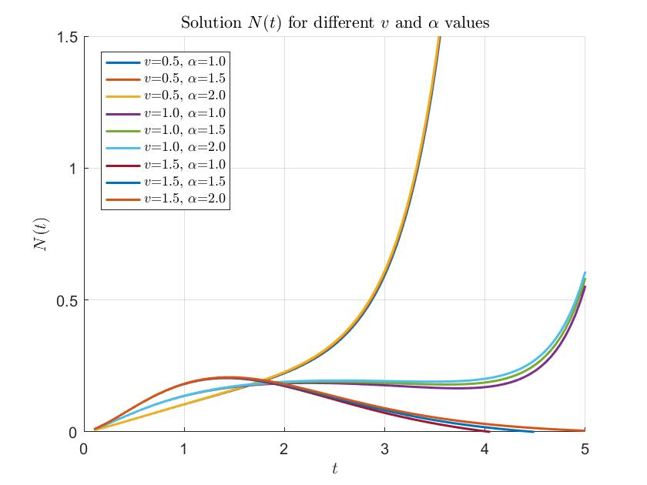
Fig. 1 Solution $N(t)$ of the Theorem 1 for different combinations of the values of $v$ and $α$.

which in view of Eq. (1.22) gives
$N\left(t\right)=N_{0}\sum_{k=0}^{∞}{\frac{{(-c)}^{k}Г\left(2k+l+2\right)}{Г\left(∝k+μ\right)Г\left(ak+\frac{l}{ξ}+\frac{b+2}{2}\right){(2)}^{2k+l+1}}.}\sum_{r=0}^{∞}{\frac{{(n)}_{r}}{(r)!}} {(-e^{v})}^{r}\frac{t^{vr+2k+l+1}}{Г(vr+2k+l+2)}$.
On interpreting the resulting series with the help of Eq. (1.15) we at once arrive at the solution in Eq. (2.3).

Theorem 2: If $e, t,v ∈R^{+} , a,b,c,l ∈C and R\left(l\right)>-1,$ then the solution of the equation
$N\left(t\right)-N_{o}{{}_{a}^{}W}_{p,b,c, ξ}^{α,μ}\left(e^{v}t^{v}\right)=-\left\{\sum_{r=1}^{n}{\left(\begin{matrix}n \\ r\end{matrix}\right){(e^{v})}^{r}{{}_{0}^{}D}_{t}^{-vr}}\right\} N(t)$, …(2.4)

i.e. ${\left(1+e^{v}{{}_{0}^{}D}_{t}^{-v}\right)}^{n}N\left(t\right)=N_{0}$ ${{}_{a}^{}W}_{p,b,c, ξ}^{α,μ}\left(e^{v}t^{v}\right)$, …(2.5)
is given by
$N\left(t\right)=N_{0}\sum_{k=0}^{∞}{\frac{{(-c)}^{k}Г\left(2kv+lv+v+1\right)}{Г\left(∝k+μ\right)Г\left(ak+\frac{l}{ξ}+\frac{b+2}{2}\right)}} {\left(\frac{e^{v}t^{v}}{2}\right)}^{2k+l+1}.E_{v,\left(2k+l+1\right)v+1}^{n}({-e}^{v}t^{v})$.…(2.6)
Proof: We can derive parallel as theorem 1.
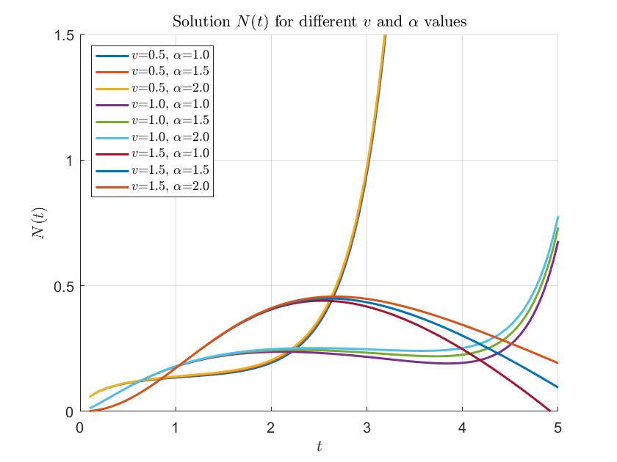
Fig. 2 Solution $N(t)$ of the Theorem 2 for different combinations of the values of $v$ and $α$.

Theorem 3: If $e, t,v ∈R^{+} , a,b,c,l ∈C and R\left(l\right)>-1 , a≠e,$ then the solution of the equation
$N\left(t\right)-N_{o}{{}_{a}^{}W}_{p,b,c, ξ}^{α,μ}\left(e^{v}t^{v}\right)=-\left\{\sum_{r=1}^{n}{\left(\begin{matrix}n \\ r\end{matrix}\right){(a^{v})}^{r}{{}_{0}^{}D}_{t}^{-vr}}\right\} N(t)$, …(2.7)

i.e. ${\left(1+a^{v}{{}_{0}^{}D}_{t}^{-v}\right)}^{n}N\left(t\right)=N_{0}$ ${{}_{a}^{}W}_{p,b,c, ξ}^{α,μ}\left(e^{v}t^{v}\right)$, …(2.8)
is given by
$N\left(t\right)=N_{0}\sum_{k=0}^{∞}{\frac{{(-c)}^{k}Г\left(2kv+lv+v+1\right)}{Г\left(∝k+μ\right)Г\left(ak+\frac{l}{ξ}+\frac{b+2}{2}\right)}} {\left(\frac{e^{v}t^{v}}{2}\right)}^{2k+l+1}.E_{v,\left(2k+l+1\right)v+1}^{n}\left({-a}^{v}t^{v}\right)$. …(2.9)
Proof: We can derive parallel as theorem 1.
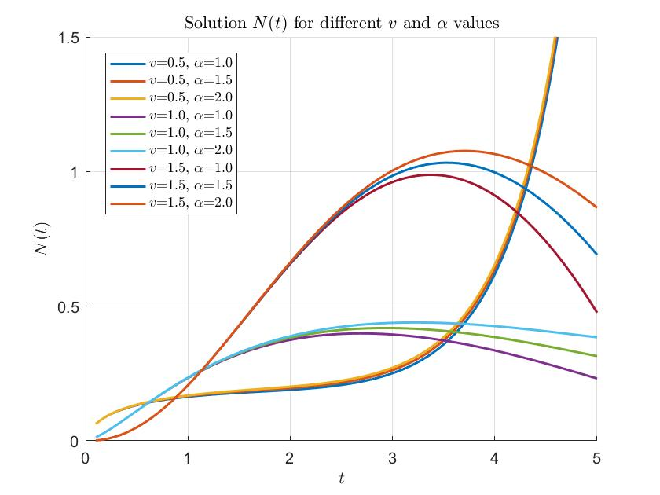
Fig. 3 Solution $N(t)$ of the Theorem 3 for different combinations of the values of $v$ and $α$.
Special Cases:
- If we take $r=1$ in theorem 1 we at once arrive the known result of [18, pp. 9, Eq. 34, 38].
- If we take $r=1$ in theorem 2 we at once arrive the known result of [18, pp. 9, Eq. 39, 40].
- If we take $r=1$ in theorem 3 we at once arrive the known result of [18, pp. 9, Eq. 41, 42].

- Conclusion
The present study investigates fractional kinetic equations involving the generalized Galué-type Struve function. The solutions to these generalized fractional kinetic equations are obtained using the Laplace transform. It is observed that the Laplace transform provides an effective method for solving such equations, with several applications and explicit solutions derived. Notably, the results presented in Theorem 1, Theorem 2, and Theorem 3 are expressed in terms of the Mittag-Leffler function. Furthermore, to illustrate the behavior and properties of the solutions, graphical representations have been provided using MATLAB (Fig. (1-3)). These visualizations support the analytical findings and offer insight into the dynamic nature of the solutions. This work opens the door for further research, where other researchers may explore alternative integral transforms and special functions to derive new or existing forms of fractional kinetic equations.
Conflict of Interest: The authors declare that they have no conflict of interest
Funding: No funds, grants, or other support was received from funding agencies except host
University

References:

[1] Bhowmick, K.N., Some relations between a generalized Struve’s function and hypergeometric functions, Vijnana Parishad Anusandhan Patrika 5, 93-99 (1962)
[2] Bhowmick, K.N., A generalized Struve’s function and its recurrence formula. Vijnana Parishad Anusandhan Patrika 6, 1-11 (1993)
[3] Chaurasia, V.B.L., Kumar D, On the solutions of generalized fractional kinetic equations. Adv stud. Theor. Phy. 4, 773-780 (2010)
[4] Chaurasia, V.B.L., Pandey, S.C., On the new computable solution of the generalized fractional kinetic equations involving the generalized function for the fractional calculus and related functions. Astrophys. Space Sci. 317, 213-219 (2008)
[5] Choi j, Kumar D., Solutions of generalized fractional kinetic equations involving Aleph functions. Math. Commun. 20, 113-123 (2015)
[6] Chouhan, A., Sarswat, S., On solution of generalized kinetic equation of fractional order. Int. J Math. Sci. Appl. 2(2), 813-818 (2012)
[7] Chouhan, A., Purohit, S.D., Saraswat, S., An alternative method for solving generalized differential equations of fractional order kragujevac J. Math. 37(2), 299-306 (2013)
[8] Erdelyi, A., Magnus, W., Oberhettinger, F. and Tricomi, F.G.: Tables of Integral Transforms, Vol.-I, McGraw-Hill Book, New York, Toronto and London (1954)

[9] Gupta, A, Parihar, C.L., On solution of generalized kinetic equations of fractional order. Bol. Soc. Paran Mat. 32 (1), 181-189 (2014)
[10] Haubold, H.J., Mathai, A.M., Haubold, H.J., On fractional kinetic equations Astrophys. Space Sci. 282, 281-287 (2002)
[11] Jaimini, B.B. and Saxena, H., Solutions of certain fractional differential equations, J. of Indian Acad. Math. 29(1), 223-236 (2007)
[12] Kanth, B.N., Integrals involving generalized Struve’s function. Nepali Math. Sci. Rep. 6, 61-64 (1981)
[13] Kumar, D, Purohit, S.D, Secer, A., Atangana, A., On generalized fractional kinetic equations involving generalized Bessel function of the first kind. Math Probl. Eng. 289387 (2015)
[14] Miller, K.S. and Ross, B., An Introduction to the Fractional Calculus and Fractional Differential Equation, A Willey Inter Science Publication, John Wiley & Sons, New York (1993)

[15] Mittag-Leffler, G.M., Sur la representation analytiqie d’une function monogene cinquieme note. Acta. Math. 29, 101-181 (1905)
[16] Nisar, K.S., Atangana, A., Exact solution of fractional kinetic equation in terms of Struve functions. (submitted), (2016)
[17] Nisar, K.S., Purohit, S.D., Mondal, S.R., Generalized fractional kinetic equations involving generalized Struve function of the first kind. J King Saud Univ Sci 28(2), 167-171 (2016b)
[18] Nisar, K.S., Baleanu, D. and Qurashi, M.A., Fractional calculus and application of generalized Struve function. SpringerPlus 5, 910 (2016)
[19] Orhan, H., Yagmur, N., Starlikeness and convexity of generalized Struve functions. Abstr. Appl. Anal. Art ID 954513:6, (2013)
[20] Orhan H., Yagmur, N., Geometric properties of generalized Struve functions. Ann Alexandru loan Cuza Univ –Math. (2014) Doi: 10. 2478/aicu-2014-0007
[21] Prabhakar, T.R., A singular integral equation with a generalized Mittag-Leffler function in the kernel. Yokohama Math. J. 19, 7-15 (1971).
[22] Rainville E.D. (1960): Special Functions, Macmillan, New York.
[22] Saichev A., Zaslavsky, M., Fractional kinetic equations: solutions and applications. Chaos 7, 753-764, (1997)
[23] Saxena, R.K., Mathai, A.M. and Haubold, H.J.,On fractional Kinetic equations, Astrophys. Space Sci. 282, 281-287 (2002)

[24] Saxena, R.K., Mathai, A.M. and Haubold, H.J.,On generalized fractional kinetic equations, Physica A, 344, 657-664 (2004)

[25] Saxena, R.K., Mathai, A.M, Haubold, H.J., Solution of generalized fractional rectional diffusion equations. Astrophys. Space Sci. 305, 305-313 (2006)

[26] Saxena, R.K., Kalla, S.L., On the solutions of certain fractional kinetic equations. Appl. Math. Comput. 199, 504-511 (2008)
[27] Singh, R.P., Generalized Struve’s function and its recurrence relations. Ranchi Univ. Math. J. 5, 67-75 (1974)
[28] Singh, R.P., Generalized Struve’s function and its recurrence equation. Vijnana Parishad Anusandhan Patrika 28, 287-292 (1985)
[29] Singh, R.P., Some integral representation of generalized Struve function. Math Ed (Siwan). 22, 91-94 (1988)
[30] Singh, R.P., On definite integrals involving generalized Struve’s function. Math Ed (Siwan). 22, 62-66 (1988)
[31] Singh, R.P., Infinite integrals involving generalized Struve function. Math Ed (Siwan). 23, 30-36 (1989)
[32] Srivastava, H.M., Saxena, R.K., Operators of fractional integration and their applications. Appl. Math Comput. 118, 1-52 (2001)
[33] Wiman, A., Uber den fundamental satz in der theorie der funktionen $E_{α}(z)$. Acta. Math. 29, 191-201 (1905)
[34] Zaslavsky, G.M., Fractional kinetic equation for Hamiltonian chaos, Physica D. 76, 110 –122 (1994)

