Fire and Landscape Configuration Shape Forest Futures: Direct and Indirect Drivers of Seedling Diversity in a Human-Modified Tropical Rainforest
Landscape Ecology
Sergio Nicasio-Arzeta, Susana Maza-Villalobos, Aline Pingarroni, Isela Zermeño-Hernández and Julieta Benítez-Malvido
Corresponding author: Susana Maza-Villalobos
El Colegio de la Frontera Sur, Unidad San Cristóbal de Las Casas, Carretera Panamericana y Periférico Sur s/n. Barrio María Auxiliadora, C.P. 29290, San Cristóbal de Las Casas, Chiapas.Email address: sumaza@ecosur.mx

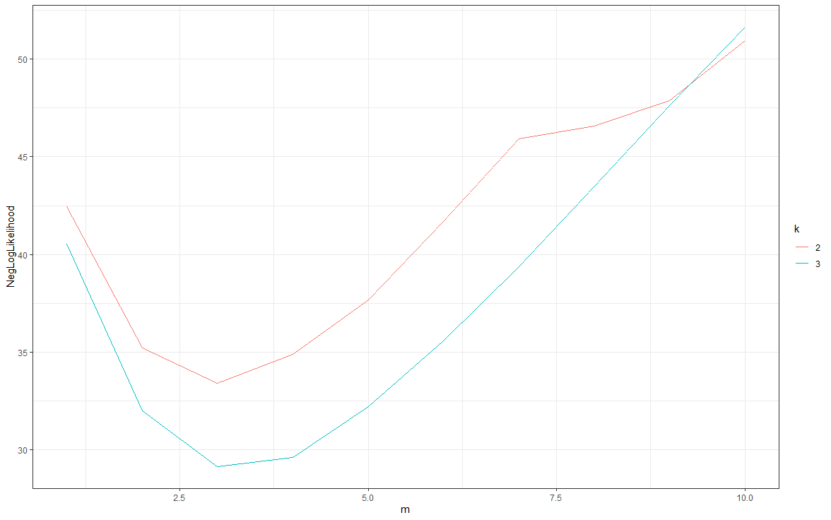
Fig S2. Association between the tunning parameter (m) and the negative Log-likelihood of models with varying m values. The red line represents a logistic PCA of two dimensions and the blue line a PCA of three dimensions.

