Supplementary Information
Reversible transdimensional phase transition in a topological semimetal
Qingrong Liang¹, Jiali Chen¹, Liu Yang^{2,}*, Wei Jiang^{1,}*, Jiadong Zhou^{1,3,}* and Shoujun Zheng^{1,3,}*
¹Centre for Quantum Physics, Key Laboratory of Advanced Optoelectronic Quantum Architecture and Measurement (MOE), School of Physics, Beijing Institute of Technology, Beijing, 100081, China,
²Department of Physics, Hubei Engineering Research Center of Weak Magnetic-field Detection, China Three Gorges University, Yichang, 443002, China
³Faculty of Marine Science and Technology, Beijing Institute of Technology, Zhuhai, Guangdong, 519088, China
Corresponding authors: yangliu1@ctgu.edu.cn, wjiang@bit.edu.cn, jdzhou@bit.edu.cn, szheng@bit.edu.cn

This PDF file includes:
Note S1
Figs. S1 to S16
Note S1: Schematic diagram of the PtBi₂ crystal structure
Figure S1: Schematic diagram of the PtBi₂ crystal structure
Figure S2: Phonon spectra of 2D FE and 3D T’ PtBi₂
Figure S3:The calculated Raman vibration modes of 2D FE PtBi₂ crystal
Figure S4: Kelvin Probe Force Microscopy (KPFM) surface potential and height analysis of PtBi₂ device
Figure S5: Device recyclability and electrical characteristics in current mode.
Figure S6: R-V curves of the PtBi₂ device at various temperatures.
Figure S7: Thermal conductivities of 2D FE and 3D T’ PtBi₂ in various directions at different temperatures
Figure S8: Simulation of the temperature distribution of the PtBi₂ device under different bias voltages.
Figure S9: Raman mapping of the PtBi₂ device before and after electrical testing
Figure S10: Based on the vertical HAADF - STEM images and EDS mapping results of the PtBi₂ device
Figure S11: Cross-sectional and top-view HAADF-STEM images and EDS mapping results of PtBi₂ nanosheets
Figure S12: HAADF-STEM images and EDS mapping results of 2D FE PtBi₂ and 3D T’PtBi₂ from the [0 1 0] perspective
Figure S13: HAADF-STEM images and EDS mapping results of 2D FE and 3D T’ PtBi₂ from the [2 1 0] perspective
Figure S14: Atomic STEM characterization and Fourier transformation of 2D FE and 3D T’ PtBi₂ crystals
Figure S15: Atomic STEM characterization and Fourier transformation of the mixed phases of 2D FE and 3D T’ PtBi₂
Figure S16: Strain analysis of FE-PtBi₂ phase transition
Figure S17: S17 Fermi surfaces of 2D FE and 3D T’ PtBi₂
Figure S18: Evolution of WCC in 2D FE and 3D T’ PtBi₂

Note S1. PtBi₂ crystalline vibration mode group theory analysis
Based on the crystal structure of PtBi₂, PtBi₂ belongs to the P31M space group (trigonal system), and its point group is C_{3v} (see table 1), which includes 3 mirror axes and 3 vertical planes. PtBi₂ contains 4 atoms per unit cell (3 Bi, 1 Pt). Each atom has 3 degrees of freedom, so the total degrees of freedom are 4×3=12. The vibration modes can be divided into 12-3 (translation modes)–3 (rotation modes)=6.
According to the characteristics of the C_{3v} point group and the irreducible representations (a_{i} = (1/g) Σg_{k}χ_{nor}(k)χ_{i}(k), where g=6 (point group), g is the number of symmetry elements), the irreducible representation coefficients are as follows:
A₁: a₁ = [12×1+1×0×2×1+2×3×1]/6 = 12 + 0 + 6 = 3
A₂: a₂ = [12×1+1×0×2×1+2×3×(-1)] /6= 12 + 0 + (-6) = 1
E: a_{E} = [12×1+0×2×(−1)+2×3×0]/6 = 24 + 0 + 0 = 4
Therefore, the total irreducible representation can be written as: 3A₁+A₂+4E. This corresponds to the vibrational modes for second-order functions such as x²+y², x², z²-y², etc. Hence, the vibrational modes can be written as: Γ_{vib}=Γ_{total}-Γ_{translation}-Γ_{rotation}=(3A₁+A₂+4E)-(A₁+E)-A₂=2A₁+3E, and the final step involves DFT calculations for the vibrational modes, leading to visualization and further analysis as shown in Figure S3.
Figure S1. Schematic diagram of the PtBi₂ crystal structure. Three structures of PtBi₂, namely 2D FE PtBi₂, 2D T PtBi₂, and 3D T’ PtBi₂ are viewed from the [010] direction (view a) and the [210] direction (view b). View a and view b can be switched by rotating 30° (or - 30°) around the specified axis. It presents the atomic arrangements of different structures from different perspectives, facilitating the comparative analysis of the characteristic differences among the three structures.

Figure S2. Calculated phonon spectra of 2D FE and 2D T phases. a-b, The phonon band structures of the 2D FE PtBi₂ phase (a) and the 2D T PtBi₂ phase (b), respectively. The horizontal axis represents the high-symmetry points in the Brillouin zone, and the vertical axis represents the phonon frequency. The phonon spectra of both phases have no imaginary frequencies, indicating that both the PtBi₂ phase and the PtBi₂ phase are in stable structural states.

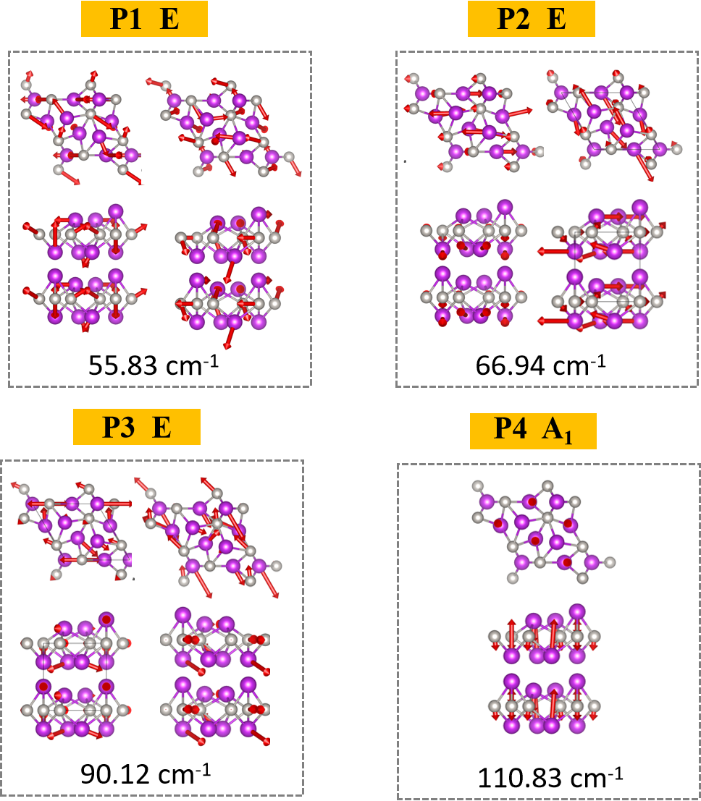

Figure S3. The calculated Raman vibration modes of 2D FE PtBi₂ crystal. Calculated Raman vibrational modes of the 2D FE PtBi₂ phase. It shows the modes of four Raman peaks, namely P1, P2, P3, and P4, corresponding to wavenumbers of 55.83 cm⁻¹, 66.94 cm⁻¹, 90.12 cm⁻¹, and 110.83 cm⁻¹, respectively. The crystal structures and the atomic arrangements related to vibrations under each mode are present by the red arrows.
Figure S4. KPFM surface potential and height analysis of PtBi₂ device. a, KPFM mapping of the original device. b, KPFM amplitude profiles along the white solid line in (a), showing the potential variation between the electrode and the sample surface. c, AFM amplitude profiles along the white solid line in (a), with the blue color showing the height variation between the electrode and the sample surface.

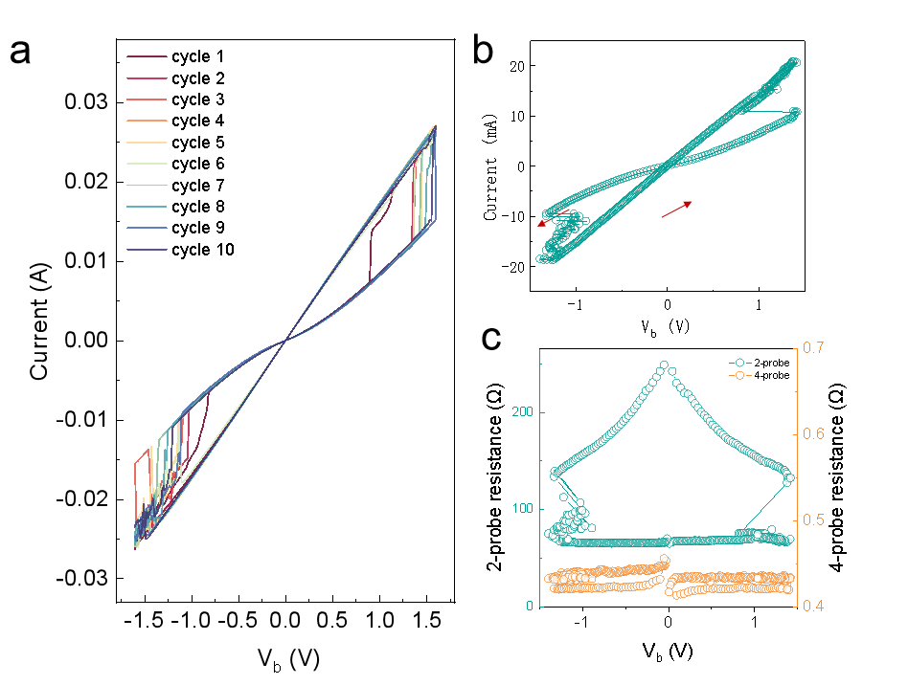
Figure S5. Device recyclability and electrical characteristics in the current mode. a, 10 cyclic tests of I-V curves at 300 K in Fig. 2a, still maintaining high and low resistance states. b, I-V curve in current test mode, showing a voltage transition at a current of 10 mA. c, R-V curves of two-probe and four-probe configurations in current test mode.

Figure S6. R-V curves of the PtBi₂ device at various temperatures. a-h, The I-V curves of the PtBi₂ device at different temperatures, exhibiting clear hysteresis loops. The bias voltages at which current jumps occur vary with different temperatures, indicating that the phase transition point changes with temperature.

Figure S7. Calculated thermal conductivities of 2D FE PtBi₂ and 3D T’ PtBi₂ in various directions at different temperatures. a-f, The variations of thermal conductivities in various directions of 2D FE PtBi₂ and 3D T’ PtBi₂ with temperature are calculated by DFT, where blue and purple represent the variations of anisotropic thermal conductivities of 2D FE and 3D T’ PtBi₂ with temperature, respectively.
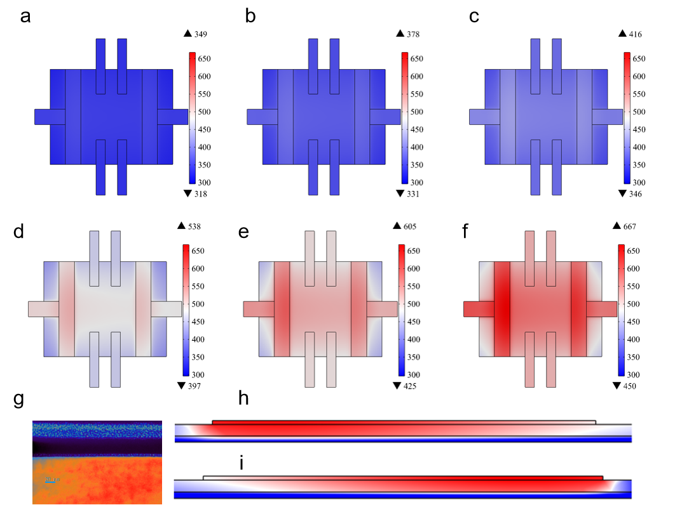

Figure S8. Temperature distribution simulation of the PtBi₂ device under different bias voltages. a-f, Top-view simulations of the temperature distribution of the PtBi₂ device under different bias voltages. g, The STEM cross-section image. h-i, are the simulations of the temperature distribution of the device electrode cross-sections, respectively.

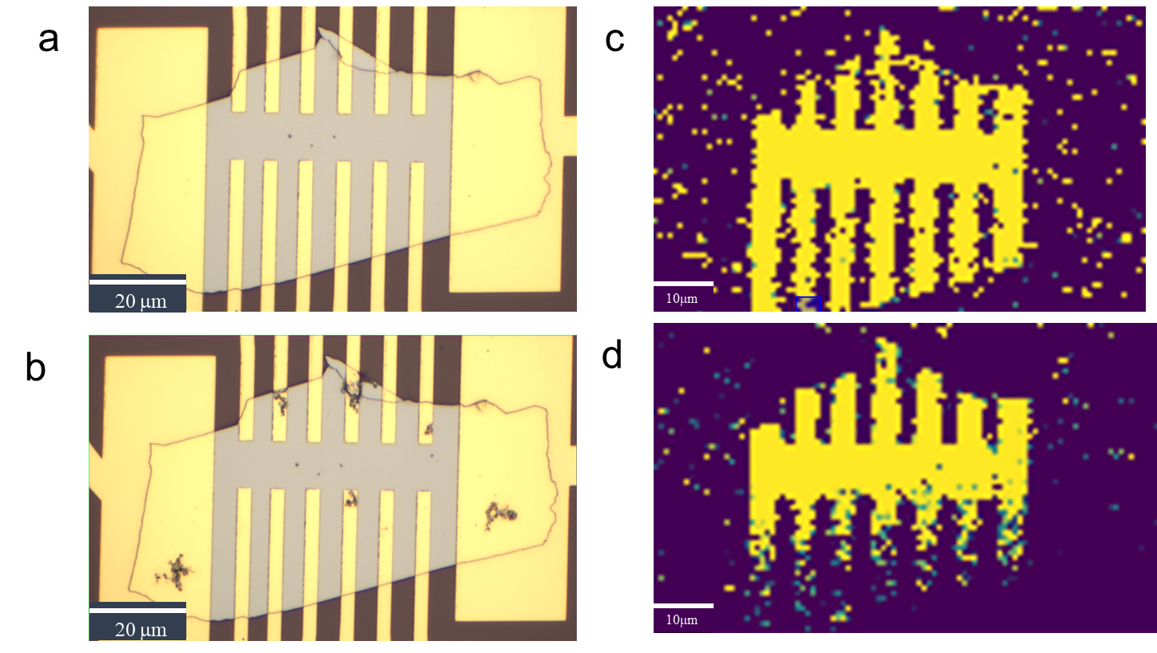

Figure S9. Raman mapping of the PtBi₂ device before and after electrical testing. a-b, The optical photographs before and after electrical testing, respectively. c-d, The Raman mappings before and after electrical testing, respectively.
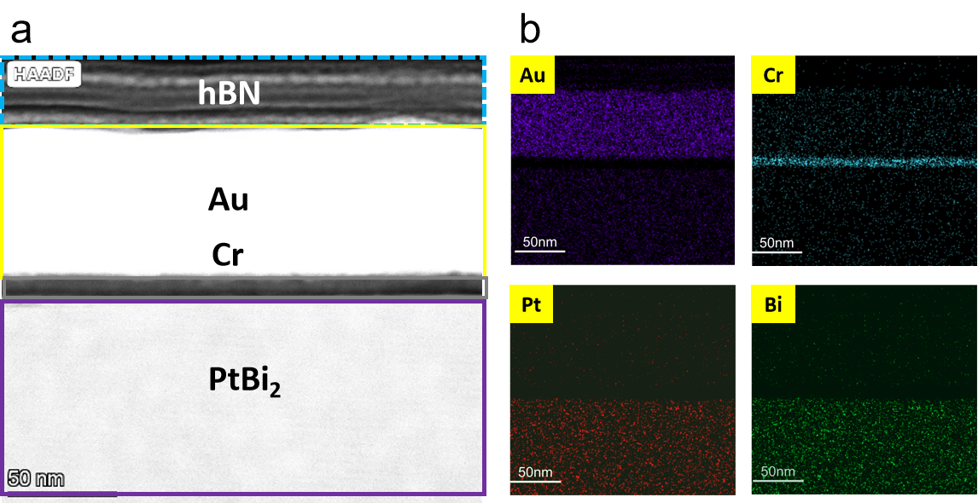

Figure S10. Based on the vertical HAADF-STEM images and EDS mapping results of the PtBi₂ device. a, Vertical HAADF-STEM image of the PtBi₂ device, with hBN, Au, Cr, and PtBi₂ in sequence from top to bottom. b, EDS mapping results from top to bottom of the PtBi₂ device in a.

Figure S11. Cross-sectional and top-view HAADF-STEM images and EDS mapping results of PtBi₂ nanosheets. a-b, HAADF-STEM images of PtBi₂ nanosheets along the [010] and [001] directions, respectively. c-f, EDS mapping results of Pt and Bi elements for PtBi₂ nanosheets along the [010] and [001] directions, respectively. g-h, Elemental composition ratios of PtBi₂ nanosheets along the [010] and [001] directions, respectively.

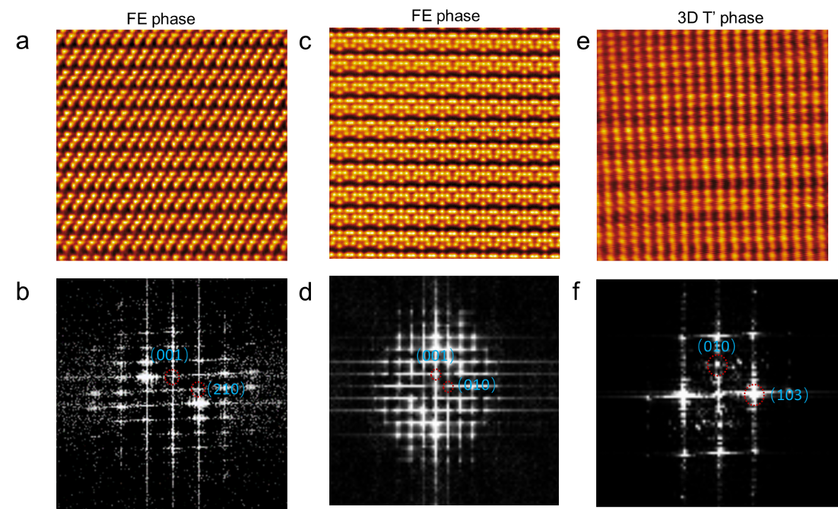
Figure S12. Atomic STEM characterization and Fourier transformation of 2D FE PtBi₂ and 3D T’ PtBi₂ crystals. a-c, HAADF-STEM images of 2D FE PtBi₂ along the [010] and [210] zone axes, respectively. b-d, FFT images corresponding to those in a-c, respectively. e-f, HAADF-STEM image and fast FFT image of 3D T’ PtBi₂ along the [103] zone axis, respectively.
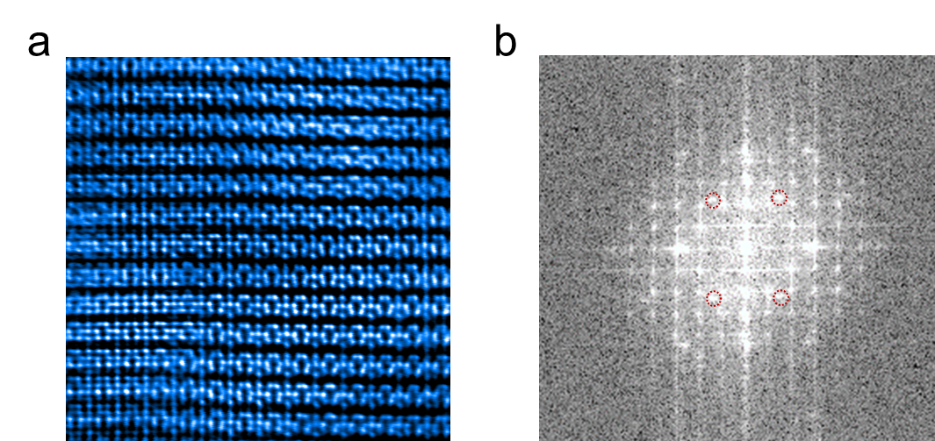

Figure S13. Atomic STEM characterization and Fourier transformation of the mixed phases of 2D FE PtBi₂ and 3D T’ PtBi₂. a, HAADF-STEM image of the mixed phases of 2D FE and 3D T’ PtBi₂ along the [010] zone axe, respectively. b, FFT image corresponding to those in a and c, respectively.

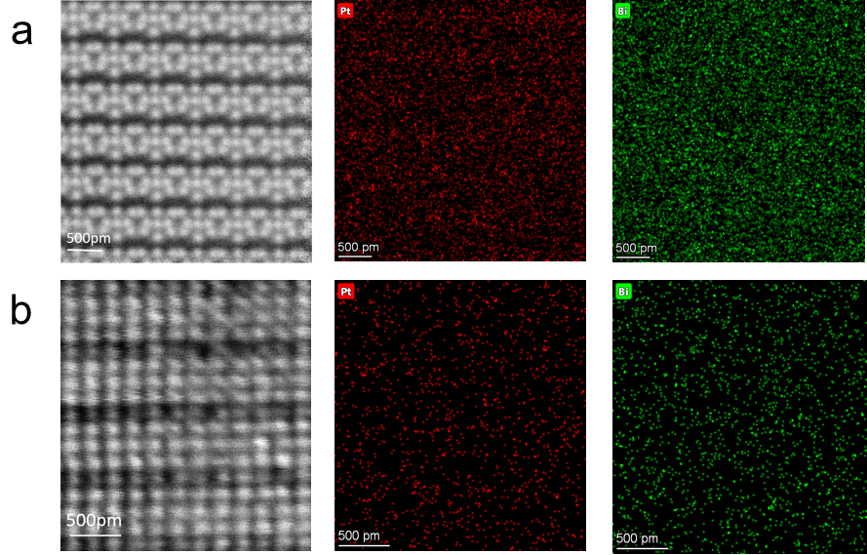

Figure S14. HAADF-STEM images and EDS mapping results of 2D FE and 3D T’ PtBi₂. a, HAADF-STEM image and EDS mapping results of 2D FE PtBi₂ from the [010] perspective. b, HAADF-STEM image and EDS mapping results of 3D T’ PtBi₂ from the [103] perspective.
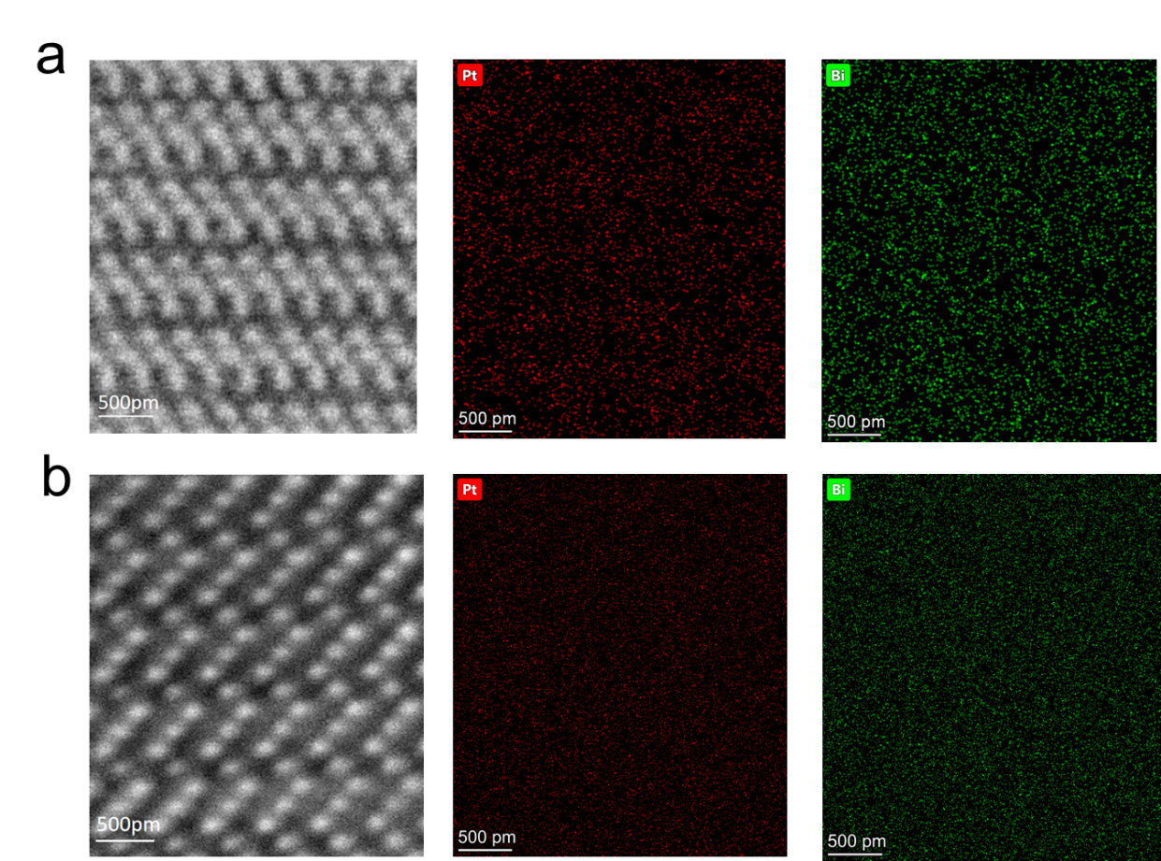

Figure S15. HAADF-STEM images and EDS mapping results of 2D FE PtBi₂ and 3D T’ PtBi₂ from the [210] perspective. a, HAADF-STEM image and EDS mapping results of 2D FE PtBi₂ from the [210] perspective. b, HAADF-STEM image and EDS mapping results of 3D T’ PtBi₂ from the [101] perspective.

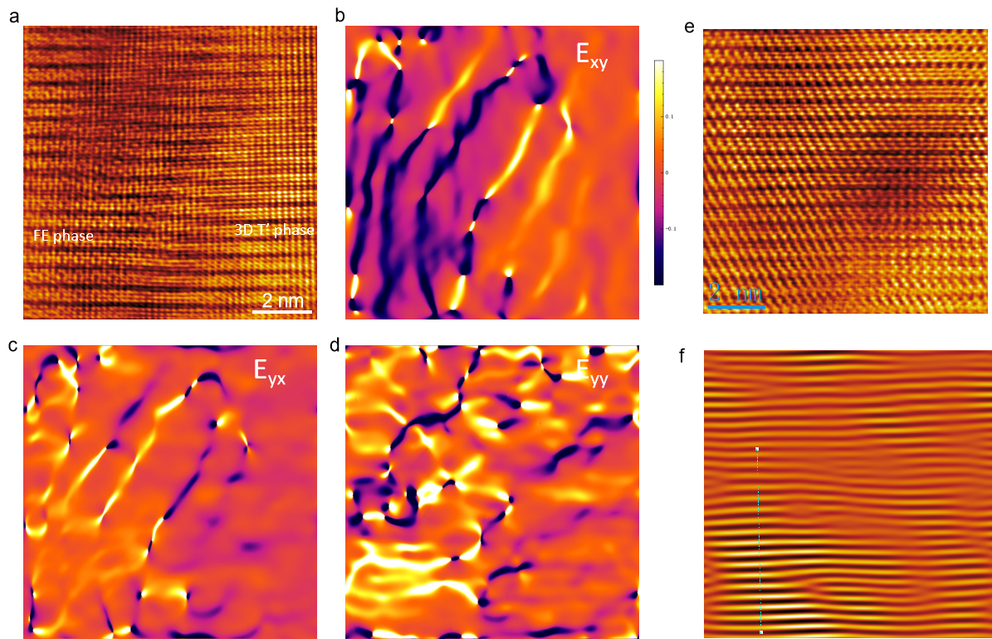

Figure S16. Strain analysis of PtBi₂ mixed phase. a, Atomic STEM characterization of the domain wall in the mixed phase of 2D FE PtBi₂ and 3D T’ PtBi₂. b-d, The strain field mapping of the mixed phases of 2D FE PtBi₂ and 3D T’ PtBi₂, including ε_{xx}, ε_{yy}, and ε_{xy}. These data were obtained by the geometric phase analysis method. Due to lattice mismatch, there are significant differences in strain distribution along the x-axis in b and y-axis in c. The ε_{xx} and ε_{yy} strain distribution maps show that the strain difference between 2D FE PtBi₂ and 3D T’ PtBi₂ at the interface is relatively large, indicating the lattice mismatch between the two phases. e-f, Atomic STEM characterization and inverse Fourier transform of the domain wall in the mixed phase of 2D FE PtBi₂ and 3D T’ PtBi₂, respectively.
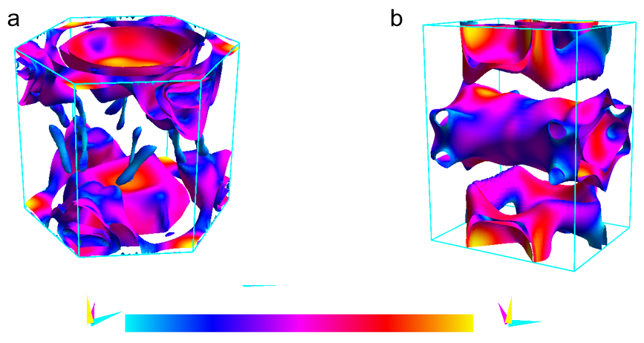

Figure S17. Fermi surfaces of 2D FE and 3D T’ PtBi₂. a-b, Fermi surfaces of 2D FE and 3D T’ PtBi₂, where the color indicates the Fermi velocity.

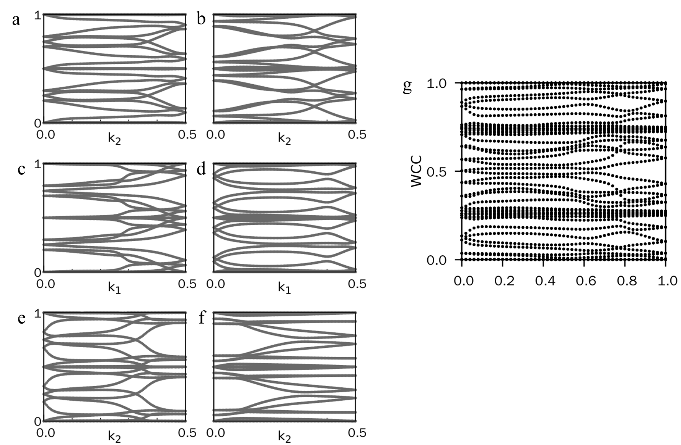

Figure S18. Evolution of WCC in 2D FE and 3D T’ PtBi₂. a-g, Evolution of WCC in 2D FE and 3D T’ PtBi₂. The Z₂ number of a 3D insulator consists of four numbers (ν₀; ν₁ν₂ν₃), where ν₀=Z₂(kᵢ=0)+Z₂(kᵢ=0.5). The Z₂ topological number of 3D T’ PtBi₂ is (1;000), which indicates that 3D T’ PtBi₂ is a strong topological insulator.

