Supplementary file
Efficacy of Erector Spinae Block on Postoperative Outcomes in Bariatric Surgery Patients: A Systematic Review, Meta-Regression, and Trial-Sequential Analysis of Randomized Controlled Trials.
Vitaliy & Salem et al. 2025
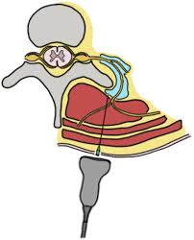

Table of Contents
Supplementary File S1: List of Search strategies and keywords 2
Supplementary File S2: Protocol for postoperative outcomes of erector spinae block in bariatric surgery: A systematic review, meta-regression and trial sequential analysis. 8
Supplementary File S3: Erector Spinae Block in Bariatric Surgical Procedures: A Systematic Review of Randomized Controlled Trials in the tabular column. 14
Supplementary File S4: Publication Bias and Meta-regression analysis 17
Supplementary File S5: Twenty-four-hour Postoperative opioids and Postoperative Nausea and Vomiting. 19
Supplementary File S6: Length of Hospital Stay and Time to Rescue Analgesia. 21
Supplementary file S7: Risk of Bias assessment by Cochrane ROB 2 tool 22
Supplementary File S8: Trial sequential analysis of resting pain score at six hours (primary outcome). 22

Supplementary File S1: List of Search strategies and keywords
Search History saved as "2025 04 SR_Erector Spinae Block_Bariatric Surgery_M_FNL"
Search History saved as "2025 04 SR_Erector Spinae Block_Bariatric Surgery_E_FNL"
Search History saved as "2025 04 SR_Erector Spinae Block_Bariatric Surgery_CCTR_FNL"
Topic: Erector Spinae Block for Bariatric Surgery
For: Dr Mahesh Nagappa
a review in Covidence titled: Postoperative outcomes after Erector Spinae Block in patients undergoing Bariatric Surgery

Database: Ovid MEDLINE(R) ALL <1946 to April 16, 2025>
Search Strategy:
1 exp Bariatric Surgery/ or (bariatric$ or post-BS or post-bariatric$ or postBS or postbariatric$).tw,kf,kw. (47390)
2 (gastrojejunostom$ or gastroplast$ or lipectom$ or ((suction$ or aspiration$) adj3 (lipectom$ or lipolys$)) or lipoplast$ or liposuction$ or lipoabdominoplast$).tw,kf,kw. (10769)
3 (bypass and (jejunoileal$ or jejuno-ileal$ or ileojejunal$ or ileo-jejunal$ or intestinal$ or gastric$ or gastroileal$ or gastroileal$ or Greenville)).tw,kf,kw. (20038)
4 (roux-en-y or RYJ or Roux's Y or roux en y or (Roux adj3 Y)).tw,kf,kw. (16406)
5 (((gastrojejunal$ or gastrojejunum$ or jejunogastric$ or GJ) and (tube$ or feed$ or anastomos$)) or GJT).tw,kf,kw. (1009)
6 (jejunostom$ adj3 feed$).tw,kf,kw. (856)
7 (exp Gastrectomy/ or (gastrectom$ or gastric$).tw,kf,kw.) and sleev$.mp. (11083)
8 or/1-7 (64608)
9 exp *Anesthesia, Conduction/ or ((anesthe$ or anaesth$ or block$) adj2 conduction$).tw,kf,kw. (63241)
10 exp Anesthesia, Local/ or ((anesthe$ or anaesth$) adj2 (local or regional$)).tw,kf,kw. (73534)
11 exp Nerve Block/ or ((nerve$ or local or sensory$ or erector$ or spina$ or plane) adj2 block$).tw,kf,kw. or (blockade$ or block$1).tw,kf,kw. or ESPB.tw,kf,kw. (555015)
12 or/9-11 (624532)
13 8 and 12 (959)
14 (back or spine$ or spinal$ or spinae$ or C-Spine$ or vertebra$).ti. or (back or spine$ or spinal$ or spinae$ or C-Spine$ or vertebra$).ab. /freq=2 (467217)
15 8 and 12 and 14 (46)
16 ((erector$ and spinae$) or (spinalis$ or longissimus$ or iliocostalis$)).mp. or ESPB.tw,kf,kw. (13217)
17 8 and 16 (34)
18 15 or 17 (52)

Database: Embase Classic+Embase <1947 to 2025 April 16>
Search Strategy:
1 exp bariatric surgery/ or (bariatric$ or post-BS or post-bariatric$ or postBS or postbariatric$).tw,kf,kw. (87631)
2 *laparoscopic bariatric surgery/ or gastrojejunostomy/ or (gastrojejunostom$ or gastroplast$ or lipectom$ or ((suction$ or aspiration$) adj3 (lipectom$ or lipolys$)) or lipoplast$ or liposuction$ or lipoabdominoplast$).tw,kf,kw. (20533)
3 (bypass and (jejunoileal$ or jejuno-ileal$ or ileojejunal$ or ileo-jejunal$ or intestinal$ or gastric$ or gastroileal$ or gastroileal$ or Greenville)).tw,kf,kw. (36543)
4 (roux-en-y or RYJ or Roux's Y or roux en y or (Roux adj3 Y)).tw,kf,kw. (29048)
5 (((gastrojejunal$ or gastrojejunum$ or jejunogastric$ or GJ) and (tube$ or feed$ or anastomos$)) or GJT).tw,kf,kw. (2301)
6 (jejunostom$ adj3 feed$).tw,kf,kw. (1495)
7 (exp gastrectomy/ or (gastrectom$ or gastric$).tw,kf,kw.) and sleev$.tw,kf,kw. (23404)
8 or/1-7 (116689)
9 exp regional anesthesia/ or interscalene block anesthesia/ or ((anesthe$ or anaesth$ or block$) adj2 conduction$).tw,kf,kw. (87174)
10 ((anesthe$ or anaesth$) adj2 (local or regional$)).tw,kf,kw. (99533)
11 (((nerve$ or local or sensory$ or erector$ or spina$ or plane) adj2 block$) or (blockade$ or block$1) or ESPB).tw,kf,kw. (741925)
12 or/9-11 (833739)
13 8 and 12 (1691)
14 (back or spine$ or spinal$ or spinae$ or C-Spine$ or vertebra$).ti. or (back or spine$ or spinal$ or spinae$ or C-Spine$ or vertebra$).ab. /freq=2 (624472)
15 8 and 12 and 14 (85)
16 exp erector spinae muscle/ or ((erector$ and spinae$) or (spinalis$ or longissimus$ or iliocostalis$)).mp. or ESPB.tw,kf,kw. (15384)
17 8 and 16 (60)
18 8 and (ultrasound guided bilateral erector spinae plane block/ or ultrasound guided erector spinae block.mp. or erector spinae plane block/ or serratus anterior plane block/ or paraertebral block/ or peripheral nere block/ or rectus sheath block/) [mp=title, abstract, heading word, drug trade name, original title, device manufacturer, drug manufacturer, device trade name, keyword heading word, floating subheading word, candidate term word] (30)
19 15 or 17 or 18 (103)
20 limit 19 to embase (62)

Database: EBM Reviews - Cochrane Central Register of Controlled Trials <March 2025>
Search Strategy:
1 exp Bariatric Surgery/ or (bariatric$ or post-BS or post-bariatric$ or postBS or postbariatric$).tw,kf,kw. (4697)
2 (gastrojejunostom$ or gastroplast$ or lipectom$ or ((suction$ or aspiration$) adj3 (lipectom$ or lipolys$)) or lipoplast$ or liposuction$ or lipoabdominoplast$).tw,kf,kw. (951)
3 (bypass and (jejunoileal$ or jejuno-ileal$ or ileojejunal$ or ileo-jejunal$ or intestinal$ or gastric$ or gastroileal$ or gastroileal$ or Greenville)).tw,kf,kw. (2675)
4 (roux-en-y or RYJ or Roux's Y or roux en y or (Roux adj3 Y)).tw,kf,kw. (1836)
5 (((gastrojejunal$ or gastrojejunum$ or jejunogastric$ or GJ) and (tube$ or feed$ or anastomos$)) or GJT).tw,kf,kw. (88)
6 (jejunostom$ adj3 feed$).tw,kf,kw. (114)
7 (exp Gastrectomy/ or (gastrectom$ or gastric$).tw,kf,kw.) and sleev$.mp. (1744)
8 or/1-7 (7118)
9 exp *Anesthesia, Conduction/ or ((anesthe$ or anaesth$ or block$) adj2 conduction$).tw,kf,kw. (5395)
10 exp Anesthesia, Local/ or ((anesthe$ or anaesth$) adj2 (local or regional$)).tw,kf,kw. (26089)
11 exp Nerve Block/ or ((nerve$ or local or sensory$ or erector$ or spina$ or plane) adj2 block$).tw,kf,kw. or (blockade$ or block$1).tw,kf,kw. or ESPB.tw,kf,kw. (77513)
12 or/9-11 (92152)
13 8 and 12 (559)
14 (back or spine$ or spinal$ or spinae$ or C-Spine$ or vertebra$).ti. or (back or spine$ or spinal$ or spinae$ or C-Spine$ or vertebra$).ab. /freq=2 (53702)
15 8 and 12 and 14 (60)
16 ((erector$ and spinae$) or (spinalis$ or longissimus$ or iliocostalis$)).mp. or ESPB.tw,kf,kw. (3116)
17 8 and 16 (56)

Database: Scopus
Results: 14
( TITLE-ABS-KEY ( ( bariatric* AND surg* OR post-bs OR post-bariatric* AND surg* OR postbs OR postbariatric* AND surg* OR sleeve AND gastrectom* OR lipectomy* ) ) AND TITLE-ABS-KEY ( ( ( erector* AND spinae* ) OR ( spinalis* OR longissimus* OR iliocostalis* OR espb ) ) ) )

Supplementary File S2: Protocol for postoperative outcomes of erector spinae block in bariatric surgery: A systematic review, meta-regression and trial sequential analysis.
Protocol Study protocol for systematic review and meta-regression analysis to determine the Postoperative Outcomes of Erector Spinae Block in Bariatric Surgery

Vitaliy Voznyy and Salem Abu Alburak et al. “Postoperative Outcomes of Erector Spinae Block in Bariatric Surgery: A Systematic Review and meta-regression analysis.”

Objective
In this systematic review and meta-regression analysis, we aim to investigate the impact of erector spinae plane block on postoperative pain and nausea/vomiting in adult patients undergoing bariatric surgery.

Inclusion Criteria
Study Type
- Randomized control trials that present information on our primary outcomes (postoperative pain and postoperative nausea/vomiting) in individuals receiving erector spinae plane block for bariatric surgery
- Observational studies that present information on our primary outcomes (postoperative pain and postoperative nausea/vomiting) in individuals receiving erector spinae plane block for bariatric surgery
Participants
- Adult patients (>18 years old) undergoing bariatric surgery with erector spinae plane block

Definition of Exposition
- All studies that used the erector spinae plane block for bariatric surgery and reported primary outcomes were included
Outcome variable
- All studies which reported postoperative pain scores, postoperative opioid usage, or postoperative nausea/vomiting were included.
Publication type
- Fully published papers, excluding case reports, review articles, and editorials, will be eligible. No language restrictions will be applied.
Search Methods
We will search the following electronic databases:
- MedLine (via PubMed)
- EMBASE
- Scopus
- Web of Science
- Google Scholar
There will be no restriction on the time or language of publication. In these databases, we will search according to the thesaurus of the NCBI MESH browser, the following terms and combinations of keywords in full text:
The following keywords will be employed:

The search included the combination of the following MESH key words: "bariatric surgery", "Bariatric Surgery,", "gastric bypass", "sleeve gastrectomy", "Roux-en-Y", "biliopancreatic diversion", "adjustable gastric banding", "Obesity, Morbid", "laparoscopic bariatric surgery", "Erector Spinae Plane Block", "Erector Spinae Plane Block", "ESP block", "Erector Spinae Analgesia", "Erector Spinae Plane Regional Anesthesia", "ESP regional block", "Erector Spinae Plane Catheter", "Erector Spinae Nerve Block", "Nausea", "Nausea", "Vomiting", "Vomiting", "Pain", "Pain", "Pain Management", "Pain Management", "Opioid Consumption", "Opioid Analgesics", "Opioid Use", "Opioid Requirement", "Opioid-Sparing", "Morphine Equivalent", "Opioid-Free Anesthesia", "Fentanyl", "Morphine”, "Oxycodone", "Hydromorphone", "Pulmonary Function", "Respiratory Depression", "Length of Stay", "Hospital Stay", "PACU", and "recovery time".
Additionally, bibliographies of identified publications and published reviews will be hand-searched for potentially relevant articles. Authors will be contacted if data, methods and/or parameter definitions provided from the respective studies are unclear.

Reviews
All references cited in the identified reviews will be manually searched for potentially relevant studies.
Data collection
Two reviewers (VV, SA) will independently scrutinize the list of titles, and if available, the abstracts, to determine the potential usefulness of the article. Final selection will be based on the full text of potentially relevant articles by the two reviewers independently. In cases of disagreement, both authors will review the materials together until a consensus is reached. Study quality will be measured using the Newcastle–Ottawa scale (Wells et al. 2011).
The following study characteristics will be extracted: study ID, publication year, country, study design, cohort size, demographic data (age, gender, BMI), comorbidities, surgical procedures, postoperative pain scores, postoperative opioid usage, and postoperative nausea/vomiting. From all eligible studies, relevant data will be abstracted in duplicate, using a standardized data extraction sheet. An independent reviewer will confirm all data entries and will check at least twice for completeness and accuracy. A modified version of the Newcastle-Ottawa scale will be used to rate quality indicators.

Meta-analysis & Meta-regression
Dichotomous comparisons
- Data on the number of patients receiving the erector spinae plane block (ESPB) versus those receiving standard analgesia, along with corresponding crude odds ratios and 95% confidence intervals for postoperative outcomes, will be calculated.
- Random-effects models will be used to estimate the pooled odds ratios for the effect of ESPB on postoperative pain, opioid consumption, and postoperative nausea/vomiting across included studies. A random-effects Bayesian meta-analysis will be conducted to verify the results in case of sparse data. The value of the I² statistic will be used to select the appropriate pooling method: fixed-effects models if I² < 50% and random-effects models if I² ≥ 50%.

Assessment of heterogeneity
- Impact of heterogeneity will be assessed by calculating the I² according to Higgins et al. (Higgins JP et al. 2003). Confidence intervals around the I² will also be provided.
Influence analysis
- Influence analyses will check robustness of the pooled estimates. Each of the studies will be individually omitted from the data set, followed in each case by recalculation of the pooled estimate of the remaining studies.
Subgroup/Sensitivity analyses
- To identify potential sources of heterogeneity and bias, patients will be stratified based on analgesic approach (ESPB vs. standard analgesia), study design, study quality scores, measured outcome definitions, patient loss to follow-up, and relevant medical comorbidities (e.g., obstructive sleep apnea, diabetes, cardiovascular disease).
- Further stratifications will be made based on adjustment for confounders, type of study (retrospective vs. prospective), and variations in ESPB technique (e.g., dosage, catheter vs. single-shot block). Meta-regression will be used to evaluate whether effect size estimates differ significantly by study characteristics and quality factors, with corresponding meta-regression coefficients and p-values reported. Galbraith and funnel plots will be used to assess potential sources of heterogeneity and identify outliers.
- Forest Plots: Forest plots will be generated to display pooled effect estimates with summary points.

Evaluation of bias and confounding
Publication bias
- Publication bias will be assessed by inspection of the funnel plot and formal testing for funnel plot asymmetry, using Begg’s test (Sterne JA et al. 2001).
Discussion and Evaluating
- The results will be critically and integratively discussed.

Supplementary File S3: Erector Spinae Block in Bariatric Surgical Procedures: A Systematic Review of Randomized Controlled Trials in the tabular column.

Author [Country]  Journal Published Sample size (n) | Block characteristic  Timing  Guidance Local anesthetics, Adjuvants, Laterality, Level | Medical Co-morbidities | Other baseline data | Results
Karaveli et al. 2025  • Obesity Surgery  • n=40 | • Preoperative  • Ultrasound guided  • 0.25% (40ml)  • Bupivacaine  • No Adjuvants  • Bilateral  • T7 | HTN  OSA  DM  Smoking | ESB vs. Control  • Anesthesia time (minute)  77.50(66.25-84.25) vs. 74.5(67.75-84); p=0.779  • Surgery time (minute)  60.5(53.5-66) vs. 58.0(52.75-63.0); p=0.231  • Pneumoperitoneum time (minute)  54(45-60) vs. 48.5(43.5-54.25); p=0.242  • Intraoperative fentanyl consumption  200(200-200) vs. 350(300-400); p<0.0001  • Patient satisfaction  3.5(3-4) vs. 3.0(2-3); p=0.011 | ESB vs. Control  • Postoperative tramadol consumption  150(100-200) vs. 450(400-500); p<0.0001  • Postoperative pain scores at rest and during movement (0h, 1h, 3h, 6h, 9h, 12h, 18h, 24h); p<0.05  • PONV incidence  5% vs. 15%  • Hospital stays (days)  4(3.25-4) vs. 4(4-4)  • Spirometry data, pH, Horowitz ratio, PaCO₂; NS
Jinaworn et al. 2024  • Obesity Surgery  • n=61 | • Preoperative  • Ultrasound guided  • 0.25% (50ml)  • Bupivacaine  • Adrenaline  • Bilateral  • T7 | DM  HTN Dyslipidemia OSA  Liver disease  Psychotic disorder | ESB vs. Control  • Anesthesia time (minute)  160 (132-206) vs. 163.5 (131-270); p = 0.885  • Surgery time (minute)  118 (94-171) vs. 139.5 (90-227); p = 0.429  • Intraoperative desflurane (mL)  68.8 (45.0-84.5) vs. 74.5 (57.1-113.4); p = 0.632  • Intraoperative fentanyl consumption (μg)  100 (80-125) vs. 125 (100-150); p = 0.047  • PACU Fentanyl consumption (μg)  50 (25-75) vs. 50 (25-75); p=1.0 | ESB vs. Control  • Postoperative morphine consumption (mg)  13.0 (6-23) vs. 14.5 (7-24); p = 0.652  • Postoperative NRS pain scores at rest and at movement (0h, 1h, 6h, 12h, 18h, 24h); p<0.05
Elghamry et al. 2024  • Journal of opioid management  • n=40 | • Preoperative  • Ultrasound guided  • 0.25% (40ml)  • Bupivacaine  • Adrenaline  • Bilateral  • T7 | NA | ESB vs. Control  • Surgery time (minute)  101.4 ± 7.44 vs. 101.8 ± 6.5; p = 0.844  • Intraoperative fentanyl consumption (µg)  6.94 ± 20.23 vs. 46.05 ± 46.65; p = 0.010  • Sevoflurane consumption (mL)  13.90 ± 2.09 vs. 21.63 ± 2.88; p < 0.001  • Recovery time (minutes)  18.17 ± 1.38 vs. 22.47 ± 1.50; p < 0.001 | ESB vs. Control  • Postoperative fentanyl consumption (µg)  57.78 ± 16.65 vs. 103.2 ± 20.29; p < 0.001  • Postoperative VAS scores (0h, 0.5h, 2h, 4h, 8h, 12h, 18h, 24h)  • Time to first analgesic request post-operative (minutes)  805 ± 81.2 vs. 141 ± 23.4; p < 0.001  • Adverse events  Oxygen desaturation: 16.7% vs. 73.7%; p=0.001  PONV: 5.6% vs. 21.1%; p=0.34  Nausea: 5.6% vs. 0%; p=0.48  • Spirometry data, mean HR; NS
Toprak et al. 2023  • Obesity Surgery  • n=80 | • Preoperative  • Ultrasound guided  • 0.25% (40ml)  • Bupivacaine  • No Adjuvants, • Bilateral  • T8 | NA | ESB vs. Control  • Time of the first mobilization (hour)  8.40 (5.75) vs. 8.15 (4.24); p = 0.6  • Time for unassisted mobilization (hour)  20.20 (13.51) vs. 20.48 (11.72); p = 0.7 | ESB vs. Control  • NRS Pain scores at rest and on activity (15 mins, 30 mins, 1h, 2h, 6h, 12h, 24h, 48h); p < 0.05  • Postoperative rescue analgesics (15 mins, 30 mins, 1h, 2h, 6h, 12h, 24h, 48h); p < 0.05 at 30 mins  • Postoperative tramadol consumption (mg)  24h: 40.00 (46.96) vs. 86.40 (69.60); p = 0.002  48h: 41.25 (46.53) vs. 96.35 (80.25); p = 0.001  • QoR-40  175.02 ± 11.25 vs. 167.78 ± 18.59; p=0.008  • Side effects; p = 0.3  Nausea: 12.5% vs. 10%  Vomiting: 12.5% vs. 22.5%  Dizziness: 7.5% vs. 2.5%
Ashoor et al. 2023  • Pain Physician Journal  • n=67 | • Preoperative  • Ultrasound guided  • 0.25% (60ml)  • Bupivacaine  • No Adjuvants • Bilateral  • T7 | DM  HTN | ESB vs. Control  • Anesthesia time (minute)  125.6 ± 7.3 vs. 109.6 ± 6.2; p < 0.001  • Surgery time (minute)  103.9 ± 7.3 vs. 105.1 ± 6.0; p = 0.329  • Intraoperative fentanyl consumption (µg)  231.2 ± 25.4 vs. 224.2 ± 20.7; p = 0.411  •Time to first ambulation (h)  2.9 ± 0.9 vs. 4.4 ± 0.7; p < 0.001 | ESB vs. Control  • Total Nalbuphine Consumption (mg)/24 h  64.4 ± 12.4 vs. 77.5 ± 15.7; p < 0.001  • Patients who needed rescue analgesia, (n, %)  11 (34.4%) vs. 35 (100%); p <0.001  • Time to first rescue analgesia (h)  21.4 ± 1.6 vs. 0.7 ± 0.2; p < 0.001  • VAS scores at rest and movement (0.5h, 2h, 4h, 6h, 8h, 12h, 18h, 24h)  • PACU duration (minute)  27.7 ± 1.7 vs. 30.9 ± 1.7  • Hospital duration (days)  1.6 ± 0.3 vs. 2.2 ± 0.3; p < 0.001  • Postoperative Nausea  12 (37.5%) vs. 23 (65.7%); p = 0.011  • Postoperative Vomiting  4 (12.5%) vs. 14 (40.0%); p = 0.002  • Patient satisfaction score  3.9 ± 0.6 vs. 1.6 ± 0.6; p<0.001
Elshazly et al. 2022  • Korean Journal of Anesthesiology  • n=60 | • Preoperative  • Ultrasound guided  • 0.25% (40ml)  • Bupivacaine  • No Adjuvants • Bilateral  • T5 | HTN  DBM | N/A | ESB vs. TAP  • VAS score (5mins, 10mins, 15mins, 20mins, 25mins, 30mins, 2h, 4h, 8h, 12h, 18h, 24h); mean p < 0.001  • Time to first rescue analgesia (hour)  7.2 ±1.56 vs. 5.3±2.8; p = 0.001  • Postoperative nalbuphine consumption (mg)  12.34 ±2.16 vs. 16.87 ±3.21; p < 0.0001  • Time for flatus or stool (hour)  15.33 ±1.03 vs. 17.33 ±1.58; p < 0.001
Zengin et al. 2021  • Obesity Surgery  • n=62 | • Preoperative  • Ultrasound guided  • Bupivacaine (0.5%) + Lidocaine (0.2%) = 50ml  • No Adjuvants • Bilateral  • T9 | NA | ESB vs. Control  • Total propofol (mg)  1790.0 ± 323.1 vs. 1867.4 ± 447.1; p = 0.446 | ESB vs. Control  • Total intraoperative remifentanil (mcg)  1356.3 ± 177.8 vs. 3273.3 ± 961.9; p < 0.001  • Patients requiring rescue analgesia (%n)  0% vs. 100%  • Mean VAS scores (0h, 6h, 12h, 24h)  • Changes in VAS score (24h); p < 0.001  • heart rate, mean arterial pressure, ANI, and BIS scores at 15-min intervals
Mostafa et al. 2021  • World institute of pain, pain practice Journal  • n=60 | • Preoperative  • Ultrasound guided  • 0.25% (40ml)  • Bupivacaine  • No Adjuvants  • Bilateral  • T7 | NA | ESB vs. Control  • Duration of surgery (mins)  163.5 ± 13.5 vs. 158.8 ± 12.4; p = 0.162  • End-tidal isoflurane concentration (%)  1.25 ± 0.12 vs. 1.31 ± 0.12; p = 0.076  • Number of patients who required intraoperative fentanyl  10 (33.3%) vs. 28 (93.3%); p < 0.001  • Intraoperative fentanyl consumption (µg)  0.0 (0.0 – 74.5) vs. 159.5 (112.0 – 177.8); p < 0.001 | ESB vs. Control  • VAS scores (0h, 30mins, 1h, 2h, 4h, 6h, 8h, 12h, 18h, 24h)  • Cumulative morphine consumption (mg)  8.0 (7-9) vs. 21.0 (17 -26.25); p < 0.001  • Time to first morphine dose (min)  420 (195–805) vs. 27.5 (12.5-60); p < 0.001  • Spirometry; NS
Wang et al. 2023  • Clinical Therapeutics  • n=154 | • Preoperative  • Ultrasound guided  • 0.33% (60ml)  • Ropivacaine  • No Adjuvants  • Bilateral  • T7 | HypertensionDM  OSA | ESB vs. Control  • Duration of surgery (mins)  119.0 (25.2) vs. 122.9 (19.0); p = 0.28  • Respiratory complications (%)  1% vs. 0%; p = 0.32 | ESB vs. Control  • Pain scores (6h, 12h, 24h, 36h)  • Cumulative consumption of oxycodone (mg)  11 (3-17) vs. 10 (5-20); p = 0.27  • Cumulative consumption of flurbiprofen (mg)  365 (250-500) vs. 350 (275-500); p = 0.34  • Rate of rescue analgesia (%)  5% vs. 9%; p = 0.34  • PACU discharge time, median (IQR), min  60 (55-60) vs. 60 (50-65); p = 0.41  • Postoperative activity time, median (IQR), min  180 (120-240), 190 (125-250); p = 0.33  • Length of stay (days)  7 (6-7) vs. 7 (6-8); p= 0.03  • QoR-15 (24h and 48h)
Huda et al. 2024  • Qatar Medical Journal  • n=50 | • Preoperative  • Ultrasound guided  • 0.25% (30ml)  • Ropivacaine  • No Adjuvants • Bilateral  • T9 | NA | ESB vs. Control  • Intraoperative remifentanil consumption (mcg)  400 vs. 950  • Duration of surgery (minute)  145 vs. 139 | ESB vs. Control  • Postoperative NRS pain scores (15mins, 30mins, 1h, 2h, 6h, 12h, 24h)  • 24 hours opioid consumption (mg)  13 vs. 22; p = 0.002
Yang et al. 2024  • Peer Journal  • n=107 | • Preoperative  • Ultrasound guided  • 0.33% (40ml)  • Ropivacaine  • No Adjuvants • Bilateral  • T8 | NA | ESB vs. PVB  • Surgery duration  129.8 ± 20.5 vs. 128.2 ± 18.2; p=0.673  • Preoperative QoR-15  138.5 (131-144) vs. 141 (131.5-146) | ESB vs. PVB  • Postoperative NRS pain scores at rest and movement (30mins, 2h, 6h, 12h, 24h, 36h, 48h)  • Postoperative time to first ambulation (h)  2 (2-2) vs. 2 (2-2); p = 0.117  • Time to first anal exhaust, (h)  23 (18-26) vs. 21 (18-25); p = 0.4  • Postoperative oxycodone consumption (mg)  19.8 ± 11.2 vs. 17.0 ± 9.6; p = 0.168  • PONV, n (%)  14 (25.93%) vs. 13 (24.53%); p = 0.868  • QoR-15 (24h)  131 (112-140) vs. 124 (111-142.5); p=0.525
Abdelhamid et al. 2020  • Minerva Anestesiologica  • n=44 | • Preoperative  • Ultrasound guided  • 0.25% (30ml)  • Bupivacaine  • No Adjuvants • Bilateral  • T9 | NA | ESB vs. Control  • Surgery duration (mins)  124.6 ± 8.7 vs. 125.7±10.7; p = 0.992 | ESB vs. Control  • Postoperative Paracetamol consumption (g)  12h: 1 (0-1) vs. 1 (1-2); p < 0.001  24h: 1 (0-1) vs. 1 (1-1.25); p = 0.011  • Postoperative Pethidine consumption (mg)  12h: 0 (0-0) vs. 100 (50-100); p < 0.001  24h: 0 (0-50) vs. 50 (27-100); p = 0.006  • No. of patients that needed pethidine  7 (31.8%) vs. 22 (100%); p < 0.001  • First request of rescue analgesia (h)  24 (18-24) vs. 2 (0.5-2); p < 0.001  • Total fentanyl requirement (µg)  100 (100-100) vs. 150 (137.5- 200); p < 0.001  • No. patients needing fentanyl other than induction dose  1 (4.5%) vs. 17 (77.3%); p < 0.001  • VAS Score (0.5h, 2h, 4h, 6h, 8h, 12h, 18h, 24h); p < 0.001  • Nausea incidence  8 (36.4%) vs. 14 (63.6%); p = 0.003  • Vomiting incidence  4 (18.2%) vs. 7 (31.8%); p = 0.029
Median(IQR/range); Mean±SD; NS: not Significant; please see the Excel file for numeric pain score.

Supplementary File S4: Publication Bias and Meta-regression analysis

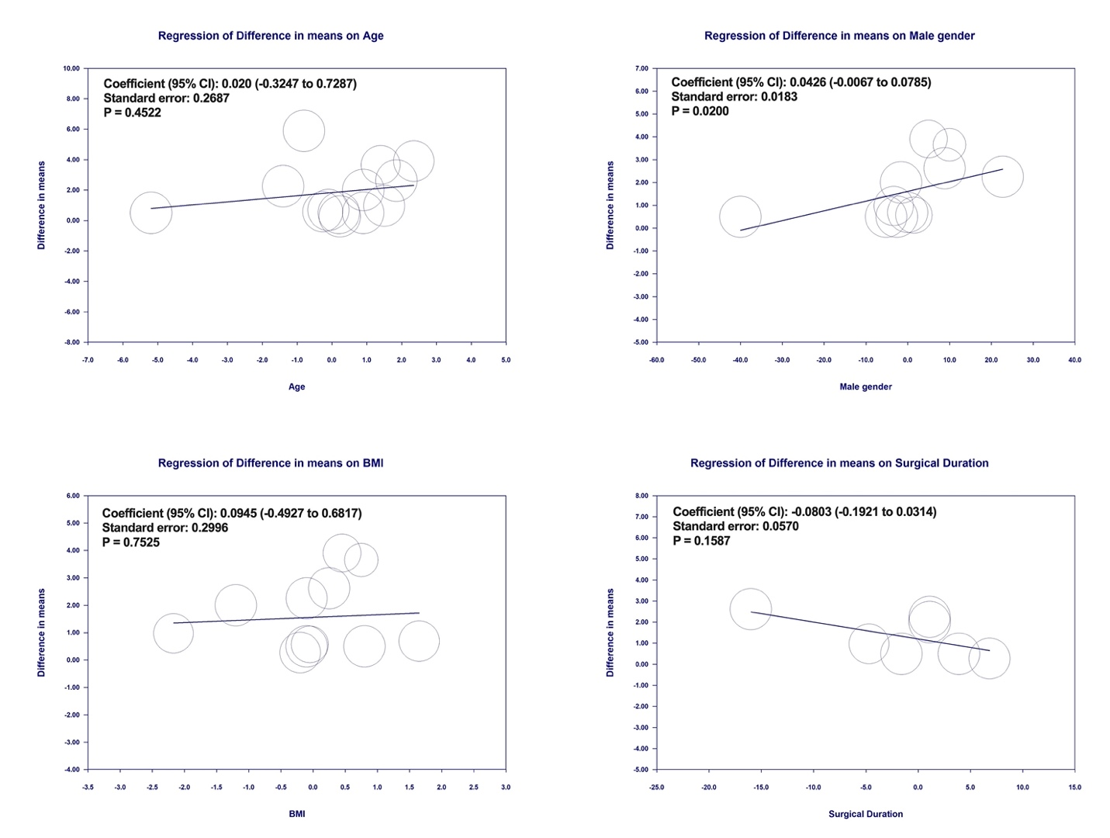

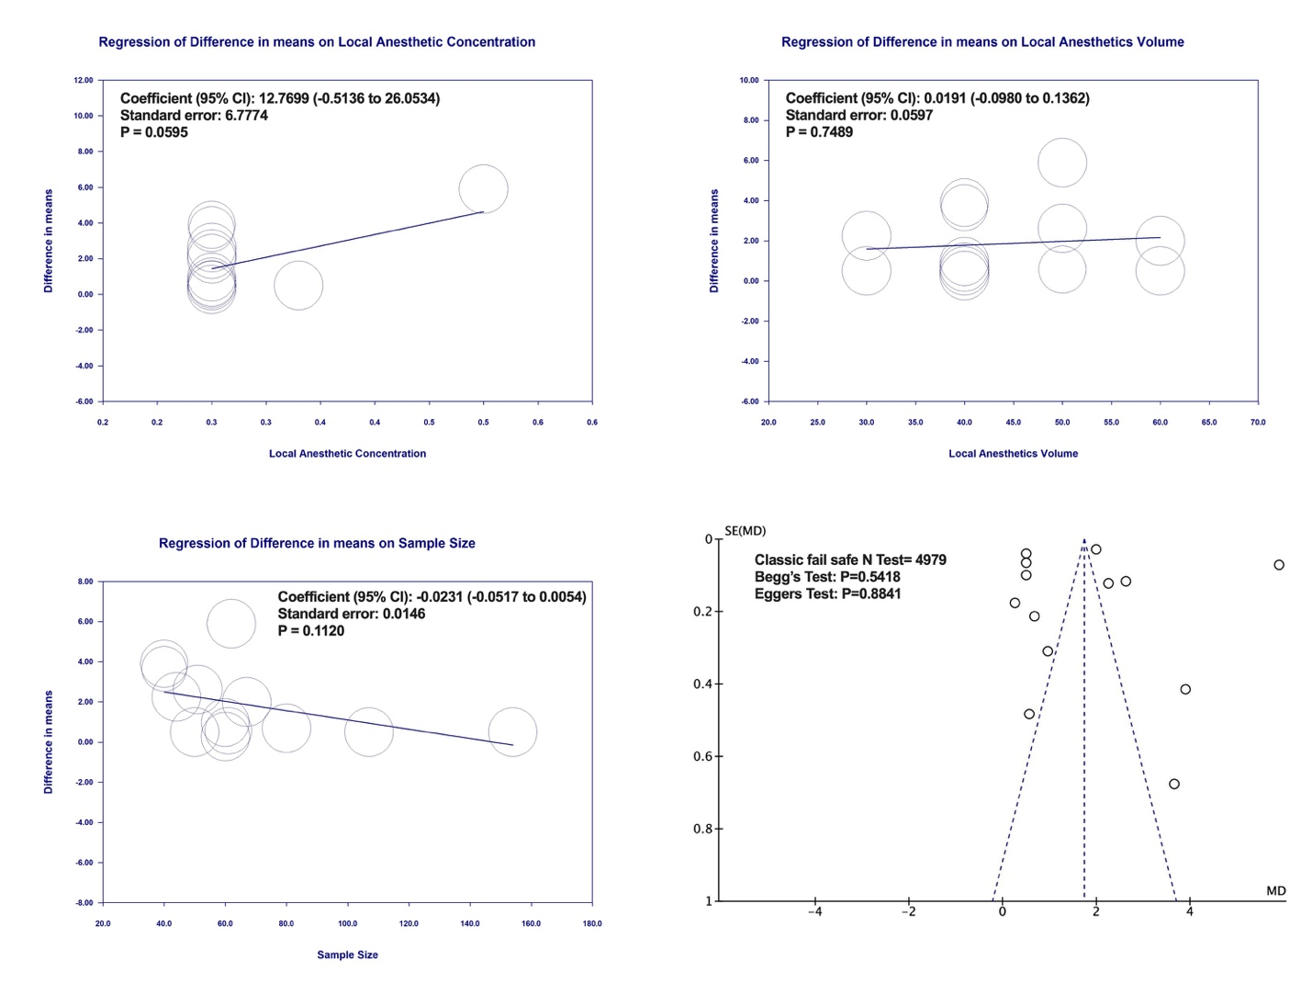

Supplementary File S5: Twenty-four-hour Postoperative opioids and Postoperative Nausea and Vomiting.
Panel (A) 24-hour Postoperative Opioids
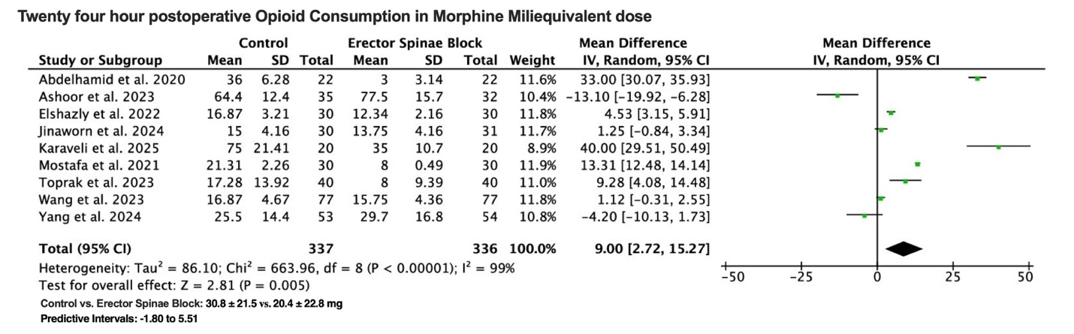
Panel (B) Postoperative Nausea and Vomiting.
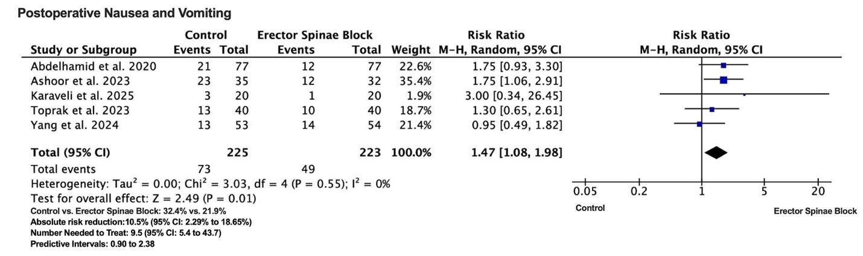Panel of meta-analysis forest plots showing Mean Difference (MD) or Risk Ratio (RR) for postoperative outcomes in Panel (A) 24-hour Postoperative Opioids; Panel (B) Postoperative Nausea and Vomiting. The RR of each included study is displayed. A pooled estimate of overall RR (diamonds) and 95% confidence intervals (indicated by the width of the diamonds) summarizes the effect size using the random-effects model. CI = confidence interval; IV = Inverse Variance method; MH = Mantel-Haenszel.

Supplementary File S6: Length of Hospital Stay and Time to Rescue Analgesia.
Panel (A) displays Length of Hospital Stay (days)
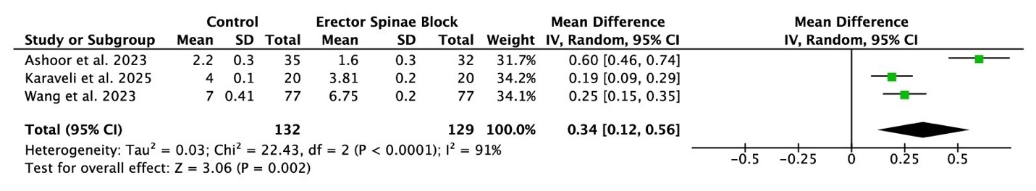
Panel (B) shows Time to rescue analgesia (hours)
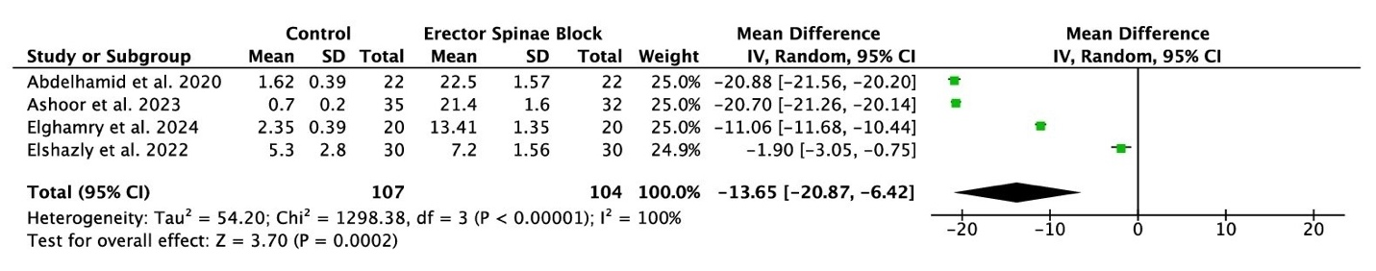
This panel shows meta-analysis forest plots illustrating the Mean Difference (MD) for postoperative outcomes. Panel (A) displays Length of Hospital Stay (days); Panel (B) shows Time to rescue analgesia (hours). Each study's MD is plotted. A pooled estimate of the overall MD (represented by diamonds) and 95% confidence intervals (indicated by the width of the diamonds) summarise the effect size using a random-effects model. CI = confidence interval; IV = Inverse Variance statistical method.

Supplementary file S7: Risk of Bias assessment by Cochrane ROB 2 tool
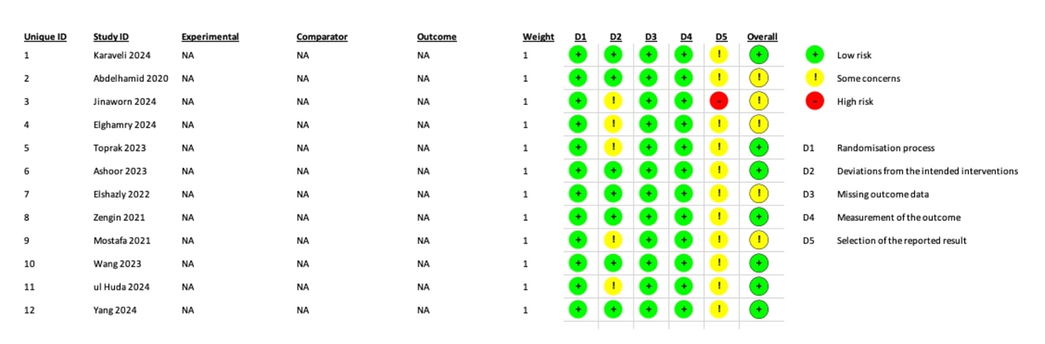

Supplementary File S8: Trial sequential analysis of resting pain score at six hours (primary outcome).
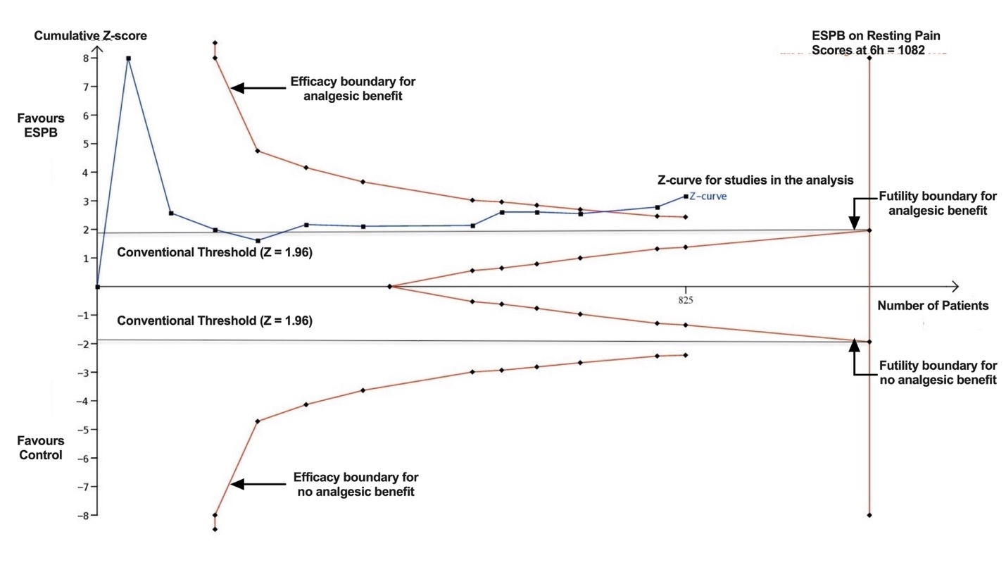
The figure depicts a model where we used empirical mean difference and variance estimators. The x-axis shows the accumulating number of studies (and participants), labelled as the ‘information size’. The y-axis displays the z-values, representing the statistical summary of the sequentially collected data from studies. The horizontal lines marking the ‘conventional threshold’ indicate the Z-value of 1.96 (toward ESPB) and −1.96 (toward control), corresponding to a p-value of 0.05 in standard analysis. The curved lines at the top and bottom (trial sequential boundaries) represent the thresholds for statistical significance, while a diamond signifies the incremental data added from each trial. The diagonal lines within the conventional threshold bounds denote the boundaries of futility. The top cumulative Z-curve shows the total amount of information as data from studies accumulate, with each square representing an individual trial. In this case, the Z-curve crosses the ‘efficacy boundary for analgesic benefit’ and approaches the required information size.

