PATH WAY FOR ELECTRICAL CONDUCTION IN ZnO BASED TERNARY NANOCOMPOSITE ROOM TEMPERATURE ETHANOL SENSORS
M. Chitra ª*, G. Mangamma ^{b}*, A. Rajesh ^{b}, K. Uthayarani ª, and Rajib Sahu ^{c}*
ªDepartment of Physics, Sri Ramakrishna Engineering College, Coimbatore 641022, Tamilnadu, India
^{b}Surface and Nanoscience Division, Material Science Group, Indira Gandhi Centre for Atomic Research, Homi Bhabha National Institute, Kalpakkam, Tamilnadu, 603102, India
^{c} RWTH Aachen University and Max-Planck-Institut für Eisenforschung GmbH, Dusseldrof, 40237, Germany
Corresponding authors: g.mangamma@gmail.com, gm@igcar.gov.in, chitra.muthukumaravel@srec.ac.in and r.sahu@mpie.de

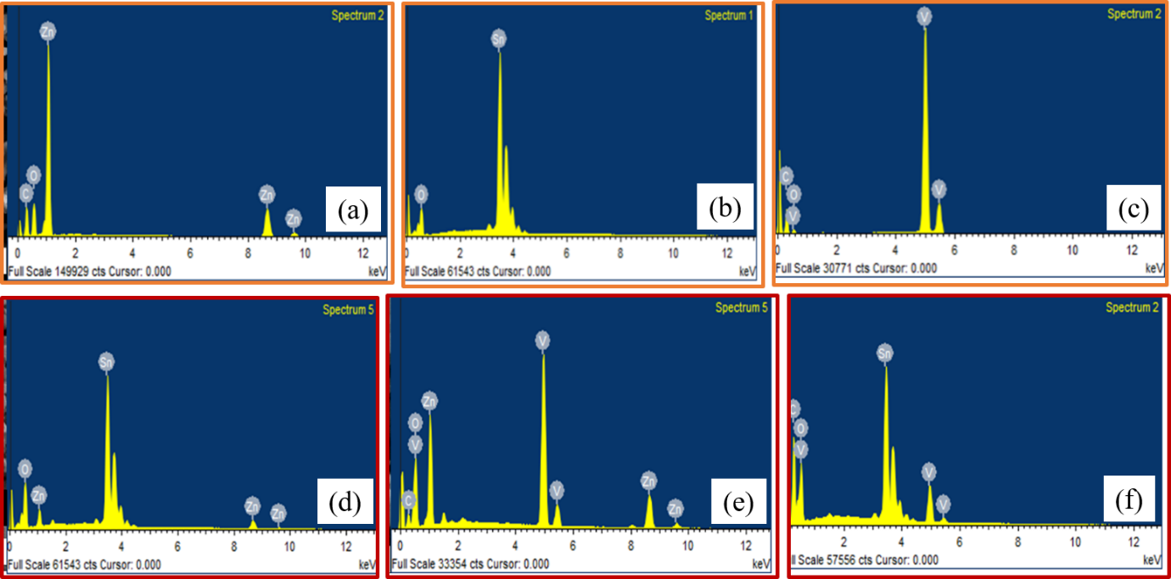
EDS Analysis:

Figure S1: Phase impurity by EDS spectrum of ZnO, SnO₂, V₂O₅, ZT, ZV and TV in (a) –(f)

