SUPPLEMENTARY FIGURES AND TABLES
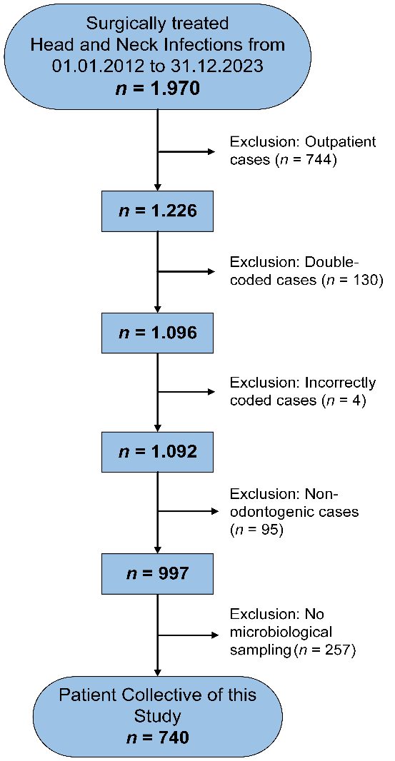
Supplementary Figure 1: Exclusion criteria of the study population

Supplementary Table 1: ICD-10-GM codes used for case selection

ICD-10-GM code | Description
H05.0 | Acute inflammation of orbit
J34.0 | Abscess, furuncle and carbuncle of nose
J36 | Peritonsillar abscess
J39.0 | Retropharyngeal and parapharyngeal abscess
J39.1 | Other abscess of pharynx
K00.7 | Teething syndrome
K04.0 – K04.9 | Diseases of pulp and periapical tissues
K10.20 – K10.29 | Inflammatory conditions of jaws
K10.3 | Alveolitis of jaws
K11.3 | Abscess of salivary gland
K12.20 – K12.29 | Cellulitis and abscess of mouth
L02.0 | Cutaneous abscess, furuncle and carbuncle of face

Supplementary Table 2: OPS codes used for case selection

OPS code | Description
5-240 | Operations on gums, alveolae and jaw: Incision into the gum and osteotomy of the alveolar ridge
5-240.0 | Incision into the gum
5-240.1 | Periodontal drainage
5-270 | Other operations on mouth and face: External incision and drainage in mouth, jaw and face area
5-270.0 | Temporal
5-270.1 | Periorbital
5-270.2 | Paranasal
5-270.3 | Cheek area
5-270.4 | Parotid region
5-270.5 | Submandibular
5-270.6 | Submandibular, mandibular angle area
5-270.7 | Submental
5-270.8 | Tongue base
5-270.9 | Sternocleidomastoid muscle area
5-270.x | Other
5-270.y | Unspecified
5-273 | Other operations on mouth and face: Incision, excision and destruction in the oral cavity
5-273.0 | Incision and drainage, vestibular submucosal
5-273.1 | Incision and drainage, vestibular subperiosteal
5-273.2 | Incision and drainage, sublingual
5-280 | Operations in the nasopharyngeal and oropharyngeal area: Transoral incision and drainage of a pharyngeal or parapharyngeal abscess
5-280.0 | (Peri)tonsillar
5-280.1 | Parapharyngeal
5-280.2 | Retropharyngeal
5-280.3 | In the floor of mouth area
5-280.x | Other
5-280.y | Unspecified

Supplementary Table 3: Frequency of detected microorganisms
Presentation of the detected microorganisms from microbiological reports as part of the retrospective analysis. Absolute frequencies and percentage distribution in relation to the total of all isolates (n = 1,516) are shown.

Pathogens | Number of isolates | Percent (%)
Viridans streptococci | 435 | 28,7
Prevotella spp. | 337 | 22,2
Coagulase-negative staphylococci | 105 | 6,9
Peptostreptococci | 71 | 4,7
Veillonella spp. | 71 | 4,7
Fusobacterium spp. | 68 | 4,5
Haemophilus spp. | 54 | 3,6
Bacteroides spp. | 50 | 3,3
Propionibacteria | 43 | 2,8
Candida spp. | 39 | 2,6
Neisseria spp. | 36 | 2,4
β-hemolytic streptococci | 33 | 2,2
Eikenella corrodens | 31 | 2,0
Peptococci | 25 | 1,6
Staphylococcus aureus | 20 | 1,3
Capnocytophaga spp. | 14 | 0,9
Escherichia coli | 12 | 0,8
Enterococci | 10 | 0,7
Klebsiella spp. | 9 | 0,6
Actinomyces spp. | 5 | 0,3
Enterobacter cloacae complex | 5 | 0,3
Pseudomonas aeruginosa | 5 | 0,3
Bifidobacterium spp. | 4 | 0,3
Cutibacterium acnes | 4 | 0,3
Corynebacterium spp. | 3 | 0,2
Morganella morganii | 3 | 0,2
Serratia marcescens | 3 | 0,2
Slackia exigua | 3 | 0,2
Citrobacter spp. | 2 | 0,1
Porphyromonas spp. | 2 | 0,1
Proteus mirabilis | 2 | 0,1
Acinetobacter baumannii complex | 1 | 0,1
Aggregatibacter spp. | 1 | 0,1
Bacillus spp. | 1 | 0,1
Campylobacter rectus | 1 | 0,1
Gemella sp. | 1 | 0,1
Lactococcus spp. | 1 | 0,1
Leuconostoc spp. | 1 | 0,1
Parvimonas micra | 1 | 0,1
Pasteurella spp. | 1 | 0,1
Pediococcus pentosaceus | 1 | 0,1
Rothia dentocariosa | 1 | 0,1
Fusarium spp. | 1 | 0,1

Supplementary Table 4: Results of the Poisson regression to analyze the annual development of resistance to selected antibiotics in the period from 2012 to 2023.
The incidence rate ratios (IRR), 95% confidence intervals (95% CI) and p-values for temporal trends in resistance rates at infection level in the observation period are shown. An infection was considered resistant if at least one pathogen detected was resistant to the respective antibiotic. The regression analyses were performed using the annual number of susceptibility tests per antibiotic as an offset.

Antibiotic | IRR | 95%-CI | p-Value
Clindamycin | 1.015 | 0.969 – 1.064 | 0.521
Penicillin | 0.974 | 0.919 – 1.031 | 0.363
Amoxicillin | 0.985 | 0.926 – 1.049 | 0.645
Amoxicillin/clavulanate | 1.071 | 0.955 – 1.202 | 0.241
Moxifloxacin | 1.118 | 0.934 – 1.339 | 0.225
Offset: Annual number of susceptibility tests per antibiotic

Supplementary Table 5: Results of the binary-logistic regression analysis on the influence of microbiological resistance to selected antibiotics on prolonged hospitalization in hospitalized odontogenic infections
The odds ratios (OR) with associated 95% confidence intervals (95% CI) and p-values for prolonged hospitalization in hospitalized odontogenic infections treated by means of surgical therapy depending on the presence of a resistant infection to the respective antibiotic are shown. An infection was considered resistant if at least one pathogen detected was resistant to the respective antibiotic (n = number of infections with susceptibility test to the respective antibiotic).

Antibiotic | OR | 95%-CI | p-Value
Clindamycin ª | 1.370 | 0.678 – 2.769 | 0.380
Penicillin ^{b} | 1.674 | 0.778 – 3.601 | 0.187
Amoxicillin ^{c} | 1.561 | 0.721 – 3.382 | 0.259
Amoxicillin/ clavulanate ^{d} | 1.791 | 0.583 – 5.503 | 0.309
Moxifloxacin ^{e} | 0.950 | 0.114 – 7.893 | 0.962
ª n = 380; ^{b} n = 388; ^{c} n = 411; ^{d} n = 437; ^{e} n = 221

