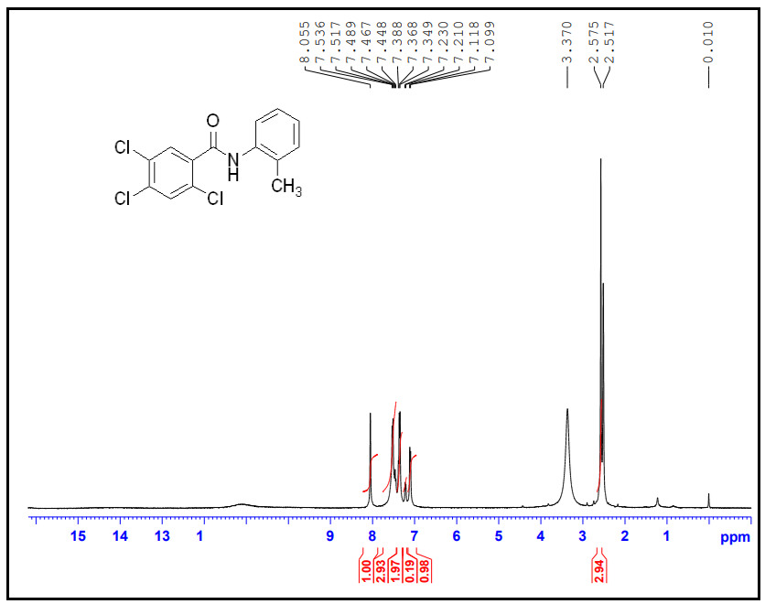
Figure 1: ¹H NMR Spectrum of 2a
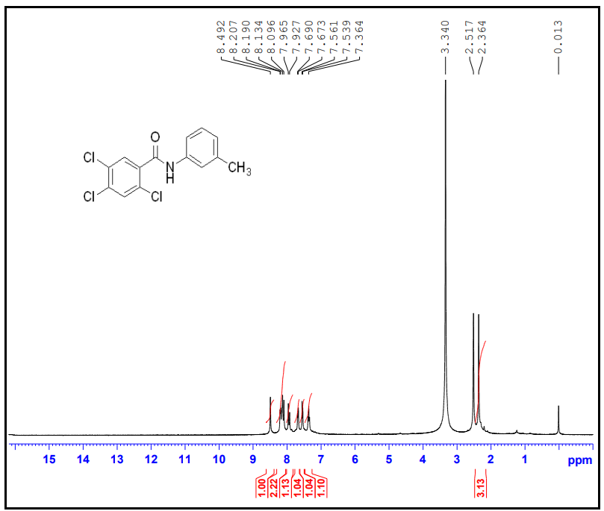
Figure 2: ¹H NMR Spectrum of 2b
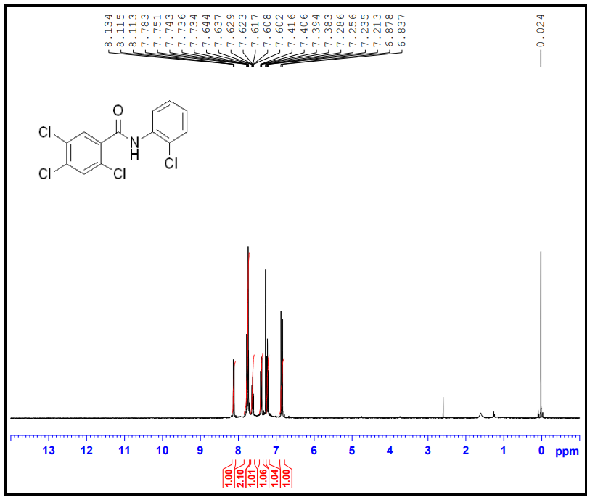Figure 3: ¹H NMR Spectrum of 2c
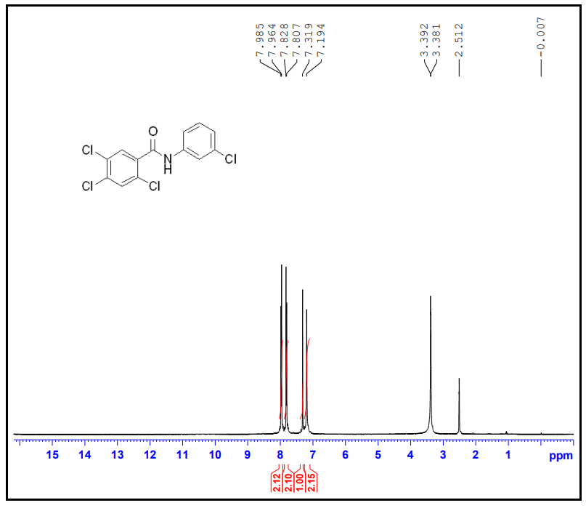
Figure 4: ¹H NMR Spectrum of 2d
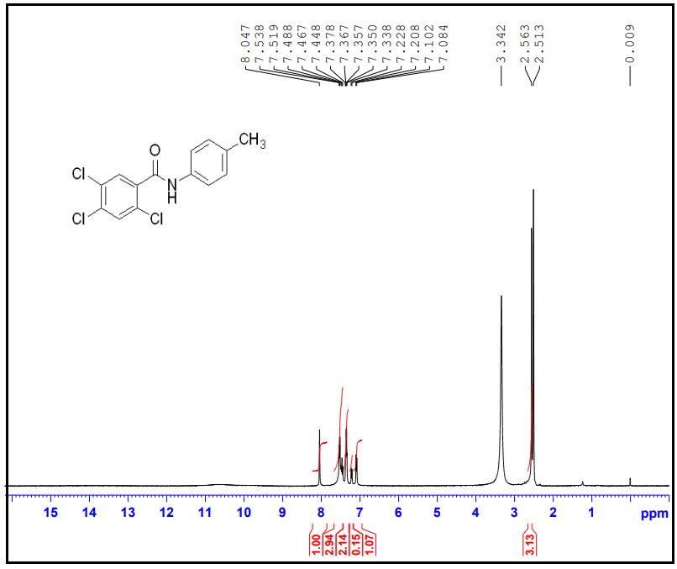
Figure 5: ¹H NMR Spectrum of 2e
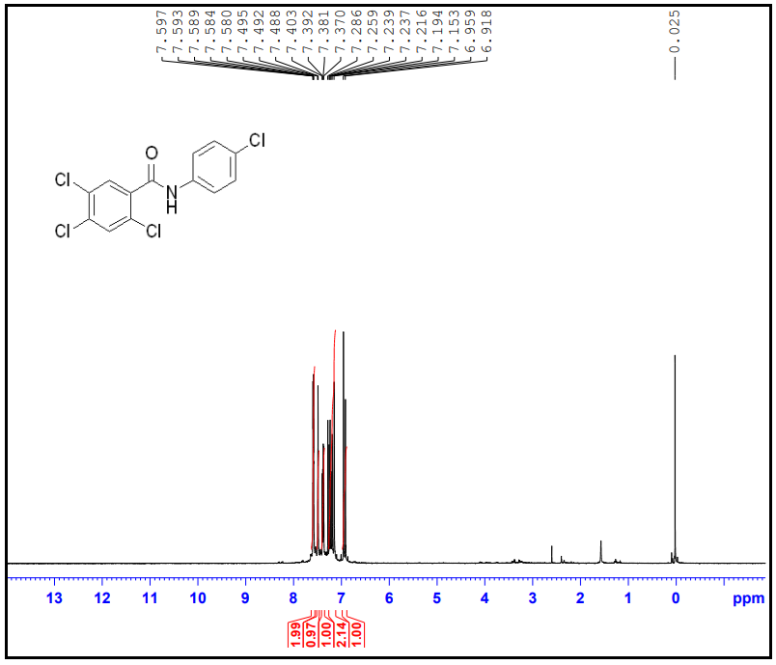
Figure 6: ¹H NMR Spectrum of 2f
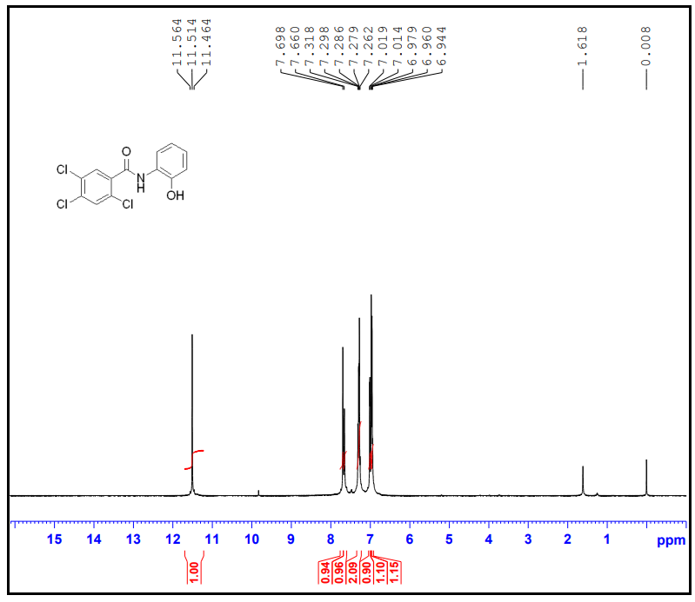
Figure 7: ¹H NMR Spectrum of 2g
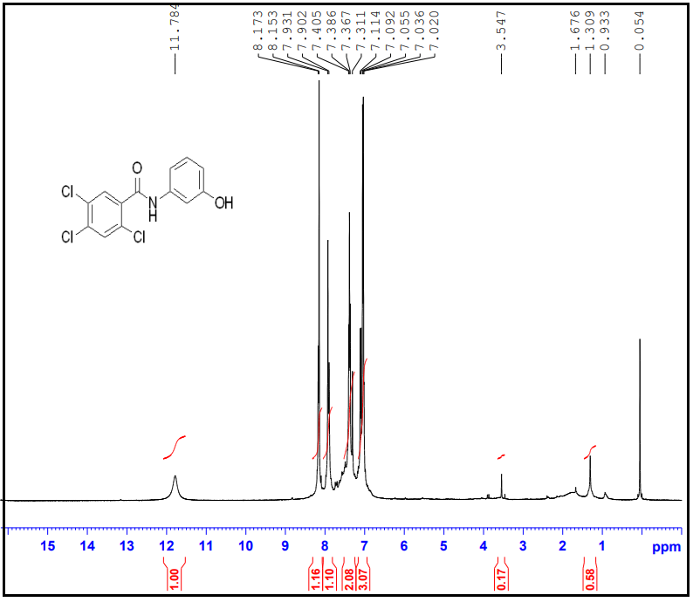
Figure 8: ¹H NMR Spectrum of 2h
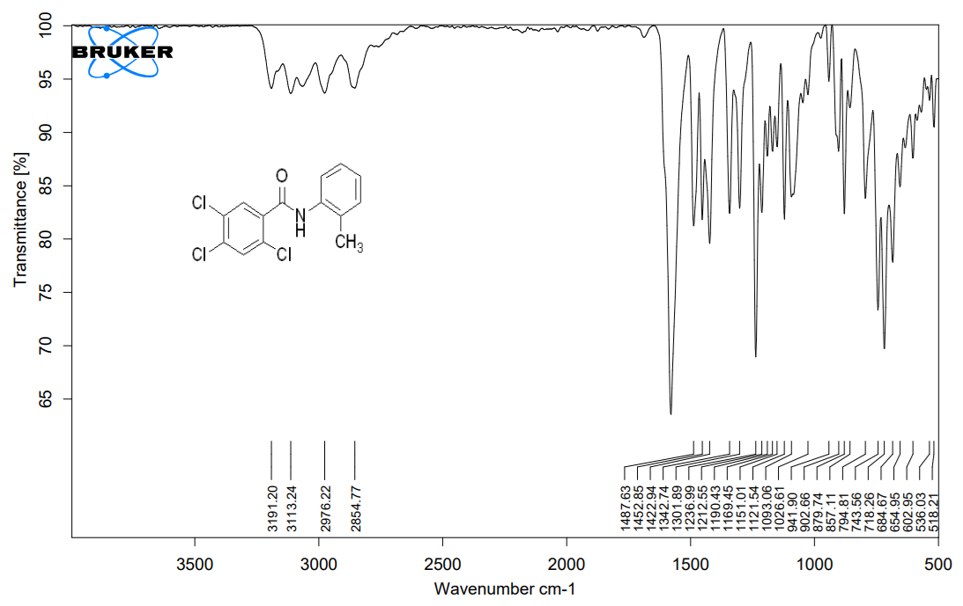
Figure 9: FTIR Spectrum of 2a
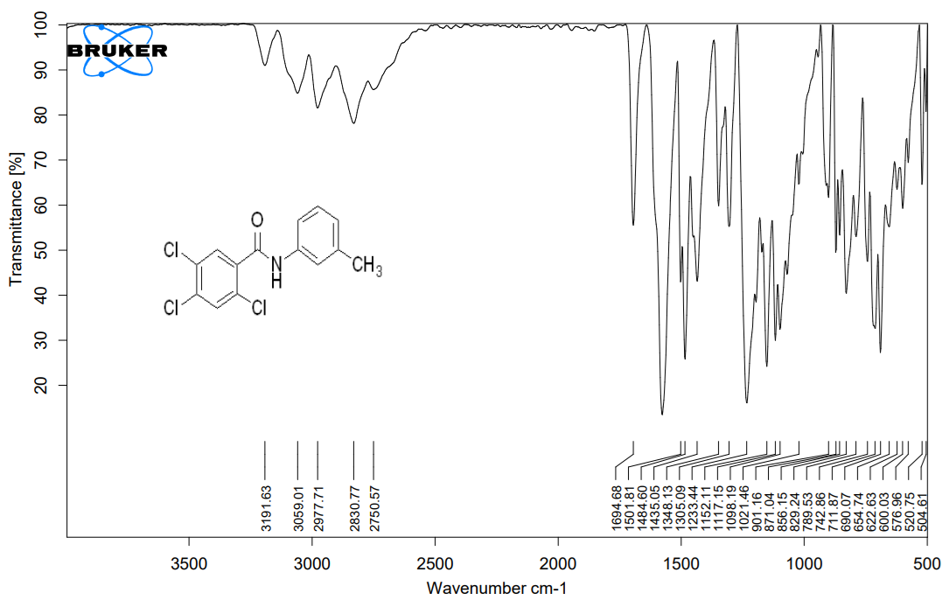
Figure 10: FTIR Spectrum of 2b
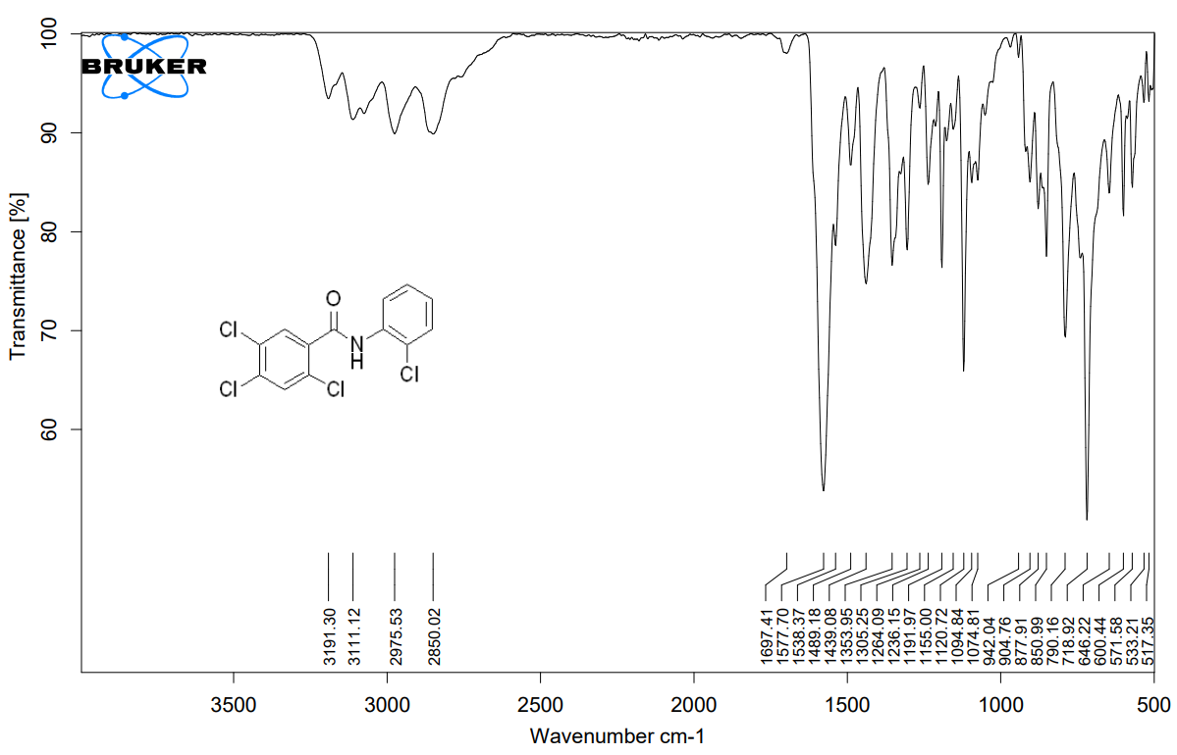
Figure 11: FTIR Spectrum of 2c
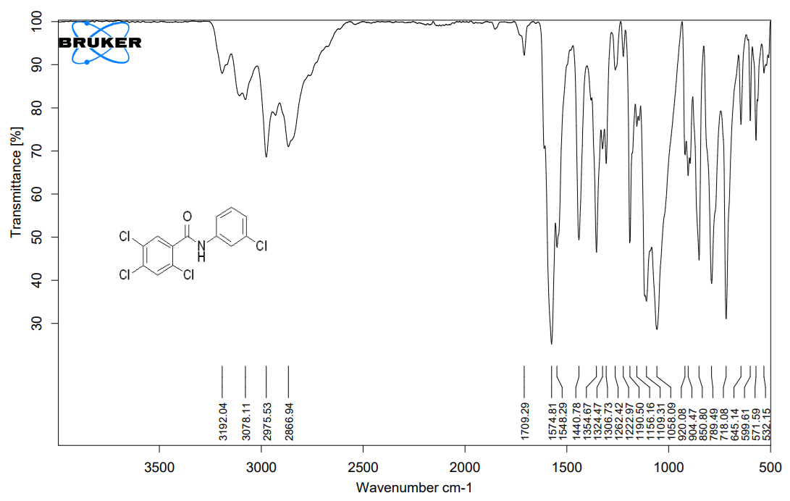
Figure 12: FTIR Spectrum of 2d
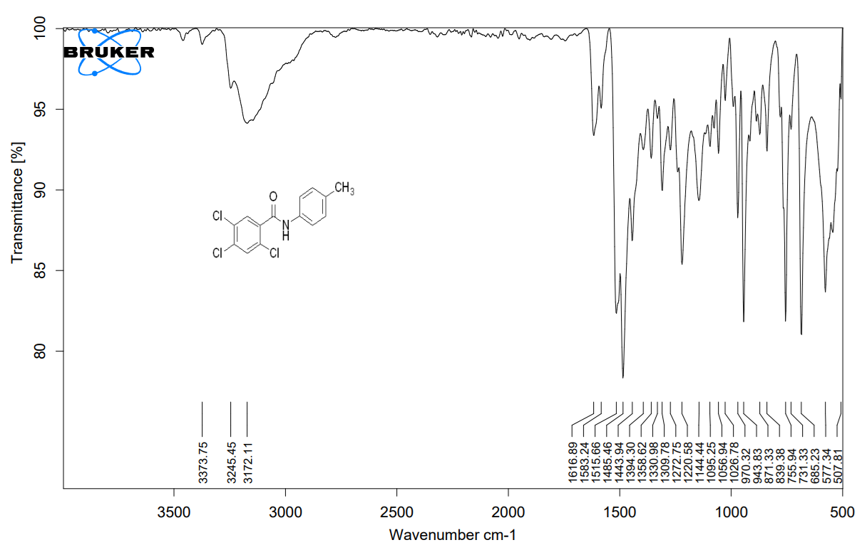
Figure 13: FTIR Spectrum of 2e
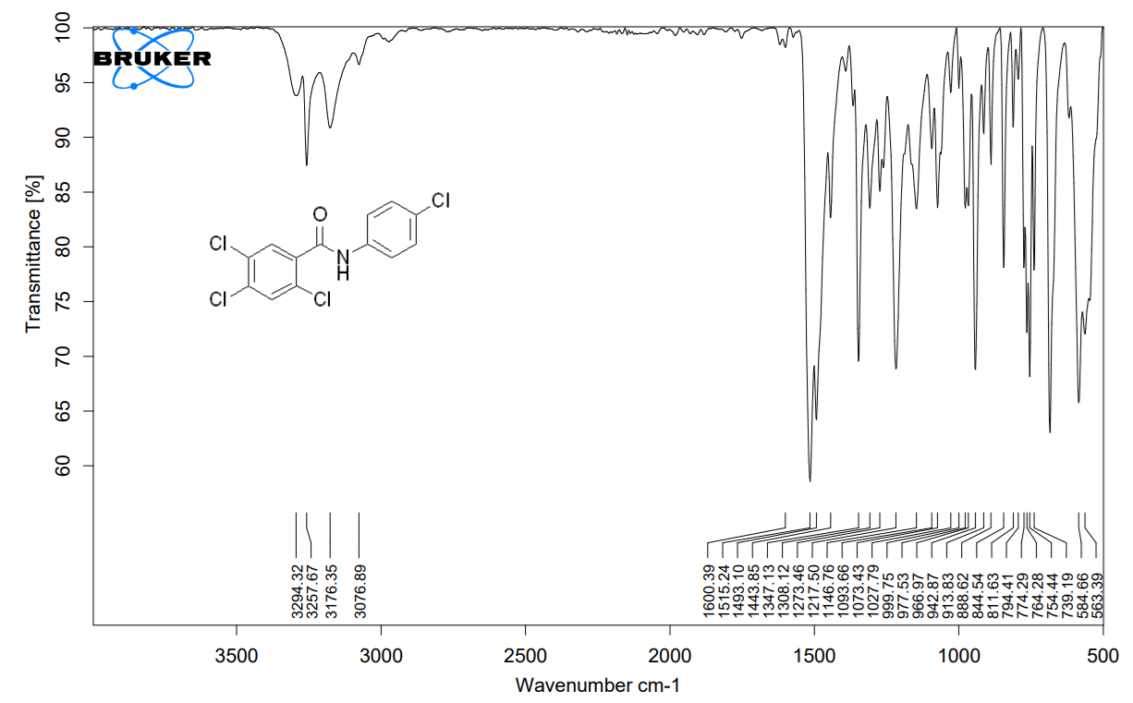
Figure 14: FTIR Spectrum of 2f
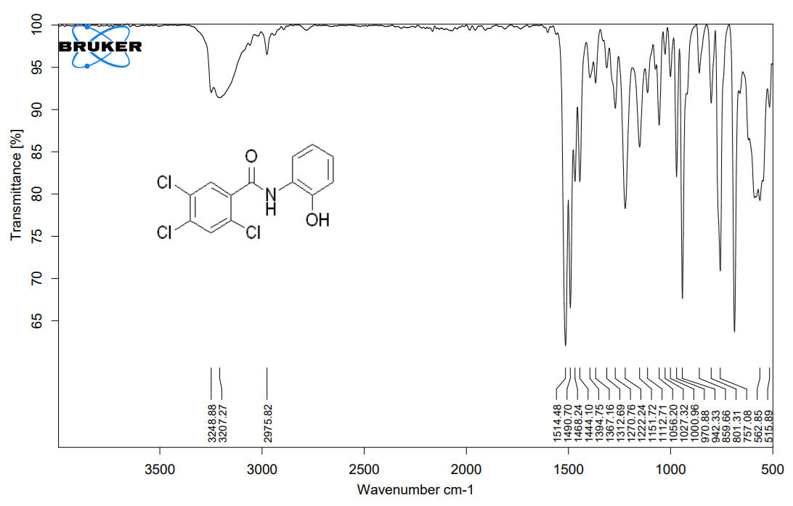
Figure 15: FTIR Spectrum of 2g
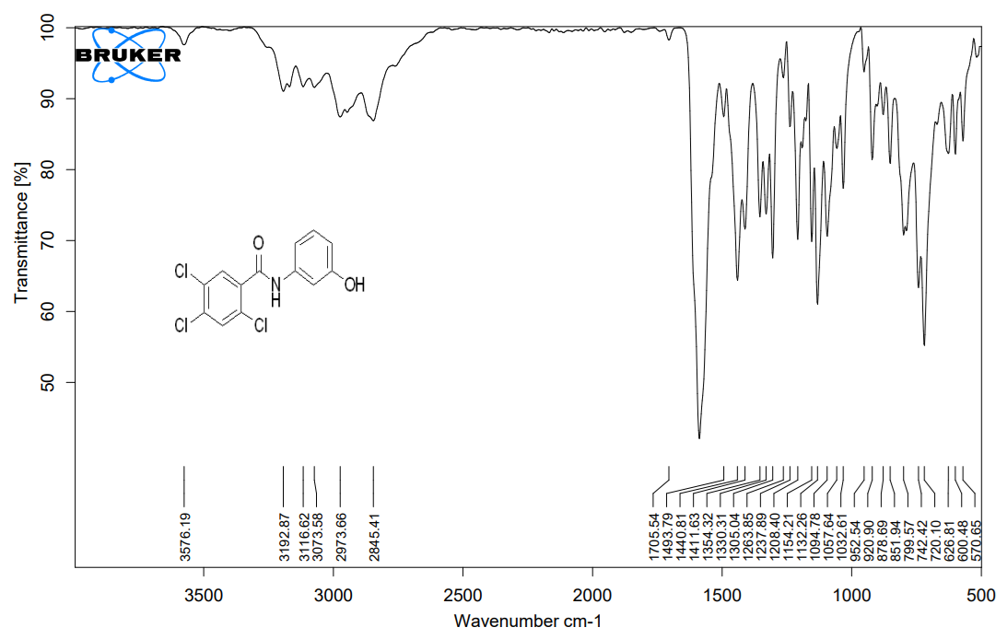
Figure 16: FTIR Spectrum of 2h
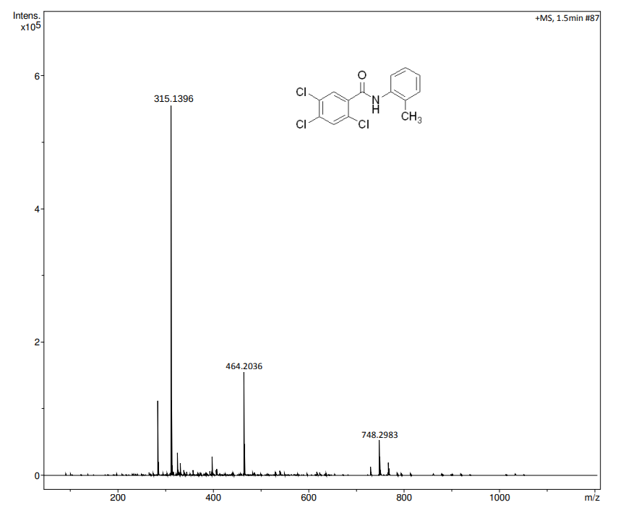
Figure 17: HRMS Spectrum of 2a
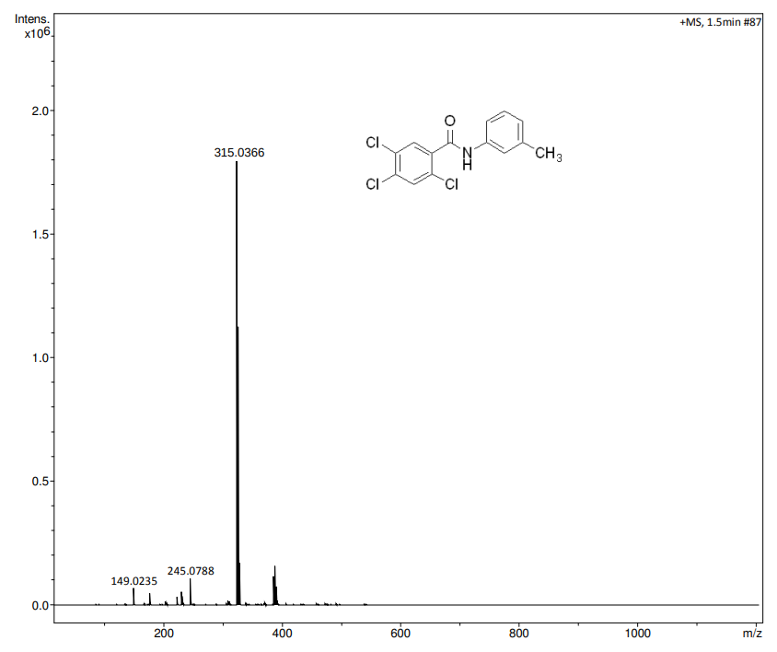
Figure 18: HRMS Spectrum of 2b
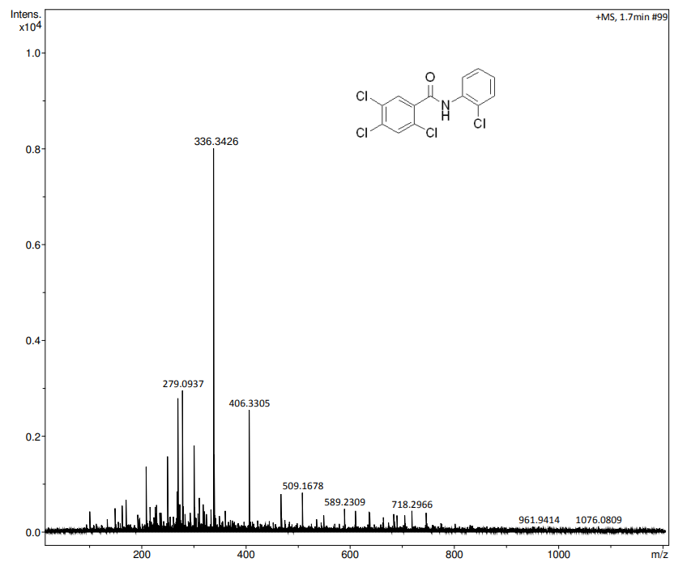
Figure 19: HRMS Spectrum of 2c
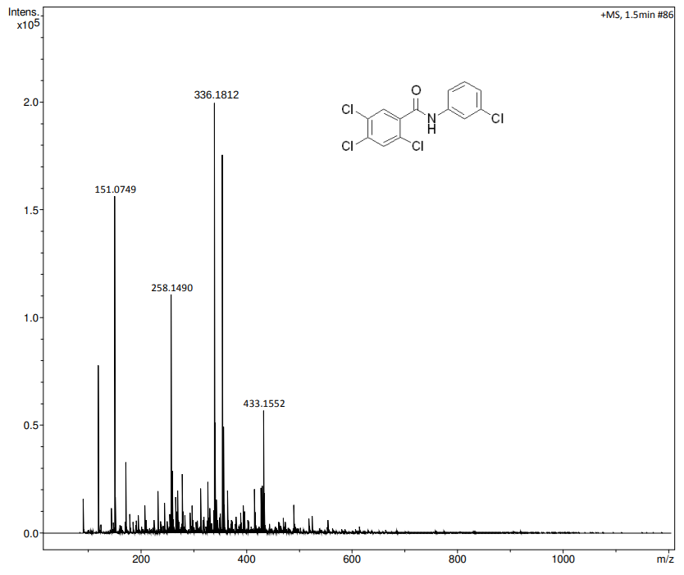
Figure 20: HRMS Spectrum of 2d
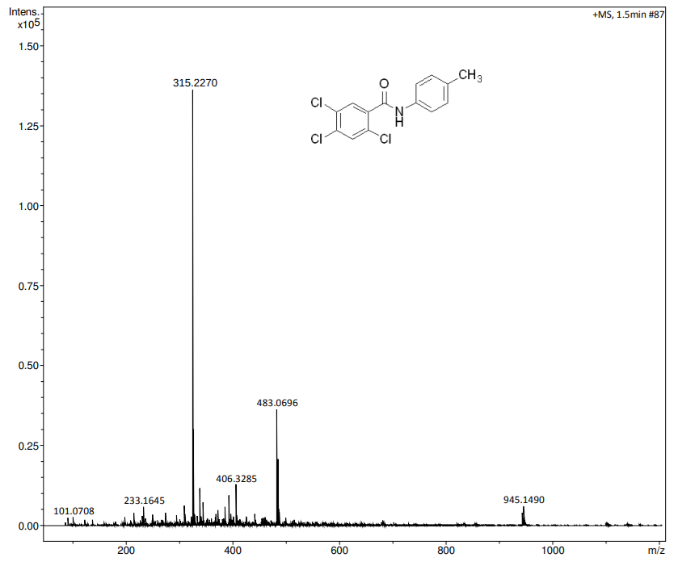
Figure 21: HRMS Spectrum of 2e
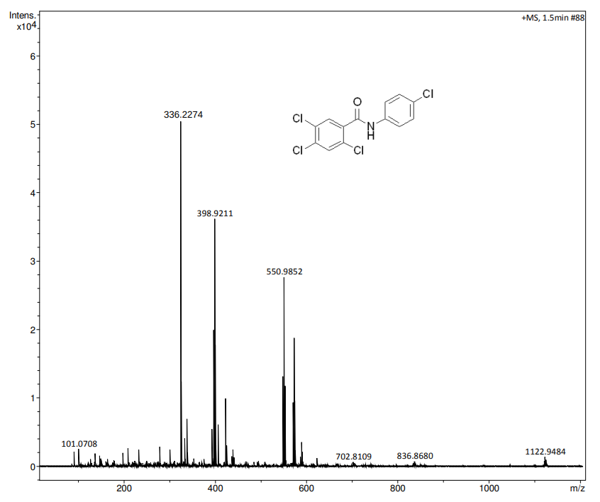
Figure 22: HRMS Spectrum of 2f
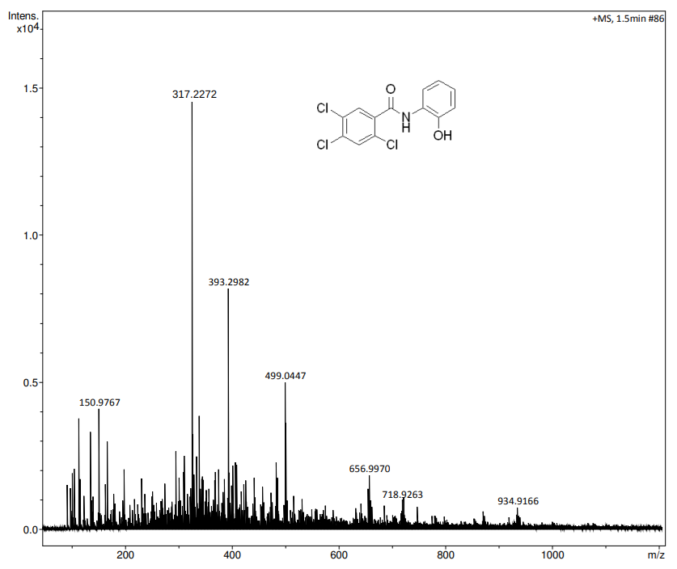
Figure 23: HRMS Spectrum of 2g
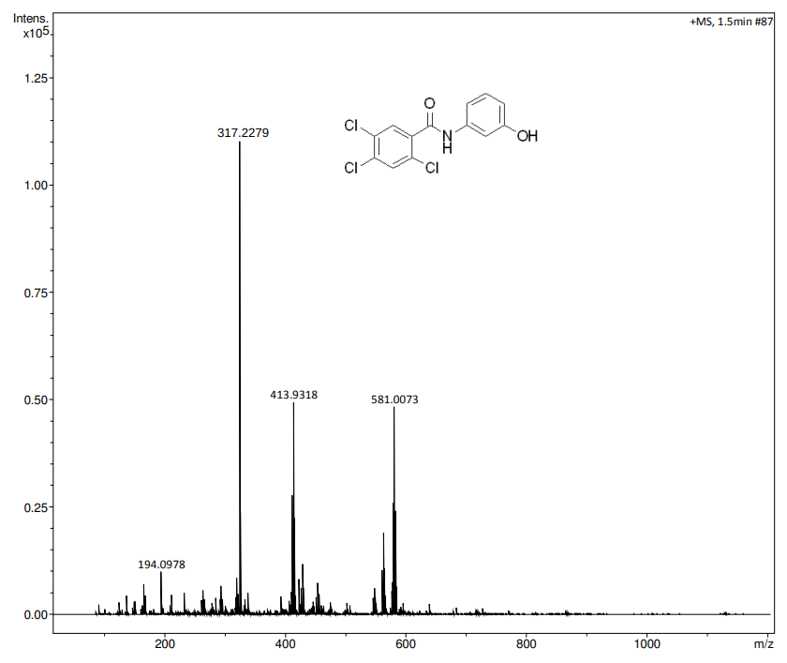
Figure 24: HRMS Spectrum of 2h
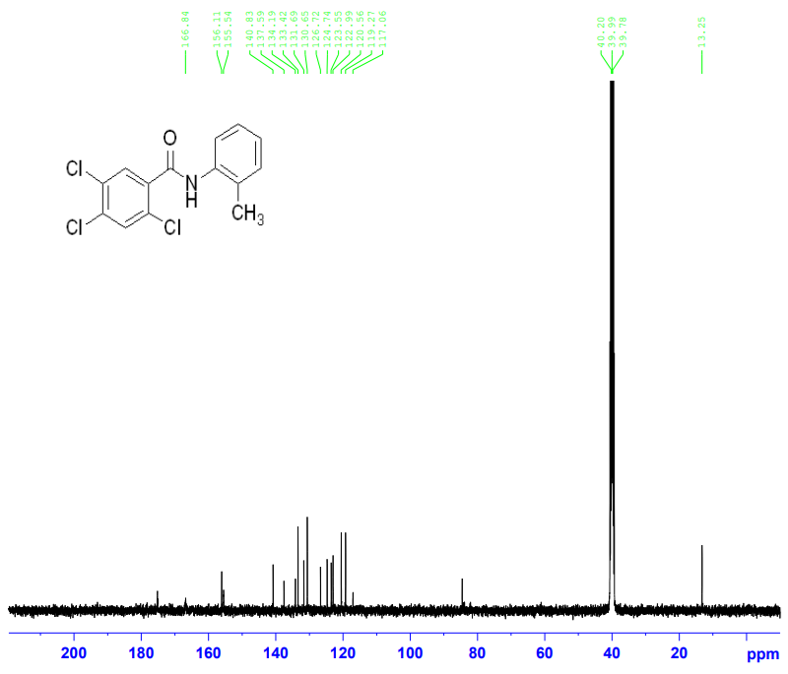
Figure 25: ¹³C NMR Spectrum of 2a
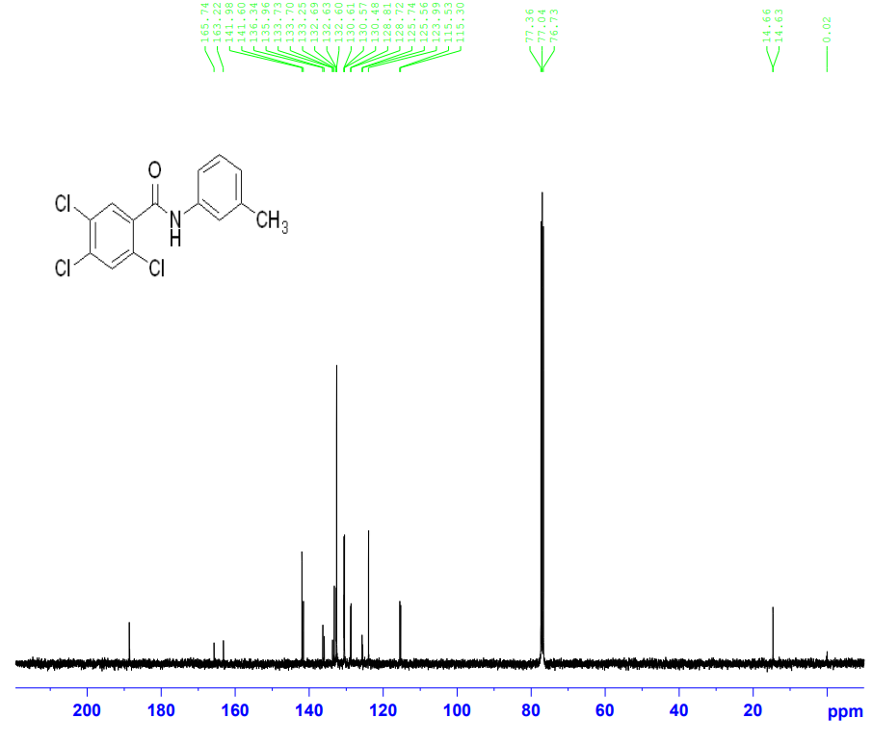
Figure 26: ¹³C NMR Spectrum of 2b
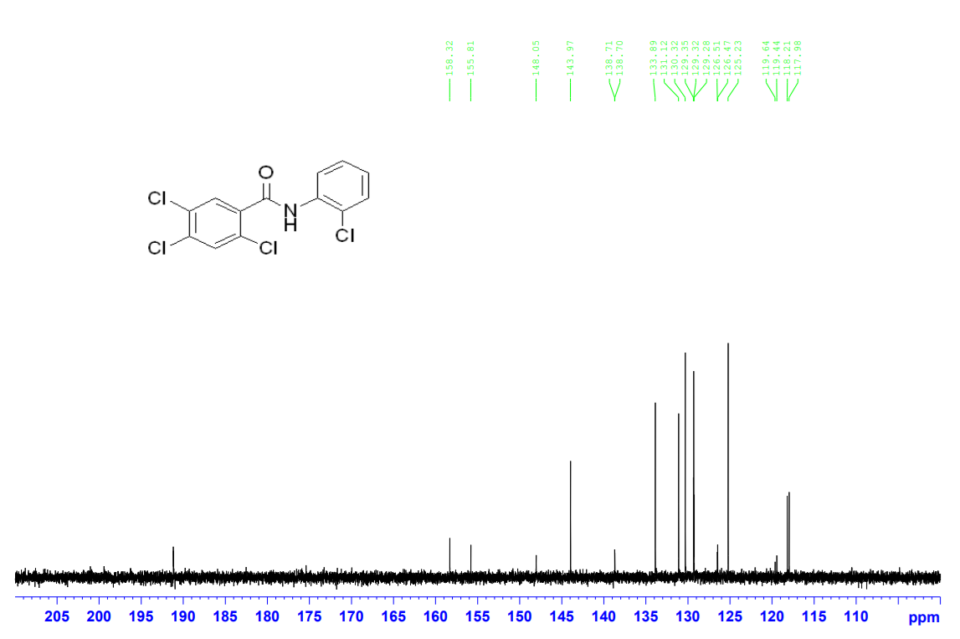
Figure 27: ¹³C NMR Spectrum of 2c
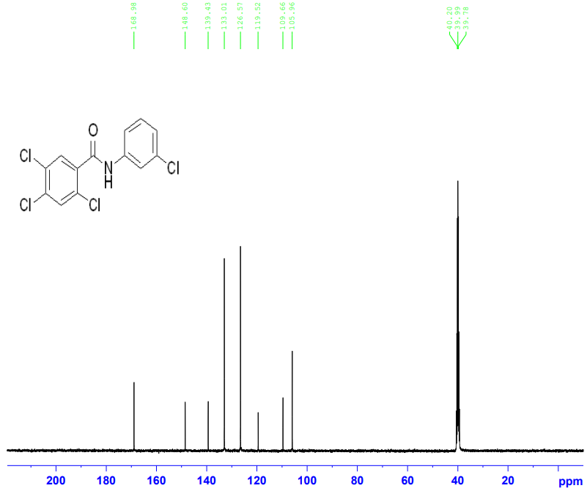
Figure 28: ¹³C NMR Spectrum of 2d
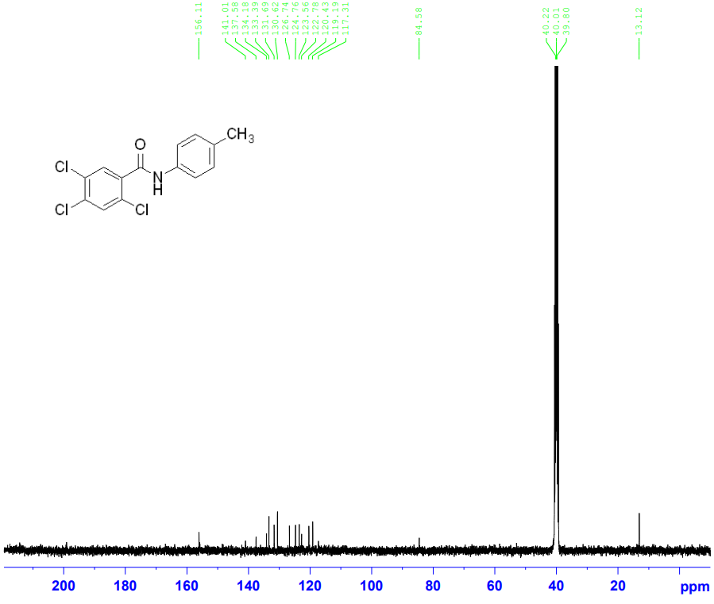
Figure 29: ¹³C NMR Spectrum of 2e
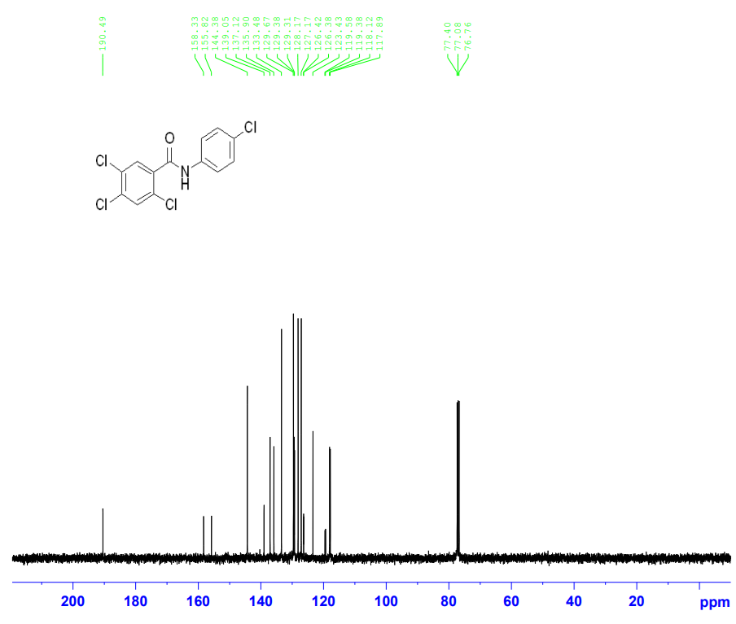
Figure 30: ¹³C NMR Spectrum of 2f
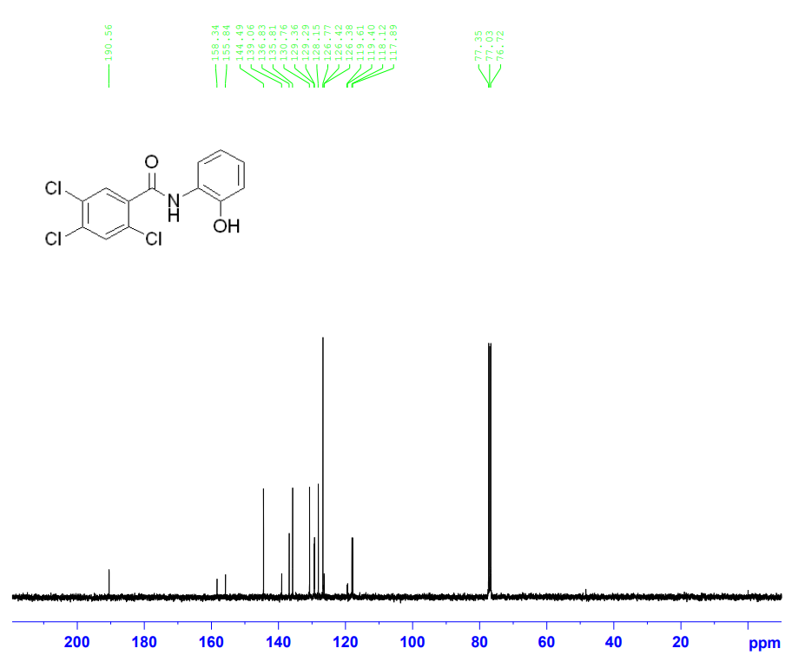
Figure 31: ¹³C NMR Spectrum of 2g
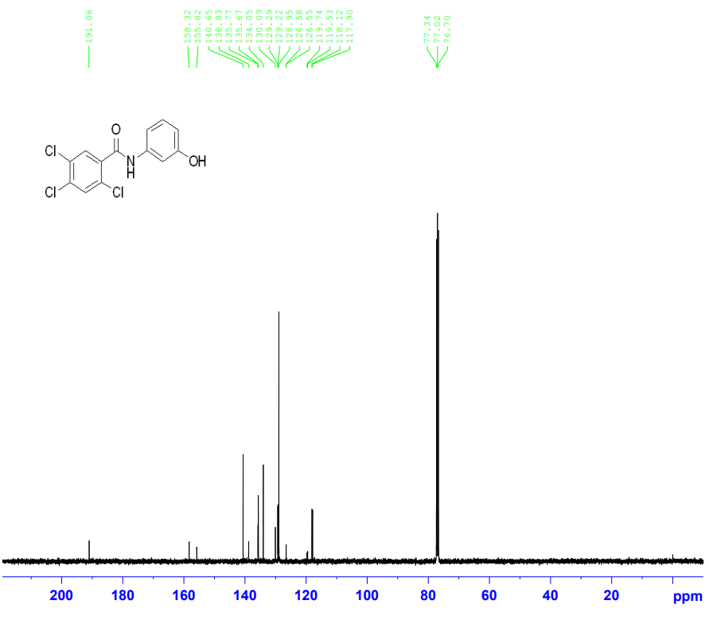
Figure 32: ¹³C NMR Spectrum of 2h

