Table S1. Definition and assignment of variables
N | Variables | Label | Type | Code
1 | Age | Age ( years) | Cont
2 | Gender | Gender | Categ | 1:Male; 0:Female
3 | Education | Education levels | Categ | 1:Illiterate; 2.Junior school; 3:High schools and vocational school; 4: Higher education
4 | Marriage | Marital status | Categ | 1:Married; 0:Single
5 | Cancer | Whether the respondent reported having cancer or a malignant tumor (excluding minor skin cancers) | Categ | 1:Yes; 0:No
6 | Liver | Whether the respondent reported having any liver disease (except fatty liver, tumors, and cancer) | Categ | 1:Yes; 0:No
7 | Kidney | Whether the respondent reported having any kidney disease (except for tumor or cancer) | Categ | 1:Yes; 0:No
8 | Digest | Whether the respondent reported having any stomach or other digestive disease (except for tumor or cancer) | Categ | 1:Yes; 0:No
9 | Hypertension | Whether the respondent reported or self-reported history having hypertension | Categ | 1:Yes; 0:No
10 | Drinking | Had any alcoholic beverage in the last 12 months | Categ | 1:Yes; 0:No
11 | Smoking | Whether there is a habit of smoking at present | Categ | 1:Yes; 0:No
12 | M_{waist} | Waist measurement(cm) | Cont
13 | BMI | Body mass index (kg/m2) | Cont
14 | Sleep | Hours of sleep(h) | Cont
15 | WBC | White blood cell count(10^9/L) | Cont
16 | MCV | Mean corpuscular volume(fl) | Cont
17 | PLT | Platelet count(10^9/L) | Cont
18 | BUN | Blood urea nitrogen (mg/dl) | Cont
19 | FBG | Fasting blood glucose (mg/dl) | Cont
20 | CREA | Serum creatinine (mg/dl) | Cont
21 | CHO | Total cholesterol (mg/dl) | Cont
22 | TG | Triglycerides (mg/dl) | Cont
23 | HDL-c | High-density lipoprotein cholesterol (mg/dl) | Cont
24 | LDL-c | Low-density lipoprotein cholesterol (mg/dl) | Cont
25 | CRP | C-reactive protein (mg/l) | Cont
26 | HbA1c | Glycated hemoglobin (%) | Cont
27 | UA | Uric acid(mg/dl) | Cont
28 | TyG | Triglyceride glucose index | Cont
29 | TyG-BMI | Baseline triglyceride glucose-body mass index | Cont
30 | Cumulative TyG-BMI | Cumulative triglyceride glucose-body mass index | Cont
31 | TyG-BMI-category | Categorized by quartiles of the index of cumulative TyG-BMI | Categ | 1:Q1; 2:Q2; 3:Q3; 4:Q4
The variables are all from the CHARLS data.
N: Number of Variables; Variables: The name or abbreviation of a variable; Label: the full name or description of the variable; Type: The type of variable, Cont (continuous variable) or Categ (categorical variable); Code: Assignment of categorical variables in R.

Table S2. Collinearity Statistics
variables | VIF | Df | VIF^{(1/(2Df))}
Cumulative TyG-BMI | 11.168879 | 1 | 3.341987
Gender | 2.270442 | 1 | 1.506799
Age | 1.482442 | 1 | 1.217556
Education | 1.317076 | 3 | 1.046972
Marriage | 1.147885 | 1 | 1.071394
Smoking | 1.592948 | 1 | 1.262120
Drinking | 1.335251 | 1 | 1.155531
Digest | 1.030806 | 1 | 1.015286
M_{waist} | 1.772411 | 1 | 1.331319
Sleep | 1.037640 | 1 | 1.018646
WBC | 1.120799 | 1 | 1.058678
MCV | 1.061629 | 1 | 1.030354
PLT | 1.106357 | 1 | 1.051835
BUN | 1.092941 | 1 | 1.045438
CHO | 8.664069 | 1 | 2.943479
HDL-c | 2.578273 | 1 | 1.605700
LDL-c | 6.798883 | 1 | 2.607467
HbA1c | 1.051893 | 1 | 1.025618
UA | 1.389701 | 1 | 1.178856
Hypertension | 1.124605 | 1 | 1.060474
TyG | 4.108766 | 1 | 2.027009
TyG-BMI | 12.463590 | 1 | 3.530381
Abbreviations as in table S1.
VIF: variance inflation factor; DF: Degrees of Freedom; VIF^{(1/(2Df))}: Variance Inflation Factor (adjusted by 1/(2 * Degrees of Freedom)).
The variables with VIF^{(1/(2Df))}>10 will be regarded as collinear variables and cannot be included in the multiple regression model.

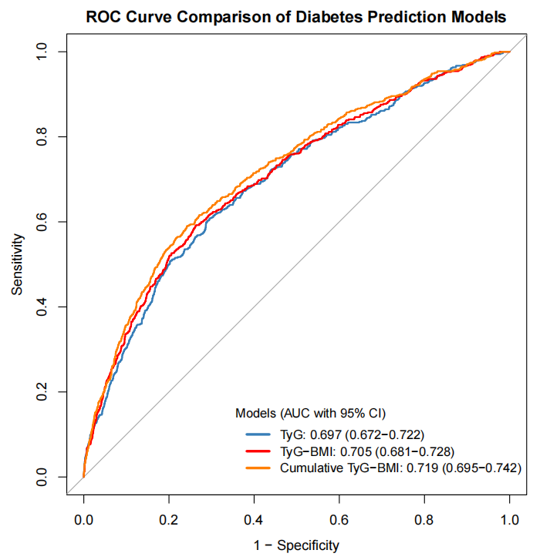
Figure S1. ROC curves comparison of diabetes prediction models in TyG, TyG-BMI and cumulative TyG-BMI
Abbreviations as in table S1.
AUC: Area Under the Receiver Operating Characteristic Curve; CI: Confidence interval.

Table S3.Compare baseline characteristics of selected and excluded participants
Variables |  | Excluded | Included | P | SMD
N |  | 9783 | 4945
Age(mean (SD)) |  | 59.4 (10.4) | 58.9 (8.7) | 0.006 | 0.050
Gender (%) | 0 | 4848 (49.6) | 2635 (53.3) | <0.001 | 0.075
 | 1 | 4935 (50.4) | 2310 (46.7)
Excluded:excluded participants; Included: included participants.
SMD: standardized mean differences.

Table S4.Association between the cumulative TyG-BMI index and the incidence of diabetes incidence
Cumulative  TyG-BMI(cluster center) | N(%) | Crude |  |  | Model 1 |  |  | Model 2 |  |  | Model 3
Cumulative  TyG-BMI(cluster center) | N(%) | OR(95%CI) | P |  | OR(95%CI) | P |  | OR(95%CI) | P |  | OR(95%CI) | P
C2(574.712) | 1683(34.034) | 1.455(1.083~1.955) | 0.013 |  | 1.592(1.181~2.146) | 0.002 |  | 1.553(1.142~2.114) | 0.005 |  | 1.497(1.090~2.055) | 0.013
C3(667.703) | 1349(27.280) | 2.498(1.877~3.325) | <0.001 |  | 2.844(2.123~3.801) | <0.001 |  | 2.745(1.978~3.811) | <0.001 |  | 2.522(1.775~3.3583) | <0.001
C4(786.864) | 712(14.398) | 4.320(3.202~5.828) | <0.001 |  | 5.167(3.783~7.057) | <0.001 |  | 4.671(3.187~6.844) | <0.001 |  | 3.577(2.341~5.465) | <0.001
P_{trend} |  | <0.001 |  |  | <0.001 |  |  | <0.001 |  |  | <0.001
Crude：Cumulative TyG-BMI index was divided into four clusters (C1-C4) using K-means cluster analysis.
Model 1：Adjusted for gender and age.
Model 2：Adjusted for the variables in model 1 plus education, marry, smoking, drinking, digest, Mwaist, sleep, hypertension.
Model 3:Adjusted for the variables in model 2 plus WBC, MCV, PLT, BUN, CHO, HDL-c, LDL-c, HbA1c, UA.
Cluster center: The average of all data points in each cluster; Cumulative TyG-BMI: Cumulative triglyceride glucose-body mass index; OR: Odds ratio; CI: Confidence interval.

Table S5. Association between cumulative Ty G-BMI index and incidence of diabetes in elderly populations aged 65 years and older
Cumulative  TyG-BMI | Crude |  |  | Model 1 |  |  | Model 2 |  |  | Model 3
Cumulative  TyG-BMI | OR(95%CI) | P |  | OR(95%CI) | P |  | OR(95%CI) | P |  | OR(95%CI) | P
Q2 | 0.925（0.530~1.617） | 0.785 |  | 0.919(0.525~1.608) | 0.767 |  | 0.922(0.519~1.637) | 0.782 |  | 0.920(0.507~1.668) | 0.783
Q3 | 1.496(0.898~2.493) | 0.122 |  | 1.473(0.882~2.462) | 0.139 |  | 1.392(0.789~2.456) | 0.254 |  | 1.348(0.740~2.457) | 0.329
Q4 | 3.502(2.203~5.567) | <0.001 |  | 3.276(2.040~5.261) | <0.001 |  | 3.005(1.641~5.502) | 0.001 |  | 2.625(1.320~5.220) | 0.006
P_{trend} | <0.001 |  |  | <0.001 |  |  | <0.001 |  |  | <0.001
Per 1 SD increase | 1.718(1.465~2.014) | <0.001 |  | 1.673(1.421~1.969) | <0.001 |  | 1.681(1.352~2.090) | <0.001 |  | 1.554(1.211~1.996) | 0.001
Crude：Interquartile grouping of the cumulative TyG-BMI index or Scale cumulative TyG-BMI index.
Model 1：Adjusted for gender and age.
Model 2：Adjusted for the variables in model 1 plus education, marry, smoking, drinking, digest, Mwaist, sleep, hypertension.
Model 3:Adjusted for the variables in model 2 plus WBC, MCV, PLT, BUN, CHO, HDL-c, LDL-c, HbA1c, UA.
Cumulative TyG-BMI: Cumulative triglyceride glucose-body mass index. OR: Odds ratio; CI: Confidence interval.

