Appendix

Indicative mapping between DERP and SSP frameworks
While the DERP framework is distinct from the SSPs, any quantitative application requires a set of background socioeconomic assumptions. As the SSPs are the community standard for providing this context, Table A.1 below serves as a heuristic guide for researchers on how to plausibly combine the two frameworks. The pairings indicate which SSP storyline can provide a coherent socioeconomic backdrop for a given DERP narrative; they do not imply a direct equivalence. The “Key modifications” column lists at least one lever for each DERP dimension (mitigation action ambition and resilience to socioeconomic impacts); concrete examples of such levers appear in Table 2.
Table A.1: Indicative Mapping between DERP Narratives and Compatible SSP ones
Notation: ✔ = particularly suitable SSP, △ = usable SSP with additional adjustments
DERP Narrative | Compatible SSP(s) | Key modifications (mitigation axis / resilience axis) | Rationale and implementation guidance
DERP1 - Derailment | ✔ SSP3  △ SSP4 | Mitigation: relax climate-policy stringency and technology learning.  Resilience: amplify regional fragmentation, raise investment risk premiums, reduce institutional response capacity. | SSP3’s rivalry and weak cooperation mirror low resilience  SSP4’s inequality can generate similar vulnerabilities. Emphasise cascading vulnerability and limited recovery capacity.
DERP2 - Current Trends | ✔ SSP2  △ any other SSP as status-quo variant | Mitigation: continue announced NDCs, medium techology diffusion.  Resilience: maintain historical adaptive capacity with moderate contingency funding. | SSP2’s “middle of the road” trajectory already sits near DERP2. Apply moderate disruptions while keeping socioeconomic trajectory largely unchanged.
DERP3 - Fragile Transition | ✔ SSP5  △ SSP1 | Mitigation: concentrate policy incentives on a single low-carbon option (e.g. CCS or EVs), restrict diversity elsewhere.  Resilience: keep supply-chain diversity low, limit redundancy, increase price sensitivity. | SSP5’s techno-optimism fits high, narrow mitigation  SSP1 can also yield a “green but myopic” variant if policy over-favours one solution. Highlight over-reliance and weak fallback capacity.
DERP4 - Resilient Inertia | △ Any SSP (often SSP2) | Mitigation: scale back long-term climate ambition, extend fossil infrastructure lifetime.  Resilience: harden existing assets, add redundancy for known threats, improve emergency logistics. | DERP4 is about disruption management rather than socioeconomic transformation. Choose a suitable SSP context and then layer resilience measures focused on hardening existing systems and maintaining the status quo, rather than enabling systemic change
DERP5 - Robust Transformation | ✔ SSP1 | Mitigation: ambitious, economy-wide carbon pricing and diversified low-carbon portfolio.  Resilience: build adaptive institutions, system redundancy, and flexible infrastructure. | SSP1 supplies a sustainability-oriented baseline; additional levers must lift institutional adaptiveness and engineered redundancy beyond the SSP1 default to achieve high resilience.
See Table 2 for indicative parameter categories (e.g., carbon pricing, energy supply diversity, risk premiums) that can operationalise the qualitative modifications listed above.

Additional Results - FRIDA
Here we present additional results from the model FRIDA to illustrate the driving forces behind the uncertainties of its 1,000 ensemble members, as shown in Figure A.1 below.
Changes in fossil capacity are minimal under D1 with narrow ranges, since their addition is constrained. Slight reductions are seen as plants are phased out, or rendered redundant by the rapid increases in renewable capacity. This renewable increase is dominated by wind power over solar in the median response, but with huge uncertainties on their relative contributions.
The uncertainty parameters most strongly correlated with the capacities of solar and wind power relative to the baseline scenario in 2050 under D1 are the sensitivity of their costs to grid storage needs (not shown). Each of the two source’s capacity is most strongly (negatively) correlated with their own cost sensitivity – i.e. with lower capacity for stronger cost increases – while they are positively correlated with the source’s cost sensitivity, indicating the competition between solar and wind in these ensembles. While these correlations are only around 0.1-0.2, the number of parameters is large (626).
All ensemble members see rising wind power in the near term, and in extreme cases, the learning-by-doing dynamic accelerates wind rollout at the expense of solar, with capacity doubling compared to the baseline in 2070. At the other end of the range, some members see wind capacity track back to under the baseline level by 2100, with solar instead increasing to meet demand. Biomass energy also increases robustly, with rising uncertainty throughout the period.
In the D4 scenario, total capacity is slightly higher than the baseline due to the higher energy needs, with a similar range, without the shock in the renewable sector seen in D1 due to the lack of limits on fossil capacity. At the technology level, however, there is uncertainty in the role of particularly coal towards the end of the scenario, and to a lesser extent gas. Coal and gas capacity in 2050 were found to be most correlated with their cost parameters, with the tendency of pollutant emissions per coal use to decrease over time also playing a role due to the effect on energy investment under future climate policy.

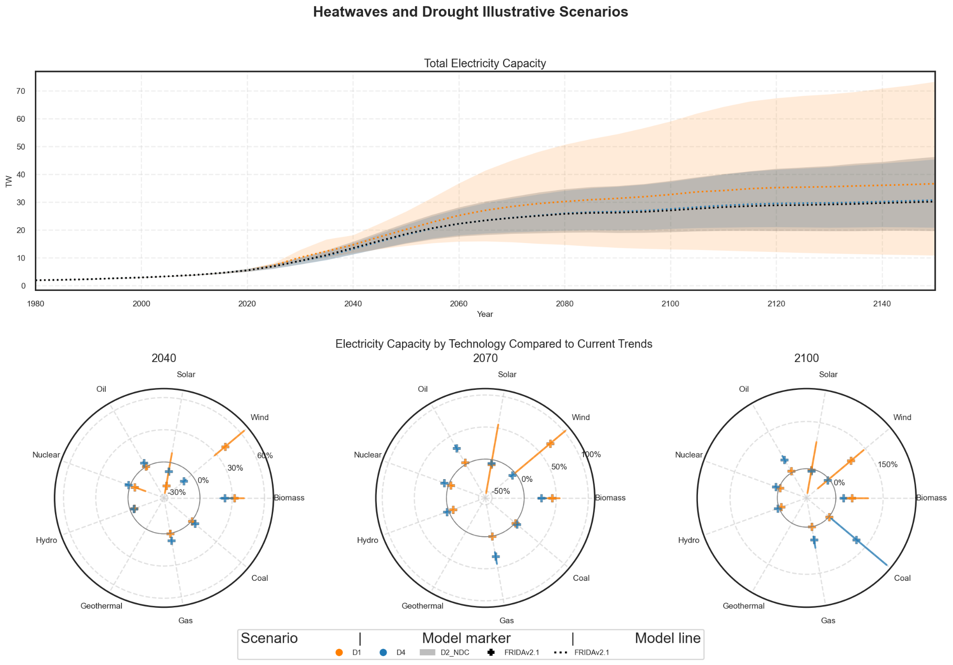
Figure A.1: Energy system responses to intensifying heatwaves and droughts across DERP narratives - FRIDA 2.1 ensemble members
Panel a (top row) shows Total Electricity Capacity (TW) trajectories from 2025-2100 for FRIDAv2.1, 5th to 95th percentile, with medians as dotted lines. Panel b (bottom row) Percentage changes in Electricity Capacity by Technology Compared to Current Trends (2040, 2070, and 2100) displayed as polar charts where the 0% solid circles in the middle represent Current Trends, ranges shown with plus sign for medians.

Supplementary Material
Table SM.1 (Capacity factors).
Table SM.2 (Cooling demand).

