Incorporation of apricot shell loads into novel highly ductile thermoplastic zein biopolymers through injection molding for food packaging
Jorge Israel Peñafiel-Alvarado^{1,2}, Jaume Gomez-Caturla^{2*}, Jan Novak³, Pavel Brdlík³, Rafael Balart², Luis Quiles-Carrillo²
¹ Pontificia Universidad Católica del Ecuador – Ibarra (PUCE - Ibarra), Av. Jorge Guzmán Rueda y Ave. Padre Aurelio Espinoza Polit, Ibarra 100112, Ecuador. J.I.P-A.: jipenafiel@pucesi.edu.ec.
² Instituto Universitario de Investigación de Tecnología de Materiales, Universitat Politècnica de València, IUITM-UPV, Alcoy, España. J.G-C.: jaugoca@epsa.upv.es; L.Q-C.: luiquic1@epsa.upv.es; R.B.: rbalart@mcm.upv.es
³ Faculty of Mechanical Engineering, Technical University of Liberec, Studentska 1402/2, 46117 Liberec, Czech Republic. J.N.: jan.novak@tul.cz; P.B: pavel.brdlik@tul.cz
*Corresponding author: jaugoca@epsa.upv.es

Supplementary Information
S.I.1. Fourier Transformed Infrared Spectroscopy (FTIR) of zein-DEG-ASF materials
Figure SI.1. FTIR spectra for the thermoplastic zein-ASF materials.

S.I.2. Thermomechanical analysis (TMA) of the zein-ASF thermoplastic materials.

Figure SI.2. TMA thermograms of zein-ASF thermoplastic materials.
S.I.3. X-ray diffraction patterns of zein-ASF thermoplastic materials.
Figure SI.3. XRD diffractograms of zein-ASF thermoplastic materials.

S.I.4. Visual aspect of zein-ASF materials after the water uptake test.
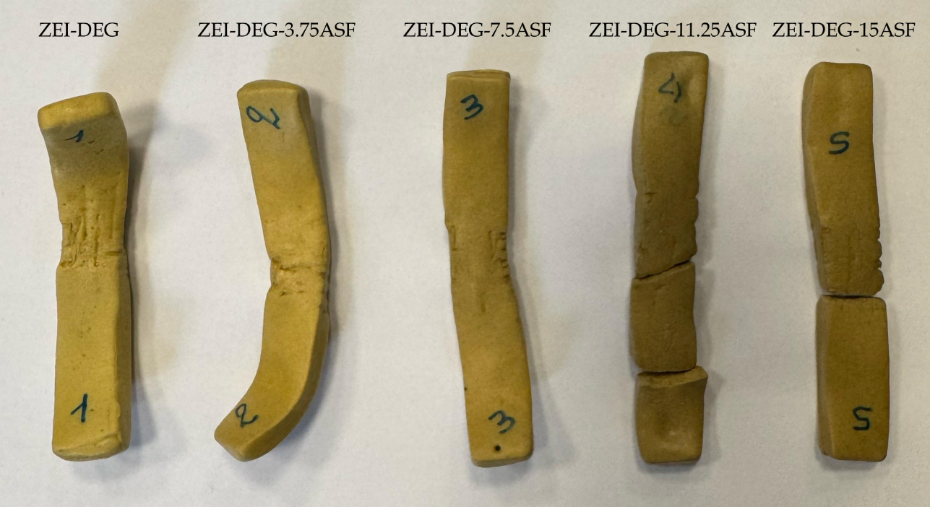
Figure SI.4. Visual aspect of zein-ASF materials after 5 weeks of immersion in distilled water.

