Supplementary data to paper on excitation/inhibition balance in Nrxn1α
By Freja Gam Østergaard & Martien Kas

ERP model
The data was tested with a linear mixed effects model of peak~gene*time + error (ID). The outcome of an ANOVA of this model is shown in the table below.
There was a general effect over time for ERP. None of the tests showed a significant effect of genotype (WT, HET, HOM) alone. Effects of time are expected as the surgery is carried out when the animals are ‘young adults’. The general tendency is for amplitudes to increase and for latencies to increase over time. Significant interactions of time and genotype are shown in the figures under the tables.

VEP

Amplitude
Table 1 amplitude of the different peaks of the VEP
peak | Time | gene*time interaction
P1 | F(3,256)=2.53, p=0.0579 | F(6,256)=1.92, p=0.0777
N1 | F(3,256)=6.57, p=0.0003* | F(6,256)=0.781, p=0.586
P2 | F(3,256)=10.2, p<0.0001* | F(6,256)=0.373, p=0.896
N2 |  | F(6,256)=3.73, p=0.0014*
P3 | F(3,256)=25.6, p<0.0001* | F(6,256)=1.83, p=0.0936
N3 | F(3,256)=20.3, p<0.0001* | F(6,256)=1.07, p=0.378
P4 | F(3,256)=1.85, p=0.138 | F(6,256)=0.152, p=0.989

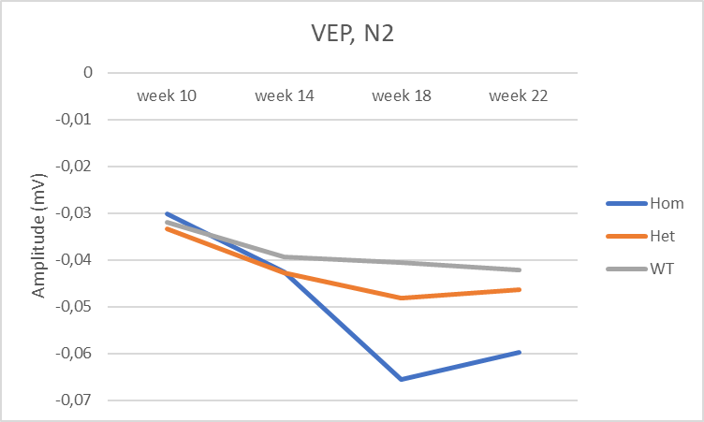
Figure S 1 Only N2 shows a significant interaction between gene and time. The KO shows a more negative amplitude than WT at week 18 and 22. Stars indicate significant post-hoc, the color corresponds to the group.

Latency
Table 2 Latency of the peaks of the VEP.
peak | Time | gene*time interaction
P1 | F(3,256)=9.39, p<0.0001* | F(6,256)=1.03, p=0.406
N1 | F(3,256)=1.6, p=0.193 | F(6,256)=0.90, p=0.494
P2 | F(3,256)=2.90, p=0.0355* | F(6,256)=0.60, p=0.732
N2 | F(3,256)=3.57, p=0.0147* | F(6,256)=0.480, p=0.826
P3 | F(3,256)=20.9, p<0.0001* | F(6,256)=1.13, p=0.345
N3 | F(3,256)=8.82, p<0.0001* | F(6,256)=0.732, p=0.624
P4 | F(3,256)=4.40, p=0.0049* | F(6,256)=1.14, p=0.341

AEP

Amplitude
Table 3 Amplitude of the peaks of the AEP.
peak | Time | gene*time interaction
P1 |  | F(6,274)=2.14, p=0.0490*
N1 |  | F(6,274)=2.38, p=0.0293*
P2 |  | F(6,274)=2.77, p=0.0125*
N2 |  | F(6,274)=3.26, p=0.0041*
P3 | F(3,274)=1.57, p=0.198 | F(6,274)=0.554, p=0.766

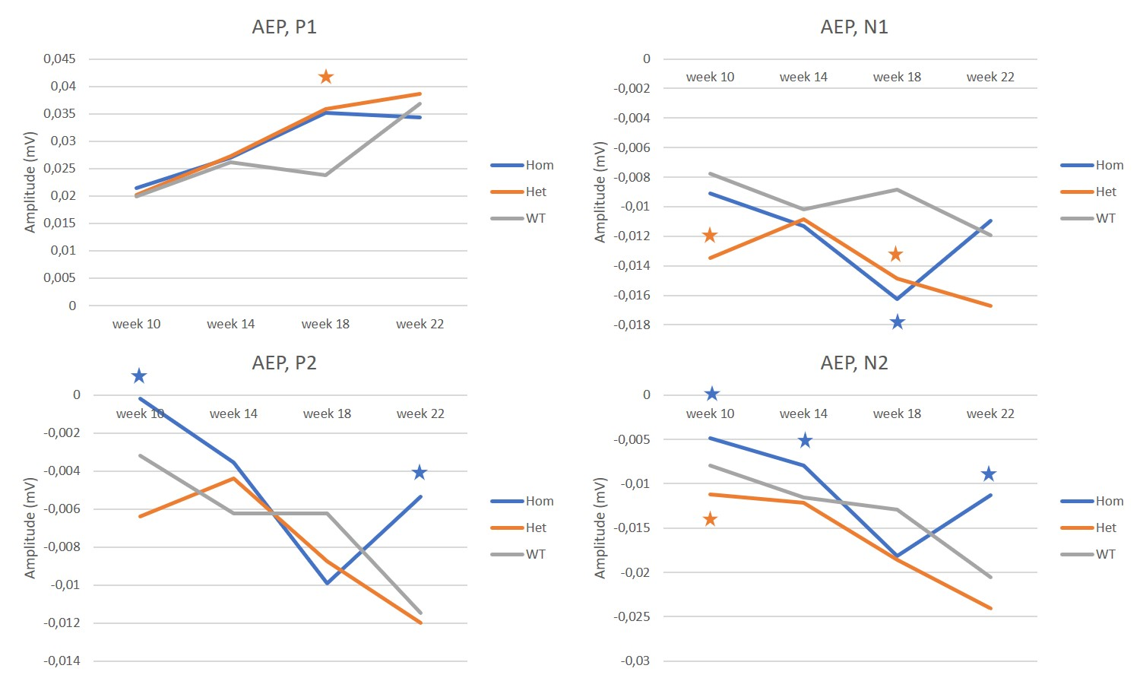
Figure S 2 Most peaks are affected in the AEP. P1 shows higher amplitude in the Het group in week 18 compares to WT. In the N1, the HET group is more negative in week 10 and 18. The KO group is more negative than WT in week 18. For P2, the KO is closer to baseline than the WT in week 10 and 22. For the amplitude of peak N2, the KO is less negative than the WT in week 10, 14 and 22. The Het group is more negative than the WT in week 10. Stars indicate results of post-hoc estimation statistics. The color of the star corresponds to the affected group.

Latency
Table 4 Latency of the peaks of the AEP.
peak | Time | gene*time interaction
P1 | F(3,274)=10.1, p<0.0001* | F(6,274)=0.380, p=0.892
N1 | F(3,274)=3.37, p=0.0191* | F(6,274)=0.760, p=0.605
P2 | F(3,274)=2.27, p=0.0810 | F(6,274)=0.380, p=0.893
N2 |  | F(6,274)=2.45, p=0.0251*
P3 | F(3,274)=5.92, p=0.0006* | F(6,274)=1.66, p=0.131

Figure S 3 AEP latency of the HET is short at first recording. The star indicates a significant result of the post-hoc estimation statistics, the color corresponds to the group.

Example of gating
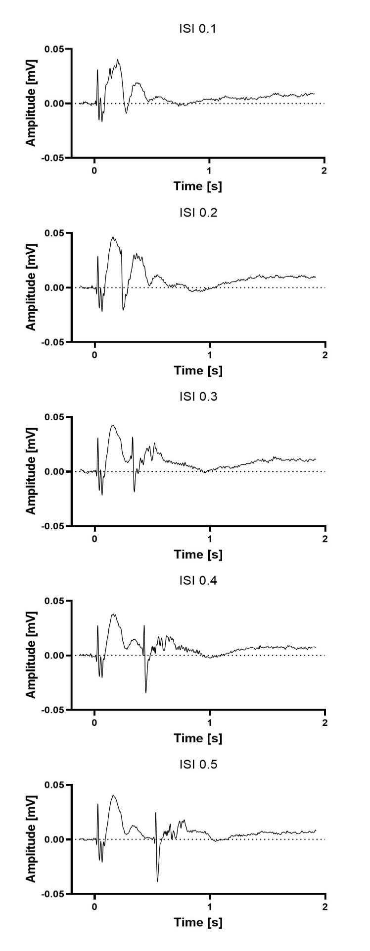
Figure S 4 Grand averages of visual gating paradigm. Top panel shows the traces from two light flashes being presented with the interstimulus interval (ISI) of 100 ms. The next panel shows the traces with ISI of 200 ms. The third panel shows the traces with ISI of 300 ms. The fourth panel shows the traces with ISI of 400 ms. The last panel shows the traces with ISI of 500 ms.
Table 5 Estimation statistics of visual gating, with the variables genotype and ISI.
ISI (s) | HET | KO
0.1 | -0.092 [95CI -0.169; -0.0128]* | 0.0553 [95CI -0.0314; 0.152]
0.2 | -0.0415 [95CI -0.115; 0.031] | 0.224 [95CI 0.126; 0.334]*
0.3 | 0.0644 [95CI 0.0221; 0.109]* | 0.237 [95CI 0.18; 0.3]*
0.4 | 0.0513 [95CI 0.00962; 0.0927]* | 0.151 [95CI 0.0918; 0.216]*
0.5 | 0.0889 [95CI 0.0462; 0.133]* | 0.188 [95CI 0.135; 0.242]*

Table 6 Both Het and KO show more auditory gating at timepoint 3 (week 18). The table shows the outcome of the estimation statistics of the interaction between genotype and time depicted in figure 2.
Age (weeks) | HET | KO
10 | -0.0507 [95CI -0.0952; -0.00988]* | 0.00292 [95CI -0.0384; 0.0415]
14 | -0.00917 [95CI -0.0497; 0.0312] | 0.0118 [95CI -0.0232; 0.0487]
18 | -0.0955 [95CI -0.135; -0.0587]* | -0.0698 [95CI -0.114; -0.0261]*
22 | -0.0411 [95CI -0.0761; -0.00413]* | 0.0308 [95CI -0.00527; 0.068]

Table 7 Heterozygous mice showed consistently more auditory gating compared to WT. The outcome of estimation statistics shows mean difference and 95 % confidence interval. The interval which does not include 0 are considered significant and marked with an asterisk.
ISI (s) | HET | KO
0.1 | -0.0883 [95CI -0.135; -0.0439]* | -0.00655 [95CI -0.0604; 0.0516]
0.2 | -0.109 [95CI -0.168; -0.0531]* | -0.0568 [95CI -0.115; 0.000722]
0.3 | -0.0513 [95CI -0.0974; -0.0063]* | -0.00481 [95CI -0.0527; 0.0438]
0.4 | -0.0594 [95CI -0.0987; -0.0197]* | 0.00196 [95CI -0.0456; 0.0466]
0.5 | -0.0481 [95CI -0.0917; -0.00437]* | 0.0148 [95CI -0.0299; 0.0611]
0.75 | -0.0142 [95CI -0.057; 0.028] | -0.00132 [95CI -0.044; 0.0406]
1 | 0.0283 [95CI -0.0178; 0.0759] | 0.00734 [95CI -0.0419; 0.0494]

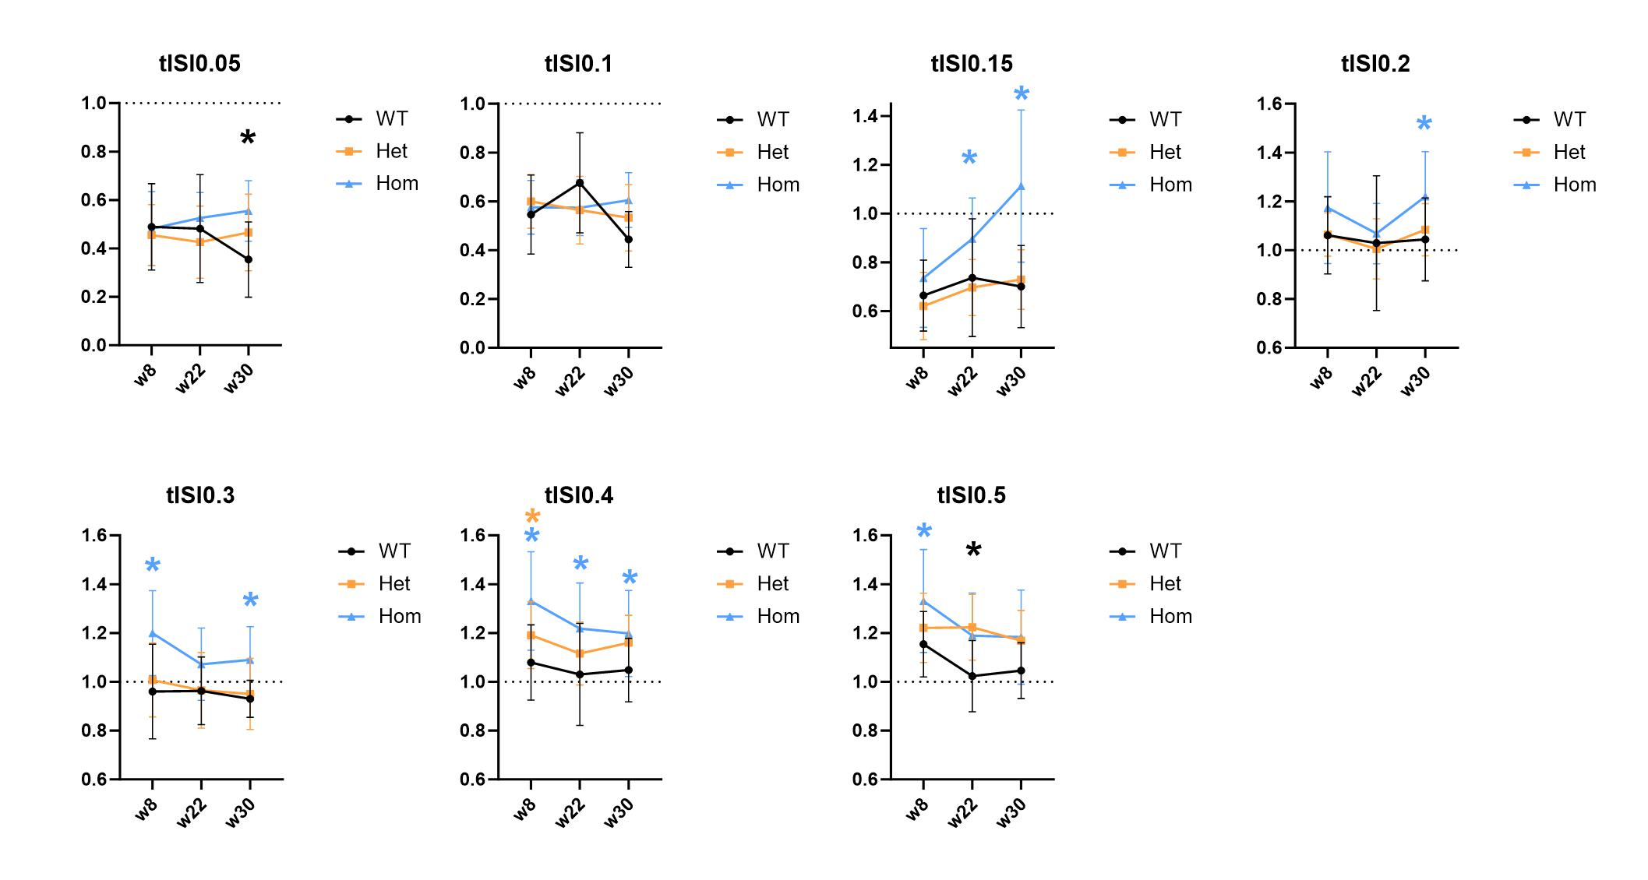
Figure S 5 Developmental changes in the visual T/C ratio of the vehicle condition. For most ISIs the T/C ratio of the Hom group changes away from the WT. To look closer at the time variable visual gating was recorded at 8 weeks, 22 weeks and 30 weeks. The 3-way interaction of genotype, time and ISI was significant F(24, 841)=2.1517, p=0.0011. The T/C ratio of the Hom group changed affected over time, while the Het and WT groups were barely influenced. Here the ISI 150 ms is revealing a developmental effect for Hom group. ISI 400 ms shows increased gating over time, moving the Hom and Het closer to the WT group. Black; WT, orange; Het, blue; Hom. The asterisks indicate a difference from the WT w8 point.

Visual Chirp & SSVEP
The chirp and SSVEP were pre-processed as ERPs and gating. The signal was decomposed into frequency components using a wavelet convolution. Statistics were carried out by permutation analysis. A fake signal was created by averaging across 100 random permutations of the data. Z-maps were computed for the test against the fake signal.

The difference of HET-WT
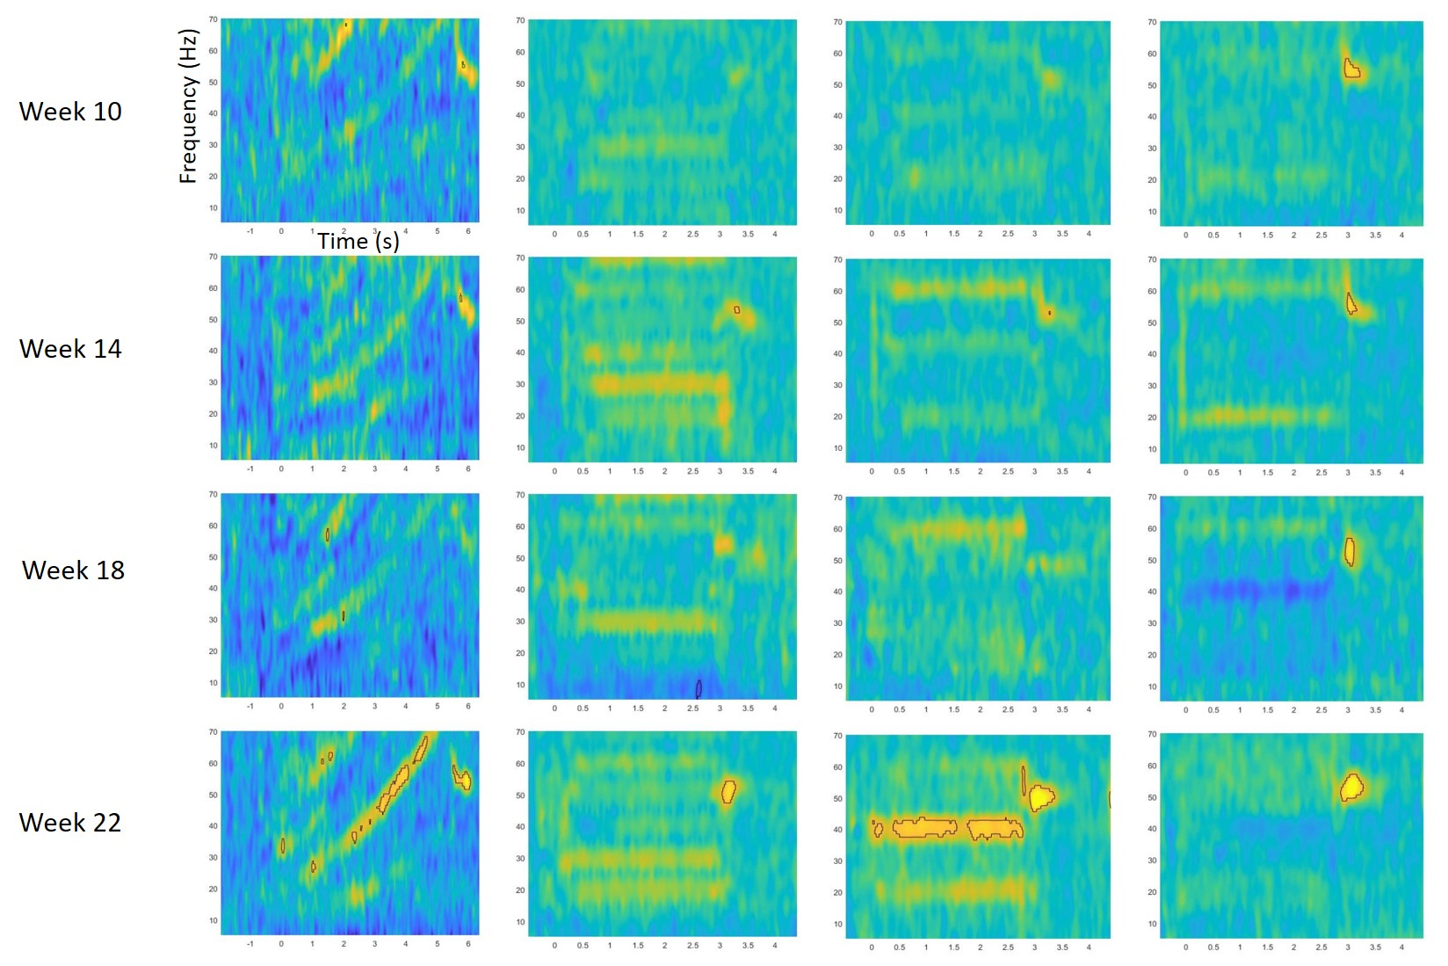
Figure S 6 Higher power in HET compared to WT in week 22. Column one shows the chirp response. Column two through four of SSVEPs at three different presentation rates: 10 Hz, 20 Hz and 40 Hz. There are significant increases of power of the HET group at week 22 for the chirp response above 40 Hz and SSVEP 20 Hz at 40 Hz.

Coherence
Table 8 Coherence from 4h recordings. There was an independent effect of channels pair that did not interact with genotype or time. All channel pairs are pooled and compared to WT group and time point 1 (10 weeks). Increase of overall coherence for the awake states at the later timepoint (22 weeks).
 | A1 | A2 | A3 | REM | nREM1 | nREM2 | nREM3
WT2-WT1 | 0.0381  [-0.0213; 0.1] | 0.0179  [-0.0396; 0.078] | 0.0128  [-0.0463; 0.0722] | -0.0598  [-0.11;  -0.00931] | -0.0423  [-0.097; 0.0122] | -0.0606  [-0.114;  -0.00693] | -0.0387  [-0.0874; 0.00976]
Het1-WT1 | -0.0178  [-0.0818; 0.0497] | -0.0417  [-0.103; 0.0192] | -0.0464  [-0.11; 0.0155] | -0.0574  [-0.111;  -0.00428] | -0.0919  [-0.155;  -0.0286] | -0.0862  [-0.148;  -0.027] | -0.0844  [-0.137;  -0.0333]
Het2-WT1 | 0.12  [0.063; 0.178] | 0.0871  [0.0298; 0.147] | 0.0783  [0.0176; 0.14] | 0.021  [-0.03; 0.0724] | 0.00538  [-0.0568; 0.0656] | 0.000961  [-0.0578; 0.0559] | -0.0171  [-0.071; 0.0359]
Hom1-WT1 | 0.0404  [-0.0199; 0.0999] | 0.0331  [-0.0245; 0.0911] | 0.0258  [-0.0299; 0.0823] | 0.00379  [-0.0481; 0.0517] | 0.0294  [-0.0232; 0.0846] | 0.000813  [-0.0537; 0.0536] | 0.00743  [-0.0428; 0.0572]
Hom2-WT1 | 0.135  [0.0762; 0.195] | 0.11  [0.0513; 0.167] | 0.104  [0.0469; 0.16] | 0.0478  [-0.00541; 0.0966] | -0.00482  [-0.0619; 0.053] | 0.00398  [-0.0529; 0.0596] | 0.00914  [-0.0439; 0.0599]

Spindles in the auditory channel (ch 2)
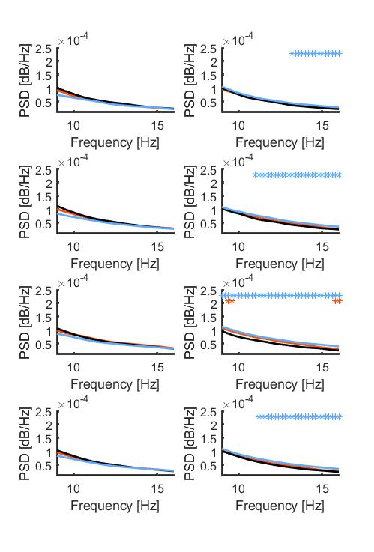
Figure S 7 Narrowband filtered signal from the auditory channel in nREM1 (top), nREM2, nREM3 and natural sleep (bottom). Left column is the earliest time point (8 weeks). Right column is the later time point (22 weeks). Black; WT, orange; het and blue; hom.

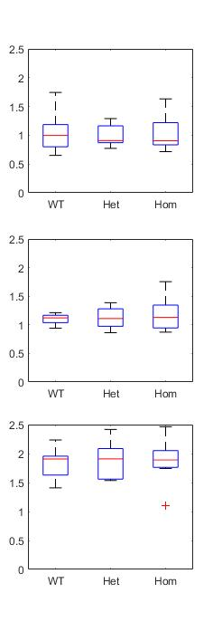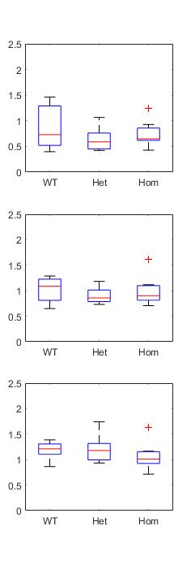
Figure S 8 Spindle density as spindle/minute at the two timepoints in nREM1, nREM2, nREM3.

Sleep intensity

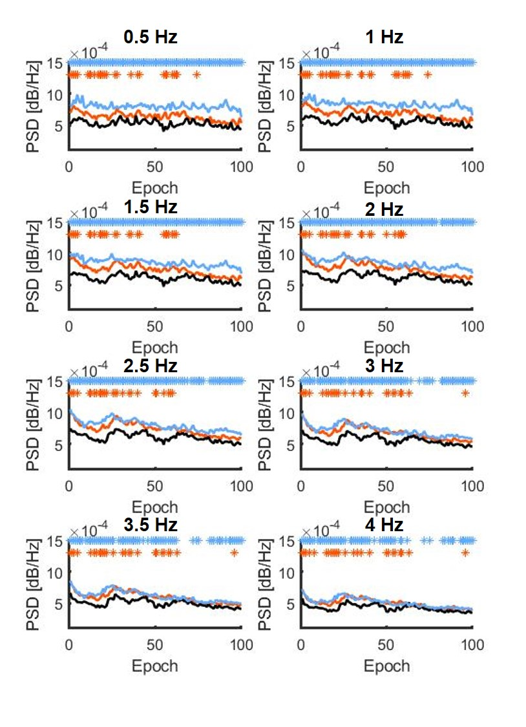
Figure S 9 Sleep intensity depending on frequencies at timepoint 1 (8-10 weeks). The asterisks refer to the difference between the WT (black) and Het (orange) or KO (blue).

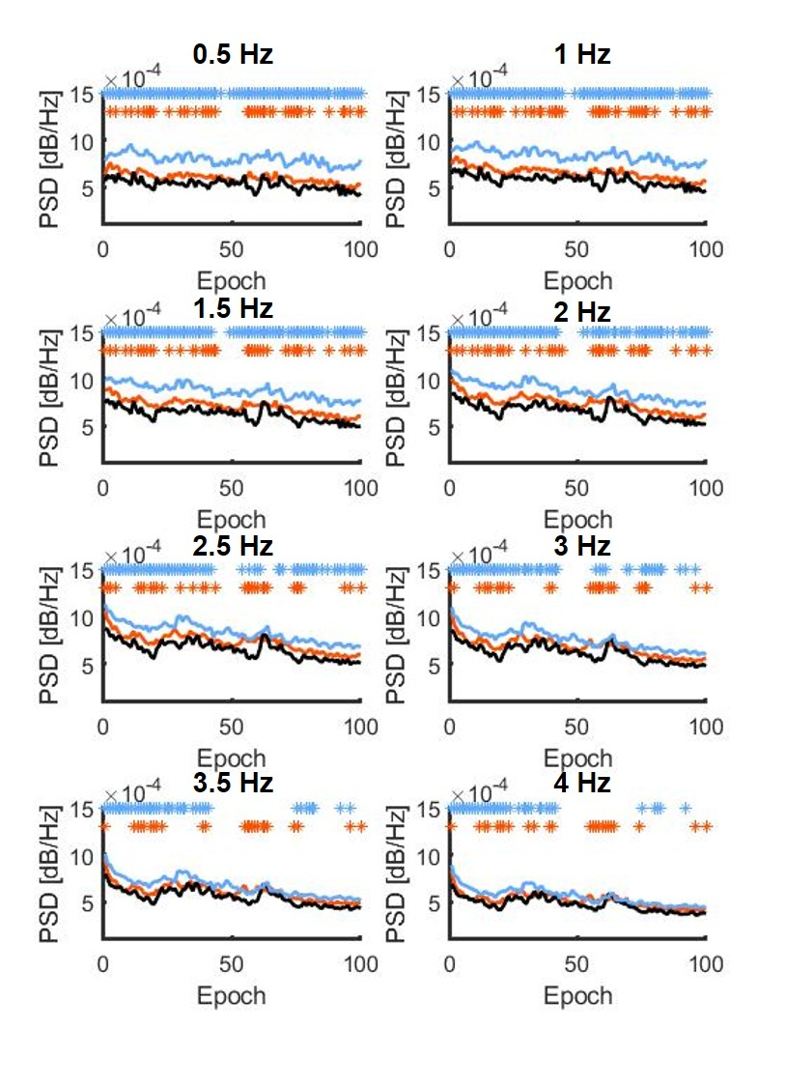
Figure S 10 Sleep intensity depending on frequencies at timepoint 2 (20-22 weeks). The asterisks refer to the difference between the WT (black) and Het (orange) or KO (blue).

Arbaclofen pilot
Before testing Arbaclofen in the Nrxn1s pharmacokinetic testing was done in male and female C57Bl/6J mice, both male and female, yielding the below values from brain tissue and plasma, 1, 2 and 3 hours after intraperitoneal administration of 6 mg/kg arbaclofen in saline. There seems to be a difference in clearance rate between the sexes, however, this is not statistically significant, therefore the calculations below are based on the pooled data.
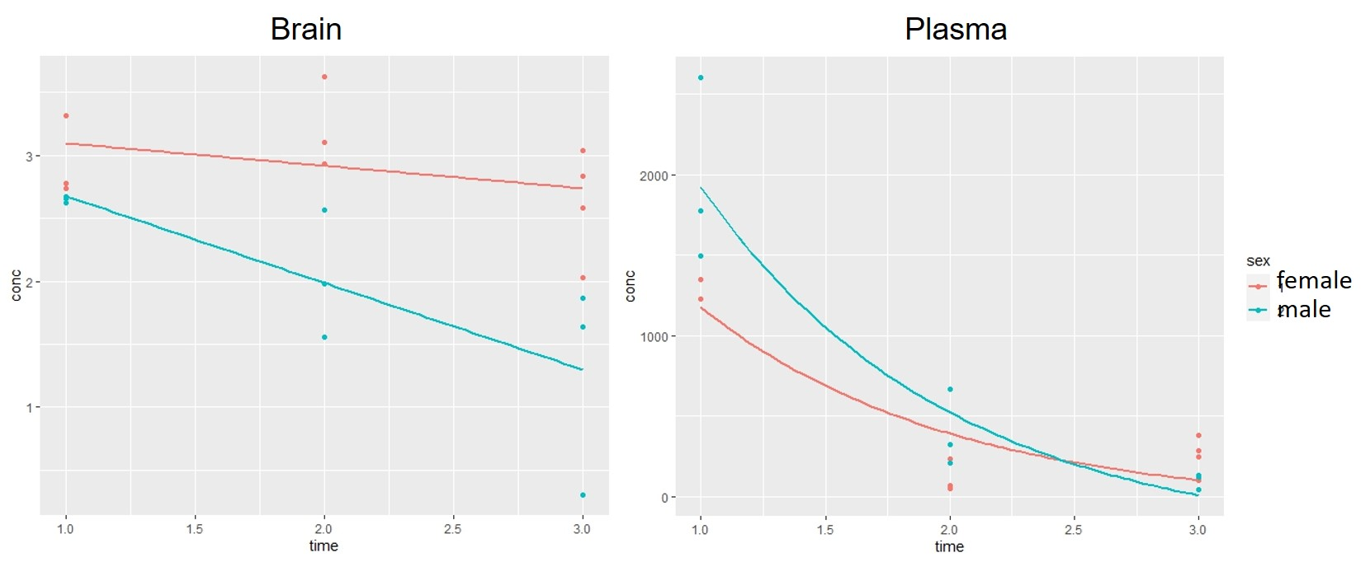
Figure S 11 Pharmacokinetics of arbaclofen in brain and plasma. X-axes shows time in hours. Y-axes shows concentration in µg/ g brain, respectively in ng/ml plasma. A) Brain average linear fit: conc=-0.38*time+3.25, giving an elimination of 1 µg/g pr ~3 hours. IC50=15 nM (cat cerebellum, [DOI: 10.1021/jm00017a015]). Average concentration in the brain at 1 hour = 3949.6 nM (263 times the IC50). mol mass=213.66 g/mol [Pubchem]. Giving an estimated availability in the brain of 14 % of the administered dose (injected IP), 1 hour after administration. The Emax (figure S 12) seems to be at 55 min after administration, therefore it can be assumed that the 1 hour is close to the Cmax of the brain. B) Plasma [ng/ml] exponential fit: ln(conc)=-1.13^{time}+8.13 conc= 3389.0445 * 0.3227^{time}, giving a T½ of 0.613 h ~ 40 min.
This shows that arbaclofen is cleared relatively fast from the plasma, but lingers in the brain. The electrophysiological effect is depicted in figure S 8. Showing how the animal ‘falls asleep’ 10 min after dosing of arbaclofen at 6 mg/kg, and how even the power of sleep is reduced during the maximum effect of the drug. This reduction in power may be due to desynchronization of the neurons.
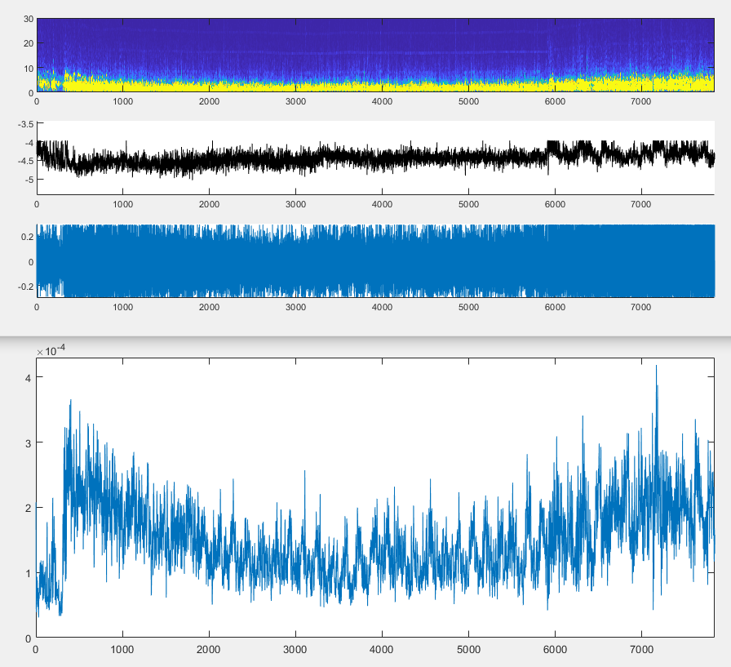
Figure S 12 Example of spectrogram after 6 mg/kg arbaclofen from time 0 to 7800 s. The spectrogram was binned into 5-minute bins and power is compared using estimation statistics comparing to the starting point. To deal with the reduction of power, the power of each bin is divided by the total mean across the recording. Right after administering 6 mg/kg arbaclofen intraperitoneally, the normalized power was 0.569±0.179 and bimodally distributed in the delta >4Hz and the alpha (7-10 Hz) bands. Approximately, 15 minutes later the power is concentrated in the delta band and significantly increased by 0.357 [95CI: 0.236; 0.48]) compared to the start. At 55 min (3300 s) after administration the power is reduced to 0.776±0.118 which is 0.207 [95CI: 0.111; 0.292] above starting point and the spectra reveal a sharp delta from 1-3 Hz. After 90 minutes the power reaches a local maximum of 1.113±0.179, 0.544 above starting point [95CI: 0.43; 0.645], still in the delta band. The high power suggests that the animals are in the excitatory phase of the anesthesia. After 120 minutes the power is 0.691 above starting point [95CI: 0.578; 0.793].

Arbaclofen in Nrxn1

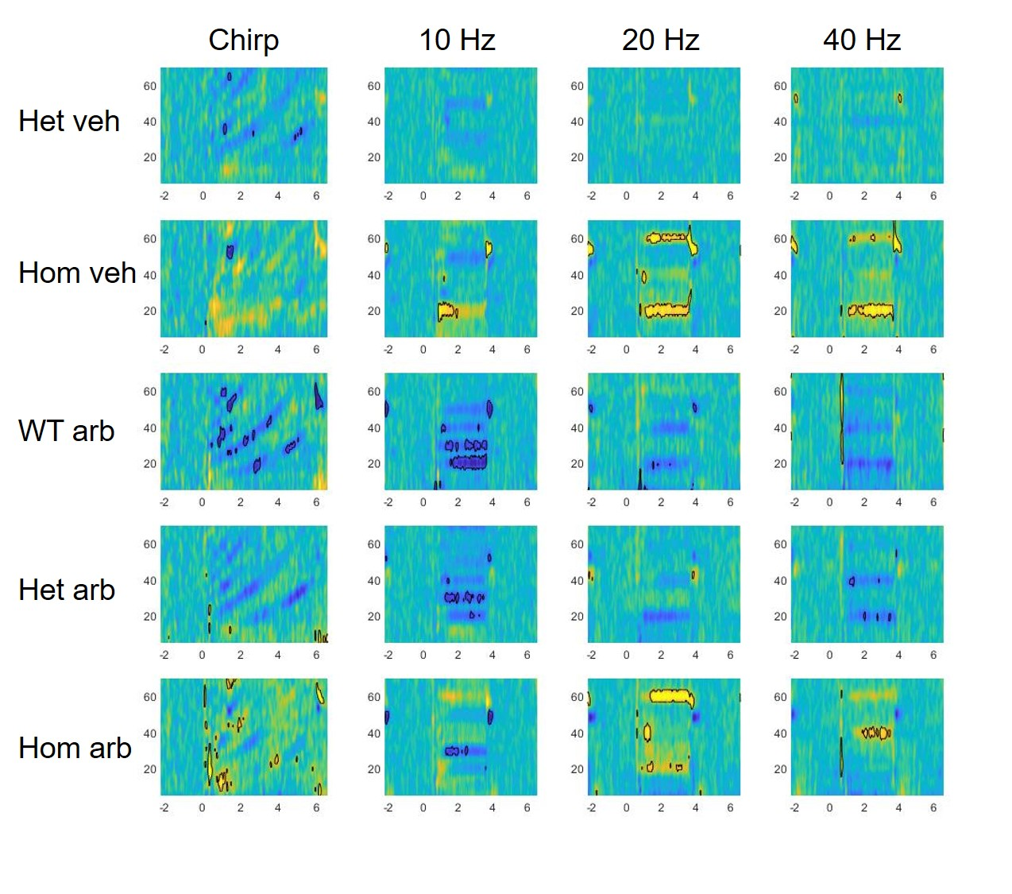
Figure S 13 Time point 1 (10 weeks of age) all colormaps are normalized to WT vehicle condition. Significant decrease when arbaclofen is administered in the wildtype. While arb in the Hom group increases power in the chirp paradigm.

