Supplemental Digital Content 1 to

Internet-based cognitive-behavioral writing therapy for reducing posttraumatic stress after severe sepsis in patients and their spouses (REPAIR): results of a randomized controlled trial

Romina Gawlytta; Miriam Kesselmeier; André Scherag; Helen Niemeyer; Maria Boettche; Christine Knaevelsrud; Jenny Rosendahl

Detailed description of methods

Outcomes measures 2
Primary efficacy outcome measure 2
Secondary efficacy outcome measures 2
Statistical methods 3
Definition of analysis populations 3
Statistical analysis 3
Missing data 5
Overview 5
Best-case/worst-case substitution 5
Multiple imputation 6
Additional references 7
Additional figures 8

Outcomes measures

Primary efficacy outcome measure
PCL-5:
- 20-item self-report measure
- total symptom severity score: sum of all items (range: 0-80)
- higher scores indicating more severe symptoms

Secondary efficacy outcome measures
BSI-18:
- 3 subscales (anxiety, depression, and somatization) with 6 items each
- Global Severity Index (GSI): sum of all subscales (range: 0-72)
- higher scores indicating more severe symptoms
RAS:
- 7 items
- total score: mean across all items (range: 1-7)
- higher scores indicating higher satisfaction
EQ-5D-5L:
- 5 dimensions (mobility, self-care, usual activities, pain/discomfort, anxiety/depression) with 5 levels (range: no problems to extreme problems)
- utility values:
  - range: -0.661 to 1
  - anchored at 0 (death) and 1 (perfect health)
  - lower values indicating worse quality of life

Statistical methods

Definition of analysis populations
The dyad population includes randomized participants irrespective of their presumptive PTSD diagnosis. The PTSD population only comprises participants with a presumptive PTSD diagnosis. We apply the intention-to-treat (ITT) and the per-protocol (PP) principle to both populations. In case of the ITT principle, we consider all randomized participants (with a presumptive PTSD diagnosis). In case of the PP principle, we consider randomized participants (with a presumptive PTSD diagnosis) who provided pre- (t0) and post-treatment/waiting (t1) information. For further details on the populations, we refer to the section “Missing data”.

Statistical analysis
Participant characteristics (dyad population) are summarized as absolute and relative frequencies or as medians together with the first and third quartile (Q1, Q3). Furthermore, each outcome (PTSD population) was summarized as median together with Q1 and Q3. Additionally, we provide p-values from Fisher’s exact test and Mann-Whitney-U test, respectively.
For the primary outcome PCL-5 change (analyzed in the PTSD population), we applied multivariable generalized estimating equation (GEE) modelling with the identity as link function, with the sandwich estimator and with an assumed unstructured correlation structure. We included the treatment group (iCBT or WL control group; binary) as well as the baseline PCL-5 value (t0) as independent variables and the dyad membership as cluster. The primary analysis was performed according to the ITT principle with best-case/worst-case substitution (see section “Missing data” for definition). We performed several sensitivity analyses. First, we extended the aforementioned sparse multivariable model by (i) a binary variable related to the occurrence of PTSD symptoms within the dyads (both dyad members suffering from PTSD) and (ii) additionally by age (numeric), post-ICU patient (binary) and pre-existing mental disorder (binary). Secondly, we repeated the modelling according to the ITT principle gained by multiple imputation by chained equations (MICE; see section “Missing data” for definition) and according to the PP principle. In case of MICE, data was pooled according to Rubin (1). We provide regression coefficients with 95% confidence intervals (CIs) and p-values.
For the secondary efficacy outcomes (analyzed in the PTSD population), we adapted the GEE modelling for the primary outcome with respect to the included dependent and independent variables. Of note, remission of PTSD was analyzed in the population of participants with a PTSD diagnosis (according to CAPS-5) before the treatment/waiting period and with the logit-link in the respective GEEs. For remission, we could not include the variable “baseline value (t0)” in the extended multivariable models, because all included participants showed PTSD symptoms at baseline. Furthermore, we did not apply the extended multivariable model (ii) for remission due to sample size issues. For the safety outcomes (analyzed in the PTSD population), we provided absolute and relative frequencies according to the PP principle. Dyadic concordance in treatment effects (in terms of PCL-5; analyzed in the dyad population) was assessed with Spearman correlation (together with the corresponding 95% CIs) independently from the treatment condition between post-ICU patients and his/her spouse according to both ITT (both approaches) and PP principle.
We applied a two-sided significance level of 0.05 and did not correct for multiple testing. We used R (version 3.6.0) for statistical analyses and, in particular, the R packages gee (version 4.13-20; 2), mice (version 3.8.0; 3), norm (version 1.0-9.5; 4) and psych (version 1.9.12; 5).

Missing data

Overview
Overall, the number of missing data increases with proceeding time since study initiation (Supplemental Digital Content 2, Supplemental Table S2). One participant (iCBT group, post-ICU patient) dropped-out directly after randomization. For this participant, baseline data was collected but there is no data related to the intervention/waiting time. Missing information on score changes is mainly driven by missing data at t1. The missing data pattern in the iCBT and the WL control group are provided for the dyad population in Additional Figures A1 and A2 as well as for the PTSD population in Additional Figures A3 and A4 (at the end of this document), respectively.
Based on the expected adequate/high consistency of the scores, we substituted missing items with the mean of the provided items of the respective participant if 10% or fewer items were missing. Due to the small sample size, we decided to replace the remaining missing score values when following the ITT principle. The remaining missing values were then replaced, stratified by intervention group and type of treatment (defined according to the strata for the randomization), (i) according to best-case/worst-case substitution and (ii) with multiple imputation by chained equations (MICE). We decided to use MICE as sensitivity analysis for the best-case/worst-case substitution, because the latter is the most rigorous method for handling missing data.

Best-case/worst-case substitution
For missing information on the change score from t0 to t1, missing values were substituted with the worst observed change for participants in the iCBT group and with the best observed change for participants in the WL control group.
Missing values at the pre-treatment time point (t0) were replaced in a three-step approach (under consideration of the defined respective score range). (i) If the post-treatment value was available, the pre-treatment value was calculated relying on the already substituted change. (ii) In case of the PCL-5 score, the value was substituted by the screening value (approximately four weeks earlier than t0) if the pre-treatment value was still missing. (iii) Otherwise, the pre-treatment missing value was replaced by relying on the worst observed (iCBT group) and best observed (WL control group) post-treatment value (t1), respectively, and the already replaced change score.

Multiple imputation
For missing information in the data, we applied multiple imputation by chained equations (MICE) using fully conditional specification (3). We imputed 20 data sets, used 20 iterations and applied predictive mean matching (3,6). Score values imputed with predictive mean matching are restricted to observed score values (3,7). For imputation, we relied on baseline characteristics that we expected to be relevant for the score values and its change. To impute post-treatment values, we additionally used the respective pre-treatment values. The considered baseline characteristics comprised patient status (post-ICU patient or spouse), sex, age (in years), time since ICU discharge (in years), duration of intensive care treatment (in days), need of mechanical ventilation, highest educational qualification, duration of relationship (between post-ICU patient and spouse; in years), marital status, internet literacy, pre-existing mental illness (prior to sepsis), treated mental illness both before and after sepsis as well as treatment group (iCBT or WL control group) and type of treatment (related to occurrence of PTSD symptoms within the dyads). Characteristics of the imputed data (dyad population) are provided in Additional Figures A5-A9 (at the end of this document).

Additional references
- Rubin DB. Multiple Imputation for Nonresponse in Surveys. New York: John Wiley and Sons, 1987.
- Carey VJ, Lumley T, Ripley B (2019). gee: Generalized Estimation Equation Solver. URL https://CRAN.R-project.org/package=gee
- van Buuren S, Groothuis-Oudshoorn K. mice: Multivariate Imputation by Chained Equations in R. Journal of Statistical Software 2011;45(3):1-67. https://doi.org/10.18637/jss.v045.i03
- Novo AA, Schafer JL (2013). norm: Analysis of multivariate normal datasets with missing values. URL https://CRAN.R-project.org/package=norm
- Revelle W (2019). psych: Procedures for Psychological, Psychometric, and Personality Research. URL https://CRAN.R-project.org/package=psych
- Schafer JL, Graham JW. Missing Data: Our View of the State of the Art. Psychological Methods. 2002;7(2):147–177. https://doi.org/10.1037//1082-989X.7.2.147
- Little RJA. Missing-Data Adjustments in Large Surveys. Journal of Business & Economic Statistics 1988;6(3): 287-296. https://doi.org/10.2307/1391878

Additional figures
Additional Figure A1. Missing data pattern in the iCBT group of the dyad population. Baseline variables used for imputation and imputed variables are provided. t0 denotes the time point at which the intervention (iCBT group) / waiting (WL control group) begins and t1 the time point where the intervention (iCBT group) / waiting (WL control group) ends. Numbers on the left side indicates the frequency with which this missing data pattern occurs. Numbers in the bottom indicates the number of missing data of the respective variable. Numbers on the right side indicates the number of missing variables in the respective missing data pattern. Color coding: blue, not missing; red, missing. Abbreviations: BSI, Brief Symptom Inventory; CAPS-5, Clinician-Administered PTSD Scale for DSM-5; EQ-5D-5L, Health questionnaire of the EuroQol group in five dimensions with five levels; iCBT, internet-based cognitive-behavioral writing therapy; ICU, intensive care unit; PCL-5, PTSD Checklist for DSM-5; PTSD, post-traumatic stress disorder; RAS, Relationship Satisfaction Scale; WL, waitlist.
Additional Figure A2. Missing data pattern in the WL control group of the dyad population. Baseline variables used for imputation and imputed variables are provided. t0 denotes the time point at which the intervention (iCBT group) / waiting (WL control group) begins and t1 the time point where the intervention (iCBT group) / waiting (WL control group) ends. Numbers on the left side indicates the frequency with which this missing data pattern occurs. Numbers in the bottom indicates the number of missing data of the respective variable. Numbers on the right side indicates the number of missing variables in the respective missing data pattern. Color coding: blue, not missing; red, missing. Abbreviations: BSI, Brief Symptom Inventory; CAPS-5, Clinician-Administered PTSD Scale for DSM-5; EQ-5D-5L, Health questionnaire of the EuroQol group in five dimensions with five levels; iCBT, internet-based cognitive-behavioral writing therapy; ICU, intensive care unit; PCL-5, PTSD Checklist for DSM-5; PTSD, post-traumatic stress disorder; RAS, Relationship Satisfaction Scale; WL, waitlist.

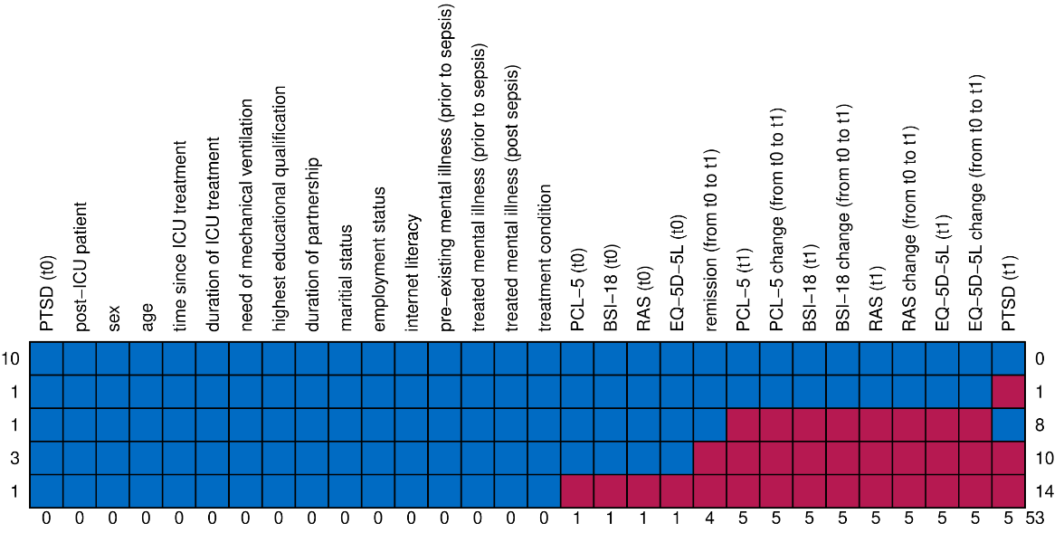
Additional Figure A3. Missing data pattern in the iCBT group of the PTSD population. Baseline variables used for imputation and imputed variables are provided. t0 denotes the time point at which the intervention (iCBT group) / waiting (WL control group) begins and t1 the time point where the intervention (iCBT group) / waiting (WL control group) ends. Numbers on the left side indicates the frequency with which this missing data pattern occurs. Numbers in the bottom indicates the number of missing data of the respective variable. Numbers on the right side indicates the number of missing variables in the respective missing data pattern. Color coding: blue, not missing; red, missing. Abbreviations: BSI, Brief Symptom Inventory; CAPS-5, Clinician-Administered PTSD Scale for DSM-5; EQ-5D-5L, Health questionnaire of the EuroQol group in five dimensions with five levels; iCBT, internet-based cognitive-behavioral writing therapy; ICU, intensive care unit; PCL-5, PTSD Checklist for DSM-5; PTSD, post-traumatic stress disorder; RAS, Relationship Satisfaction Scale; WL, waitlist.

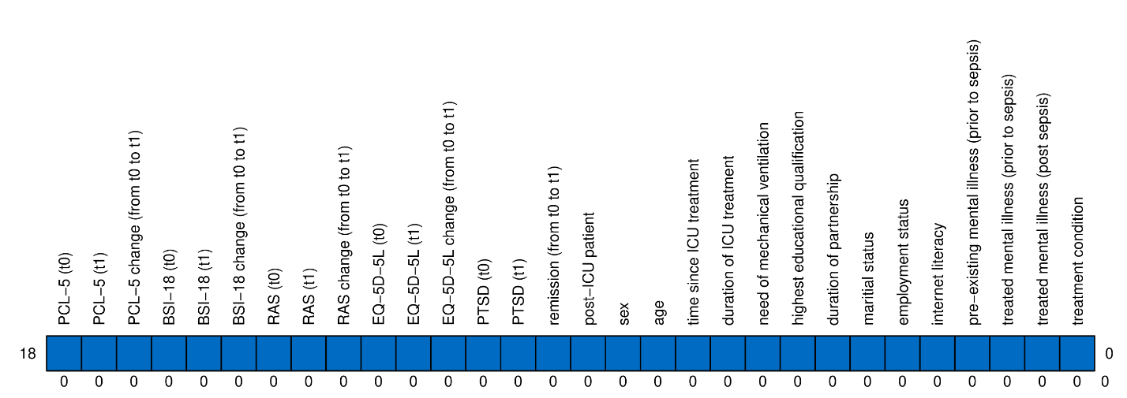
Additional Figure A4. Missing data pattern in the WL control group of the PTSD population. Baseline variables used for imputation and imputed variables are provided. t0 denotes the time point at which the intervention (iCBT group) / waiting (WL control group) begins and t1 the time point where the intervention (iCBT group) / waiting (WL control group) ends. Numbers on the left side indicates the frequency with which this missing data pattern occurs. Numbers in the bottom indicates the number of missing data of the respective variable. Numbers on the right side indicates the number of missing variables in the respective missing data pattern. Color coding: blue, not missing; red, missing. Abbreviations: BSI, Brief Symptom Inventory; CAPS-5, Clinician-Administered PTSD Scale for DSM-5; EQ-5D-5L, Health questionnaire of the EuroQol group in five dimensions with five levels; iCBT, internet-based cognitive-behavioral writing therapy; ICU, intensive care unit; PCL-5, PTSD Checklist for DSM-5; PTSD, post-traumatic stress disorder; RAS, Relationship Satisfaction Scale; WL, waitlist.

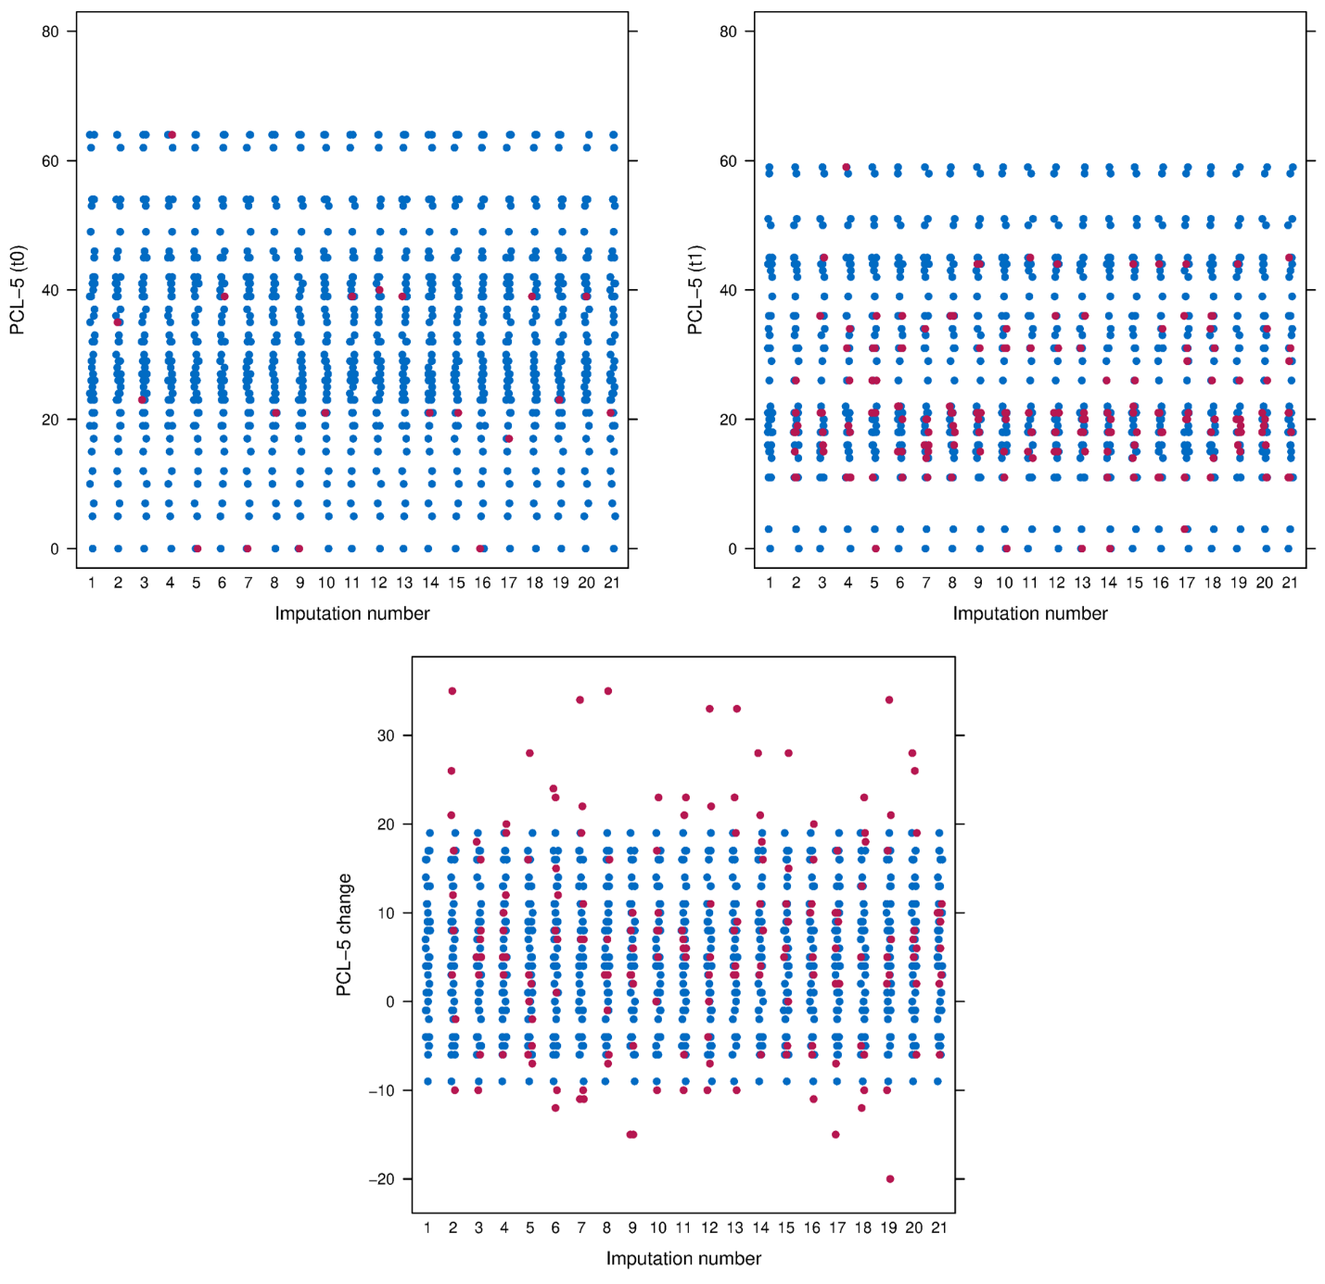
Additional Figure A5. Original (imputation number 1) and the imputed data sets (dyad population) for PCL-5 (imputation numbers 2 to 21). PCL-5 denotes the PTSD Checklist for DSM-5. Imputed values (red) and original values (blue) are provided for the pre- (t0) and post-treatment (t1) value as well as the change from t0 to t1.

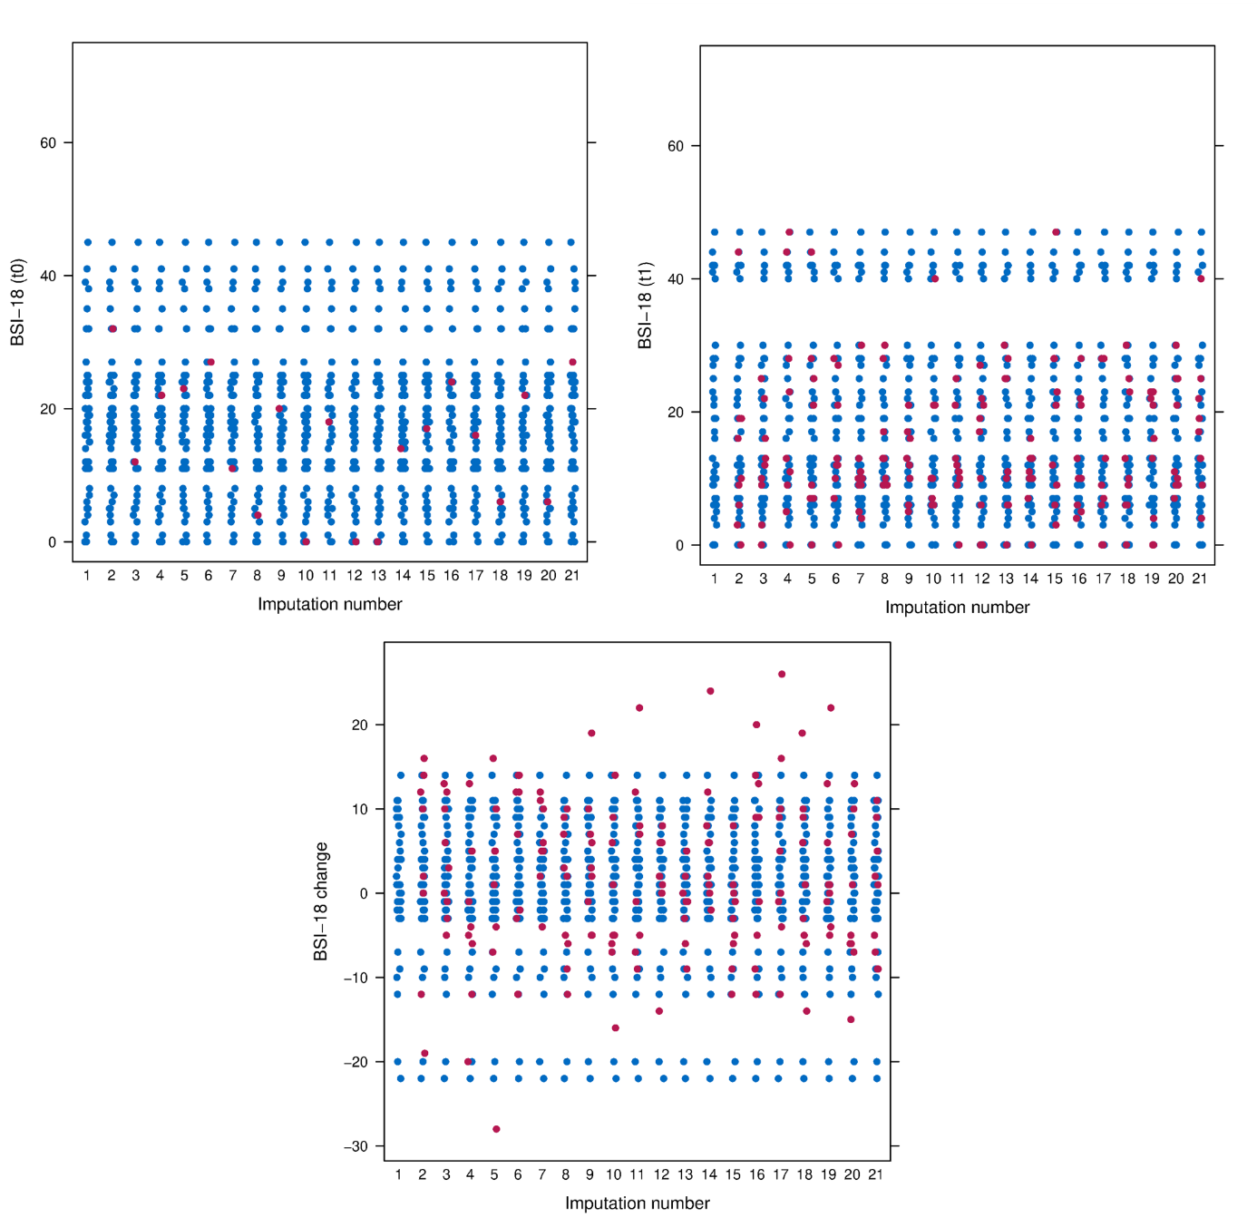
Additional Figure A6. Original (imputation number 1) and the imputed data sets (dyad population) for BSI-18 (imputation numbers 2 to 21). BSI-18 denotes the Brief Symptom Inventory-18. Imputed values (red) and original values (blue) are provided for the pre- (t0) and post-treatment (t1) value as well as the change from t0 to t1.

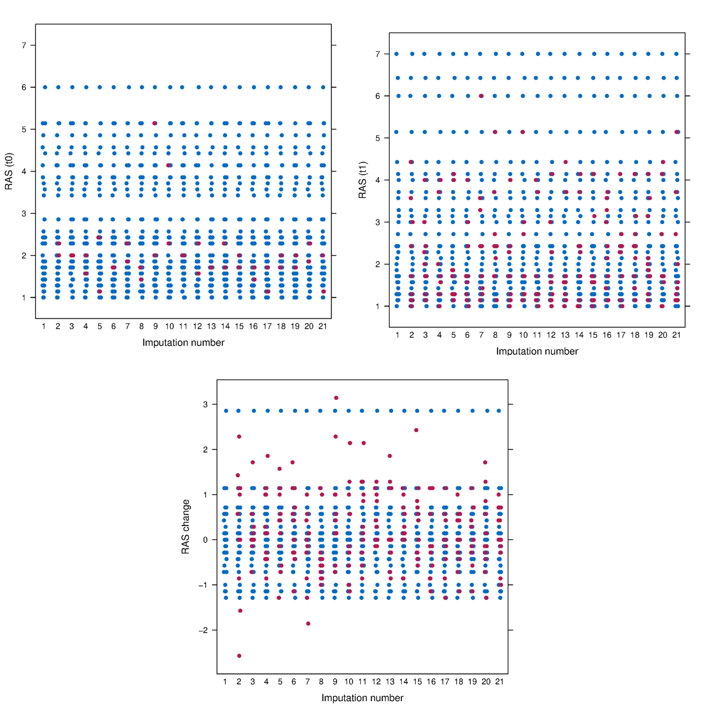
Additional Figure A7. Original (imputation number 1) and the imputed data sets (dyad population) for RAS (imputation numbers 2 to 21). RAS denotes the Relationship Satisfaction Scale. Imputed values (red) and original values (blue) are provided for the pre- (t0) and post-treatment (t1) value as well as the change from t0 to t1.

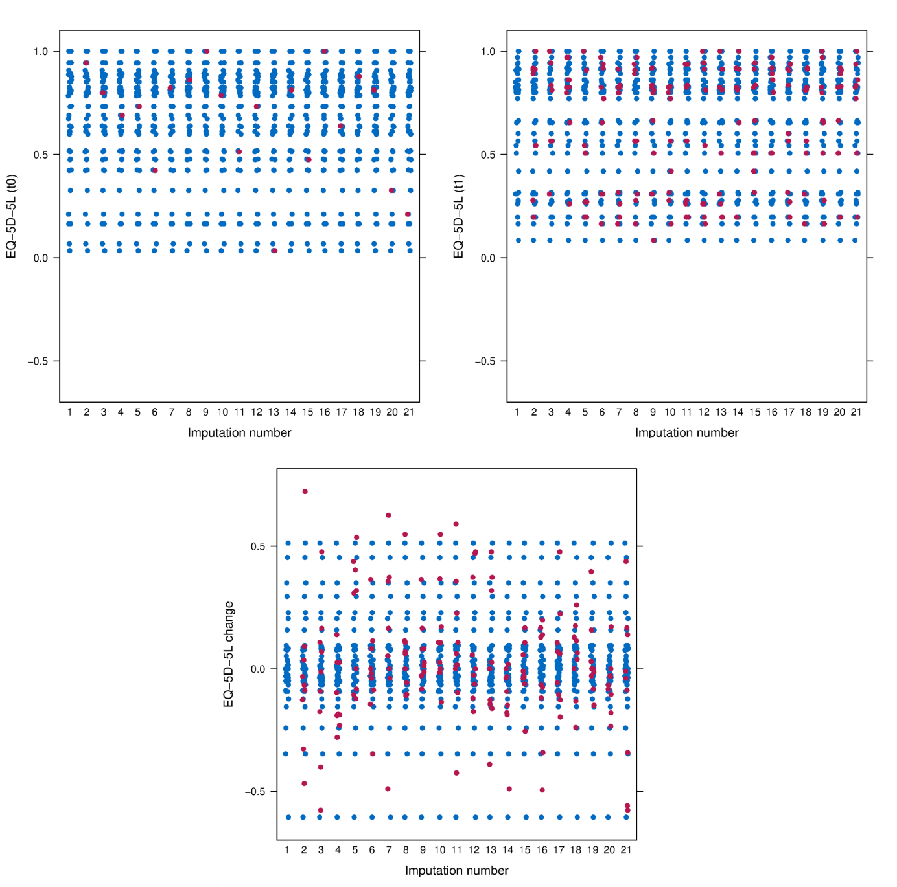
Additional Figure A8. Original (imputation number 1) and the imputed data sets (dyad population) for EQ-5D-5L (imputation numbers 2 to 21). EQ-5D-5L denotes the Health questionnaire of the EuroQol group in five dimensions with five levels. Imputed values (red) and original values (blue) are provided for the pre- (t0) and post-treatment (t1) value as well as the change from t0 to t1.

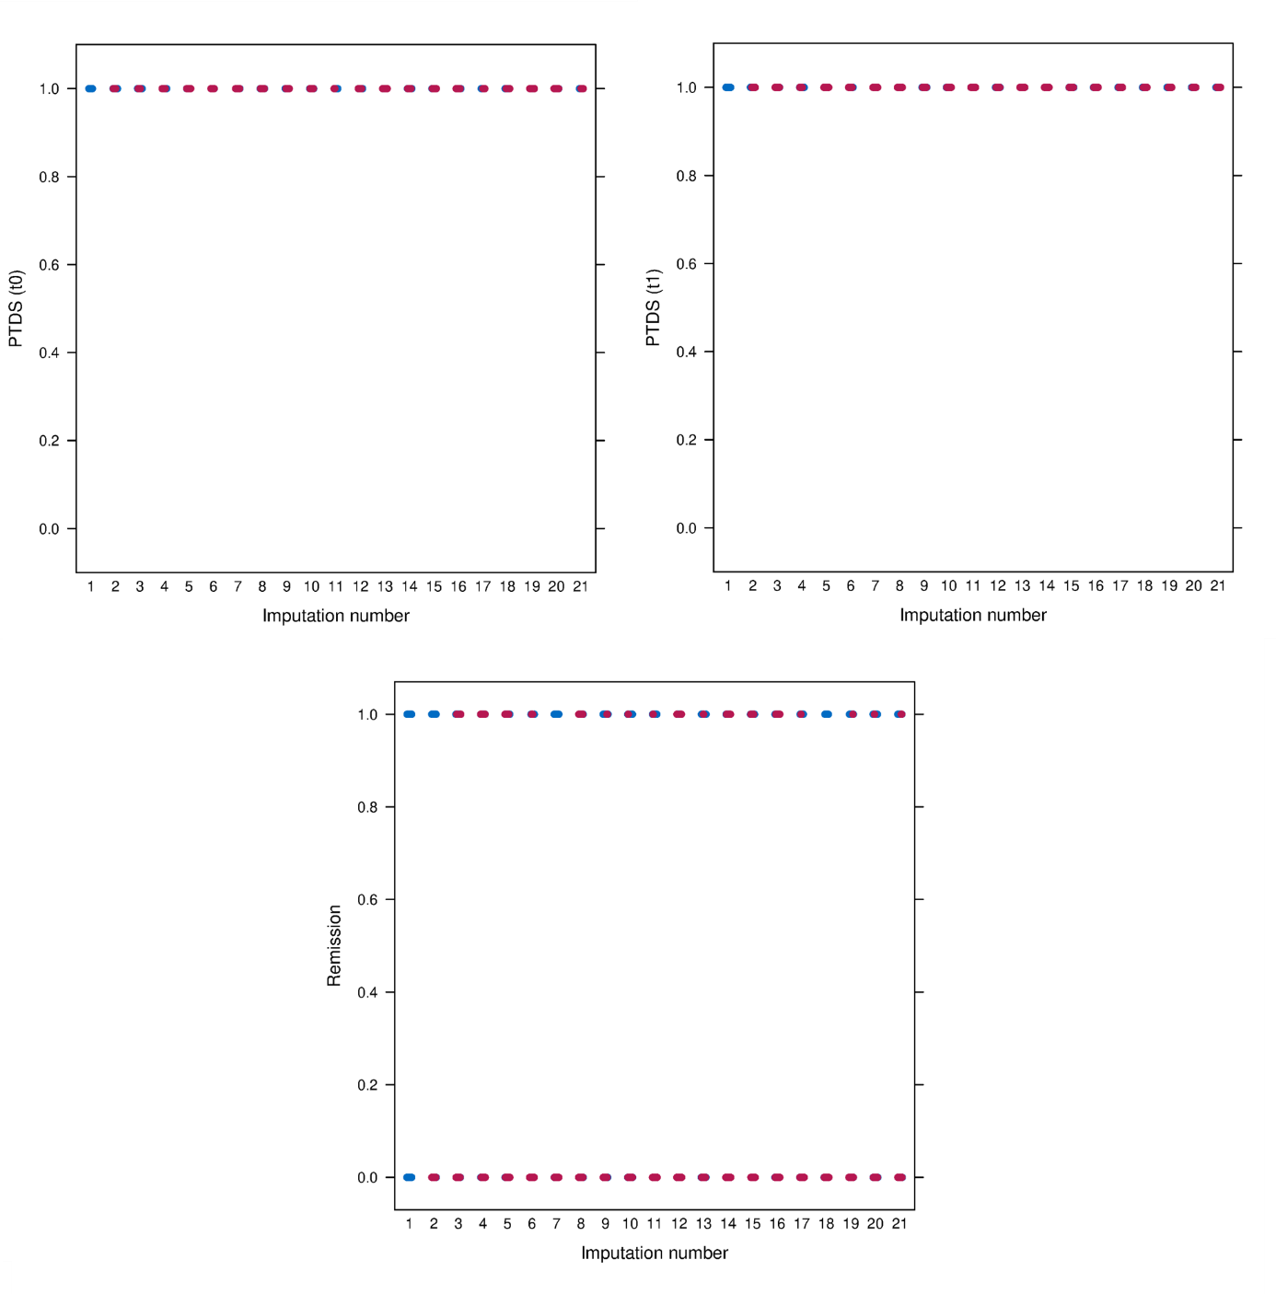
Additional Figure A9. Original (imputation number 1) and the imputed data sets (dyad population) for post-traumatic stress disorder (PTSD) and remission (imputation numbers 2 to 21). Note that results are based on those dyad members exhibiting PTSD symptoms at t0. Imputed values (red) and original values (blue) are provided for the pre- (t0) and post-treatment (t1) value as well as the change from t0 to t1.

