Interpretable Evolutionary Learning for Personalized Risk Prediction of Postoperative Infection after Liver Resection

Methods

Infection Characteristics of the Study Cohort
Infection sites of the study cohort included the intra-abdominal region, biliary tract, pulmonary system, pleural cavity, urinary tract, surgical site, and bloodstream. Infections were diagnosed through relevant imaging (chest X-rays or CT scans) or positive cultures from body fluids, including blood, bile, pleural effusion, or surgical wounds. Major clinical complications, such as liver failure and bile leakage, were assessed using standardized criteria, including the "50-50" criteria (Balzan et al) [1] and the International Study Group of Liver Surgery (ISGLS) definitions [2]. Postoperative morbidity and mortality were assessed using the Clavien-Dindo classification [3] within 90 days after surgery.
Liver resections were performed using either open or laparoscopic techniques, with tissue-fracture or energy devices used for transection. Laparoscopic resections were completed in 316 cases (40.25%). Intraoperative inflow occlusion methods, such as hemihepatic vascular occlusion or the Pringle maneuver, were utilized in most cases. After surgery, patients were carefully monitored for signs of infection, fever, and other complications. A routine diagnostic workup for POI, including chest radiography and cultures from various sites, was conducted selectively based on clinical presentation. Among the 785 cases, POI occurred in 116 patients (14.78%), while 669 patients (85.22%) did not develop the condition. The infection rates varied across different anatomical sites, with the intra-abdominal region being the most common (37.06%), biliary tract (9.48%), pulmonary (19.80%), pleural cavity (16.37%), urinary tract (17.24%), surgical site (12.93%), and bloodstream (8.62%).

EL-PIRLR Performance Evaluation
A novel statistical approach was applied to evaluate the impact of missing values on prediction outcomes. Initially, we selected key features from the training set using IBCGA. The detailed process is illustrated in Figure 2. Subsequently, we determined the corresponding missing values in the test set and categorized them into subsets according to the number of missing values. This methodology provided valuable insights into how these key missing values influence EL-PIRLR performance. The detailed results are summarized in Table S3, highlighting the importance of complete data for optimizing prediction accuracy.

Supplemental Tables
Table S1. Distribution and criteria of infection sites among 116 patients.
Infection site | n (%) | Criteria for postoperative infection
Intraabdominal | 43 (37.06) | Clinical evidence of IAI ± bacterial culture (+)
Biliary tract | 11 (9.48) | Clinical evidence of BTI ± bacterial culture (+)
Pulmonary | 23 (19.8) | Clinical evidence of pulmonary infection
Pleural cavity | 19 (16.37) | Bacteria culture (+) in pleural effusion
Urinary tract | 20 (17.24) | Clinical evidence of UTI ± bacterial culture (+)
Surgical site | 15 (12.93) | Purulent discharge from the incision or surgical space ± bacterial culture (+)
Bloodstream | 10 (8.62) | Bacteria culture (+) in bloodstream
Abbreviations: IAI, Intra-abdominal infection; BTI, Biliary tract infection; UTI, Urinary tract infection

Table S2. Data distribution and statistical significance of the 28 identified features of EL-PIRLR.
Rank | Feature name | Feature description | MED | P-value
1 | Fever_Score | Postoperative fever pattern within three days (0-3): 0 points for no fever, 1 point for fever on the first two days but not the third, 2 points for fever on all three days, and 3 points for fever only on the third day. | 0.045 | 1.189×10⁻¹³
2 | Body_Temp_Over38-III | Fever on postoperative day three (>38°C). | 0.043 | 2.468×10⁻¹⁴
3 | Body_Temp-I | Postoperative day one body temperature. | 0.035 | 0.004
4 | IMM | Institut Mutualiste Montsouris Classification (1~3) | 0.029 | 6.142×10⁻⁷
5 | CCI | Charlson Comorbidity Index | 0.028 | 0.007
6 | NLR-Pre_ln | Preoperative NLR (log-transformed). | 0.023 | 0.591
7 | IV_Op | Intravenous fluid intake on the day of surgery. | 0.021 | 1.375×10⁻⁵
8 | Drain Volume-II | Drainage output on postoperative day two. | 0.019 | 2.237×10⁻⁷
9 | INR-I | Postoperative day one INR. | 0.014 | 0.052
10 | FEV1-Pre | Preoperative FEV1 | 0.011 | 0.017
11 | ALT-I | Postoperative day one ALT | 0.011 | 0.328
12 | Fluid_Balance-III | Fluid balance (intake-output difference) on postoperative day three. | 0.009 | 0.440
13 | Body_Weight | Body weight. | 0.009 | 0.953
14 | CHF | Congestive heart failure (Positive: 1, Negative: 0) | 0.007 | 0.879
15 | FluidIntake-Op | Intraoperative fluid intake. | 0.007 | 3.576×10⁻⁵
16 | INR-Pre | Preoperative INR | 0.007 | 0.016
17 | Cr-I | Postoperative day one Cr level | 0.007 | 0.132
18 | GGT-Pre_ln | Preoperative GGT (log-transformed) | 0.007 | 0.004
19 | Vomiting_Volume-III | Postoperative day three vomiting volume. | 0.001 | 0.001
20 | GGT-I | Postoperative day one GGT | 0.001 | 0.012
21 | Infection_Point | Each for one point (0~4): fever on postoperative day one and two, fever on postoperative day three, leukocytosis on postoperative day four, and multiple fever peaks. | 0.001 | 3.741×10⁻¹⁵
22 | Creatinine-Pre | Preoperative Cr level | -0.003 | 0.609
23 | FEV1/FVC_Ratio | FEV1/FVC ratio. | -0.005 | 0.796
24 | Oral_Intake-Op | Oral intake on the day of surgery. | -0.006 | 0.068
25 | INR-Pre_ln | Preoperative INR (log-transformed). | -0.009 | 0.016
26 | Seg-I_ln | Postoperative day one polymorphonuclear leukocyte ratio. | -0.015 | 0.533
27 | Cirrhosis | Liver cirrhosis (Positive: 1, Negative: 0). | -0.029 | 0.100
28 | Output_Volume-Op_ln | Urine output on the day of surgery. | -0.029 | 1.805×10⁻⁴
Note: P-value refers to the univariate analysis results between the infected and non-infected groups. Abbreviations: MED, main effect difference, the larger the score, the greater the contribution to the prediction accuracy of the feature; NLR, Neutrophil to Lymphocyte Ratio; INR, International Normalized Ratio; FEV1, forced expiratory volume in one second; ALT, alanine transaminase; CHF, congestive heart failure; Cr, creatinine; GGT, gamma-glutamyl transpeptidase; FVC, forced vital capacity. The suffix '-Pre' represents preoperative features, while a numerical suffix (e.g., '-I', '-II', '-III') indicates measurements taken on the corresponding postoperative day. The suffix 'Op' denotes features measured on the day of surgery, and '_ln' signifies that the feature has been log-transformed.

Table S3. EL-PIRLR performance on the test subsets with different numbers of missing values based on the identified features.
Number of missing values | ACC | AUC | MCC | Infection case | Non-infection case | Total case number
0 | 0.88 | 0.89 | 0.46 | 8 | 96 | 104
1 | 0.80 | 0.82 | 0.26 | 11 | 45 | 56
2 | 0.71 | 0.61 | 0.09 | 15 | 48 | 63
3 | 1.00 | - | - | 0 | 11 | 11
Note: For cases with three missing values, the dataset included only non-infection patients (n = 11), resulting in an accuracy of 100%. However, the absence of infection cases in this subgroup precluded the calculation of AUC and MCC values. Abbreviations: ACC, accuracy; AUC, the area under the receiver operating characteristic curve; MCC, Matthews correlation coefficient.

Supplemental Figures
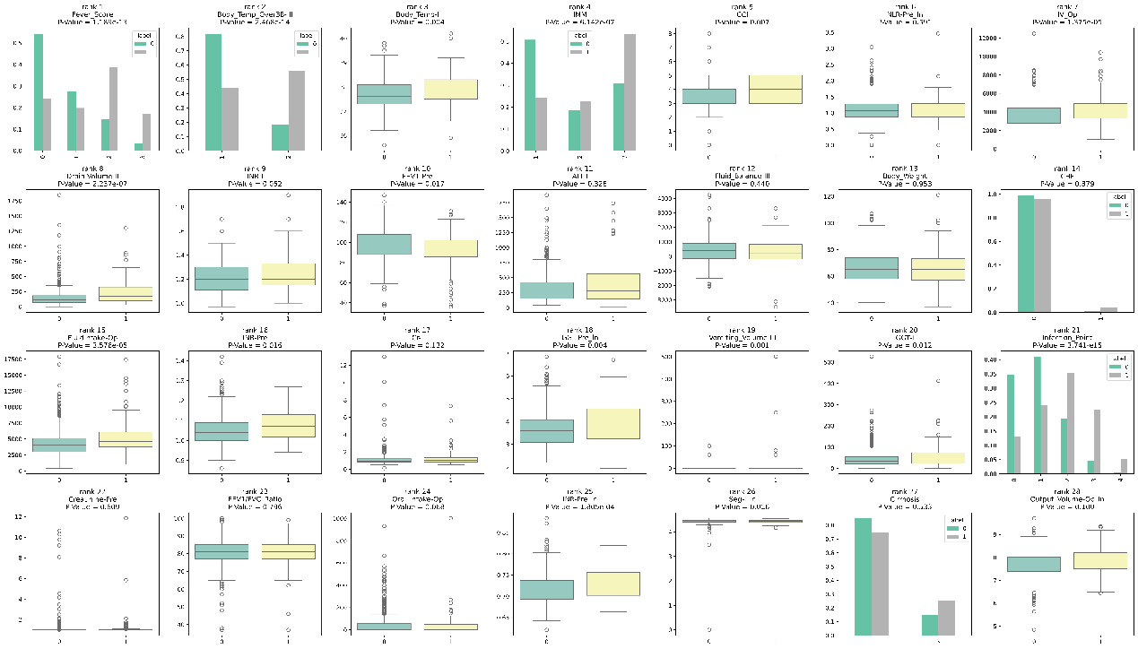
Figure S1
The distribution of the 28 selected features across infection and non-infection patients, with each feature's main effect difference (MED) rank and univariate statistical significance evaluated across the entire dataset.

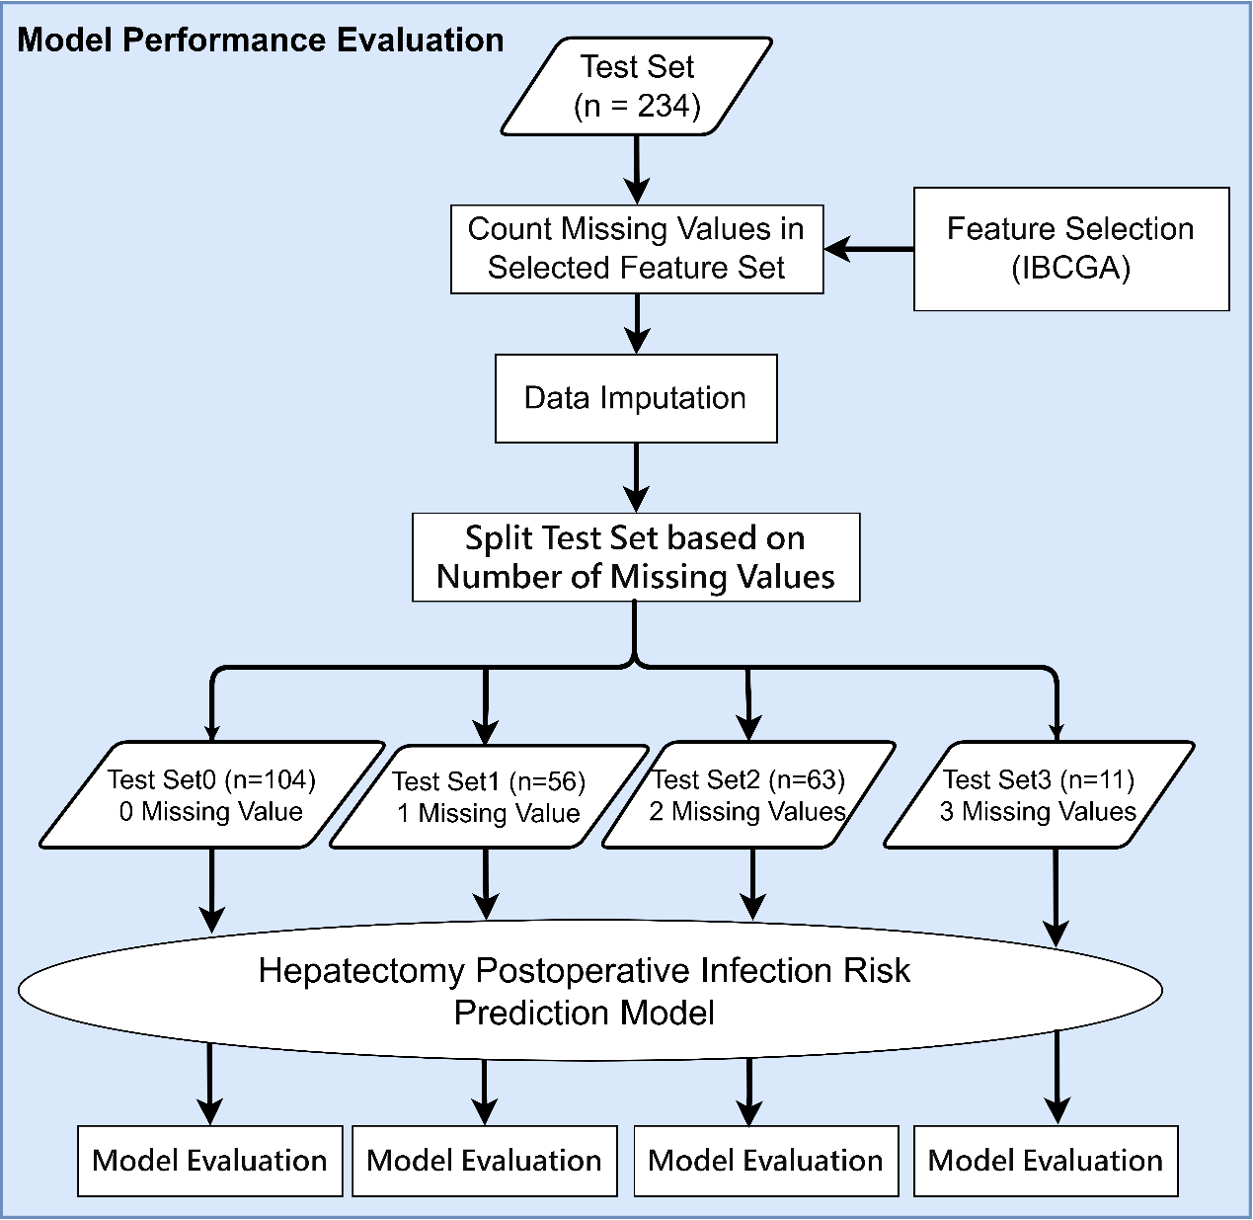
Figure S2
Flowchart of the proposed EL-PIRLR performance evaluation method based on the number of missing values in the independent test set.

References
1. Balzan, S., J. Belghiti, O. Farges, et al. The “50-50 criteria” on postoperative day 5: an accurate predictor of liver failure and death after hepatectomy. Annals of Surgery 242 (2005) 824-829.
2. Rahbari, N. N., O. J. Garden, R. Padbury, et al. Posthepatectomy liver failure: a definition and grading by the International Study Group of Liver Surgery (ISGLS). Surgery 149 (2011) 713-724.
3. Dindo, D., N. Demartines and P. A. Clavien. Classification of surgical complications: a new proposal with evaluation in a cohort of 6336 patients and results of a survey. Ann Surg 240 (2004) 205-213.

