Supplementary material
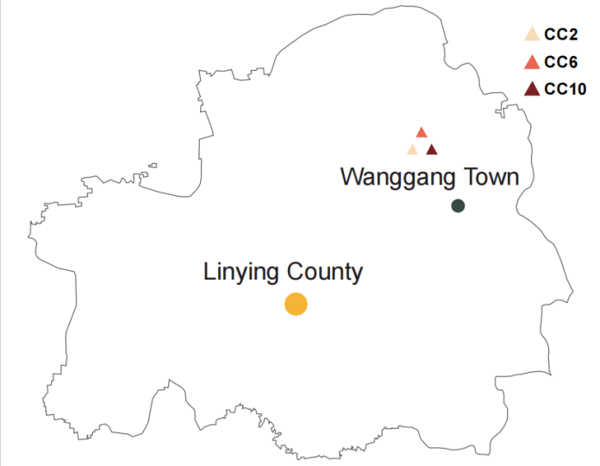
Fig. S1 Soil samples were collected from three different plots in Luohe City, Linying County, Wanggang Town, Henan Province (33°48’54’’N, 113°58’05’’E; central China) CC2: 2 years of continuous cropping; CC6: 6 years of continuous cropping; CC10: 10 years of continuous cropping.

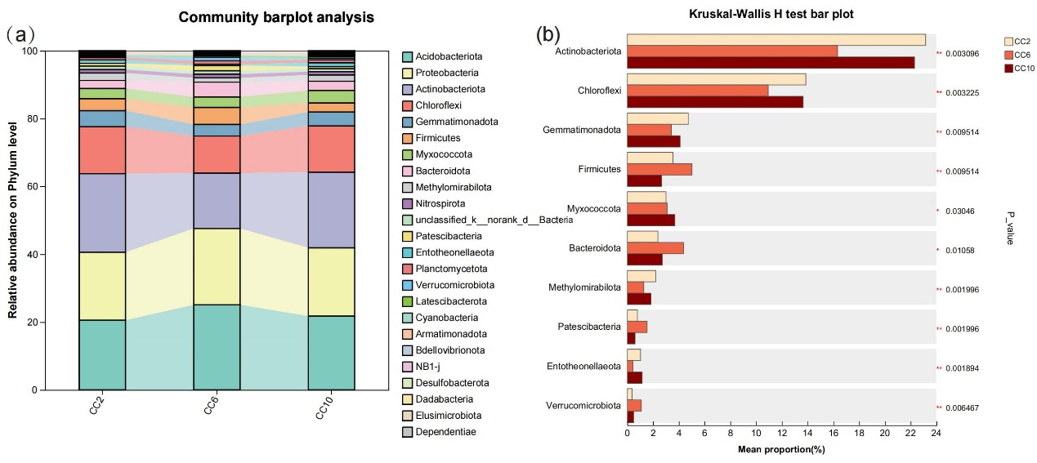

Fig. S2 (a) Stacked bar plot depicting the relative abundances (%) of the major phyla present in the bacterial communities. (b) The vertical axis represents the species names at the phylum level, and the horizontal axis represents the percentage value of the abundance of a certain species in the sample. Different colors indicate different groups. The values on the far right are P values: * 0.01 < P ≤ 0.05, ** 0.001 < P ≤ 0.01, *** P ≤ 0.001

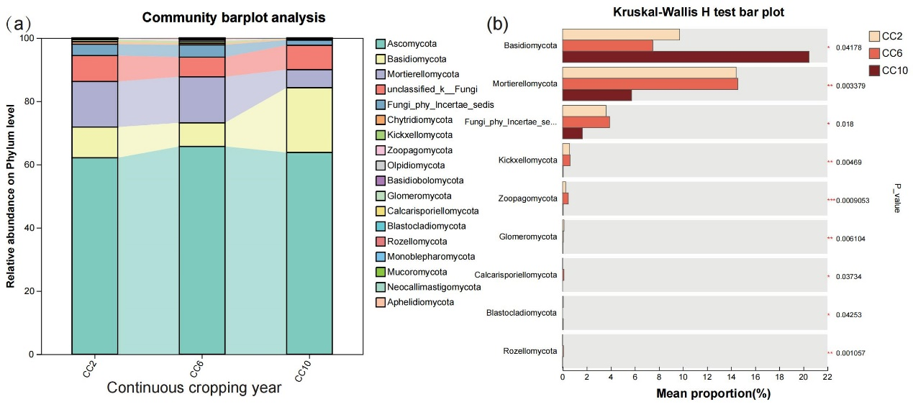
Fig. S3 (a) Stacked bar plot depicting the relative abundances (%) of the major phyla present in the fungal communities. (b) The vertical axis represents the species names at the phylum level, and the horizontal axis represents the percentage value of the abundance of a certain species in the sample. Different colors indicate different groups. The values on the far right are P values: * 0.01 < P ≤ 0.05, ** 0.001 < P ≤ 0.01, *** P ≤ 0.001

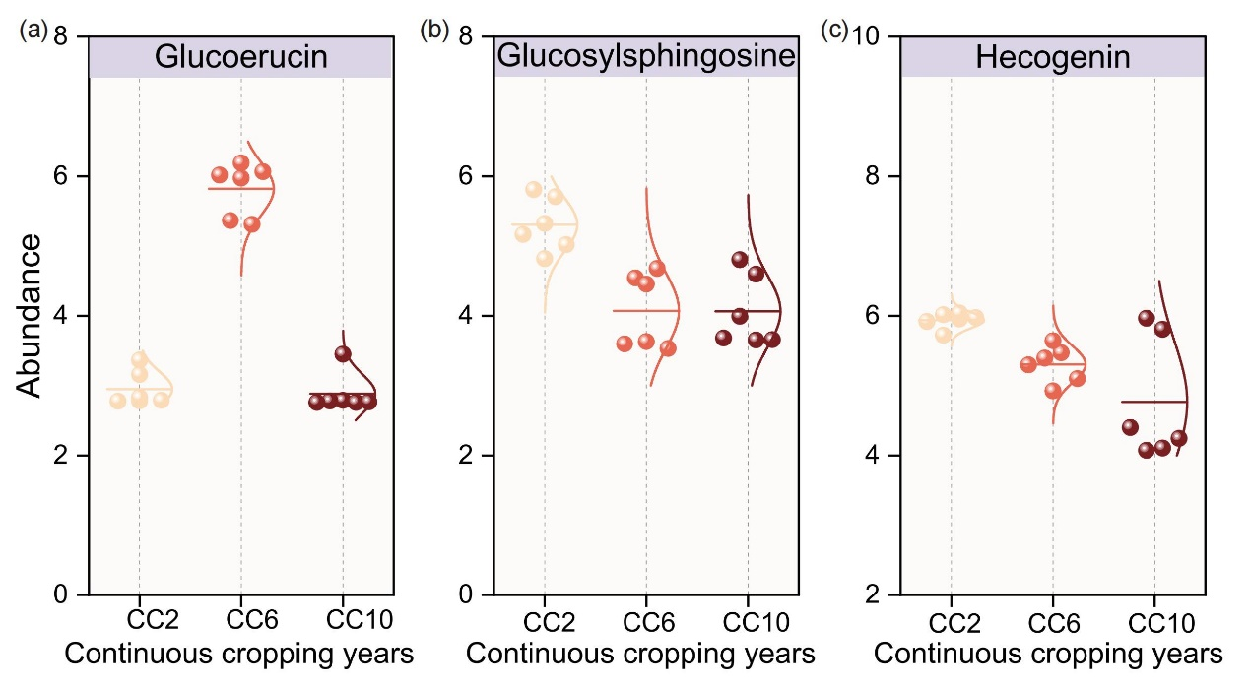
Fig. S4 Contents of the crucial differential metabolites: (a) glucoerucin, (b) glucosylsphingosine, and (c) hecogenin under different continuous cropping durations.

Table S1 PERMANOVA (analysis of variance based on distance matrices) performed using the “adonis” function in the R package vegan (version 2.6-4). Bray–Curtis dissimilarity matrices of bacterial ASV data used to assess differences in soil microbial communities across continuous cropping durations (CC2, CC6, CC10). Significance levels: ***P < 0.001, **P < 0.01, *P < 0.05. R² represents the proportion of variance explained by each factor.
Group | Source | Df | SumOfSqs | R2 | F | Pr(>F) | Significance level
CC2_vs_CC6 | Model | 1 | 0.79112 | 0.6362 | 17.488 | 0.003 | **
CC2_vs_CC6 | Residual | 10 | 0.45239 | 0.3638
CC2_vs_CC6 | Total | 11 | 1.24351 | 1.0000
CC2_vs_CC10 | Model | 1 | 0.13460 | 0.26133 | 3.5379 | 0.004 | **
CC2_vs_CC10 | Residual | 10 | 0.38046 | 0.73867
CC2_vs_CC10 | Total | 11 | 0.51506 | 1.0000
CC6_vs_CC10 | Model | 1 | 0.83519 | 0.67498 | 20.768 | 0.003 | **
CC6_vs_CC10 | Residual | 10 | 0.40216 | 0.32502
CC6_vs_CC10 | Total | 11 | 1.23735 | 1.0000

Table S2 Bray–Curtis dissimilarity matrices of fungal ASV data used to assess differences in soil microbial communities across continuous cropping durations (CC2, CC6, CC10). Significance levels: ***P < 0.001, **P < 0.01, *P < 0.05. R² represents the proportion of variance explained by each factor.
Group | Source | Df | SumOfSqs | R² | F | Pr(>F) | Significance level
CC2_vs_CC6 | Model | 1 | 0.61178 | 0.43858 | 7.8121 | 0.003 | **
CC2_vs_CC6 | Residual | 10 | 0.78312 | 0.56142
CC2_vs_CC6 | Total | 11 | 1.39491 | 1.0000
CC2_vs_CC10 | Model | 1 | 0.48424 | 0.38809 | 6.3424 | 0.004 | **
CC2_vs_CC10 | Residual | 10 | 0.7635 | 0.61191
CC2_vs_CC10 | Total | 11 | 1.24775 | 1.0000
CC6_vs_CC10 | Model | 1 | 0.72377 | 0.46562 | 8.7132 | 0.003 | **
CC6_vs_CC10 | Residual | 10 | 0.83066 | 0.53438
CC6_vs_CC10 | Total | 11 | 1.55443 | 1.0000

