SUPPLEMENTAL MATERIAL
Twenty-Year Temporal Trends in Sarcopenic Obesity and Mortality Risk: The Evolving Landscape of Body Composition in US Adults

Table of contents
Table S1. The prevalence of sarcopenic obesity among different subgroups.
Table S2. The association between sarcopenic obesity and risk of all-cause mortality in subgroups
Table S3. The association between sarcopenic obesity and risk of cause-specific mortality in subgroups
Fig S1. Flow chart of the participants in the current analysis
Fig S2. Trends in body composition indices by race and ethnicity in US Adults
Fig S3. Trends in body composition indices by age in US Adults
Fig S4. Association of body composition indices with cardiovascular mortality
Fig S5. Association of body composition indices with cancer mortality

Table S1. The prevalence of sarcopenic obesity among different subgroups.*
Parameters | 1999-2000 | 2001-2002 | 2003-2004 | 2005-2006 | 2011-2012 | 2013-2014 | 2015-2016 | 2017-2018
Fat mass-Fat-free mass ratio
Sex
Males | 6.4 (5.3,7.8) | 6.0 (4.8,7.6) | 6.4 (5.5,7.3) | 6.9 (5.5,8.5) | 6.0 (4.1,8.6) | 5.9 (4.0,8.6) | 6.6 (4.8,9.0) | 7.2 (5.2,9.8)
Females | 6.0 (4.9,7.2) | 5.6 (4.5,7.0) | 6.4 (4.7,8.6) | 5.1 (3.5,7.3) | 1.9 (1.2,3.0) | 2.6 (1.9,3.6) | 2.2 (1.4,3.7) | 2.7 (1.7,4.1)
Age groups
<40 years | 6.6 (5.2,8.4) | 6.3 (4.9,8.1) | 7.4 (6.2,9.0) | 5.6 (4.3,7.1) | 4.4 (2.9,6.7) | 5.8 (4.1,8.1) | 5.5 (3.8,8.0) | 4.3 (3.0,6.3)
40-59 years | 5.7 (4.3,7.6) | 5.7 (4.4,7.3) | 5.9 (4.6,7.5) | 6.6 (5,8.7.0) | 3.2 (1.6,6.3) | 2.7 (1.8,4.1) | 3.2 (1.9,5.1) | 4.1 (2.5,6.5)
≥60 years † | 6.2 (4.8,8.0) | 5.3 (4.1,6.8) | 5.3 (4.6,6.1) | 5.4 (3.2,9.0) | NA | NA | NA | NA
Race and ethnicity
Non-Hispanic White | 5.8 (4.4,7.6) | 5.4 (3.6,8.1) | 5.3 (4.0,7.0) | 6.1 (4.0,9.2) | 5.7 (3,10.6) | 4.1 (1.9,8.4) | 5.6 (3.3,9.3) | 5.6 (3.2,9.7)
Non-Hispanic Black | 6.1 (5.1,7.1) | 5.9 (4.8,7.3) | 6.7 (5.7,7.8) | 6.1 (4.7,7.9) | 3.5 (2.3,5.4) | 5.2 (3.4,8.0) | 4.4 (3.1,6.2) | 5.2 (3.8,6.9)
Hispanic | 6.5 (5.3,8) | 5.6 (4.2,7.3) | 6.8 (5.2,8.9) | 6.5 (4.3,9.8) | 5.7 (4.0,8.3) | 2.3 (1.5,3.5) | 4.0 (2.7,6.0) | 4.1 (2.0,8.3)
Non-Hispanic Asian † | NA | NA | NA | NA | 0.5 (0.1,2.0) | 0.5 (0.1,1.7) | 1.2 (0.5,3.0) | 2.3 (1.2,4.3)
Trunk fat mass-Appendicular muscle mass ratio
Gender
Males | 6.8 (5.0,9.1) | 5.5 (4.3,7.2) | 5.7 (4.8,6.7) | 7.5 (6.1,9.3) | 4.5 (3.1,6.6) | 5.4 (4.1,7.2) | 5.9 (4.2,8.2) | 4.5 (2.9,7.0)
Females | 5.6 (4.3,7.4) | 5.3 (4.2,6.7) | 5.7 (4.5,7.2) | 6.0 (4.8,7.5) | 1.6 (1.0,2.6) | 3.6 (2.8,4.7) | 2.7 (1.6,4.3) | 2.5 (1.6,3.9)
Age groups
<40 years | 6.1 (4.5,8.1) | 5.5 (4.0.3,7) | 7.0 (6.0,8.1) | 6.2 (5.0,7.6) | 3.8 (2.6,5.5) | 5.3 (3.9,7.1) | 5.9 (4.5,7.7) | 4.1 (2.6,6.3)
40-59 years | 6.5 (4.3,9.9) | 4.7 (3.3,6.7) | 5.1 (3.6,7.0) | 7.3 (5.7,9.2) | 2.6 (1.5,4.5) | 3.8 (2.8,5.1) | 2.4 (1.6,3.6) | 2.4 (1.2,4.7)
≥60 years † | 5.9 (4.8,7.3) | 6.3 (4.8,8.2) | 4.6 (3.6,5.7) | 6.9 (4.9,9.8) | NA | NA | NA | NA
Race and ethnicity
Non-Hispanic White | 8.4 (6.4,11) | 6.9 (5.3,9.0) | 9.0 (6.5,12.5) | 8.6 (6.1,12.1) | 5.7 (3.7,8.7) | 6.3 (3.9,10.1) | 7 (4.2,11.4) | 4.7 (2.6,8.5)
Non-Hispanic Black | 6.6 (5.2,8.4) | 5.8 (4.5,7.4) | 6.0 (5.0,7.1) | 7.4 (6.3,8.8) | 3.0 (1.9,4.9) | 5.4 (3.9,7.3) | 4.4 (3.3,6.0) | 4.3 (2.7,6.6)
Hispanic | 0.9 (0.5,1.5) | 1.5 (0.9,2.7) | 3.4 (2.3,5.0) | 3.0 (1.6,5.5) | 2.2 (1.2,3.8) | 1.2 (0.7,2.3) | 1.5 (0.7,2.9) | 1.5 (0.4,5.9)
Non-Hispanic Asian † | NA | NA | NA | NA | 0.5 (0.1,2.1) | 0.5 (0.1,2.0) | 1.7 (0.7,3.7) | 0.8 (0.3,2.1)

* The sarcopenic obesity was defined by fat-to-fat-free mass ratio or trunk fat-to-appendicular skeletal muscle mass ratio. All estimates were sex and age standardized to the 2000 US Census population, using the age groups 20 to 39 years, 40 to 59 years, and 60 or older.
† The 60 years and older category was not available after 2010 and the Non-Hispanic Asian category was not available before 2011 due to the survey design or thus estimates could not be presented separately.

Table S2. The association between sarcopenic obesity and risk of all-cause mortality in subgroups
Parameters | Fat mass-Fat-free mass ratio * |  |  | Trunk fat mass-Appendicular muscle mass ratio †
Parameters | HR (95%CI) | P value |  | HR (95%CI) | P value
Males
Non-SO | Ref |  |  | Ref
SO | 1.46(1.22,1.74) | <0.001 |  | 1.52(1.27,1.82) | <0.001
Females
Non-SO | Ref |  |  | Ref
SO | 1.12(0.91,1.36) | 0.278 |  | 1.55(1.30,1.85) | <0.001
<40 years
Non-SO | Ref |  |  | Ref
SO | 0.84(0.46,1.56) | 0.587 |  | 1.76(1.08,2.86) | 0.023
40-59 years
Non-SO | Ref |  |  | Ref
SO | 1.51(1.17,1.94) | 0.002 |  | 1.86(1.45,2.39) | <0.001
>=60 years
Non-SO | Ref |  |  | Ref
SO | 1.46(1.22,1.74) | 0.013 |  | 1.46(1.22,1.74) | <0.001
Non-Hispanic
Non-SO | Ref |  |  | Ref
SO | 1.53(1.14,2.05) | 0.005 |  | 1.64(1.29,2.09) | <0.001
Non-Hispanic White
Non-SO | Ref |  |  | Ref
SO | 1.23(1.04,1.47) | 0.019 |  | 1.41(1.21,1.65) | <0.001
Non-Hispanic Black
Non-SO | Ref |  |  | Ref
SO | 1.30(0.96,1.77) | 0.093 |  | 3.41(2.15,5.41) | <0.001
* According to the gender and age curves of fat-to-fat-free mass ratio, the group with a fat-to-fat-free mass ratio above the 95th centile are considered as the sarcopenic obesity group.
† According to the gender and age curves of trunk fat-to-appendicular skeletal muscle mass ratio, the group with trunk fat-to-appendicular skeletal muscle mass ratio above the 95th centile is considered as the sarcopenic obesity group.
Model adjusted for age, sex, height, race/ethnicity, education level, race and ethnicity, education, family income-to-poverty ratio, home ownership, type of health insurance, high-density lipoprotein cholesterol, and total cholesterol, if not already stratified.
SO: sarcopenic obesity.
Table S3. The association between sarcopenic obesity and risk of cause-specific mortality in subgroups
Parameters | Fat mass-Fat-free mass ratio * |  |  | Trunk fat mass-Appendicular muscle mass ratio †
Parameters | HR (95%CI) | P value |  | HR (95%CI) | P value
Cardiovascular mortality
Males
Non-SO | Ref |  |  | Ref
SO | 1.88(1.39,2.55) | <0.001 |  | 1.69(1.21,2.36) | 0.002
Females
Non-SO | Ref |  |  | Ref
SO | 1.26(0.89,1.77) | 0.186 |  | 1.94(1.43,2.63) | <0.001
<40 years
Non-SO | Ref |  |  | Ref
SO | 0.6(0.14,2.49) | 0.478 |  | 2.46(1,6.02) | 0.049
40-59 years
Non-SO | Ref |  |  | Ref
SO | 2.22(1.42,3.47) | <0.001 |  | 2.87(1.82,4.52) | <0.001
>=60 years
Non-SO | Ref |  |  | Ref
SO | 1.45(1.1,1.9) | 0.007 |  | 1.52(1.16,2) | 0.003
Non-Hispanic
Non-SO | Ref |  |  | Ref
SO | 2.17(1.36,3.46) | 0.001 |  | 2.17(1.4,3.36) | 0.001
Non-Hispanic White
Non-SO | Ref |  |  | Ref
SO | 1.53(1.14,2.05) | 0.005 |  | 1.68(1.28,2.2) | <0.001
Non-Hispanic Black
Non-SO | Ref |  |  | Ref
SO | 1.22(0.67,2.2) | 0.513 |  | 3.26(1.19,8.92) | 0.022
Cancer mortality
Males
Non-SO | Ref |  |  | Ref
SO | 1.16(0.74,1.83) | 0.517 |  | 1.37(0.89,2.09) | 0.149
Females
Non-SO | Ref |  |  | Ref
SO | 1.17(0.76,1.8) | 0.485 |  | 2.02(1.39,2.95) | <0.001
<40 years
Non-SO | Ref |  |  | Ref
SO | 0.83(0.20,3.48) | 0.794 |  | 2.11(0.72,6.15) | 0.172
40-59 years
Non-SO | Ref |  |  | Ref
SO | 0.97(0.56,1.67) | 0.902 |  | 1.37(0.81,2.31) | 0.238
>=60 years
Non-SO | Ref |  |  | Ref
SO | 1.25(0.84,1.86) | 0.274 |  | 1.76(1.24,2.5) | 0.001
Non-Hispanic
Non-SO | Ref |  |  | Ref
SO | 1.10(0.54,2.25) | 0.792 |  | 1.49(0.86,2.56) | 0.152
Non-Hispanic White
Non-SO | Ref |  |  | Ref
SO | 1.03(0.67,1.58) | 0.902 |  | 1.56(1.1,2.23) | 0.013
Non-Hispanic Black
Non-SO | Ref |  |  | Ref
SO | 1.52(0.82,2.82) | 0.188 |  | 3.63(1.33,9.96) | 0.012
* According to the gender and age curves of fat-to-fat-free mass ratio, the group with fat-to-fat-free mass ratio above the 95th centile are considered as the sarcopenic obesity group.
† According to the gender and age curves of trunk fat-to-appendicular skeletal muscle mass ratio, the group with trunk fat-to-appendicular skeletal muscle mass ratio above the 95th centile is considered as the sarcopenic obesity group.
Model adjusted for age, sex, height, race/ethnicity, education level, race and ethnicity, education, family income-to-poverty ratio, home ownership, type of health insurance, high-density lipoprotein cholesterol, and total cholesterol, if not already stratified.
SO: sarcopenic obesity.

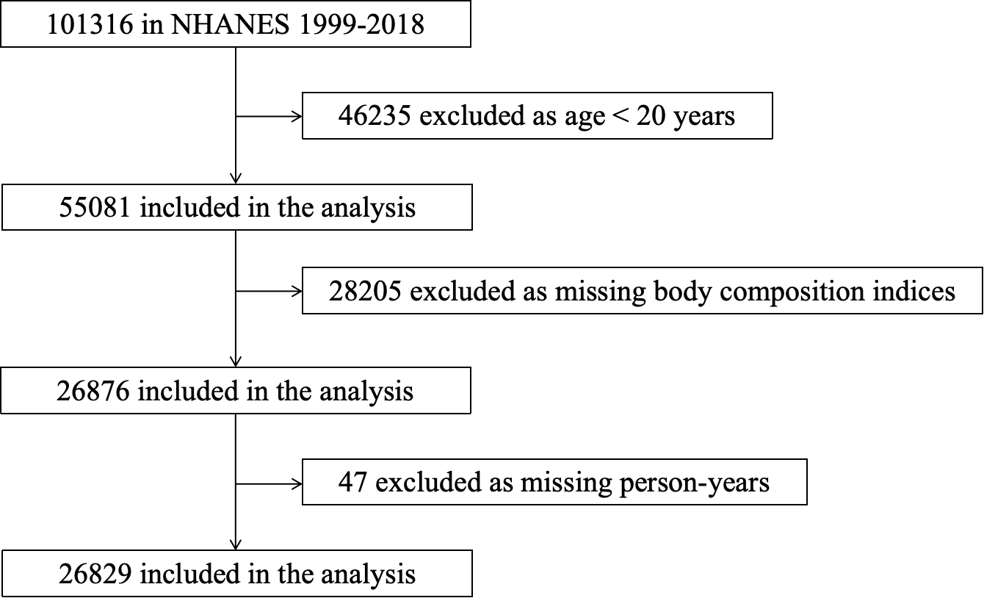

Fig S1 Flow chart of the participants in the current analysis
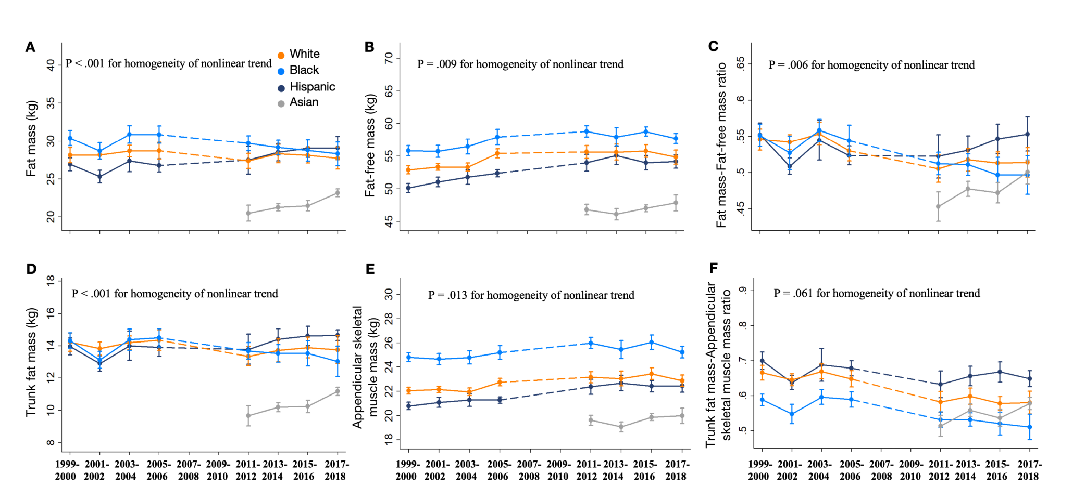
Fig S2 Trends in body composition indices by Race and Ethnicity in US Adults
(A) mean fat mass (P = .046, P = .001, P = .002, and P < .001 for linear trend in White, Black, Hispanic, and Asian individuals, respectively); (B) mean fat-free mass (all P < .001 for linear trend in White, Black and Hispanic); (C) mean fat mass to fat-free mass ratio (all P < .001 for linear trend in White and Black, and P = .003 for linear trend in Asian) ; (D) mean trunk fat mass (all P < .001 for linear trend in White, Black and Asian); (E)mean appendicular muscle mass (all P < .001 for linear trend in White, Black and Hispanic and P = .034 for linear trend in Asian); and (F) mean trunk fat mass to appendicular muscle mass ratio (all P < .001 for linear trend in White and Black, P = .046 for linear trend in Hispanic, and P = .004 for linear trend in Asian).
All estimates were standardized to the 2000 US Census population using 6 age and sex categories: males aged 20-39, 40-59, and ≥ 60 years and females aged 20-39, 40-59, and ≥ 60 years. Linear and polynomial models were used to test linear and nonlinear trends.
The homogeneity of trends among racial and ethnic subgroups was tested using an interaction term of time × race and ethnicity in the regression models.
Error bars indicate 95% CIs.
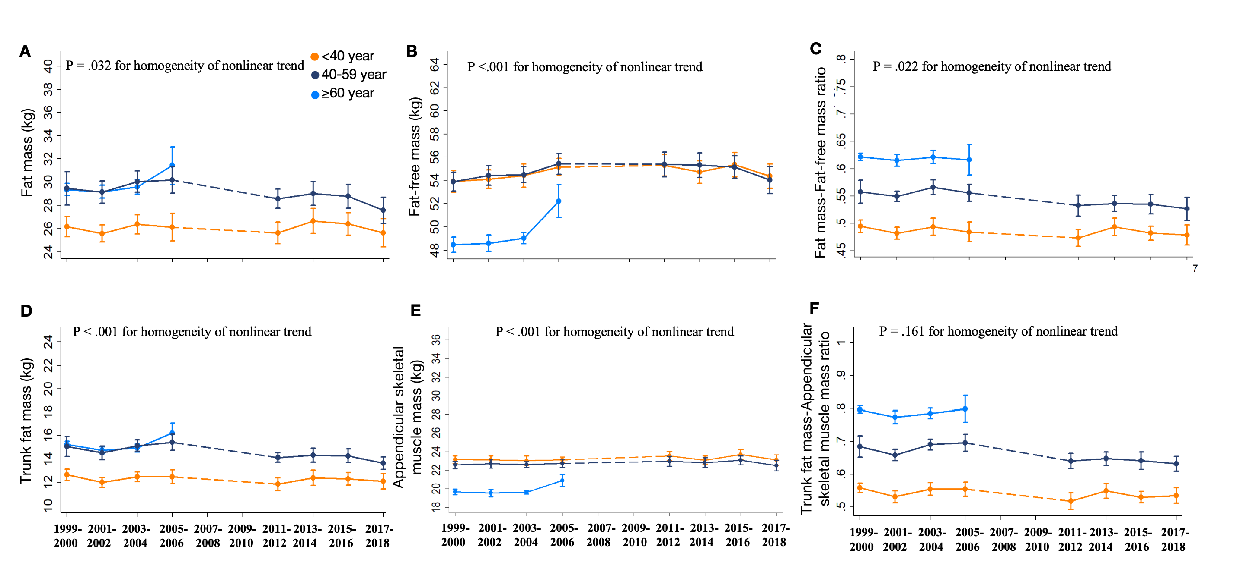
Fig S3 Trends in body composition indices by age in US Adults
(A) mean fat mass (P = .013 and P = .017 for linear trend in individuals with aged 40-59 years and ≥60 years, respectively); (B) mean fat- free mass (P < .001 for linear trend in group aged ≥60 years); (C) mean fat mass to fat- free mass ratio (P < .001 for linear trend in group aged 40-59 years) ; (D) mean trunk fat mass (P = .001 for linear trend in group aged 40-59 years); (E) mean appendicular muscle mass (P = .007 for linear trend in group aged ≥60 years) ; and (F) mean trunk fat mass to appendicular muscle mass ratio (P < .001 for linear trend in group aged 40-59 years).
All estimates were standardized to the 2000 US Census population using 6 age and sex categories: males aged 20-39, 40-59, and ≥ 60 years and females aged 20-39, 40-59, and ≥ 60 years. Linear and polynomial models were used to test linear and nonlinear trends.
The homogeneity of trends among age subgroups was tested using an interaction term of time ×age group in the regression models.
Error bars indicate 95% CIs.
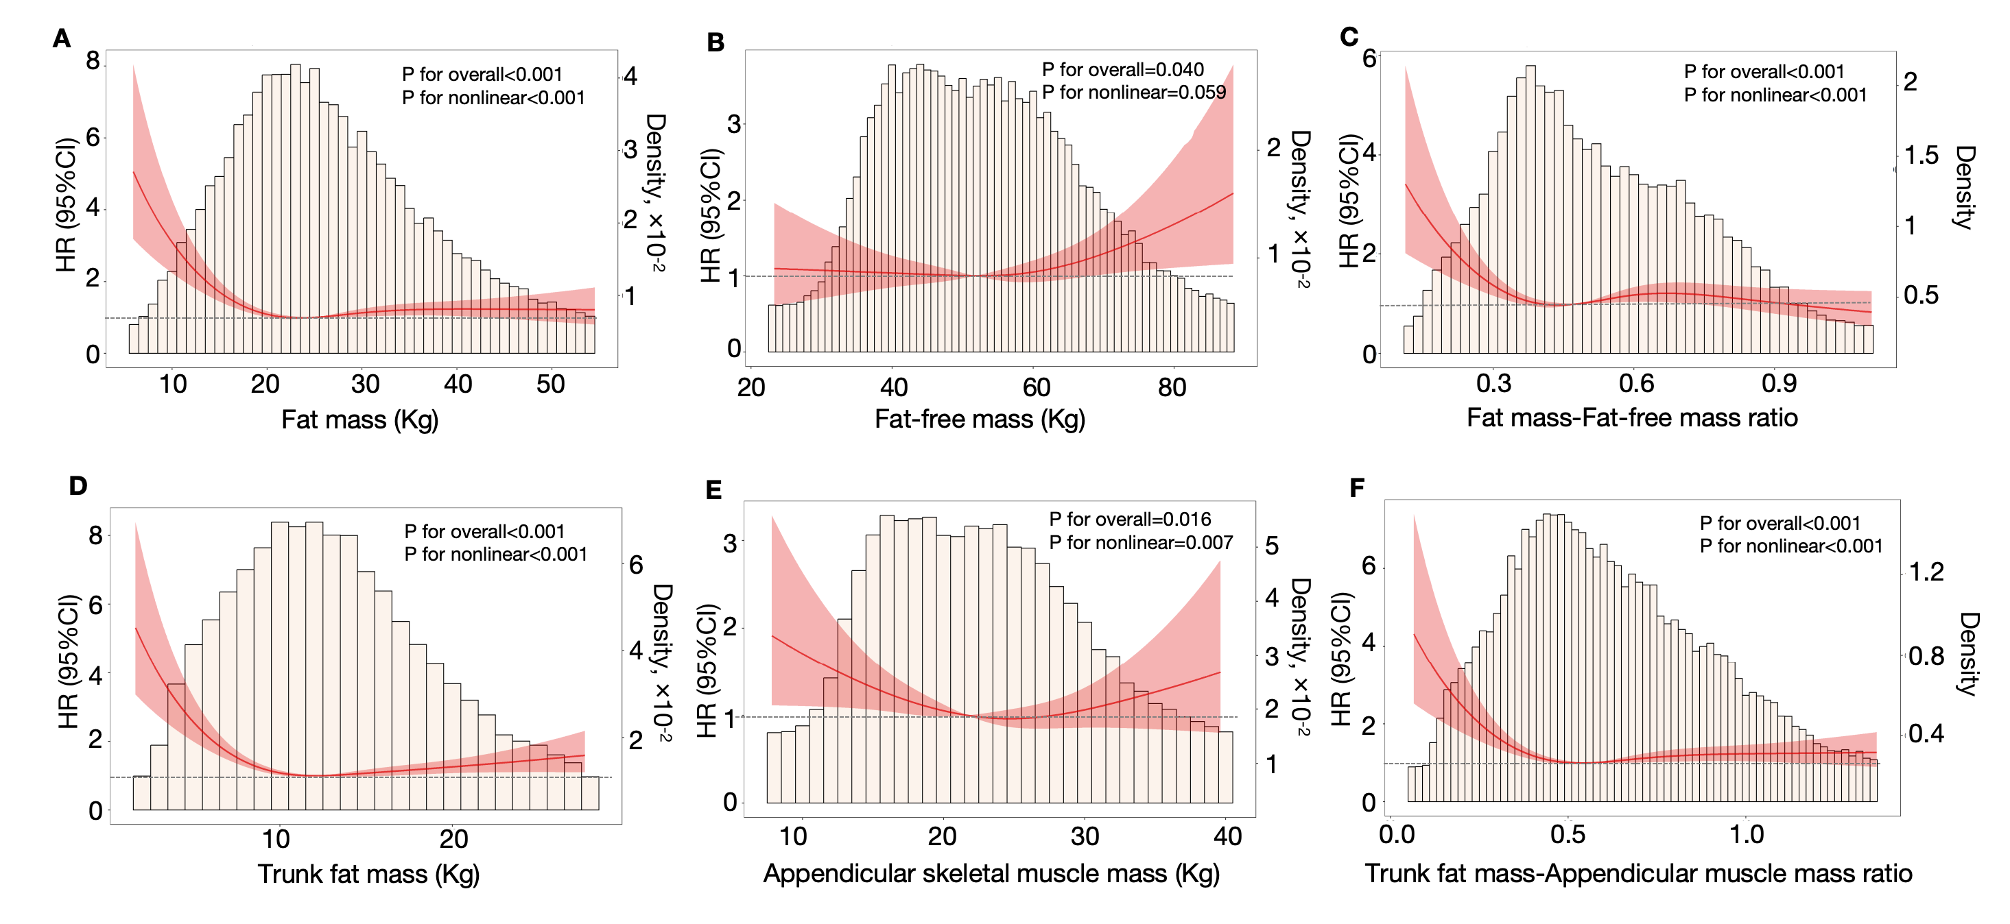
Fig S4 Association of body composition indices with cardiovascular mortality
Estimates adjusted for age, sex, height, race/ethnicity, education level, race and ethnicity, education, family income-to-poverty ratio, home ownership, type of health insurance, high-density lipoprotein cholesterol, and total cholesterol, and mutually adjusted for fat mass or free fat mass. HR=hazard ratio.
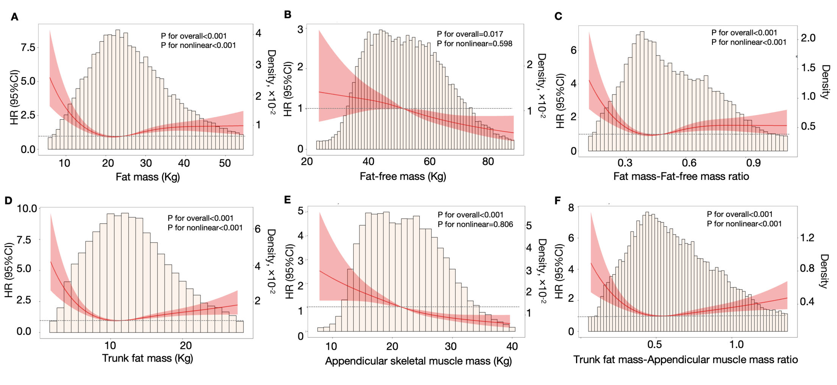
Fig S5 Association of body composition indices with cancer mortality
Estimates adjusted for age, sex, height, race/ethnicity, education level, race and ethnicity, education, family income-to-poverty ratio, home ownership, type of health insurance, high-density lipoprotein cholesterol, and total cholesterol, and mutually adjusted for fat mass or free fat mass. HR=hazard ratio.

