Supplemental Data

Tables
Association between LC and WDSM 2-9
Association between LC symptoms and WDSM 10-65
Association between Global Health Scores and WDSM 66-74
WDSM mean (SD) by Sleep Clusters 75
Figures
Association between LC and WDSM 76-77
Sensitivity analyses: Association between LC and WDSM 78-82
Heatmaps: Association between LC symptoms and WDSM 83-86
Association between LC symptoms and WDSM 87-100
Association between Global Health Scores and WDSM 101-102
Clustering Scree Plot 103
Criterion Profile Analysis 104-105
Stratified analyses: Association between LC and WDSM 106-108

Tables

Table S1. Association between Long COVID Research Index Status and WDSM (Model 1)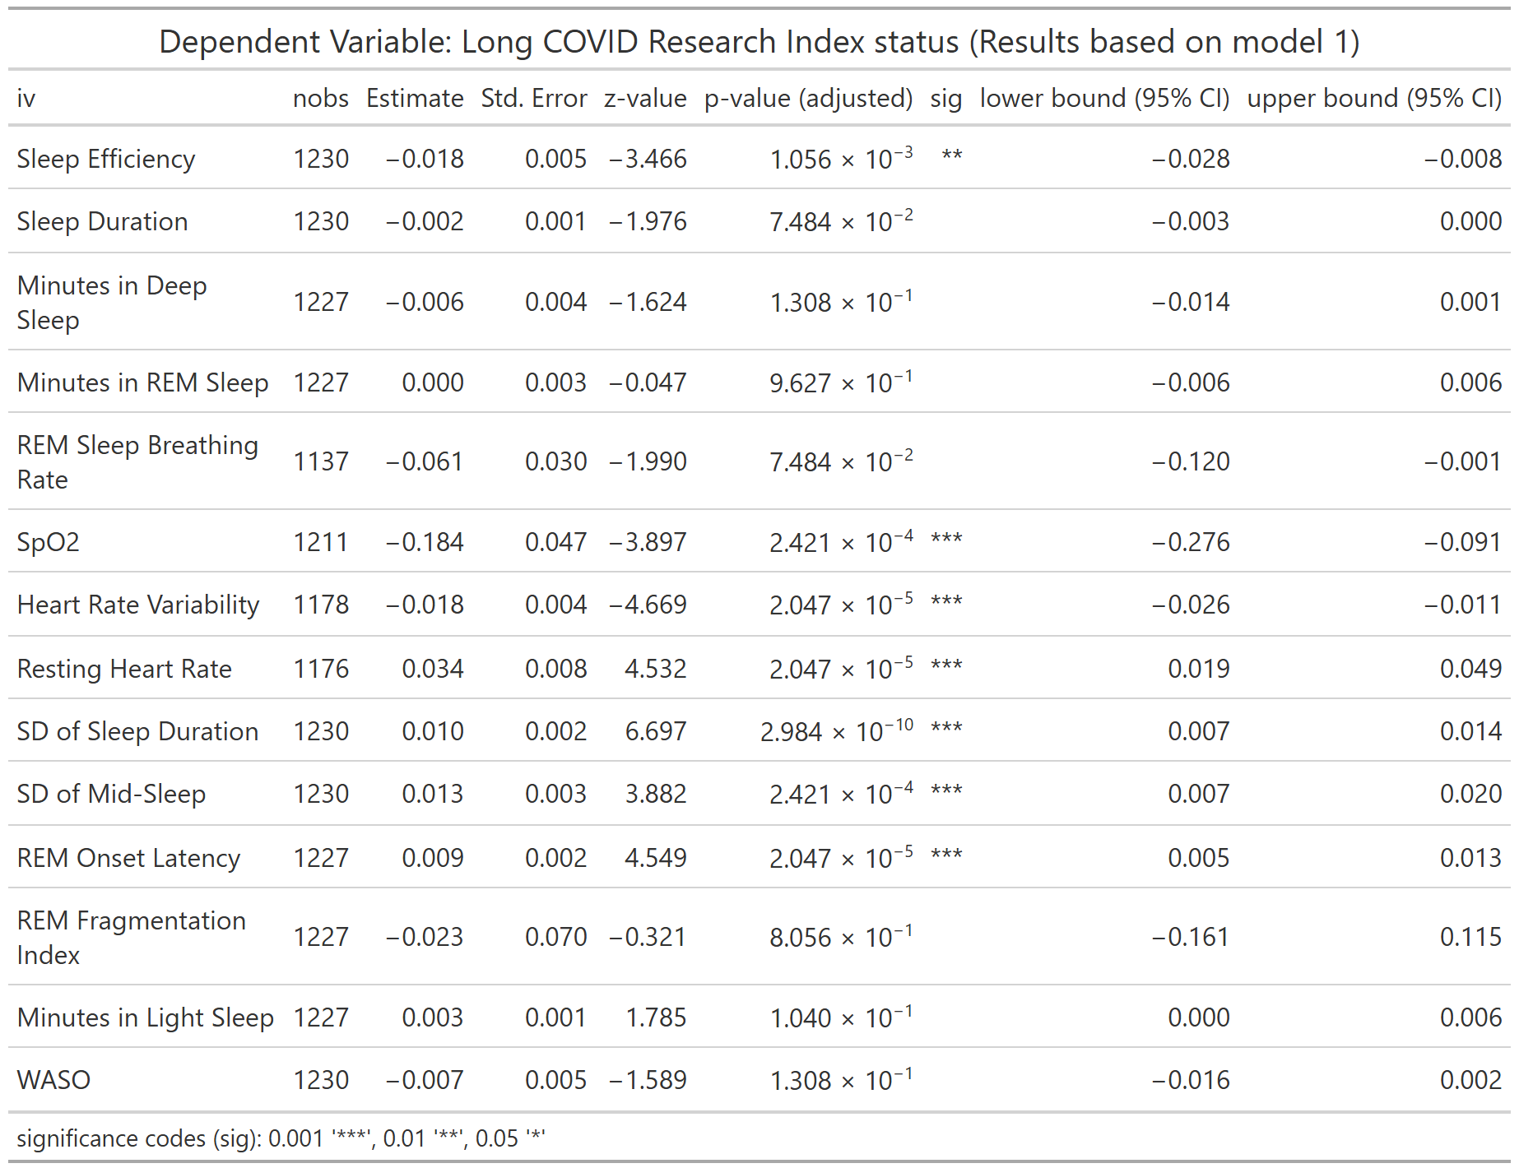
nobs = number of observations
Table S2. Association between Long COVID Research Index Status and WDSM (Model 2)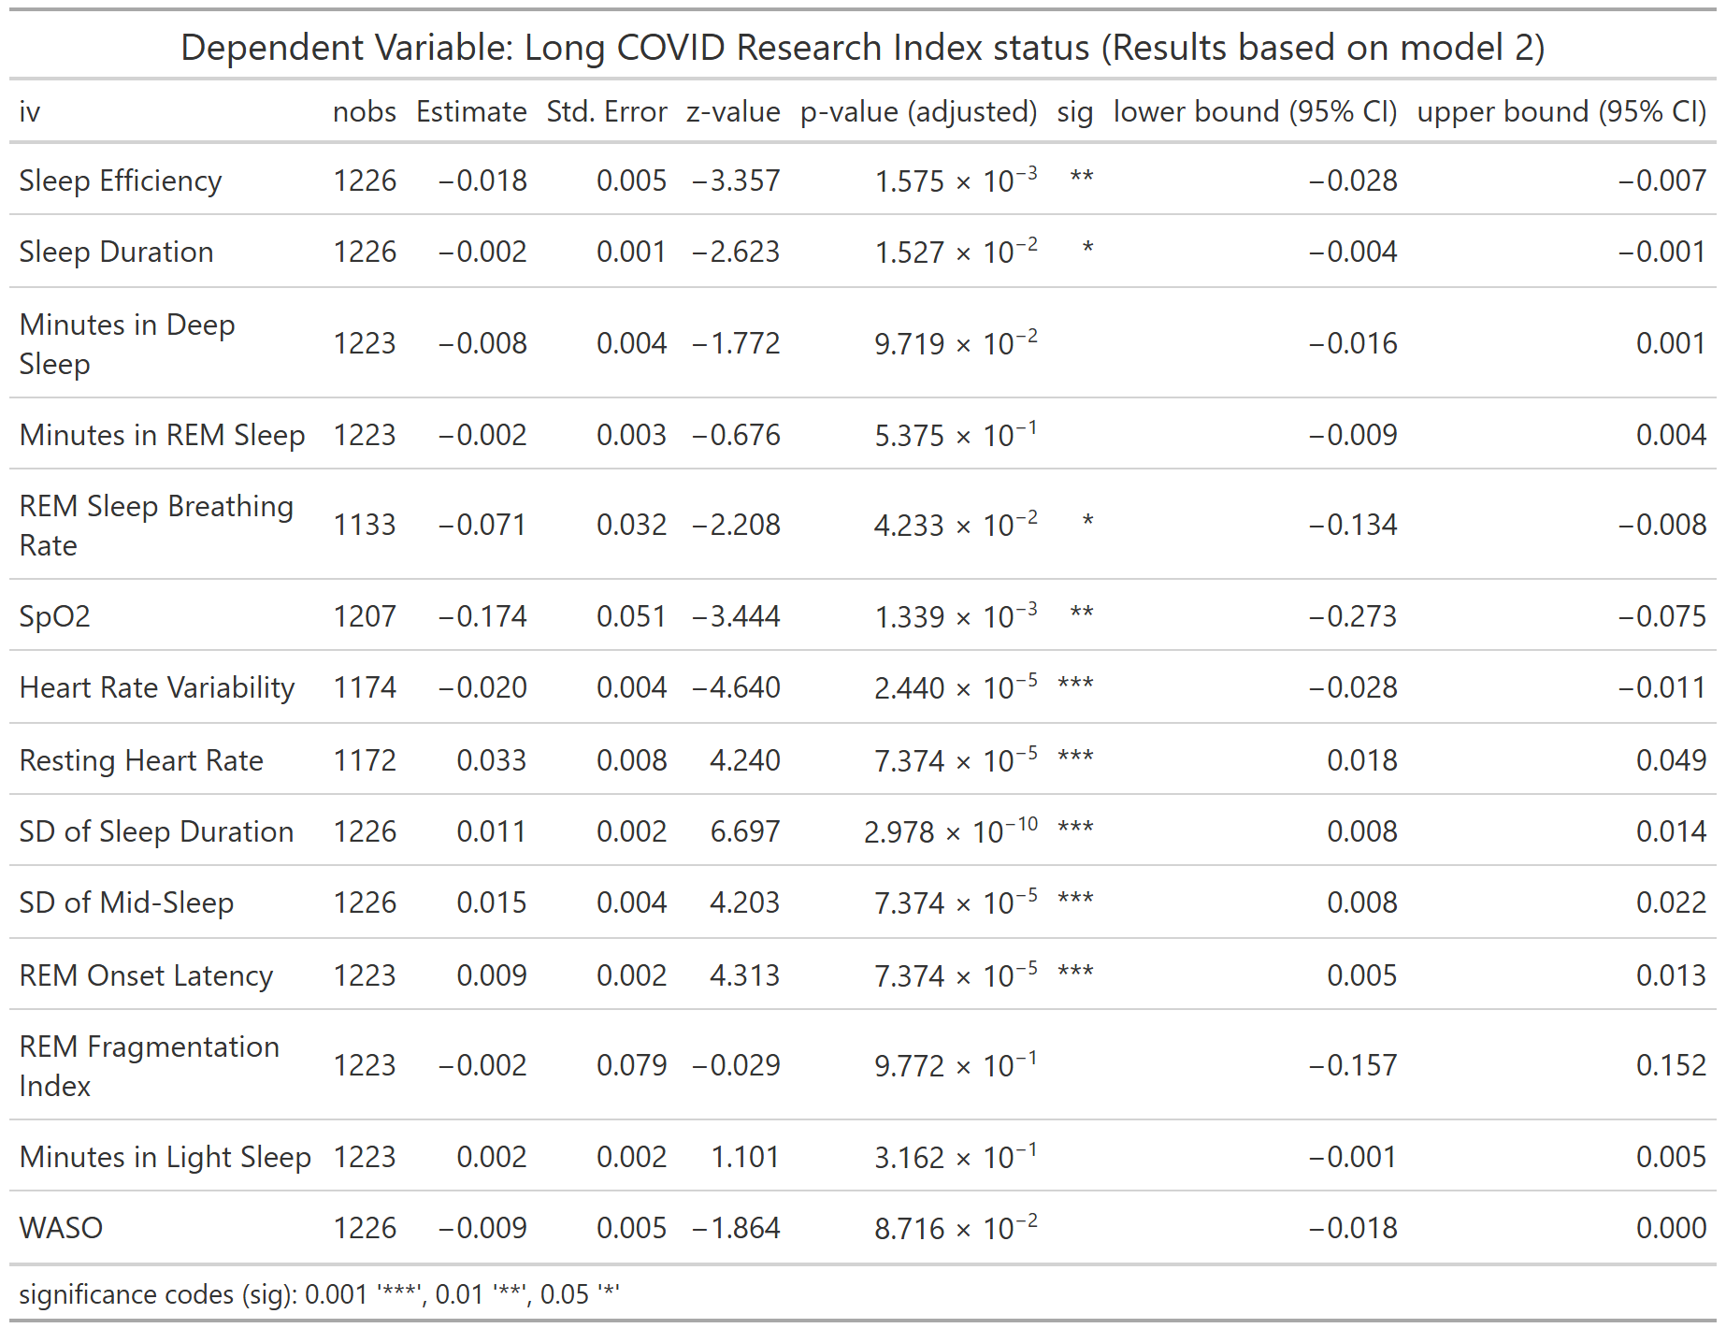
nobs = number of observations
Table S3. Association between Long COVID Research Index Status and WDSM (Model 3)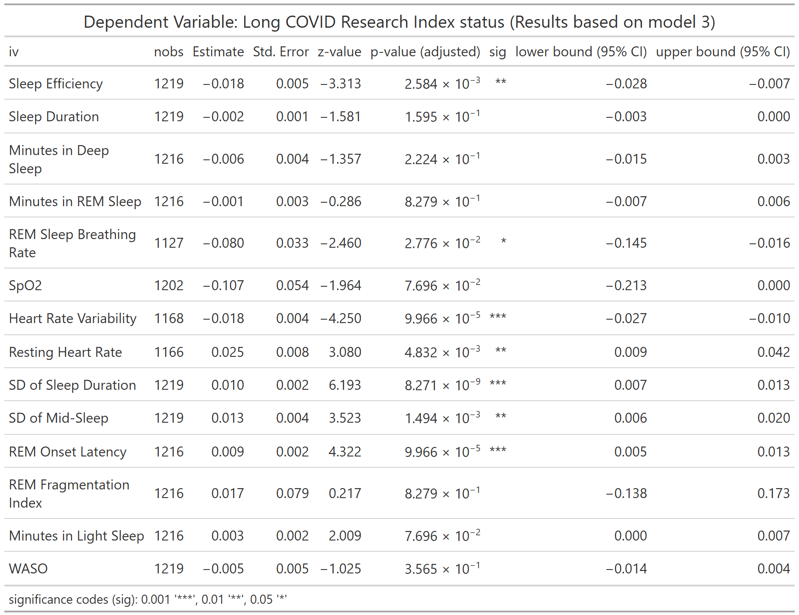
nobs = number of observations
Table S4. Association between Long COVID Research Index Status and WDSM (Full Model)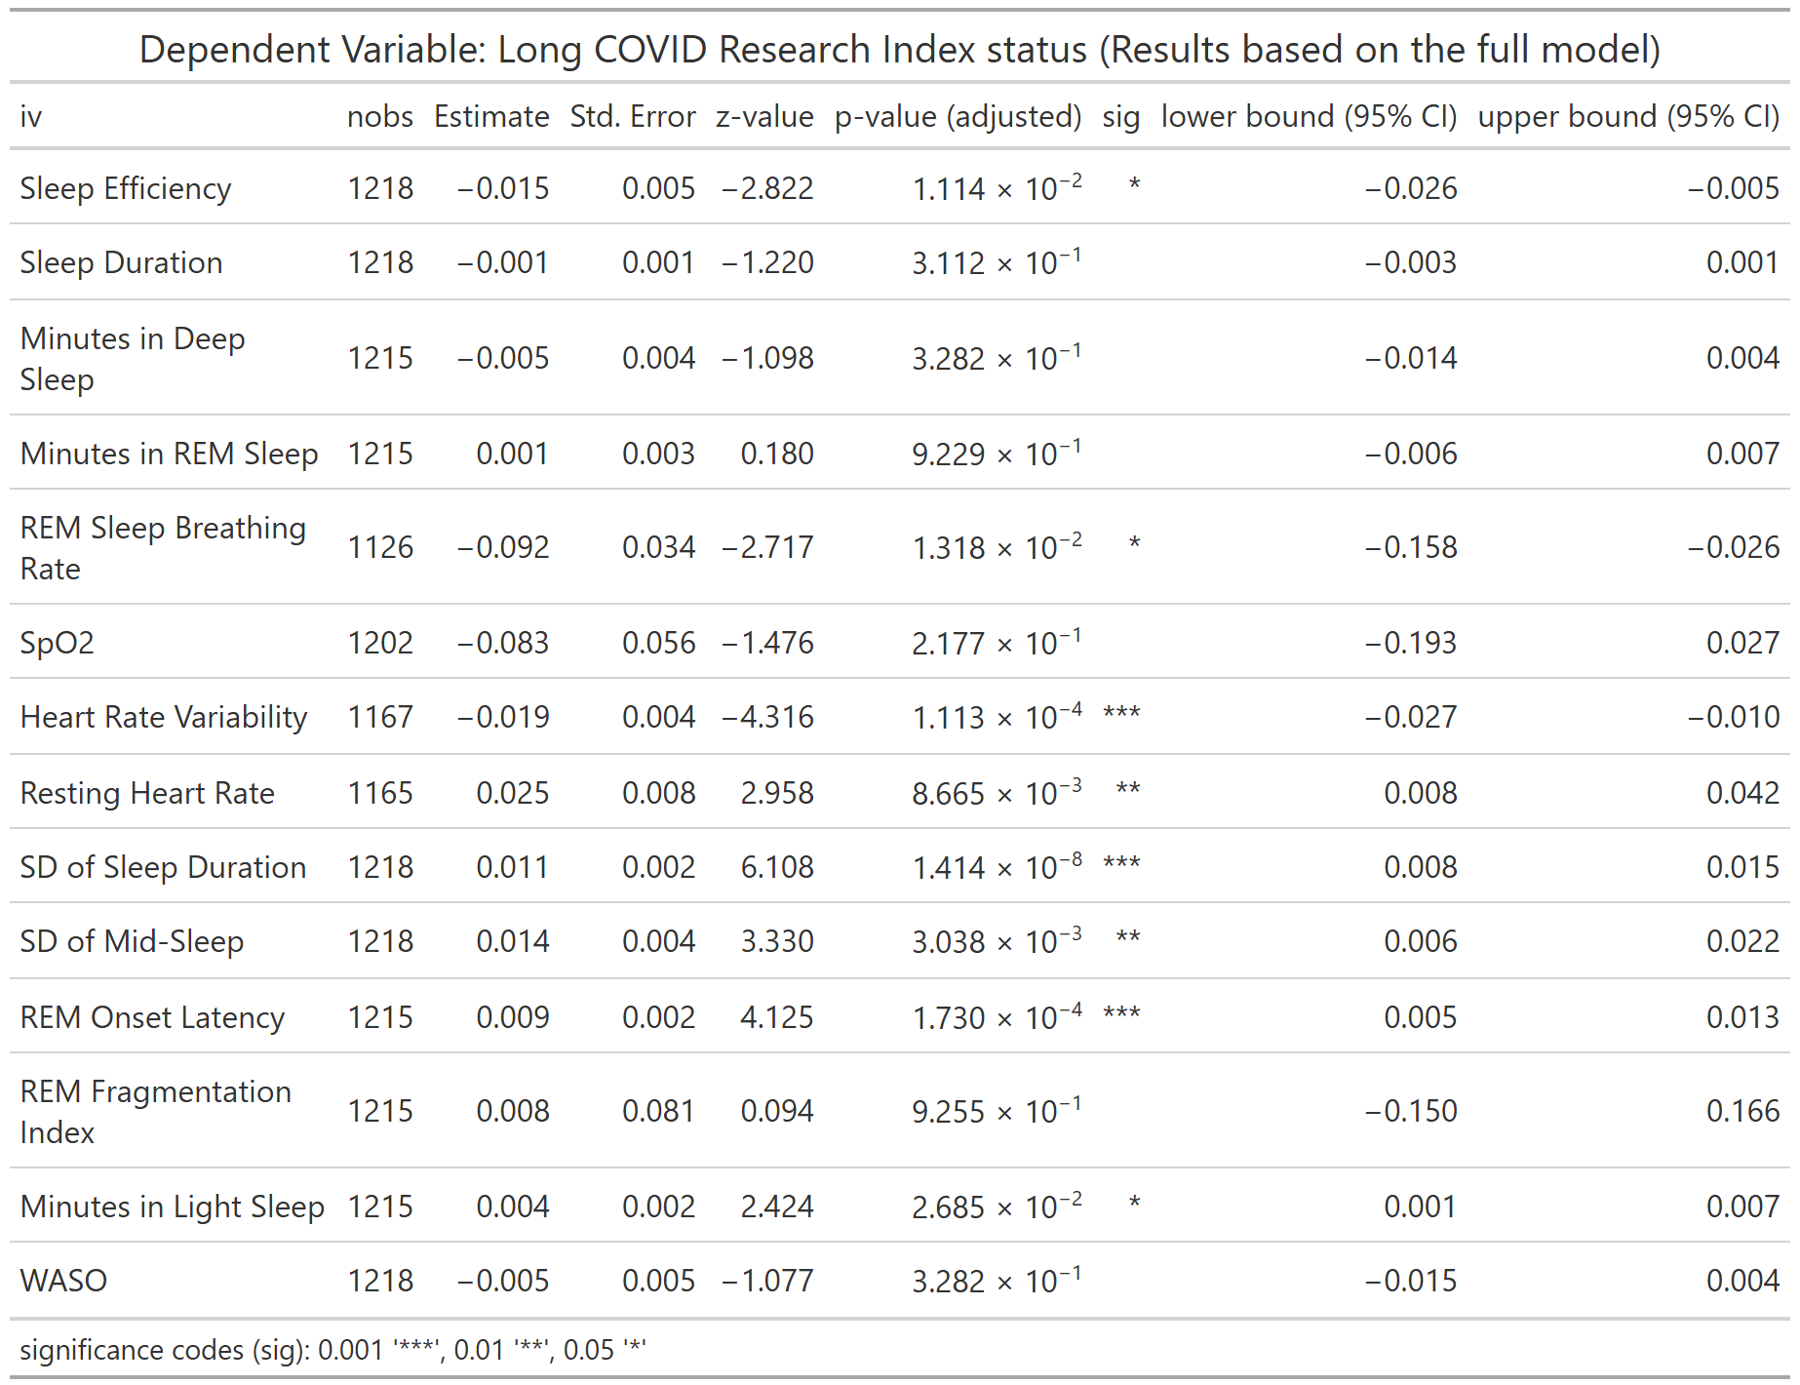
nobs = number of observations
Table S5. Association between Long COVID Research Index Score and WDSM (Model 1)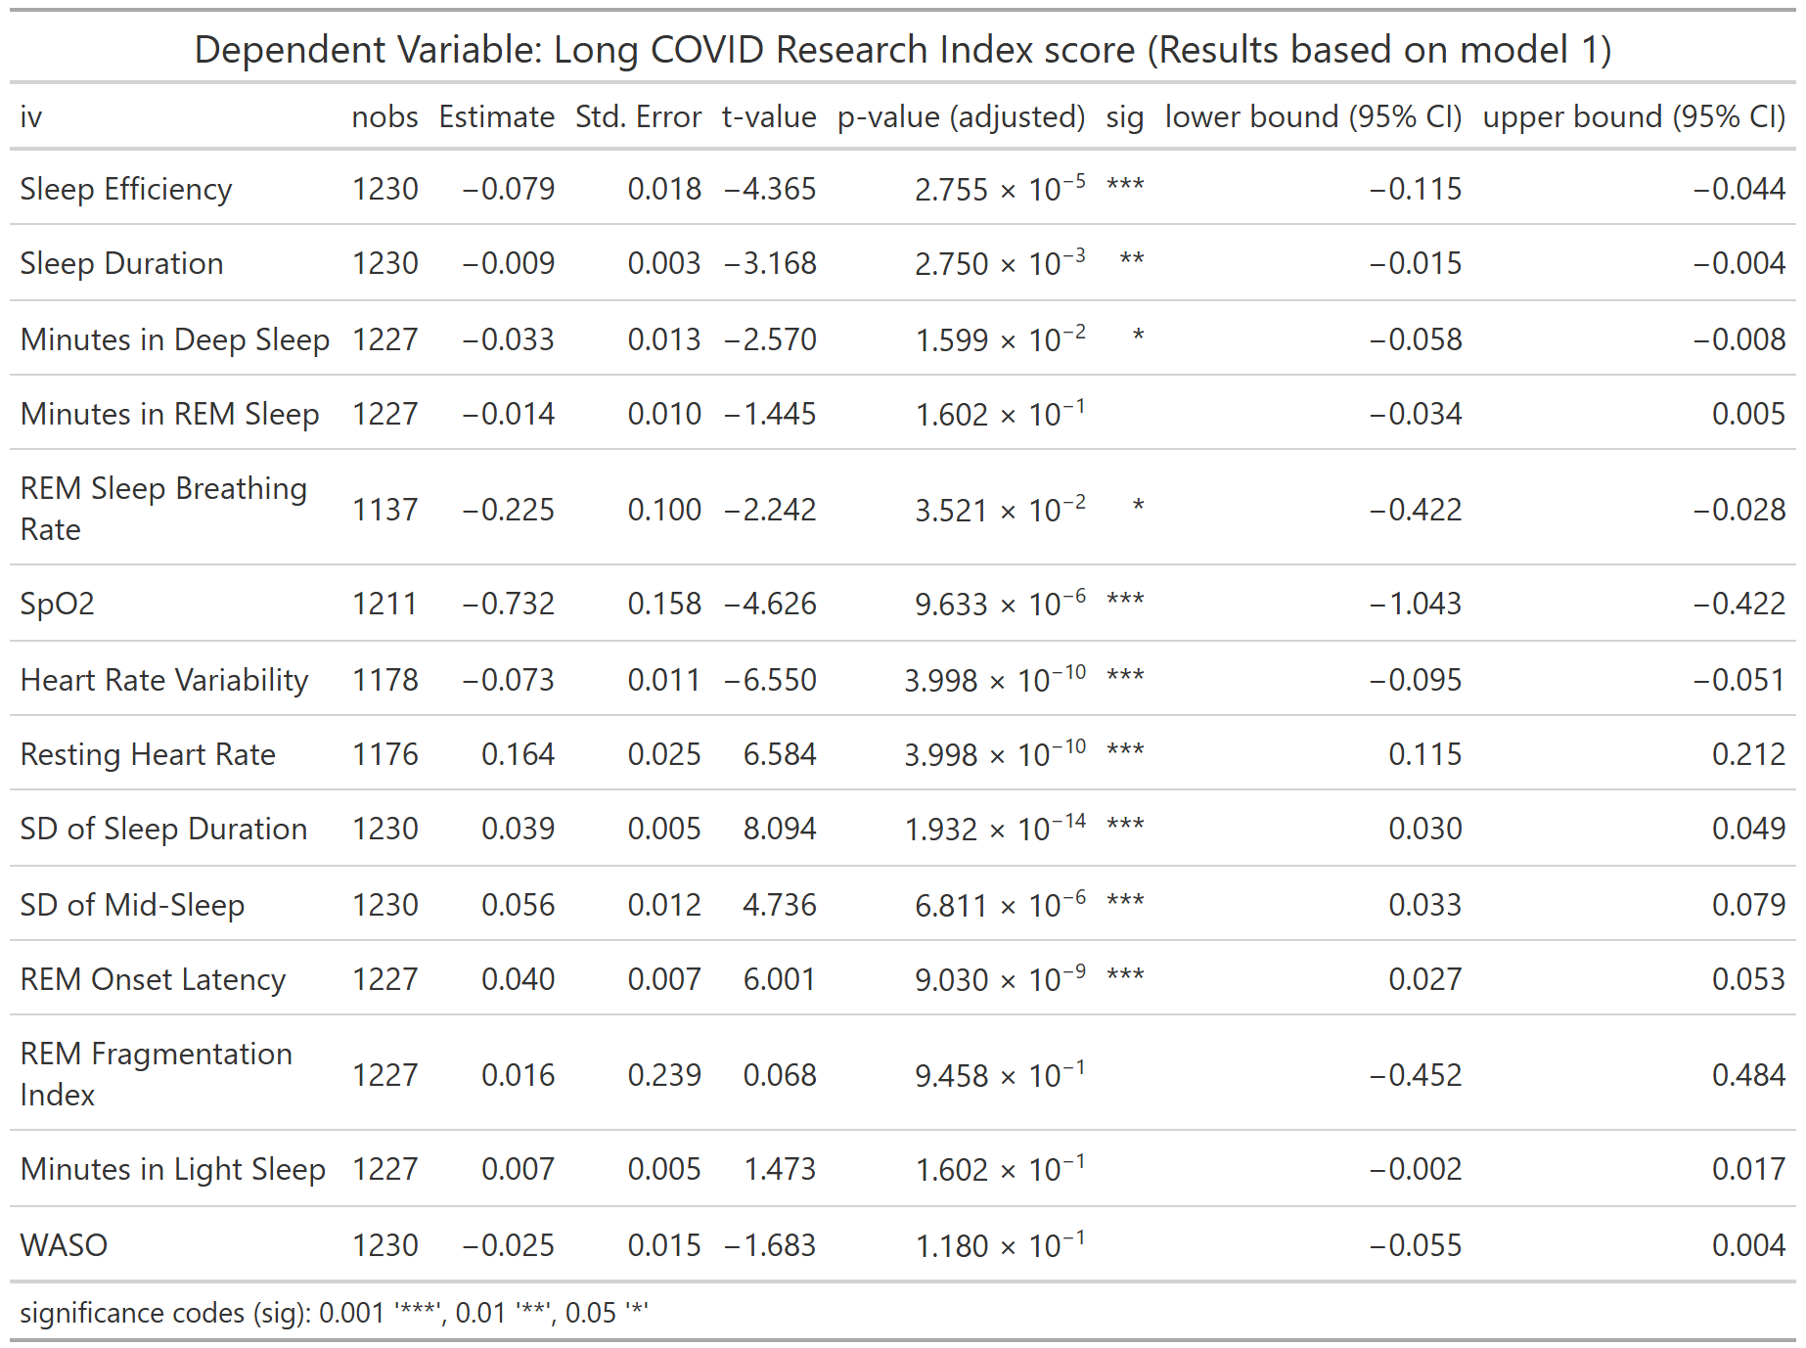
nobs = number of observations
Table S6. Association between Long COVID Research Index Score and WDSM (Model 2)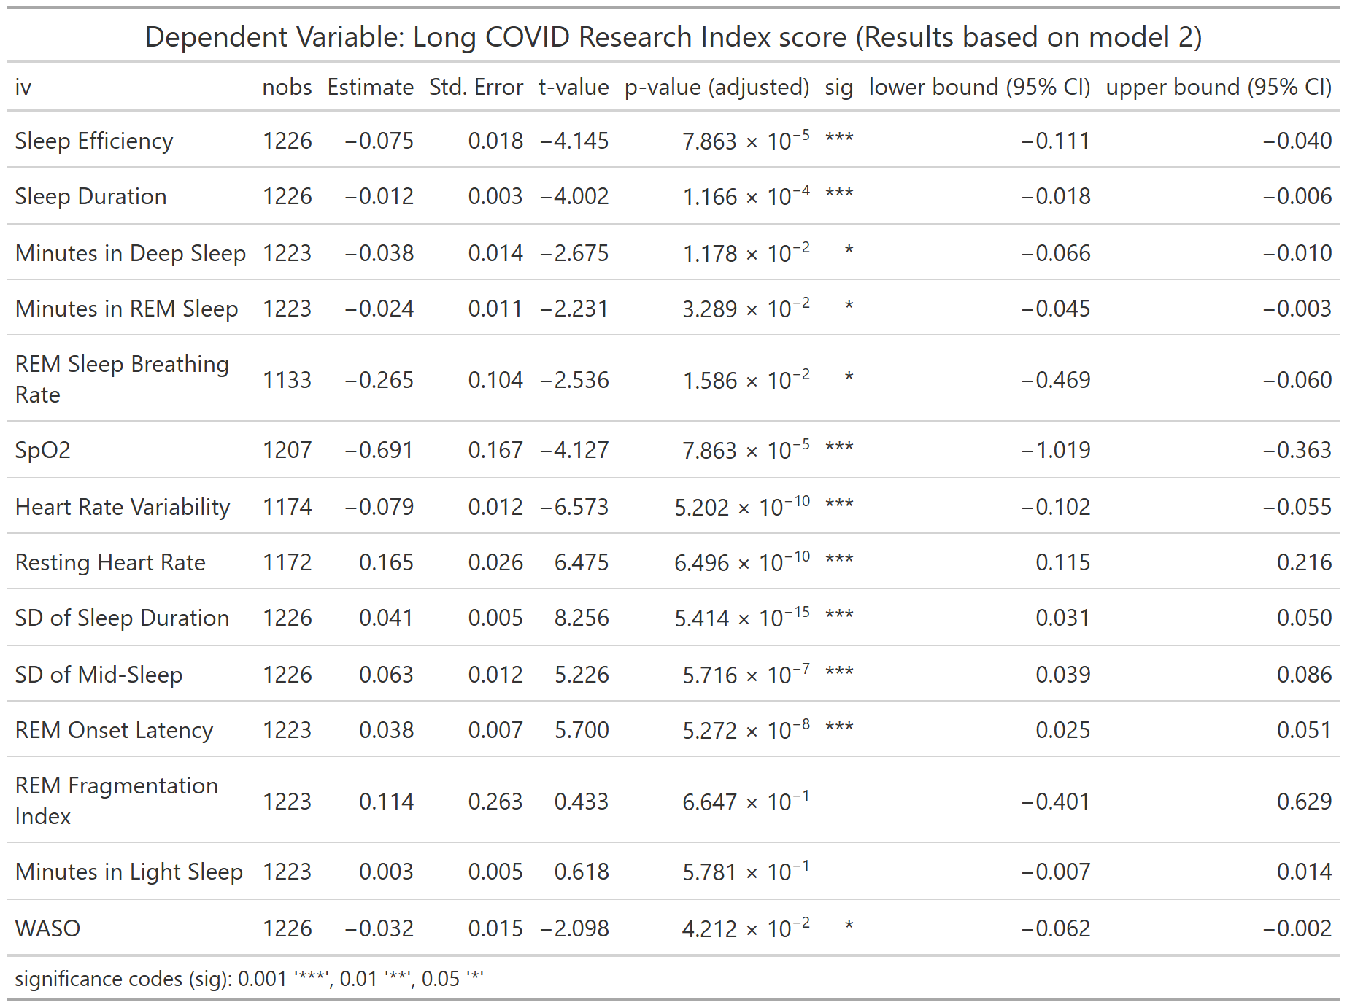
nobs = number of observations
Table S7. Association between Long COVID Research Index Score and WDSM (Model 3)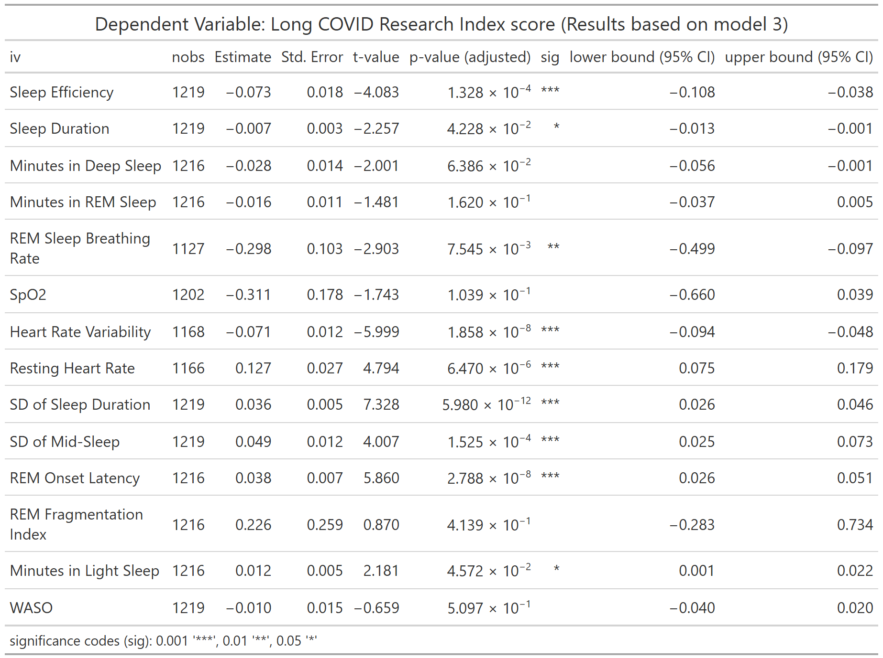
nobs = number of observations
Table S8. Association between Long COVID Research Index Score and WDSM (Full Model)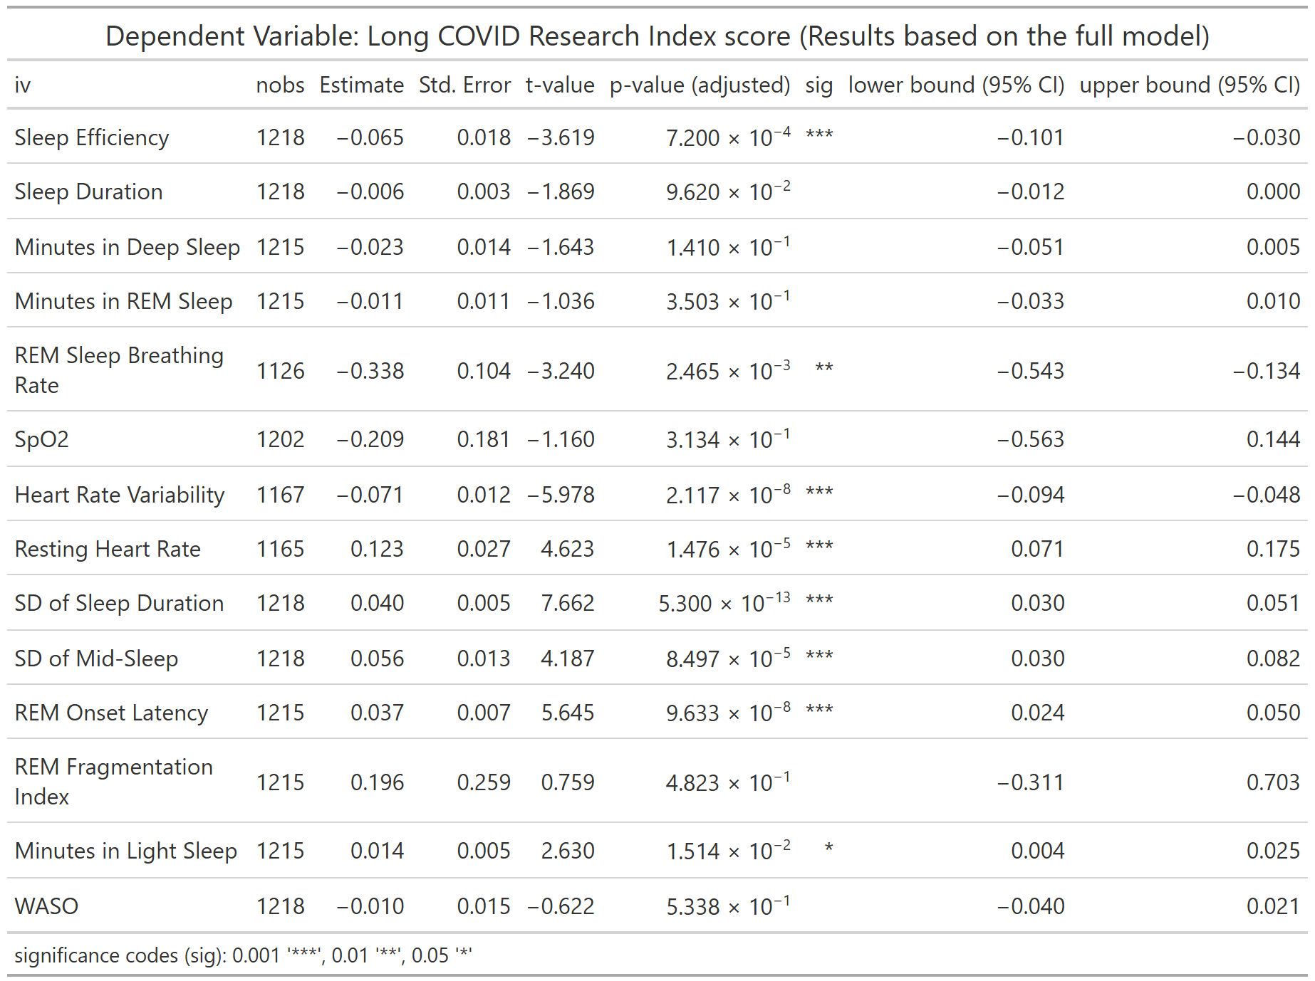
nobs = number of observations

Table S9. Association between LC symptom of Smell or Taste and WDSM (Model 1) 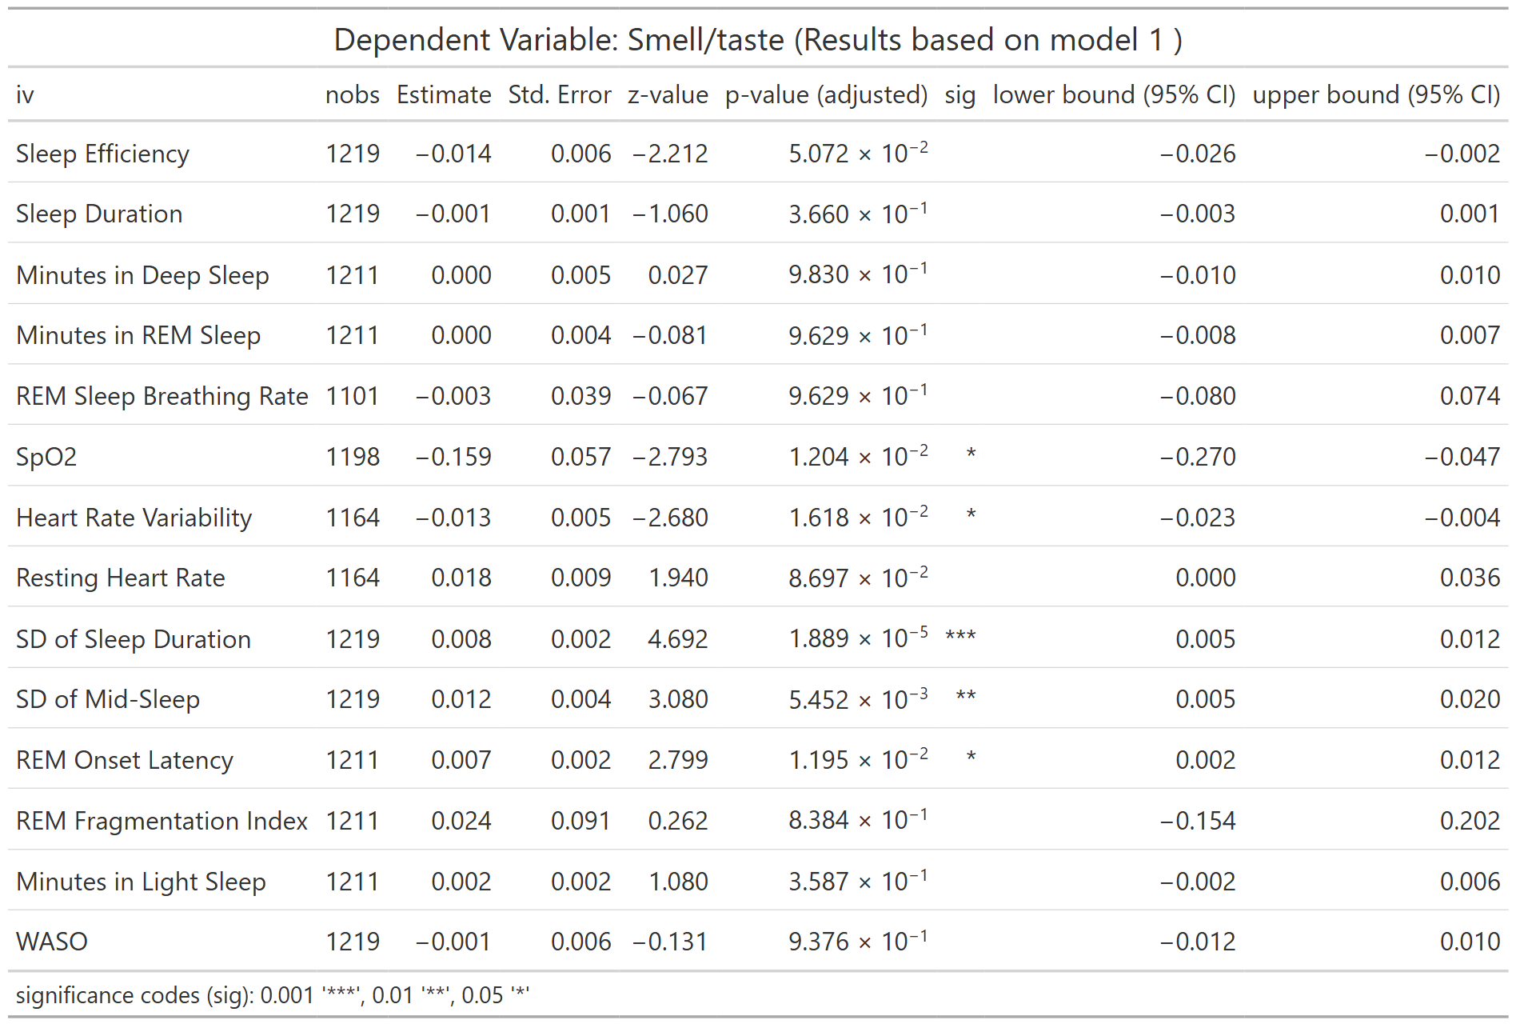
nobs = number of observations
Table S10. Association between LC symptom of Smell or Taste and WDSM (Model 2) 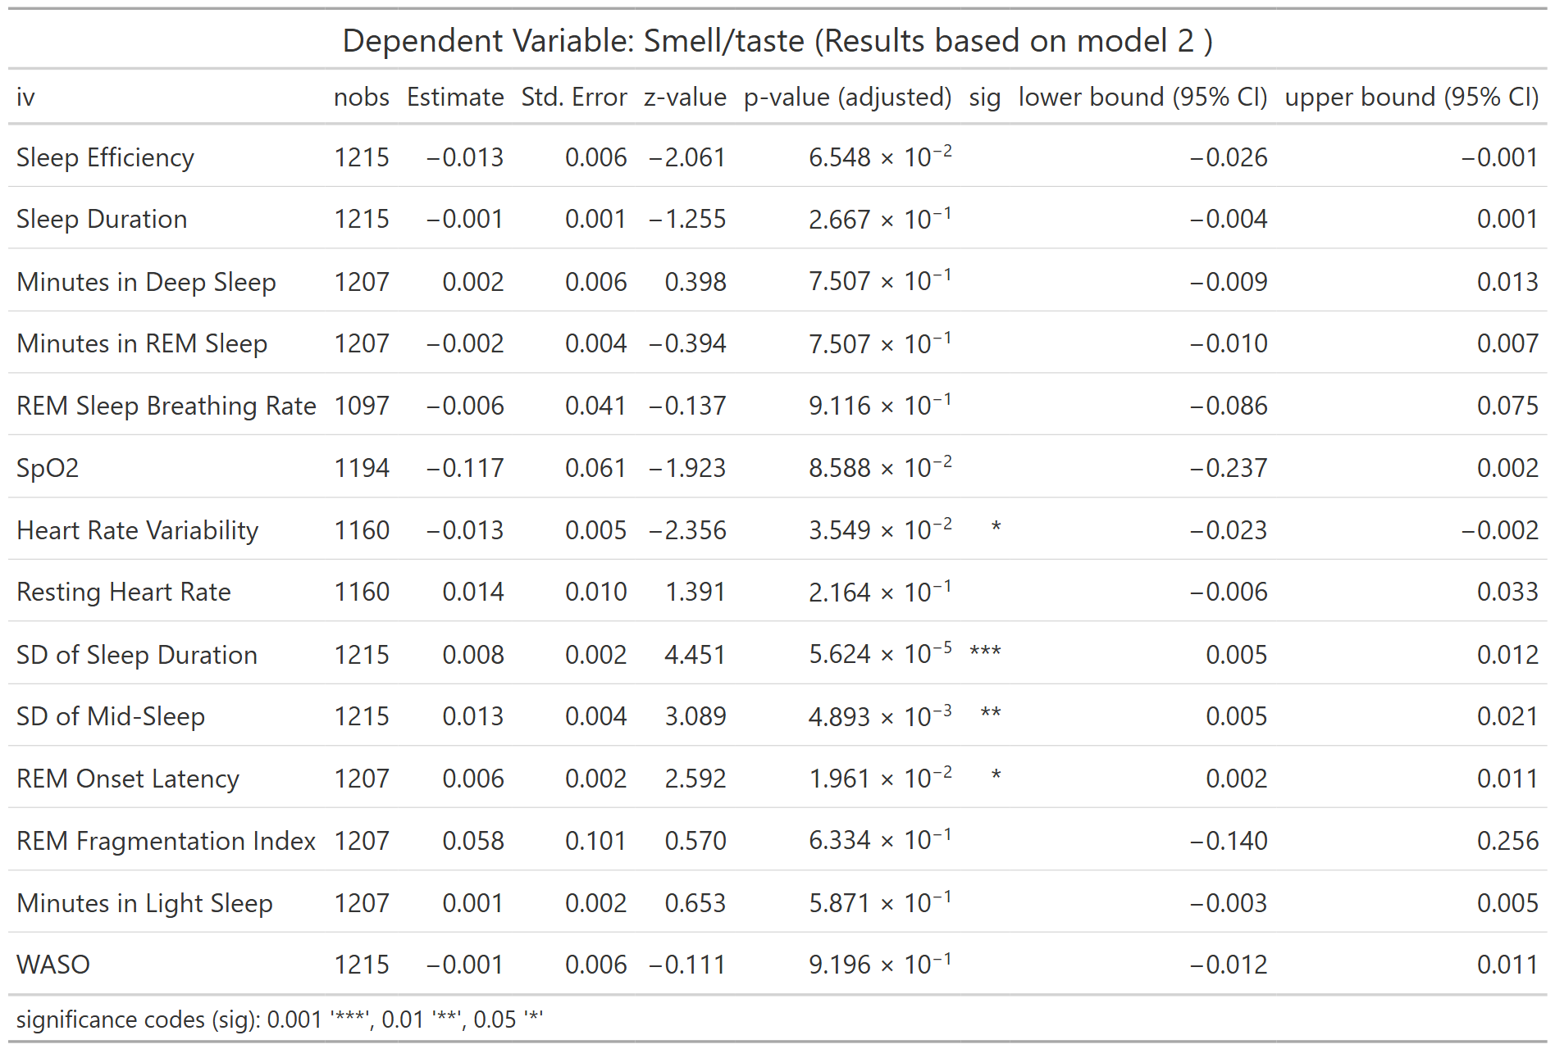
nobs = number of observations
Table S11. Association between LC symptom of Smell or Taste and WDSM (Model 3)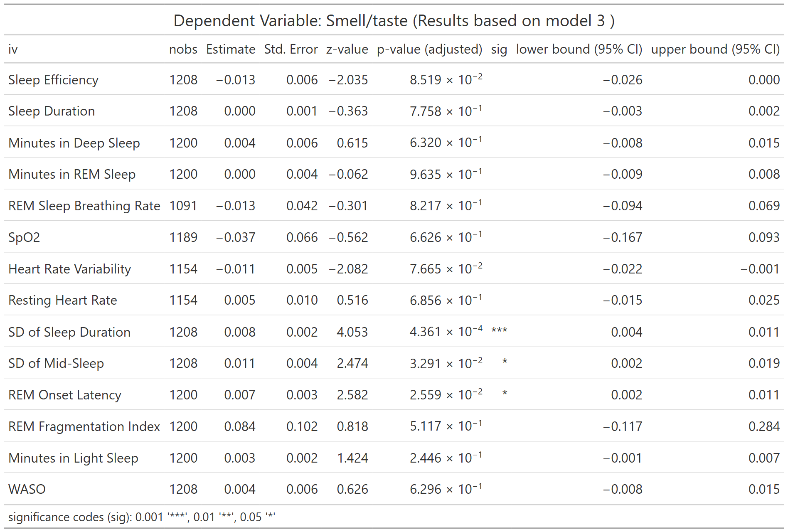
nobs = number of observations
Table S12. Association between LC symptom of Smell or Taste and WDSM (Full Model) 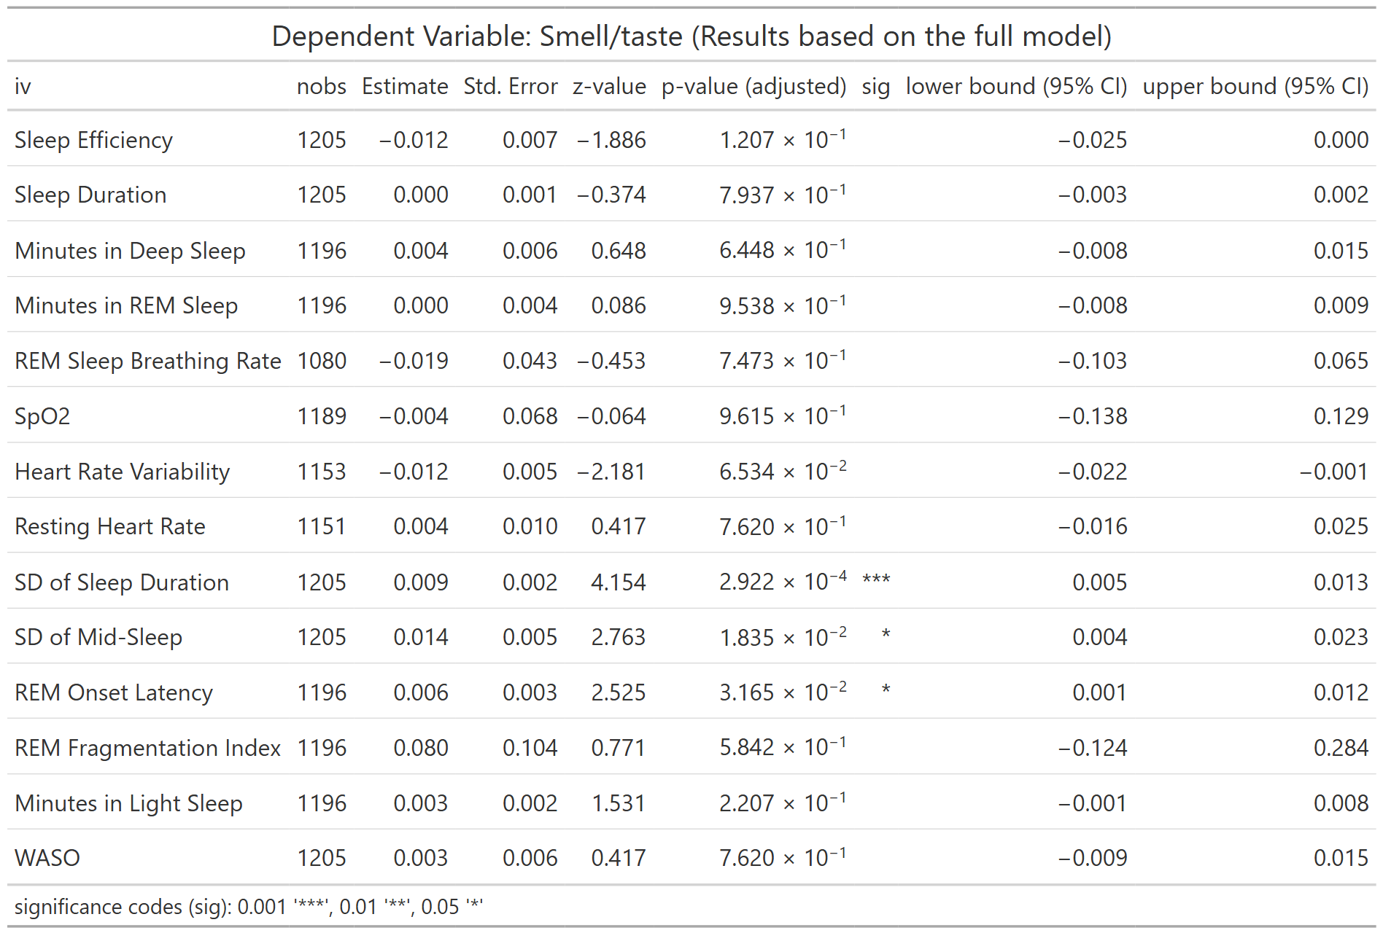
nobs = number of observations
Table S13. Association between LC symptom of Post-exertional Malaise and WDSM (Model 1) 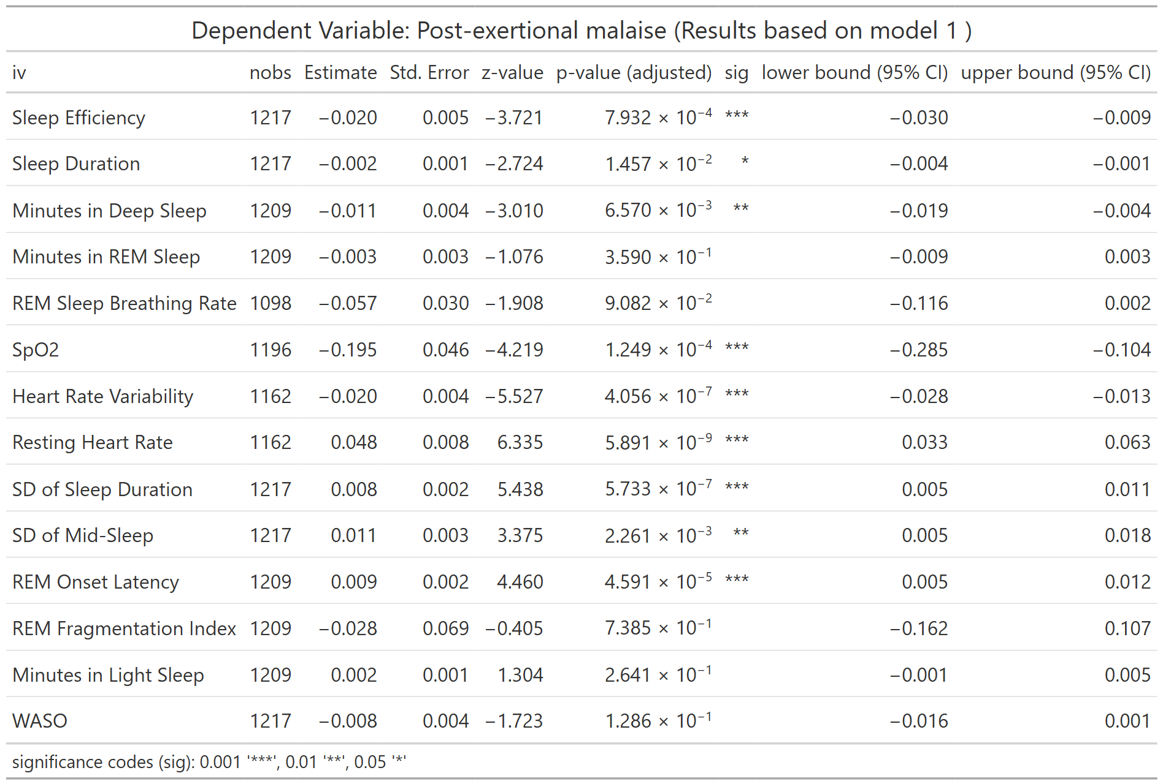
nobs = number of observations
Table S14. Association between LC symptom of Post-exertional Malaise and WDSM (Model 2)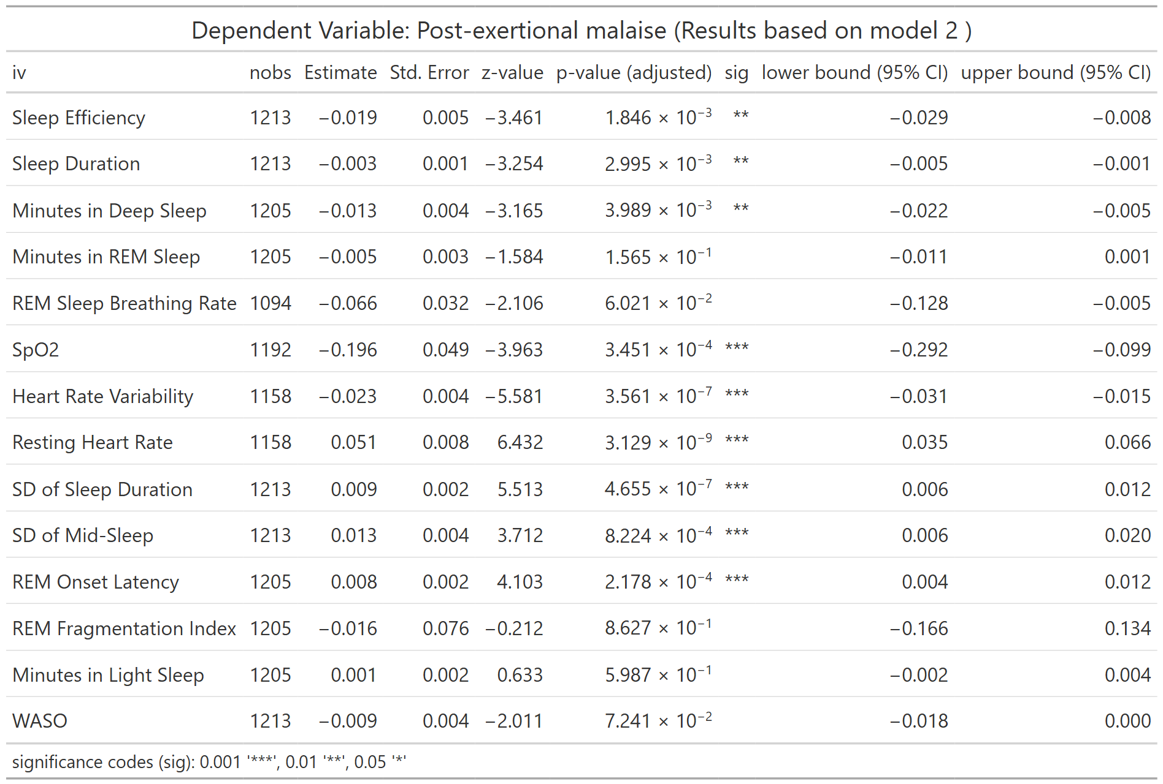
nobs = number of observations
Table S15. Association between LC symptom of Post-exertional Malaise and WDSM (Model 3)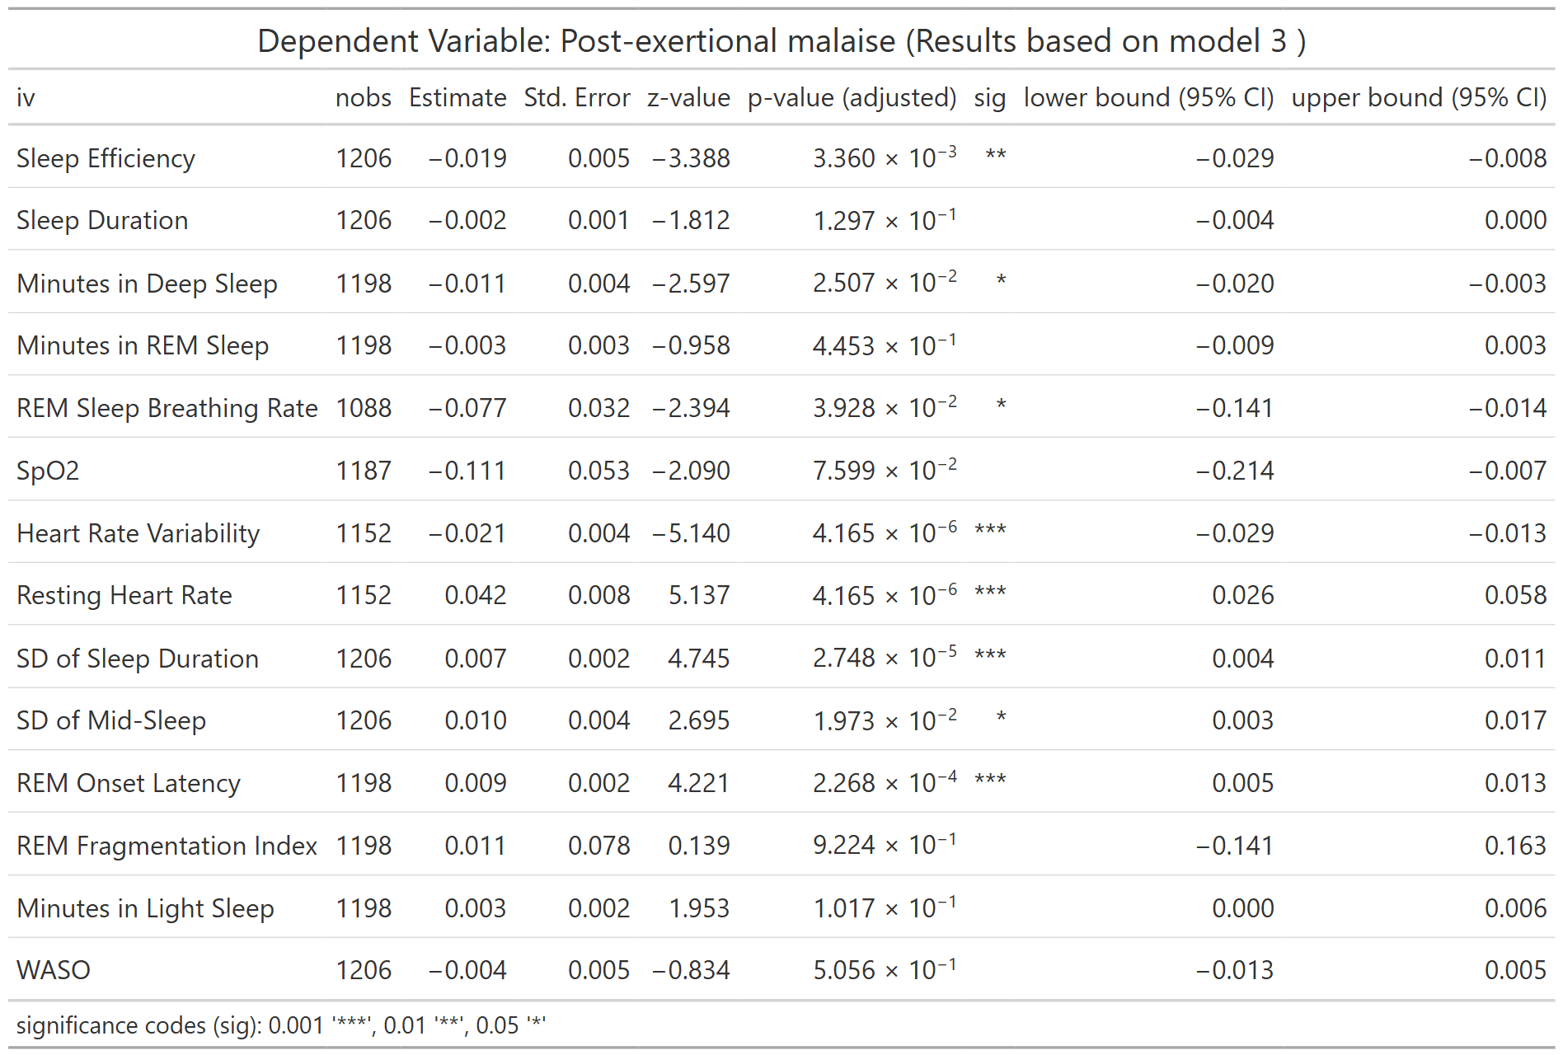
nobs = number of observations
Table S16. Association between LC symptom of Post-exertional Malaise and WDSM (Full Model)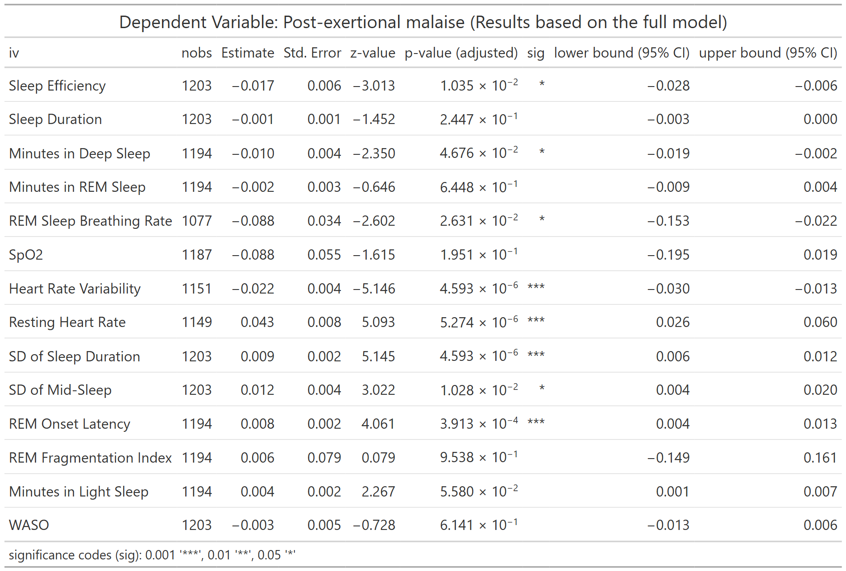
nobs = number of observations
Table S17. Association between LC symptom of Chronic Cough and WDSM (Model 1) 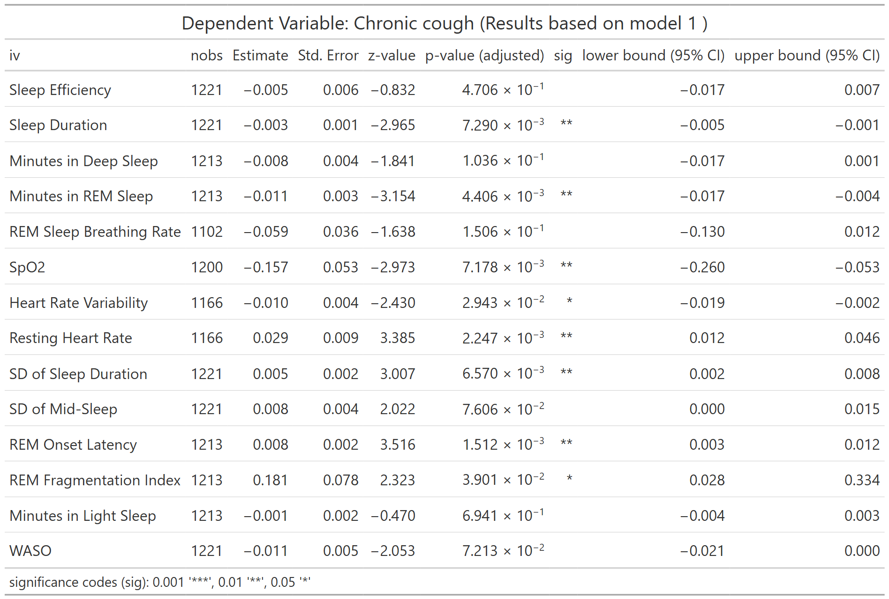
nobs = number of observations
Table S18. Association between LC symptom of Chronic Cough and WDSM (Model 2) 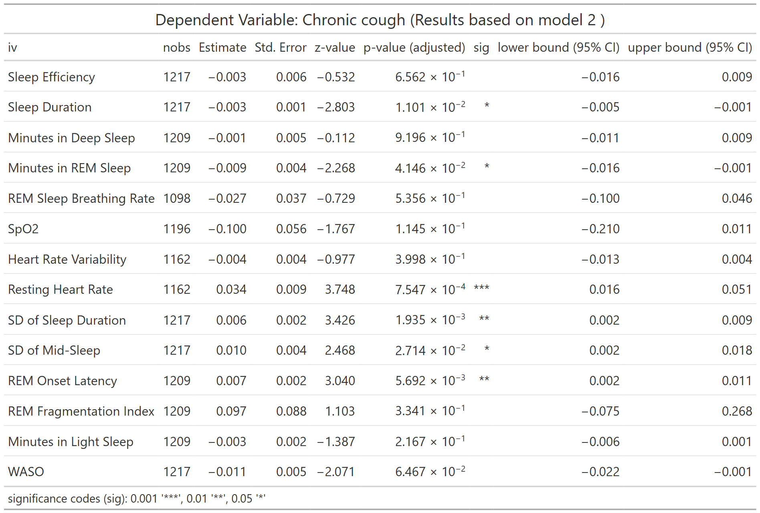
nobs = number of observations
Table S19. Association between LC symptom of Chronic Cough and WDSM (Model 3) 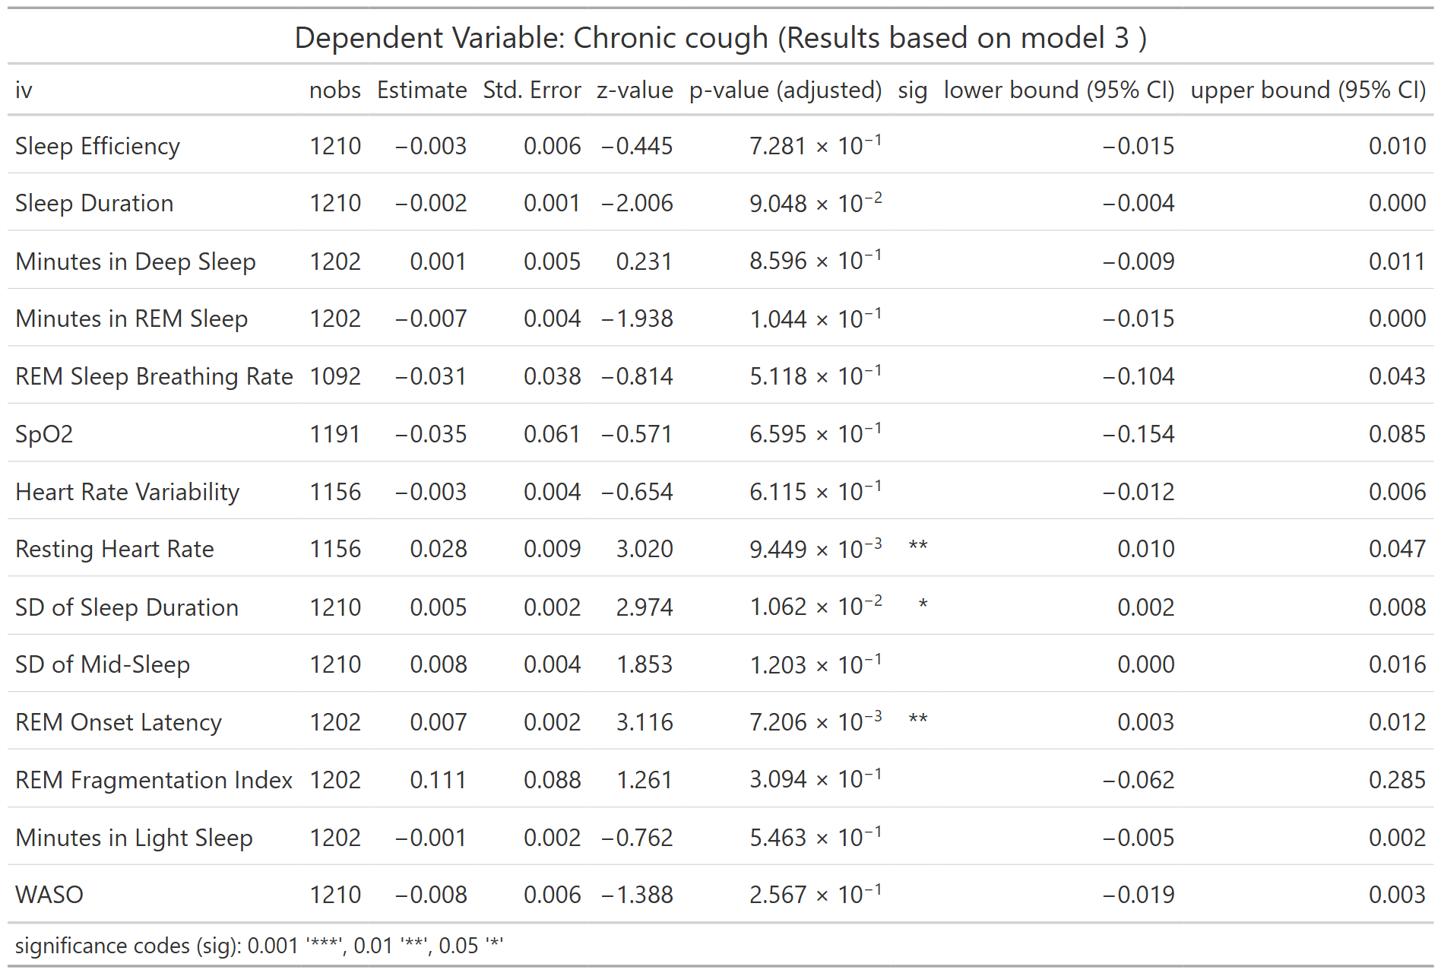
nobs = number of observations
Table S20. Association between LC symptom of Chronic Cough and WDSM (Full Model) 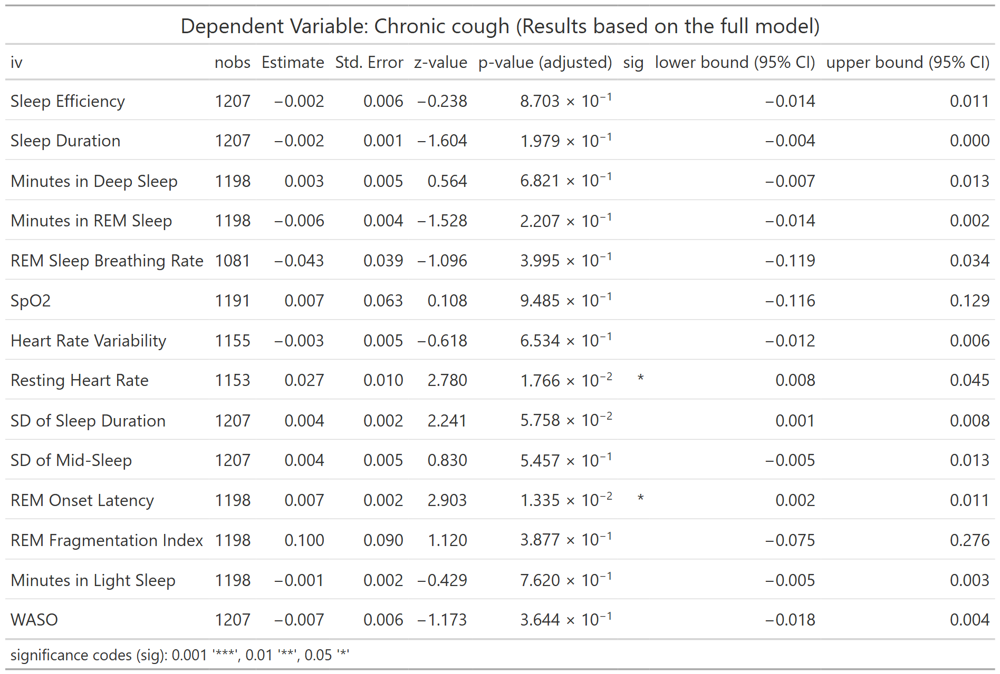
nobs = number of observations
Table S21. Association between LC symptom of Brain Fog and WDSM (Model 1)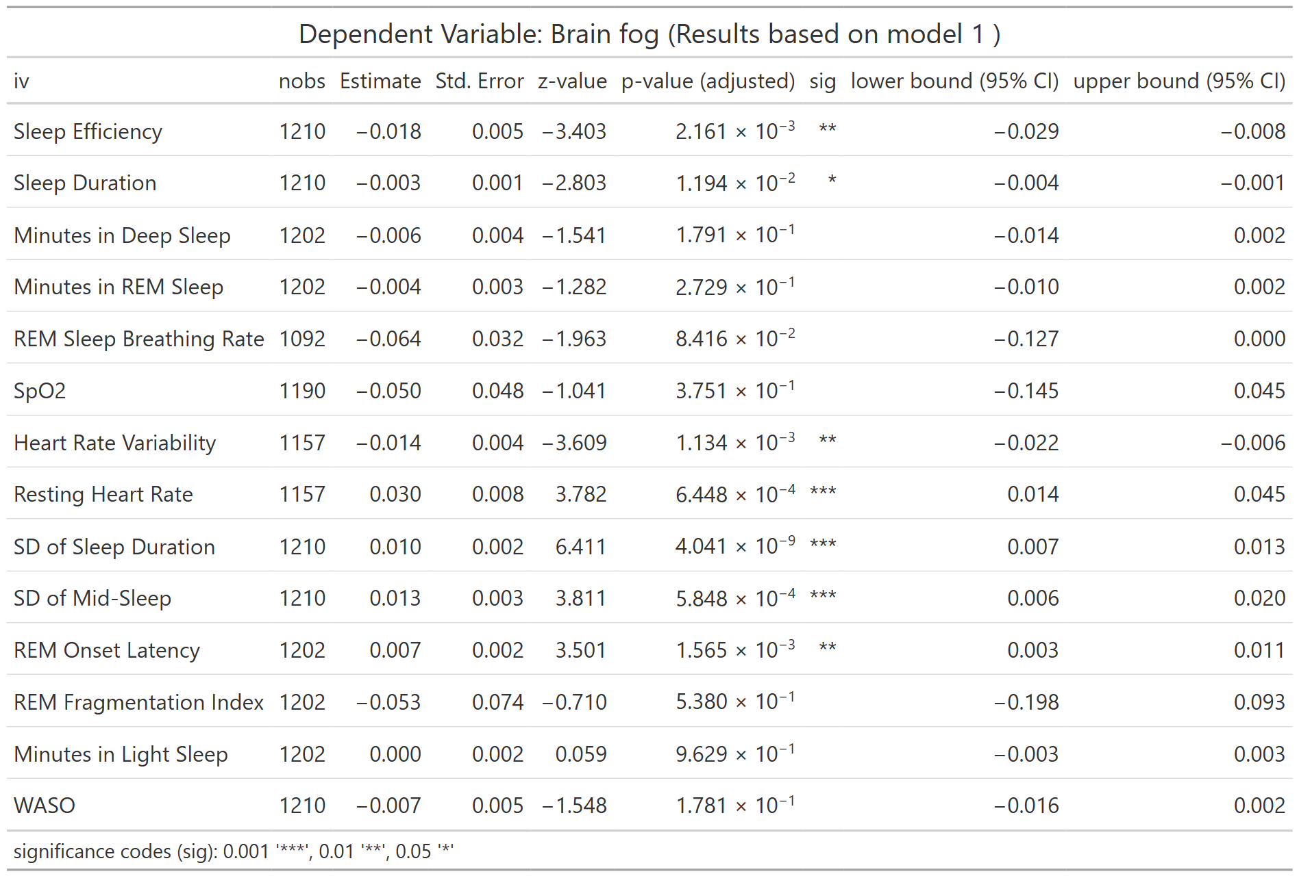
nobs = number of observations
Table S22. Association between LC symptom of Brain Fog and WDSM (Model 2) 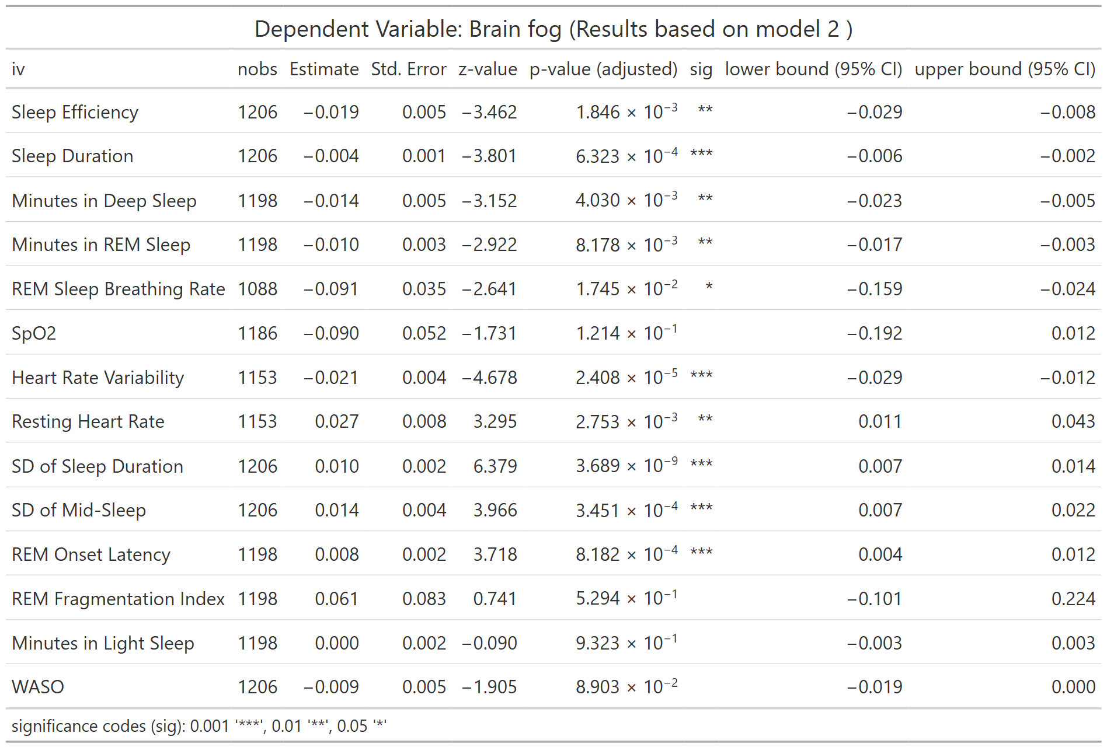
nobs = number of observations
Table S23. Association between LC symptom of Brain Fog and WDSM (Model 3)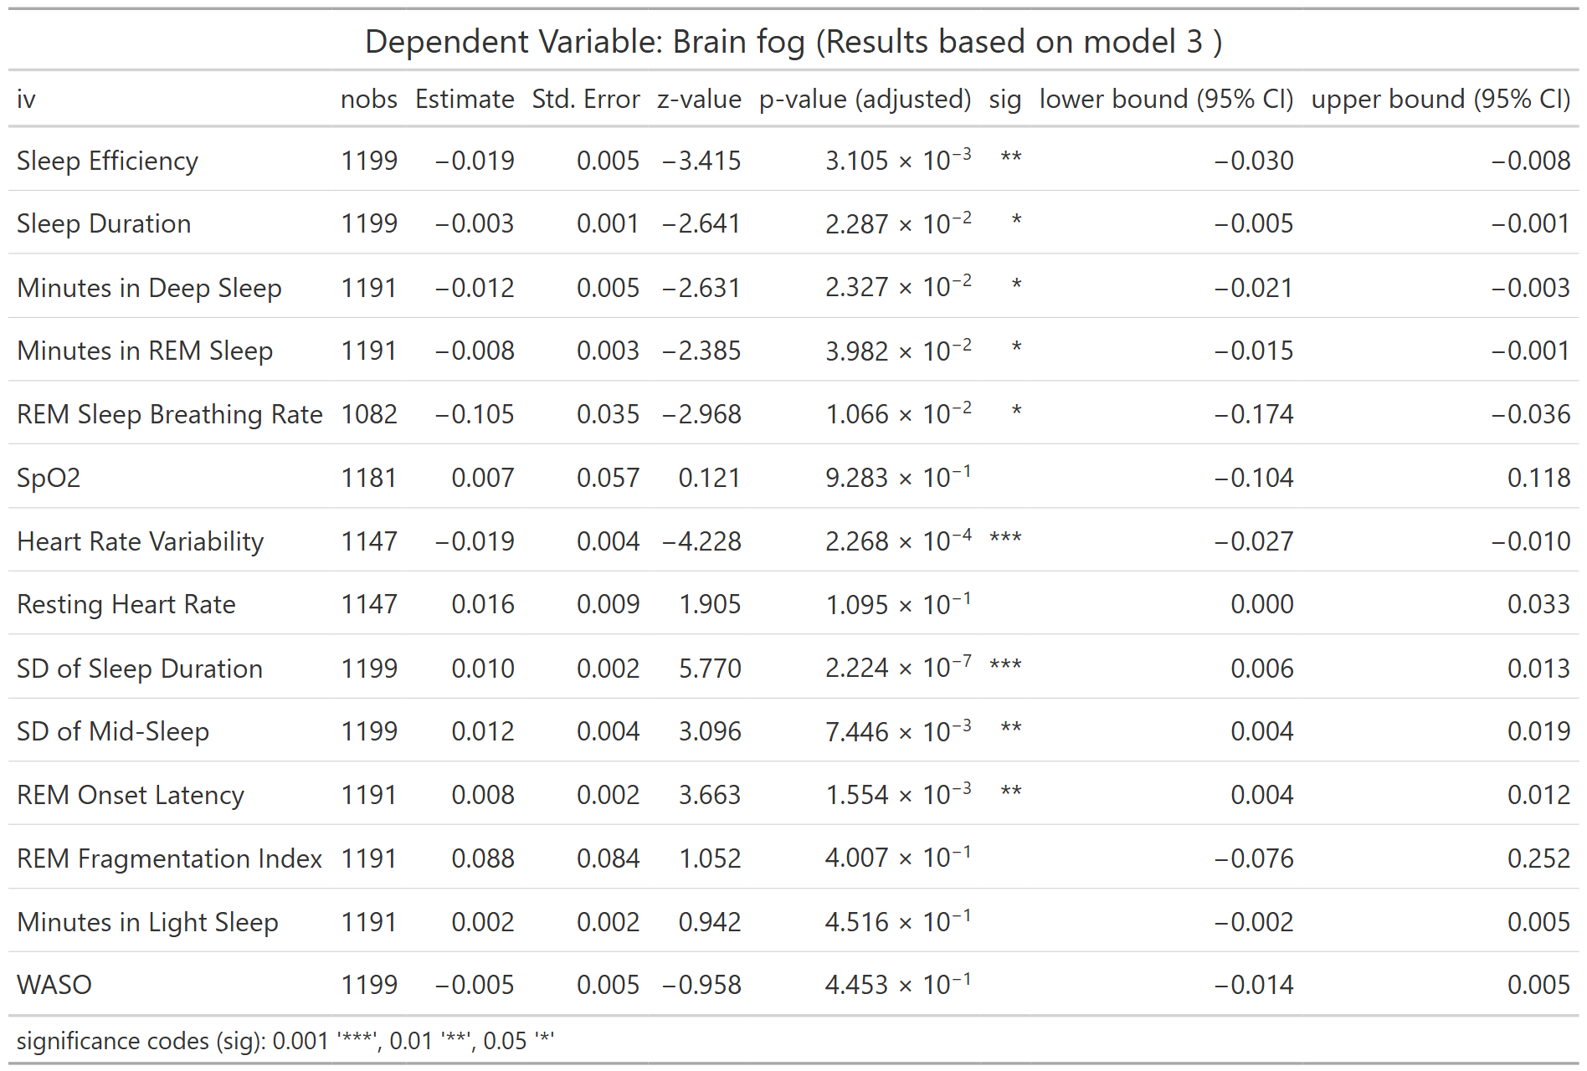
nobs = number of observations
Table S24. Association between LC symptom of Brain Fog and WDSM (Full Model)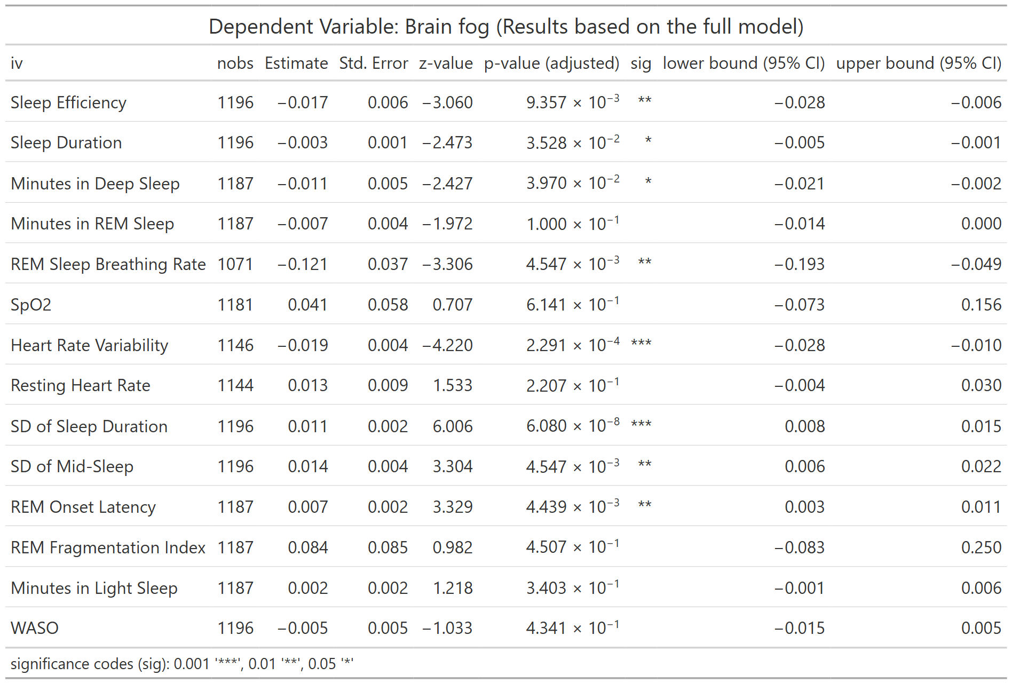
nobs = number of observations
Table S25. Association between LC symptom of Thirst and WDSM (Model 1)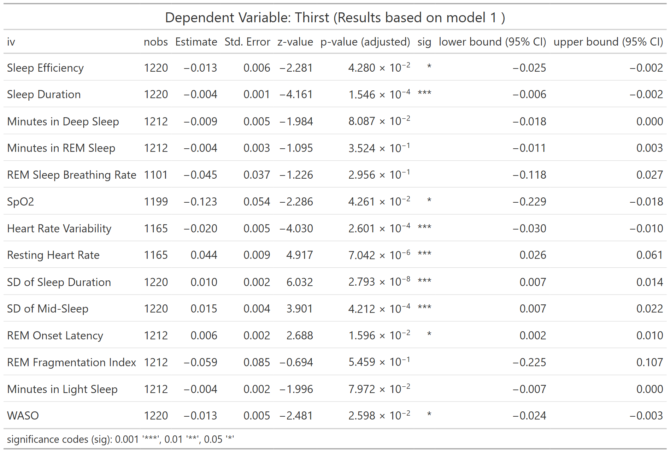
nobs = number of observations
Table S26. Association between LC symptom of Thirst and WDSM (Model 2)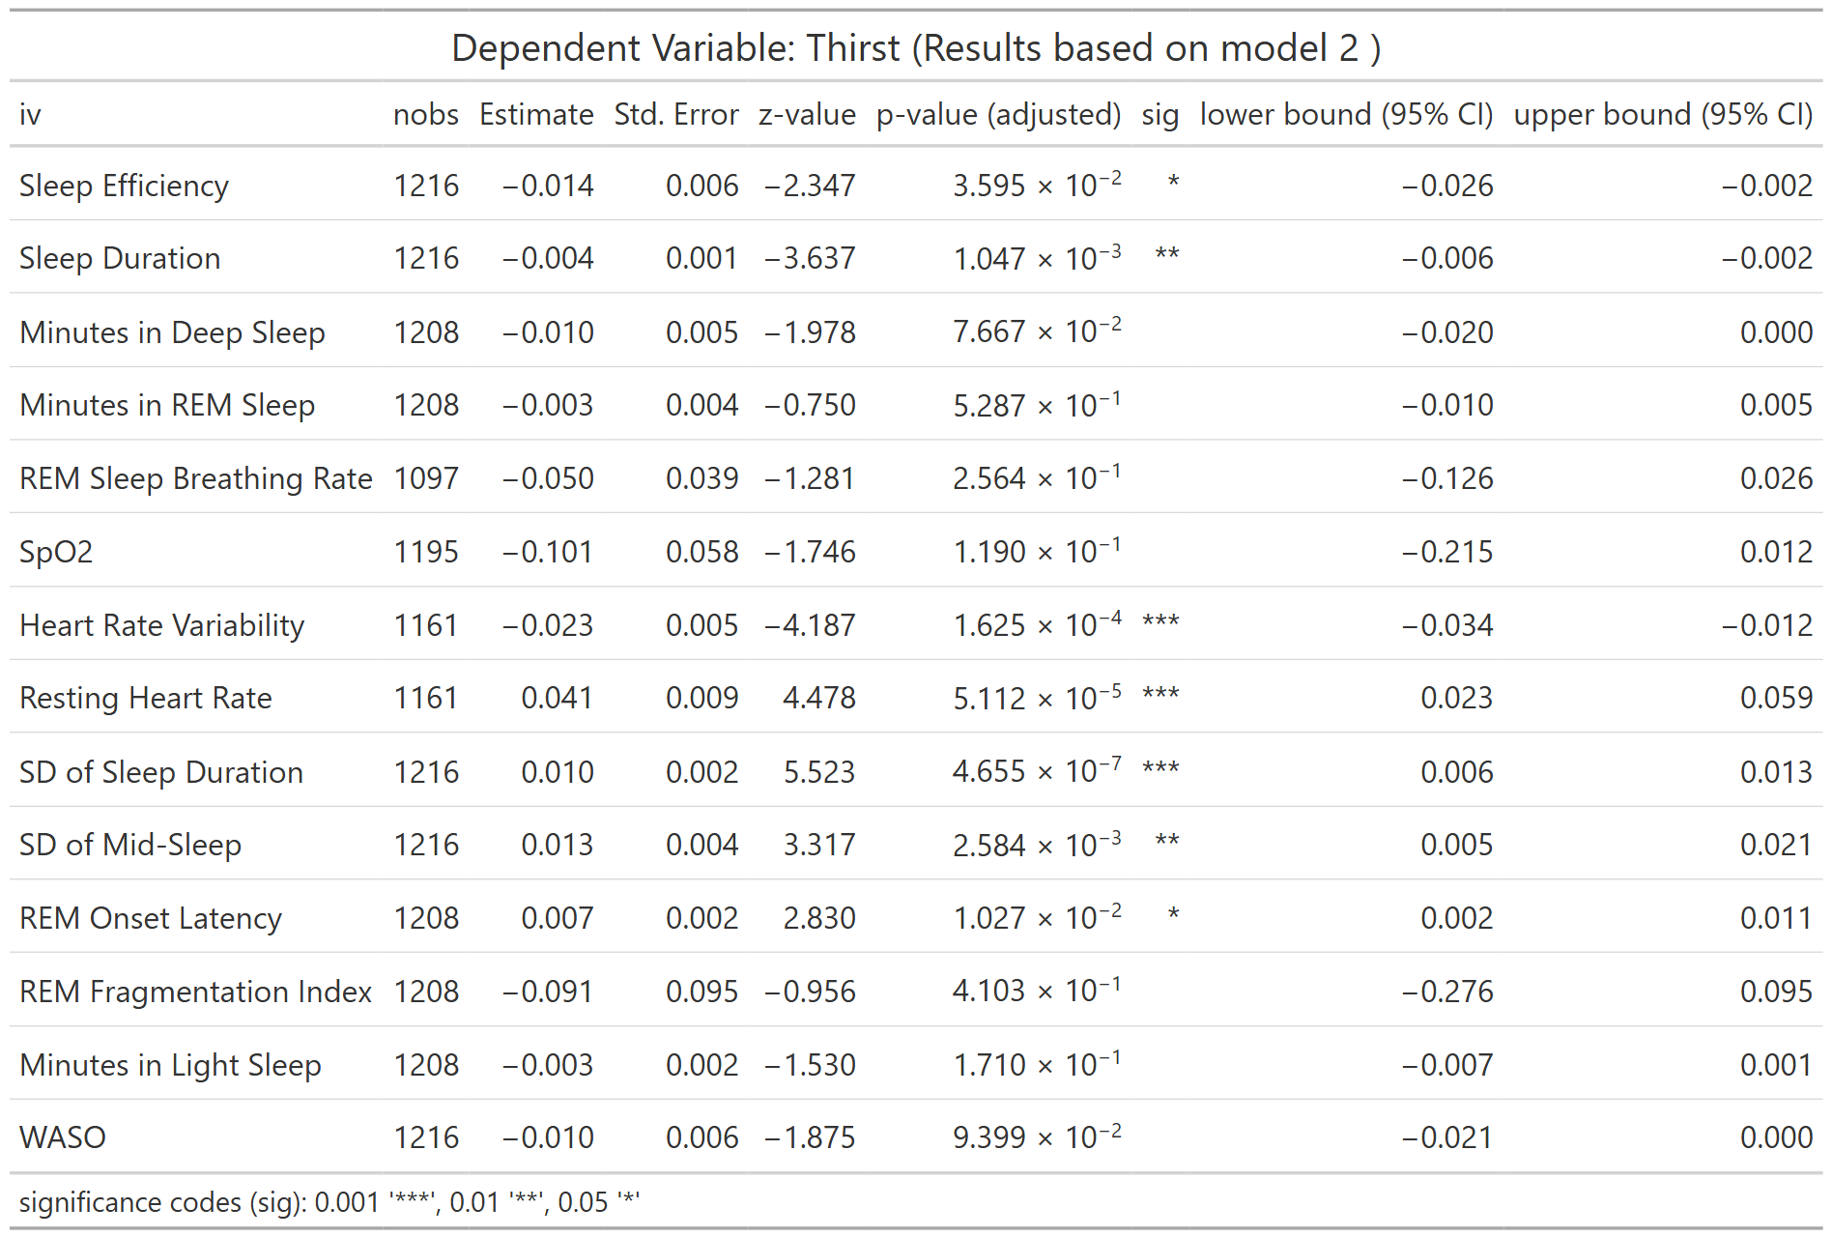
nobs = number of observations
Table S27. Association between LC symptom of Thirst and WDSM (Model 3)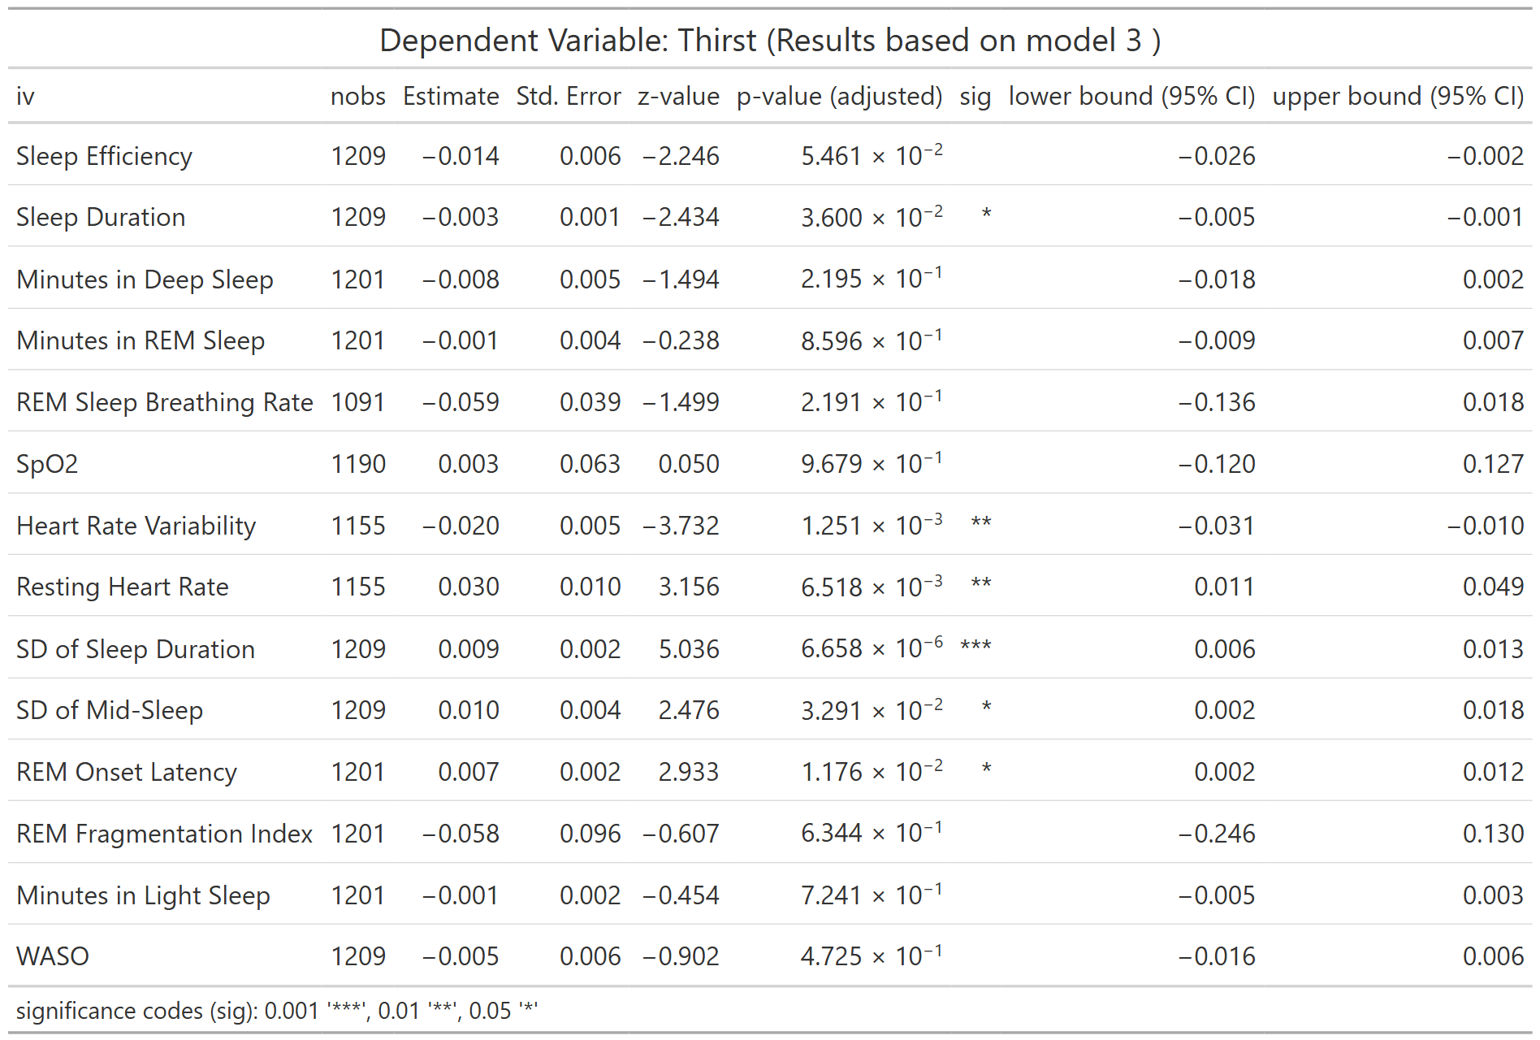
nobs = number of observations
Table S28. Association between LC symptom of Thirst and WDSM (Full Model)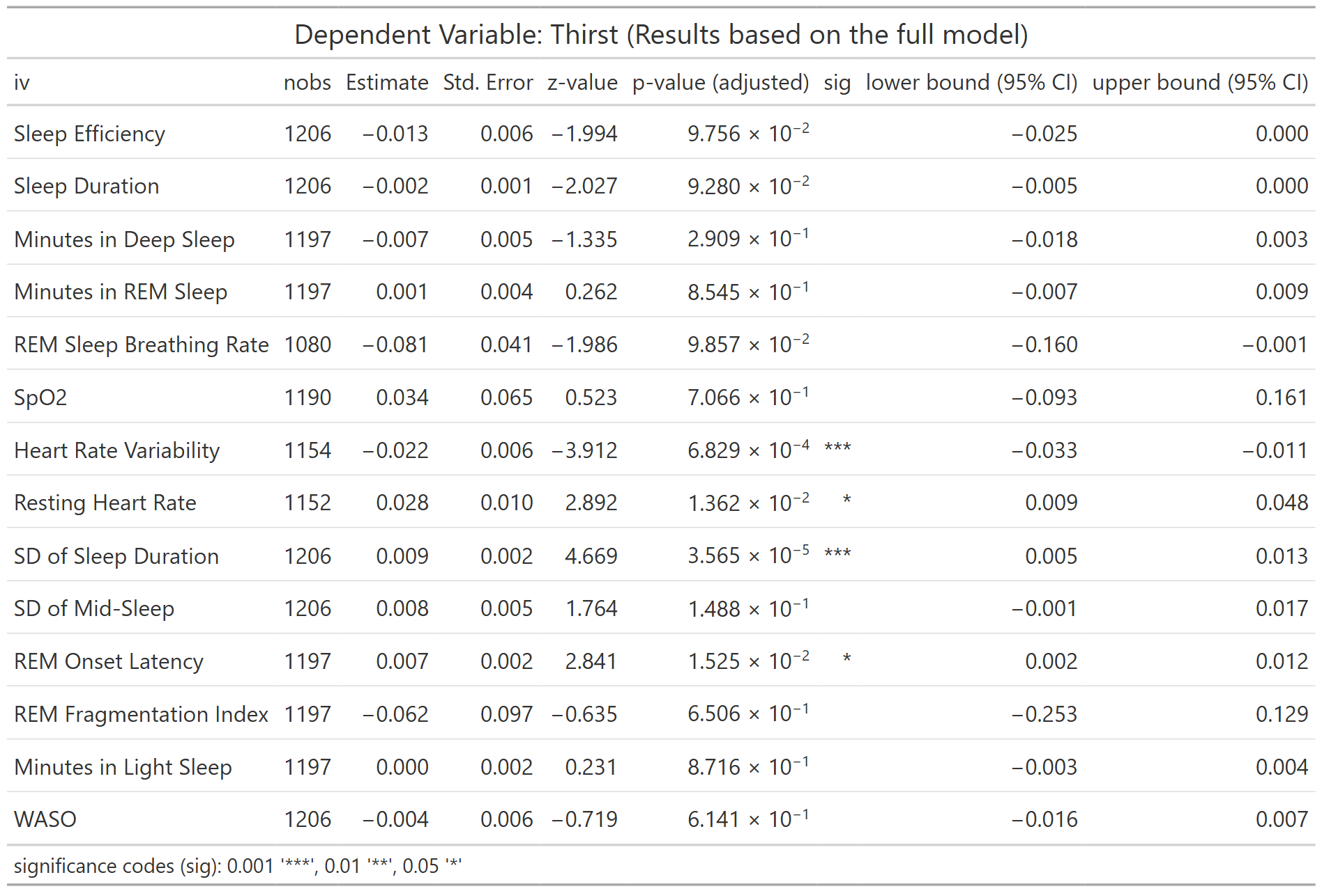
nobs = number of observations
Table S29. Association between LC symptom of Palpitations and WDSM (Model 1)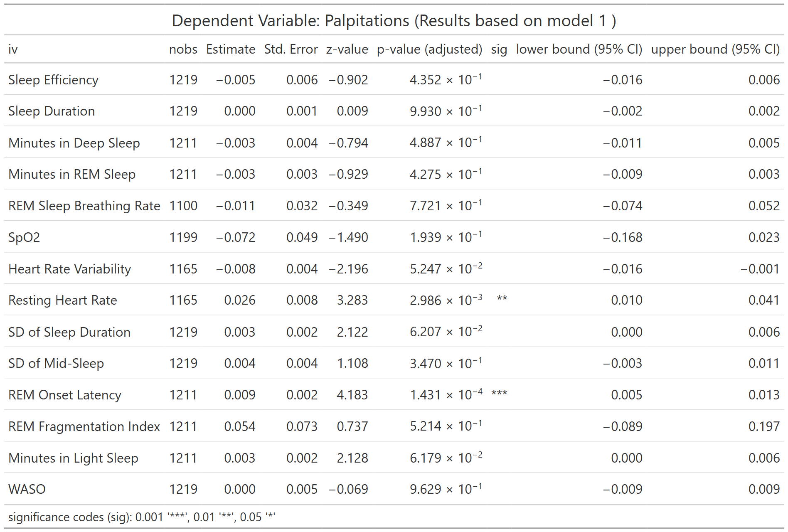
nobs = number of observations
Table S30. Association between LC symptom of Palpitations and WDSM (Model 2)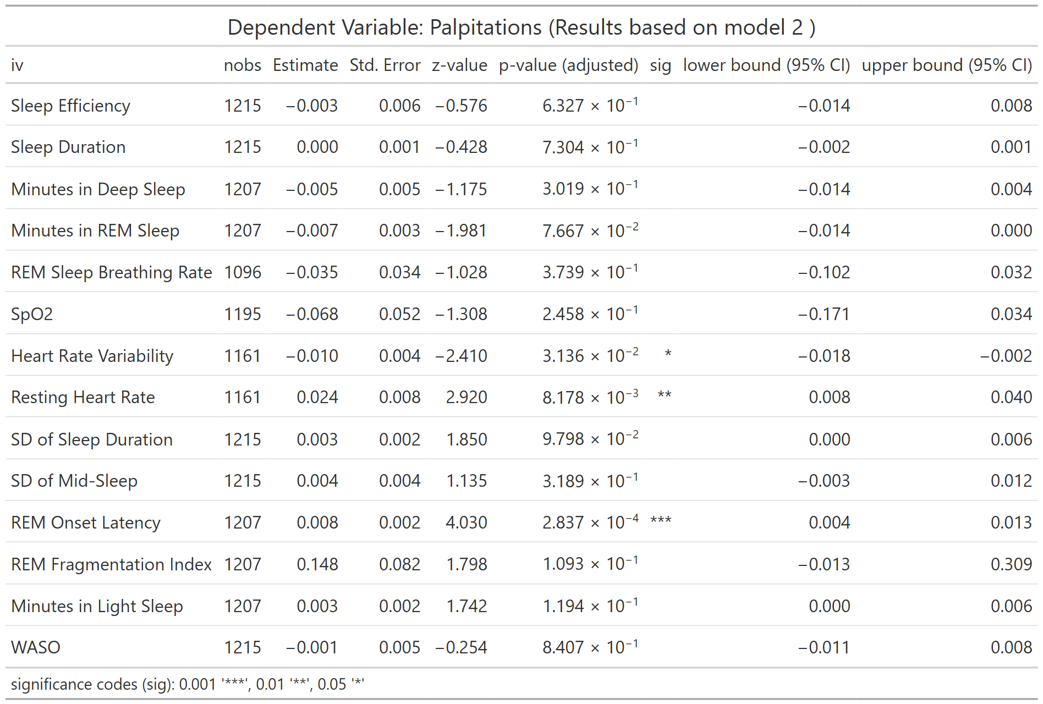
nobs = number of observations
Table S31. Association between LC symptom of Palpitations and WDSM (Model 3)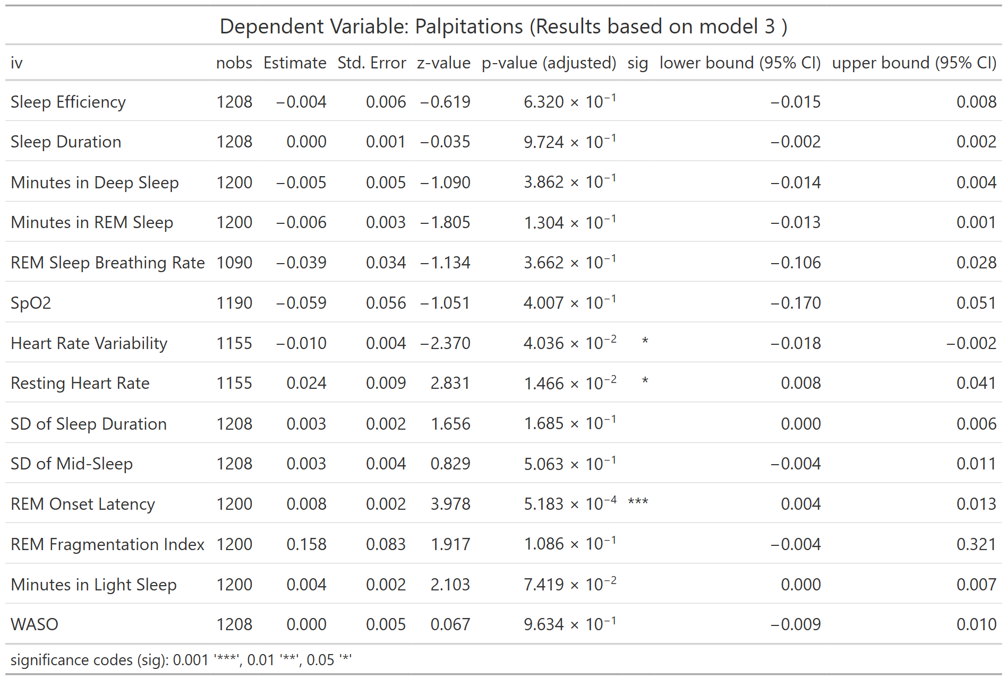
nobs = number of observations
Table S32. Association between LC symptom of Palpitations and WDSM (Full Model)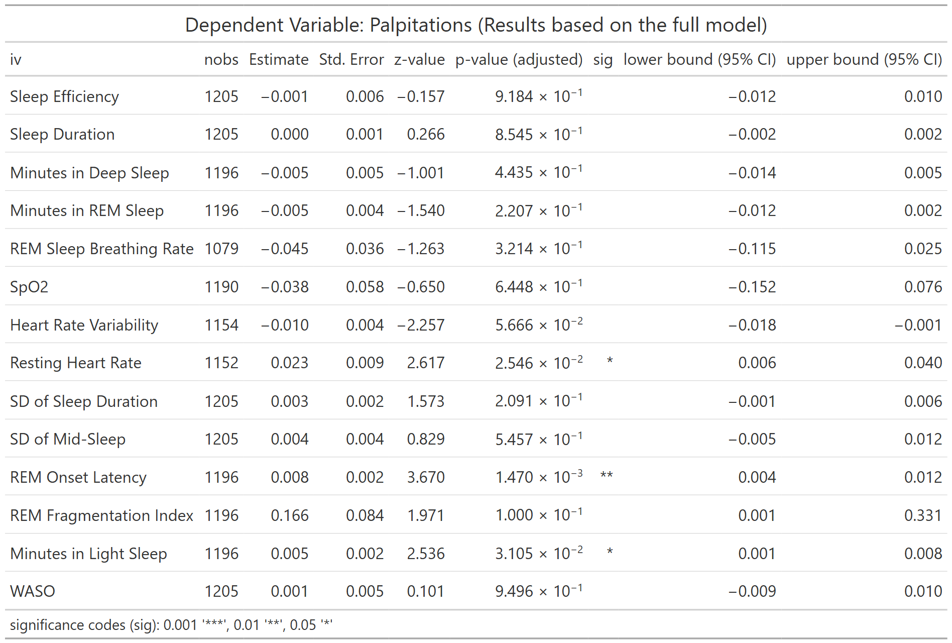
nobs = number of observations
Table S33. Association between LC symptom of Chest Pain and WDSM (Model 1)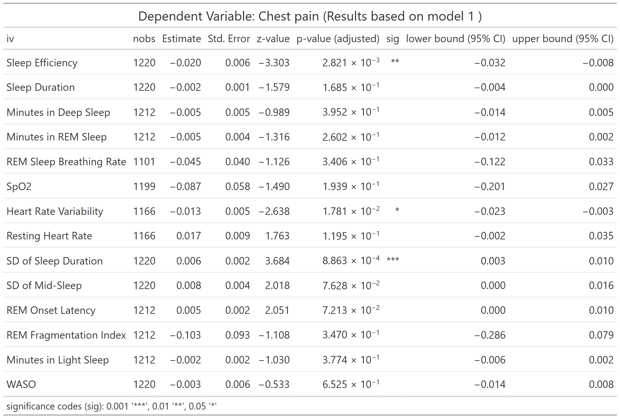
nobs = number of observations
Table S34. Association between LC symptom of Chest Pain and WDSM (Model 2)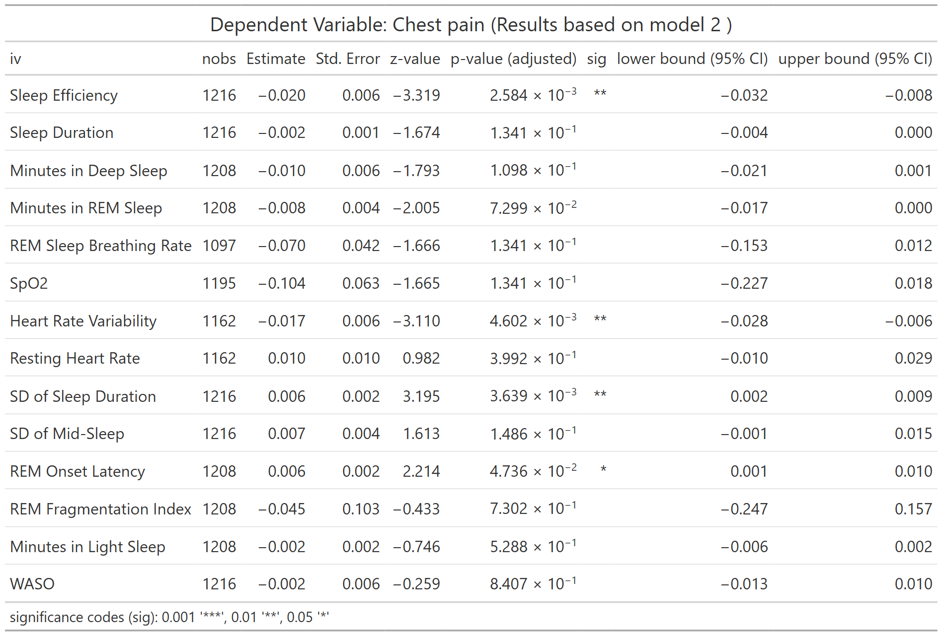
nobs = number of observations
Table S35. Association between LC symptom of Chest Pain and WDSM (Model 3)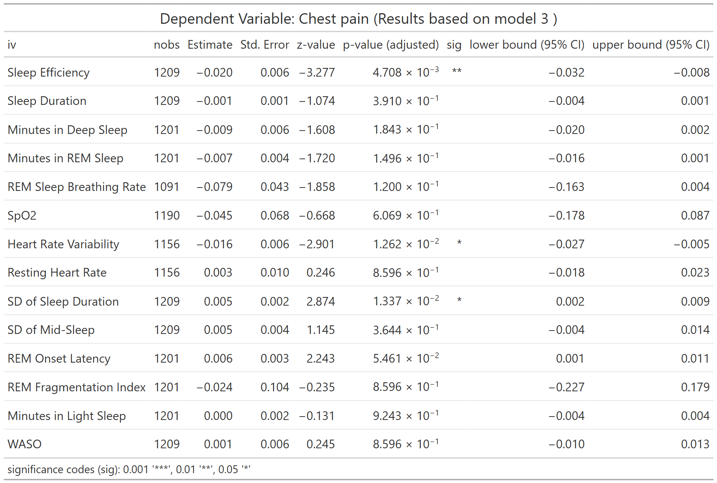
nobs = number of observations
Table S36. Association between LC symptom of Chest Pain and WDSM (Full Model)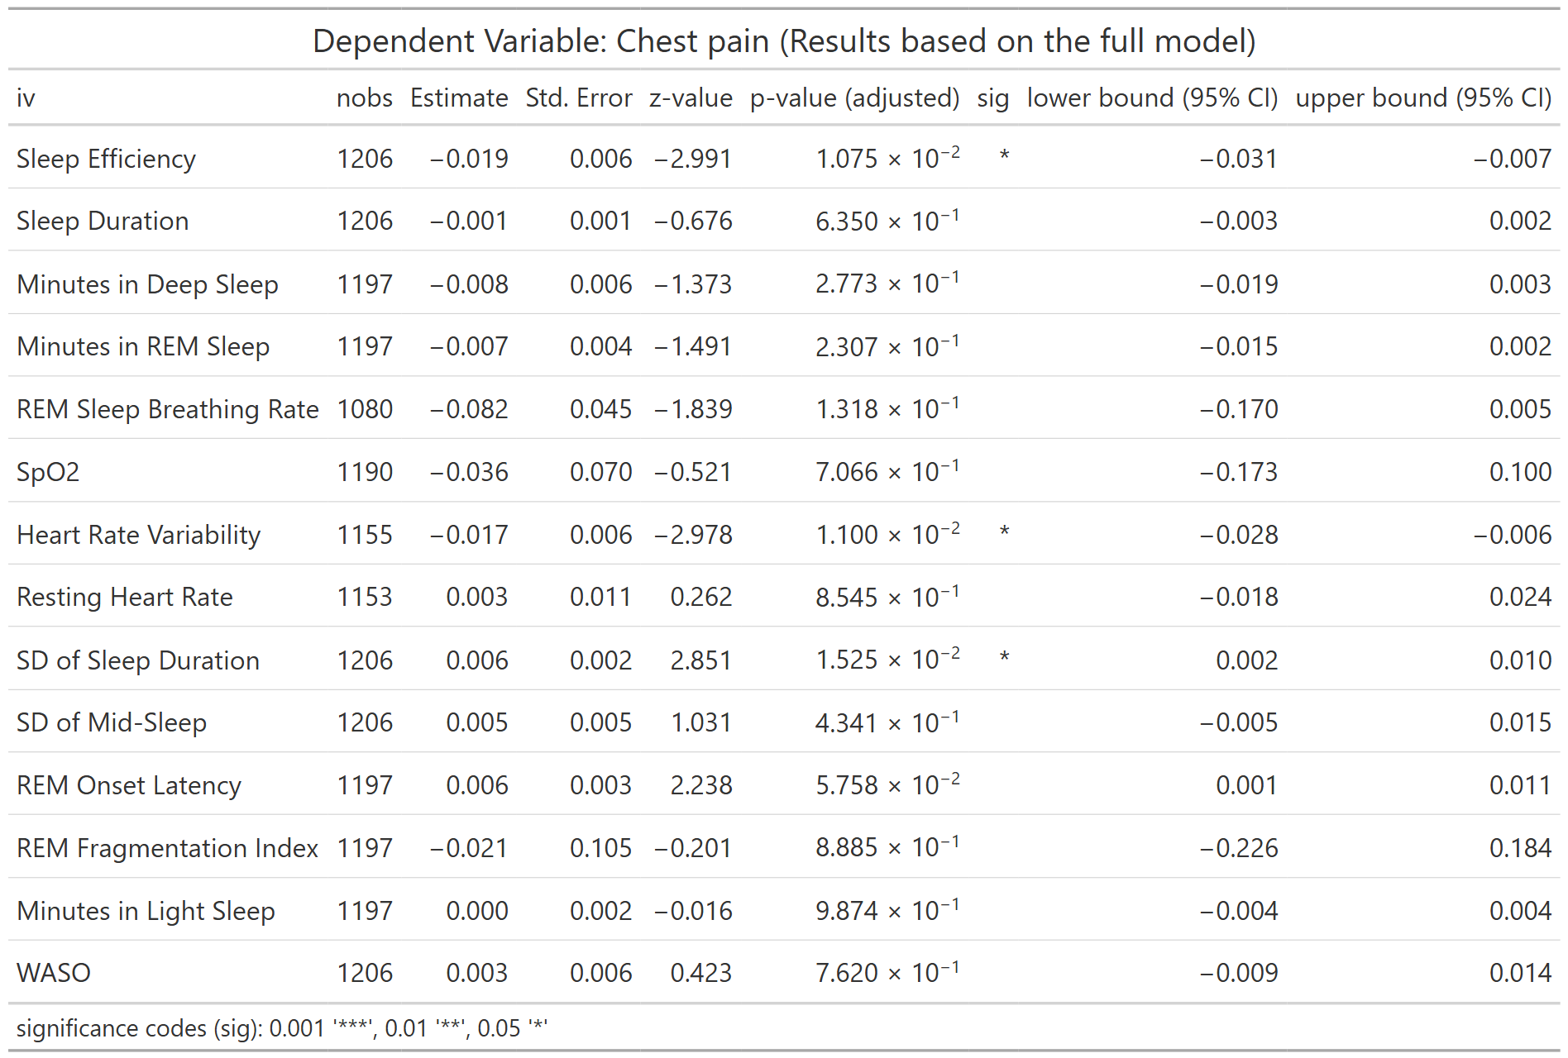
nobs = number of observations
Table S37. Association between LC symptom of Fatigue and WDSM (Model 1)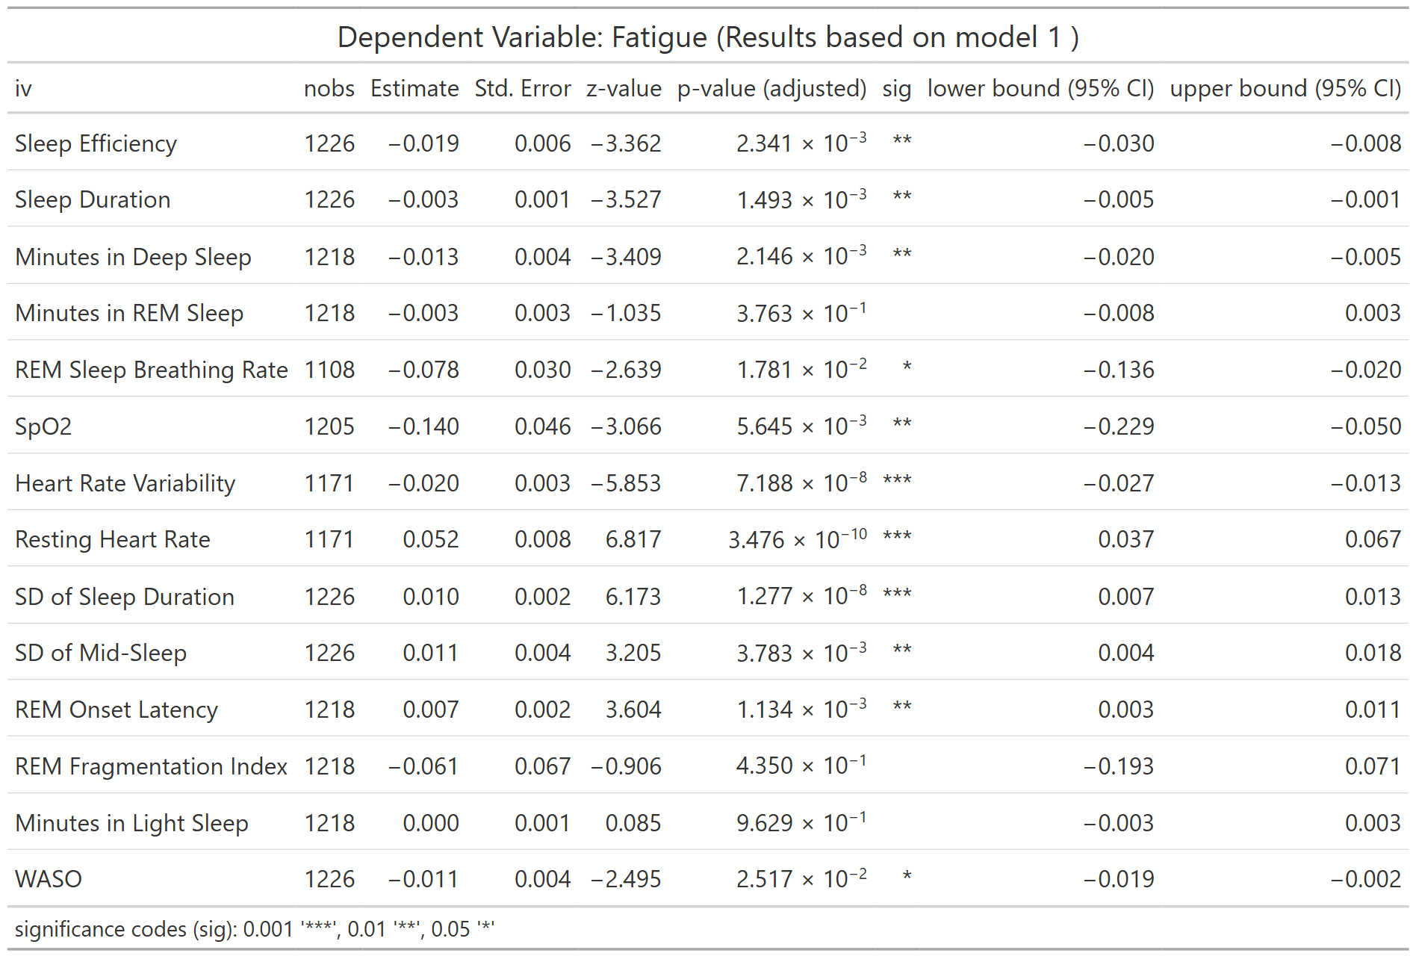
nobs = number of observations
Table S38. Association between LC symptom of Fatigue and WDSM (Model 2)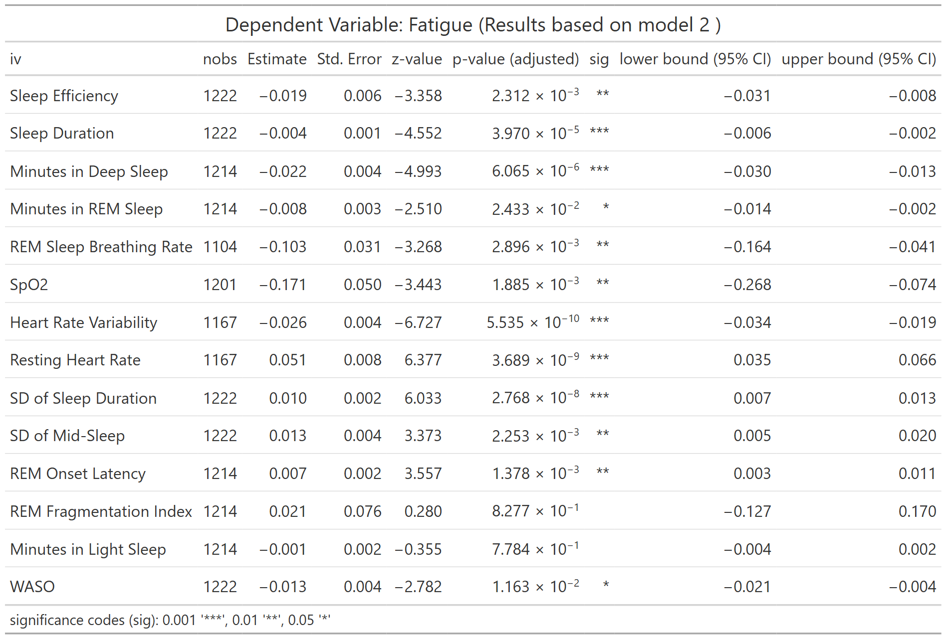
nobs = number of observations
Table S39. Association between LC symptom of Fatigue and WDSM (Model 3)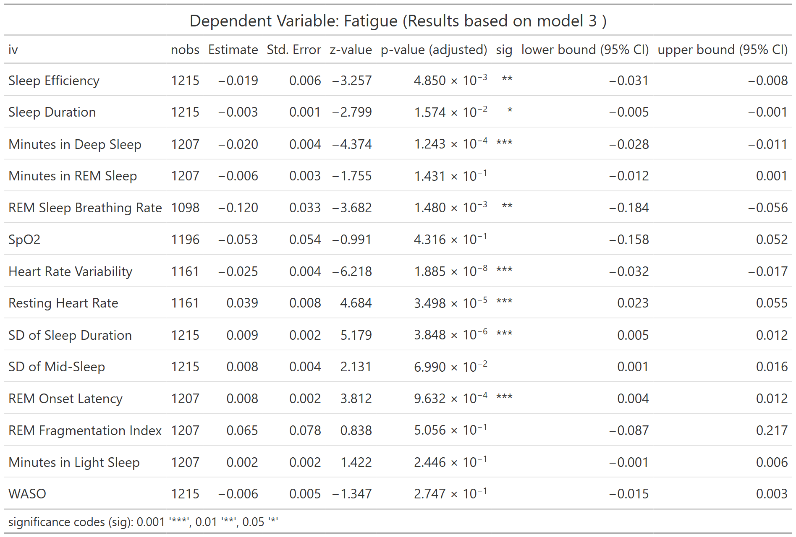
nobs = number of observations
Table S40. Association between LC symptom of Fatigue and WDSM (Full Model)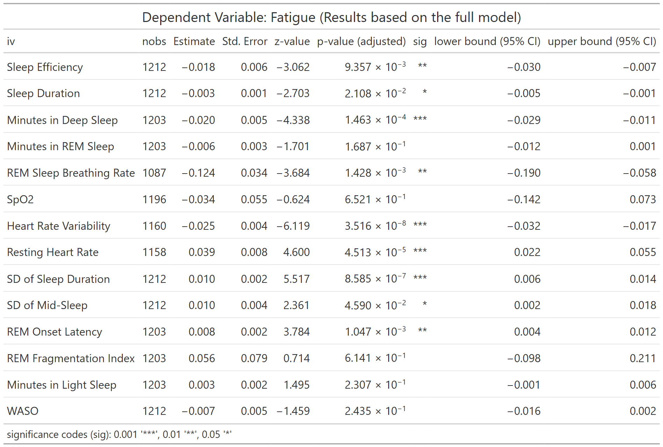
nobs = number of observations
Table S41. Association between LC symptom of Dizziness and WDSM (Model 1)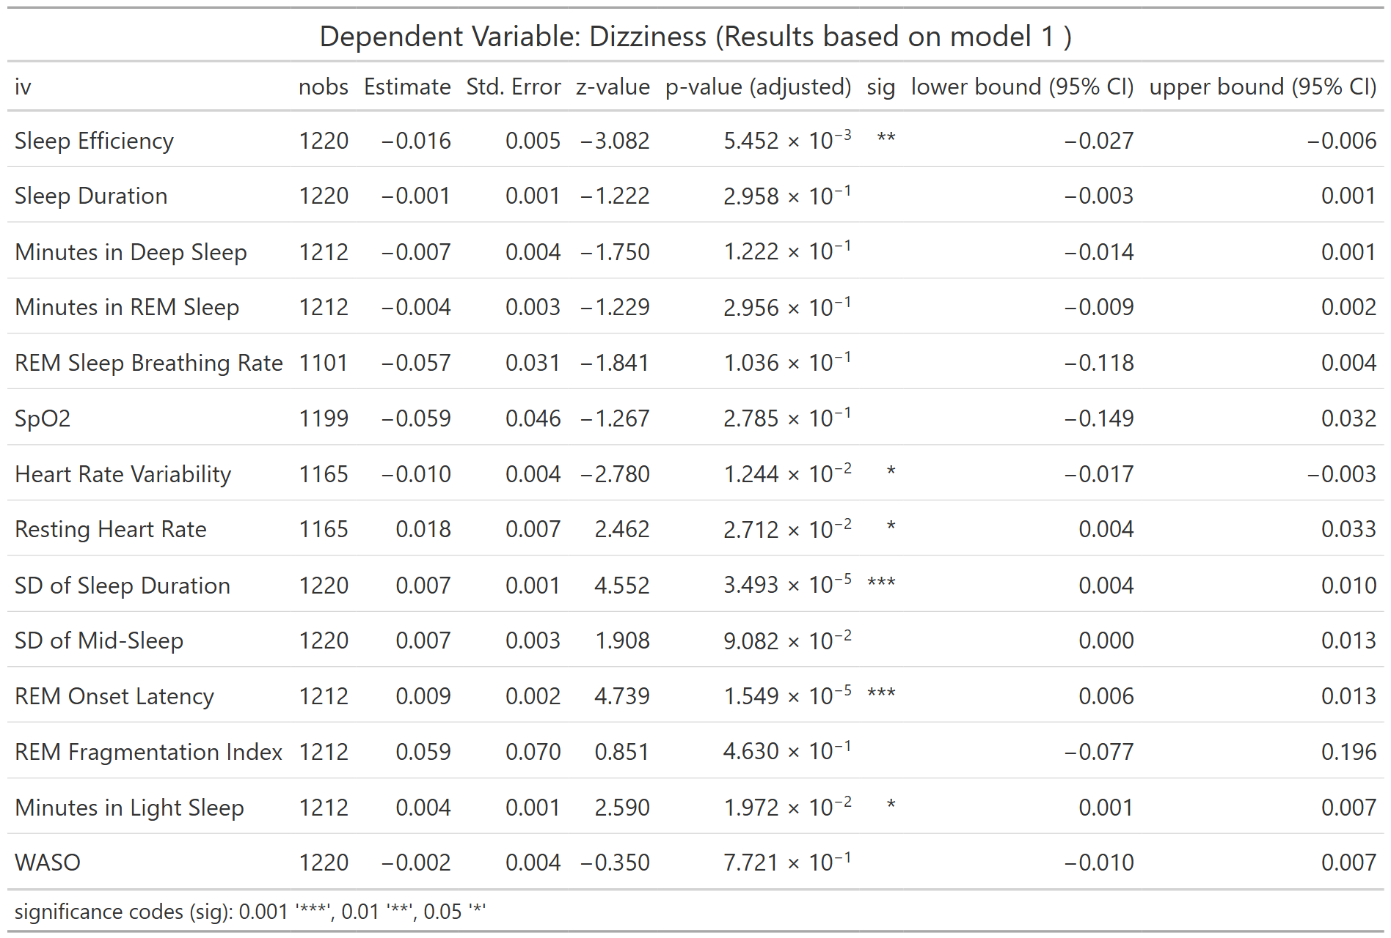
nobs = number of observations
Table S42. Association between LC symptom of Dizziness and WDSM (Model 2) 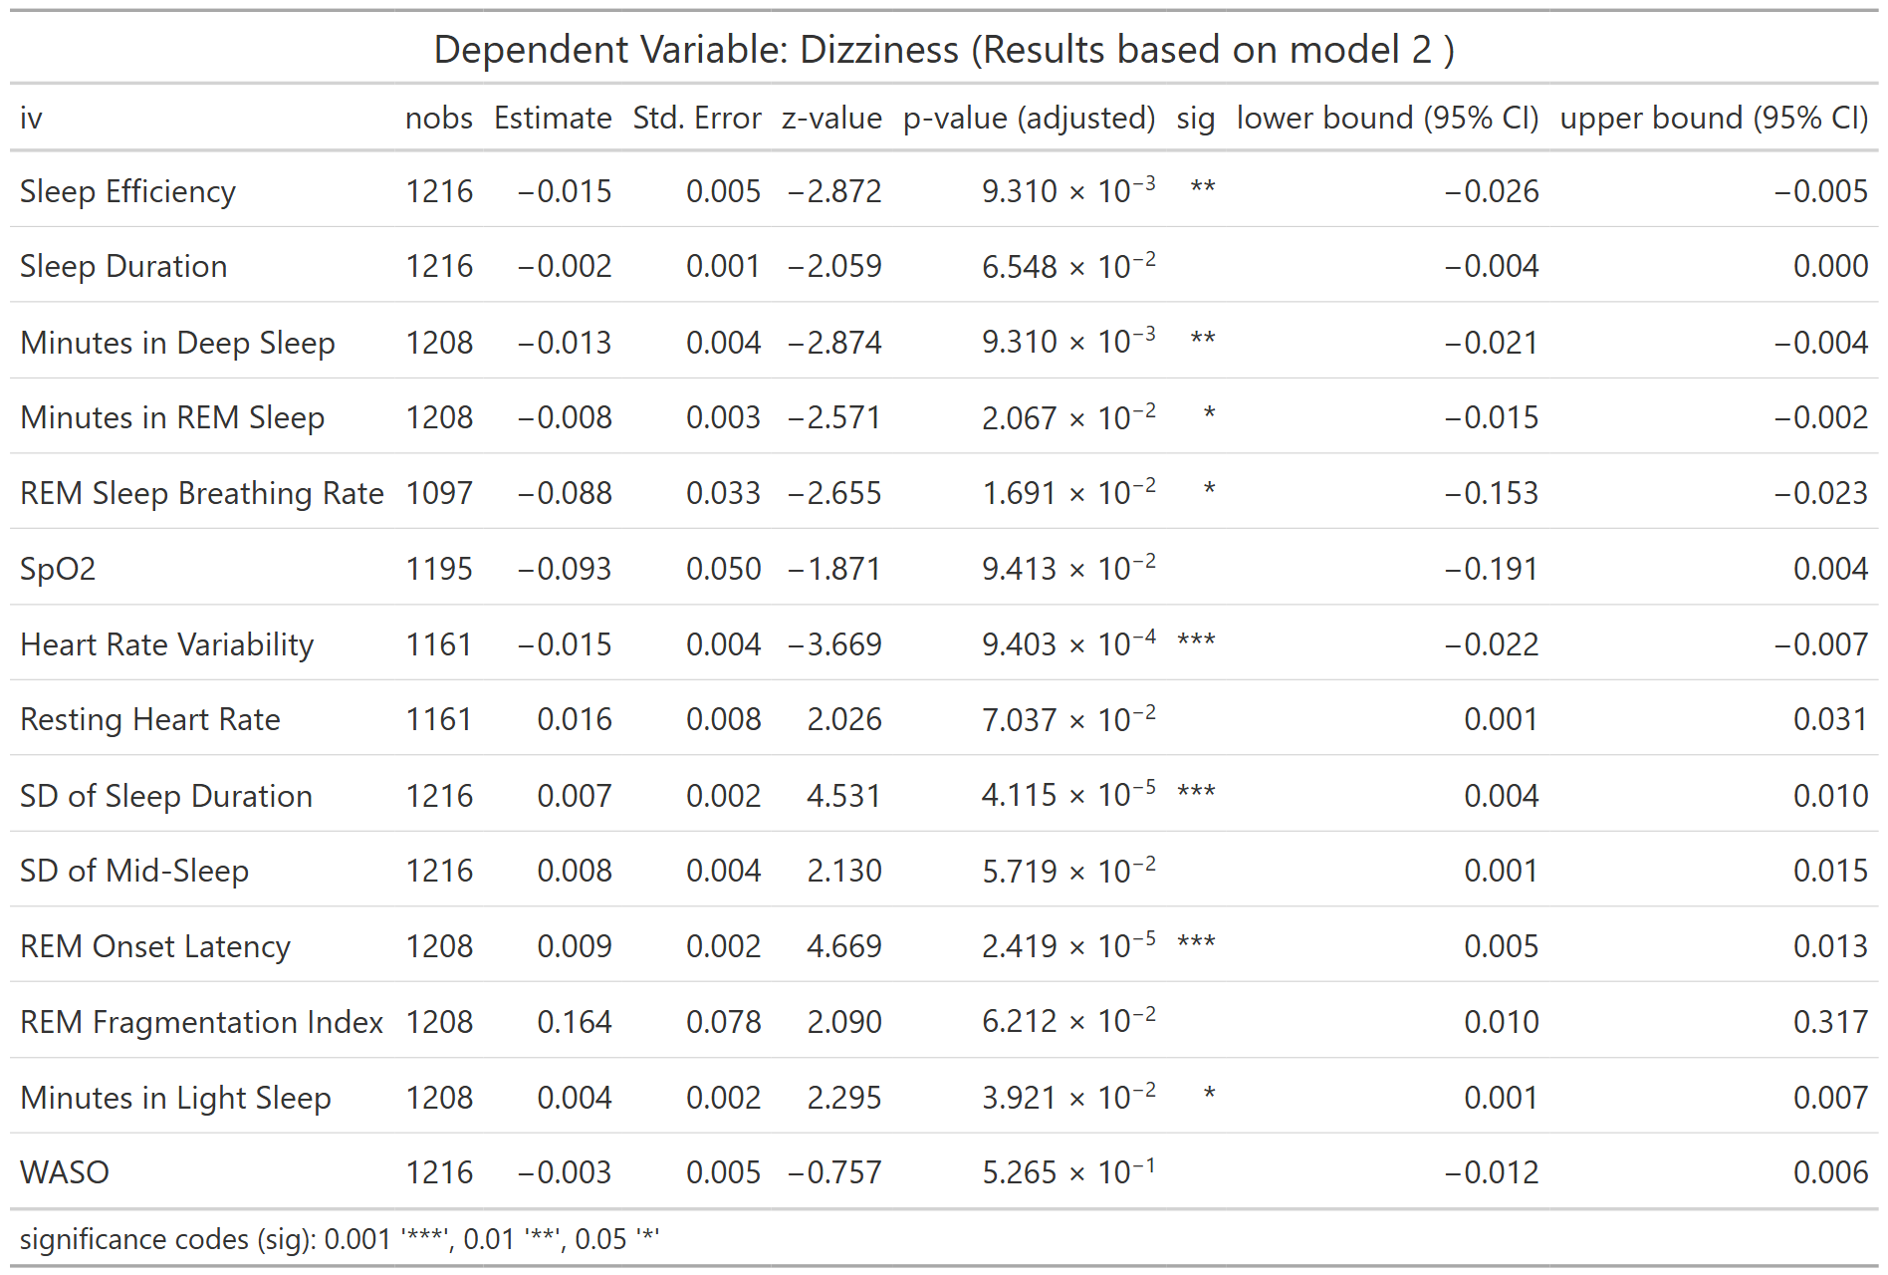
nobs = number of observations
Table S43. Association between LC symptom of Dizziness and WDSM (Model 3)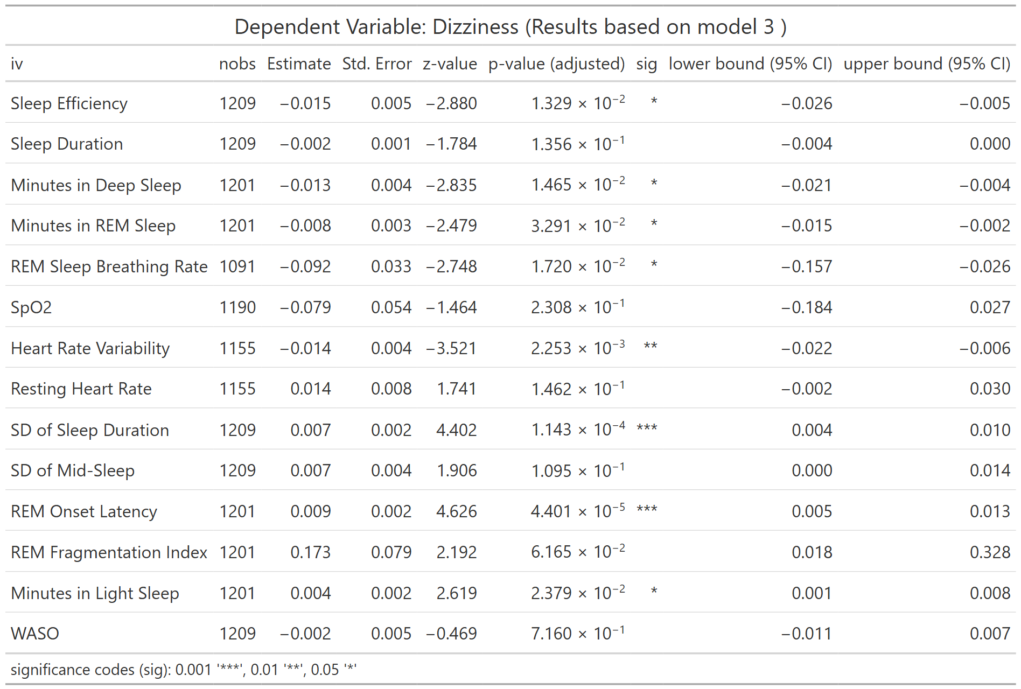
nobs = number of observations
Table S44. Association between LC symptom of Dizziness and WDSM (Full Model)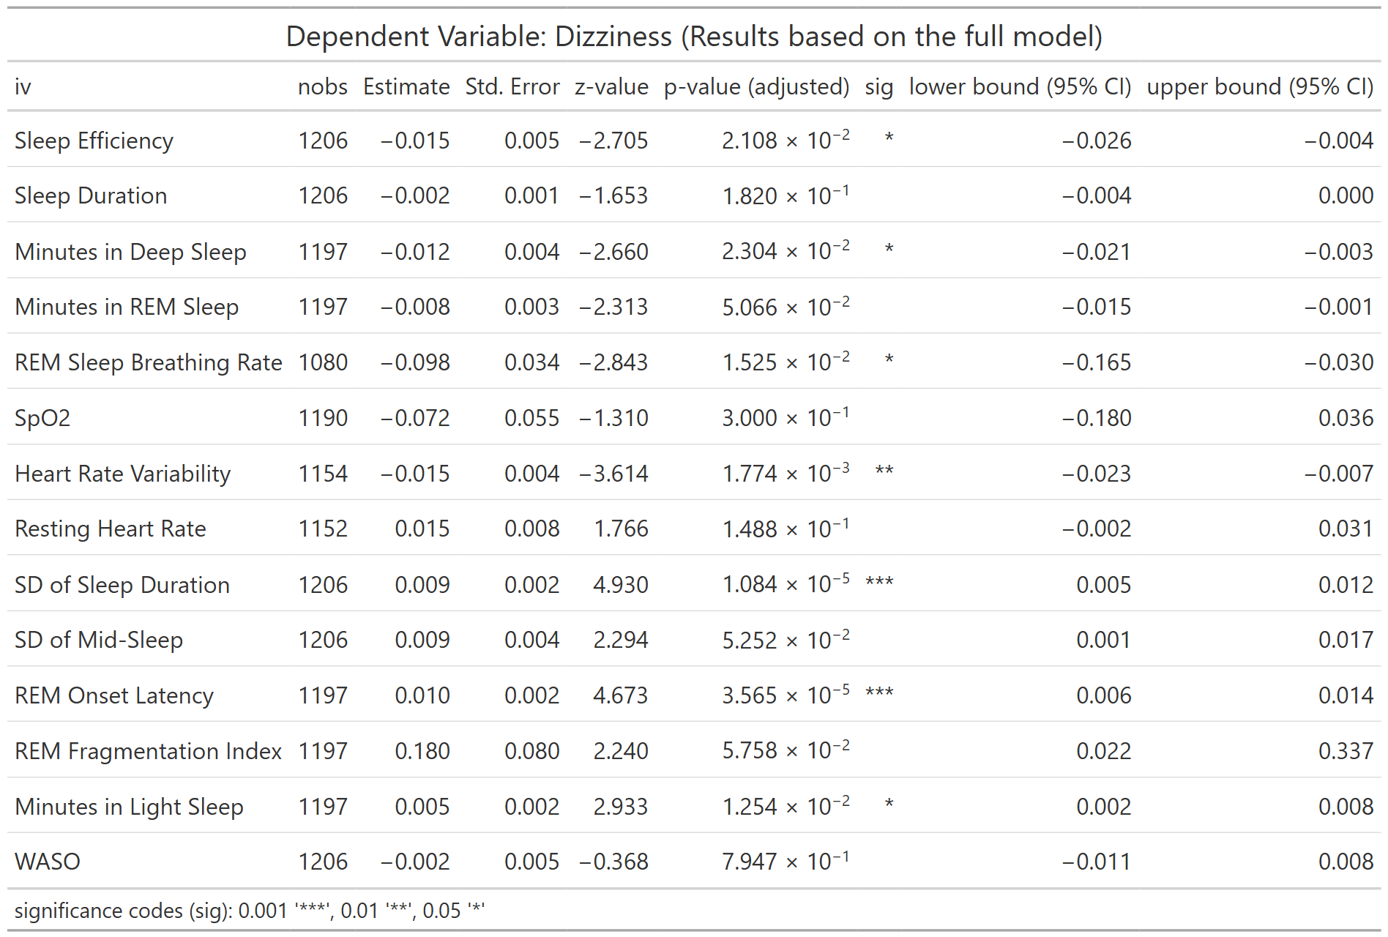
nobs = number of observations
Table S45. Association between LC symptom of Gastrointestinal Symptoms and WDSM (Model 1) 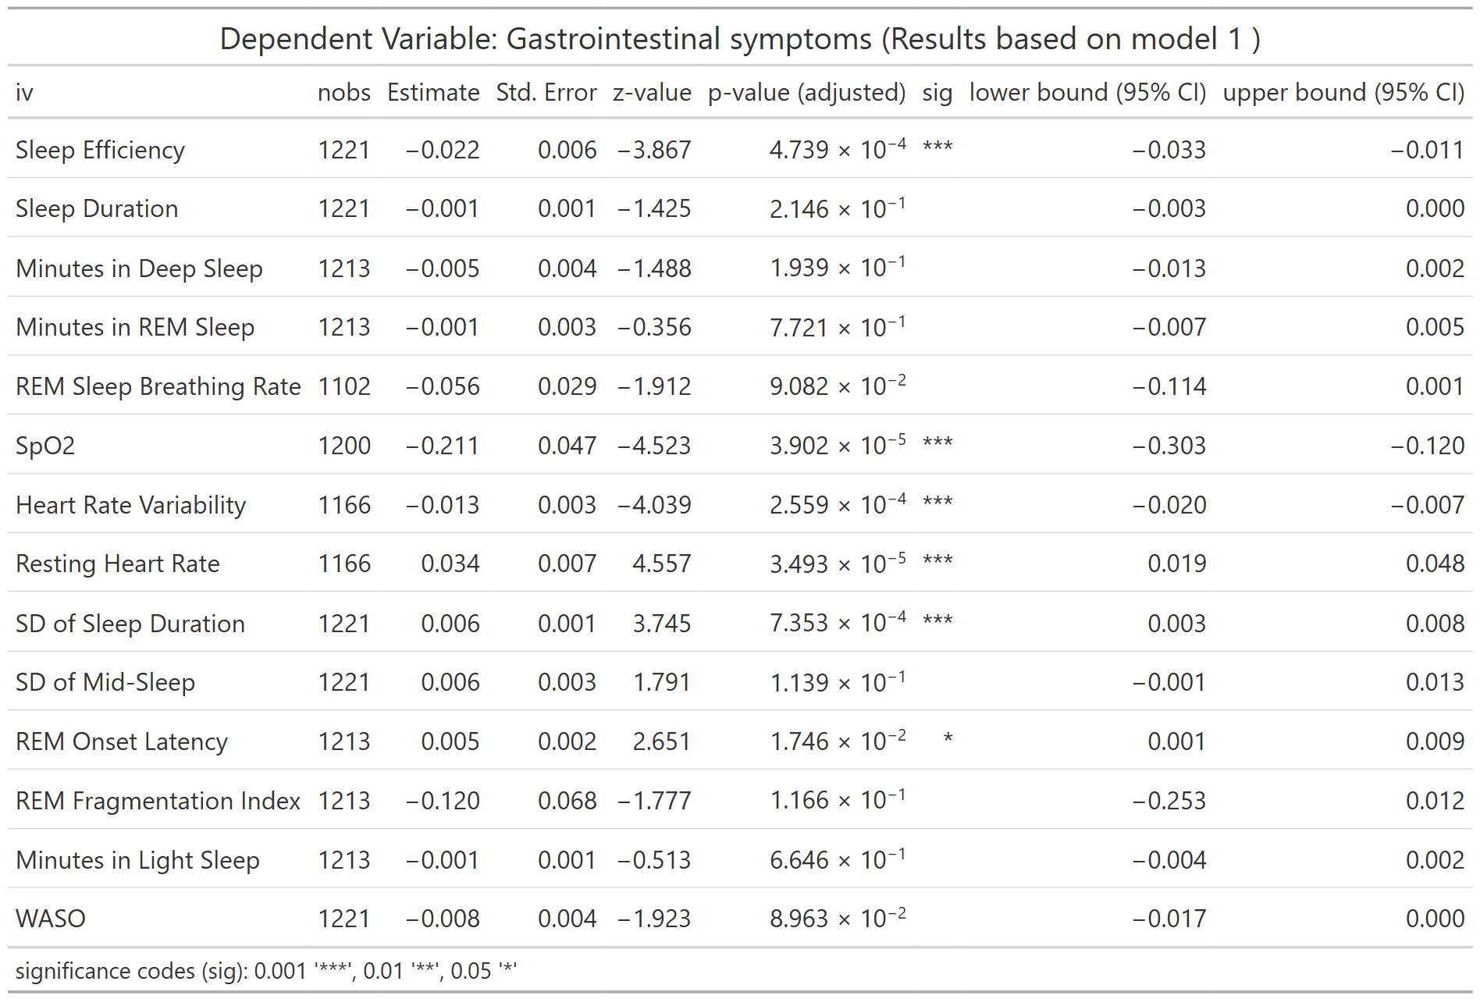
nobs = number of observations
Table S46. Association between LC symptom of Gastrointestinal Symptoms and WDSM (Model 2) 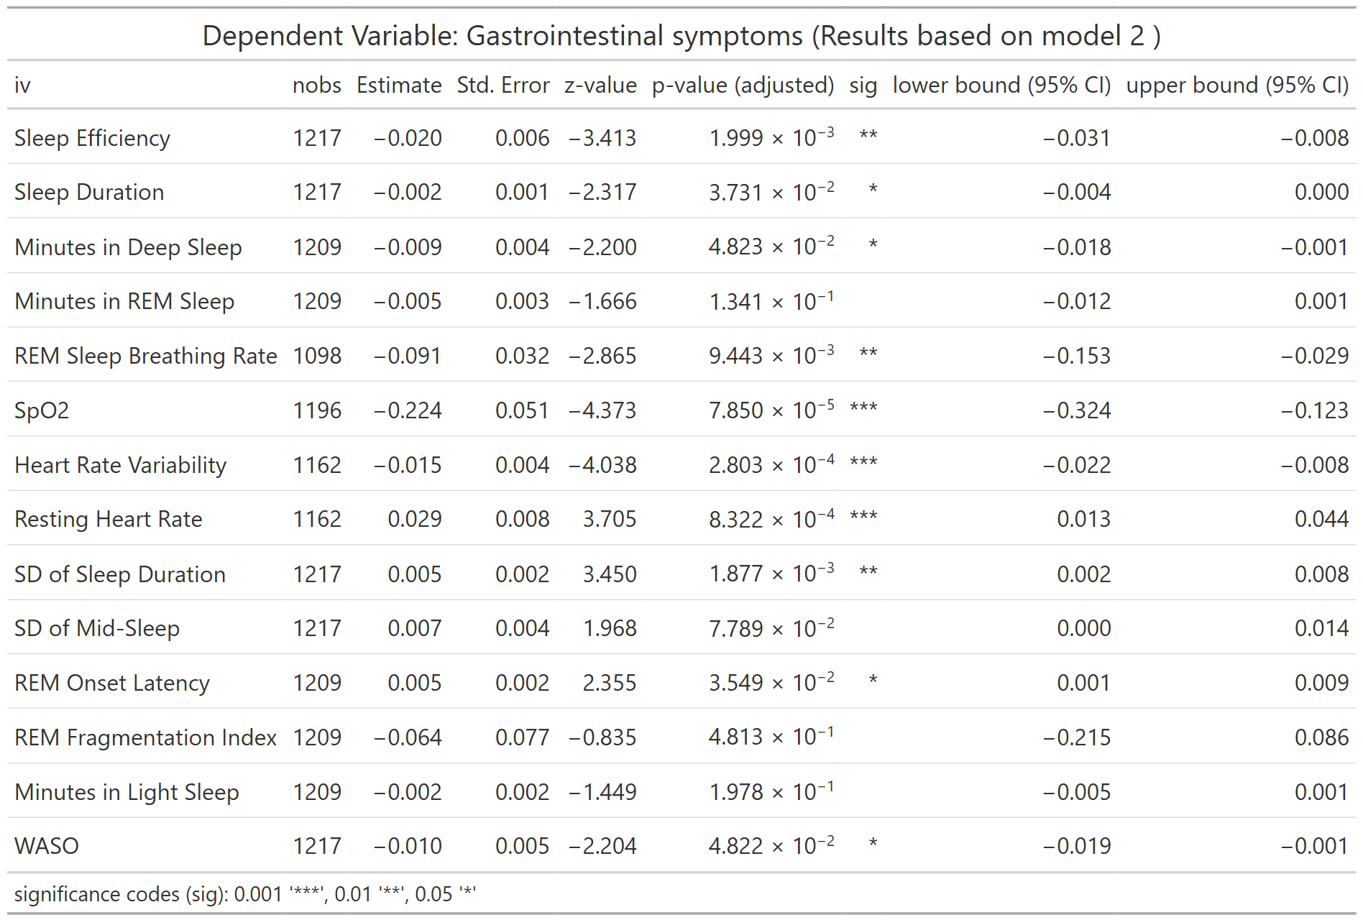
nobs = number of observations
Table S47. Association between LC symptom of Gastrointestinal Symptoms and WDSM (Model 3) 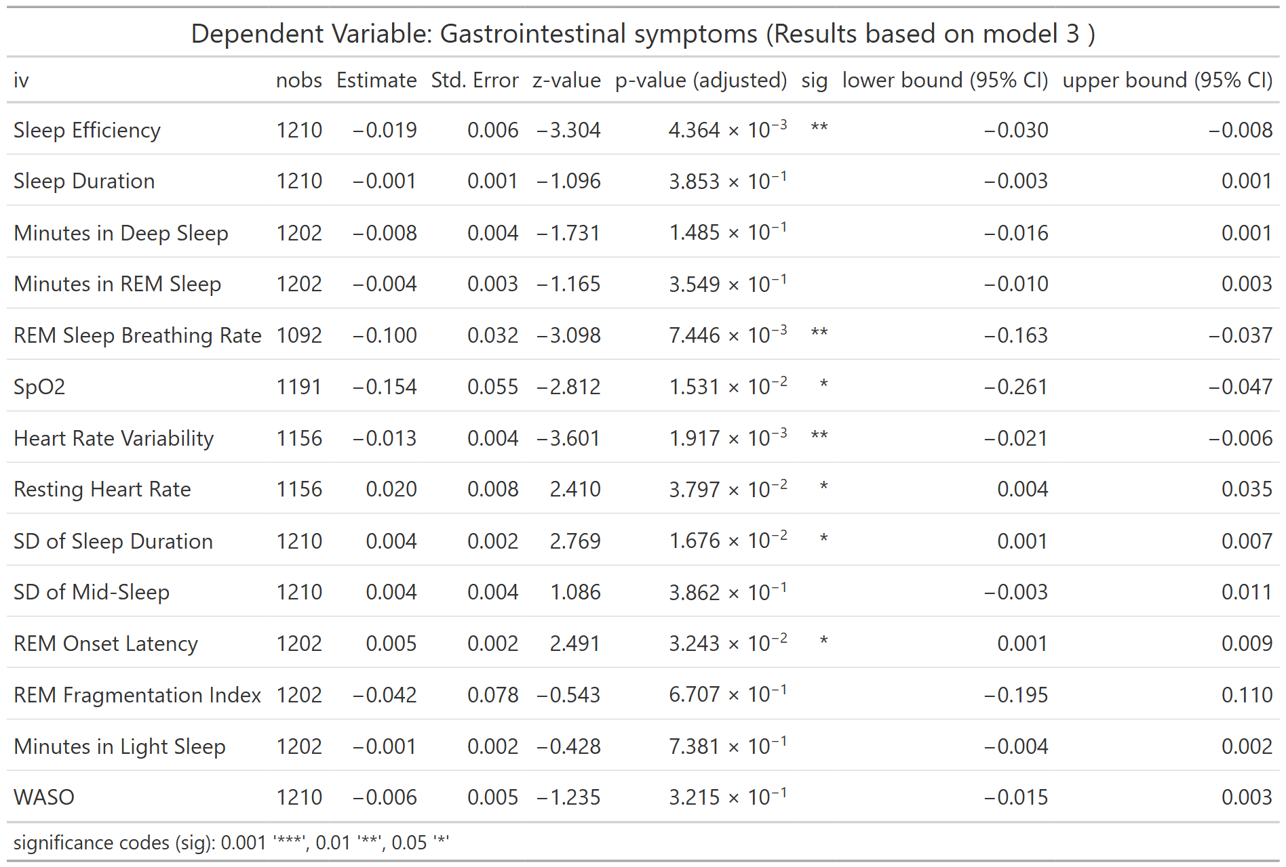
nobs = number of observations
Table S48. Association between LC symptom of Gastrointestinal Symptoms and WDSM (Full Model)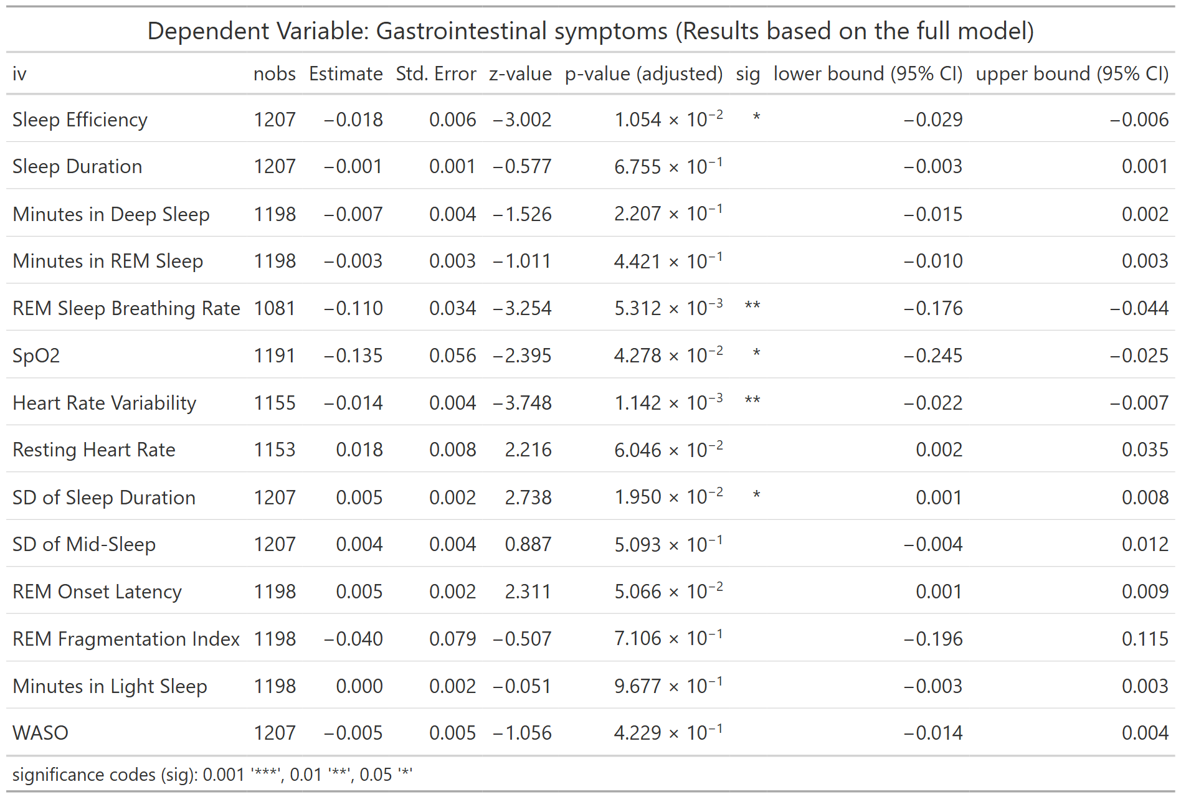
nobs = number of observations
Table S49. Association between LC symptom of Head Pain and WDSM (Model 1) 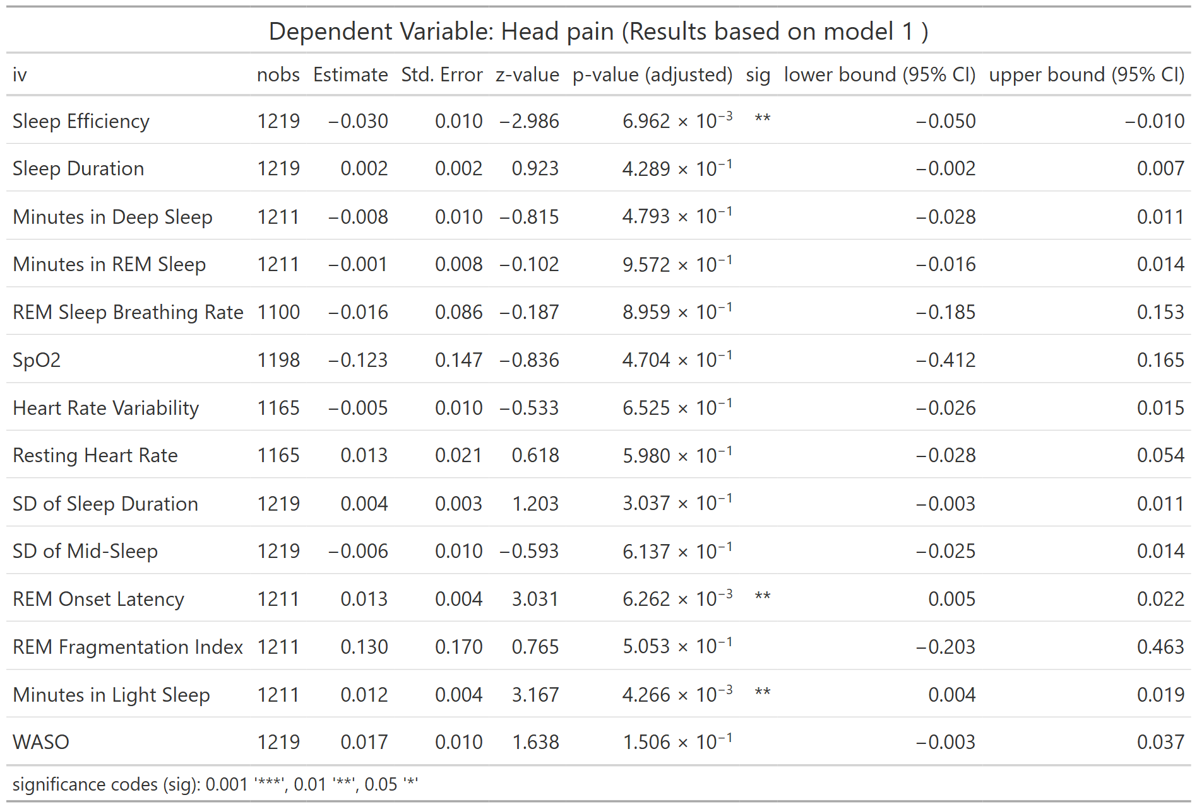
nobs = number of observations
Table S50. Association between LC symptom of Head Pain and WDSM (Model 2) 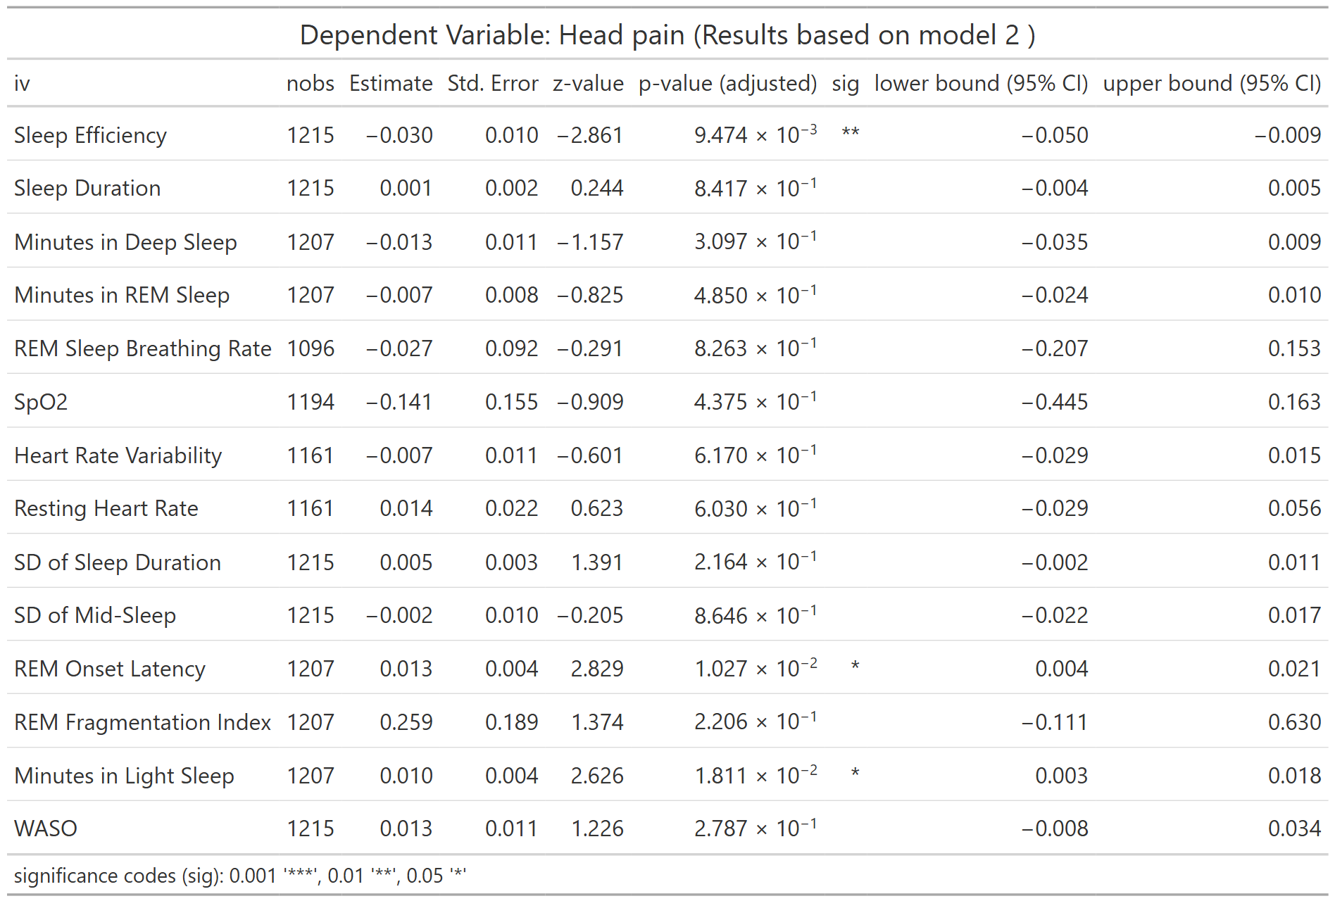
nobs = number of observations
Table S51. Association between LC symptom of Head Pain and WDSM (Model 3)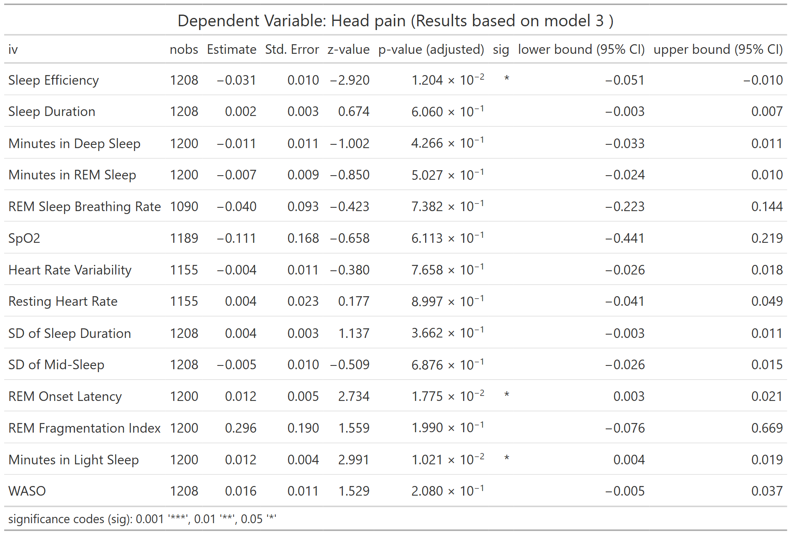
nobs = number of observations
Table S52. Association between LC symptom of Head Pain and WDSM (Full Model) 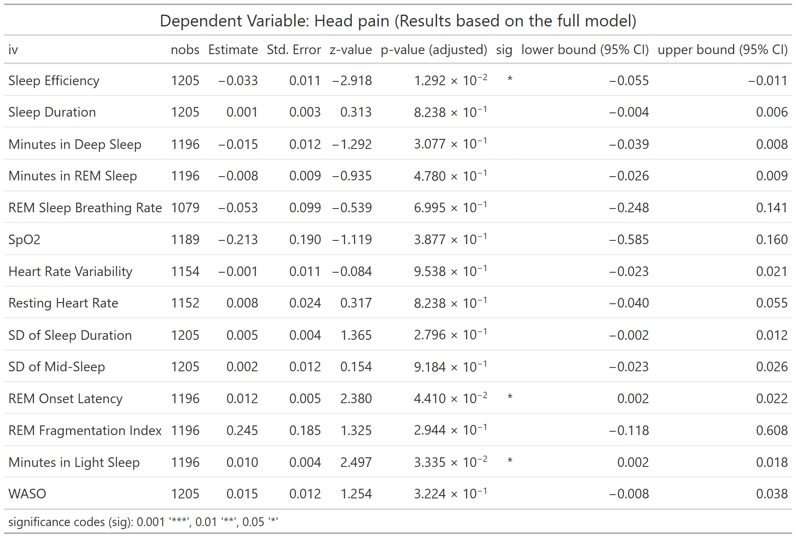
nobs = number of observations
Table S53. Association between LC symptom of Shortness of Breath and WDSM (Model 1) 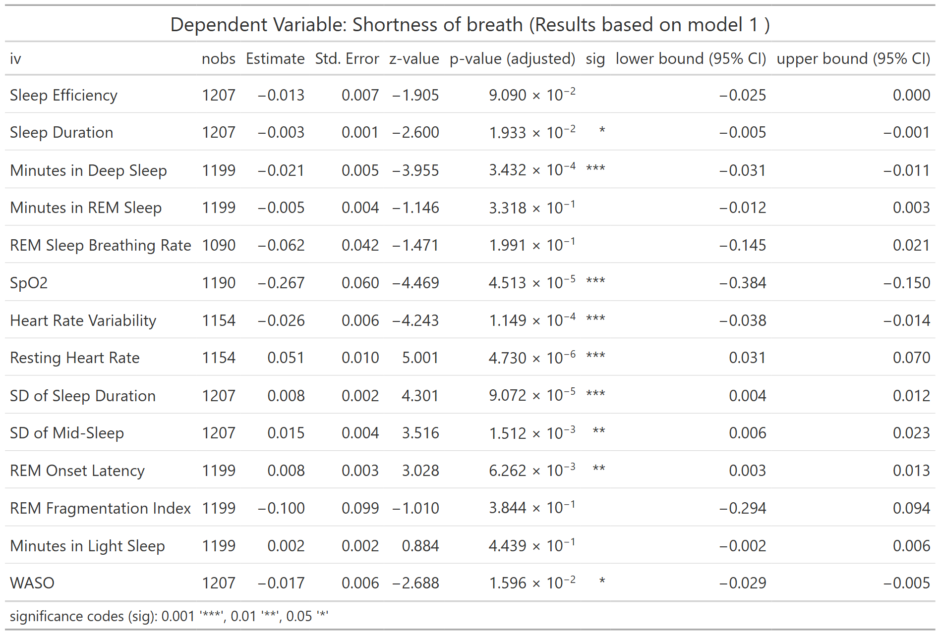
nobs = number of observations
Table S54. Association between LC symptom of Shortness of Breath and WDSM (Model 2)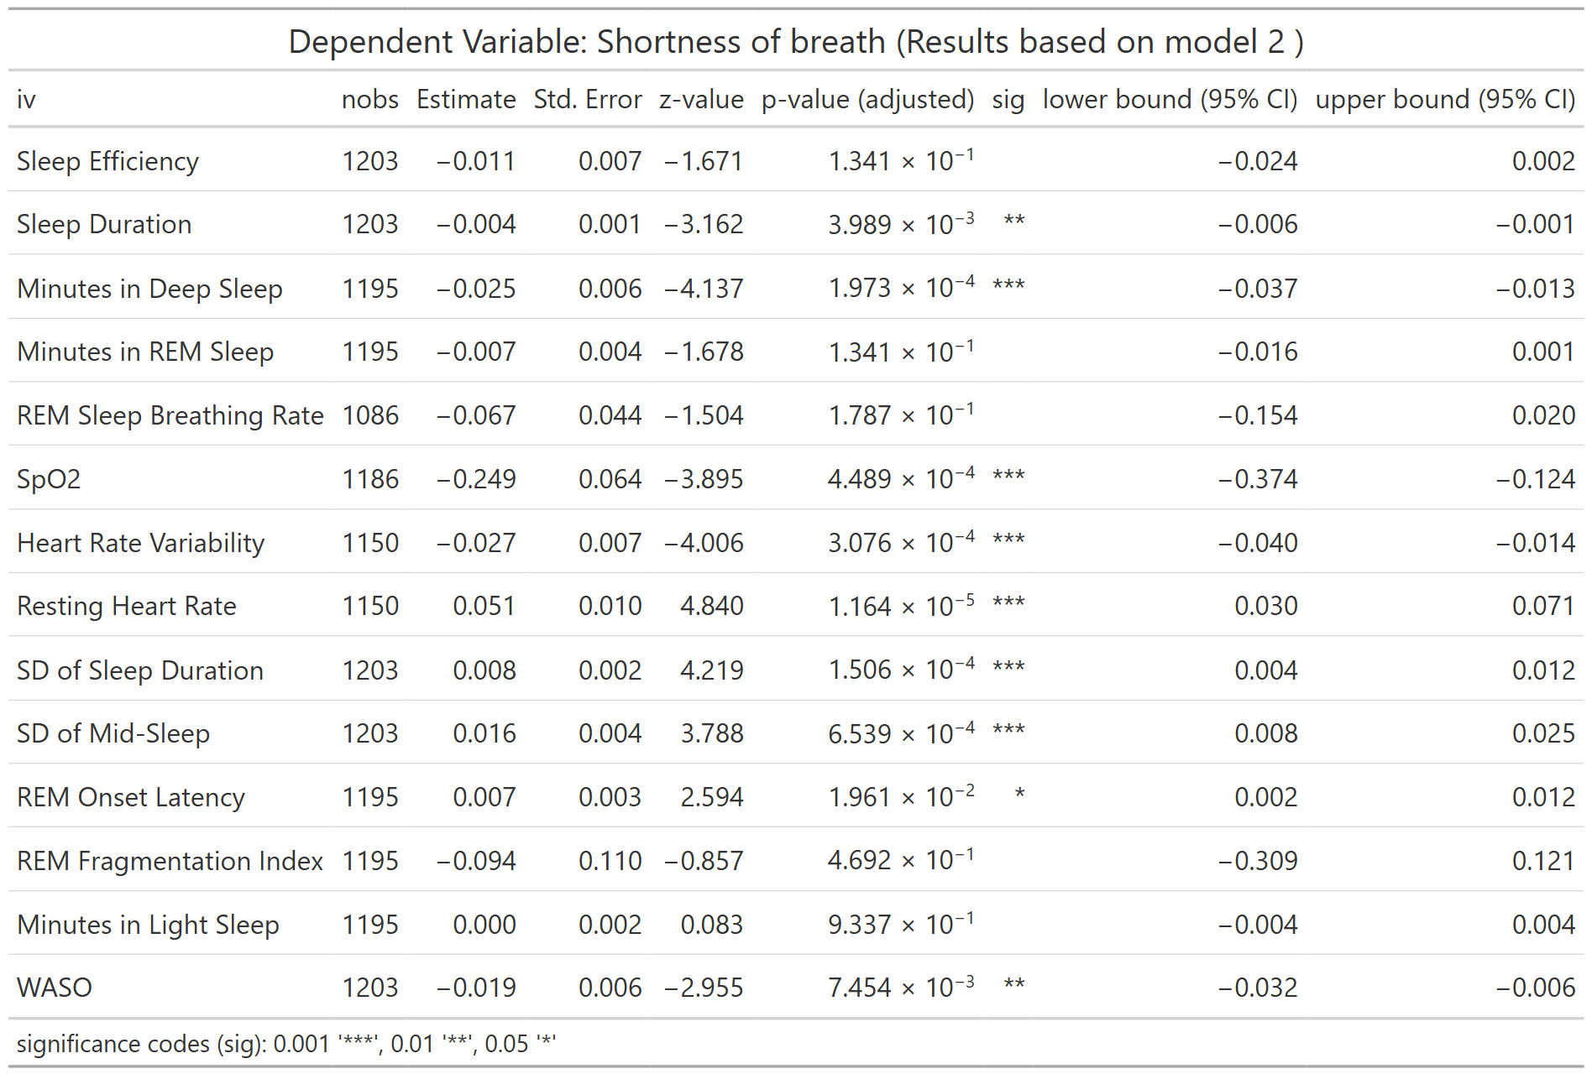
nobs = number of observations

Table S55. Association between LC symptom of Shortness of Breath and WDSM (Model 3)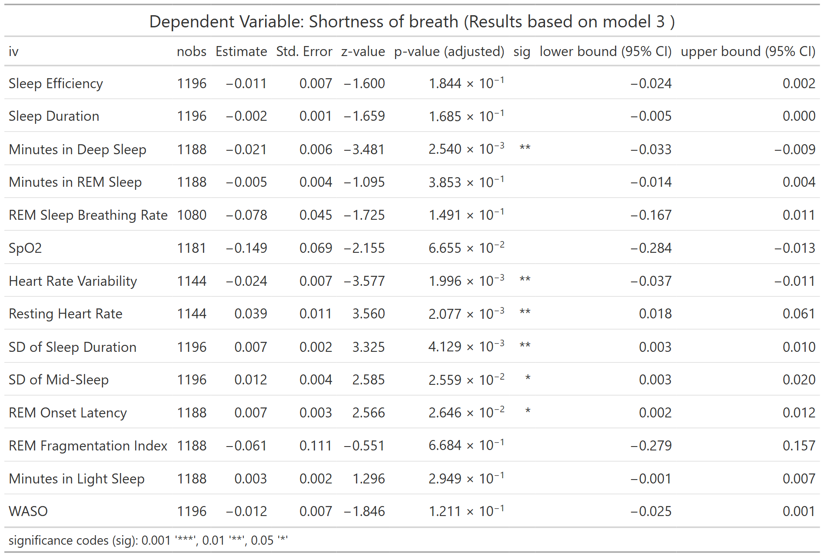
nobs = number of observations
Table S56. Association between LC symptom of Shortness of Breath and WDSM (Full Model)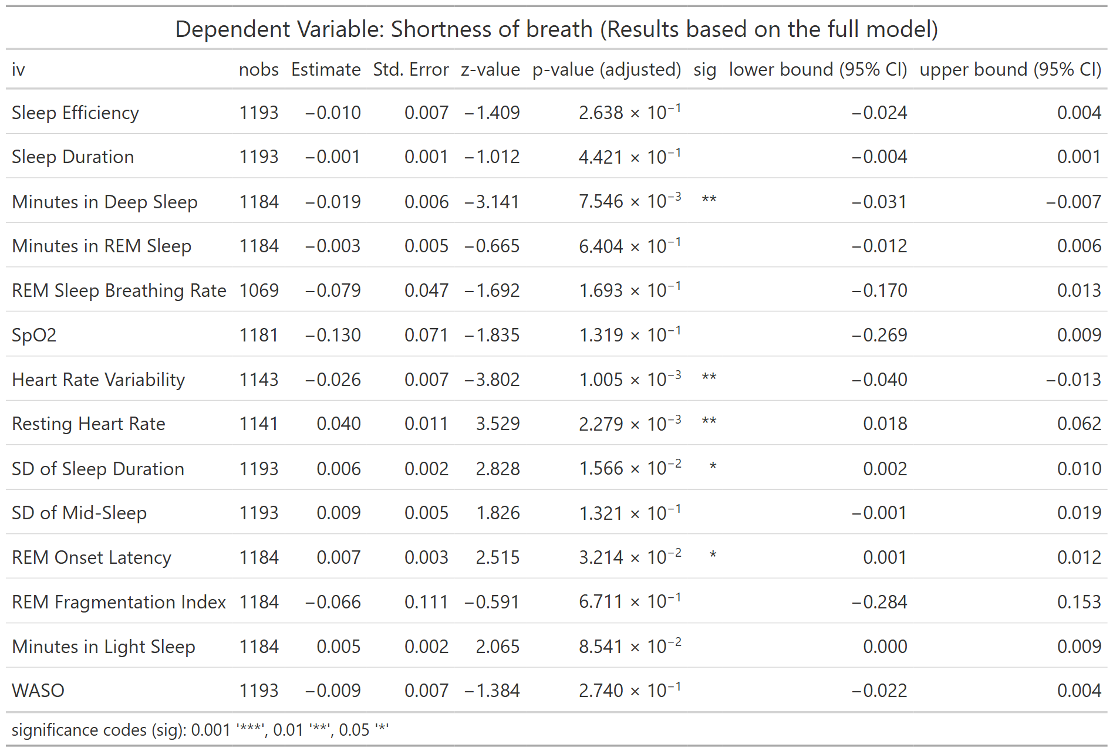
nobs = number of observations
Table S57. Association between LC symptom of Sleep Apnea and WDSM (Model 1) 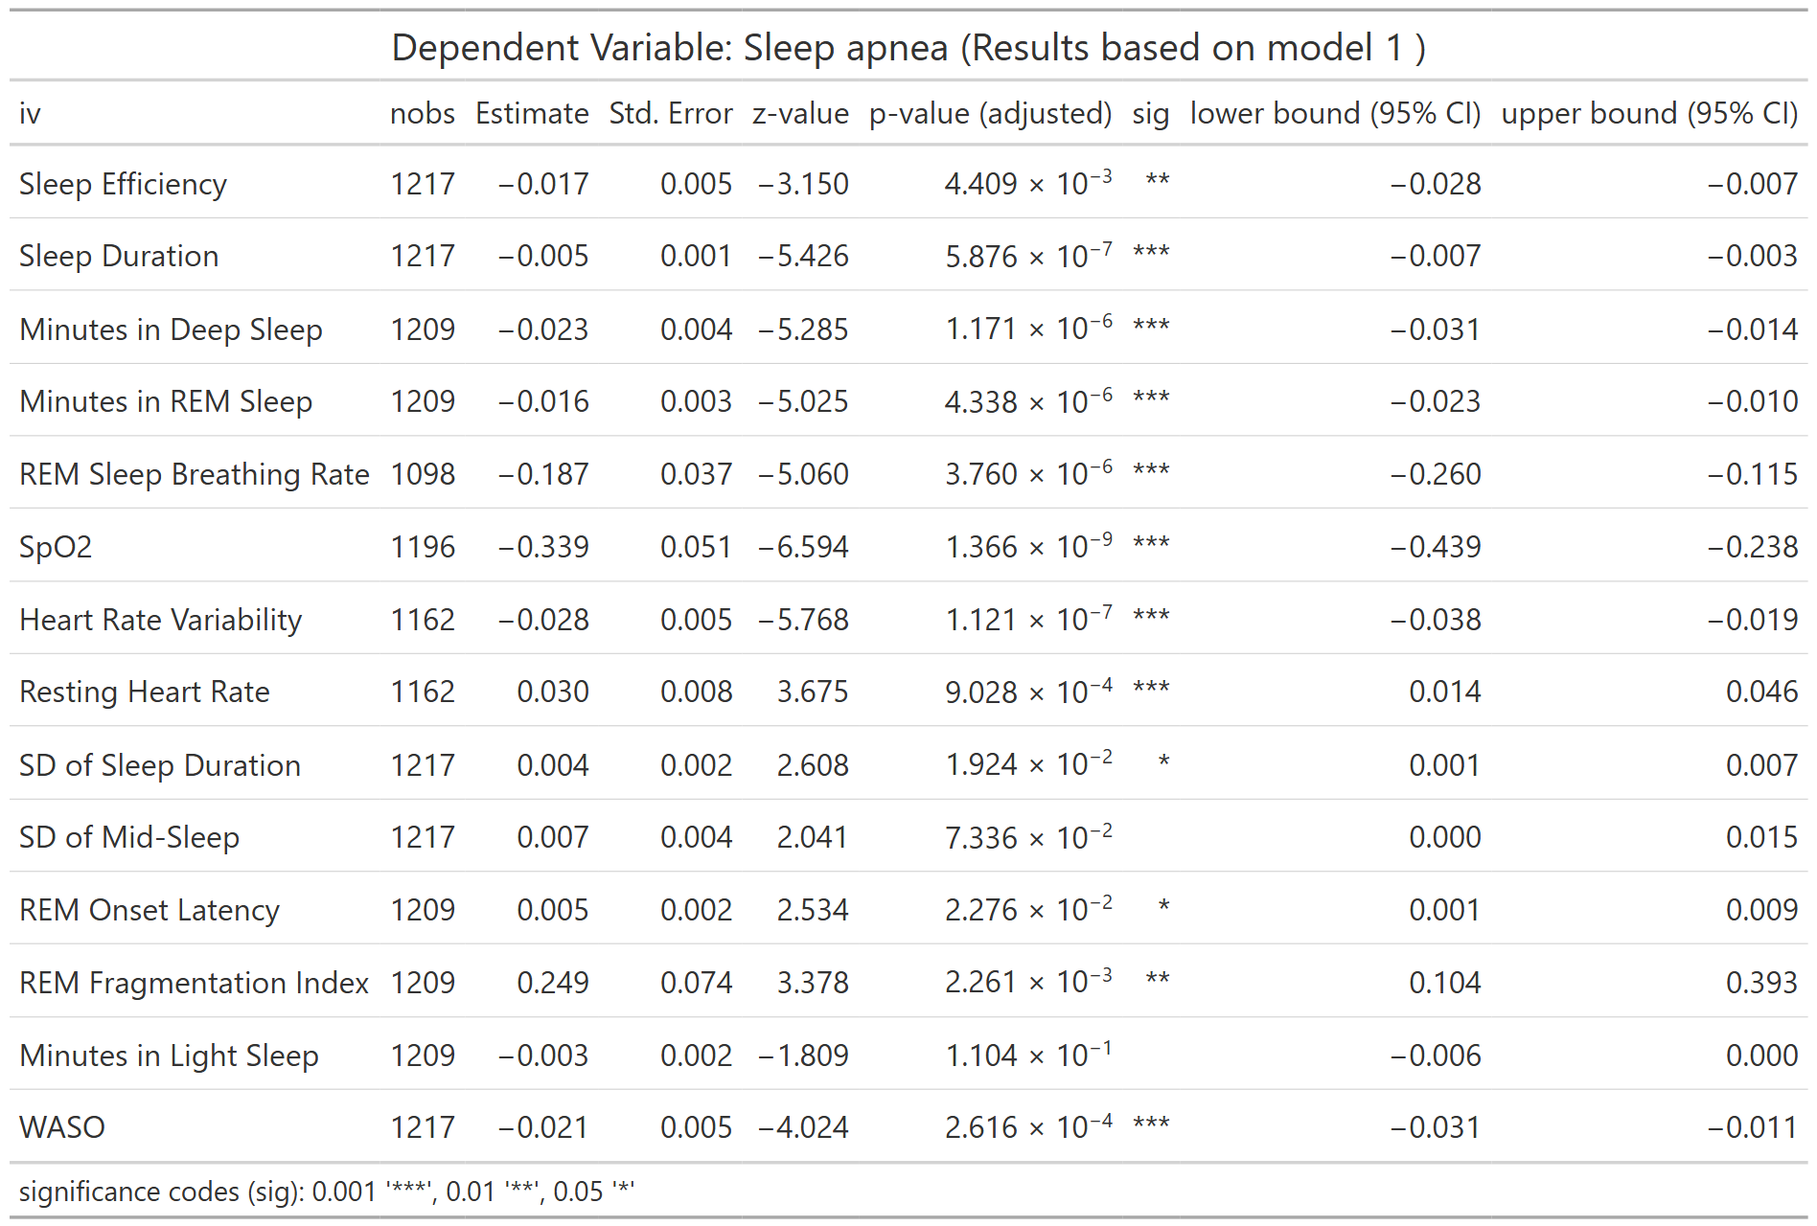
nobs = number of observations
Table S58. Association between LC symptom of Sleep Apnea and WDSM (Model 2)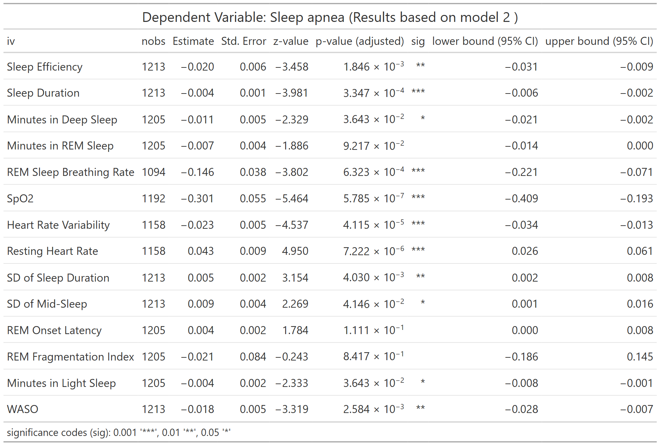
nobs = number of observations
Table S59. Association between LC symptom of Sleep Apnea and WDSM (Model 3)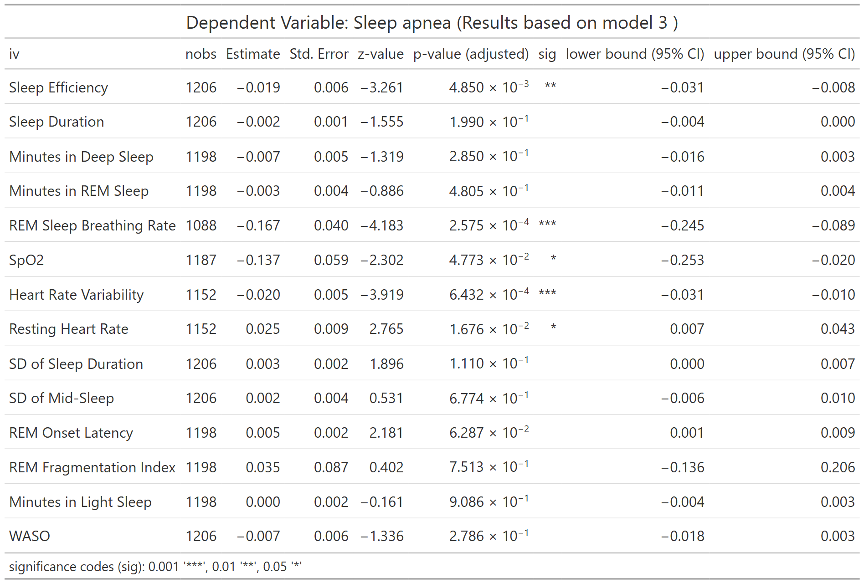
nobs = number of observations
Table S60. Association between LC symptom of Sleep Apnea and WDSM (Full Model) 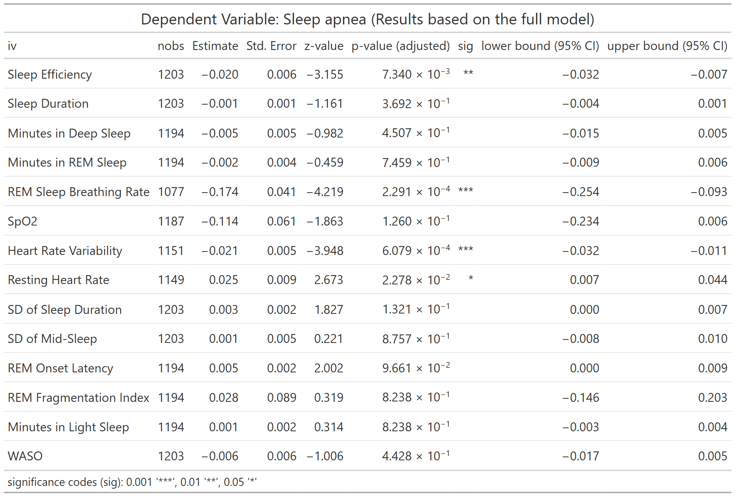
nobs = number of observations
Table S61. Association between LC symptom of Sleep Disturbance and WDSM (Model 1)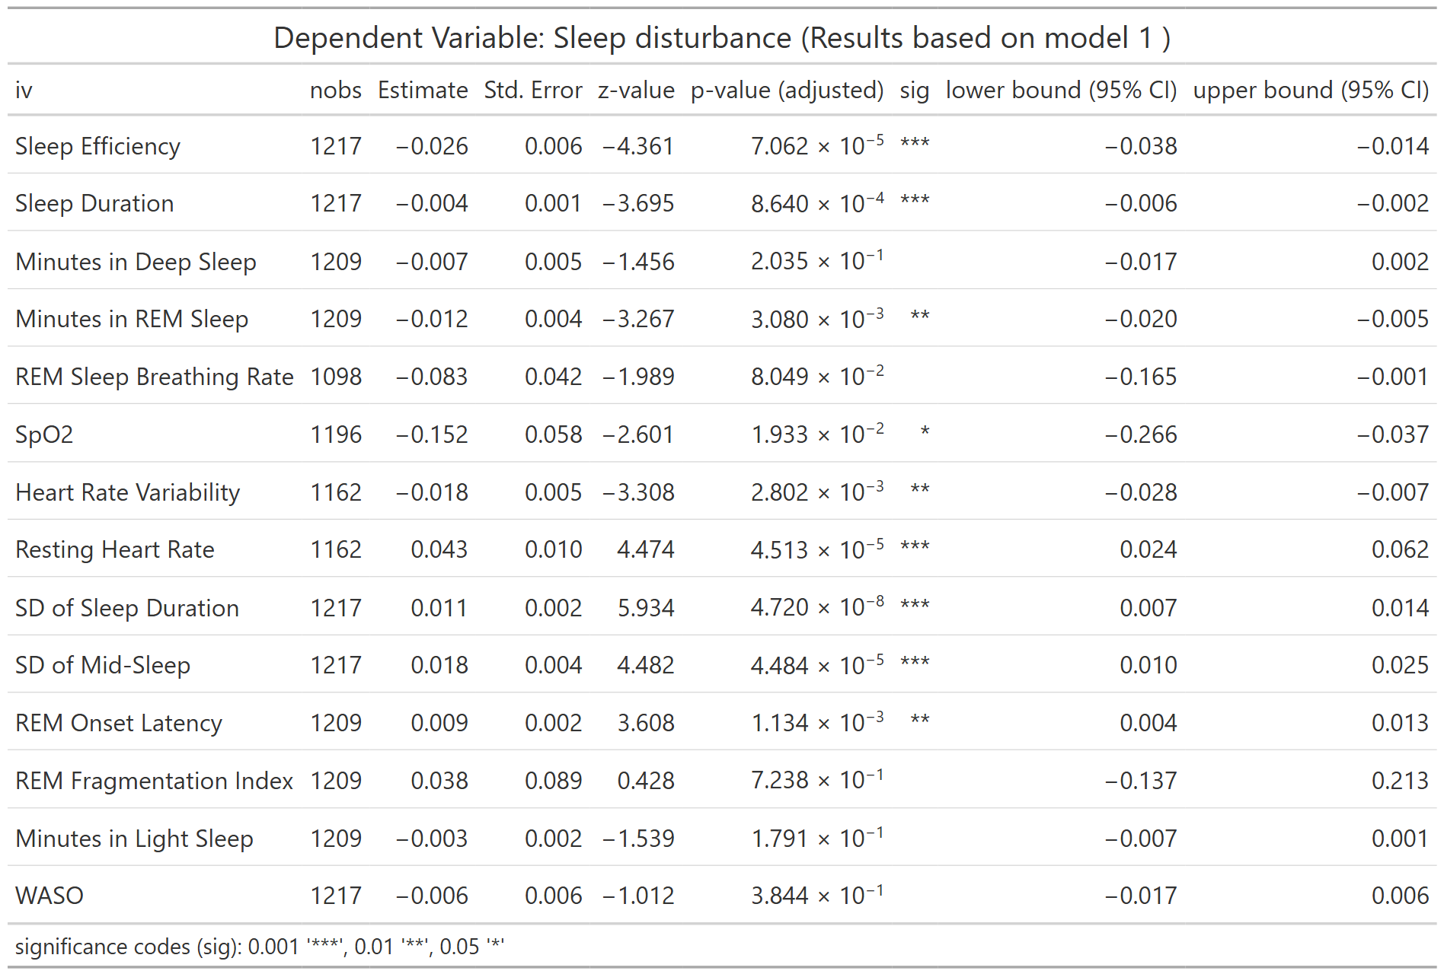
nobs = number of observations
Table S62. Association between LC symptom of Sleep Disturbance and WDSM (Model 2)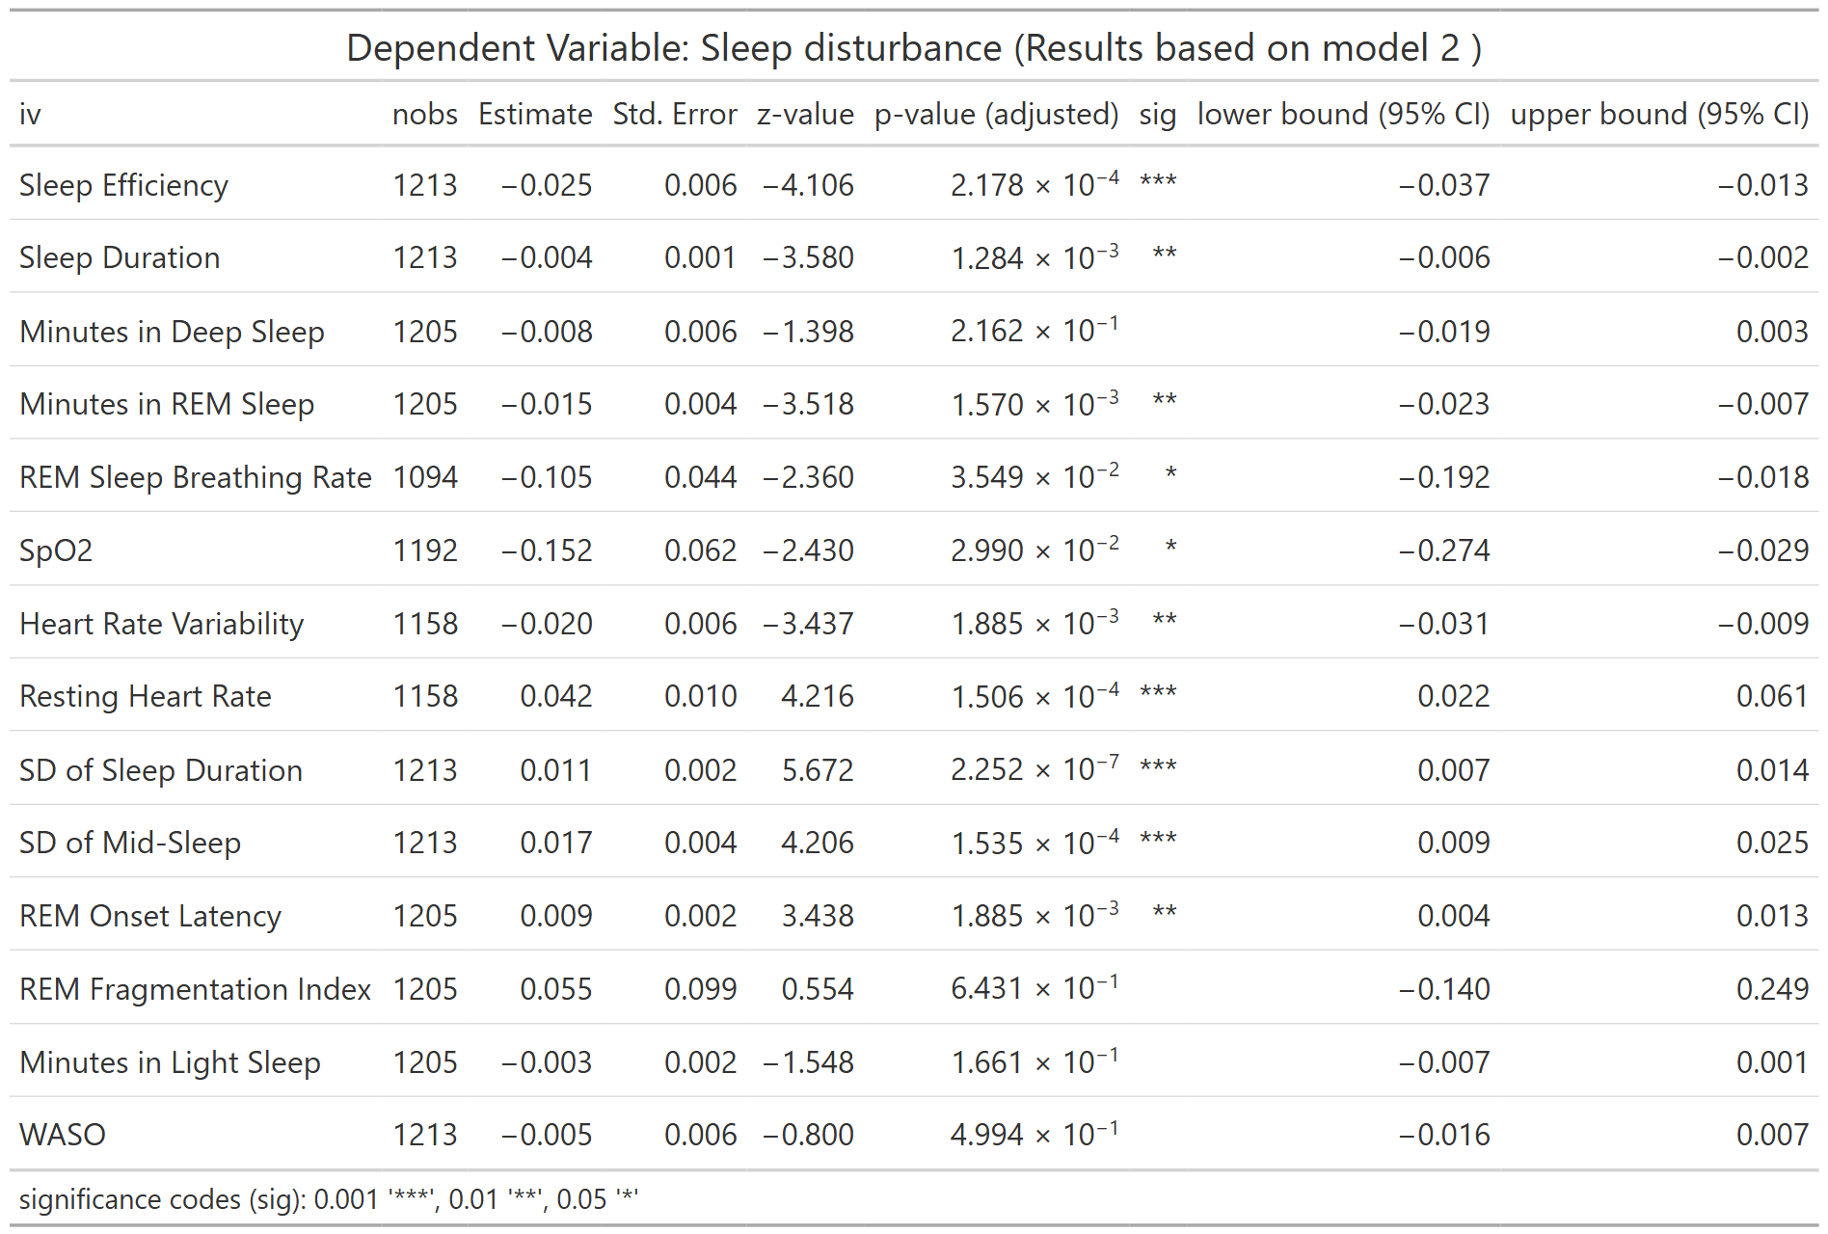
nobs = number of observations
Table S63. Association between LC symptom of Sleep Disturbance and WDSM (Model 3)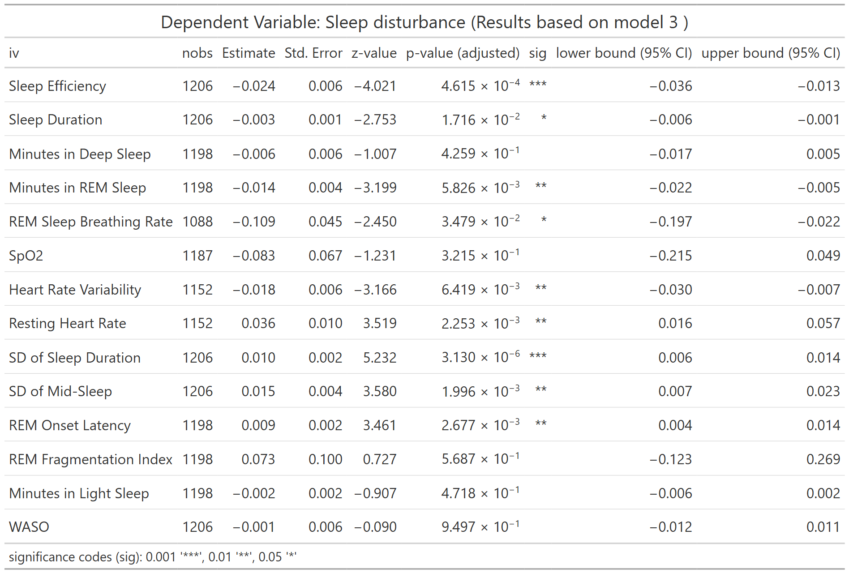
nobs = number of observations
Table S64. Association between LC symptom of Sleep Disturbance and WDSM (Full Model) 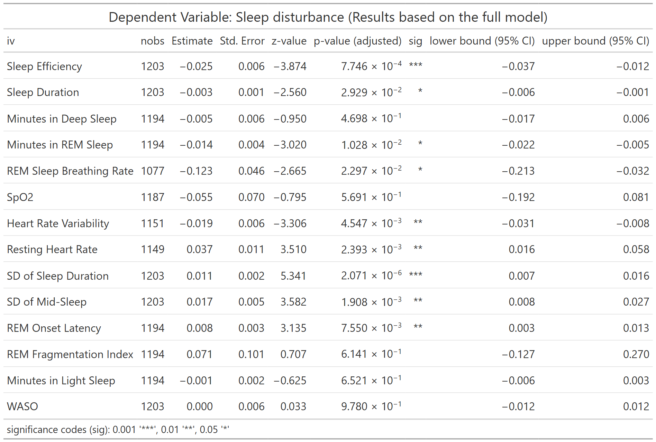
nobs = number of observations
Table S65. Association between PROMIS Global Physical Health Score and WDSM (Model 1) 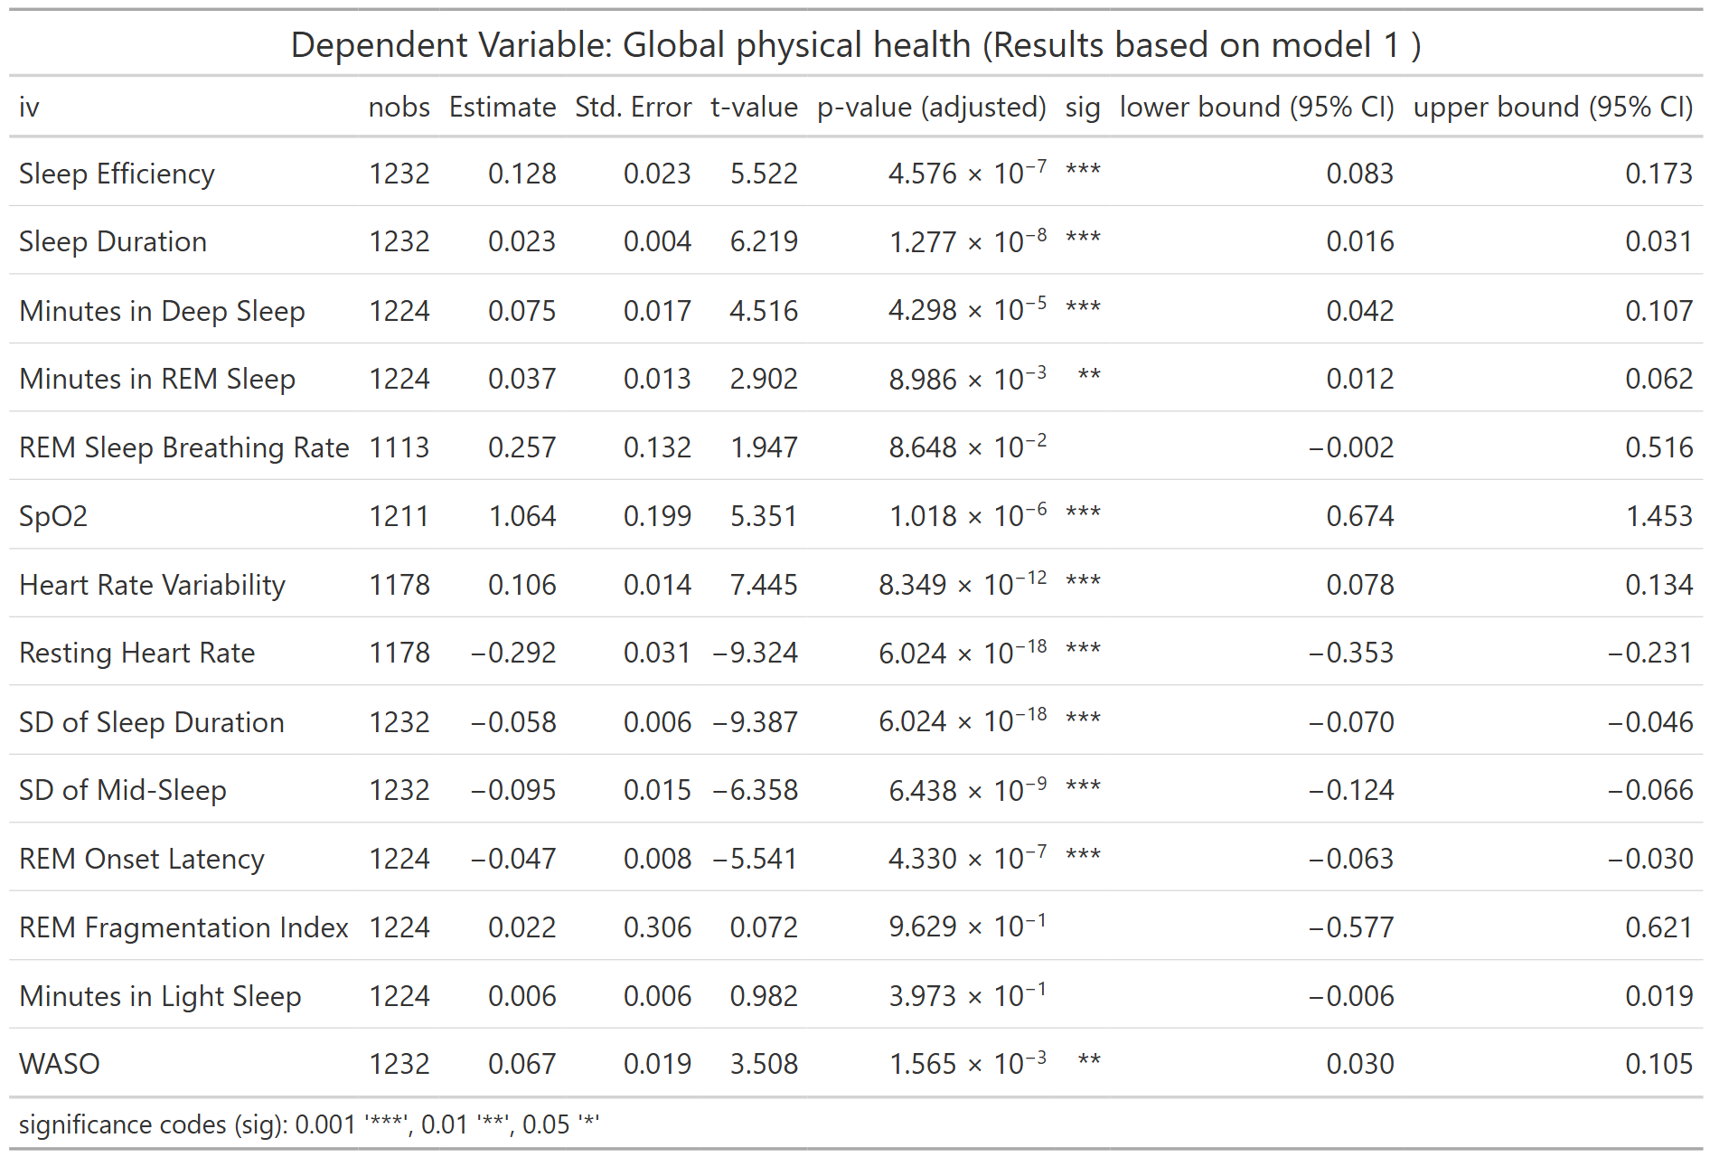
nobs = number of observations
Table S66. Association between PROMIS Global Physical Health Score and WDSM (Model 2)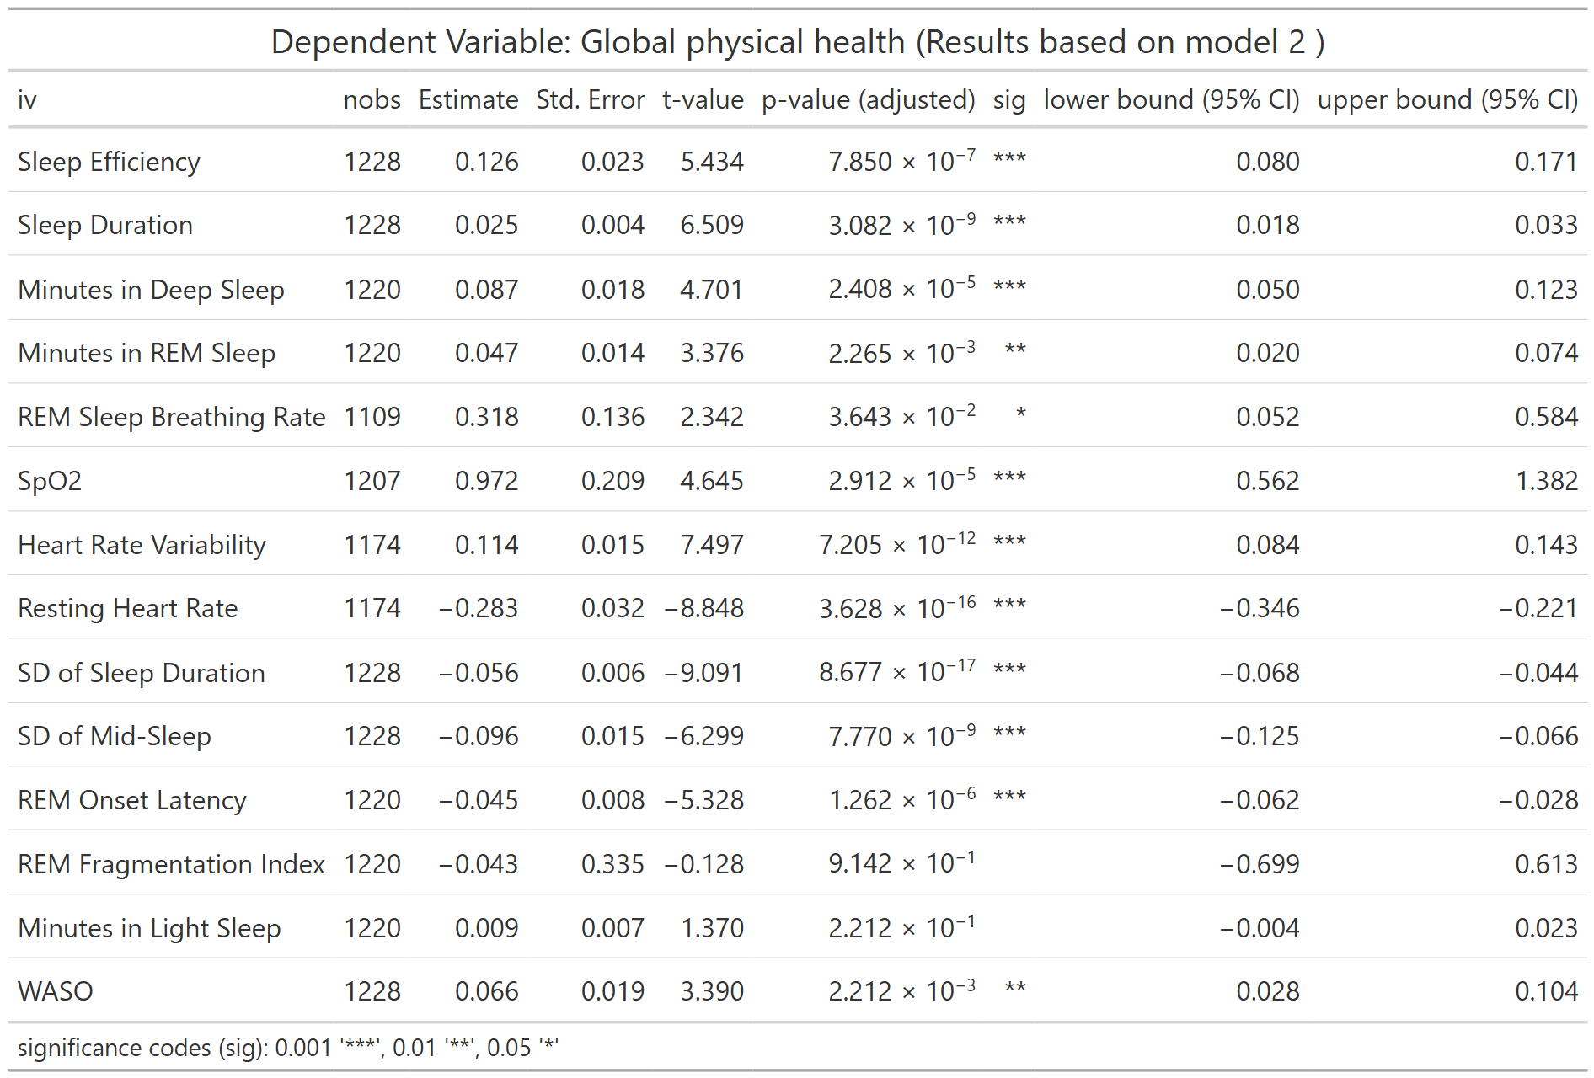
nobs = number of observations
Table S67. Association between PROMIS Global Physical Health Score and WDSM (Model 3)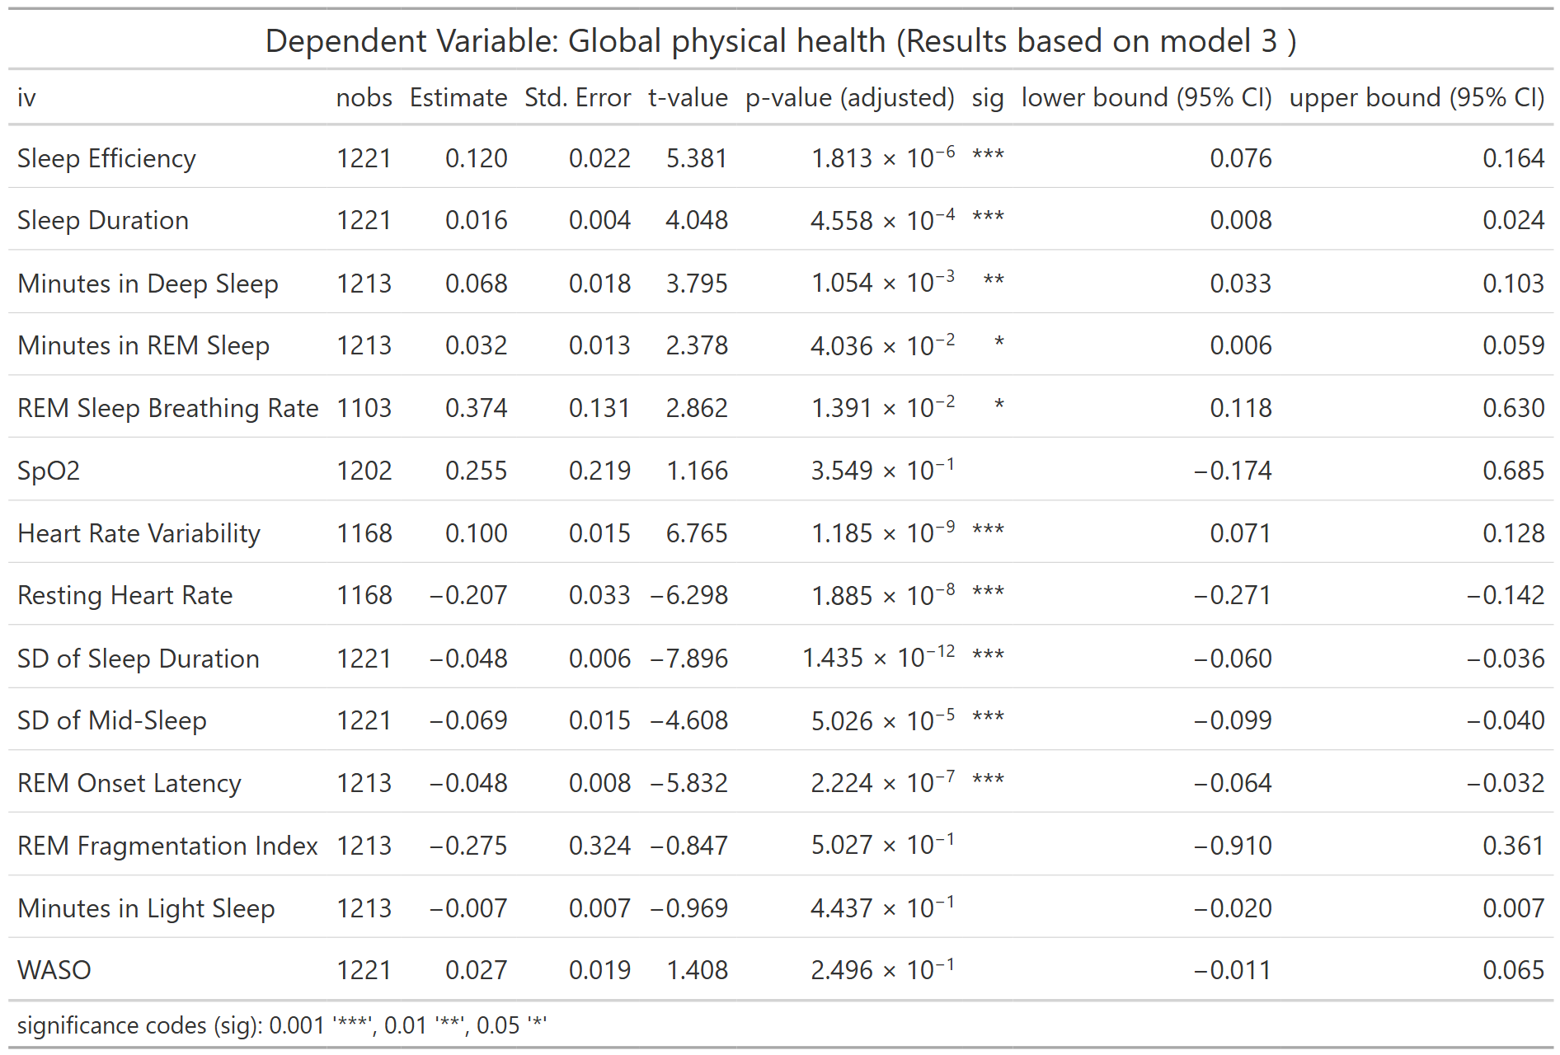
nobs = number of observations
Table S68. Association between PROMIS Global Physical Health Score and WDSM (Full Model) 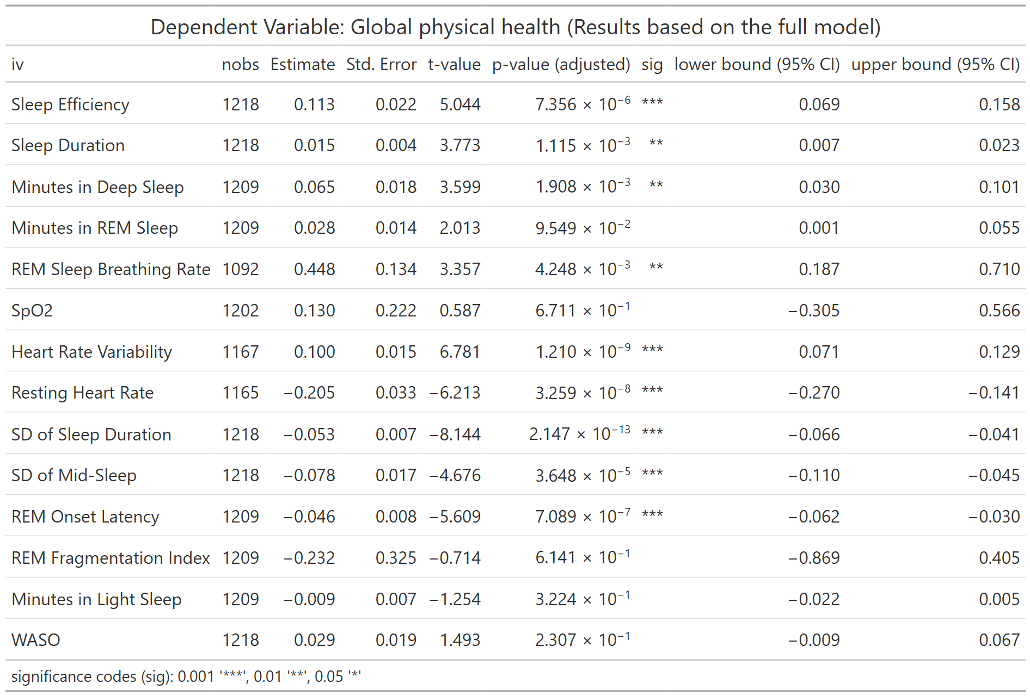
nobs = number of observations

Table S69. Association between LC symptom of Global Physical Health and WDSM (Model 2 & 3)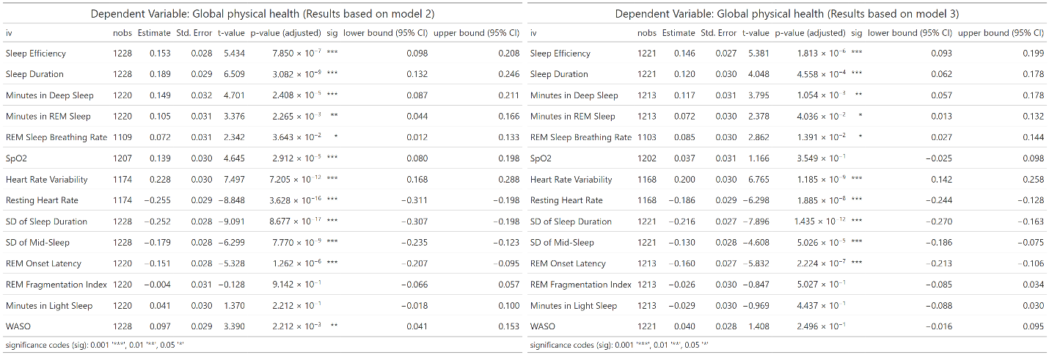
nobs = number of observations

Table S70. Association between PROMIS Global Mental Health Score and WDSM (Model 1)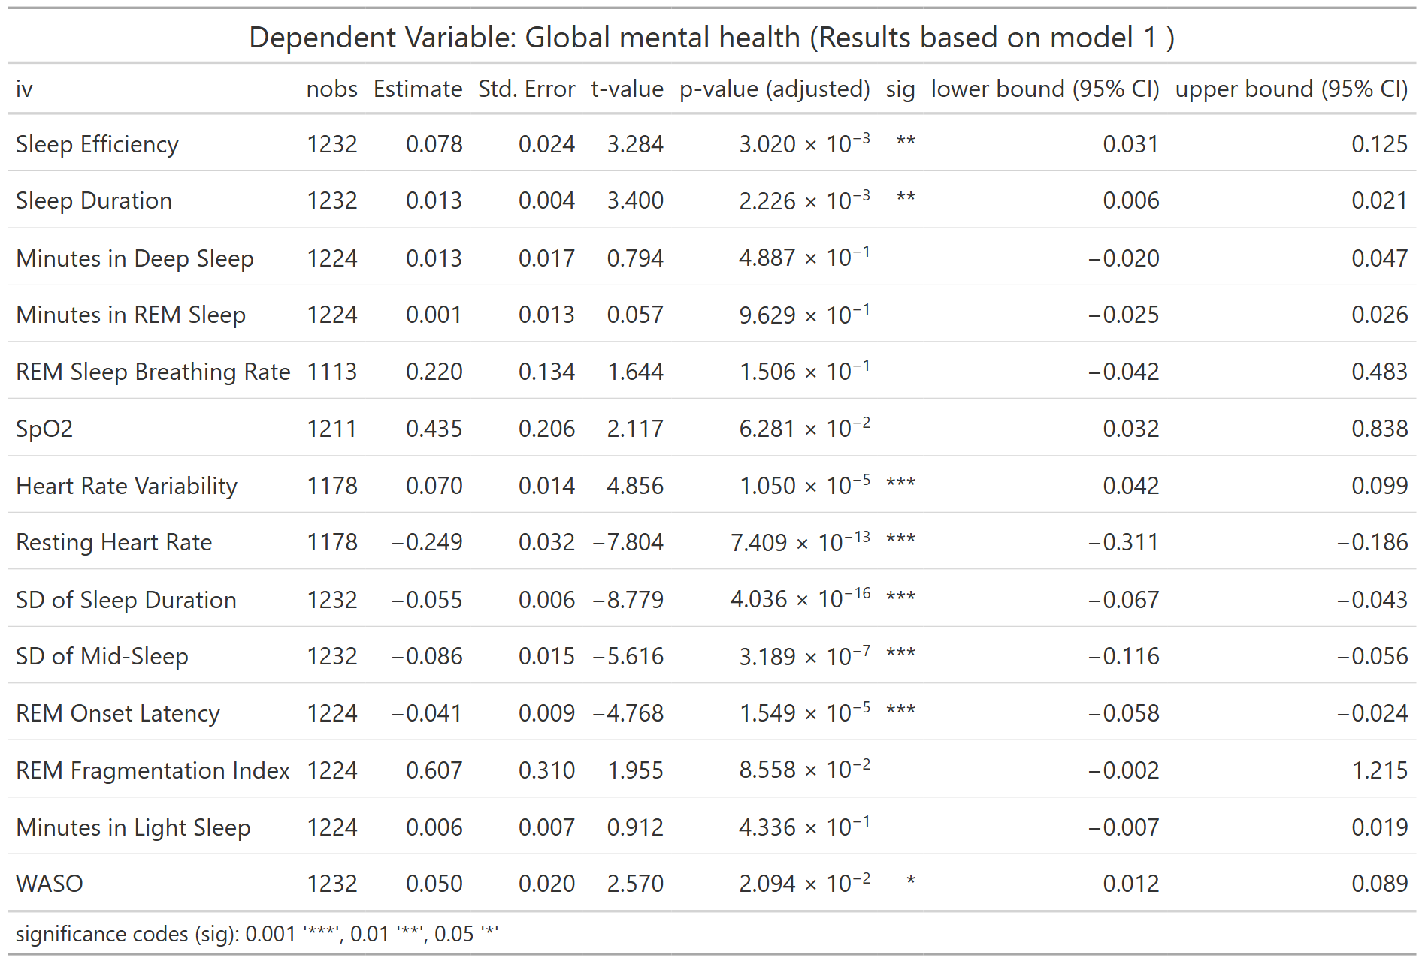
nobs = number of observations
Table S71. Association between PROMIS Global Mental Health Score and WDSM (Model 2)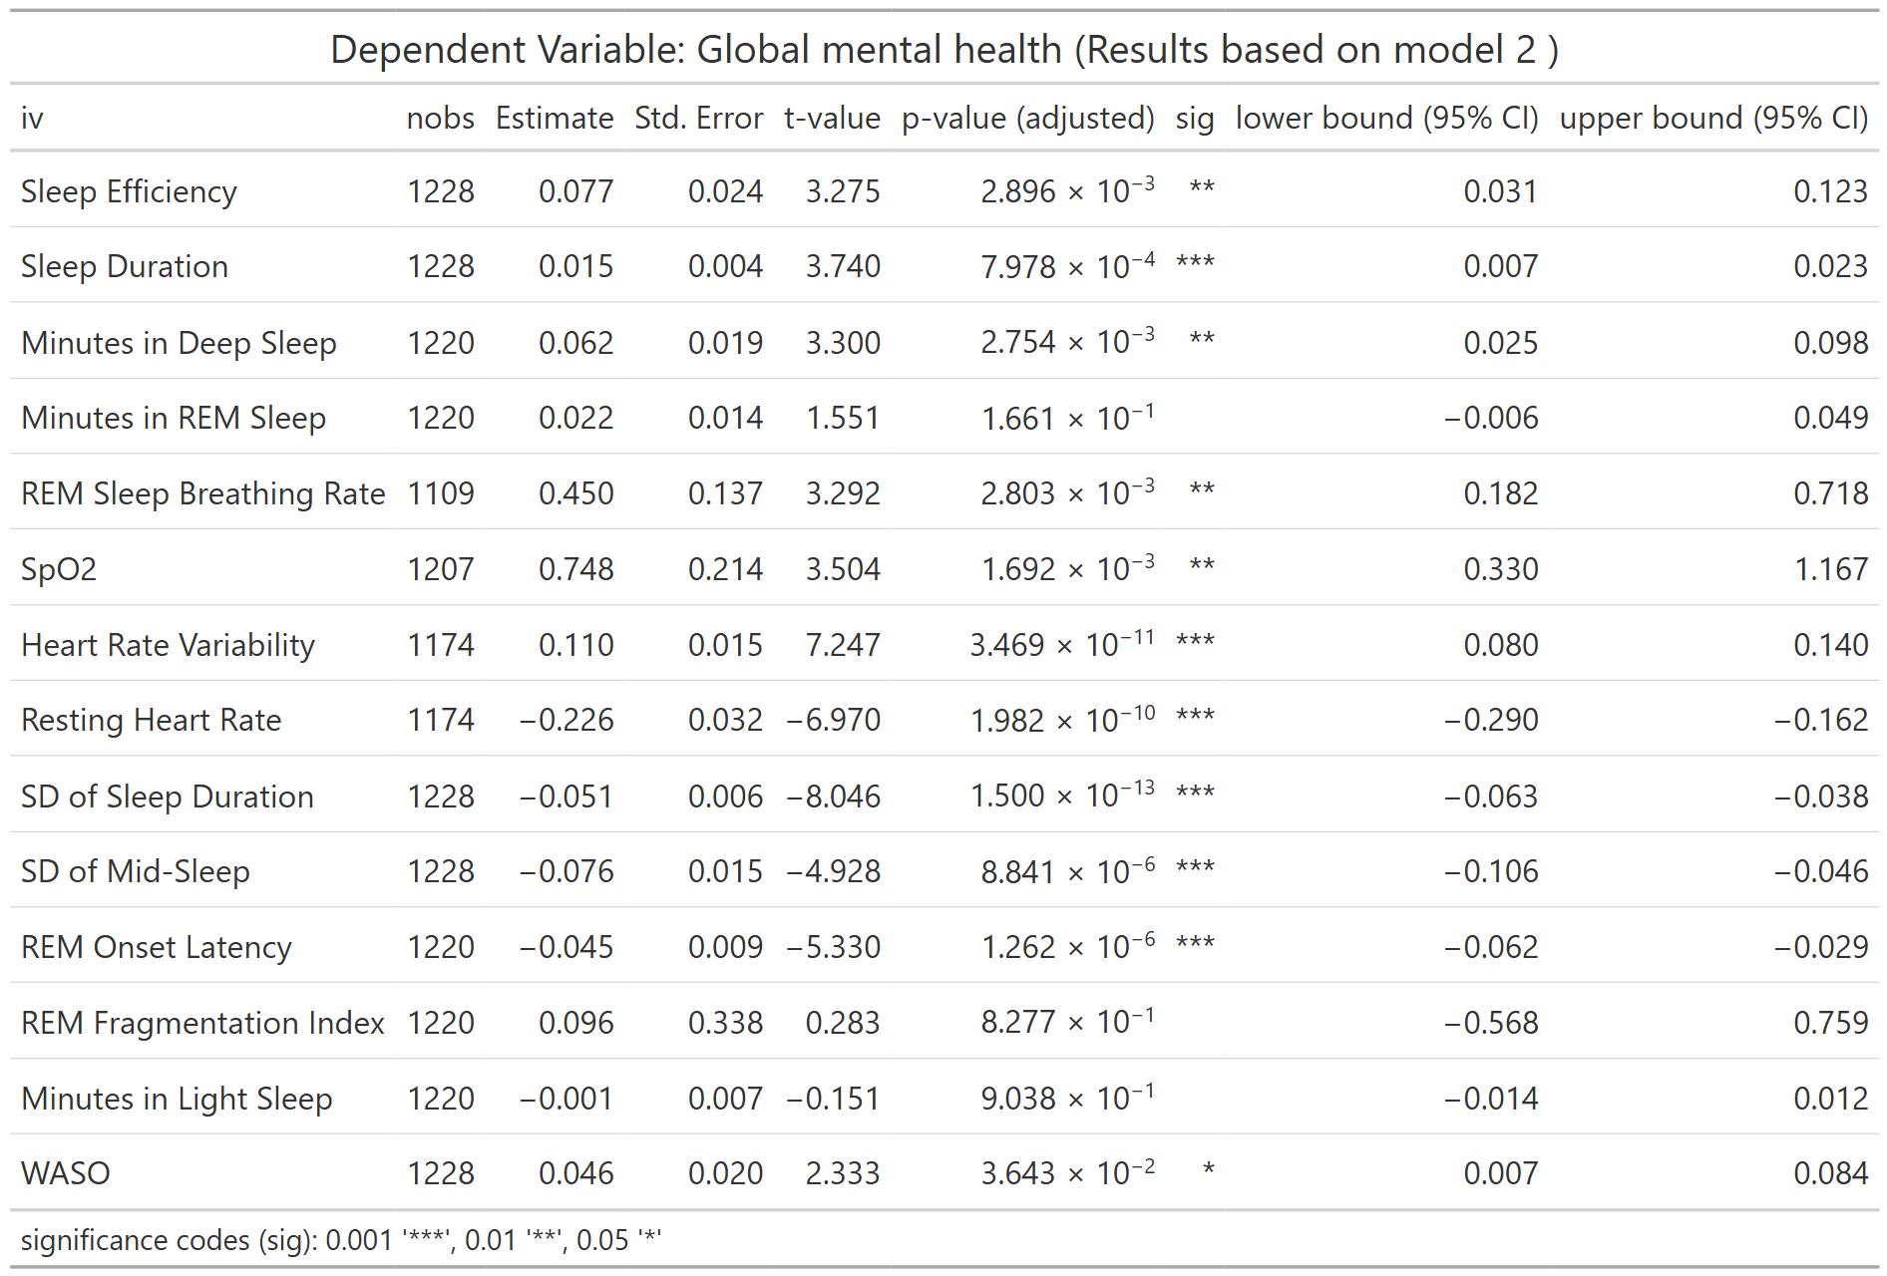
nobs = number of observations
Table S72. Association between PROMIS Global Mental Health Score and WDSM (Model 3)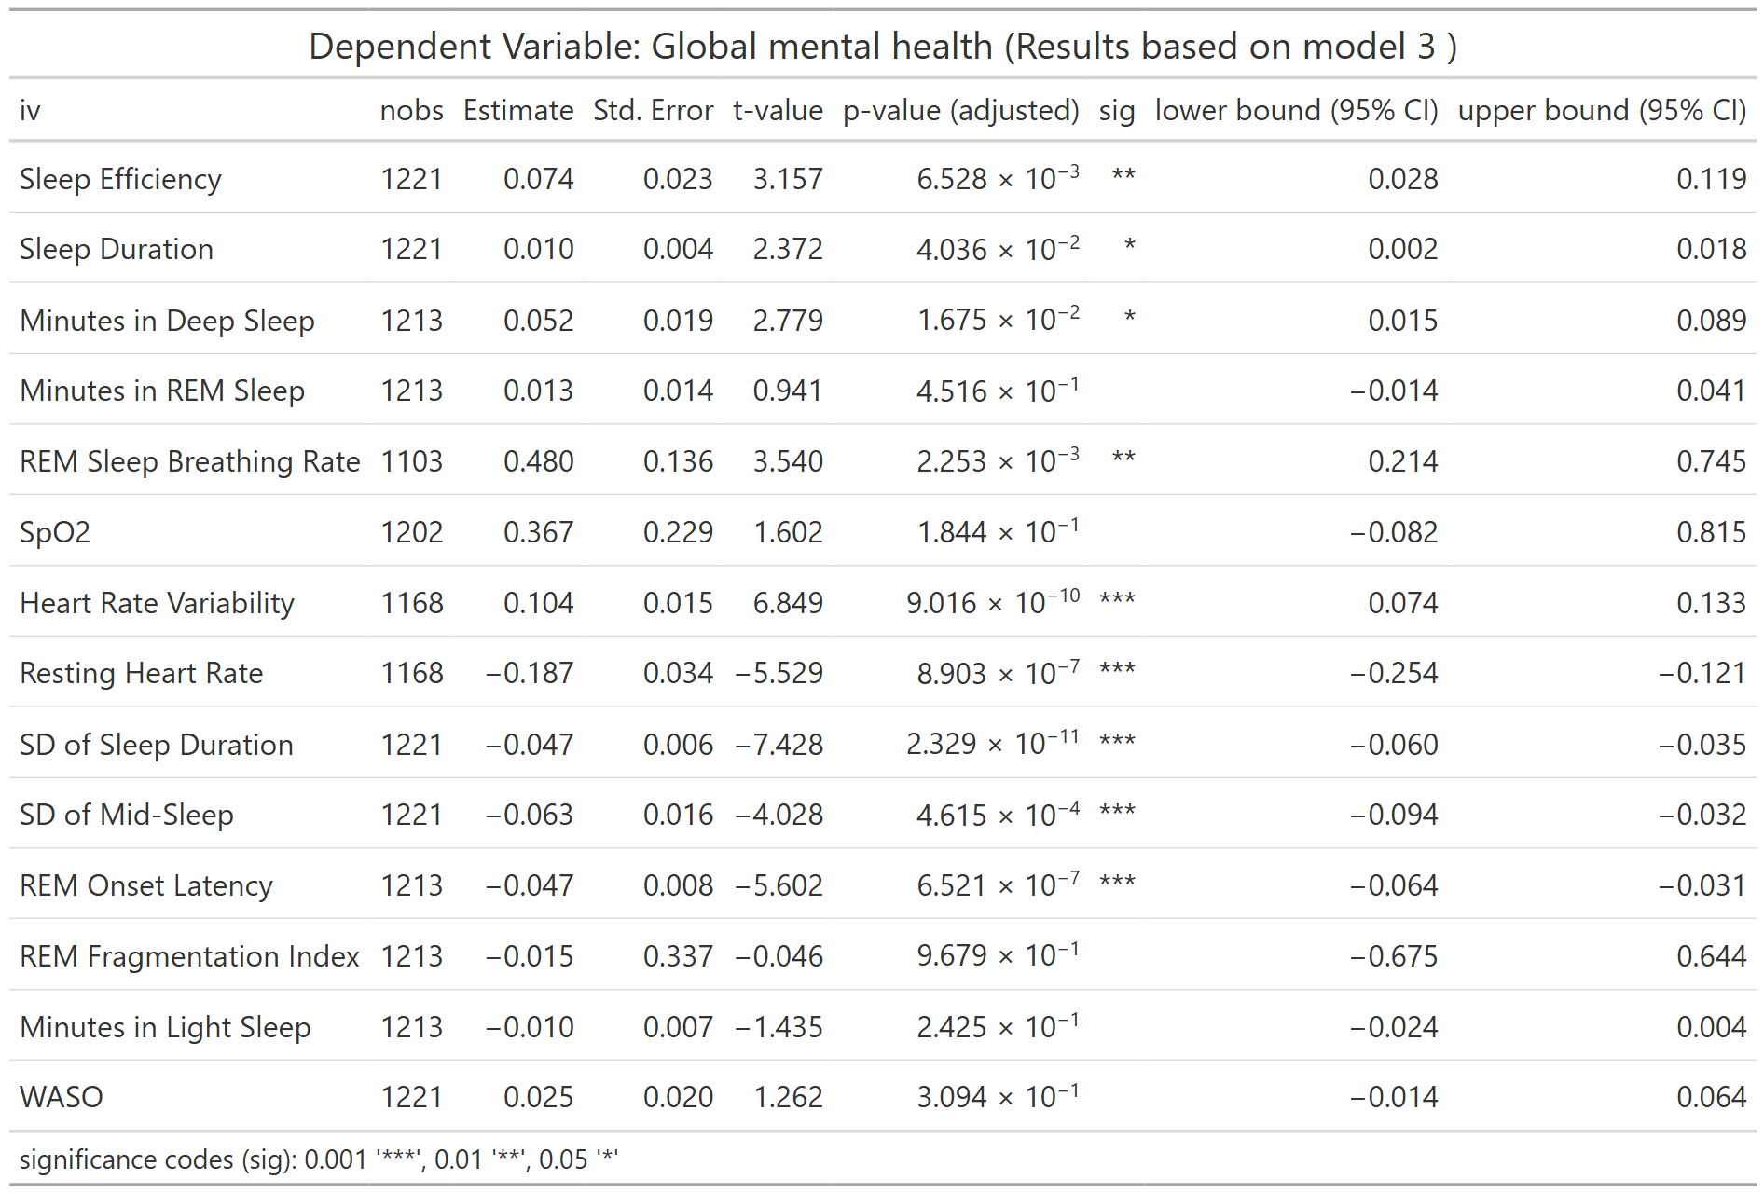
nobs = number of observations
Table S73. Association between PROMIS Global Mental Health Score and WDSM (Full Model)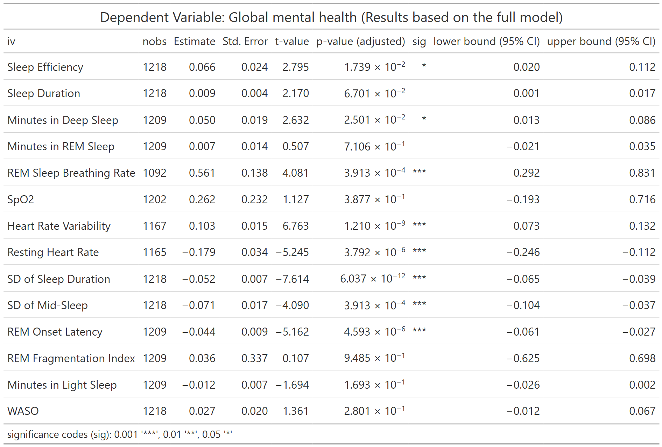
nobs = number of observations

Table S74. WDSM mean (SD) by Sleep Clusters
Cluster | Sleep Efficiency | Sleep Duration | Minutes in Deep Sleep | Minutes in REM Sleep | REM Onset Latency | REM Sleep Breathing Rate | SD of Sleep Duration | Heart Rate Variability | Resting Heart Rate
1 | 94.16 (1.9) | 381.79 (48.74) | 65.25 (14.25) | 87.88 (19.42) | 124.25 (34.91) | 14.18  (1.7) | 93.11 (29.09) | 25.54 (10.19) | 67.94 (7.28)
2 | 94  (2.3) | 366.12 (55.66) | 67.72 (14.57) | 85.13 (20.02) | 106.82 (24.93) | 15.83  (2.43) | 97.62 (31.8) | 52.04 (22.6) | 61.74 (7.15)
3 | 93.07 (3.25) | 287.1 (58.26) | 54.19 (15.96) | 71.72 (17.53) | 115.33 (24.66) | 14.18  (1.74) | 143.73 (43.11) | 23.32 (8.78) | 71.36 (8.25)
4 | 63.36 (9.68) | 337.73 (75.04) | 62.16 (15.12) | 81.66 (20.61) | 117.65 (28.26) | 14.07  (2.26) | 108.74 (33.79) | 26.95 (13.96) | 68.56 (7.56)

Figures
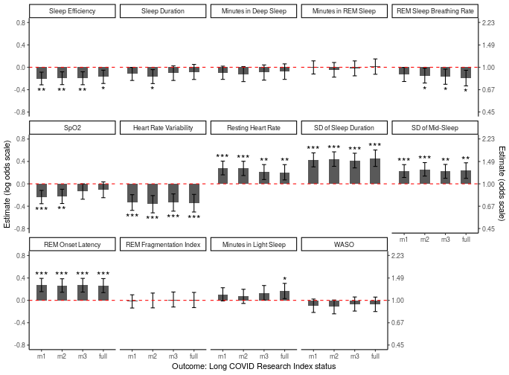
Figure S1: Wearables Derived Sleep Measurements by Long COVID Research Index Status across models 1-3 and the full model.

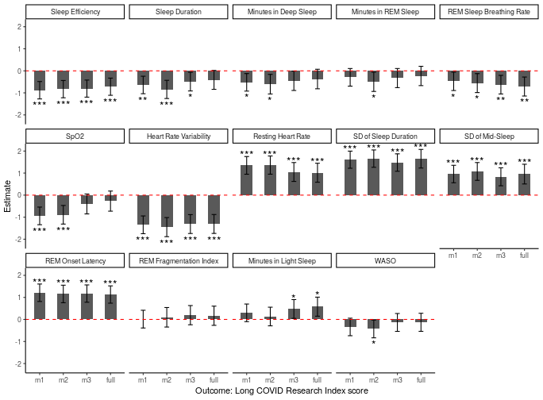
Figure S2: Wearables Derived Sleep Measurements by Long COVID Research Index Score (continuous) across models 1-3 and the full model.

Figure S3: Wearables Derived Sleep Measurements by Long COVID Research Index Status across models 1-3 and the full model using a minimum of 14 days of data (sensitivity analysis).

Figure S4: Wearables Derived Sleep Measurements by Long COVID Research Index Score (continuous) across models 1-3 and the full model using a minimum of 14 days of data (sensitivity analysis).

Figure S5: Wearables Derived Sleep Measurements by Long COVID Research Index Status across models 1-3 and the full model using a weekday data only (sensitivity analysis).

Figure S6: Wearables Derived Sleep Measurements by Long COVID Research Index Score (continuous) across models 1-3 and the full model using weekday data only (sensitivity analysis).

Figure S7: Wearables Derived Sleep Measurements by Long COVID Research Index across models 1-3 and the full model excluding participants who are LC negative (LCRI score < 11) at timepoint 1 and missing at timepoint 2 (sensitivity analysis).

Figure S8: Heatmap of Wearables Derived Sleep Measurements by Individual Long COVID Symptoms and Global quality of life scores (Model 1)

Figure S9: Heatmap of Wearables Derived Sleep Measurements by Individual Long COVID Symptoms and Global quality of life scores (Model 2)

Figure S10: Heatmap of Wearables Derived Sleep Measurements by Individual Long COVID Symptoms and Global quality of life scores (Model 3)

Figure S11: Heatmap of Wearables Derived Sleep Measurements by Individual Long COVID Symptoms and Global quality of life scores (Full Model)

Figure S12: Wearables Derived Sleep Measurements by LC Symptom of Change in Smell/Taste across models 1-3 and the full model.

Figure S13: Wearables Derived Sleep Measurements by LC Symptom of Post-exertional malaise across models 1-3 and the full model.

Figure S14: Wearables Derived Sleep Measurements by LC Symptom of Chronic Cough across models 1-3 and the full model.

Figure S15: Wearables Derived Sleep Measurements by LC Symptom of Brain Fog across models 1-3 and the full model.

Figure S16: Wearables Derived Sleep Measurements by LC Symptom of Excessive Thirst across models 1-3 and the full model.

Figure S17: Wearables Derived Sleep Measurements by LC Symptom of Heart Palpitations across models 1-3 and the full model.

Figure S18: Wearables Derived Sleep Measurements by LC Symptom of Chest Pain across models 1-3 and the full model.

Figure S19: Wearables Derived Sleep Measurements by LC Symptom of Fatigue across models 1-3 and the full model.

Figure S20: Wearables Derived Sleep Measurements by LC Symptom of Dizziness across models 1-3 and the full model.

Figure S21: Wearables Derived Sleep Measurements by LC Symptom of Gastrointestinal Symptoms across models 1-3 and the full model.

Figure S22: Wearables Derived Sleep Measurements by LC Symptom of Head Pain across models 1-3 and the full model.

Figure S23: Wearables Derived Sleep Measurements by LC Symptom of Shortness of Breath across models 1-3 and the full model.

Figure S24: Wearables Derived Sleep Measurements by LC Symptom of Sleep Apnea across models 1-3 and the full model.

Figure S25: Wearables Derived Sleep Measurements by LC Symptom of Sleep Disturbance across models 1-3 and the full model.

Figure S26: Wearables Derived Sleep Measurements by PROMIS Global Physical Health Score across models 1-3 and the full model.

Figure S27: Wearables Derived Sleep Measurements by PROMIS Global Mental Health Score across models 1-3 and the full model.

Figure S28: Scree plot for determine the number of clusters from the cluster analysis of digital sleep measures (sleep efficiency, sleep duration, minutes in deep sleep, minutes in REM sleep, REM onset latency, REM sleep breathing rate, SD of sleep duration, HRV and resting HR). We identified the optimal number of clusters to be 4. This was also confirmed via model-based clustering using the R package mclust.

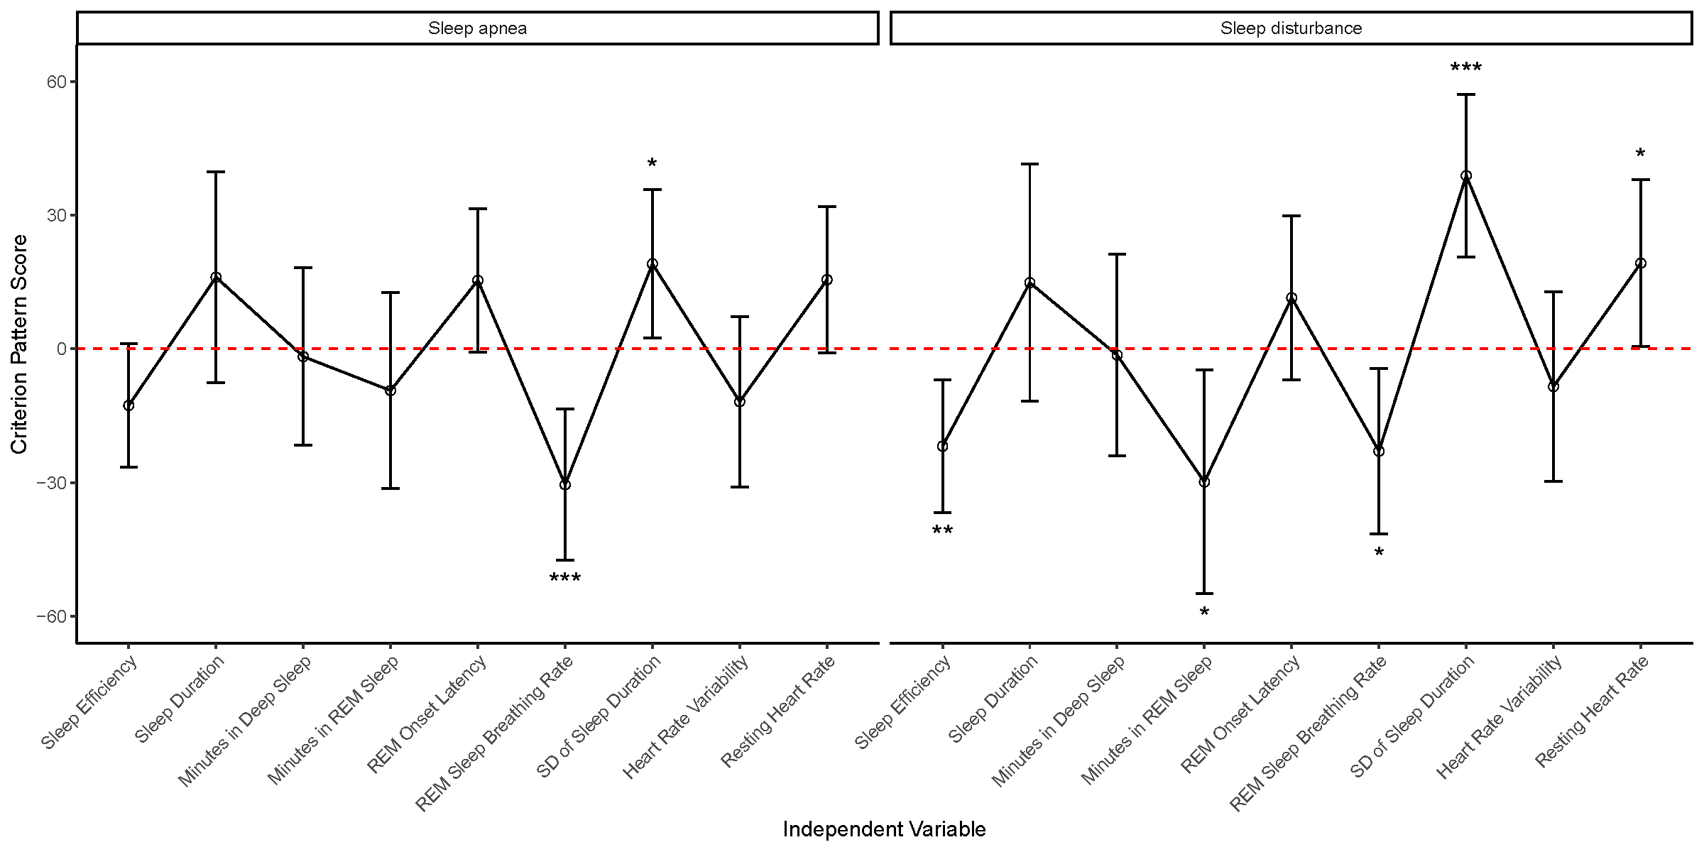
Figure S29: Criterion Profile Analysis (CPA) of WDSMs with reported Sleep Apnea and Sleep Disturbance. Sleep apnea was associated with a decrease in REM sleep breathing rate and increase of variability of sleep duration. Sleep disturbance was associated with both those factors, as well as, a decrease in sleep efficiency, minutes in REM sleep and an increase in resting HR.

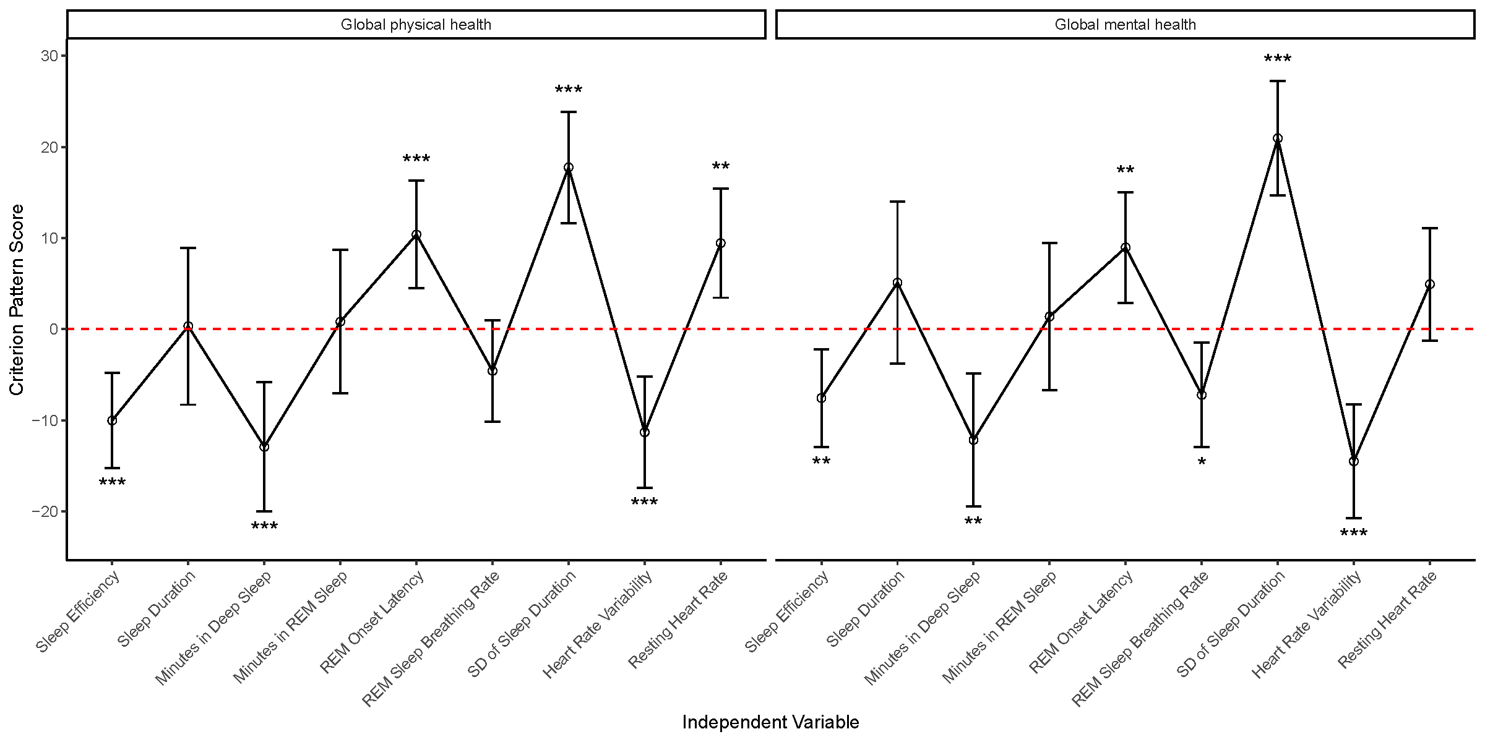
Figure S30: Criterion Profile Analysis (CPA) of WDSMs with PROMIS Global Physical Health Score and PROMIS Global Mental Health Score. In both cases, scores have been reversed so positive Criterion Pattern Score means that an increase in the WDSM variable is associated with a reduction in PROMIS score.
Lower scores for the Global Physical Health and Mental Health measures were associated with decreases in sleep efficiency and minutes in deep sleep, as well as lower HRV. Lower scores are also associated with increases in REM onset latency and SD of sleep duration. Increase in resting HR was associated with lower Global Physical Health. Lower REM sleep breathing rate was associated with lower Global Mental Health.

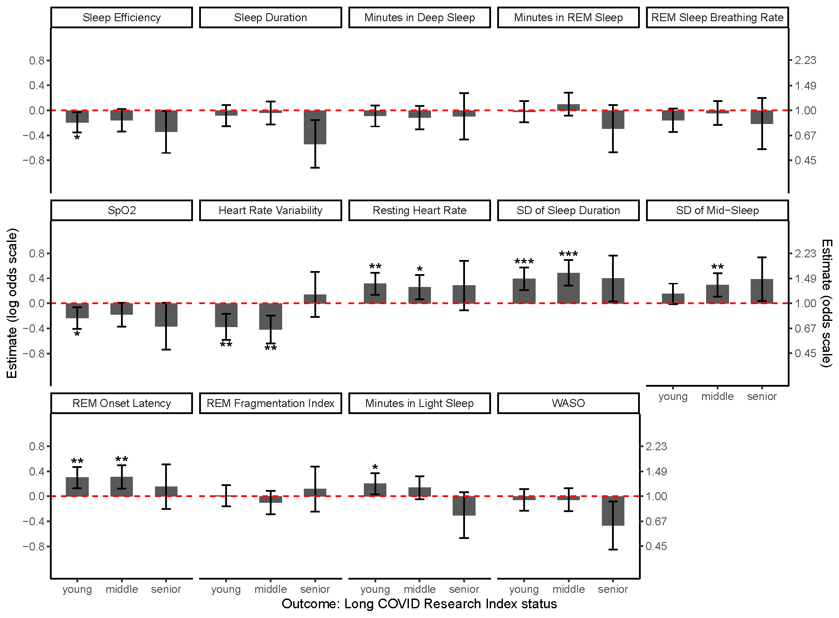
Figure S31: Wearables Derived Sleep Measurements by Long COVID Research Index Status stratified by Age Group: young (<45), middle (45-65), senior (>65).

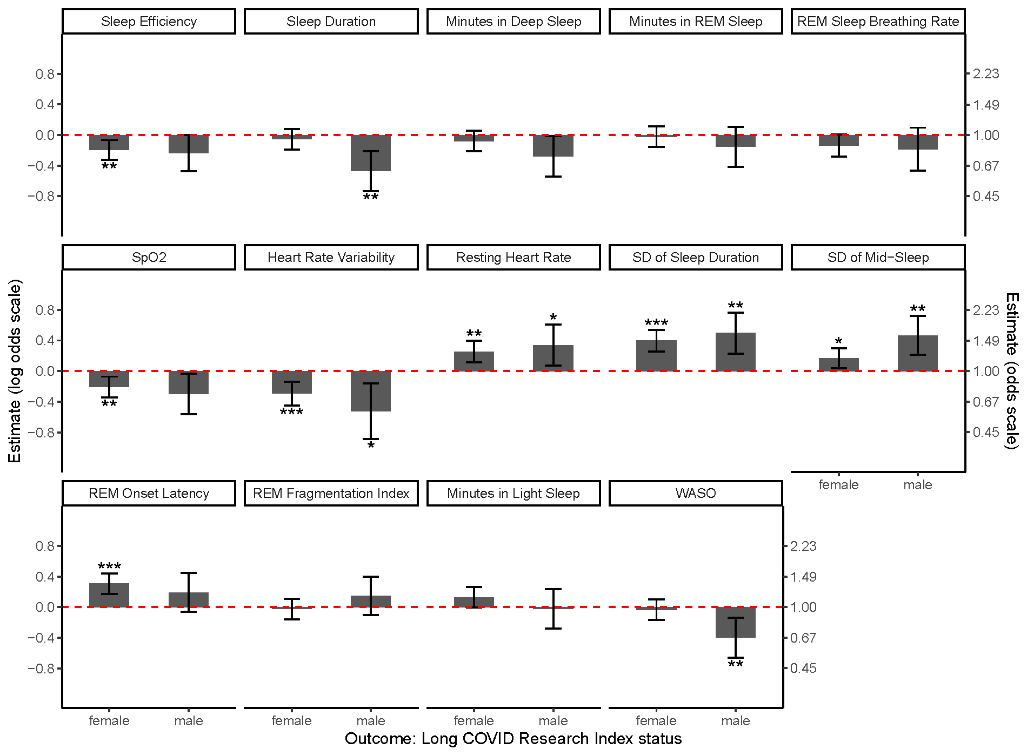
Figure S32: Wearables Derived Sleep Measurements by Long COVID Research Index Status stratified by Sex.

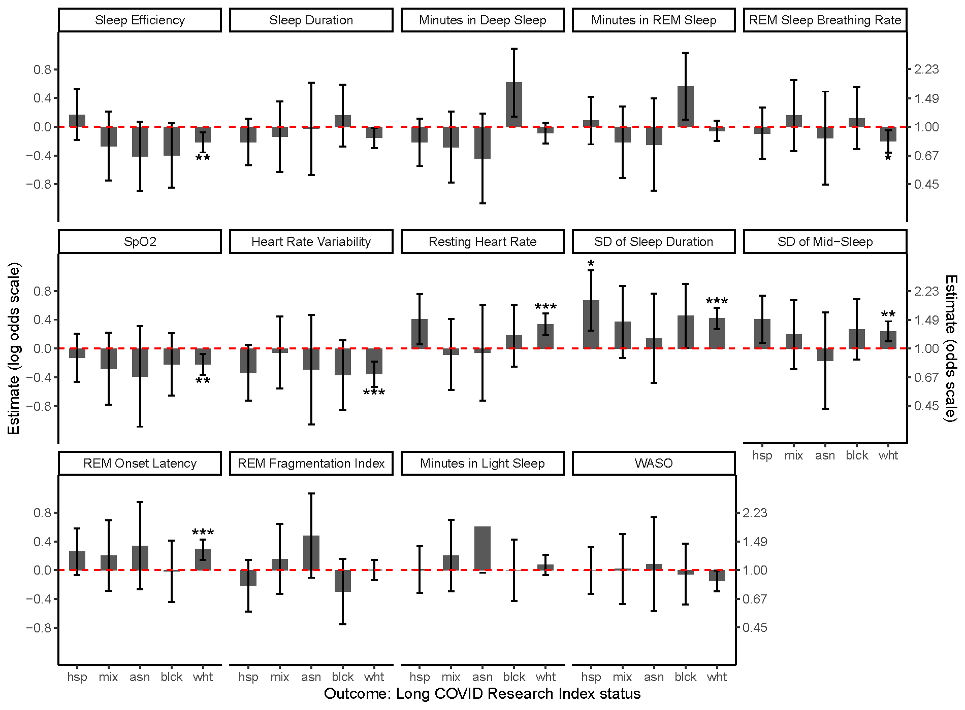
Figure S33: Wearables Derived Sleep Measurements by Long COVID Research Index Status stratified by race/ethnicity: Hispanic (hsp), mixed race/other/missing (mix), Asian, non-Hispanic (asn), Black, non-Hispanic (blck), White, non-Hispanic (wht).

