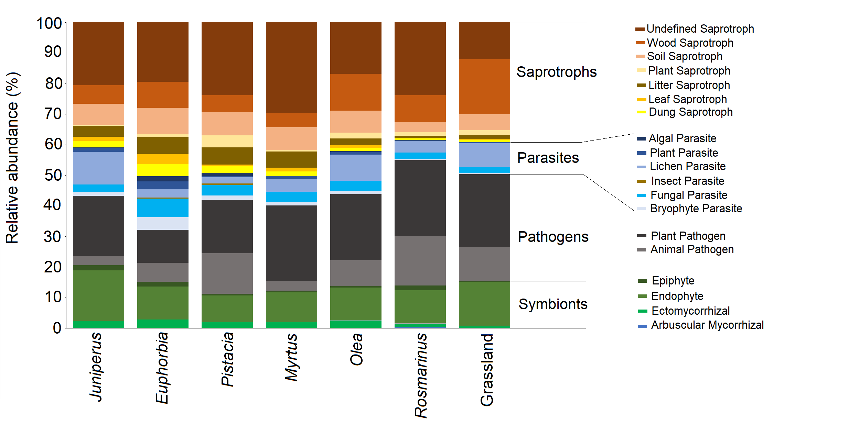
Fig S1. Relative abundance of fungal functional guilds under the canopy of each plant at the studied shrubland and the grassland.

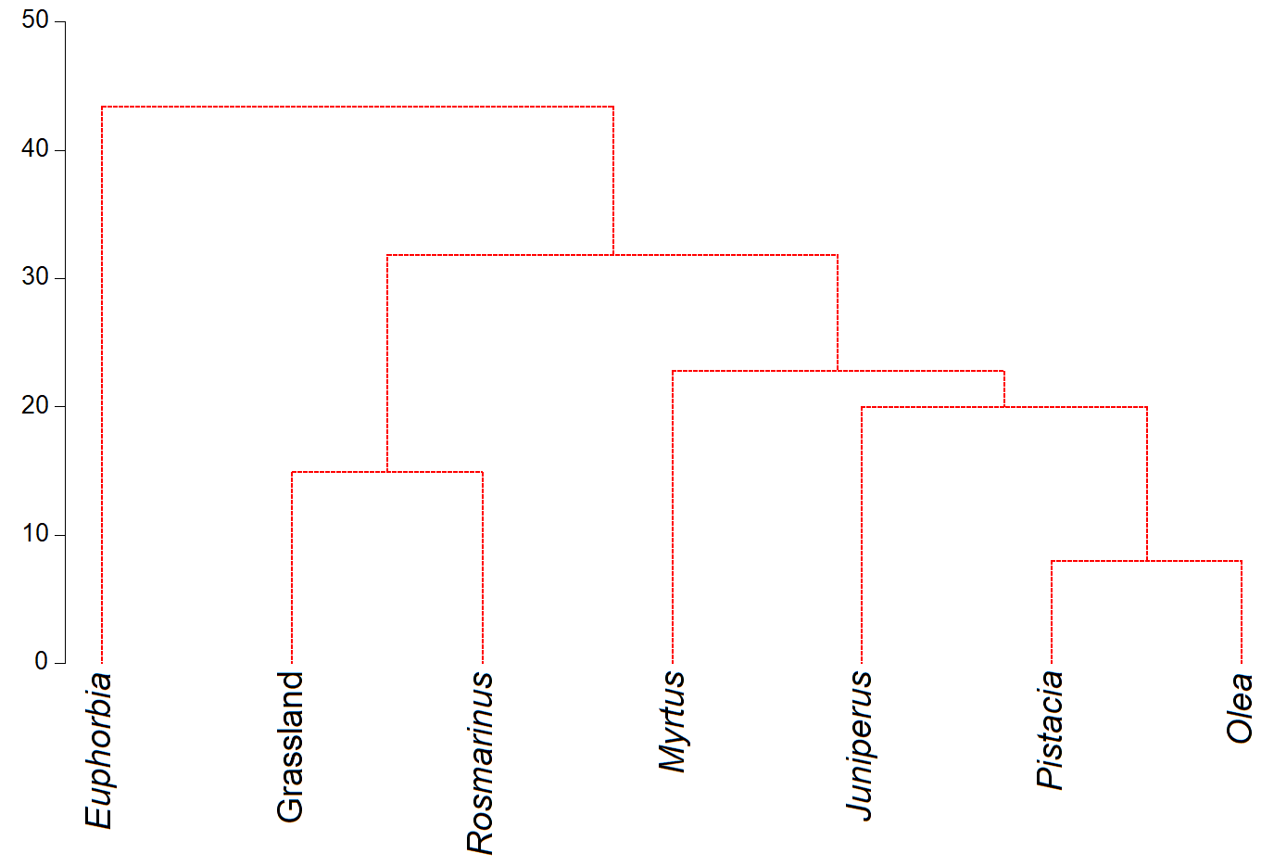
Fig S2. The clustering of the different shrubs and the grass based on the chemical variables.
Euclidean distance

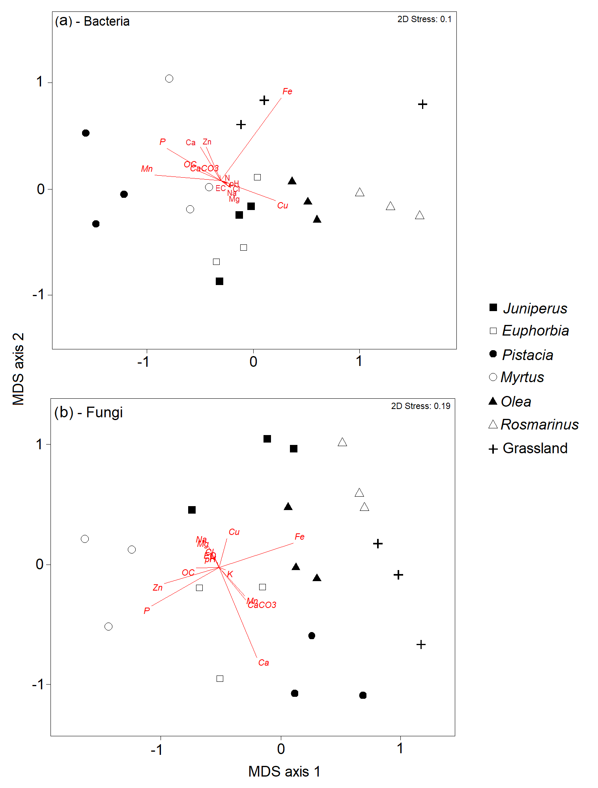
Fig S3. Nonmetric multidimensional scaling (NMDS) plots of bacteria (a) and fungi (b) communities under the canopy of each plant across the shrubland. MDS axis 1 and MDS axis 2 represent the two axes of the two-dimensional ordination space. Each point represents the microbiome of one replicate of the plant. The stress-level shown in each plot indicates how well the individual distances between objects are represented (between 0 and 1; the closer to 0, the better are original data points represented in the ordination space). Vectors represent soil environmental variables which significantly correlated with the ordination (P < 0.05 based on 999 permutations).
Table S1. Results of PERMANOVA significance test across shrub species in Capo-Palinuro grassland. Shrub species were used as the fixed factor (N° of permutation 999). Here reported the main significant variation between the studied shrub species for fungal and bacterial communities. Test of significance is based on Bray-Curtis similarity values. The significance level is fixed for p-value below 0.05 (in Bold).
 | Bacteria |  |  |  |  | Fungi
 | df | SS | MS | Pseudo-F | p-value | df | SS | MS | Pseudo-F | p-value
Shrubs | 6 | 7657.1 | 1276.2 | 5.4542 | 0.001 | 6 | 27837 | 4639.4 | 4.4436 | 0.001

Table S2. Results of PERMANOVA significance test across shrub species in Capo-Palinuro grassland. Shrub species were used as the fixed factor (N° of permutation 999). Here reported significant pairwise changes between the studied shrub species for fungal and bacterial communities. The test of significance is based on Bray-Curtis similarity values. The significance level is fixed for p-value below 0.05.
 | Bacteria |  |  | Fungi
 | Pseudo-F/t | p-value | Pseudo-F/t |  | p-value
Juniperus vs Euphorbia | 1.4836 | 0.145 | 1.9054 |  | 0.039
Juniperus vs Pistacia | 2.4375 | 0.020 | 2.1325 |  | 0.026
Juniperus vs Myrtus | 1.7493 | 0.068 | 2.3001 |  | 0.029
Juniperus vs Olea | 2.3660 | 0.017 | 2.0855 |  | 0.031
Juniperus vs Grassland | 1.7730 | 0.079 | 1.6271 |  | 0.092
Juniperus vs Rosmarinus | 2.9599 | 0.009 | 2.0451 |  | 0.041
Euphorbia vs Pistacia | 2.2239 | 0.026 | 1.7732 |  | 0.059
Euphorbia vs Myrtus | 1.8283 | 0.062 | 2.3363 |  | 0.023
Euphorbia vs Olea | 2.4773 | 0.032 | 2.0016 |  | 0.035
Euphorbia vs Grassland | 1.8995 | 0.051 | 1.6734 |  | 0.075
Euphorbia vs Rosmarinus | 2.8621 | 0.010 | 2.3655 |  | 0.012
Pistacia vs Myrtus | 2.2252 | 0.029 | 2.6857 |  | 0.009
Pistacia vs Olea | 3.8597 | 0.006 | 2.3523 |  | 0.011
Pistacia vs Grassland | 2.2810 | 0.021 | 1.5727 |  | 0.084
Pistacia vs Rosmarinus | 3.7648 | 0.005 | 2.5272 |  | 0.014
Myrtus vs Olea | 2.6052 | 0.010 | 2.9630 |  | 0.010
Myrtus vs Grassland | 1.8266 | 0.070 | 2.1269 |  | 0.035
Myrtus vs Rosmarinus | 3.1049 | 0.011 | 3.1230 |  | 0.009
Olea vs Grassland | 1.5606 | 0.104 | 1.6089 |  | 0.080
Olea vs Rosmarinus | 2.4847 | 0.028 | 2.5024 |  | 0.017
Grassland vs Rosmarinus | 1.6972 | 0.070 | 1.5854 |  | 0.084

Table S3. Topological parameters for the microbial networks in the grassland versus the shrubland
 | Grassland | Shrubland
Number of Nodes | 91 | 97
Number of Edges | 1946 | 1159
Positive correlations (%) | 81.96 | 99.65
Negative correlations (%) | 18.04 | 0.35
Network diameter | 5 | 5
Network heterogeneity ª | 0.453 | 0.699
Network density ^{b} | 0.475 | 0.259
Network centralization ^{c} | 0.207 | 0.246
Avg. clustering coefficient ^{d} | 0.427 | 0.364
Characteristic path length ^{e} | 1.866 | 2.290
Modularity ^{f} | 0.208 | 0.228
ª Measurement of the diversity in the node degrees with respect to a completely homogeneous network of the same number of nodes.
^{b} Measurement indicating the percentage of potential connections that actually exist among nodes in a network.
^{c} Describes the extent to which the density is organized around particular focal nodes.
^{d} Degree of nodes tending to cluster together.
^{e} Average number of edges in the shortest paths between all node pairs.
^{f} Degree of nodes tending to differentiate into different communities (network modules).

Table S4. Summary of the General Linear Model (GLM) testing for main and interactive effects of shrub species with proximate and NMR parameters.
 | Degree of freedom | F | P
Shrubs | 6 | 6.725 | < 0.001***
proximate parameters | 4 | 5.21 | < 0.001 ***
CPMAS NMR parameters | 6 | 31.3 | < 0.001 ***
Shrubs × proximate parameters | 24 | 14.02 | < 0.001 ***
Shrubs × CPMAS NMR parameters | 36 | 9.46 | < 0.001 ***
*significant at 0.05

Table S5. Summary of the General Linear Model (GLM) testing for main and interactive effects of shrub species and chemical parameters of the soils.
 | Degree of freedom | F | P
Shrubs | 6 | 6.725 | 0.001 ***
Chemicals | 16 | 217.443 | < 0.001 ***
Shrubs × Chemicals | 96 | 10.269 | < 0.001 ***
Residuals | 238
* significant at 0.05

