Supplementary Table S1. Diagnosis codes for bladder cancer
Diagnosis Codes for Bladder Cancer
Any recurrence or progression event | 233.7
Any recurrence or progression event | 188.X
Any recurrence or progression event | D09.0
Any recurrence or progression event | C67.X
For Index TURBT Only | 233.7
For Index TURBT Only | 188.X
For Index TURBT Only | D09.0
For Index TURBT Only | C67.X
For Index TURBT Only | 233.7
For Index TURBT Only | 188.X
For Index TURBT Only | D09.0
For Index TURBT Only | C67.X
For Index TURBT Only | 233.7
For Index TURBT Only | 188.X
For Index TURBT Only | D09.0
For Index TURBT Only | C67.X
For Index TURBT Only | 233.7
For Index TURBT Only | 188.X
For Index TURBT Only | D09.0
For Index TURBT Only | C67.X
For Index TURBT Only | 233.7
For Index TURBT Only | 188.X
For Index TURBT Only | D09.0
For Index TURBT Only | C67.X
For Index TURBT Only | 233.7

Supplementary Table S2. Perioperative outcomes and complications coding

Code | Description | Code Type | Diag/Proc Code
0WJG0ZZ | Inspection of Peritoneal Cavity, Open Approach | 10 | Proc
0WJH0ZZ | Inspection of Retroperitoneum, Open Approach | 10 | Proc
0WJJ0ZZ | Inspection of Pelvic Cavity, Open Approach | 10 | Proc
D78.11 | Accidental puncture and laceration of the spleen during a procedure on the spleen | 10 | Diag
D78.12 | Accidental puncture and laceration of the spleen during other procedure | 10 | Diag
D78.81 | Other intraoperative complications of the spleen | 10 | Diag
D78.89 | Other postprocedural complications of the spleen | 10 | Diag
E36.11 | Accidental puncture and laceration of an endocrine system organ or structure during an endocrine system procedure | 10 | Diag
E36.12 | Accidental puncture and laceration of an endocrine system organ or structure during other procedure | 10 | Diag
E36.8 | Other intraoperative complications of endocrine system | 10 | Diag
E89.89 | Other postprocedural endocrine and metabolic complications and disorders | 10 | Diag
G97.31 | Intraoperative hemorrhage and hematoma of a nervous system organ or structure complicating a nervous system procedure | 10 | Diag
G97.32 | Intraoperative hemorrhage and hematoma of a nervous system organ or structure complicating other procedure | 10 | Diag
G97.48 | Accidental puncture and laceration of other nervous system organ or structure during a nervous system procedure | 10 | Diag
G97.49 | Accidental puncture and laceration of other nervous system organ or structure during other procedure | 10 | Diag
G97.81 | Other intraoperative complications of nervous system | 10 | Diag
G97.82 | Other postprocedural complications and disorders of nervous system | 10 | Diag
H59.211 | Accidental puncture and laceration of right eye and adnexa during an ophthalmic procedure | 10 | Diag
H59.212 | Accidental puncture and laceration of left eye and adnexa during an ophthalmic procedure | 10 | Diag
H59.213 | Accidental puncture and laceration of eye and adnexa during an ophthalmic procedure, bilateral | 10 | Diag
H59.219 | Accidental puncture and laceration of unspecified eye and adnexa during an ophthalmic procedure | 10 | Diag
H59.221 | Accidental puncture and laceration of right eye and adnexa during other procedure | 10 | Diag
H59.222 | Accidental puncture and laceration of left eye and adnexa during other procedure | 10 | Diag
H59.223 | Accidental puncture and laceration of eye and adnexa during other procedure, bilateral | 10 | Diag
H59.229 | Accidental puncture and laceration of unspecified eye and adnexa during other procedure | 10 | Diag
H95.31 | Accidental puncture and laceration of the ear and mastoid process during a procedure on the ear and mastoid process | 10 | Diag
H95.32 | Accidental puncture and laceration of the ear and mastoid process during other procedure | 10 | Diag
I97.51 | Accidental puncture and laceration of a circulatory system organ or structure during a circulatory system procedure | 10 | Diag
I97.52 | Accidental puncture and laceration of a circulatory system organ or structure during other procedure | 10 | Diag
J95.71 | Accidental puncture and laceration of a respiratory system organ or structure during a respiratory system procedure | 10 | Diag
J95.72 | Accidental puncture and laceration of a respiratory system organ or structure during other procedure | 10 | Diag
K91.71 | Accidental puncture and laceration of a digestive system organ or structure during a digestive system procedure | 10 | Diag
K91.72 | Accidental puncture and laceration of a digestive system organ or structure during other procedure | 10 | Diag
L76.11 | Accidental puncture and laceration of skin and subcutaneous tissue during a dermatologic procedure | 10 | Diag
L76.12 | Accidental puncture and laceration of skin and subcutaneous tissue during other procedure | 10 | Diag
L76.81 | Other intraoperative complications of skin and subcutaneous tissue | 10 | Diag
L76.82 | Other postprocedural complications of skin and subcutaneous tissue | 10 | Diag
M96.820 | Accidental puncture and laceration of a musculoskeletal structure during a musculoskeletal system procedure | 10 | Diag
M96.821 | Accidental puncture and laceration of a musculoskeletal structure during other procedure | 10 | Diag
N17.0 | Acute kidney failure with tubular necrosis | 10 | Diag
N17.1 | Acute kidney failure with acute cortical necrosis | 10 | Diag
N17.2 | Acute kidney failure with medullary necrosis | 10 | Diag
N17.8 | Other acute kidney failure | 10 | Diag
N17.9 | Acute kidney failure, unspecified | 10 | Diag
N99.0 | Postprocedural (acute) (chronic) kidney failure | 10 | Diag
N99.71 | Accidental puncture and laceration of a genitourinary system organ or structure during a genitourinary system procedure | 10 | Diag
N99.72 | Accidental puncture and laceration of a genitourinary system organ or structure during other procedure | 10 | Diag
R17. | Unspecified jaundice | 10 | Diag
R57.1 | Hypovolemic shock | 10 | Diag
R57.8 | Other shock | 10 | Diag
R57.9 | Shock, unspecified | 10 | Diag
R62.7 | Adult failure to thrive | 10 | Diag
S44.10XA | Injury of median nerve at upper arm level, unspecified arm, initial encounter | 10 | Diag
S44.11XA | Injury of median nerve at upper arm level, right arm, initial encounter | 10 | Diag
S44.12XA | Injury of median nerve at upper arm level, left arm, initial encounter | 10 | Diag
S44.20XA | Injury of radial nerve at upper arm level, unspecified arm, initial encounter | 10 | Diag
S44.21XA | Injury of radial nerve at upper arm level, right arm, initial encounter | 10 | Diag
S44.22XA | Injury of radial nerve at upper arm level, left arm, initial encounter | 10 | Diag
S44.8X1A | Injury of other nerves at shoulder and upper arm level, right arm, initial encounter | 10 | Diag
S44.8X2A | Injury of other nerves at shoulder and upper arm level, left arm, initial encounter | 10 | Diag
S44.8X9A | Injury of other nerves at shoulder and upper arm level, unspecified arm, initial encounter | 10 | Diag
S44.90XA | Injury of unspecified nerve at shoulder and upper arm level, unspecified arm, initial encounter | 10 | Diag
S44.91XA | Injury of unspecified nerve at shoulder and upper arm level, right arm, initial encounter | 10 | Diag
S44.92XA | Injury of unspecified nerve at shoulder and upper arm level, left arm, initial encounter | 10 | Diag
S54.10XA | Injury of median nerve at forearm level, unspecified arm, initial encounter | 10 | Diag
S54.11XA | Injury of median nerve at forearm level, right arm, initial encounter | 10 | Diag
S54.12XA | Injury of median nerve at forearm level, left arm, initial encounter | 10 | Diag
S54.20XA | Injury of radial nerve at forearm level, unspecified arm, initial encounter | 10 | Diag
S54.21XA | Injury of radial nerve at forearm level, right arm, initial encounter | 10 | Diag
S54.22XA | Injury of radial nerve at forearm level, left arm, initial encounter | 10 | Diag
S54.8X1A | Unspecified injury of other nerves at forearm level, right arm, initial encounter | 10 | Diag
S54.8X2A | Unspecified injury of other nerves at forearm level, left arm, initial encounter | 10 | Diag
S54.8X9A | Unspecified injury of other nerves at forearm level, unspecified arm, initial encounter | 10 | Diag
S54.90XA | Injury of unspecified nerve at forearm level, unspecified arm, initial encounter | 10 | Diag
S54.91XA | Injury of unspecified nerve at forearm level, right arm, initial encounter | 10 | Diag
S54.92XA | Injury of unspecified nerve at forearm level, left arm, initial encounter | 10 | Diag
S64.10XA | Injury of median nerve at wrist and hand level of unspecified arm, initial encounter | 10 | Diag
S64.11XA | Injury of median nerve at wrist and hand level of right arm, initial encounter | 10 | Diag
S64.12XA | Injury of median nerve at wrist and hand level of left arm, initial encounter | 10 | Diag
S64.20XA | Injury of radial nerve at wrist and hand level of unspecified arm, initial encounter | 10 | Diag
S64.21XA | Injury of radial nerve at wrist and hand level of right arm, initial encounter | 10 | Diag
S64.22XA | Injury of radial nerve at wrist and hand level of left arm, initial encounter | 10 | Diag
S64.8X1A | Injury of other nerves at wrist and hand level of right arm, initial encounter | 10 | Diag
S64.8X2A | Injury of other nerves at wrist and hand level of left arm, initial encounter | 10 | Diag
S64.8X9A | Injury of other nerves at wrist and hand level of unspecified arm, initial encounter | 10 | Diag
S64.90XA | Injury of unspecified nerve at wrist and hand level of unspecified arm, initial encounter | 10 | Diag
S64.91XA | Injury of unspecified nerve at wrist and hand level of right arm, initial encounter | 10 | Diag
S64.92XA | Injury of unspecified nerve at wrist and hand level of left arm, initial encounter | 10 | Diag
S74.00XA | Injury of sciatic nerve at hip and thigh level, unspecified leg, initial encounter | 10 | Diag
S74.01XA | Injury of sciatic nerve at hip and thigh level, right leg, initial encounter | 10 | Diag
S74.02XA | Injury of sciatic nerve at hip and thigh level, left leg, initial encounter | 10 | Diag
S74.10XA | Injury of femoral nerve at hip and thigh level, unspecified leg, initial encounter | 10 | Diag
S74.11XA | Injury of femoral nerve at hip and thigh level, right leg, initial encounter | 10 | Diag
S74.12XA | Injury of femoral nerve at hip and thigh level, left leg, initial encounter | 10 | Diag
S74.20XA | Injury of cutaneous sensory nerve at hip and thigh level, unspecified leg, initial encounter | 10 | Diag
S74.21XA | Injury of cutaneous sensory nerve at hip and high level, right leg, initial encounter | 10 | Diag
S74.22XA | Injury of cutaneous sensory nerve at hip and thigh level, left leg, initial encounter | 10 | Diag
S74.8X1A | Injury of other nerves at hip and thigh level, right leg, initial encounter | 10 | Diag
S74.8X2A | Injury of other nerves at hip and thigh level, left leg, initial encounter | 10 | Diag
S74.8X9A | Injury of other nerves at hip and thigh level, unspecified leg, initial encounter | 10 | Diag
S74.90XA | Injury of unspecified nerve at hip and thigh level, unspecified leg, initial encounter | 10 | Diag
S74.91XA | Injury of unspecified nerve at hip and thigh level, right leg, initial encounter | 10 | Diag
S74.92XA | Injury of unspecified nerve at hip and thigh level, left leg, initial encounter | 10 | Diag
S84.20XA | Injury of cutaneous sensory nerve at lower leg level, unspecified leg, initial encounter | 10 | Diag
S84.21XA | Injury of cutaneous sensory nerve at lower leg level, right leg, initial encounter | 10 | Diag
S84.22XA | Injury of cutaneous sensory nerve at lower leg level, left leg, initial encounter | 10 | Diag
S84.801A | Injury of other nerves at lower leg level, right leg, initial encounter | 10 | Diag
S84.802A | Injury of other nerves at lower leg level, left leg, initial encounter | 10 | Diag
S84.809A | Injury of other nerves at lower leg level, unspecified leg, initial encounter | 10 | Diag
S84.90XA | Injury of unspecified nerve at lower leg level, unspecified leg, initial encounter | 10 | Diag
S84.91XA | Injury of unspecified nerve at lower leg level, right leg, initial encounter | 10 | Diag
S84.92XA | Injury of unspecified nerve at lower leg level, left leg, initial encounter | 10 | Diag
S94.00XA | Injury of lateral plantar nerve, unspecified leg, initial encounter | 10 | Diag
S94.01XA | Injury of lateral plantar nerve, right leg, initial encounter | 10 | Diag
S94.02XA | Injury of lateral plantar nerve, left leg, initial encounter | 10 | Diag
S94.10XA | Injury of medial plantar nerve, unspecified leg, initial encounter | 10 | Diag
S94.11XA | Injury of medial plantar nerve, right leg, initial encounter | 10 | Diag
S94.12XA | Injury of medial plantar nerve, left leg, initial encounter | 10 | Diag
S94.30XA | Injury of cutaneous sensory nerve at ankle and foot level, unspecified leg, initial encounter | 10 | Diag
S94.31XA | Injury of cutaneous sensory nerve at ankle and foot level, right leg, initial encounter | 10 | Diag
S94.32XA | Injury of cutaneous sensory nerve at ankle and foot level, left leg, initial encounter | 10 | Diag
S94.8X1A | Injury of other nerves at ankle and foot level, right leg, initial encounter | 10 | Diag
S94.8X2A | Injury of other nerves at ankle and foot level, left leg, initial encounter | 10 | Diag
S94.8X9A | Injury of other nerves at ankle and foot level, unspecified leg, initial encounter | 10 | Diag
S94.90XA | Injury of unspecified nerve at ankle and foot level, unspecified leg, initial encounter | 10 | Diag
S94.91XA | Injury of unspecified nerve at ankle and foot level, right leg, initial encounter | 10 | Diag
S94.92XA | Injury of unspecified nerve at ankle and foot level, left leg, initial encounter | 10 | Diag
T41.0X5A | Adverse effect of inhaled anesthetics, initial encounter | 10 | Diag
T41.1X5A | Adverse effect of intravenous anesthetics, initial encounter | 10 | Diag
T41.205A | Adverse effect of unspecified general anesthetics, initial encounter | 10 | Diag
T41.295A | Adverse effect of other general anesthetics, initial encounter | 10 | Diag
T41.3X5A | Adverse effect of local anesthetics, initial encounter | 10 | Diag
T41.45XA | Adverse effect of unspecified anesthetic, initial encounter | 10 | Diag
T50.905A | Adverse effect of unspecified drugs, medicaments and biological substances, initial encounter | 10 | Diag
T78.2XXA | Anaphylactic shock, unspecified, initial encounter | 10 | Diag
T78.3XXA | Angioneurotic edema, initial encounter | 10 | Diag
T80.30XA | ABO incompatibility reaction due to transfusion of blood or blood products, unspecified, initial encounter | 10 | Diag
T80.310A | ABO incompatibility with acute hemolytic transfusion reaction, initial encounter | 10 | Diag
T80.311A | ABO incompatibility with delayed hemolytic transfusion reaction, initial encounter | 10 | Diag
T80.319A | ABO incompatibility with hemolytic transfusion reaction, unspecified, initial encounter | 10 | Diag
T80.39XA | Other ABO incompatibility reaction due to transfusion of blood or blood products, initial encounter | 10 | Diag
T80.40XA | Rh incompatibility reaction due to transfusion of blood or blood products, unspecified, initial encounter | 10 | Diag
T80.410A | Rh incompatibility with acute hemolytic transfusion reaction, initial encounter | 10 | Diag
T80.411A | Rh incompatibility with delayed hemolytic transfusion reaction, initial encounter | 10 | Diag
T80.419A | Rh incompatibility with hemolytic transfusion reaction, unspecified, initial encounter | 10 | Diag
T80.49XA | Other Rh incompatibility reaction due to transfusion of blood or blood products, initial encounter | 10 | Diag
T80.51XA | Anaphylactic reaction due to administration of blood and blood products, initial encounter | 10 | Diag
T80.61XA | Other serum reaction due to administration of blood and blood products, initial encounter | 10 | Diag
T80.89XA | Other complications following infusion, transfusion and therapeutic injection, initial encounter | 10 | Diag
T80.90XA | Unspecified complication following infusion and therapeutic injection, initial encounter | 10 | Diag
T80.910A | Acute hemolytic transfusion reaction, unspecified incompatibility, initial encounter | 10 | Diag
T80.911A | Delayed hemolytic transfusion reaction, unspecified incompatibility, initial encounter | 10 | Diag
T80.919A | Hemolytic transfusion reaction, unspecified incompatibility, unspecified as acute or delayed, initial encounter | 10 | Diag
T80.92XA | Unspecified transfusion reaction, initial encounter | 10 | Diag
T80.A0XA | Non-ABO incompatibility reaction due to transfusion of blood or blood products, unspecified, initial encounter | 10 | Diag
T80.A10A | Non-ABO incompatibility with acute hemolytic transfusion reaction, initial encounter | 10 | Diag
T80.A11A | Non-ABO incompatibility with delayed hemolytic transfusion reaction, initial encounter | 10 | Diag
T80.A19A | Non-ABO incompatibility with hemolytic transfusion reaction, unspecified, initial encounter | 10 | Diag
T80.A9XA | Other non-ABO incompatibility reaction due to transfusion of blood or blood products, initial encounter | 10 | Diag
T81.10XA | Postprocedural shock unspecified, initial encounter | 10 | Diag
T81.11XA | Postprocedural cardiogenic shock, initial encounter | 10 | Diag
T81.12XA | Postprocedural septic shock, initial encounter | 10 | Diag
T81.19XA | Other postprocedural shock, initial encounter | 10 | Diag
T81.500A | Unspecified complication of foreign body accidentally left in body following surgical operation, initial encounter | 10 | Diag
T81.501A | Unspecified complication of foreign body accidentally left in body following infusion or transfusion, initial encounter | 10 | Diag
T81.502A | Unspecified complication of foreign body accidentally left in body following kidney dialysis, initial encounter | 10 | Diag
T81.503A | Unspecified complication of foreign body accidentally left in body following injection or immunization, initial encounter | 10 | Diag
T81.504A | Unspecified complication of foreign body accidentally left in body following endoscopic examination, initial encounter | 10 | Diag
T81.505A | Unspecified complication of foreign body accidentally left in body following heart catheterization, initial encounter | 10 | Diag
T81.506A | Unspecified complication of foreign body accidentally left in body following aspiration, puncture or other catheterization, initial encounter | 10 | Diag
T81.507A | Unspecified complication of foreign body accidentally left in body following removal of catheter or packing, initial encounter | 10 | Diag
T81.508A | Unspecified complication of foreign body accidentally left in body following other procedure, initial encounter | 10 | Diag
T81.509A | Unspecified complication of foreign body accidentally left in body following unspecified procedure, initial encounter | 10 | Diag
T81.510A | Adhesions due to foreign body accidentally left in body following surgical operation, initial encounter | 10 | Diag
T81.511A | Adhesions due to foreign body accidentally left in body following infusion or transfusion, initial encounter | 10 | Diag
T81.512A | Adhesions due to foreign body accidentally left in body following kidney dialysis, initial encounter | 10 | Diag
T81.513A | Adhesions due to foreign body accidentally left in body following injection or immunization, initial encounter | 10 | Diag
T81.514A | Adhesions due to foreign body accidentally left in body following endoscopic examination, initial encounter | 10 | Diag
T81.515A | Adhesions due to foreign body accidentally left in body following heart catheterization, initial encounter | 10 | Diag
T81.516A | Adhesions due to foreign body accidentally left in body following aspiration, puncture or other catheterization, initial encounter | 10 | Diag
T81.517A | Adhesions due to foreign body accidentally left in body following removal of catheter or packing, initial encounter | 10 | Diag
T81.518A | Adhesions due to foreign body accidentally left in body following other procedure, initial encounter | 10 | Diag
T81.519A | Adhesions due to foreign body accidentally left in body following unspecified procedure, initial encounter | 10 | Diag
T81.520A | Obstruction due to foreign body accidentally left in body following surgical operation, initial encounter | 10 | Diag
T81.521A | Obstruction due to foreign body accidentally left in body following infusion or transfusion, initial encounter | 10 | Diag
T81.522A | Obstruction due to foreign body accidentally left in body following kidney dialysis, initial encounter | 10 | Diag
T81.523A | Obstruction due to foreign body accidentally left in body following injection or immunization, initial encounter | 10 | Diag
T81.524A | Obstruction due to foreign body accidentally left in body following endoscopic examination, initial encounter | 10 | Diag
T81.525A | Obstruction due to foreign body accidentally left in body following heart catheterization, initial encounter | 10 | Diag
T81.526A | Obstruction due to foreign body accidentally left in body following aspiration, puncture or other catheterization, initial encounter | 10 | Diag
T81.527A | Obstruction due to foreign body accidentally left in body following removal of catheter or packing, initial encounter | 10 | Diag
T81.528A | Obstruction due to foreign body accidentally left in body following other procedure, initial encounter | 10 | Diag
T81.529A | Obstruction due to foreign body accidentally left in body following unspecified procedure, initial encounter | 10 | Diag
T81.530A | Perforation due to foreign body accidentally left in body following surgical operation, initial encounter | 10 | Diag
T81.531A | Perforation due to foreign body accidentally left in body following infusion or transfusion, initial encounter | 10 | Diag
T81.532A | Perforation due to foreign body accidentally left in body following kidney dialysis, initial encounter | 10 | Diag
T81.533A | Perforation due to foreign body accidentally left in body following injection or immunization, initial encounter | 10 | Diag
T81.534A | Perforation due to foreign body accidentally left in body following endoscopic examination, initial encounter | 10 | Diag
T81.535A | Perforation due to foreign body accidentally left in body following heart catheterization, initial encounter | 10 | Diag
T81.536A | Perforation due to foreign body accidentally left in body following aspiration, puncture or other catheterization, initial encounter | 10 | Diag
T81.537A | Perforation due to foreign body accidentally left in body following removal of catheter or packing, initial encounter | 10 | Diag
T81.538A | Perforation due to foreign body accidentally left in body following other procedure, initial encounter | 10 | Diag
T81.539A | Perforation due to foreign body accidentally left in body following unspecified procedure, initial encounter | 10 | Diag
T81.590A | Other complications of foreign body accidentally left in body following surgical operation, initial encounter | 10 | Diag
T81.591A | Other complications of foreign body accidentally left in body following infusion or transfusion, initial encounter | 10 | Diag
T81.592A | Other complications of foreign body accidentally left in body following kidney dialysis, initial encounter | 10 | Diag
T81.593A | Other complications of foreign body accidentally left in body following injection or immunization, initial encounter | 10 | Diag
T81.594A | Other complications of foreign body accidentally left in body following endoscopic examination, initial encounter | 10 | Diag
T81.595A | Other complications of foreign body accidentally left in body following heart catheterization, initial encounter | 10 | Diag
T81.596A | Other complications of foreign body accidentally left in body following aspiration, puncture or other catheterization, initial encounter | 10 | Diag
T81.597A | Other complications of foreign body accidentally left in body following removal of catheter or packing, initial encounter | 10 | Diag
T81.598A | Other complications of foreign body accidentally left in body following other procedure, initial encounter | 10 | Diag
T81.599A | Other complications of foreign body accidentally left in body following unspecified procedure, initial encounter | 10 | Diag
T81.60XA | Unspecified acute reaction to foreign substance accidentally left during a procedure, initial encounter | 10 | Diag
T81.61XA | Aseptic peritonitis due to foreign substance accidentally left during a procedure, initial encounter | 10 | Diag
T81.69XA | Other acute reaction to foreign substance accidentally left during a procedure, initial encounter | 10 | Diag
T81.89XA | Other complications of procedures, not elsewhere classified, initial encounter | 10 | Diag
T81.9XXA | Unspecified complication of procedure, initial encounter | 10 | Diag
T88.2XXA | Shock due to anesthesia, initial encounter | 10 | Diag
T88.59XA | Other complications of anesthesia, initial encounter | 10 | Diag
T88.6XXA | Anaphylactic reaction due to adverse effect of correct drug or medicament properly administered, initial encounter | 10 | Diag
T88.8XXA | Other specified complications of surgical and medical care, not elsewhere classified, initial encounter | 10 | Diag
Y65.0 | Mismatched blood in transfusion | 10 | Diag
46.03 | Exteriorization of large intestine | 9 | Proc
54.12 | Reopening of recent laparotomy site | 9 | Proc
584.5 | Acute kidney failure with lesion of tubular necrosis | 9 | Diag
584.6 | Acute kidney failure with lesion of renal cortical necrosis | 9 | Diag
584.7 | Acute kidney failure with lesion of renal medullary [papillary] necrosis | 9 | Diag
584.8 | Acute kidney failure with other specified pathological lesion in kidney | 9 | Diag
584.9 | Acute kidney failure, unspecified | 9 | Diag
782.4 | Jaundice, unspecified, not of newborn | 9 | Diag
783.7 | Adult failure to thrive | 9 | Diag
785.50 | Shock, unspecified | 9 | Diag
785.52 | Septic shock | 9 | Diag
785.59 | Other shock without mention of trauma | 9 | Diag
955.1 | Injury to median nerve | 9 | Diag
955.3 | Injury to radial nerve | 9 | Diag
955.7 | Injury to other specified nerve(s) of shoulder girdle and upper limb | 9 | Diag
955.8 | Injury to multiple nerves of shoulder girdle and upper limb | 9 | Diag
955.9 | Injury to unspecified nerve of shoulder girdle and upper limb | 9 | Diag
956.0 | Injury to sciatic nerve | 9 | Diag
956.1 | Injury to femoral nerve | 9 | Diag
956.4 | Injury to cutaneous sensory nerve, lower limb | 9 | Diag
956.5 | Injury to other specified nerve(s) of pelvic girdle and lower limb | 9 | Diag
956.8 | Injury to multiple nerves of pelvic girdle and lower limb | 9 | Diag
956.9 | Injury to unspecified nerve of pelvic girdle and lower limb | 9 | Diag
995.0 | Other anaphylactic reaction | 9 | Diag
995.1 | Angioneurotic edema, not elsewhere classified | 9 | Diag
995.20 | Unspecified adverse effect of unspecified drug, medicinal and biological substance | 9 | Diag
995.22 | Unspecified adverse effect of anesthesia | 9 | Diag
995.4 | Shock due to anesthesia, not elsewhere classified | 9 | Diag
997.01 | Central nervous system complication | 9 | Diag
997.09 | Other nervous system complications | 9 | Diag
997.99 | Complications affecting other specified body systems, not elsewhere classified | 9 | Diag
998.00 | Postoperative shock, unspecified | 9 | Diag
998.01 | Postoperative shock, cardiogenic | 9 | Diag
998.02 | Postoperative shock, septic | 9 | Diag
998.09 | Postoperative shock, other | 9 | Diag
998.2 | Accidental puncture or laceration during a procedure, not elsewhere classified | 9 | Diag
998.4 | Foreign body accidentally left during a procedure | 9 | Diag
998.7 | Acute reaction to foreign substance accidentally left during a procedure | 9 | Diag
998.89 | Other specified complications of procedures not elsewhere classified | 9 | Diag
998.9 | Unspecified complication of procedure, not elsewhere classified | 9 | Diag
999.41 | Anaphylactic reaction due to administration of blood and blood products | 9 | Diag
999.51 | Other serum reaction due to administration of blood and blood products | 9 | Diag
999.60 | ABO incompatibility reaction, unspecified | 9 | Diag
999.61 | ABO incompatibility with hemolytic transfusion reaction not specified as acute or delayed | 9 | Diag
999.62 | ABO incompatibility with acute hemolytic transfusion reaction | 9 | Diag
999.63 | ABO incompatibility with delayed hemolytic transfusion reaction | 9 | Diag
999.69 | Other ABO incompatibility reaction | 9 | Diag
999.70 | Rh incompatibility reaction, unspecified | 9 | Diag
999.71 | Rh incompatibility with hemolytic transfusion reaction not specified as acute or delayed | 9 | Diag
999.72 | Rh incompatibility with acute hemolytic transfusion reaction | 9 | Diag
999.73 | Rh incompatibility with delayed hemolytic transfusion reaction | 9 | Diag
999.74 | Other Rh incompatibility reaction | 9 | Diag
999.75 | Non-ABO incompatibility reaction, unspecified | 9 | Diag
999.76 | Non-ABO incompatibility with hemolytic transfusion reaction not specified as acute or delayed | 9 | Diag
999.77 | Non-ABO incompatibility with acute hemolytic transfusion reaction | 9 | Diag
999.78 | Non-ABO incompatibility with delayed hemolytic transfusion reaction | 9 | Diag
999.79 | Other non-ABO incompatibility reaction | 9 | Diag
999.80 | Transfusion reaction, unspecified | 9 | Diag
999.83 | Hemolytic transfusion reaction, incompatibility unspecified | 9 | Diag
999.84 | Acute hemolytic transfusion reaction, incompatibility unspecified | 9 | Diag
999.85 | Delayed hemolytic transfusion reaction, incompatibility unspecified | 9 | Diag
999.88 | Other infusion reaction | 9 | Diag
999.89 | Other transfusion reaction | 9 | Diag
E870 | Accidental cut, puncture, perforation or hemorrhage during surgical operation | 9 | Diag
E870.0 | Accidental cut, puncture, perforation or hemorrhage during surgical operation | 9 | Diag
E870.8 | Accidental cut, puncture, perforation or hemorrhage during other specified medical care | 9 | Diag
E870.9 | Accidental cut, puncture, perforation or hemorrhage during unspecified medical care | 9 | Diag
E871.0 | Foreign object left in body during surgical operation | 9 | Diag
E876.0 | Mismatched blood in transfusion | 9 | Diag

Supplementary Table 1 Pre-operative baseline characteristics after reweighting with sIPWs.
 | Treatment
Characteristic | TURBT alone  9,424¹ | TURBT + POC  1,583¹ | SMD²
Age, years | 70 (68, 72) | 70 (68, 72) | 0.023
Gender |  |  | 0.021
Male | 6,993 (74) | 1,189 (75)
Female | 2,431 (26) | 394 (25)
Marital status at diagnosis |  |  | 0.051
Married/domestic partner | 6,410 (68) | 1,110 (70)
Single/widowed/divorced | 2,243 (24) | 344 (22)
Unknown | 771 (8) | 129 (8)
Charlson Index |  |  | 0.045
0 | 5,901 (63) | 957 (60)
1 | 3,524 (37) | 626 (40)
Smoking status |  |  | 0.026
Never | 8,459 (90) | 1,408 (89)
Current/Former | 965 (10) | 175 (11)
Year of diagnosis |  |  | 0.033
2000-2003 | 2,134 (23) | 378 (24)
2004-2007 | 2,283 (24) | 368 (23)
2008-2011 | 1,914 (20) | 323 (20)
2011-2014 | 1,561 (17) | 260 (16)
2015-2017 | 1,532 (16) | 253 (16)
Race |  |  | 0.024
White | 8,953 (95) | 1,511 (96)
Black | 250 (3) | 37 (2)
Others | 222 (2) | 35 (2)
Hispanic |  |  | 0.079
No | 9,142 (97) | 1,554 (98)
Yes | 283 (3) | 28 (2)
SEER Registry |  |  | 0.082
Northeast | 2,132 (23) | 381 (24)
South/ southeast | 2,402 (26) | 418 (26)
Midwest | 1,231 (13) | 230 (15)
West | 3,660 (39) | 554 (35)
Rurality |  |  | 0.025
Metropolitan | 7,703 (82) | 1,278 (81)
Urban | 1,492 (16) | 264 (17)
Rural | 230 (2) | 41 (3)
Census tract poverty level |  |  | 0.059
0% - 5% poverty | 2,763 (29) | 446 (28)
5% - 10% poverty | 2,667 (28) | 477 (30)
10% - 20% poverty | 2,260 (24) | 391 (25)
20% - 100% poverty | 964 (10) | 142 (9)
Unknown | 771 (8) | 126 (8)
Income | 54,539 (40,598, 75,588) | 54,156 (40,591, 77,174) | 0.001
Education level (% no HS education census tract) |  |  | 0.091
>29 | 970 (10) | 126 (8)
20-28.9 | 1,229 (13) | 215 (14)
14-19.9 | 1,520 (16) | 284 (18)
<14 | 5,705 (61) | 958 (61)
Tumor grade |  |  | 0.023
High Grade | 2,432 (26) | 393 (25)
Low Grade | 6,992 (74) | 1,190 (75)
Tumor size (in cm) |  |  | 0.086
<0.5 | 666 (7) | 141 (9)
0.5-2 | 2,638 (28) | 411 (26)
2-5 | 3,810 (40) | 616 (39)
> 5 | 2,311 (25) | 415 (26)
Annual surgeon TURBT volume | 31 (16, 50) | 33 (18, 50) | 0.006
¹Median (IQR); n (%) ²SMD: Standardized Mean Difference

Supplementary Table 2 Table of RFS at 1-, 3-, 5-, 7-, and 10-years (sIPW adjusted).
Characteristic | Time | Survival estimate
TURBT alone | 12 | 0.63 (0.62, 0.64)
TURBT + POC | 12 | 0.70 (0.66, 0.74)
TURBT alone | 36 | 0.46 (0.45, 0.47)
TURBT + POC | 36 | 0.55 (0.51, 0.60)
TURBT alone | 60 | 0.40 (0.39, 0.41)
TURBT + POC | 60 | 0.50 (0.45, 0.54)
TURBT alone | 84 | 0.37 (0.35, 0.38)
TURBT + POC | 84 | 0.46 (0.41, 0.51)
TURBT alone | 120 | 0.33 (0.32, 0.34)
TURBT + POC | 120 | 0.43 (0.38, 0.48)

Supplementary Table 3 Table of high-risk RFS at 1-, 3-, 5-, 7-, and 10-years (sIPW adjusted).
Characteristic | Time | Survival estimate
TURBT alone | 12 | 0.88 (0.87, 0.89)
TURBT + POC | 12 | 0.90 (0.88, 0.93)
TURBT alone | 36 | 0.80 (0.79, 0.81)
TURBT + POC | 36 | 0.86 (0.83, 0.89)
TURBT alone | 60 | 0.77 (0.76, 0.78)
TURBT + POC | 60 | 0.84 (0.80, 0.87)
TURBT alone | 84 | 0.74 (0.73, 0.75)
TURBT + POC | 84 | 0.82 (0.79, 0.86)
TURBT alone | 120 | 0.71 (0.70, 0.72)
TURBT + POC | 120 | 0.81 (0.78, 0.85)

Supplementary Table 4 Table of PFS at 1-, 3-, 5-, 7-, and 10-years (sIPW adjusted).
Characteristic | Time | Survival estimate
TURBT alone | 12 | 1.00 (1.00, 1.00)
TURBT + POC | 12 | 1.00 (1.00, 1.00)
TURBT alone | 36 | 0.99 (0.99, 0.99)
TURBT + POC | 36 | 0.99 (0.99, 1.00)
TURBT alone | 60 | 0.97 (0.97, 0.98)
TURBT + POC | 60 | 0.98 (0.97, 0.99)
TURBT alone | 84 | 0.96 (0.95, 0.96)
TURBT + POC | 84 | 0.97 (0.96, 0.98)
TURBT alone | 120 | 0.94 (0.93, 0.95)
TURBT + POC | 120 | 0.96 (0.95, 0.97)

Supplementary Table 5 Rates of perioperative morbidity stratified by treatment arm, after sIPWs reweighting.
 | Treatment
Characteristic | TURBT alone  9,424¹ | TURBT + POC  1,583¹ |  | P-value²
Readmission (within 30 days of TURBT date) |  |  |  | 0.03
No | 8,964 (95) | 1,531 (97)
Yes | 461 (5) | 52 (3)
ER utilization (within 30 days of TURBT date) |  |  |  | <0.01
No | 9,170 (97) | 1,560 (99)
Yes | 254 (3) | 23 (1)
Observation stay (within 30 days of TURBT date after the index TURBT discharge) |  |  |  | 0.84
No | 9,126 (97) | 1,535 (97)
Yes | 298 (3) | 48 (3)
Readmissions/Observation stay (within 30 days of RC date) |  |  |  | 0.11
No | 8,695 (92) | 1,487 (94)
Yes | 729 (8) | 95 (6)
Any Complications (within 30 days of RC date) |  |  |  | <0.01
No | 9,066 (96) | 1,548 (98)
Yes | 358 (4) | 35 (2)
¹n (%) ²P-value

Supplementary Figure 1 CONSORT diagram for the study cohort.
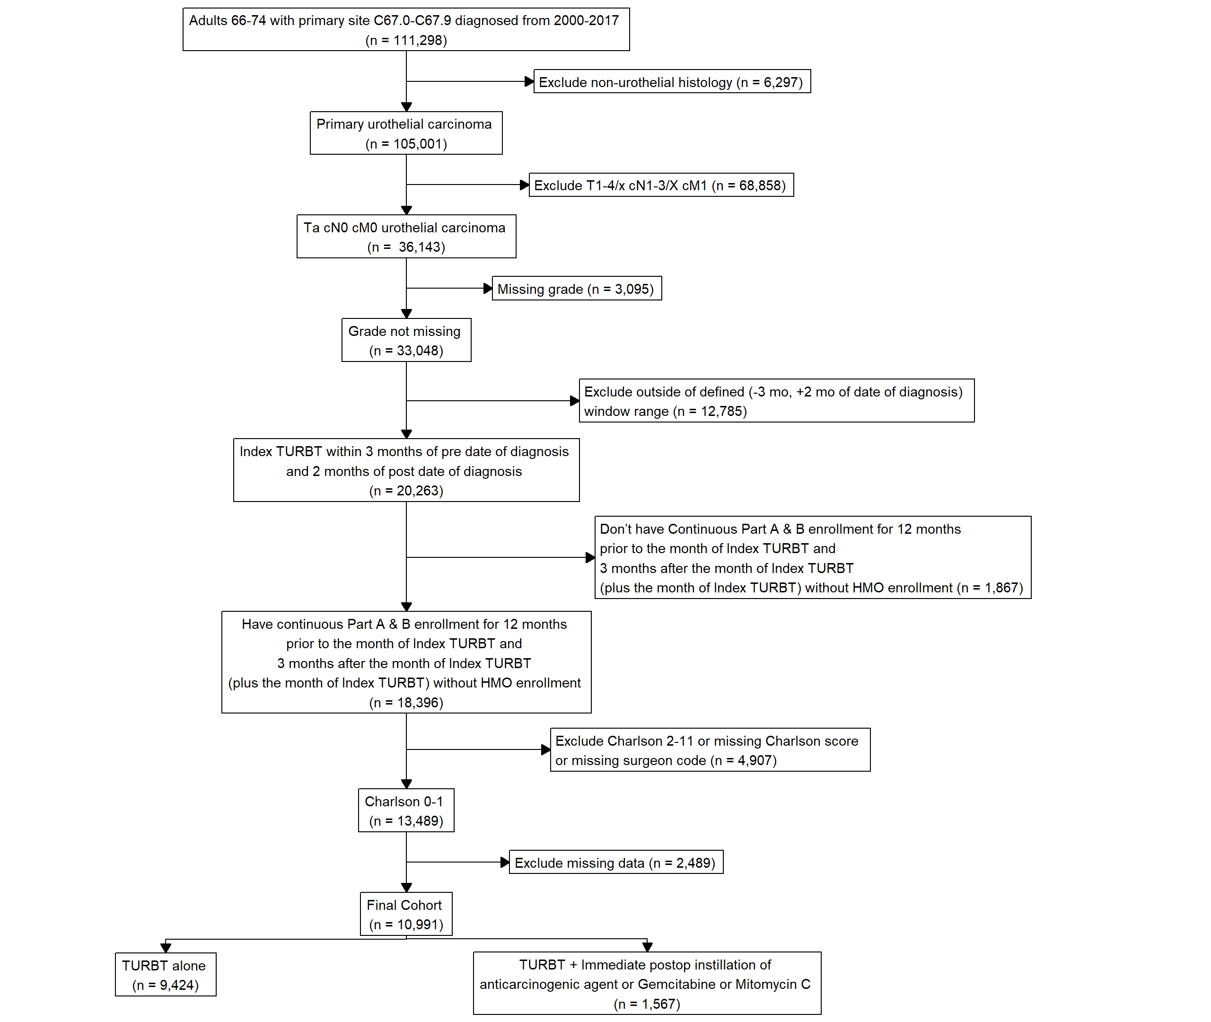

Supplementary Figure 2 Kaplan-Meier plot of high-risk recurrence free survival (HR-RFS) among patients treated with TURBT alone versus TURBT + POC.
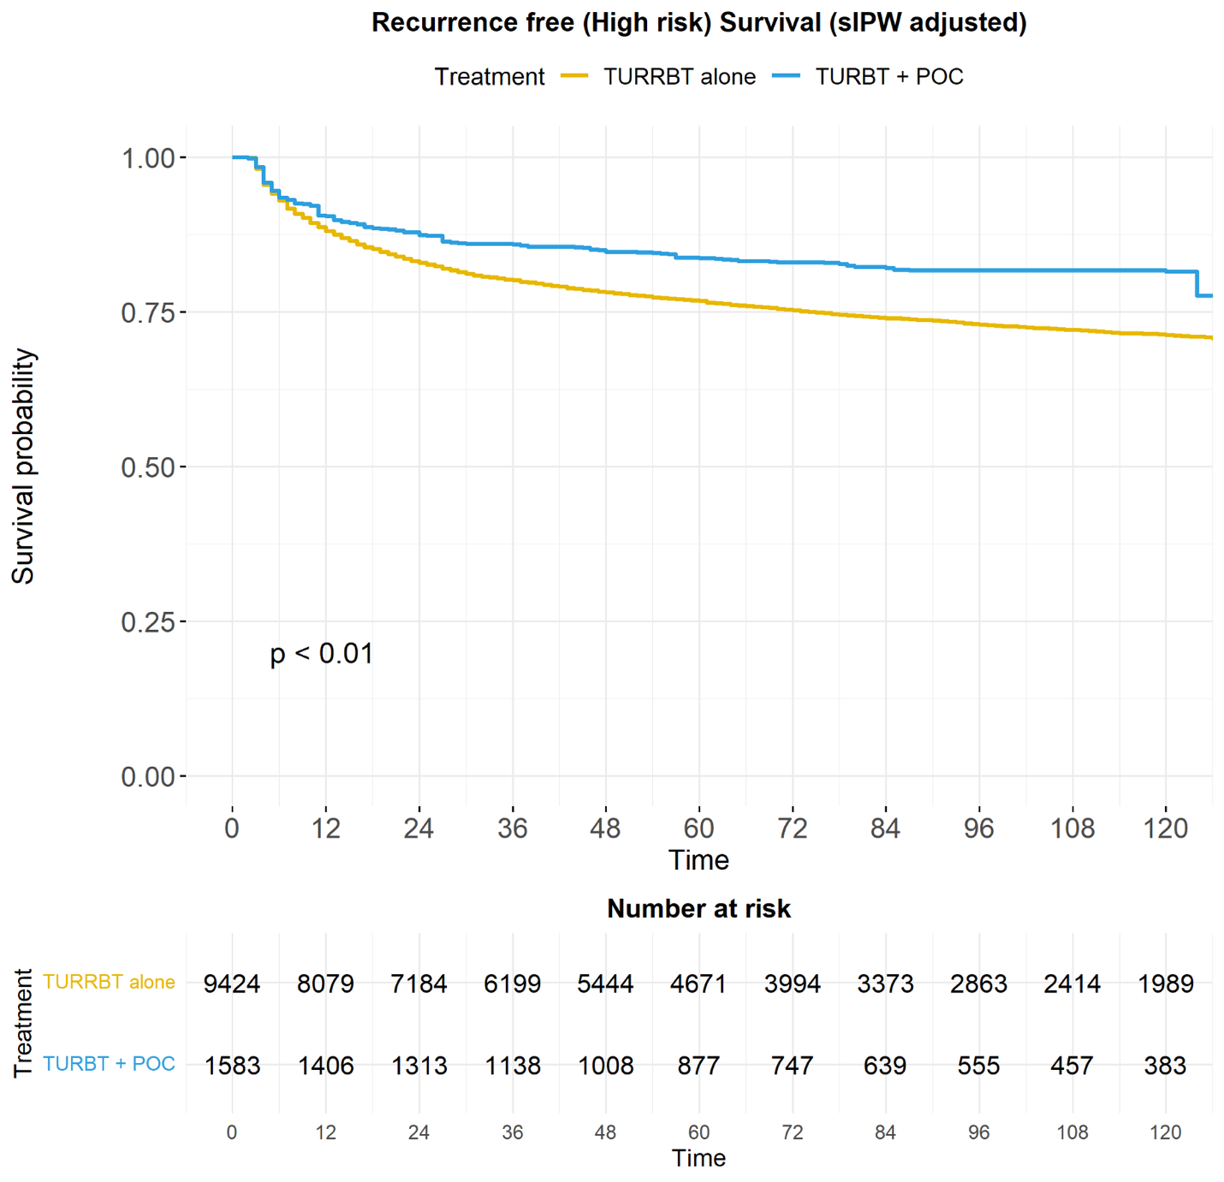

Supplementary Figure 3 Forest plot evaluating high-risk RFS across selected baseline characteristics.
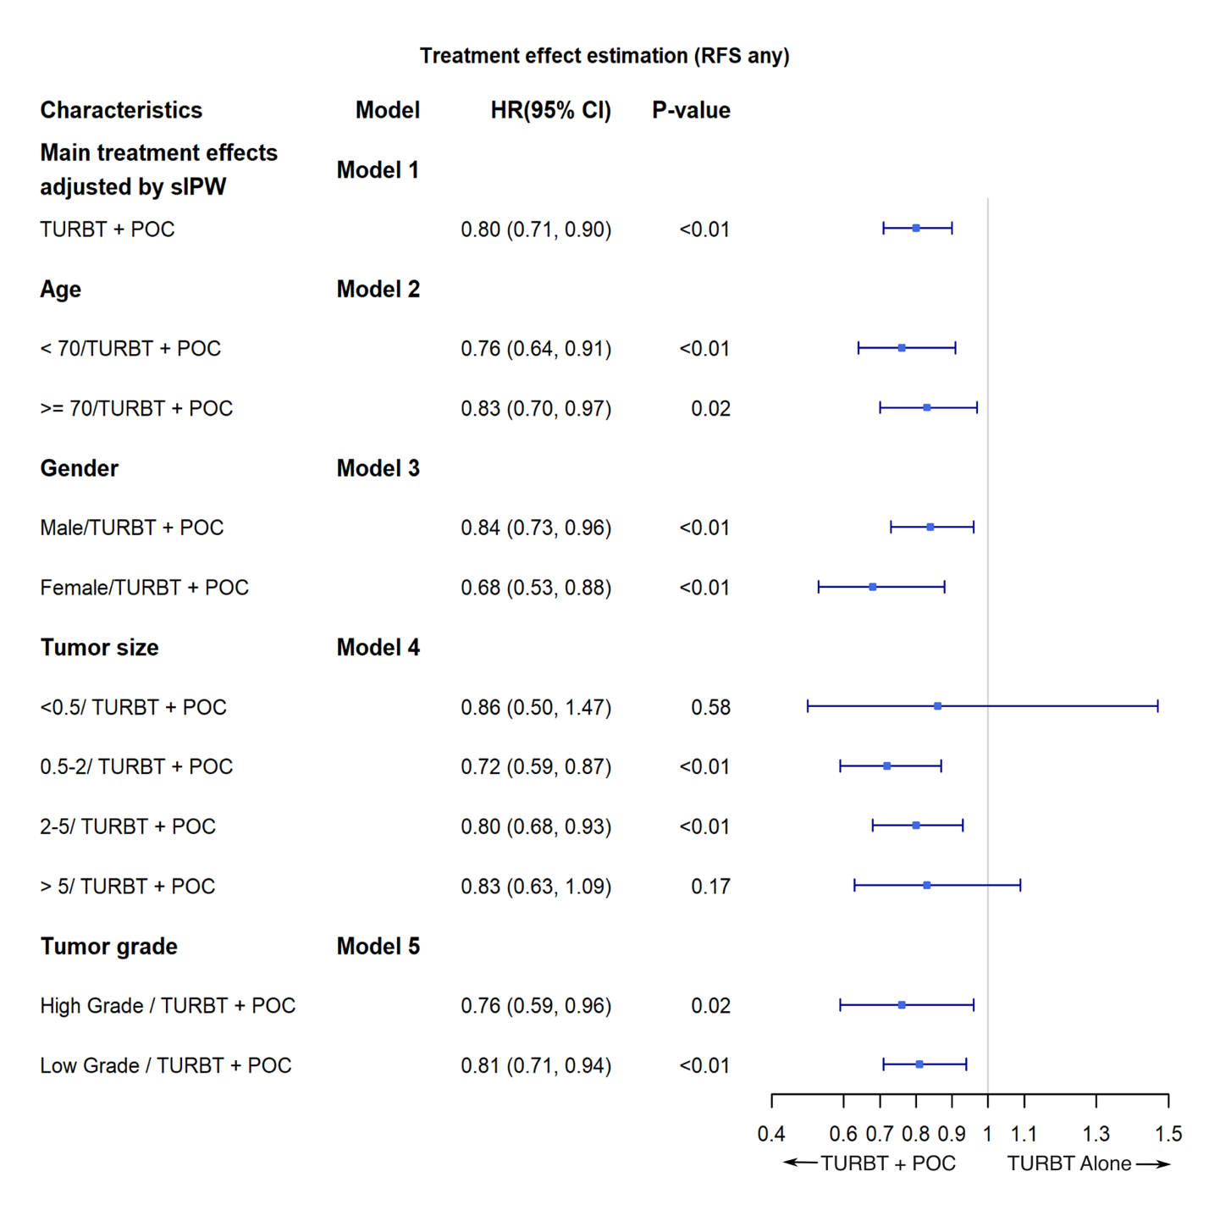

Supplementary Figure 4 Forest plot evaluating PFS across selected baseline characteristics.
