Table A. Overview of Variables, Categories, and Intercoder Reliability
Variable | Category | Intercoder Reliability
Accessibility | Does the fact-checking article/video text provide the original claim being verified, and if so, how is it provided?  0 = No original claim is provided or the original claim cannot be accessed  1 = The original claim is provided directly (e.g., a link to a video of the original source or a screenshot with the original claim directly embedded)  2 = Original claim provided indirectly (e.g., screenshot of video or audio; citation of original claim without direct link or screenshot of original claim) | α = .92
Verdict | What type of verdict does the fact-checking article/video text provide?  0 = No verdict provided  1 = A definitive verdict such as ‘false’, ‘inaccurate’, ‘misleading’, ‘rumour’, etc. is provided in the title or body of the article/video texts  2 =A narrative verdict is provided, usually in the last paragraph or at the top of the article/video text. | α = .91
Claimant | Who made or issued the original claim?  0 = Claimant not mentioned  1 = Domestic government department  2 = International government department  3 = Transport sector  4 = Traditional media sector  5 = New media sector  6 = Science and research sector  7 = Civil sector  8 = Business sector  9 = Professional associations  10 = Religious and ethnic sector  11 = Healthcare sector  12 = Education and cultural sector  13 = Justice sector  14 = social media user(s) | α = .88
Visuals | Does the fact-checking article/video text provide visuals to support the article’s verdict?  0 = no  1 = yes | α = .98
Sources | What types of information are used in the fact-checking article to verify this claim and to justify its verdict?  0 = No source provided  1 = Domestic government department  2 = International government sector  3 = Transport sector  4 = Traditional media sector  5 = Sports and Arts Sector  6 = Science and research sector  7 = Civil sector  8 = Business sector  9 = Professional associations  10 = Religious and ethnic sector  11 = Public security department  12 =Medical institutions  13 = Education, and academic sector  14 =Fact-checking organization's own resources  15 = Justice sector  16 = Social media  17 = Health environment sector  (Optional open coding) | α = .83
Source types | How many types of sources are provided in the fact-checking article/video text?  0=not provided  1=one type  2=two or more types

Table B. Overview of Topic Groups and Topics
Topic Groups and Topics | Prevalence(%）
Topic Groups and Topics | All  (n= 4732) | Official Model |  |  | Professional/Commercial Model |  | Independent/Academic Model |  | Individual Fact-checking Model
Topic Groups and Topics | All  (n= 4732) | (n = 1，440) |  |  | (n = 706) |  | (n = 573) |  | (n = 709)
Topic Groups and Topics | All  (n= 4732) | Wen Zheng  （n=442） | Qiu Zhen  （n=86） | Chinese Internet United Rumor-Debunking Platform  （n=912） | FactPaper  （n=494） | Jiao Zhen  （n=212） | China Fact Check  （n=533） | He Zhen Lu  （n=40） | Fei Die Shuo  （n=83） | Daddy Lab  （n=525） | XLab  （n=101）
Domestic Politics | 15.87% | 24.21% | 23.26% | 33.55% | 8.30% | 16.98% | 6.00% | 5.00% | 0.00% | 0.00% | 0.00%
National Policies/Statements |  | 2.49% | 10.47% | 4.61% | 0.40% | 0.47% | 0.00% | 2.50% | 0.00% | 0.00% | 0.00%
Legal Enhancement and Development |  | 0.68% | 0.00% | 3.73% | 0.00% | 0.00% | 0.00% | 0.00% | 0.00% | 0.00% | 0.00%
Market Regulation |  | 0.23% | 0.00% | 4.28% | 0.20% | 0.94% | 0.19% | 0.00% | 0.00% | 0.00% | 0.00%
Public Health Emergency Response System |  | 3.39% | 0.00% | 1.86% | 0.00% | 4.72% | 0.00% | 2.50% | 0.00% | 0.00% | 0.00%
Epidemic Prevention and Control Policies |  | 9.05% | 0.00% | 3.29% | 0.20% | 5.66% | 0.00% | 0.00% | 0.00% | 0.00% | 0.00%
Misconduct and Irregularities |  | 0.90% | 0.00% | 1.64% | 0.00% | 0.00% | 0.00% | 0.00% | 0.00% | 0.00% | 0.00%
Conferences and Activities |  | 0.00% | 0.00% | 0.88% | 0.00% | 0.00% | 0.00% | 0.00% | 0.00% | 0.00% | 0.00%
Government and Public Institution Announcements |  | 2.04% | 6.98% | 3.07% | 0.20% | 0.47% | 0.00% | 0.00% | 0.00% | 0.00% | 0.00%
Marriage and Natalist Policies |  | 0.00% | 0.00% | 0.66% | 0.20% | 0.00% | 0.00% | 0.00% | 0.00% | 0.00% | 0.00%
Tibet and Xinjiang |  | 0.68% | 0.00% | 4.93% | 1.21% | 1.89% | 1.50% | 0.00% | 0.00% | 0.00% | 0.00%
Local Policies |  | 4.75% | 0.00% | 1.64% | 0.00% | 0.94% | 0.00% | 0.00% | 0.00% | 0.00% | 0.00%
Social Security Policies |  | 0.00% | 5.81% | 2.19% | 0.00% | 0.94% | 0.00% | 0.00% | 0.00% | 0.00% | 0.00%
Cross-Strait Issues |  | 0.00% | 0.00% | 0.77% | 5.87% | 0.94% | 4.32% | 0.00% | 0.00% | 0.00% | 0.00%
International Politics | 14.47% | 2.04% | 0.00% | 4.17% | 48.79% | 3.30% | 34.15% | 30.00% | 3.61% | 0.76% | 0.00%
Other Asian Political, Economic and Social Issues |  | 0.00% | 0.00% | 0.33% | 6.07% | 0.00% | 5.07% | 2.50% | 1.20% | 0.19% | 0.00%
European Political, Economic and Social Issues |  | 0.68% | 0.00% | 1.54% | 6.68% | 0.47% | 3.56% | 2.50% | 0.00% | 0.00% | 0.00%
Political, Economic and Social Issues in Japan, South Korea and North Korea |  | 0.90% | 0.00% | 1.97% | 9.11% | 1.89% | 3.75% | 15.00% | 1.20% | 0.19% | 0.00%
Russia-Ukraine Issues |  | 0.00% | 0.00% | 0.00% | 6.07% | 0.00% | 4.32% | 0.00% | 0.00% | 0.00% | 0.00%
Russian Political, Economic and Social Issues |  | 0.00% | 0.00% | 0.11% | 9.51% | 0.47% | 11.26% | 0.00% | 1.20% | 0.19% | 0.00%
Australian Political, Economic and Social Issues |  | 0.00% | 0.00% | 0.22% | 4.05% | 0.47% | 2.44% | 2.50% | 0.00% | 0.19% | 0.00%
Political, Economic and Social Issues in Other Countries |  | 0.45% | 0.00% | 0.00% | 7.29% | 0.00% | 3.75% | 7.50% | 0.00% | 0.00% | 0.00%
COVID-19 | 8.87% | 16.74% | 4.65% | 11.95% | 2.83% | 36.79% | 3.19% | 0.00% | 0.00% | 1.33% | 0.99%
Shanghai COVID-19 Outbreak |  | 4.52% | 1.16% | 0.00% | 0.00% | 3.77% | 0.19% | 0.00% | 0.00% | 0.00% | 0.00%
Origin, Characteristics, and Transmission of the Outbreak |  | 2.26% | 0.00% | 1.86% | 0.81% | 0.00% | 0.75% | 0.00% | 0.00% | 0.00% | 0.00%
Cures, Prevention, Treatments |  | 2.04% | 1.16% | 2.30% | 0.61% | 3.30% | 0.19% | 0.00% | 0.00% | 0.00% | 0.00%
Vaccination and Controversies |  | 0.23% | 0.00% | 2.08% | 0.61% | 5.19% | 0.56% | 0.00% | 0.00% | 0.00% | 0.00%
Masks |  | 0.68% | 0.00% | 1.54% | 0.20% | 5.66% | 0.75% | 0.00% | 0.00% | 1.14% | 0.99%
Community Quarantine |  | 0.90% | 0.00% | 1.64% | 0.40% | 6.13% | 0.38% | 0.00% | 0.00% | 0.19% | 0.00%
Shelter Hospital Quarantine |  | 1.58% | 1.16% | 0.22% | 0.00% | 5.66% | 0.00% | 0.00% | 0.00% | 0.00% | 0.00%
COVID-19 Supplies |  | 0.68% | 1.16% | 0.33% | 0.20% | 0.00% | 0.00% | 0.00% | 0.00% | 0.00% | 0.00%
Statistical Data |  | 2.26% | 0.00% | 0.99% | 0.00% | 2.83% | 0.38% | 0.00% | 0.00% | 0.00% | 0.00%
Government Response |  | 0.68% | 0.00% | 0.22% | 0.00% | 0.47% | 0.94% | 0.00% | 3.61% | 0.00% | 4.95%
Society | 8.40% | 8.60% | 12.79% | 7.35% | 0.00% | 2.36% | 11.26% | 5.00% | 13.25% | 14.67% | 16.83%
Social Issues, Social Services |  | 0.68% | 2.33% | 0.33% | 0.00% | 0.00% | 0.00% | 0.00% | 0.00% | 0.00% | 0.00%
Social Activities, International Activities |  | 1.13% | 1.16% | 0.33% | 0.00% | 0.00% | 0.19% | 0.00% | 0.00% | 0.00% | 0.00%
Sensational News |  | 2.26% | 0.00% | 1.10% | 0.00% | 0.00% | 0.00% | 0.00% | 0.00% | 0.00% | 0.00%
National Identity and Patriotism |  | 0.68% | 3.49% | 0.88% | 0.00% | 0.00% | 0.75% | 0.00% | 0.00% | 0.00% | 0.00%
Manipulation of Public Opinion |  | 0.45% | 0.00% | 0.00% | 0.00% | 0.47% | 1.31% | 0.00% | 0.00% | 0.00% | 0.00%
Delayed Retirement, Pension |  | 0.68% | 5.81% | 3.29% | 0.00% | 0.00% | 0.00% | 0.00% | 0.00% | 0.00% | 0.00%
Social Controversies |  | 0.90% | 0.00% | 0.00% | 0.00% | 0.00% | 0.00% | 0.00% | 0.00% | 0.19% | 0.00%
Commodity Safety |  | 0.68% | 0.00% | 0.22% | 0.00% | 0.47% | 0.94% | 0.00% | 3.61% | 11.43% | 4.95%
Housing Prices, Second-hand Housing |  | 0.00% | 0.00% | 0.00% | 0.00% | 0.00% | 0.19% | 0.00% | 0.00% | 0.00% | 0.00%
Matchmaking, Gender Discrimination |  | 0.00% | 0.00% | 0.11% | 0.00% | 0.47% | 0.38% | 0.00% | 1.20% | 0.38% | 0.99%
Women's Rights or Rights of Vulnerable Groups,Surrogacy |  | 0.00% | 0.00% | 0.11% | 0.00% | 0.47% | 6.38% | 5.00% | 2.41% | 0.57% | 3.96%
Overtime, Work Rights |  | 0.45% | 0.00% | 0.22% | 0.00% | 0.47% | 0.75% | 0.00% | 1.20% | 0.19% | 0.99%
Chinese Style |  | 0.23% | 0.00% | 0.00% | 0.00% | 0.00% | 0.00% | 0.00% | 2.41% | 0.95% | 1.98%
Spring Festival Travel Rush, Holidays, etc. |  | 0.45% | 0.00% | 0.77% | 0.00% | 0.00% | 0.38% | 0.00% | 2.41% | 0.95% | 3.96%
Economy | 8.84% | 5.88% | 9.30% | 3.18% | 1.01% | 11.32% | 2.63% | 12.50% | 13.25% | 30.48% | 20.79%
Trade and Supply Chain |  | 0.45% | 0.00% | 0.00% | 0.00% | 0.00% | 0.00% | 0.00% | 0.00% | 0.00% | 0.00%
Food Delivery, Group Buying, and Courier Services |  | 2.49% | 1.16% | 0.99% | 0.00% | 5.66% | 0.19% | 0.00% | 2.41% | 1.52% | 1.98%
Manufacturing and Labour |  | 0.45% | 0.00% | 0.00% | 0.00% | 0.00% | 0.00% | 0.00% | 0.00% | 0.00% | 0.00%
Promotions, Discounts, and Subsidies |  | 0.00% | 3.49% | 0.00% | 0.00% | 0.47% | 0.00% | 0.00% | 6.02% | 1.90% | 4.95%
Tourism Development: Policies and Economics |  | 0.90% | 2.33% | 0.66% | 0.81% | 1.42% | 0.19% | 0.00% | 0.00% | 0.76% | 0.00%
Investment and Gold |  | 0.00% | 0.00% | 0.22% | 0.00% | 0.00% | 0.56% | 0.00% | 0.00% | 0.19% | 0.00%
Real Estate, Housing Provident Fund, and Public Rental Housing |  | 0.23% | 1.16% | 0.11% | 0.20% | 0.00% | 1.13% | 0.00% | 0.00% | 1.14% | 0.00%
Banking and Finance |  | 0.23% | 0.00% | 0.55% | 0.00% | 0.94% | 0.56% | 5.00% | 0.00% | 0.00% | 0.00%
Domestic Product Economy |  | 0.23% | 1.16% | 0.11% | 0.00% | 0.00% | 0.00% | 2.50% | 1.20% | 0.57% | 1.98%
Economic Sanctions |  | 0.00% | 0.00% | 0.11% | 0.00% | 0.00% | 0.00% | 0.00% | 0.00% | 0.00% | 0.00%
Economic Regulations and Industry Assessments |  | 0.45% | 0.00% | 0.00% | 0.00% | 1.89% | 0.00% | 0.00% | 3.61% | 22.86% | 9.90%
Employment Market |  | 0.00% | 0.00% | 0.33% | 0.00% | 0.94% | 0.00% | 2.50% | 0.00% | 0.00% | 0.00%
Regional and Industry Economics |  | 0.45% | 0.00% | 0.11% | 0.00% | 0.00% | 0.00% | 2.50% | 0.00% | 1.52% | 1.98%
Justice and Crime | 4.55% | 2.71% | 10.47% | 9.10% | 4.45% | 1.89% | 4.32% | 0.00% | 1.20% | 0.38% | 0.00%
Impersonating Public Officials |  | 0.68% | 1.16% | 0.00% | 0.00% | 0.47% | 0.00% | 0.00% | 0.00% | 0.00% | 0.00%
Social Security Card Cash-out Scams |  | 0.23% | 0.00% | 0.00% | 0.00% | 0.00% | 0.00% | 0.00% | 0.00% | 0.00% | 0.00%
Scams, Illegal Lending |  | 0.45% | 4.65% | 1.97% | 1.01% | 0.47% | 0.00% | 0.00% | 0.00% | 0.19% | 0.00%
Sexual Assault, Molestation of Minors |  | 0.00% | 2.33% | 0.00% | 0.00% | 0.00% | 0.19% | 0.00% | 0.00% | 0.00% | 0.00%
Animal Abuse, Child Abuse, Elder Abuse |  | 0.45% | 0.00% | 0.00% | 1.62% | 0.00% | 1.31% | 0.00% | 0.00% | 0.00% | 0.00%
Public Disturbance |  | 0.23% | 0.00% | 0.00% | 0.00% | 0.00% | 1.69% | 0.00% | 0.00% | 0.00% | 0.00%
Illegal Activities |  | 0.23% | 0.00% | 2.63% | 0.00% | 0.94% | 0.19% | 0.00% | 0.00% | 0.00% | 0.00%
Domestic Violence, Trafficking |  | 0.45% | 0.00% | 0.11% | 0.00% | 0.00% | 0.38% | 0.00% | 1.20% | 0.19% | 0.00%
Telecommunications Fraud |  | 0.00% | 2.33% | 1.21% | 1.82% | 0.00% | 0.38% | 0.00% | 0.00% | 0.00% | 0.00%
Criminal Cases |  | 0.00% | 0.00% | 3.18% | 0.00% | 0.00% | 0.19% | 0.00% | 0.00% | 0.00% | 0.00%
Food and Health (Medical) | 7.93% | 11.76% | 2.33% | 3.51% | 0.40% | 1.42% | 1.31% | 15.00% | 34.94% | 23.24% | 16.83%
Water, Public Resources |  | 0.90% | 1.16% | 0.22% | 0.00% | 0.00% | 0.19% | 5.00% | 1.20% | 4.38% | 2.97%
Diseases and Treatment |  | 0.68% | 0.00% | 0.22% | 0.00% | 0.00% | 0.38% | 2.50% | 0.00% | 0.00% | 0.00%
Food Safety, Food Additives |  | 2.94% | 0.00% | 0.22% | 0.00% | 0.00% | 0.19% | 0.00% | 1.20% | 11.81% | 2.97%
Depression, Anxiety, and Other Psychological Issues |  | 0.00% | 0.00% | 0.00% | 0.40% | 0.47% | 0.19% | 2.50% | 1.20% | 0.57% | 0.99%
Medical Insurance |  | 1.58% | 1.16% | 2.41% | 0.00% | 0.00% | 0.00% | 0.00% | 0.00% | 0.00% | 0.00%
Supplies and Supply Security |  | 0.45% | 0.00% | 0.00% | 0.00% | 0.94% | 0.00% | 0.00% | 0.00% | 0.00% | 0.00%
Doctor-Patient Relations |  | 0.23% | 0.00% | 0.44% | 0.00% | 0.00% | 0.00% | 0.00% | 1.20% | 0.19% | 0.99%
Science Popularisation |  | 2.71% | 0.00% | 0.00% | 0.00% | 0.00% | 0.19% | 2.50% | 24.10% | 3.81% | 4.95%
Health Care |  | 2.26% | 0.00% | 0.00% | 0.00% | 0.00% | 0.19% | 2.50% | 6.02% | 2.48% | 3.96%
Environment and Climate Change | 3.62% | 1.36% | 8.14% | 4.71% | 3.24% | 2.36% | 3.94% | 2.50% | 2.41% | 3.05% | 6.93%
Traffic Restrictions and Vehicle Number Restrictions and Other Environmental Protection Measures |  | 0.00% | 0.00% | 0.11% | 0.00% | 0.00% | 0.00% | 0.00% | 0.00% | 0.00% | 0.00%
PM2.5 and Air Quality |  | 0.00% | 0.00% | 0.22% | 0.20% | 0.47% | 1.13% | 0.00% | 1.20% | 1.52% | 2.97%
Earthquakes |  | 0.68% | 2.33% | 1.75% | 1.42% | 0.00% | 0.75% | 0.00% | 0.00% | 0.00% | 0.00%
Extreme Weather Events |  | 0.23% | 0.00% | 0.77% | 0.00% | 0.00% | 0.94% | 0.00% | 0.00% | 0.95% | 0.00%
Environmental Policies |  | 0.45% | 2.33% | 0.33% | 0.61% | 1.42% | 0.56% | 0.00% | 0.00% | 0.00% | 0.00%
Carbon Dioxide Emissions |  | 0.00% | 0.00% | 0.11% | 0.00% | 0.00% | 0.19% | 0.00% | 0.00% | 0.00% | 0.00%
Natural Disasters |  | 0.00% | 3.49% | 1.21% | 0.81% | 0.00% | 0.00% | 2.50% | 0.00% | 0.19% | 0.00%
Renewable Energy Technologies |  | 0.00% | 0.00% | 0.11% | 0.00% | 0.00% | 0.19% | 0.00% | 1.20% | 0.38% | 3.96%
Agriculture |  | 0.00% | 0.00% | 0.11% | 0.20% | 0.47% | 0.19% | 0.00% | 0.00% | 0.00% | 0.00%
United States | 5.72% | 0.90% | 0.00% | 1.97% | 16.40% | 0.00% | 16.32% | 12.50% | 1.20% | 0.00% | 0.00%
U.S.-China Activities |  | 0.45% | 0.00% | 0.33% | 4.66% | 0.00% | 3.19% | 0.00% | 0.00% | 0.00% | 0.00%
U.S.-China Relations |  | 0.23% | 0.00% | 0.33% | 2.83% | 0.00% | 2.25% | 0.00% | 0.00% | 0.00% | 0.00%
U.S. Military, Political, Economic, and Social Activities |  | 0.23% | 0.00% | 1.32% | 6.48% | 0.00% | 2.44% | 10.00% | 1.20% | 0.00% | 0.00%
Donald John Trump and Elon Musk |  | 0.00% | 0.00% | 0.00% | 7.09% | 0.00% | 8.44% | 2.50% | 0.00% | 0.00% | 0.00%
Public Transportation | 3.56% | 7.01% | 3.49% | 3.51% | 2.02% | 5.66% | 4.69% | 2.50% | 2.41% | 0.57% | 2.97%
Ride-hailing/Car/Taxi |  | 1.13% | 1.16% | 0.44% | 0.40% | 0.47% | 0.38% | 0.00% | 1.20% | 0.57% | 0.00%
Airplane/Flight |  | 0.45% | 1.16% | 0.55% | 0.61% | 1.42% | 0.94% | 0.00% | 0.00% | 0.00% | 0.00%
Subway/Train |  | 3.85% | 1.16% | 2.08% | 0.40% | 1.89% | 1.50% | 2.50% | 0.00% | 0.00% | 1.98%
Bus |  | 0.68% | 0.00% | 0.22% | 0.20% | 0.94% | 0.19% | 0.00% | 1.20% | 0.00% | 0.00%
Maritime Transport |  | 0.45% | 0.00% | 0.11% | 0.20% | 0.47% | 1.69% | 0.00% | 0.00% | 0.00% | 0.00%
Bicycle/Ride-hailing Bike/Electric Bike/Motorcycle |  | 0.45% | 0.00% | 0.11% | 0.20% | 0.47% | 0.00% | 0.00% | 0.00% | 0.00% | 0.99%
Hong Kong (Macau) | 1.72% | 0.00% | 0.00% | 0.22% | 4.05% | 16.98% | 0.00% | 0.00% | 1.20% | 0.00% | 0.00%
Hong Kong (Macao) COVID-19 Situation |  | 0.00% | 0.00% | 0.00% | 0.40% | 8.49% | 0.00% | 0.00% | 0.00% | 0.00% | 0.00%
Hong Kong (Macao) Government |  | 0.00% | 0.00% | 0.00% | 3.04% | 4.72% | 0.00% | 0.00% | 0.00% | 0.00% | 0.00%
Hong Kong (Macao) Economic and Social Activities |  | 0.00% | 0.00% | 0.22% | 0.61% | 3.77% | 0.00% | 0.00% | 1.20% | 0.00% | 0.00%
Technology | 3.91% | 0.90% | 2.33% | 0.44% | 6.68% | 0.00% | 2.81% | 5.00% | 8.43% | 8.38% | 22.77%
Social Media |  | 0.00% | 0.00% | 0.00% | 0.40% | 0.00% | 0.00% | 0.00% | 0.00% | 0.00% | 0.00%
AI |  | 0.00% | 0.00% | 0.11% | 2.43% | 0.00% | 0.19% | 2.50% | 4.82% | 2.10% | 11.88%
Technology Products |  | 0.23% | 0.00% | 0.11% | 0.40% | 0.00% | 0.00% | 0.00% | 1.20% | 3.05% | 5.94%
Live Streaming, Gaming, Animation |  | 0.00% | 0.00% | 0.00% | 1.21% | 0.00% | 0.19% | 2.50% | 1.20% | 1.71% | 2.97%
Data Security |  | 0.23% | 1.16% | 0.11% | 2.43% | 0.00% | 2.25% | 0.00% | 0.00% | 1.33% | 0.00%
Emerging Technologies Such As Automotive and Aerospace |  | 0.23% | 0.00% | 0.11% | 0.00% | 0.00% | 0.00% | 0.00% | 1.20% | 0.00% | 0.99%
Software and Networking |  | 0.23% | 1.16% | 0.00% | 0.20% | 0.00% | 0.19% | 0.00% | 0.00% | 0.19% | 0.99%
Public Security (Police) and Military | 6.94% | 11.54% | 18.60% | 13.27% | 0.40% | 0.00% | 9.01% | 0.00% | 0.00% | 0.00% | 0.00%
Military Exercises and Activities |  | 0.00% | 0.00% | 0.99% | 0.00% | 0.00% | 6.57% | 0.00% | 0.00% | 0.00% | 0.00%
Public Security Investigation |  | 0.90% | 0.00% | 0.00% | 0.00% | 0.00% | 0.56% | 0.00% | 0.00% | 0.00% | 0.00%
Maintaining Public Order and Stability |  | 0.90% | 1.16% | 0.00% | 0.00% | 0.00% | 1.88% | 0.00% | 0.00% | 0.00% | 0.00%
Public Safety |  | 0.68% | 0.00% | 0.33% | 0.00% | 0.00% | 0.00% | 0.00% | 0.00% | 0.00% | 0.00%
Public Security Education |  | 0.00% | 0.00% | 0.00% | 0.00% | 0.00% | 0.00% | 0.00% | 0.00% | 0.00% | 0.00%
War of Resistance against Japanese Aggression and Historical Activities |  | 0.00% | 0.00% | 1.21% | 0.00% | 0.00% | 0.00% | 0.00% | 0.00% | 0.00% | 0.00%
Military Enlistment Requirements, Military Training |  | 0.23% | 0.00% | 0.33% | 0.00% | 0.00% | 0.00% | 0.00% | 0.00% | 0.00% | 0.00%
Drug Control, Counter-Terrorism, Border Control |  | 0.23% | 0.00% | 0.11% | 0.40% | 0.00% | 0.00% | 0.00% | 0.00% | 0.00% | 0.00%
Household Registration Management |  | 0.23% | 0.00% | 2.63% | 0.00% | 0.00% | 0.00% | 0.00% | 0.00% | 0.00% | 0.00%
Administrative Enforcement Announcements |  | 8.37% | 17.44% | 7.68% | 0.00% | 0.00% | 0.00% | 0.00% | 0.00% | 0.00% | 0.00%
Education | 5.60% | 6.33% | 4.65% | 3.07% | 1.42% | 0.94% | 0.38% | 10.00% | 18.07% | 17.14% | 11.88%
Educational Measures |  | 1.81% | 0.00% | 0.33% | 0.00% | 0.00% | 0.00% | 0.00% | 1.20% | 0.00% | 0.00%
Education System |  | 0.45% | 0.00% | 0.33% | 0.00% | 0.00% | 0.00% | 2.50% | 0.00% | 0.00% | 0.00%
Student Aid Programs |  | 0.68% | 0.00% | 0.11% | 0.00% | 0.00% | 0.00% | 0.00% | 0.00% | 0.00% | 0.00%
School Bullying |  | 0.00% | 0.00% | 0.11% | 0.00% | 0.00% | 0.00% | 0.00% | 0.00% | 0.19% | 0.00%
Teacher Competence |  | 0.23% | 0.00% | 0.11% | 0.00% | 0.00% | 0.00% | 0.00% | 0.00% | 0.19% | 0.00%
Academic Misconduct |  | 0.68% | 1.16% | 0.88% | 0.00% | 0.00% | 0.00% | 0.00% | 0.00% | 0.00% | 0.00%
English Language Learning |  | 0.45% | 0.00% | 0.22% | 0.00% | 0.00% | 0.00% | 0.00% | 1.20% | 0.19% | 0.00%
Educational Curriculum and Youth Education |  | 0.45% | 0.00% | 0.11% | 0.20% | 0.47% | 0.00% | 0.00% | 0.00% | 13.33% | 0.00%
College Entrance Exam, Competitions, and Academic Advancement |  | 1.36% | 1.16% | 0.66% | 0.00% | 0.00% | 0.00% | 5.00% | 4.82% | 0.19% | 0.99%
National and Provincial Civil Service Examinations |  | 0.00% | 1.16% | 0.11% | 0.40% | 0.00% | 0.00% | 0.00% | 0.00% | 0.00% | 0.00%
Campus Recruitment |  | 0.23% | 1.16% | 0.11% | 0.81% | 0.00% | 0.38% | 0.00% | 0.00% | 0.00% | 0.00%
Historical Figures, Events, and Knowledge |  | 0.00% | 0.00% | 0.00% | 0.00% | 0.47% | 0.00% | 2.50% | 10.84% | 3.05% | 10.89%

Table C. Compare Accessibility, Type of Verdict, Visual Elements Used, and the Number of Resource Types
 | Official |  |  | Professional/commercial |  | Independent/academic |  | Individual fact-checking
 | (n = 1440 articles) |  |  | (n=706 articles) |  | (n=573 articles) |  | (n = 709 video texts)
 | Qiu Zhen | Wen Zheng | Chinese Internet United Rumor-Debunking Platform | Jiao Zhen | FactPaper | China Fact Check | He Zhen Lu | Fei Die Shuo | XLab | Daddy Lab
Accessibility
not provide | 3(7.5%) | 4(10%) | 6(15%) | 2(5%) | - | - | - | 30(%) | 8(20%) | 10(25%)
direct provide | 21(52.5%) | 22(55%) | 20(50%) | 22(55%) | 25(62.5%) | 28(70%) | 23(57.5%) | 4(10%) | 12(30%) | 16(40%)
indirect provide | 16(40%) | 14(35%) | 14(35%) | 16(40%) | 15(37.5%) | 12(30%) | 17(42.5%) | 6(15%) | 20(50%) | 14(35%)
Verdict
no verdict | - | - | - | - | - | - | - | - | - | -
definitive verdict | 40(100%) | 40(100%) | 40(100%) | 37(92.5%) | 33(82.5%) | 38(95%) | 28(70%) | 30(75%) | 28(70%) | 27(67.5%)
narrative verdict | - | - | - | 3(7.5%) | 7(17.5%) | 2(5%) | 12(30%) | 10(25%) | 12(30%) | 13(32.5%)
Visuals | 27(67.5%) | 28(70%) | 35(87.5%) | 26(65%) | 40(100%) | 39(97.5%) | 40(100%) | 40(100%) | 40(100%) | 40(100%)
Resource
no resource | - | - | - | - | - | - | - | - | - | -
one type | 26(65%) | 31(77.5%) | 27(67.5%) | 23(57.5%) | 1(2.5%) | 17(17.5%) | 3(7.5%) | 36(90%) | 24(60%) | 25(62.5%)
two or more types | 14(35%) | 9(22.5%) | 13(32.5%) | 17(42.5%) | 39(97.5%) | 33(82.5%) | 37(92.5%) | 4(10%) | 16(40%) | 15(37.5%)

Figure A. Comparing Claimants of Misinformation
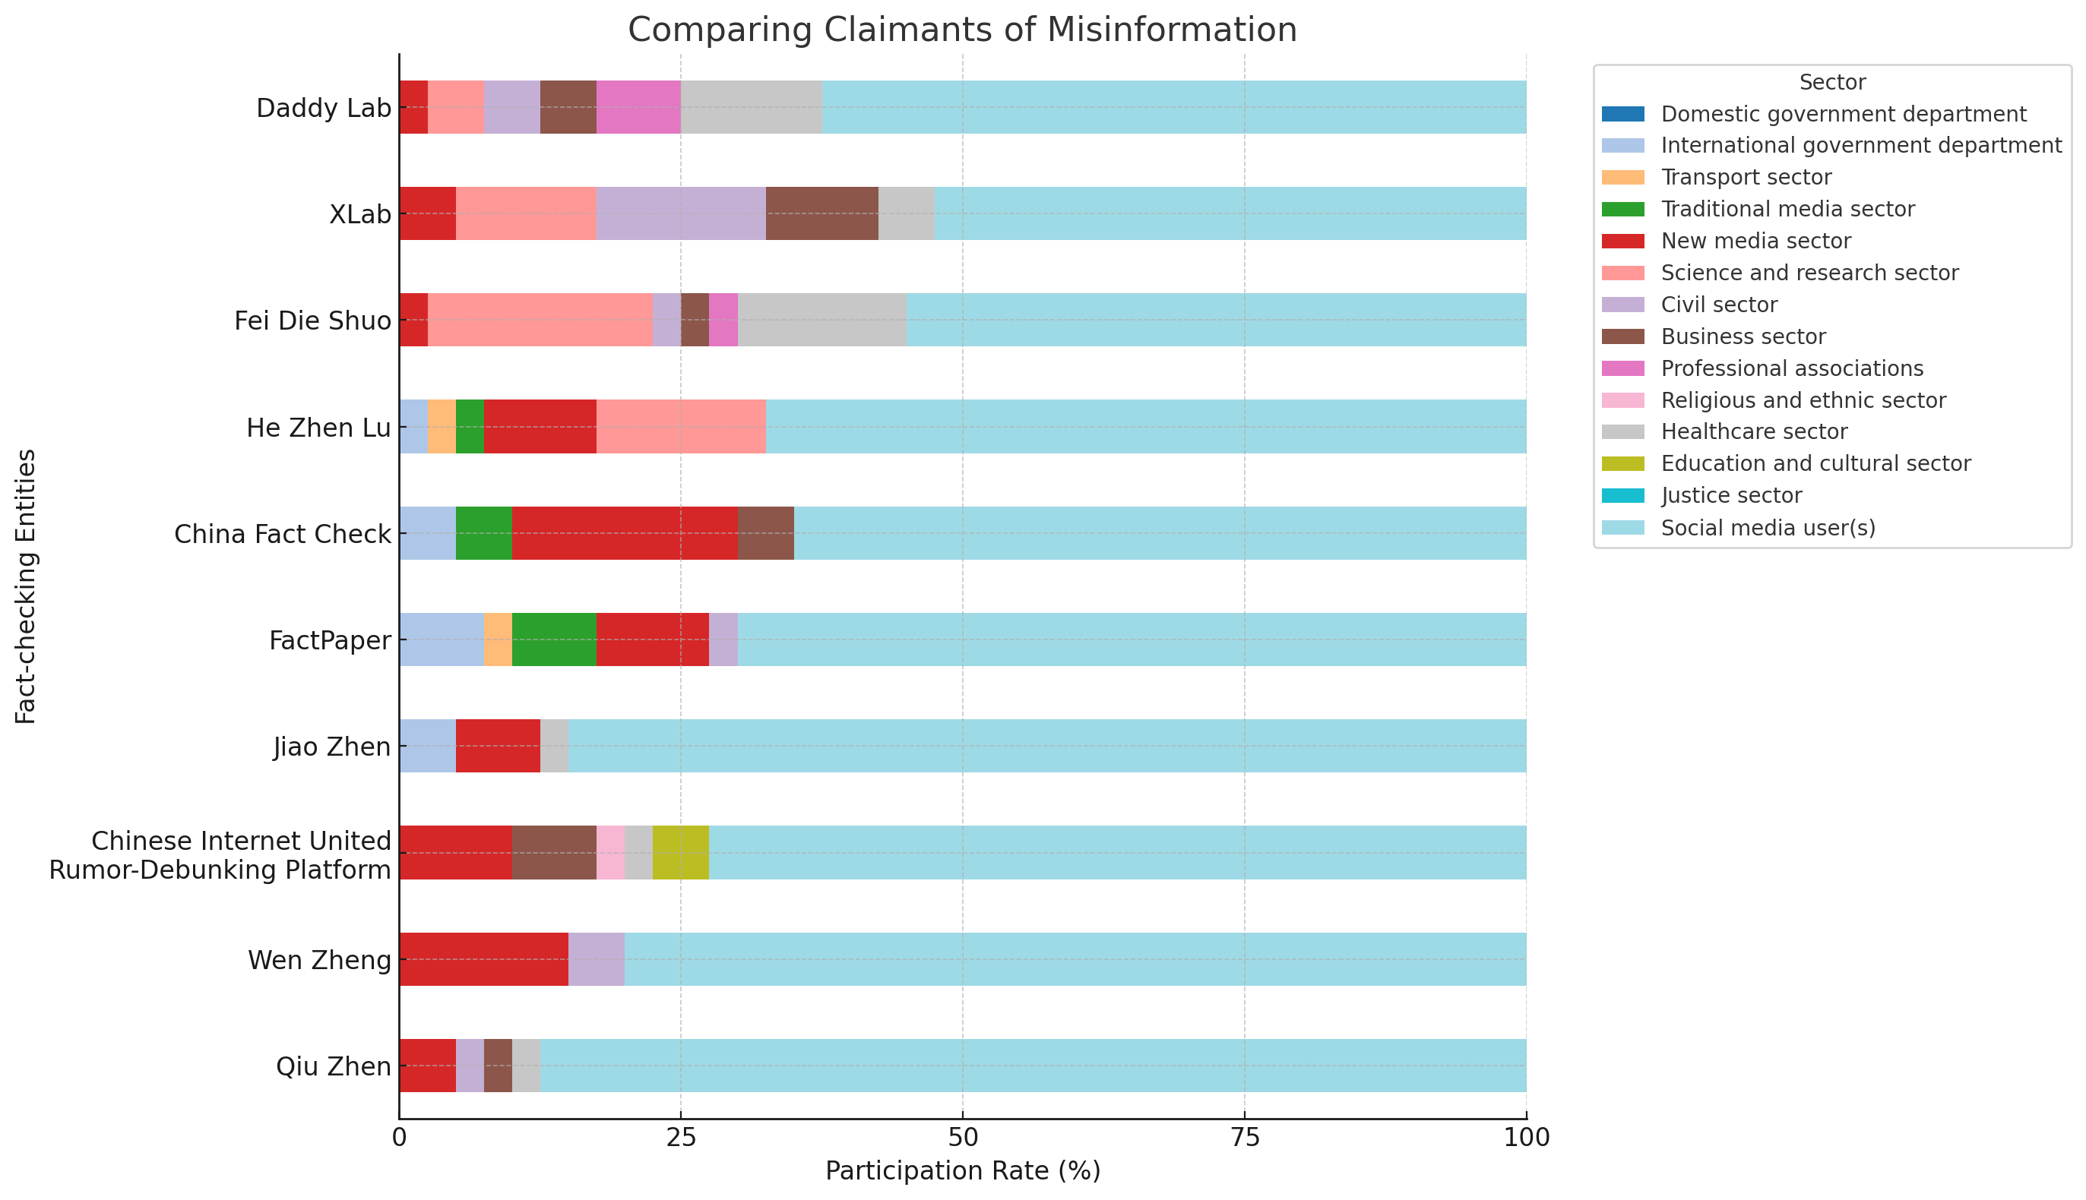
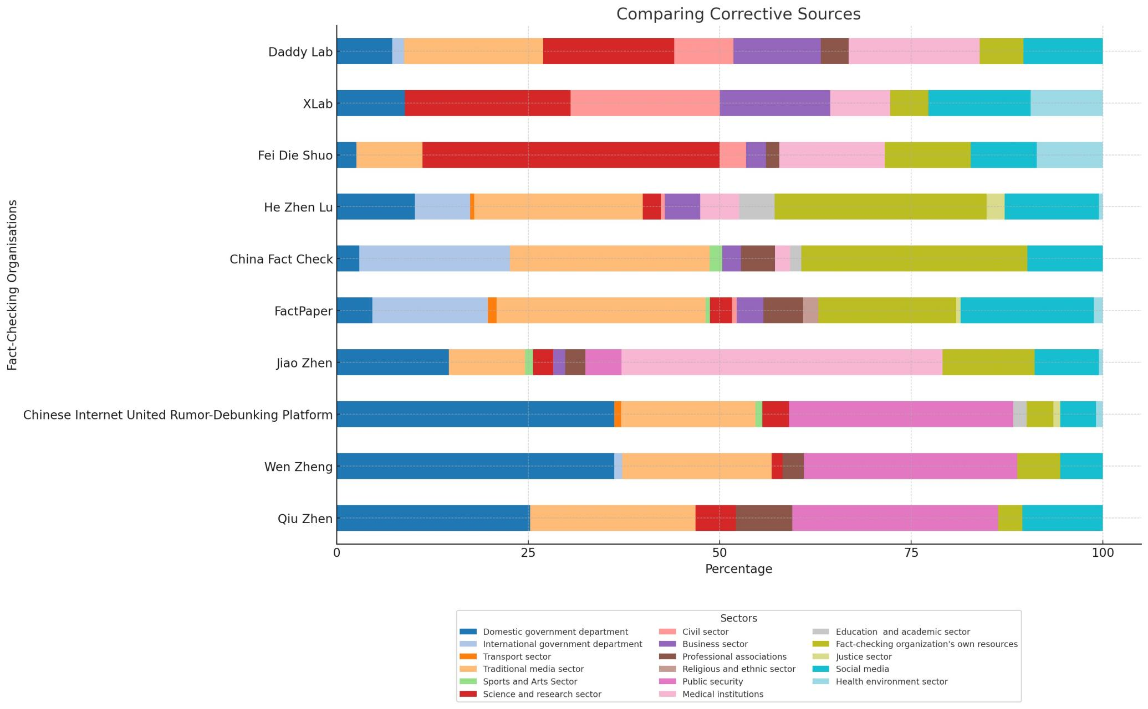
Figure B. Comparing Corrective Sourc

