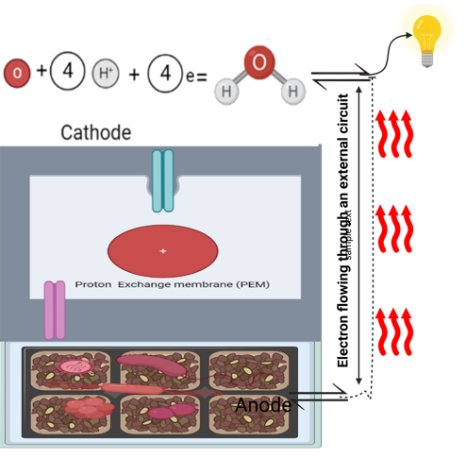
A proton exchange membrane (PEM) divides the horizontally positioned anode and cathode compartments. The anode compartment is filled with the agro-waste substrate that has been combined with culturable-isolated fungi and bacteria from the substrate, and the cathode is in contact with oxygen, which is converted to water. When bacteria at the anode oxidize organic matter (agro-waste substrate), electrons are produced. These electrons go through an external electrical circuit to the cathode, where they produce electrical energy.

