Genetic sequencing of bacteria and yeasts isolated from agrowastes used for the controlled Microbial fuel cell (MFC)

ACAACACCTAAATGTGGAATATAGCATATAGTCGACAAGAGAAATCTACGAAAAACMAAC
MAAACTTTCMACAACGGATCTCTTGGTTCTCSCATCSATGAARARCGCAGCGAAATGSGA
TACCTARTGKGAATTGCAGCCMTCGTGAATCATCSAGTTCTTGAACGCACATTGSGCCCC
TCSGCATTCCGGGGGGSATGCCTGKTTGARCGKCGTTTCCMTCTTGCGCGTGCGCARART
TGGGGGARCGGARCGGACSACGTGKAAAGARCGTCGGARCTGCSACTCSCCTGAAAGGGA
RCGAARCTGGCCSARCGAACTARACTTTTTTTCMGGGACSCTTGGCGGCCGARARCGART
GKTGCGARACAACAAAAAGCTCSACCTCMAATCAGGKARGAATACCCGCTGAACTTAAG
Pichia kudriavzevii MN007220.1

CAWTTTGTGAMCGTACTACGAACAAACAAAAAAAATTATAKYCAAAAAAAAATTAAAC AACTTTTCAACTGGGGATCCCTGGGTTCCSWTCCCKTAAAAAAACCCAGCAAACCCCYA TTTTTCTGGGGATTTGCAAAAGGGACCCATCATTTTTAGCCCCCCTTTTGCACTTTGGGG AACCCCCCAARKTATCCTGGTTRGAGGGTTGTTTCCCTTTGGGATGGGCTTTTCCTTTCC
AAAAAAACRGAYCCAATATCSTTGAAATTTCCTTTTTTTTAACCCTCAAATCARRRAGGA TTCCCCGTTAACTTWASCCATATCAATARGCGGGGAA
Geotrichum candidum MK943778.1

AGGTTACCTCACCGACTTCGGGTGTTACAAACTCTCGTGGTGTGACGGGCGGTGTGTACA
AGGCCCGGGAACGTATTCACCGCGGCATGCTGATCCGCGATTACTAGCGATTCCAGCTTC
ACGCAGTCGAGTTGCAGACTGCGATCCGAACTGAGAACAGATTTGTGGGATTGGCTTAAC
CTCGCGGTTTCGCTGCCCTTTGTTCTGTCCATTGTAGCACGTGTGTAGCCCAGGTCATAA
GGGGCATGATGATTTGACGTCATCCCCACCTTCCTCCGGTTTGTCACCGGCAGTCACCTT
AGAGTGCCCAACTGAATGCTGGCAACTAAGATCAAGGGTTGCGCTCGTTGCGGGACTTAA
CCCAACATCTCACGACACGAGCTGACGACAACCATGCACCACCTGTCACTCTGCCCCCGA
AGGGGACGTCCTATCTCTAGGATTGTCAGAGGATGTCAAGACCTGGTAAGGTTCTTCGCG
TTGCTTCGAATTAAACCACATGCTCCACCGCTTGTGCGGGCCCCCGTCAATTCCTTTGAG
TTTCAGTCTTGCGACCGTACTCCCCAGGCGGAGTGCTTAATGCGTTAGCTGCAGCACTAA
GGGGCGGAAACCCCCTAACACTTAGCACTCATCGTTTACGGCGTGGACTACCAGGGTATC
TAATCCTGTTCGCTCCCCACGCTTTCGCTCCTCAGCGTCAGTTACAGACCAGAGAGTCGC
CTTCGCCACTGGTGTTCCTCCACATCTCTACGCATTTCACCGCTACACGTGGAATTCCAC
TCTCCTCTTCTGCACTCAAGTTCCCCAGTTTCCAATGACCCTCCCCGGTTGAGCCGGGGG
CTTTCACATCAGACTTAA
Bacillus subtilis NR102783.2

TTACCTCAMCGACTTCGGGTGTTACAAACTCTCGTGGTGTGACGGGCGGTGTGTACAAGG
CCCGGGAACGTATTCACCGCGGCATGCTGATCCGCGATTACTAGCGATTCCGGCTTCATG
TAGGCGAGTTGCAGCCTACAATCCGAACTGAGAACGACTTTATCGGATTAGCTCCCTCTC
GCGAGTTGGCAACCGTTTGTATCGTCCATTGTAGCACGTGTGTAGCCCAGGTCATAAGGG
GCATGATGATTTGACGTCATCCCCACCTTCCTCCGGTTTGTCACCGGCAGTCACCTTAGA
GTGCCCAACTAAATGATGGCAACTAAGATCAAGGGTTGCGCTCGTTGCGGGACTTAACCC
AACATCTCACGACACGAGCTGACGACAACCATGCACCACCTGTCACCGTTGCCCCCGAAG
GGGAAACTATATCTCTACAGTGGTCAACGGGATGTCAAGACCTGGTAAGGTTCTTCGCGT
TGCTTCGAATTAAACCACATGCTCCACCGCTTGTGCGGGCCCCCGTCAATTCCTTTGAGT
TTCAGTCTTGCGACCGTACTCCCCAGGCGGAGTGCTTAATGCGTTAGCTGCAGCACTAAG
GGGCGGAAACCCCCTAACACTTAGCACTCATCGTTTACGGCGTGGACTACCAGGGTATCT
AATCCTGTTTGCTCCCCACGCTTTCGCGCCTCAGCGTCAGTTACAGACCAGAAAGTCGCC
TTCGCCACTGGTGTTCCTCCAAATCTCTACGCATTTCACCGCTACACTTGGAATTCCACT
TTCCTCTTCTGCACTCAAGTCCCCCAGTTTCCAATGACCCTCCACGGGTTGAGCCGTGGG
CTTTCACATCAGACTTAAA
Lysinibacillus fusiformis KP419973.1

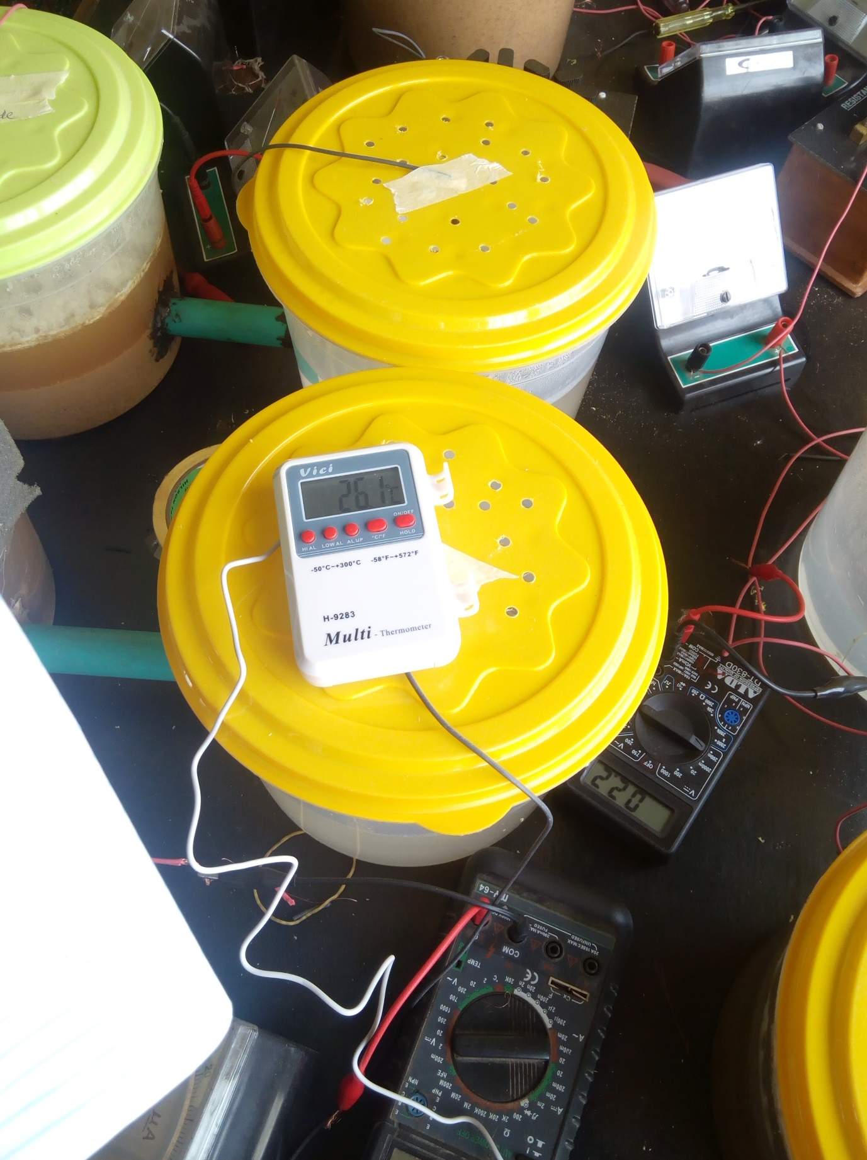
Microbial fuel cell set up inoculated with substrates

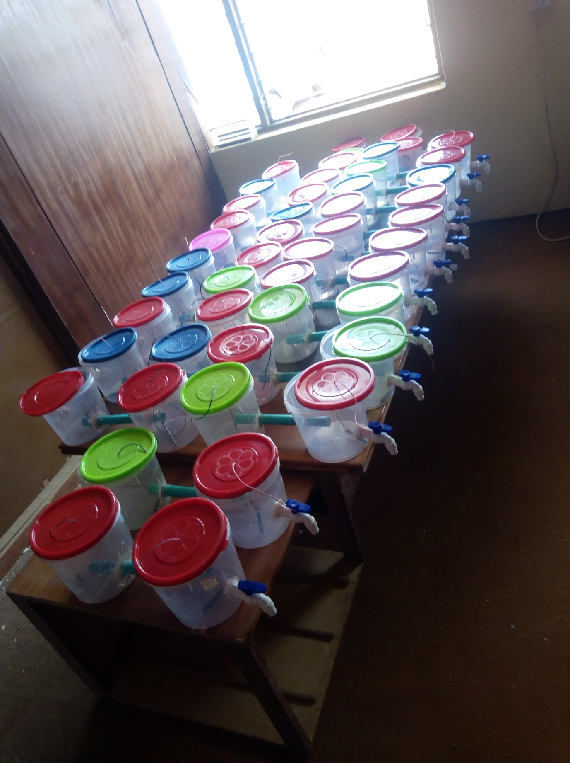
Completely constructed controlled microbial fuel cell

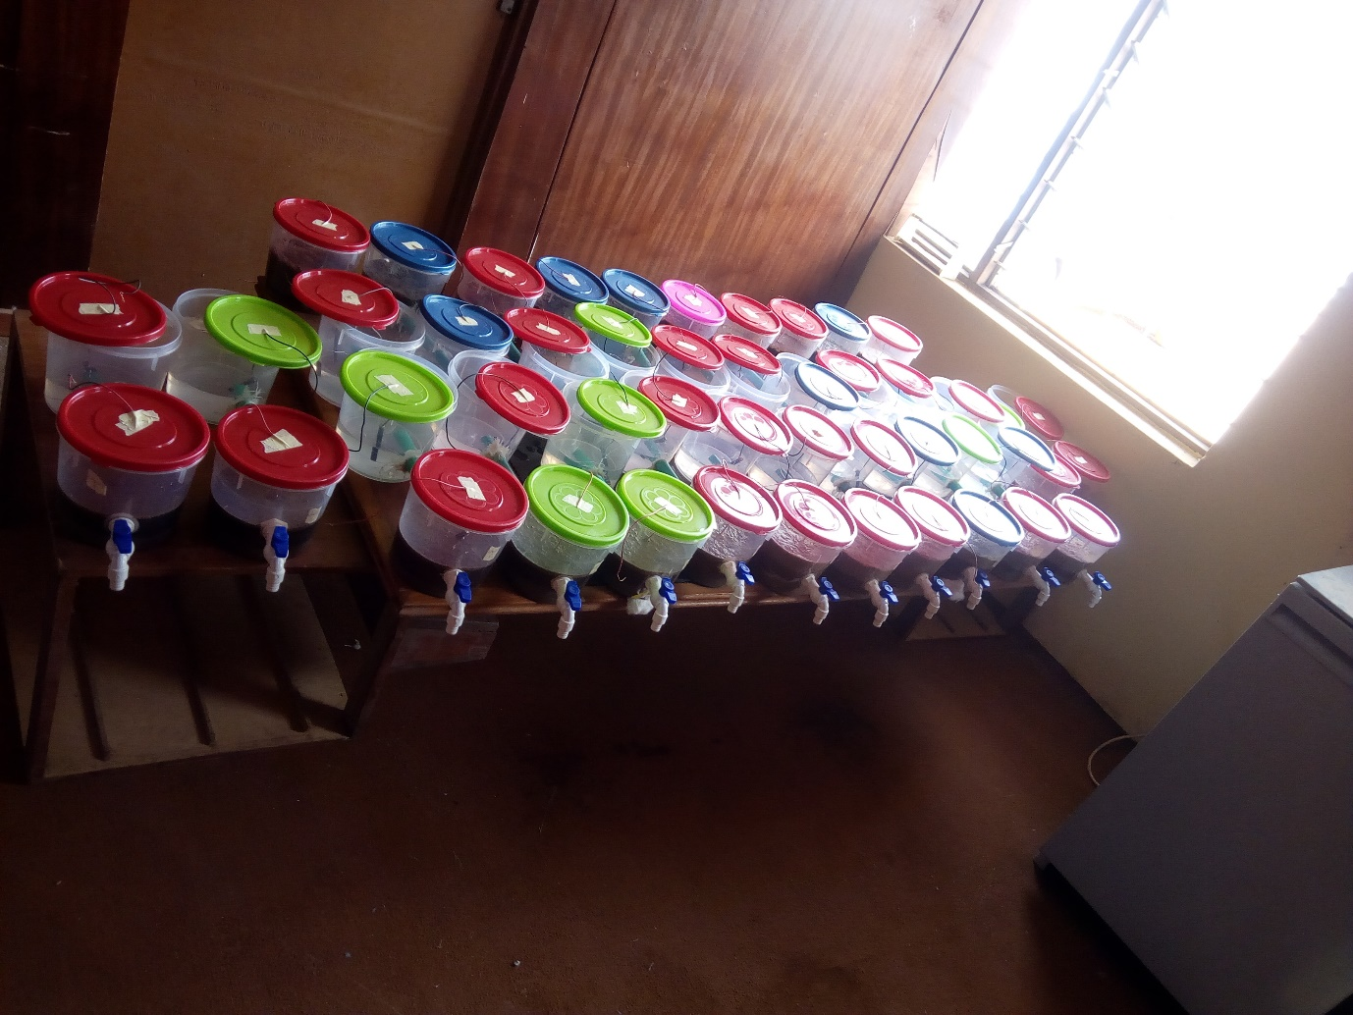
Controlled microbial fuel cell set up inoculated with substrates and organisms

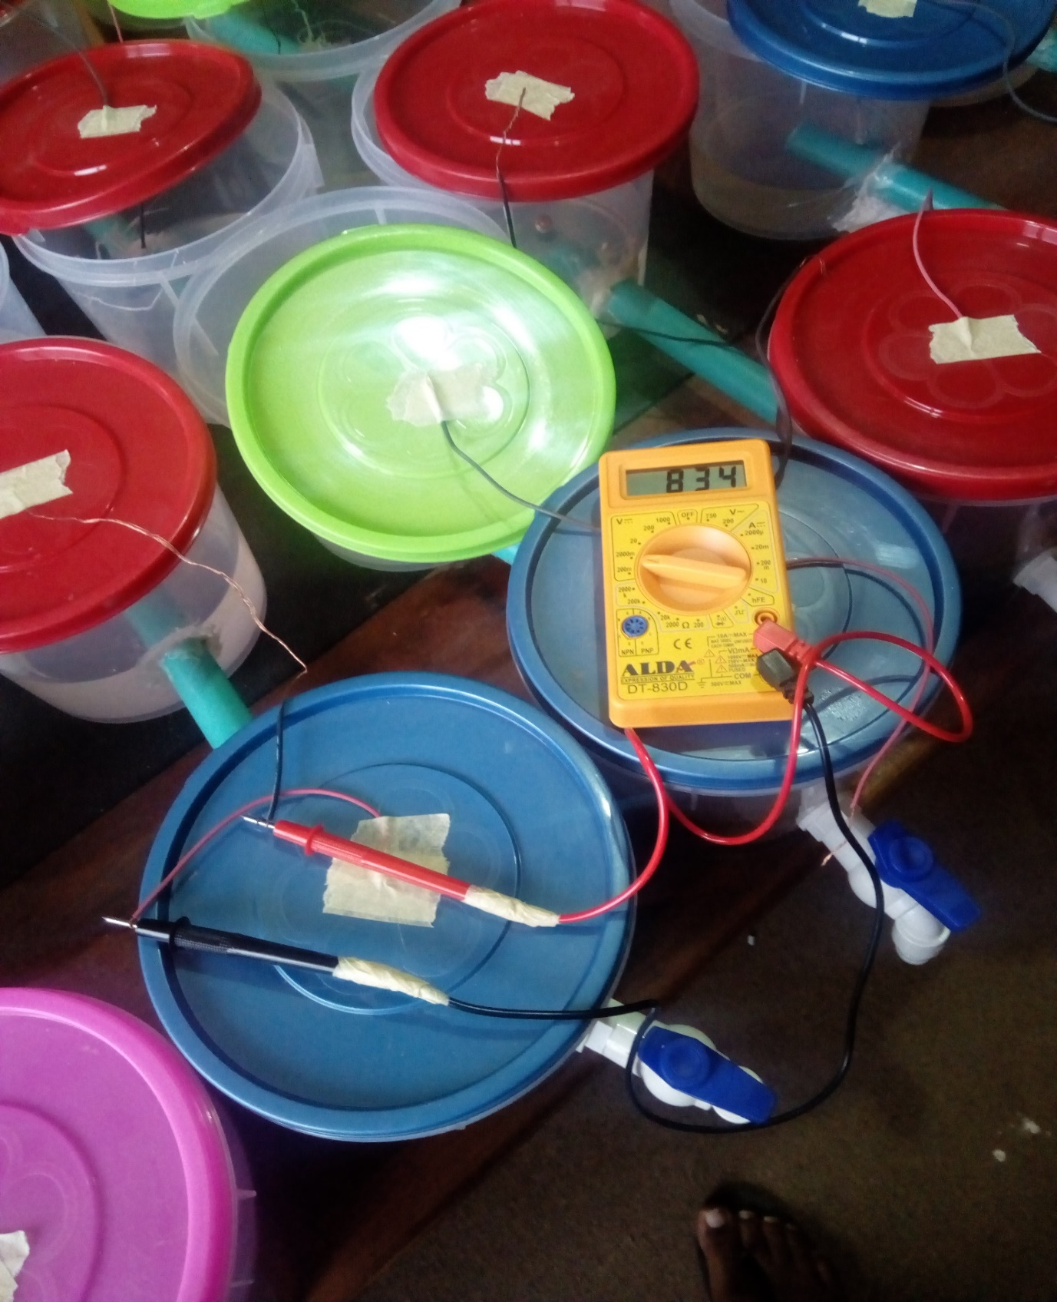
Voltage reading

Table 5: Proximate content (%) of substrates (agro-wastes) before and after fermentation
The data are presented as the means ± S.E.ss (n=3). Values with the same superscript letter(s) in the same column are not significantly different (P<0.05).
AG | Moisture |  | Ash |  | Crude protein |  | Crude fat |  | Crude fibre |  | Carbohydrate
AG | raw | fermented | raw | fermented | raw | fermented | raw | fermented | raw | fermented | raw | fermented
A | 1.24±0.06^{b} | 19.99±0.31ª | 1.26±0.04ª | 0.49±0.02ª | 6.82±0.18^{c} | 14.10±0.13^{d} | 0.19±0.01^{b} | 1.28±0.03ª | 12.16±0.14^{b} | 8.17±0.05^{c} | 79.38±0.62ª | 57.26±0.73^{c}
B | 3.03±0.07^{c} | 35.85±0.55^{b} | 1.59±0.01^{b} | 0.87±0.04^{c} | 1.49±0.11ª | 6.84±0.37^{b} | 0.04±0.01ª | 2.01±0.09^{c} | 10.63±0.57^{b} | 6.59±0.53^{b} | 84.49±0.50^{b} | 50.22±0.78^{b}
C | 1.34±0.06^{b} | 38.77±0.53^{c} | 1.79±0.01^{c} | 0.91±0.01^{c} | 5.87±0.14^{b} | 10.05±0.15^{c} | 0.46±0.05^{c} | 1.08±0.01ª | 7.09±0.03ª | 4.99±0.23ª | 84.37±0.63^{b} | 46.08±0.92ª
D | 0.71±0.09ª | 18.71±0.61ª | 1.86±0.04^{c} | 0.68±0.04^{b} | 1.96±0.03ª | 2.86±0.34ª | 1.87±0.05^{d} | 1.30±0.02^{b} | 16.74±0.56^{c} | 10.25±0.07^{d} | 78.81±1.18ª | 68.54±1.25^{d}

Key: A= potato peels, B= sugarcane shaft, C= wheat shaft, D= maize husk, AG-Agrowaste

AG | K |  | Na |  | Zn |  | Pb |  | Fe |  | Ca
AG | raw | fermented | raw | fermented | raw | fermented | Raw | fermented | raw | Fermented | raw | fermented
A | 166.00±3.00ª | 285.50±4.50ª | 24.50±1.50ª | 13.01±0.99ª | 1.29±0.03ª | 0.41±0.09^{b} | 0.01±0.00ª | 0.00±0.00 | 1.07±0.03ª | 2.42±0.08ª | 52.55±0.45^{c} | 34.00±1.00ª
B | 203.50±1.50^{b} | 321.00±2.00^{b} | 46.50±1.50^{d} | 63.04±0.96^{c} | 2.28±0.07^{b} | 1.04±0.03^{c} | 0.00±0.00ª | 0.00±0.00 | 3.08±0.03^{c} | 6.40±0.02^{c} | 41.70±0.30^{b} | 83.62±1.00^{d}
C | 373.50±2.50^{c} | 494.00±2.00^{d} | 33.53±1.47^{b} | 50.00±2.00^{b} | 1.59±0.05^{b} | 0.05±0.01ª | 0.00±0.00ª | 0.00±0.00 | 3.25±0.05^{c} | 9.57±0.04^{d} | 75.05±0.95^{d} | 54.45±0.55^{c}
D | 210.50±1.50^{b} | 346.00±2.00^{c} | 40.04±1.96^{c} | 17.02±0.98ª | 2.07±0.06^{c} | 4.10±0.02^{d} | 0.04±0.00^{b} | 0.00±0.00 | 1.71±0.07^{b} | 5.86±0.06^{b} | 30.06±0.95ª | 43.05±0.95^{b}
Mineral content (mg/100 g) of substrates (agrowastes) before and after fermentation
The data are presented as the means ± S.E.ss (n=3). Values with the same superscript letter(s) in the same column are not significantly different (P<0.05).

Keywords: A= potato peels, B= sugarcane shaft, C= wheat shaft, D= maize husk, AG-agrowaste

Vitamin content (mg/g) of substrates (agrowastes) before and after fermentation
Samples | Vitamin C |  | Vitamin B1 |  | Vitamin B2 |  | Vitamin D |  | Vitamin A
Samples | raw | fermented | Raw | fermented | raw | fermented | raw | fermented | raw | fermented
A | 8.58±0.47^{c} | 26.93±0.19^{d} | 1.04±0.00^{b} | 1.71±0.00^{d} | 0.61±0.00^{d} | 1.17±0.00^{d} | 0.65±0.00^{c} | 1.85±0.01^{c} | 235.02±27.01ª | 828.63±3.41^{d}
B | 5.19±0.23ª | 18.58±0.50ª | 0.33±0.12ª | 0.46±0.00ª | 0.05±0.00ª | 0.29±0.00ª | 0.75±0.01^{d} | 1.23±0.01ª | 228.63±2.46ª | 377.05±25.66ª
C | 4.12±0.31ª | 22.92±0.19^{c} | 0.51±0.00ª | 1.05±0.00^{c} | 0.33±0.00^{c} | 0.60±0.00^{b} | 0.58±0.01^{b} | 1.43±0.01^{b} | 280.87±25.96ª | 600.58±28.14^{c}
D | 6.82±0.19^{b} | 19.83±0.34^{b} | 0.35±0.00ª | 0.86±0.00^{b} | 0.19±0.00^{b} | 0.65±0.00^{c} | 0.06±0.00ª | 1.25±0.01ª | 375.61±21.47ª | 513.52±4.46^{b}
The data are presented as the means ± S.E.ss (n=3). Values with the same superscript letter(s) in the same column are not significantly different (P<0.05).

Keywords: A= potato peels, B= sugarcane shaft, C= wheat shaft, D= maize husk, Vit. = vitamin

Ethanol (%) and organic acid (mg/L) contents of the substrates (agrows) before and after fermentation
Samples | Ethanol |  | Formic acid |  | Malic acids |  | Citric acids |  | Acetic acids |  | Lactic acids
Samples | raw | fermented | raw | fermented | Raw | fermented | raw | fermented | raw | fermented | raw | fermented
A | 0.00±0.0 | 0.56±0.04^{b} | 0.08±0.00^{b} | 0.39±0.03ª | 0.07±0.00^{b} | 0.37±0.04ª | 0.08±0.01ª | 0.38±0.03ª | 0.03±0.00^{ab} | 0.15±0.02^{b} | 0.02±0.00^{b} | 1.24±0.00^{c}
B | 0.00±0.0 | 1.16±0.05^{c} | 0.03±0.00ª | 1.15±0.00^{c} | 0.05±0.00^{ab} | 0.59±0.02^{b} | 0.06±0.01ª | 0.47±0.02^{b} | 0.02±0.00ª | 0.09±0.00ª | 0.01±0.00ª | 1.41±0.00^{d}
C | 0.00±0.0 | 0.47±0.05^{ab} | 0.05±0.00ª | 1.73±0.05^{d} | 0.04±0.00ª | 0.43±0.02ª | 0.08±0.01ª | 0.71±0.01^{c} | 0.07±0.01^{c} | 0.07±0.01ª | 0.02±0.00^{b} | 1.06±0.00ª
D | 0.00±0.0 | 0.29±0.01ª | 0.02±0.00ª | 0.88±0.04^{b} | 0.14±0.01^{c} | 0.69±0.02^{b} | 0.09±0.04ª | 0.81±0.01^{d} | 0.05±0.00^{bc} | 0.06±0.01ª | 0.02±0.00^{b} | 1.15±0.00^{b}
The data are presented as the means ± S.E.ss (n=3). Values with the same superscript letter(s) in the same column are not significantly different (P<0.05).
Keywords: A= potato peels, B= sugarcane shaft, C= wheat shaft, D= maize husk

Enzyme content (mg/ml/min) of substrates (agrowastes) before and after fermentation
Samples | Amylase |  | Cellulase |  | Protease |  | Pectinase
Samples | Raw | Fermented | raw | fermented | raw | fermented | raw | fermented
A | 0.08±0.00^{d} | 0.24±0.02^{c} | 0.11±0.00^{d} | 7.15±0.03ª | 0.01±0.00ª | 0.01±0.00ª | 0.01±0.00^{b} | 0.02±0.00^{b}
B | 0.02±0.00^{c} | 0.10±0.00^{b} | 0.09±0.00^{c} | 8.49±0.03^{b} | 0.01±0.00ª | 0.01±0.00ª | 0.01±0.00^{b} | 0.02±0.00^{b}
C | 0.01±0.00^{b} | 0.02±0.00ª | 0.08±0.00^{b} | 9.04±0.03^{c} | 0.01±0.00ª | 0.02±0.00b | 0.00±0.00ª | 0.01±0.00ª
D | 0.00±0.00ª | 0.01±0.00ª | 0.03±0.00ª | 9.71±0.0³ | 0.01±0.00ª | 0.02±0.00^{b} | 0.00±0.00ª | 0.02±0.00^{b}
The data are presented as the means ± S.E.ss (n=3). Values with the same superscript letter(s) in the same column are not significantly different (P<0.05).

Keywords: A= potato peels, B= sugarcane shaft, C= wheat shaft, D= maize husk

