Extended Figures and Legends
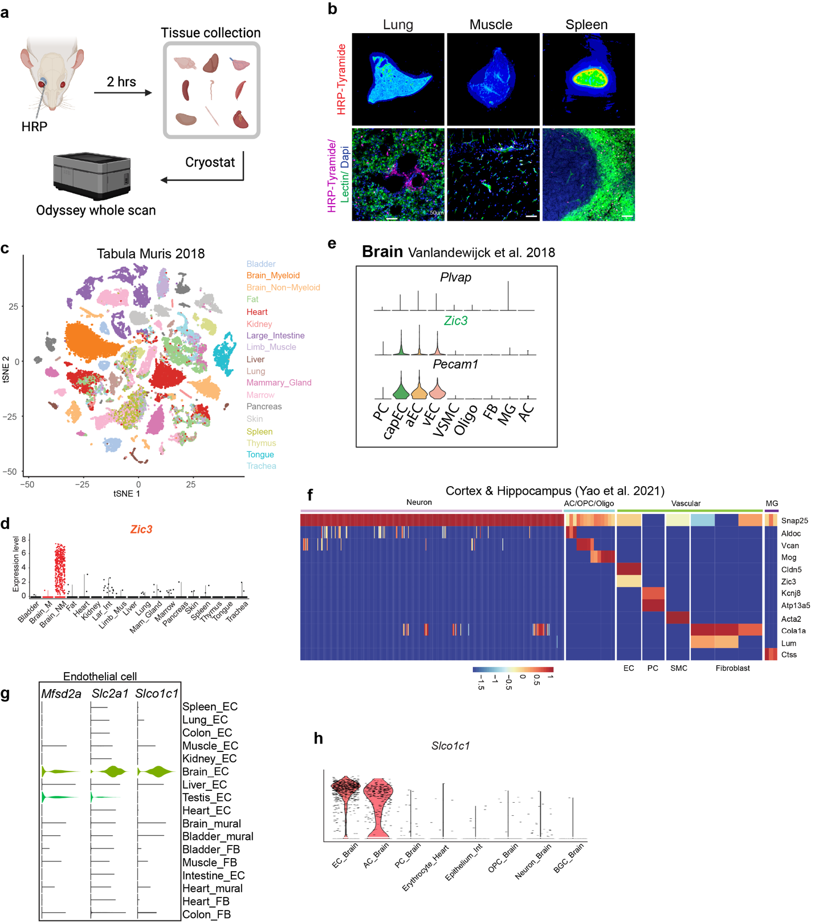

Extended Data Figure 1. Additional single cell transcriptomic analysis. (a) Schematic images showing the workflow of HRP injections and tissue preparation. (b) Representative images of mouse lung, muscle and spleen following the intravenous injection of HRP. Scale bar: 50 µm. (c) tSNE plot of all cells from different tissues of Tabula Muris database. Each dot was color-coded and annotated by tissues. (d) Violin plots showing Zic3 that distinguish across and within different tissues. Red dot indicated the brain tissue. Brain_M: Brain myeloid; Brain_NM: Brain non-myeloid; Lar_Int: Large Intestine; Mus: Muscle; Mam_Gland: Mammary Gland. (e) Violin plots showing the distribution of expression level of Plvap, Zic3 and Pecam1 in brain vasculature transcriptomics. (f) Gene expression heatmap of representative genes in Allen Institute’s dataset. AC: astrocytes; OPC: Oligodendrocyte progenitor cells; Oligo: Oligodendrocytes; EC: endothelial cells; PC: Pericytes; SMC: smooth muscle cells; MG: microglia. (g) Violin plots showing the distribution of expression level of the endothelial markers across all 20 clusters. (h) Violin plots showing the Slco1c1 expression level in the Tabula Muris dataset.

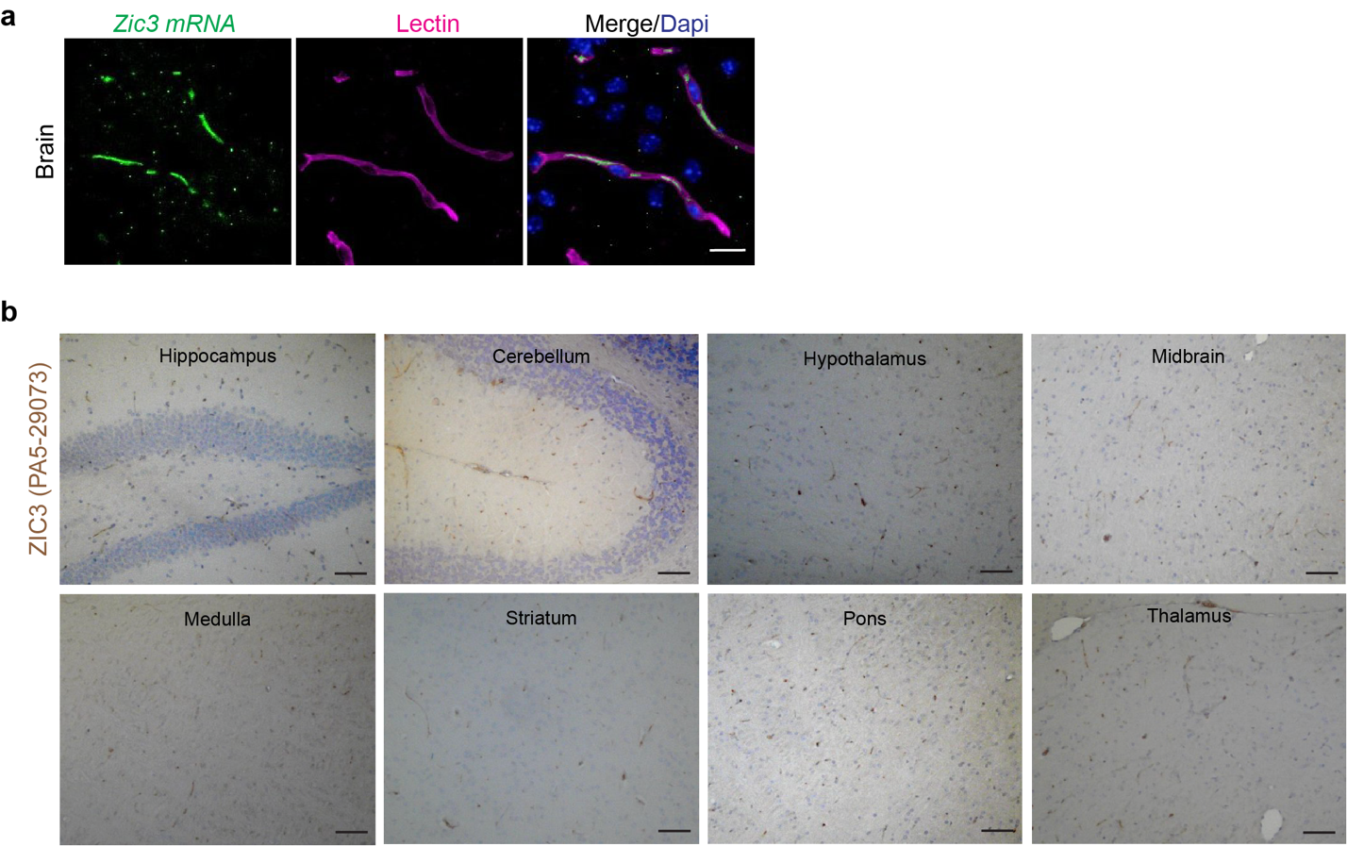
Extended Data Figure 2. Validations of Zic3 expressions in cerebrovasculature. (a) Representative images for Zic3 mRNA expression (green) and immunostaining for Lectin⁺ endothelia cells (magenta) in cortex. Scale bar: 50 µm. (b) Immunohistochemistry staining of rabbit polyclonal ZIC3 antibodies (PA5-29073) on paraffin embedded mouse brain section. Scale bar: 100 µm.
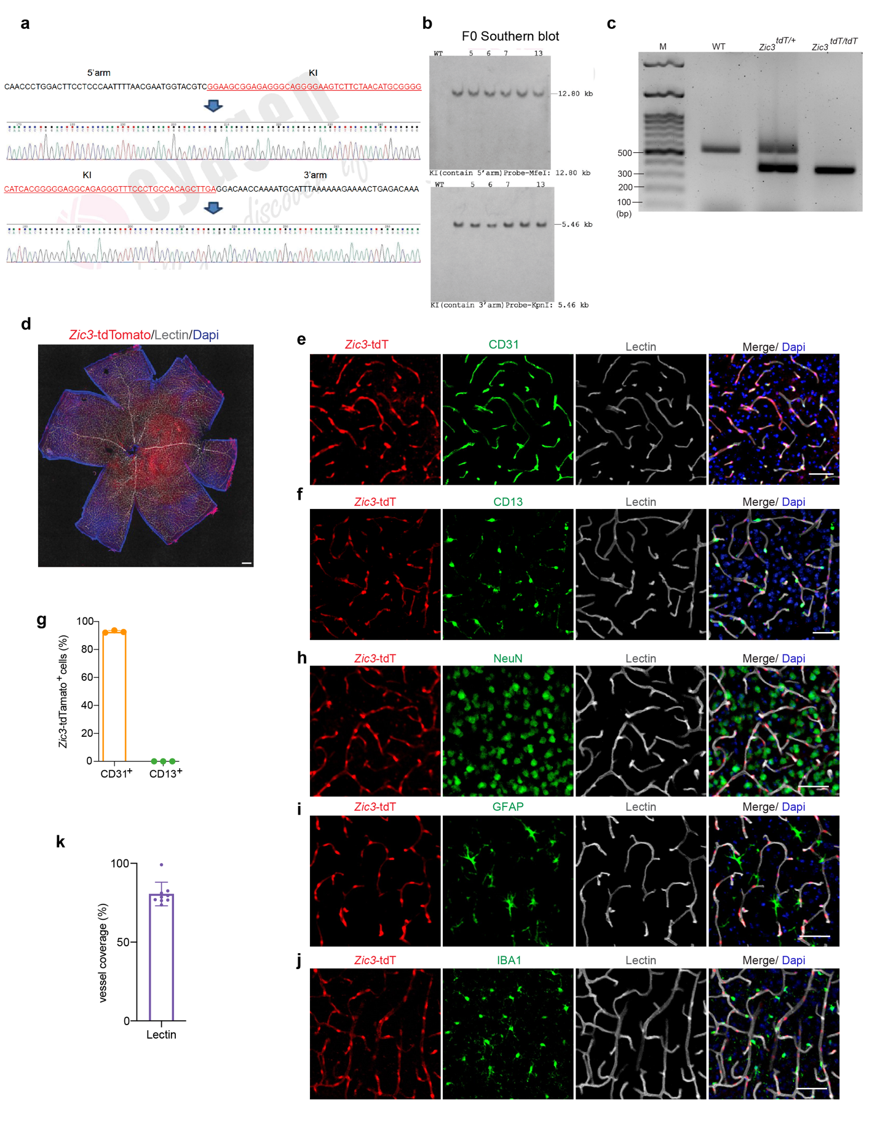Extended Data Figure 3. Generation of the Zic3-T2A-tdTomato-IRES-CreERT2 knock-in model. (a) Sequencing analysis of F1 Zic3^{tdT/+} mice showing the insertions at 5’arm (top) and 3’arm (bottom). No additional mutation or deletion were found. (b) Southern blotting analysis showing F0 and 4 F1 founders (#5, #6, #7, #13) carrying the intact allele based on hybridization of probes targeting the 5’ and 3’ arms, compared to a WT littermate. (c) Genotyping result showing the genotype of WT (with a 544-bp band), Zic3^{tdT/+} (with 544-bp and 375-bp bands) and Zic3^{tdT/tdT} (with a 375-bp band). tdT, tdTomato. (d) Flat mount of homozygous Zic3-T2A-tdTomato-IRES-CreERT2 mouse retina. (e) Colocalization of Zic3-tdTomato with endothelial marker CD31 (green) on Lectin (gray) positive endothelium. Scale bar: 50 µm. (f) Representative confocal images showing that Zic3-tdTomato is not expressed in CD13⁺ pericytes. (g) Quantification of the percentage of Zic3-tdTomato⁺ cells in CD31⁺ endothelial cells or CD13⁺ pericytes. n = 3 mice. Data are presented in mean ± SEM. (h-j) Representative confocal images showing that Zic3-tdTomato is not expressed in NeuN⁺ cortical neurons (h), glial fibrillar acidic protein (GFAP)⁺ astrocytes (i), or ionized calcium binding adaptor molecule 1 Iba1⁺ microglia (j). (k) Quantification of the percentage of Zic3-tdTomato⁺ cells in lectin⁺ vessels. n = 3 mice. Data are presented in mean ± SEM.

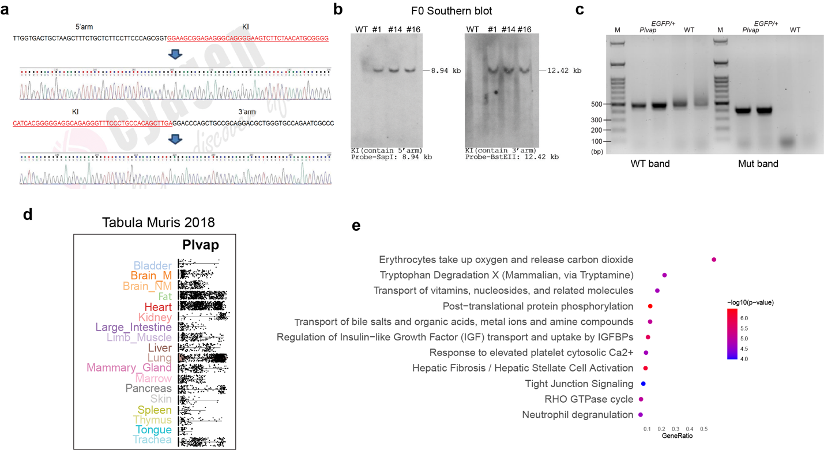
Extended Data Figure 4. Generation of the Plvap-T2A-EGFP-IRES-CreERT2 knock-in model and additional characterization. (a) Sequencing analysis of F1 Plvap^{EGFP/+} mice showing the insertions at 5’arm (top) and 3’arm (bottom). No additional mutation or deletion were found. (b) Southern blotting analysis showing F0 and 3 F1 founders (#1, #14, #16) carrying the intact allele based on hybridization of probes targeting the 5’ and 3’ arms, compared to a WT littermate. (c) Genotyping result showing the genotype of WT (with a 483-bp band) and plvap^{EGFP/+} (with 483-bp and 405-bp bands). (d) Violin plots showing Plvap that distinguish across and within 18 tissues in Tabula Muris dataset. (e) IPA Pathway analysis on 341 BBB endothelial cells enriched genes.

